C程序设计

姓名 : 吴律华

学号 : 20172581

1. 求邮寄费用

**代码**

1. #include <iostream>
2. #include <conio.h>
4. **int** main(**int** argc, **char**\*\* argv){
5. **double** weight;
6. printf("\n\n\n\t\t\t请输入要邮寄的物品重量 [单位kg]：");
7. scanf("%lf", &weight);
8. **if**(weight<0){
9. printf("\n\n\n\t\t\tem... 重量不能为负数哦。");
10. }**else** **if**(weight>0&&weight<=10){
11. printf("\n\n\n\t\t\t总共将收取%.2lf元。明细如下：", weight * 0.8 + 0.2);
12. printf("\n\n\n\t\t\t\t\t\t手续费：￥0.2");
13. printf("\n\n\n\t\t\t\t\t\t首重费：￥%.2lf",weight*0.8);
14. printf("\n\n\n\t\t\t\t\t\t====================");
15. printf("\n\n\n\t\t\t\t\t\t合计：￥%.2lf",weight * 0.8 + 0.2);
16. }**else** **if**(weight>10&&weight<=20){
17. printf("\n\n\n\t\t\t总共将收取%.2lf元。明细如下：", (weight-10)*0.75+10 * 0.8 + 0.2);
18. printf("\n\n\n\t\t\t\t\t\t手续费：￥0.2");
19. printf("\n\n\n\t\t\t\t\t\t首重费：￥%.2lf",10*0.8);
20. printf("\n\n\n\t\t\t\t\t\t续重费：￥%.2lf",(weight-10)*0.75);
21. printf("\n\n\n\t\t\t\t\t\t====================");
22. printf("\n\n\n\t\t\t\t\t\t合计：￥%.2lf", (weight-10)*0.75+10 * 0.8 + 0.2);
23. }**else** **if**(weight<=30){
24. printf("\n\n\n\t\t\t总共将收取%.2lf元。明细如下：", (weight-20)*0.7+10*0.75+10 + 0.2);
25. printf("\n\n\n\t\t\t\t\t\t手续费：￥0.2");
26. printf("\n\n\n\t\t\t\t\t\t首重费：￥%.2lf",10*0.8);
27. printf("\n\n\n\t\t\t\t\t\t续重费：￥%.2lf", weight-20*0.7+10*0.75);
28. printf("\n\n\n\t\t\t\t\t\t====================");
29. printf("\n\n\n\t\t\t\t\t\t合计：￥%.2lf", (weight-20)*0.7+10*0.75+10 + 0.2);
30. }**else**{
31. printf("Fail");
32. }
33. getch();
34. }

**运行结果**

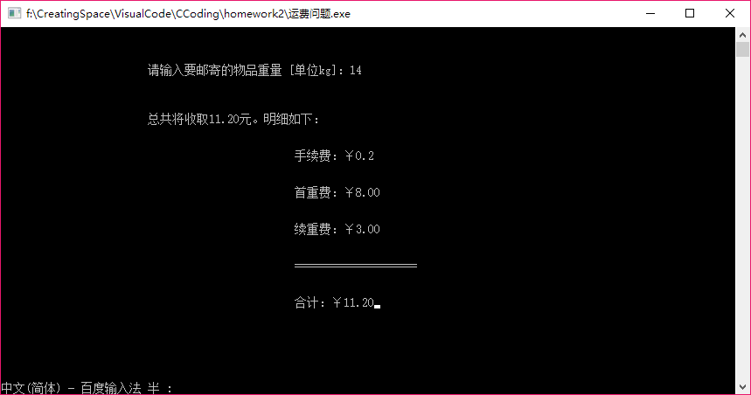

1. 字符统计
2. #include <conio.h>
3. #include <ctype.h>
4. #include <iostream>
6. **int** main(**int** argc, **char** **argv)
7. {
8. printf("\n\n\n\t\t\t请输入要统计的字符：");
9. **char** ch;
10. unsigned **int** nchar = 0;
11. unsigned **int** nalpha = 0;
12. unsigned **int** ndigit = 0;
13. unsigned **int** nspace = 0;
14. unsigned **int** nother = 0;
16. **while** ((ch = getchar()) != '\n')
17. {
18. nchar++;
19. **if** (isalpha(ch)){
20. nalpha++;
21. }
22. **else** **if** (isdigit(ch)){
23. ndigit++;
24. }
25. **else** **if** (ch ==' ') {
26. nspace++;
27. }
28. **else**{
29. nother++;
30. }
31. }
32. printf("\n\n\n\t\t\t总字符数：%u", nchar);
33. printf("\n\n\n\t\t\t字母数：%u", nalpha);
34. printf("\n\n\n\t\t\t数字数：%u", ndigit);
35. printf("\n\n\n\t\t\t空格数：%u", nspace);
36. printf("\n\n\n\t\t\t其他  ：%u", nother);
37. getch();
38. }

运行结果

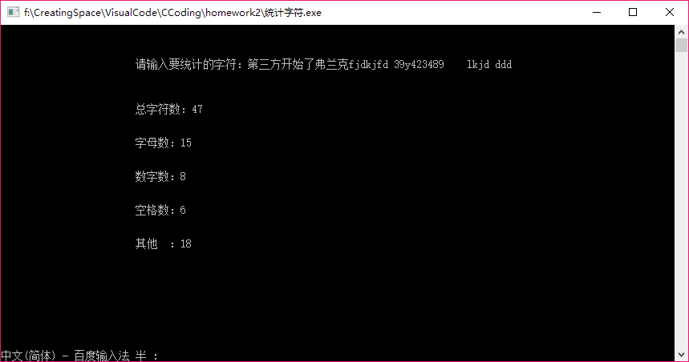

1. 开方计算

**代码**

1. #include <iostream>
2. #include <math.h>
3. #include <conio.h>
5. **double** mysqrt(**double**,unsigned **int**\*);
7. **int** main(){
8. **double** a;
9. scanf("%lf", &a);
10. unsigned **int** counter = 0;
11. printf("input = %lf\nmath.h::sqrt(): %lf\nmysqrt(): %lf，迭代了%u次。\n误差：%lf",
12. a,sqrt(a) ,mysqrt(a, &counter),counter,sqrt(a)-mysqrt(a,&counter));
13. getch();
14. }
16. **double** mysqrt(**double** a,unsigned **int** * counter){
17. **double** sqrtx(**double**, **double**);
18. **const** **float** ESP = 1e-5;
19. **double** x0 = sqrtx(a, a/2);
20. **double** tmp;
21. *counter = 0;
22. **while**(fabs((tmp=sqrtx(a, x0))-x0)>=ESP){
23. x0 = tmp;
24. (*counter)++;
25. }
26. **return** x0;
27. }
29. **double** sqrtx(**double** a,**double** x0){
30. **return** 0.5 * (x0 + a / x0);
31. }

运行结果

