Configuring Your Privacy and Security Settings via LinkedIn
Dexter Law | Information Security Intern
July 20, 2020
PURPOSE
c. This document will serve as a guide, taking you step-by-step through securing your LinkedIn account. It will also incorporate Linkedin’s very own best practices for account security and maximum visibility.
TABLE OF CONTENTS
- How to access your privacy and security settings
- Share/Network Settings
  - Edit Your Public Profile
  - Who can see your email address and connections
  - Who can see your profile
  - How is your name viewed
- Content Management
  - How are you seen on profile and view dashboards
  - Who can see your activity
  - What content should you post
- Data Management
  - Turn off data sharing with third-party applications
  - Decide which apps have access to your profile and data
- Intrusion Protection
  - Configure Two-step verification
  - STRONG passwords
- Review your account

References:
https://www.linkedin.com/help/linkedin/answer/267/account-security-and-privacy-best-practices?lang=en
https://www.socialmediaexaminer.com/how-to-make-sure-your-linkedin-account-is-secure/#:~:text=It%20helps%20keep%20you%20top,you%2C%20make%20yourself%20completely%20private.
https://heimdalsecurity.com/blog/linkedin-security-privacy-essential-guide/

How To Access Your Privacy and Security Settings
For many users, this will be your first time accessing the Privacy settings for your account. LinkedIn preconfigures most of the settings, so your profile is fairly visible and secure by default. LinkedIn has a lot of functionality, so this guide is tailored to help you decide the best settings for you. LinkedIn provides 40+ security setting options to help you decide. That is fairly overwhelming, but we’ll only cover the most important ones. If you do not know how to access your setting, below are instruction to show you how.
- Once logged in to the LinkedIn platform. Click on the “Me” tab from home page’s top header Menu, and then click on to the “Settings & Privacy” tab.
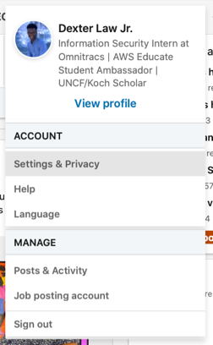
Figure 1: Once logged into the LinkedIn Platform. Navigate to the “Me” tab from the home page’s top header Menu, then click on the “Settings & Privacy” tab
- You will then be redirected to the a page where you can configure a broad number of account settings. This guide will focus only on the Privacy settings tab, and touch the Ads tab very briefly.
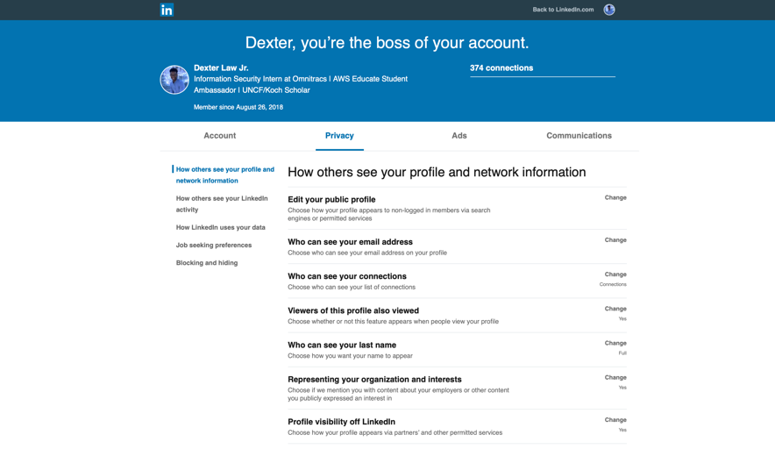
Figure 2: Snapshot of the Privacy Settings Page

Share/Network Settings
Users are able to interact with the LinkedIn platform in an extremely broad number of ways. They provide an assortment of professional networking functions like job search engine, recruiter networking, interest groups, professional networking, etc. This can be overwhelming in regards to the visibility of your information. Your Share/Network settings allow you to target who you want to see your profile.
For most users, your settings are open for the world to see, meaning whoever searches your name can find your profile. Below are all the settings related to how others see your profile and network info.
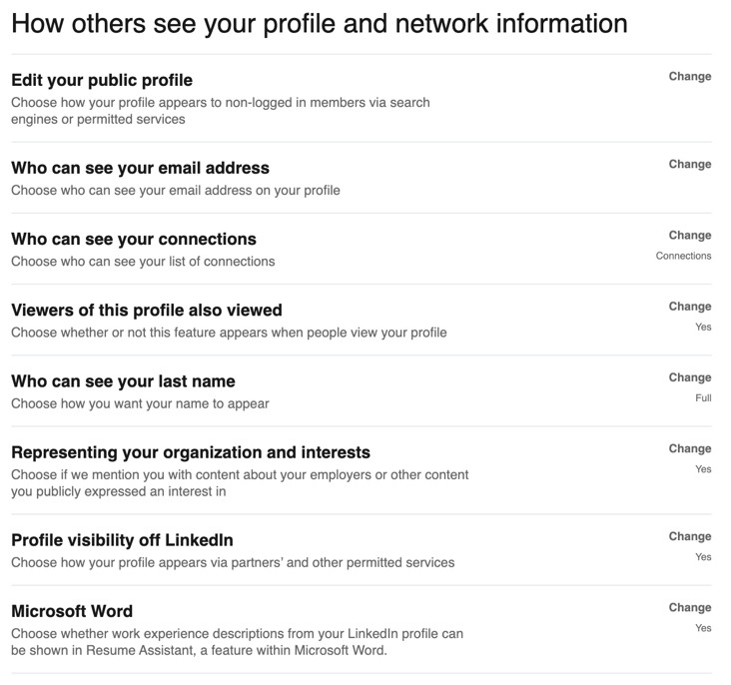
Figure 3: Snapshot of the Profile and Network settings from Linkedin
Edit your public profile
Your public profile is the profile available to non-logged in users via search engines like Google, Bing, Yahoo, etc. and other permitted services(third-party applications). Clicking on the “Change” button takes you to a snapshot of your current public profile.
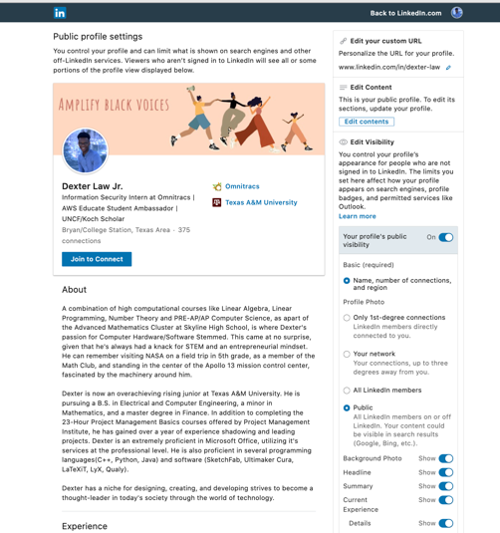
Figure 4: Snapshot of Public Profile
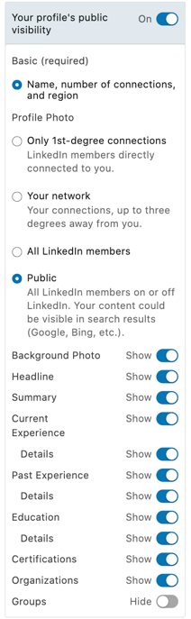
The toolbar on the right side of the page provides all of the settings related to your public profile. From here you can edit your Linkedin URL, and the contents of your page, but we’ll hoan in on your profile visibility settings.

You have the ability to make yourself unavailable to find. You can do this by clicking on the blue slider at the top of the toolbar and turning it off.

You can then decide who you want to see you connections. This can 1st degree connections(only Linkedin members directly connected to you), connections up to three degrees from you, all Linkedin members, or the general public.

Figure 5: Visibility settings

Who can see your email address and connection
You can also decide who can see your email address and connections. By default it’s only your 1st degree connections, but can be changed 1st and 2nd degree connection or all.
Who can see your profile
You can also decide if you want your public profile available from the following: third-party applications, if your mentioned in representing organizations, if your mentions in things you’ve expressed an interest in. One example is your employer being informed when you make a post.
How is your name viewed
For those of you who want to remain particularly discrete, you also have the ability to decide how your full name is viewed.

Content Management
The LinkedIn network is designed for you to expand your reach and broaden your network, however it is still ultimately up to you to decide what information you would like to share on your LinkedIn profile. Still be mindful of the content you post. Below will take you through settings related to the visibility of the activity on your page.
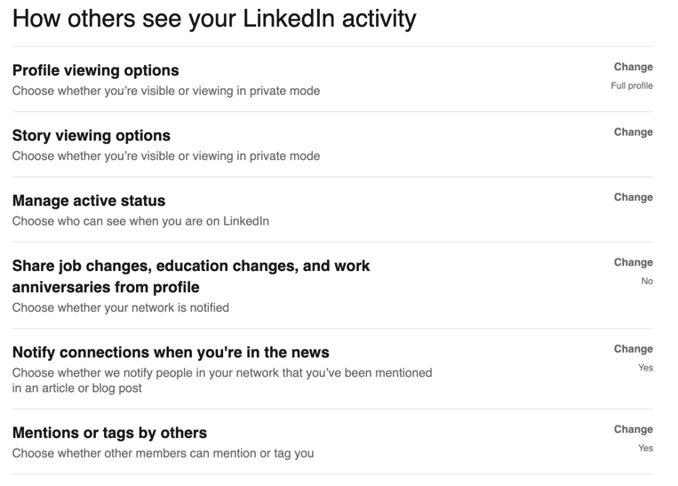
Figure 6: All settings related to your account activity
How are you seen on Profile and Story view dashboards
If you navigate to your homepage, everyone has a view dashboard available by default that allows you to see who has viewed your story or profile. You can decide how you are seen on other Linkedin member’s View Dashboard. Below are all the option.
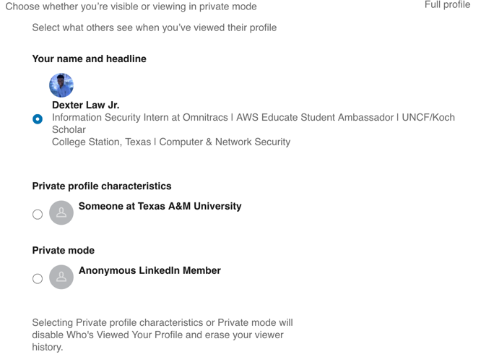
Figure 7: Profile and Story view options
Who can see my Linkedin activity?
You can see in Figure 6, the various ways in which you can control how the activity is viewed on your page. You can decide whether other members can mention you in tags, whether your connections are notified when you are mentioned in an article or other profile updates, and who can view your active status.
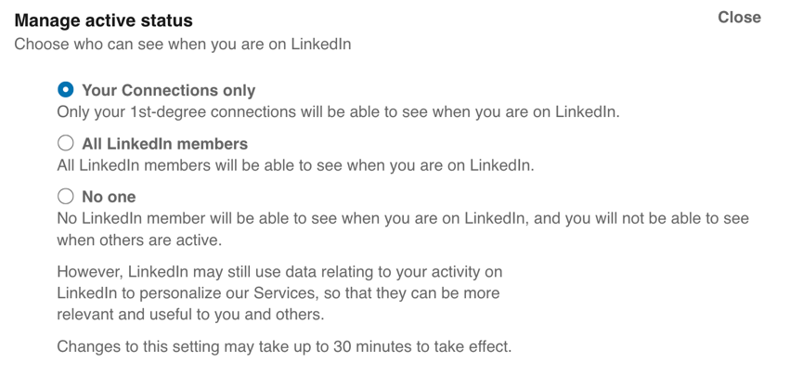
Figure 8: Manage your active status options
Data Management
The platform offers a variety a privacy settings in relation to how your data in being used by Linkedin. This data includes Linkedin users sharing your information with their permitted third-party applications, your ability to include/exclude your data about your personal demographics, and sharing salary data and many more.
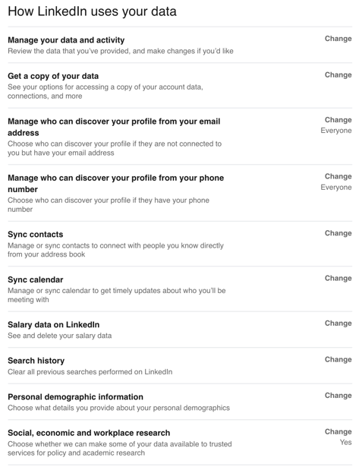
Figure 9: Data Management settings
Manage your data and activity
This allows you to review all of your most resent post, updates you made on your profile, and updates you made to your security settings. This is an easy way to keep track of your account activity.
Contact Information
You have the ability to choose who can discover your Linkedin profile from your email address or phone number. This can limit or broaden your availability depending on how you want to be discovered on Linkedin.

Third-Party Apps (Website Data)
Information in regards to third-party data can be found in the “Ads” Tab. Refer to Figure 2 if you need helping locating it. Once there, you’ll see a Third party data section like the snapshot below.
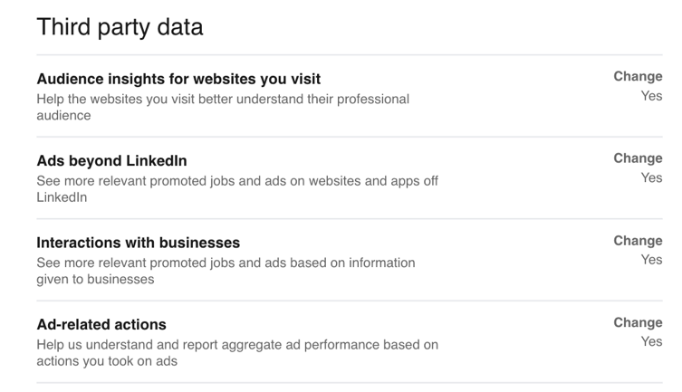
Figure 10: Third party data settings
After reaching the app screen the third-party data screen, you can see all of the options available to you. If you were every wondering how things you searched on google popped up on your ad social media, this is how. You can re-configure these settings to determine whether you want your cache data used when Linkedin tailors ad’s to you.
Third-Party Party Apps (Data)
Information in regards to third-party data can also be found in the “Account” Tab. Refer to Figure 2 if you need helping locating it. Once there, you’ll see a Third party data section like the snapshot below
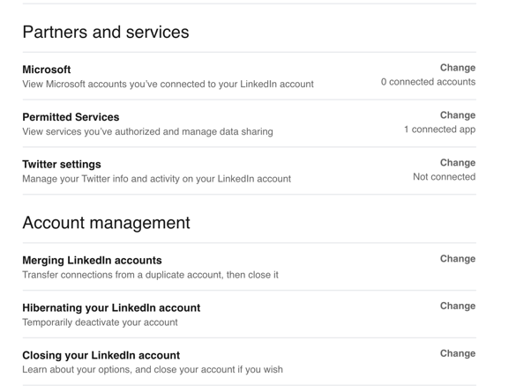
Figure 11: Account settings
You can make changed to the way Linkedin’s permitted partners and services can access your Linkedin data.

Linkedin Security Best Practices

