Howdy Omnitracers,

It is Tax Season aka Adult Season and a peak period for identity thief’s. Attackers pose of the Internal Revenue Services (IRS), other government agencies/financial institutions in an attempt to defraud you, the taxpayer. They do this by employing sophisticated phishing campaigns to lure users to malicious sites or entice them to activate malware in infected email attachments. To protect sensitive data, credentials, and payment information, you, the taxpayer, should prepare for heightened risk during tax season and remain vigilant year-round.

Phishing Attack Recap
Phishing attacks use email or malicious websites to solicit personal information by posing as trustworthy organizations. A lot of the time, the recipients are fooled into believing the phishing attempt, like the ones below, are from trusted sources. An actor may take advantage of knowledge gained from research and earlier attempts to come off as legitimate source, including replicating the look and feel of an authentic message.

How to identify a phishing email
Here are a few things to look for in an email to indicate it might be a phishing scam
- Grammatical errors, odd capitalization, and misspellings
- Low-resolution logos that appear fuzzy, indistinct, or tiny
- Odd URL links (hover over a link to get a preview of where your being redirected)

Below are examples of Phishing Campaign received by the Cybersecurity Infrastructure Agency (CERT)

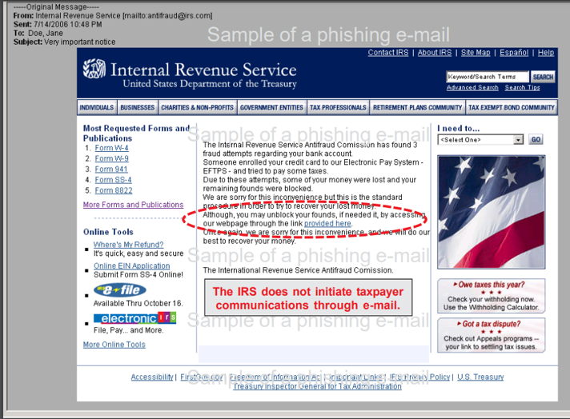
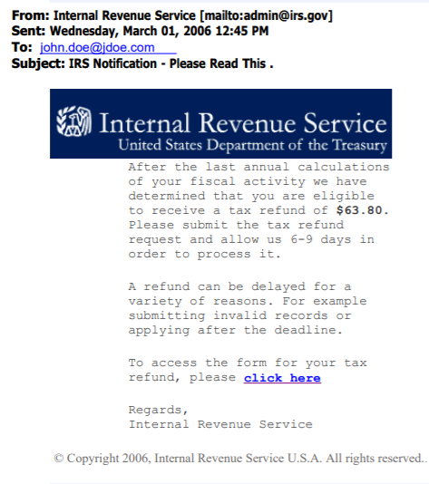
Tax fraud Phishing Campaign 2
Tax Fraud Phishing Campaign 1
BE AWARE: Scammers are constantly evolving, and their methods are becoming increasingly more cunning and difficult to trace.

Understand how the IRS communicates electronically with taxpayers
Knowing how the IRS communicates with citizens will save you from a world of trouble. Below are the ways in which the IRS will and will NOT contact you.

DONT’S: The IRS does NOT initiate contact with taxpayers by email, text message, or social media channels to request personal information; This includes personal information (PIN’s), passwords, or similar access information for credit cards, banks, or other financial institutions
DO’S: The IRS WILL contact you via snail mail or updates can be checked on the IRS’s official website: www.irs.gov.

Take Action To Avoid Becoming a Victim
If you believe you might have revealed sensitive information about you, Omnitracs, or your company’s access credentials please do the following:
- Place a Fraud Alert with a Credit Bureaus Agency
A fraud alert is a notice that is placed on your credit report that alerts credit card companies and others that might extend you credit that you may be a victim of fraud, including identify theft. Place a fraud alert by contacting one of the three nationwide credit bureaus agencies (Experian, Transunion, or Equifax). A fraud alert can make it harder for an identify thief to open more accounts in your name. It puts in alert on your credit report and tells the other two credit bureaus to do so.
- Report Suspicious Phishing Communication the IRS
Email: If you are read an email claiming to be for the IRS, do not reply or clock attachments and/or links. Forward the email as-is to phishing@irs.gov, and delete the original email
Website: If you find a website that claims to be the IRS and suspect it is fraudulent, send the URL of the suspicious site to phishing@irs.gov with subject line, “Suspicious website”
Text Message: If you receive a suspicious text message, do not reply or click on attachments and/or links. Forward the test as-is to 202-552-1226, then delete the original message.
- Report Suspicious Phishing Communication to Omnitracs
If you feel like you’ve received a suspicious email, please forward it cirt@omnitracs.com and delete it form your inbox and sent items. The Computer Incident Response Team (CIRT) will advise you on the next appropriate action. This email can also be used for any general questions or concerns.

If you are a victim of any of the above involving IRS impersonation, report to phsing@irs.gov, file a report with the Treasury Inspector General for Tax Administration, the Federal Trade Commission, and the police.

For additional information please refer to the our previous series on Social Engineering:
- https://omnitracs.sharepoint.com/sites/Intranet_Technology/SitePages/July-13%2C-2020---Social-Engineering-Alert.aspx
- https://omnitracs.sharepoint.com/sites/Intranet_Technology/SitePages/July-13%2C-2020---Social-Engineering-Alert.aspx

