Graphql

Sign Up user

Login User

Create Employee

Update Employee

User Delete

Employee Delete

Get Users

Get User by ID

Get Employees

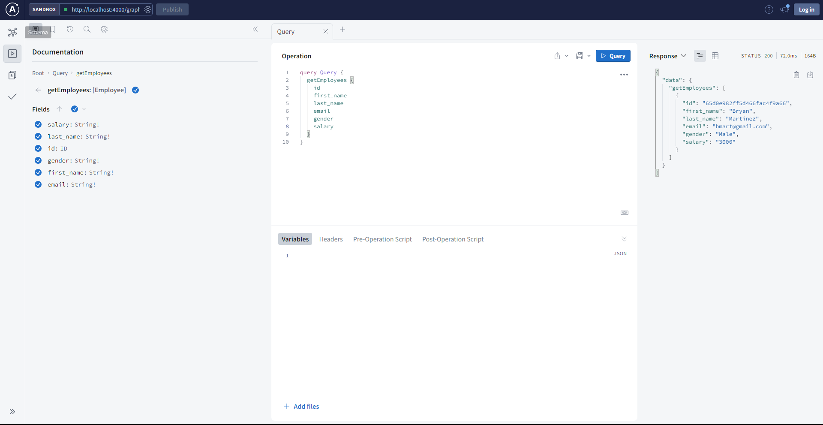

Get Employee ID

MongoDB

Employee database

User Database

