Simple Login System
Student Name: Dexter E. Quintero
Course and Section: BSIT 3 Section - 1

Software Requirements
Apache 2.4 Web Server
PHP 8.x (with pdo_pgsql enabled)
PostgreSQL 18
Git

Installation Instructions
- I-clone ang repository sa C:\Apache24\htdocs\login-system.
- Siguraduhing naka-enable ang extension=pdo_pgsql at extension=pgsql sa php.ini.
- I-restart ang Apache Server.
Database Configuration
Mag-create ng database sa pgAdmin na named lab_login.
I-import / i-run ang SQL script mula sa sql/database.sql.
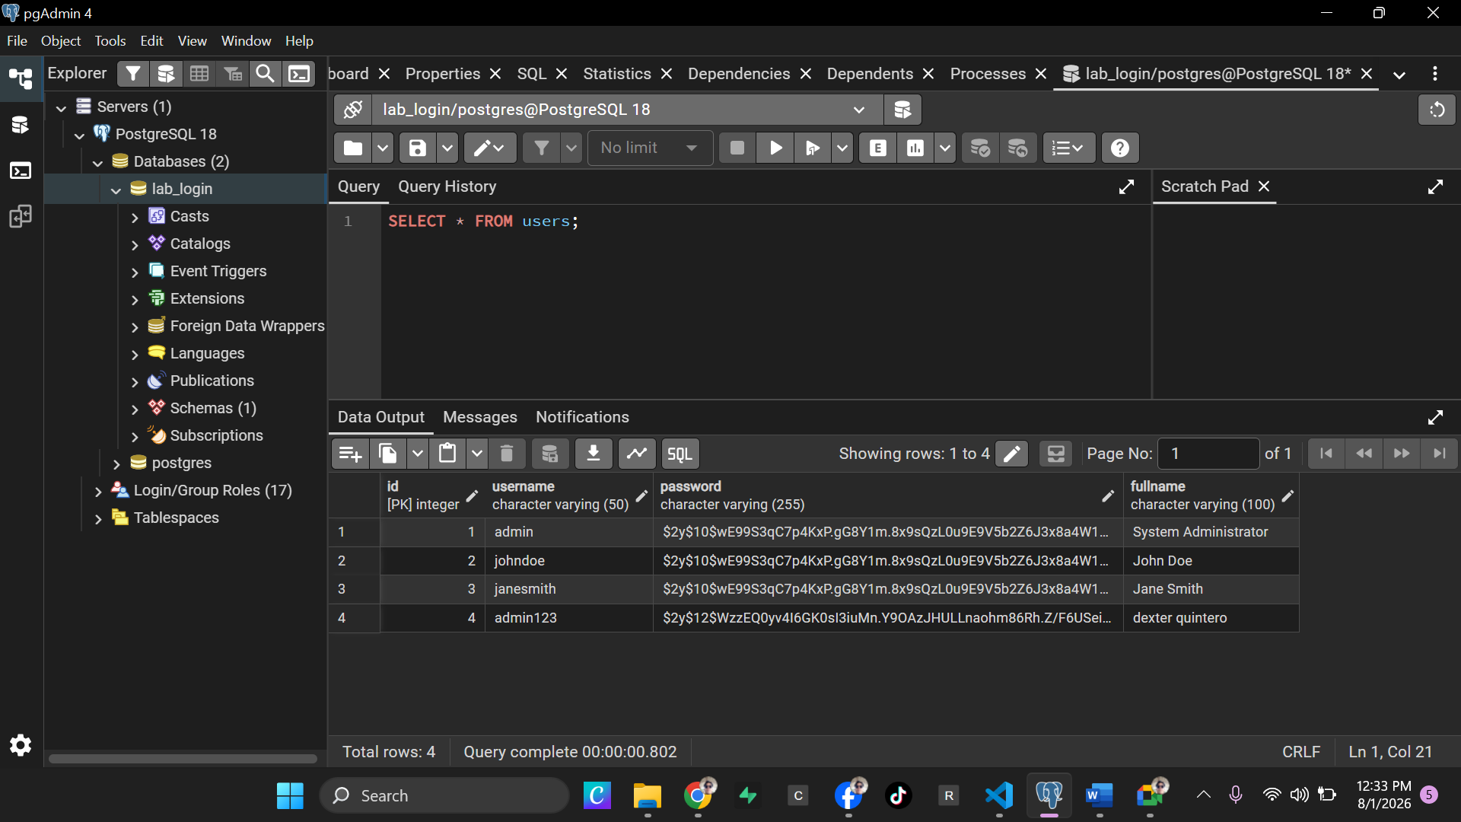

Login Credentials for Testing
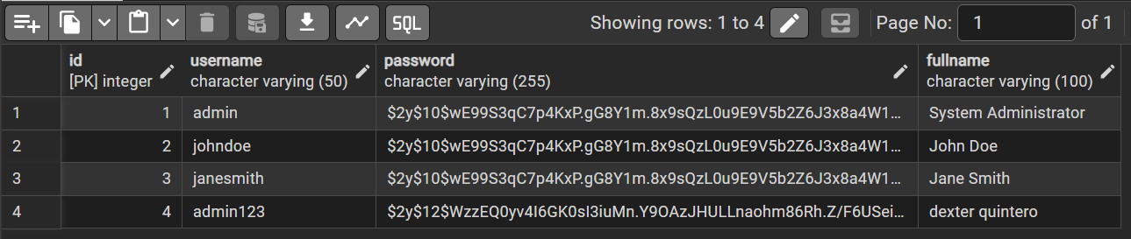
Screenshots of the Application
