NAME: MUHAMMAD HASSAN KHAN
ROLL#: BS/AI/2K24/53
DEPARTMENT:IMCS(ARTIFICIAL INTELLIGENCE) (MORNING)
SUBMITTED TO:SIR RAJESH KUMAR
COURSE: NLP
DATE: 11/09/2026

Task 1: Bag of Words Matrix

The three customer reviews provided in the lab sheet are processed using:

```python
CountVectorizer(stop_words="english")
```

The vocabulary is extracted and the transformed matrix is displayed as a Pandas DataFrame.
Output Screenshot
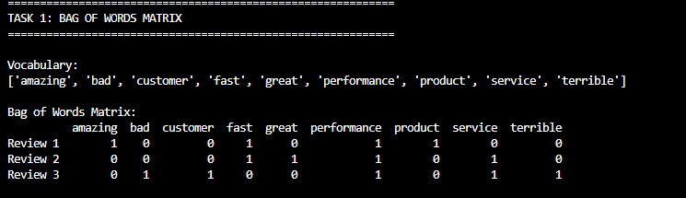

Task 2: Document Search Engine & Relevance Ranking

The four documents and the query provided in the lab sheet are converted into vectors. Cosine similarity is calculated between the query and each document. The documents are then ranked from highest similarity to lowest similarity.

Output Screenshot
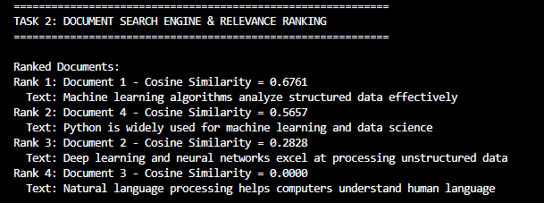

Viva / Reflection Questions

1. Word Order Invariance

Why does the sentence "Dog bites man" have the exact same Bag of Words representation as "Man bites dog"? How does this impact sentiment analysis?

Answer:
Bag of Words only counts how many times each word appears and ignores word order. Both sentences contain the same words: "dog", "bites", and "man", so their BoW representations are the same. This can be a problem for sentiment analysis because changing word order can change the meaning of a sentence, but BoW cannot understand that order.

2. Sparsity Issue

What happens to the memory size and density of the BoW matrix when the corpus contains 100,000 unique vocabulary words?

Answer:
The number of columns in the BoW matrix becomes very large. Most documents contain only a small number of those 100,000 words, so most matrix entries are zero. Therefore, the matrix becomes very sparse and can require a large amount of memory if stored as a normal dense matrix. Sparse matrix representation is more memory-efficient.

3. Zero Similarity

Explain why Document 3 in Task 2 receives a Cosine Similarity score of 0.0000 when queried against "machine learning algorithms for data".

Answer:
Document 3 is "Natural language processing helps computers understand human language". It has no overlapping terms with the query "machine learning algorithms for data". Therefore, its document vector and query vector have a dot product of zero, resulting in a cosine similarity of 0.0000.

