**General architecture (sample)**

VM (Ubuntu)





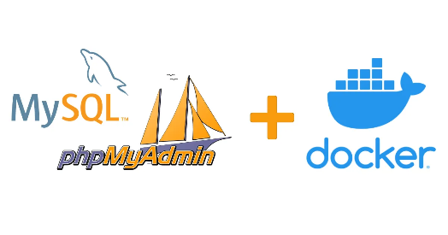

Ubuntu (Docker)

**Todo :**

-Dockerize front and back

-Host back on app-engine or compute engine

-Store assets(img, video) in firestore(as byte or hexa) or storage.