**Introduction to Wireless and Mobile Networking: Homework 2**

**Submission rule**

1. The file name of the report should be **b00901xxx_hw2_report.pdf**
2. The file name of the readme should be **b00901xxx_hw2_readme.pdf**
3. The readme should describe **how to “USE” your code** to get the result in your report
4. If you use C++, please DON’T submit .exe
5. Put the report, readme and codes (MATLAB or C++) in the same folder, which is named **b00901xxx_hw2**
6. Compress the folder to **b00901xxx_hw2.rar/b00901xxx_hw2.zip**
7. Submit the .rar/.zip to Ceiba before deadline.

Please note that the homework submission system will turn off upon deadline.

If you have troubles so that you cannot submit on time, please email to TA.

However, the grade of late submission will be lower compared to those submitted on time.

**Problem description**

19 base stations are located in an urban area with temperature 27 $℃$, which form a 19-cell map shown in Fig. 1. The coordination of the central BS is (0, 0) and ISD (inter site distance) is 500 m. The channel bandwidth is 10MHz. All BSs use the same carrier frequency (frequency reuse factor =1).The power of each base station is 33dBm. The power of each mobile device is 23dBm. The transmitter antenna gain and the receiver antenna gain for each device, including base station and mobile devices, are 14 dB. The height of each base station is 1.5m, which is located on the top of a 50m high building. The position of each mobile device is 1.5m high from the ground.

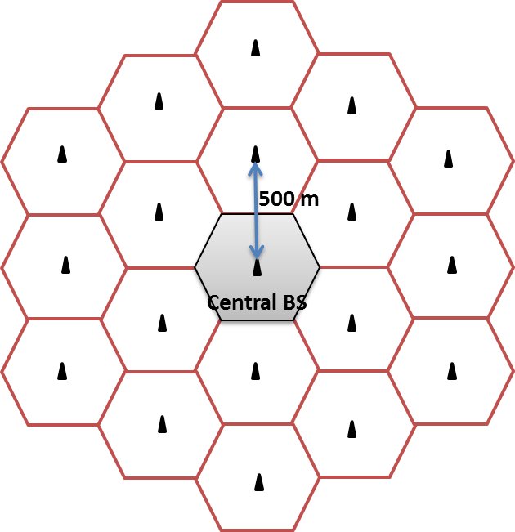

Fig. 1

Consider the **path loss** only radio propagation (without shadowing and fading). Use Two-ray-ground model as the propagation model for your simulation.

HINT: Please refer to slide 52 of Lec 2 for two-ray-ground model.

1. **[Downlink]**

Assume there are 50 mobile devices uniformly random distributed in the central cell. All the BSs are transmitting at the same time. The downlink interference for a specific mobile device comes from other BSs. Do not consider ISI (inter-symbol interference) in the case.

* 1. Please plot the location of the central BS and 50 uniformly random distributed mobile devices in the central cell. Don’t plot the location of other BSs and other mobile devices in other cells. The unit of x-axis and y-axis should be “meter”. The central BS is located at (0, 0). Also, use mark or color to differentiate the central BS from mobile devices.
  2. Based on the map in 1-1, please plot a figure with **the received power** (in dB) of a mobile device in a central BS as y-axis, and with the distance between the corresponding mobile device and the central BS as x-axis. Also, write down how to calculate the received power of a mobile device.

HINT: There should be 50 points in the figure.

* 1. According to 1-2, please plot a figure with the **SINR** (in dB) of a mobile device in the central cell as y-axis, and with the distance between the corresponding mobile device and the central BS as x-axis. Also, write down how to calculate the SINR in your report.

HINT: Both thermal noise and received power of a mobile device from other BSs should be taken into consideration.

1. **[Uplink]**

Consider only the central cell in this problem. Assume 50 uniformly random distributed mobile devices uplink to the central BS at the same time. The uplink interference for a specific mobile device happens at the BS side due to the concurrent uplink transmission of other mobile devices.

* 1. Please plot the location of the central BS and 50 uniformly random distributed mobile devices in the central cell. Don’t plot the location of other BSs and other mobile devices in other cells. The unit of x-axis and y-axis should be “meter”. The central BS is located at (0, 0). Also, use mark or color to differentiate the central BS from mobile devices.
  2. Based on the map in 2-1, please plot a figure with **the received power** (in dB) of the central BS from a specific mobile device as y-axis, and with the distance between the corresponding mobile device and the central BS as x-axis. Also, write down how to calculate the received power of the central BS from a specific mobile device.

HINT: There should be 50 points in the figure.

* 1. According to 2-1, please plot a figure with **SINR** of the central BS (in dB) as the y-axis and the distance between the BS and the corresponding mobile device (in meter) as the x-axis. Also, write down how to calculate the SINR in your report.

HINT: Both thermal noise and received power of the central BS from other mobile devices within the same cell should be taken into consideration. We don’t consider the uplink interference from mobile devices in other cells. No need to calculate inter-symbol interference (ISI).

**BONUS !!!**

**[Uplink]**

Consider 19 cells shown in Fig. 1 in this problem. There are 50 uniformly random distributed mobile devices in each cell. Assume all the uniformly distributed mobile devices uplink to their corresponding BSs at the same time. The uplink interference for a specific mobile device happens at the BS side due to the concurrent uplink transmission of other mobile devices.

B-1 Please plot the location of the 19 BSs and 50 uniformly random distributed mobile devices in each cell. The unit of x-axis and y-axis should be “meter”. The central BS is located at (0, 0). Also, use mark or color to differentiate BSs from mobile devices.

HINT: There should be 19 BSs and 50x19 mobile devices in this figure.

B-2 Based on the map in B-1, please plot a figure with **the received power** (in dB) of each BS from a specific mobile device as y-axis, and with the distance between the corresponding mobile device and the BS (in meter) as x-axis. Also, write down how to calculate the received power of a BS from a specific mobile device.

HINT: There should be 50x19 points in the figure.

B-3 According to B-1, please plot a figure with **SINR** of each BS (in dB) from a specific mobile device as the y-axis and the distance between the BS and the corresponding mobile device (in meter) as the x-axis. Also, write down how to calculate the SINR in your report.

HINT: Both thermal noise and received power of each BS from other mobile devices (instead of the specific mobile device) within/outside the cell should be considered. Different from question 2-3, we should consider the uplink interference due to concurrent transmission of other mobile devices in other cells. No need to calculate inter-symbol interference (ISI).