**Introduction to Wireless and Mobile Networking: Homework 3**

**Submission rule**

1. The file name of the report should be **b00901xxx_hw3_report.pdf**
2. The file name of the readme should be **b00901xxx_hw3_readme.pdf**
3. The readme should describe **how to “USE” your code** to get the result in your report
4. If you use C++, please DON’T submit .exe
5. Put the report, readme and codes (MATLAB or C++) in the same folder, which is named **b00901xxx_hw3**
6. Compress the folder to **b00901xxx_hw3.rar/b00901xxx_hw3.zip**
7. Submit the .rar/.zip to Ceiba before deadline.

Please note that the homework submission system will turn off upon deadline.

If you have troubles so that you cannot submit on time, please email to TA.

However, the grade of late submission will be lower compared to those submitted on time.

**Problem description**

19 base stations are located in an urban area with temperature 27 $℃$, which form a 19-cell map shown in Fig. 1. The coordination of the central BS is (0, 0) and ISD (inter site distance) is 500 m. The channel bandwidth is 10MHz. All BSs use the same carrier frequency (frequency reuse factor =1).The power of each base station is 33dBm. The power of each mobile device is 23dBm. The transmitter antenna gain and the receiver antenna gain for each device, including base station and mobile devices, are 14 dB. The height of each base station is 1.5m, which is located on the top of a 50m high building. The position of each mobile device is 1.5m high from the ground.

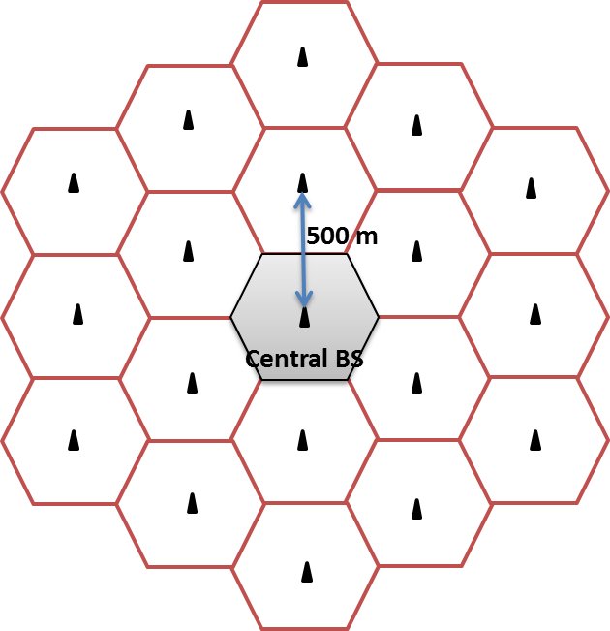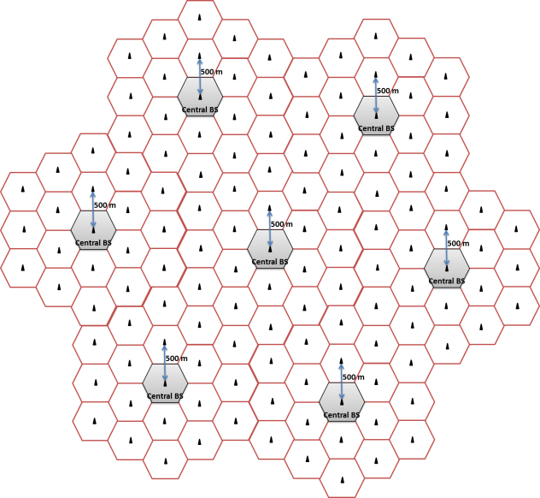

Fig. 1

Fig. 2

Consider the **path loss** only radio propagation (without shadowing and fading). Use Two-ray-ground model as the propagation model for your simulation.

HINT: Please refer to slide 52 of Lec 2 for two-ray-ground model.

**In this homework, the bonus problem is more difficult. If you want to get the bonus, you don’t need to submit problem 1.**

1. **[1 moving mobile device, downlink]**

In this problem, only downlink case is considered in this system. There are mobile devices doing downlink communication in all the cells. We only consider 1 mobile device which moves based on random walk mobility model as described below.

Random walk mobility model

1. The mobile device chooses the moving direction between [0, 2] uniformly.
2. The mobile device chooses the velocity between [minSpeed, maxSpeed] uniformly.
3. Based on the chosen direction and velocity, the mobile device moves t seconds, in which t is chosen uniformly between [minT, maxT].
4. Upon arriving the destination, the mobile device chooses another direction, velocity and travel time again according to step a, b and c.

In this problem, please use the parameter setting in Table 1.

Table 1

|  |  |
| --- | --- |
| minSpeed | 1 m/s |
| maxSpeed | 15 m/s |
| minT | 1 s |
| maxT | 6 s |

The initial location of the mobile device is (250, 0).

Total simulation time is 900 seconds.

Since the 19-cell map is symmetric, if the mobile device reaches the map boundary, it will enter the opposite cell as shown in Fig. 2. That is, from the mobile device perspective, the map seems to extend.

* 1. Please give a figure to describe how you arrange cell IDs to Fig. 1.

HINT: Cell IDs should be 1~19 for simplicity.

* 1. Based on 1-1, please list all the time when the handoff event occurs and the related cell ID following the below format:

|  |  |  |
| --- | --- | --- |
| Time | Source cell ID | Destination cell ID |
| 3s | 1 | 2 |

It means at the 3rd second, the mobile device moves from cell 1 to cell 2.

**HINT:** The criteria to decide when the handoff events occur can be either coordination-based or SINR-based. You SHOULD define your criterion in your report.

* 1. How many handoff events happen during the total simulation time?
* If the simulation time is not long enough for the handoff events to occur, you can increase the simulation time and describe the simulation time you set in the report.

**BONUS !!!**

**[100 moving mobile device, uplink]**

In this problem, only uplink case is considered. 100 mobile devices do uplink communication and moves based on random walk mobility model as described below.

Random walk mobility model

1. The mobile device chooses the moving direction between [0, 2] uniformly.
2. The mobile device chooses the velocity between [minSpeed, maxSpeed] uniformly.
3. Based on the chosen direction and velocity, the mobile device moves t seconds, in which t is chosen uniformly between [minT, maxT].
4. Upon arriving the destination, the mobile device chooses another direction, velocity and travel time again according to step a, b and c.

In this problem, please use the parameter setting in Table 1.

Table 1

|  |  |
| --- | --- |
| minSpeed | 1 m/s |
| maxSpeed | 15 m/s |
| minT | 1 s |
| maxT | 6 s |

The initial locations of all the 100 mobile devices are decided uniformly in the 19-cell map.

Total simulation time is 900 seconds.

Since the 19-cell map is symmetric, if the mobile device reaches the map boundary, it will enter the opposite cell as shown in Fig. 2. That is, from the mobile device perspective, the map seems to extend.

B-1 Please give a figure to describe how you arrange cell IDs to Fig. 1.

HINT: Cell IDs should be 1~19 for simplicity.

B-2 Please plot a map with all mobile devices in their initial location. Describe how you decide the initial location.

B-3 Based on B-1, please list all the time when the handoff event occurs and the related cell ID following the below format:

|  |  |  |
| --- | --- | --- |
| Time | Source cell ID | Destination cell ID |
| 3s | 1 | 2 |

It means at the 3rd second, the mobile device moves from cell 1 to cell 2.

**HINT:** The criteria to decide when the handoff events occur SHOULD be SINR-based. You SHOULD describe your criterion clearly in your report.

B-4 How many handoff events happen during the total simulation time?

* If the simulation time is not long enough for the handoff events to occur, you can increase the simulation time and describe the simulation time you set in the report.