**Introduction to Wireless and Mobile Networking: Homework 4**

**Submission rule**

1. The file name of the report should be **b00901xxx_hw4_report.pdf**
2. The file name of the readme should be **b00901xxx_hw4_readme.pdf**
3. The readme should describe **how to “USE” your code** to get the result in your report
4. If you use C++, please DON’T submit .exe
5. Put the report, readme and codes (MATLAB or C++) in the same folder, which is named **b00901xxx_hw4**
6. Compress the folder to **b00901xxx_hw4.rar/b00901xxx_hw4.zip**
7. Submit the .rar/.zip to Ceiba before deadline.

Please note that the homework submission system will turn off upon deadline.

If you have troubles so that you cannot submit on time, please email to TA.

However, the grade of late submission will be lower compared to those submitted on time.

**Problem description**

19 base stations are located in an urban area with temperature 27 $℃$, which form a 19-cell map shown in Fig. 1. The coordination of the central BS is (0, 0) and ISD (inter site distance) is 500 m. The channel bandwidth is 10MHz. All BSs use the same carrier frequency (frequency reuse factor =1).The power of each base station is 33dBm. The power of each mobile device is 0dBm. The transmitter antenna gain and the receiver antenna gain for each device, including base station and mobile devices, are 14 dB. The height of each base station is 1.5m, which is located on the top of a 50m high building. The position of each mobile device is 1.5m high from the ground.

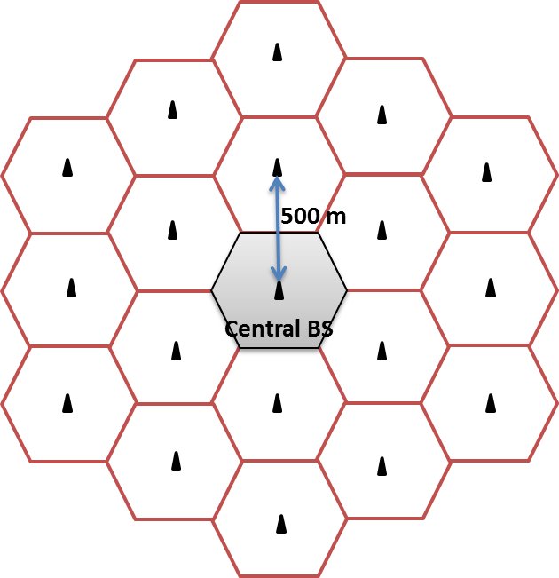

Fig. 1

Consider the **path loss** only radio propagation (without shadowing and fading). Use Two-ray-ground model as the propagation model for your simulation.

HINT: Please refer to slide 52 of Lec 2 for two-ray-ground model.

**If you wish to get bonus in this homework, you should write both problem 1 and bonus problem.**

1. **[Downlink, Constant Bit Rate]**

This is a unicast downlink problem. Assume there are 50 mobile devices uniformly random distributed in the central cell. All the BSs are transmitting at the same time. The downlink interference for a specific mobile device comes from other BSs. Do not consider ISI (inter-symbol interference) in the case. The total bandwidth in each cell, 10 MHz, is equally divided for the unicast communication of the 50 mobile devices.

Assume the traffic arrival for each mobile device follows constant bit rate (CBR), which means constant bits arrives at the traffic buffer of the BS in the simulation duration. We further assume that the parameter of CBR, X bits/s, is the same for each mobile station. However, the traffic content for each device is different. Assume the size of the BS traffic buffer is 6M bits.

Consider the AWGN channel. We use **Shannon Capacity** as the ideal throughput for each mobile device, which can be referred to slide 33 in Lec 2. However, we need to use SINR instead of SNR in the formula.

Simulation duration (T) = 1000s

CBR (X bits/s) = {Xl, Xm, Xh}, which represents {low, medium, high} traffic load respectively.

* 1. Please plot the location of the central BS and 50 uniformly random distributed mobile devices in the central cell. Don’t plot the location of other BSs and other mobile devices in other cells. The unit of x-axis and y-axis should be “meter”. The central BS is located at (0, 0). Also, use mark or color to differentiate the central BS from mobile devices.
  2. Based on the map in 1-1, please plot a figure with **Shannon Capacity** (bits/s) of a mobile device in a central BS as y-axis, and with the distance between the corresponding mobile device and the central BS as x-axis. Also, **write down** how to calculate the Shannon capacity of the mobile device in the central cell in your report.

HINT: There should be 50 points in the figure.

* 1. Based on 1-1 and 1-2, design the CBR parameters {Xl, Xm, Xh} by yourself so that you can get different values of packet loss rate in the total simulation duration for each CBR parameter. **Write down** the CBR parameters you used in your simulation. Plot a histogram figure with the **bits loss probability** in the central BS as the y-axis and **the traffic load** as the x-axis.

If you think the simulation duration 1000s is not enough, you can change it as you want. Write down the changed value of simulation time.

If you think the size of the BS traffic buffer is too large or too small, you can change it as you want. Write down the changed value of the size of the BS traffic buffer.

**BONUS !!!**

**[Downlink, Poisson Packet Arrival]**

This is a unicast downlink problem. Assume there are 50 mobile devices uniformly random distributed in the central cell. All the BSs are transmitting at the same time. The downlink interference for a specific mobile device comes from other BSs. Do not consider ISI (inter-symbol interference) in the case. The total bandwidth in each cell, 10 MHz, is equally divided for the unicast communication of the 50 mobile devices.

Assume the traffic arrival for each mobile device follows Poisson distribution, $P\left(X=x\right)=\frac{e^{-λ}λ^{x}}{x!}$, which means x bits arrives per second at the traffic buffer of the BS in the simulation duration. We further assume that the parameter $λ$ bits/s, is the same for each mobile station. However, the traffic content for each device is different. Assume the size of the BS traffic buffer is 6M bits.

Consider the AWGN channel. We use **Shannon Capacity** as the ideal throughput for each mobile device, which can be referred to slide 33 in Lec 2. However, we need to use SINR instead of SNR in the formula.

Simulation duration (T) = 1000s

Poisson traffic arrival ( $λ$ bits/s) = {$λ_{l}$, $λ_{m}$, $λ_{h}$}, which represents {low, medium, high} traffic load respectively.

B-1. Please plot the location of the central BS and 50 uniformly random distributed mobile devices in the central cell. Don’t plot the location of other BSs and other mobile devices in other cells. The unit of x-axis and y-axis should be “meter”. The central BS is located at (0, 0). Also, use mark or color to differentiate the central BS from mobile devices.

B-2. Based on the map in B-1, please plot a figure with **Shannon Capacity** (bits/s) of a mobile device in a central BS as y-axis, and with the distance between the corresponding mobile device and the central BS as x-axis. Also, **write down** how to calculate the Shannon capacity of the mobile device in the central cell in your report.

HINT: There should be 50 points in the figure.

B-3. Based on B-1 and B-2, design the Poisson traffic arrival parameters {$λ_{l}$, $λ_{m}$, $λ_{h}$} by yourself so that you can get different values of packet loss rate in the total simulation duration for each Poisson traffic arrival parameter. **Write down** the Poisson traffic arrival parameters you used in your simulation. Plot a histogram figure with the **bits loss probability** in the central BS as the y-axis and **the traffic load** as the x-axis.

If you think the simulation duration 1000s is not enough, you can change it as you want. Write down the changed value of simulation time.

If you think the size of the BS traffic buffer is too large or too small, you can change it as you want. Write down the changed value of the size of the BS traffic buffer.