


AI-TOOL FOR EARLY STAGE DEMENTIA DETECTION

A PROJECT REPORT

Submitted by
VANKA REVANTH ADITHYA – 20221CSE0260
PIRUITHVIRAJ S – 20221CSE0268
RAFAEL V – 20221CSE0270

Under the guidance of,
Mr. SRI RAM KATTA

BACHELOR OF TECHNOLOGY
IN
COMPUTER SCIENCE AND ENGINEERING
PRESIDENCY UNIVERSITY
BENGALURU
APRIL 2026




PRESIDENCY SCHOOL OF COMPUTER SCIENCE AND ENGINEERING
BONAFIDE CERTIFICATE
Certified that this report “AI-Tool for Early Stage Dementia Detection” is a Bonafide work of “VANKA REVANTH ADITHYA (20221CSE0260), PRUITHVIRAJ S (20221CSE0268), RAFAEL V (20221CSE0270)”, who have successfully carried out the project work and submitted the report for partial fulfilment of the requirements for the award of the degree of BACHELOR OF TECHNOLOGY in COMPUTER SCIENCE AND ENGINEERING during, 2025-2026.
Mr. Sri Ram Katta  Project Guide  PSCS  Presidency University | Dr. Muthuraju V  Program Project Coordinator  PSCS  Presidency University | Dr. Sampath A K  School Project Coordinator  PSCS  Presidency University | Dr. Blessed Prince  Head of Department PSCS  Presidency University
Dr. Shakkeera L  Associate Dean  PSCS  Presidency University |  |  | Dr. Duraipandian N  Dean  PSCS & PSIS  Presidency University

Name and Signature of the Examiners
SI no. | Name | Signature | Date
1. | Ms. Anu Joseph
2. | Ms. Delsy Jyothi




PRESIDENCY UNIVERSITY

PRESIDENCY SCHOOL OF COMPUTER SCIENCE AND ENGINEERING
DECLARATION

We the students of final year B. Tech in COMPUTER SCIENCE ENGINEERING at Presidency University, Bengaluru, named VANKA REVANTH ADITHYA, RAFAEL V, PIRUITHVIRAJ S hereby declare that the project work titled “AI-TOOL FOR EARLY STAGE DEMENTIA DETECTION.” has been independently carried out by us and submitted in partial fulfillment for the award of the degree of B. Tech in COMPUTER SCIENCE ENGINEERING during the academic year of 2025-26. Further, the matter embodied in the project has not been submitted previously by anybody for the award of any Degree or Diploma to any other institution.

VANKA REVANTH ADITHYA USN: 20221CSE0260
PIRUITHVIRAJ S USN: 20221CSE0268
RAFAEL V USN: 20221CSE0270

PLACE: BENGALURU
DATE: 24/04/2026
ACKNOWLEDGEMENT

For completing this project work, we have received the support and the guidance from many people whom I would like to mention with deep sense of gratitude and indebtedness.
I would like to sincerely thank my internal guide Mr. Sri Ram Katta, Assisstant Professor, Presidency School of Computer Science and Engineering, Presidency University, for his moral support, motivation, timely guidance and encouragement provided to us during the period of our project work.
I am also thankful to Dr. Blessed Prince, Professor, Head of the Department, Presidency School of Computer Science and Engineering Presidency University, for his mentor-ship and encouragement.
We express our cordial thanks to Dr. Duraipandian N, Dean PSCS & PSIS, Dr. Shakkeera L, Associate Dean, Presidency School of computer Science and Engineering and the Management of Presidency University for providing the required facilities and intellectually stimulating environment that aided in the completion of my project work.
We are grateful to Dr. Sampath A K, and Dr. Geetha A, PSCS Project Coordinators, Dr. Muthuraju V, Program Project Coordinator, Presidency School of Computer Science and Engineering, or facilitating problem statements, coordinating reviews, monitoring progress, and providing their valuable support and guidance.
We are also grateful to Teaching and Non-Teaching staff of Presidency School of Computer Science and Engineering and also staff from other departments who have extended their valuable help and cooperation.

RAFAEL V
PIRUITHVIRAJ S
VANKA REVANTH ADITHYA

ABSTRACT
Dementia is a progressive neurological disorder that affects memory, cognition, and overall quality of life. Early detection is essential for effective management, yet it remains challenging due to subtle symptoms, reliance on specialized expertise, and the high cost and time of traditional diagnostic methods. As a result, many cases are identified at later stages, highlighting the need for an accessible and efficient early screening solution.
This project introduces Dimensional AI, an artificial intelligence-based system for early dementia detection using a multi-dimensional data analysis approach. It analyzes inputs such as speech patterns, cognitive test scores, and behavioral indicators to identify early signs of cognitive decline. By leveraging machine learning and deep learning techniques, the system can detect subtle patterns that may not be evident through conventional methods.
The system architecture includes modules for data collection, preprocessing, feature extraction, model training, and prediction. Collected data is cleaned and processed, relevant features are extracted, and machine learning models are used to classify dementia risk levels. The results are displayed through a user-friendly interface, enabling easy interpretation by healthcare professionals and caregivers.
Dimensional AI offers advantages such as non-invasive assessment, reduced dependence on specialists, faster analysis, and scalability. It is also cost-effective and can be integrated into clinical and remote healthcare systems. By enabling early risk assessment, the system supports timely intervention and improved patient outcomes.
In conclusion, the project demonstrates the potential of AI in enhancing early dementia detection by providing an accurate, efficient, and accessible screening tool, with future scope for real-time analysis, multilingual support, and clinical validation.
.

TABLE OF CONTENT
Sl. No. | Title | Page No.
 | Cover Page | i
 | Bonafide Certificate | ii
 | Declaration | iii
 | Acknowledgement | iv
 | Abstract | v
 | Table of Content | vi
 | List of Figures | viii
 | List of Tables | ix
 | Abbreviations | x
1. | Introduction  1.1 Background  1.2 Statistics  1.3 Prior Existing Technologies  1.4 Proposed Approach  1.5 Objectives  1.6 SDG’s  1.7 Overview of Project Report | 1
2. | Literature Review | 6
3. | Methodology | 11
4. | Project Management  4.1 Project Timeline  4.2 Risk Analysis  4.3 Project Budget | 15
5. | Analysis and Design  5.1 Requirements  5.2 Block Diagram  5.3 System Flow Chart  5.4 Communication Model  5.5 Process Specification  5.6 Service Specification | 22
6. | Hardware, Software and Simulation  6.1 Hardware  6.2 Software Development Tools  6.3 Software Code | 38
7. | Evaluation and Results  7.1 Test Points  7.2 Test Plan  7.3 Test Results  7.4 Insights | 41
8. | Social, Legal, Ethical, Sustainability and Safety Aspects  8.1 Social Aspects  8.2 Legal Aspects  8.3 Ethical Aspects  8.4 Sustainability Aspects  8.5 Safety Aspects | 48
9. | Conclusion | 53
10. | Appendix | 54
11. | References | 70

LIST OF FIGURES
Figure | Caption | Page no.
3.1 | The Scrum Agile Model Methodology | 11
4.1 | Project Planning Timeline | 15
4.2 | PESTEL Analysis | 16
5.1 | Block Diagram of the AI-Tool | 29
5.2 | System Flow Chart | 30
5.3 | Request-Response Model Diagram | 33
5.4 | Publish-Subscribe Model Diagram | 34
5.5 | Push-Pull Model Diagram | 34
5.6 | Exclusive Pair Model Diagram | 35

LIST OF TABLES
Table no. | Caption | Page no.
 | Table of Content | IV
 | List of Figures | VI
 | List of Tables | VII
 | Abbreviations | VIII
2.1 | Literature Review from Different Reports | 6
2.2 | Summary of Literature Reviews | 9
4.1 | Project Budget | 21
5.1 | Summarizing Hardware Requirements | 25
5.2 | Summarizing Software Requirements | 26
5.3 | Additional Requirements | 27
7.1 | Test Results | 45

ABBREVIATION
Abbreviation | Full Form
AI | Artificial Intelligence
ML | Machine Learning
DL | Deep Learning
UI | User Interface
API | Application Programming Interface
PDF | Portable Document Format
IT | Information Technology
DPDP Act | Digital Personal Data Protection Act
WHO | World Health Organization
IEEE | Institute of Electrical and Electronics Engineers
NLP | Natural Language Processing
DB | Database
UX | User Experience
HTML | Hyper Text Markup Language
CSS | Cascading Style Sheets
JS | JavaScript

Chapter 1
INTRODUCTION
1.1 Background
- Dementia is a progressive neurological disorder that affects memory, thinking ability, communication, and daily functioning. It is one of the leading causes of disability among the elderly population worldwide. Despite its growing prevalence, early-stage dementia often goes undetected due to subtle symptoms such as mild memory loss, speech irregularities, and behavioural changes. These early signs are difficult to identify without specialized clinical assessments.
- Traditional diagnostic approaches rely heavily on cognitive tests, clinical interviews, and neuroimaging techniques, which are often time-consuming, expensive, and dependent on expert interpretation. Moreover, limited accessibility to such healthcare resources, especially in rural and underserved areas, further delays diagnosis and intervention.
- With advancements in artificial intelligence and machine learning, there is a growing opportunity to develop intelligent systems that can analyse multi-dimensional data such as speech, cognitive performance, and behaviour. These technologies can help identify early indicators of dementia more efficiently and accurately. This project, Dimensional AI, is developed in this context to provide a smart, scalable, and non-invasive solution for early dementia risk detection.
1.2 Statistics
- Dementia cases are rapidly increasing globally due to the aging population.
- Millions of people worldwide are affected, with a significant percentage remaining undiagnosed in early stages.
- Early detection can delay disease progression and improve quality of life.
- AI-based healthcare solutions are witnessing rapid growth and adoption.
- There is an increasing shift towards non-invasive and digital diagnostic methods.
- Speech and behavioural analysis are emerging as reliable biomarkers for early dementia detection.
- Healthcare systems are investing in technologies to reduce long-term costs.
1.3 Prior existing technologies
- Neuroimaging (MRI/CT) – Uses advanced brain imaging techniques to detect structural and functional changes in the brain, such as shrinkage or abnormalities linked to dementia.
- Cognitive Tests – Standardized assessments that measure memory, attention, reasoning, and problem-solving skills to identify signs of cognitive decline.
- Machine Learning – Utilizes algorithms trained on medical data to automatically analyse patterns and predict the likelihood of dementia in patients.
- Deep Learning – A subset of AI that uses neural networks to process complex and high-dimensional data, improving accuracy in detecting subtle cognitive changes.
- Speech Analysis – Examines speech patterns such as pauses, pitch, fluency, and word usage to identify early indicators of cognitive impairment.
1.4 Proposed approach
- Aim : To develop an AI-based system (Dimensional AI) that detects early-stage dementia by analysing speech, cognitive, and behavioural data, providing a fast, non-invasive, and cost-effective screening tool.
- Motivation : The project is motivated by the rise in dementia cases, delayed diagnosis due to subtle symptoms, and the high cost and inaccessibility of traditional methods. There is a need for a scalable, AI-driven solution that enables early detection and improves patient outcomes.
- Proposed approach:
  - Data Collection : Collect speech, cognitive, and behavioural data.
  - Data Preprocessing : Preprocess data by cleaning and normalization.
  - Feature Extraction : Extract relevant features from input data.
  - Model Development : Train machine learning models for prediction.
  - Prediction & Risk Analysis : Classify dementia risk levels (low/medium/high).
  - User Interface & Deployment : Display results through a user-friendly interface.
  - Continuous Improvement : Continuously improve model with new data.

- Applications of the project:
  - Early-stage dementia screening in hospitals and clinics.
  - Remote patient assessment through telemedicine platforms.
  - Cognitive health monitoring in elderly care centers.
  - AI-based decision support for healthcare professionals.
  - Preventive healthcare through early risk detection.
  - Accessible screening in rural and remote areas.
  - Research on speech and cognitive biomarkers.
  - Integration into mobile health applications for real-time monitoring.
- Limitation of the proposed approach:
  - Depends on quality and availability of training data.
  - Accuracy may not be reliable in very early stages.
  - Requires clinical validation for real-world use.
  - Raises data privacy and security concerns.
  - Objectives
- Behaviour: Analyse user behaviour and cognitive patterns to detect early signs of dementia. Monitor changes in speech, memory, and response patterns.
- Analysis : The system performs analysis by processing multi-dimensional data such as speech patterns, cognitive test results, and behavioural indicators. It extracts meaningful features from the data and applies machine learning algorithms to accurately predict dementia risk levels, enabling early detection of cognitive decline.
- System management : The system is designed with a scalable and efficient architecture to ensure smooth data handling and model execution. It includes a user-friendly interface that allows easy interaction, monitoring, and management of data, making it practical for use in healthcare environments.
- Security : The system ensures the protection of sensitive patient data by implementing secure storage, access control mechanisms, and encryption techniques. It maintains data privacy and confidentiality, which is critical for handling medical and personal information.
- Deployment : The solution is deployed as a web-based application, making it easily accessible across different platforms. It can be integrated with hospitals, clinics, and telemedicine systems, ensuring scalability, reliability, and ease of maintenance in real-world applications.
1.6 SDG’s
The project Dimensional AI for Early-Stage Dementia Detection aligns strongly with the United Nations Sustainable Development Goals (SDGs), particularly in the domain of healthcare innovation, accessibility, and well-being :
SDG 3 – Good Health and Well-being :
- The project enables early detection of dementia.
- Supports preventive healthcare and timely intervention.
- Reduces healthcare costs and diagnostic delays.
- Improves quality of life for patients.
- [UN, SDG 3]
SDG 4 – Quality Education :
- Promotes awareness about dementia.
- Supports research in AI and healthcare.
- Encourages learning and innovation.
- [UN, SDG 4]
SDG 9 – Industry, Innovation and Infrastructure :
- Uses AI and machine learning technologies.
- Promotes innovation in healthcare systems.
- Supports digital transformation in diagnostics.
- Builds scalable and intelligent healthcare solutions.
- [UN, SDG 9]
SDG 10 – Reduced Inequalities :
- Provides affordable screening solutions.
- Improves access in rural and underserved areas.
- Reduces healthcare accessibility gaps.
- Supports inclusive healthcare delivery.
- [UN, SDG 10]

1.7 Overview of project report
The project Dimensional AI is an artificial intelligence-based system developed to support the early detection of dementia using a multi-dimensional analysis of user data. Dementia is a progressive neurological condition that significantly affects memory, thinking, and daily functioning. One of the major challenges in managing dementia is that it is often diagnosed at later stages due to subtle early symptoms and reliance on traditional diagnostic methods that are time-consuming, expensive, and require expert intervention. This project aims to address these limitations by providing a smart, accessible, and efficient screening solution. The system utilizes techniques from Artificial Intelligence (AI), including Machine Learning (ML) and Deep Learning (DL), to analyze various inputs such as speech patterns, cognitive test responses, and behavioral indicators. These inputs are collected through an interactive and user-friendly web interface, making the system easy to use for patients, caregivers, and healthcare professionals. The collected data is first preprocessed to remove noise and inconsistencies, followed by feature extraction to identify relevant patterns. These features are then processed by trained models to classify and predict the risk level of dementia. The architecture of Dimensional AI is designed in a modular manner, consisting of components such as data collection, preprocessing, feature extraction, model training, prediction, and result visualization. This structure ensures flexibility and allows for future enhancements and scalability. The results are presented in a clear and understandable format, enabling users to interpret the outcomes easily and take appropriate action, such as consulting a medical professional. A key advantage of this system is that it is non-invasive and cost-effective, reducing the need for complex medical procedures during the initial screening phase. It also minimizes dependency on specialists by providing quick and preliminary insights. Additionally, the system is scalable and can be integrated into hospitals, clinics, and telemedicine platforms, improving accessibility, especially in rural and underserved areas. Overall, Dimensional AI highlights the potential of AI in transforming healthcare by enabling early detection and supporting preventive care. By facilitating timely intervention, the system can help improve patient outcomes and quality of life, while also reducing the burden on healthcare systems.

Chapter 2
LITERATURE REVIEW
Table 2.1 Literature Review from Different Reports
Sl.no | Literature | Summary
1 | Vasquez et al. (2023) – Machine Learning for Dementia Detection | This study highlights how machine learning models can analyse cognitive and behavioural data to improve early dementia diagnosis. It shows that AI-based methods can detect patterns that are often missed by traditional clinical approaches, improving diagnostic accuracy and efficiency [1].
2 | Fraser et al. (2024) – Speech-Based Biomarkers | The research emphasizes the importance of speech features such as pauses, pitch variation, and fluency in identifying early cognitive decline. Speech analysis is considered a non-invasive and cost-effective method for dementia screening, making it suitable for large-scale applications [2].
3 | Liu & Patel (2025) – Deep Learning Approaches | This study demonstrates that deep learning techniques outperform traditional algorithms in analysing complex medical datasets. Neural networks can identify subtle patterns in speech and cognitive data, leading to improved early-stage dementia detection [3].
4 | Kumar et al. (2024) – AI in Healthcare Screening | The paper discusses the role of AI-based decision support systems in healthcare. It highlights benefits such as scalability, faster processing, and reduced dependency on specialists, making AI suitable for early dementia screening [4].
5 | Khan & Verma (2024) – Systematic Review of ML Techniques | This review analyses various machine learning models used for dementia detection and concludes that algorithms like Support Vector Machines and Random Forest are widely used for classification tasks [5].
6 | Hernández et al. (2023) – NLP and Speech Processing | The study explores how natural language processing techniques can analyse linguistic features such as sentence structure, vocabulary usage, and speech coherence to detect cognitive impairment. Speech and language analysis are proven to be reliable indicators of early dementia [6].
7 | Sharma & Gupta (2025) – AI Decision Support Systems | This research focuses on AI-driven systems assisting clinicians by providing faster and more reliable diagnostic insights. It highlights the importance of integrating AI tools into clinical workflows [7].
8 | World Health Organization (2023) – Dementia as a Global Issue | Reports indicate that dementia affects millions globally and often remains undiagnosed in early stages. Early detection is critical for improving patient outcomes and reducing healthcare burden [8].

Vasquez et al. (2023) – Machine Learning for Dementia Detection : This study focuses on the application of machine learning algorithms for early dementia detection using cognitive and behavioural datasets. The authors demonstrate that supervised learning models can identify hidden patterns in patient data, enabling earlier diagnosis compared to traditional methods. The study emphasizes feature selection and model optimization to improve prediction accuracy, highlighting the potential of AI in clinical decision support systems [1].

Fraser et al. (2020) – Speech and Language Analysis : Fraser and colleagues explored how speech and language features can act as biomarkers for detecting cognitive decline. Their research analyses aspects such as speech pauses, fluency, vocabulary richness, and pitch variations. The study concludes that speech-based analysis is a reliable, non-invasive, and cost-effective technique for early dementia screening, making it suitable for large-scale and remote healthcare applications[2].
Liu and Patel (2025) – Deep Learning Approaches : This research investigates the use of deep learning models, particularly neural networks, for analysing complex medical datasets. The authors show that deep learning techniques can automatically learn high-level features from raw data, improving the detection of subtle cognitive impairments. The study highlights the superiority of deep learning over traditional machine learning methods in terms of accuracy and scalability[3].
Kumar et al. (2024) – AI in Healthcare Screening : Kumar et al. discuss the integration of artificial intelligence into healthcare screening systems. The paper highlights how AI can automate diagnostic processes, reduce human error, and improve efficiency. It also addresses challenges such as data quality, ethical concerns, and system reliability, while emphasizing the importance of scalable and accessible AI solutions in early disease detection[4].
Khan & Verma (2024) – Systematic Review of ML Techniques : This study provides a comprehensive review of various machine learning techniques used in dementia diagnosis. It compares multiple models such as Support Vector Machines, Decision Trees, and Random Forests, evaluating their performance in terms of accuracy and reliability. The authors conclude that proper feature selection and data preprocessing significantly impact model effectiveness in early detection tasks [5].
Hernández et al. (2023) – NLP and Speech Processing : Hernández and team focus on the role of natural language processing (NLP) in detecting cognitive impairment. The study examines linguistic features such as sentence structure, grammar usage, and semantic coherence. It demonstrates that changes in language patterns can serve as early indicators of dementia, making NLP a powerful tool for non-invasive diagnosis [6].

Sharma & Gupta (2025) - AI Decision Support Systems : This research highlights the importance of AI-based decision support systems in assisting healthcare professionals. The authors discuss how these systems provide real-time insights, improve diagnostic accuracy, and reduce workload for clinicians. The study emphasizes integrating AI tools into existing healthcare infrastructures for better outcomes [7].
World Health Organization (2023) – Dementia Report : The WHO report provides a global overview of dementia, including its prevalence, impact, and challenges in early diagnosis. It emphasizes that a large percentage of dementia cases remain undiagnosed in early stages, leading to delayed treatment. The report strongly advocates for the development of accessible, technology-driven early detection tools to reduce the global healthcare burden [8].
Table 2.2 Summary of Literature reviews
SI No. | Article Title, Published Year, Journal Name | Methods | Key Features | Merits | Demerits
1 | Early Detection of Dementia using ML (2023) | Machine Learning (Supervised Learning) | Uses cognitive & behavioral data | Improves early detection accuracy | Depends on data quality
2 | Speech & Language Analysis for Cognitive Decline (2020, IEEE JBHI) | Speech Processing, NLP | Analyzes pauses, pitch, fluency | Non-invasive and cost-effective | Language and accent limitations
3 | Deep Learning for Neurodegenerative Diseases (2025) | Deep Learning (Neural Networks) | Handles complex medical data | High accuracy and pattern detection | Requires large datasets and high computation
4 | AI in Early Dementia Screening (2024) | AI-based Decision Systems | Scalable healthcare screening | Reduces dependency on specialists | Ethical and reliability concerns
5 | ML Techniques for Dementia Diagnosis – Review (2024) | SVM, Random Forest, Classification Models | Comparative study of ML models | Identifies best-performing algorithms | Limited real-world implementation
6 | Speech & NLP for Cognitive Impairment (2023) | Natural Language Processing | Analyzes linguistic features | Effective early detection tool | Sensitive to data quality and language variation
7 | AI Decision Support Systems (2025) | AI-based Clinical Support | Real-time diagnostic assistance | Improves decision-making speed | Requires integration with healthcare system
8 | Dementia: A Public Health Priority (2023, WHO Report) | Global Health Analysis | Focus on prevalence & awareness | Highlights need for early detection tools | No technical implementation details

Chapter 3
Methodology
The V-Model is well-suited for the Dimensional AI project as it provides a structured and test-driven development approach, which is essential for healthcare applications requiring high accuracy and reliability. Since the system involves sensitive medical data and machine learning-based predictions, the V-Model ensures that each development phase is paired with a corresponding testing phase, enabling early error detection and improved performance. It also supports modular development of components such as data processing, feature extraction, and prediction, along with proper integration testing. Additionally, the project has well-defined requirements, making it ideal for a structured methodology, while the strong focus on verification and validation ensures the system is reliable and ready for real-world healthcare deployment.
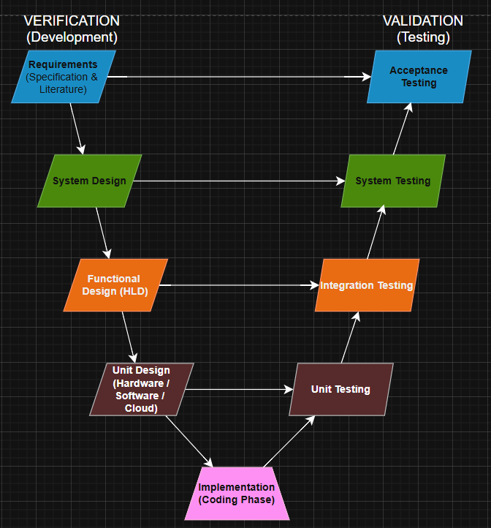
Fig 3.1 V-Model

The project's implementation will be through a sequence of the following actions:
- Requirements Phase (Specification & Literature) -> Acceptance Testing :
- Study problem statement and perform literature survey on AI, ML, speech analysis, and dementia detection.
- Define:
• Functional requirements (data input, prediction output).
• Non-functional requirements (accuracy, scalability, security).
- Acceptance Testing : Validates whether the final system meets user and healthcare requirements.
- System Design -> System Testing
- Design overall system architecture:
• Data collection module.
• Preprocessing module.
• Feature extraction module.
• ML model module.
• User Interface.
- Define system Workflow and data flow.
- System Testing : Verifies complete system functionality and performance.
- Functional Design (High-Level Design) -> Integration Testing
a. Define functionality of each module and their interactions.
b. Specify:
• Input-output relationships.
• Data flow between modules.
c. Integration Testing : Ensures all modules work together correctly.
4. Unit Design (Low-Level Design) -> Unit Testing
a. Hardware Design:
• Laptop/PC, microphone for speech input.
• Optional sensors/devices for future enhancements.
b. Software Design
• Programming: Python.
• Libraries: TensorFlow, Scikit-learn, NumPy, Pandas.
• Frameworks: Flask/Streamlit.

c. Cloud Design:
• Cloud storage for datasets.
• Deployment using platforms like AWS/GCP.
• Unit Testing: Tests individual components such as preprocessing, feature extraction, and prediction modules.
5. Implementation (Coding Phase)
a. Develop machine learning models.
b. Implement preprocessing and feature extraction.
c. Build UI and integrate backend with ML model.
6. Unit Testing
a. Test each module independently.
b. Ensure correctness of:
• Data processing
• Feature Extraction
• Model predictions
7. Integration Testing
a. Combine modules and test system workflow.
b. Verify proper communication between components.
8. Verification (System Testing)
a. Test the complete system.
b. Evaluate:
• Accuracy
• Performance
• Reliability
9. Validation (Acceptance Testing)
a. Validate system using real-world data.
b. Ensure it meets:
• User expectations
• Healthcare standards
10. Deployment & Maintenance
a. Deploy as a web-based application.
b. Integrate with healthcare platforms.
c. Perform continuous updates and improvements.
Rationale For Selecting the V-Model
We selected the V-Model because it provides us with:
- Ensures structured and systematic development process.
- Provides parallel testing (verification & validation) at every stage.
- Suitable for healthcare applications requiring high accuracy and reliability.
- Supports early error detection and risk reduction.
- Works well with well-defined project requirements.
- Enables modular development and proper integration testing.
- Improves overall system quality and performance.
- Ensures the system is ready for real-world deployment.

Chapter 4
PROJECT MANAGEMENT
4.1 Project timeline
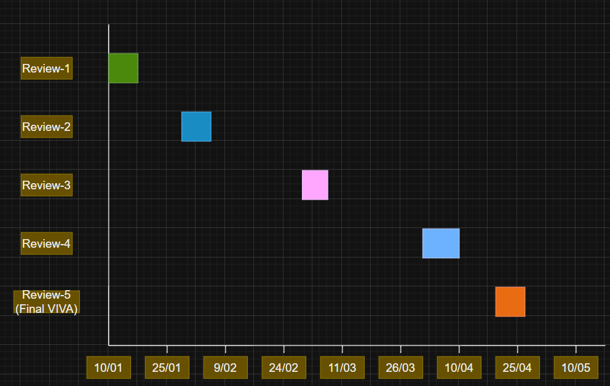
Fig 4.1 Project planning timeline
The timeline for the project spreads across five major review milestones starting on January 10, 2025, and ending with the Final Viva on April 26, 2025.
- Review-1 (10 Jan – 16 Jan):
This phase marks the beginning of the project, where the problem statement and objectives are defined. It sets the foundation for the entire project by identifying key goals and requirements.
- Review-2 (31 Jan – 06 Feb):
In this phase, a literature review is conducted and the system/model design is developed. It helps in understanding existing techniques and planning the structure of the proposed solution.
- Review-3 (28 Feb – 06 Mar):
This stage represents the development phase, where implementation begins. Progress is evaluated to ensure the system is being built according to the design.
- Review-4 (03 Apr – 09 Apr):
This phase focuses on testing and refining the system. Errors are identified and corrected, ensuring the system works accurately and efficiently.
- Final Viva & Submission (20 Apr – 26 Apr):
This is the final stage of the project, involving submission and evaluation. The completed system is presented, marking the successful completion of the project.
4.2 Risk analysis
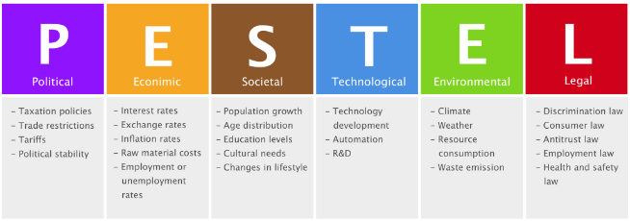
Fig 4.2 PESTEL analysis
- Political Risks:
  - Government regulations on healthcare and AI usage.
  - Approval requirements may delay deployment.
Mitigation: Follow healthcare guidelines, ensure compliance, and design system as a support tool (not a diagnostic replacement).
- Economic Risks:
  - High cost of data collection and model training.
  - Expenses for cloud deployment and maintenance.
Mitigation: Use open-source datasets and tools, optimize models, and adopt cost-efficient cloud services.
- Social Risks:
  - Low awareness of AI-based healthcare solutions.
  - Resistance to adopting new technology.
  - Difficulty for elderly users to use digital systems.
Mitigation: Conduct awareness programs, design simple user interfaces, and provide user guidance.

- Technological Risks:
  - Dependence on high-quality data.
  - Risk of model inaccuracies or system failures.
  - Requires reliable infrastructure and internet.
Mitigation: Use data preprocessing, validation techniques, regular testing, and maintain system updates.
- Legal Risks:
  - Strict data privacy and protection laws.
  - Risk of non-compliance with healthcare regulations.
Mitigation: Implement data encryption, secure storage, and access control, and follow legal standards.
- Environmental Risks:
  - Increased energy consumption due to cloud usage.
  - Minimal but present environmental impact.
Mitigation: Use efficient algorithms, optimize resource usage, and choose energy-efficient cloud services.

4.3 Project budget
Effective budgeting is essential for planning, executing, and completing the project within its financial constraints. The budgeting process for this embedded automotive system follows a structured six-step approach aimed at identifying resource requirements, estimating costs, and ensuring appropriate allocation throughout the project life cycle.
Step 1: List All Tasks and Resource Requirements
The project is divided into key stages like requirement analysis, design, development, testing, and deployment to ensure systematic progress. :
- Requirement Analysis - Define project objectives and problem.
- System Design - Plan architecture and workflow.
- Data Processing - collect and clean data.
- Model Development - Build and train ML models.
- Implementation - Develop UI and integrate system.
- Testing - Verify system accuracy and performance.
- Deployment - Launch system for use.
Step 2: Resource Requirements
Includes human resources (developers, team lead) and technical resources such as laptops, software tools, and cloud platforms needed for development:
- Human Resources:
  - Project Lead – Manages overall project execution.
  - Developers – Handle coding, ML models, and backend.
  - UI Developer – Designs user interface.
- Technical Resources:
  - Hardware – Laptop/PC for development.
  - Software – Python and ML libraries.
  - Cloud – Storage and deployment platform.
  - Datasets – Required data for training models.
Step 3: Team Availability
Team members work part-time over ~4 months, with tasks assigned based on individual skills and roles:
- Work Schedule – 3–4 hours per day.
- Project Duration – Around 4 months.
- Task Allocation – Based on skills and roles.
To adjust for review and rework, a buffer was added while the critical path of the task was determined by analysing earlier task dependencies.

Step 4: Estimated Task Duration
Each phase is allocated specific time (1–4 weeks) to maintain a structured timeline and meet project deadlines:
- Analysis Phase – ~2 weeks for planning.
- Design Phase – ~2 weeks for system structure.
- Development Phase – ~4 weeks for model building.
- Testing Phase – ~3 weeks for validation.
- Deployment Phase – ~1–2 weeks for final setup.
This experience-driven approach will improve the accuracy in budgeting each phase of the project.

Step 5: Budget Estimation
The project cost is estimated around ₹45,000–₹50,000, mainly covering hardware, cloud usage, and minor expenses:
- Hardware Cost – One-time expense if needed.
- Cloud Cost – Monthly usage charges.
- Software Cost – Mostly free (open-source).
- Miscellaneous – Small additional expenses.
- Total Cost – Approx. ₹45,000–₹50,000.
A contingency margin was added to manage unforeseen expenses, ensuring the project remains within expected cost limits.

Step 6: Budget Optimization
Costs are reduced by using open-source tools, free datasets, and minimizing cloud usage through efficient coding:
- Open-source Tools – Reduce software cos.
- Efficient Coding – Lower computational cost.
- Limited Cloud Use – Minimize cloud expenses.
Step 7: Budget Tracking
Expenses are monitored regularly and compared with estimates to avoid overspending and ensure proper financial management:
- Expense Monitoring – Track costs regularly.
- Comparison – Compare planned vs actual budget.
- Adjustments – Control unnecessary spending.
Step 8: Team Assessment
Team performance is evaluated based on task completion, quality of work, and contributions during each project phase:
- Task Completion – Check deadlines and progress.
- Work Quality – Evaluate accuracy and output.
- Contribution – Measure individual involvement.
The project is planned to be cost-effective and well-managed, ensuring efficient use of resources and timely completion.

Table 4.1 Project budget
Sl. No | Item / Resource | Quantity | Estimated Duration | Estimated Cost (₹) | Quantity
1 | Hardware | Laptop/PC for development and model training | 4 months | 30,000 - 40,000 | 1-2 Units
2 | Network | Internet connectivity for research, development, and deployment | 4 months | 1,000 -2,000 | 1
3 | Cloud Services | Cloud platform (AWS/GCP) for storage and deployment | 2-3 months | 3,000 - 5,000 | 1
4 | Software | Programming tools (Python, TensorFlow, Scikit-learn) | 4 months | Free(Open-source) | -
5 | Data Resources | Public datasets for training and testing | Initial phase | Free/Minimal cost | -
6 | Human Resources | Development team (3–4 members) | 4 months | N/A(Academic) | 3-4
7 | UI Development | Frontend frameworks and interface tools | 2 months | Free/Minimal cost | 1
8 | Testing Tools | Tools for validation and performance evaluation | 1-2 months | 500 - 1,000 | 1
9 | Documentation | Printing, report preparation, and materials | Final phase | 500 - 1,000 | -
10 | Miscellaneous | Contingency and unforeseen expenses | Entire duration | 1,000 - 2,000 | -
 | TOTAL |  |  | = ₹40,000-₹50,000

Chapter 5
ANALYSIS AND DESIGN
5.1 Requirements
System Purpose
The primary purpose of the system is to develop an AI-based solution for early detection of dementia by analyzing multi-dimensional data such as speech patterns, cognitive test results, and behavioral indicators. The system aims to provide a non-invasive, cost-effective, and accessible screening tool that assists healthcare professionals and caregivers in identifying early signs of cognitive decline, enabling timely intervention and improved patient outcomes.
System Hardware Requirement Phase
- Identify Initial Conditions:
  - Availability of a basic computing system (Laptop/PC) with moderate processing power.
  - Presence of internet connectivity for data access and cloud usage.
  - Access to input devices such as a microphone for capturing speech data.
  - Availability of initial datasets for model training and testing.
- Determine Input Parameters:
  - Speech data (audio recordings of users).
  - Cognitive test inputs (responses, scores).
  - Behavioural data (interaction patterns, response time).
  - System inputs captured through microphone and user interface devices.
- System Outcomes:
  - Prediction of dementia risk levels (Low / Medium / High).
  - Display of results via user interface/dashboard.
  - Storage of processed data for future analysis and monitoring.

- Formulate Relations:
  - Relationship between input data and output prediction using ML models.
  - Speech + cognitive + behavioural features → Feature extraction → Model prediction.
  - Hardware enables data capture → Software processes data → System generates output.
- Identify System Constraints:
  - Limited hardware processing power for large datasets.
  - Dependence on internet connectivity for cloud-based processing.
  - Quality of input devices (e.g., microphone affects speech accuracy).
  - Budget constraints limiting access to high-end hardware.
System Software Requirement Phase

- Identify Initial Conditions:
  - Availability of programming environment (Python).
  - Installation of required libraries (NumPy, Pandas, Scikit-learn, TensorFlow).
  - Setup of development frameworks (Flask/Streamlit).
  - Access to datasets and basic preprocessing tools.
- Determine Input Parameters:
  - Digital inputs such as audio files (speech data).
  - Cognitive test data (text/numerical inputs)
  - Behavioural data collected via the application
  - Inputs processed through software modules for analysis
- System Outcomes:
  - Software generates dementia risk predictions (Low/Medium/High).
  - Displays results through a graphical user interface (GUI).
  - Stores outputs in databases or files for further analysis.
- Identify System Constraints:
  - Dependency on software compatibility and library versions.
  - Platform restrictions on scheduling, content formats, or file sizes.
  - Possible issues with software bugs or integration errors.

- Formulate Relations:
  - Input data → Pre-processing → Feature Extraction → Model Training/Prediction.
  - Software modules interact to convert raw data into meaningful insights.
  - ML algorithms establish relationships between input features and output predictions.
Data Collection Requirements
- Collect speech, cognitive, and behavioural data from users.
- Ensure data is relevant, accurate, and sufficient for training.
- Support input through microphone and user interface.
- Use reliable and validated datasets for model building.
Data Analysis Requirements
- Perform data preprocessing and cleaning.
- Extract meaningful features from input data.
- Apply machine learning algorithms for prediction.
- Ensure high accuracy and consistency in analysis results.
System Management Requirements
- Maintain a scalable and efficient system architecture.
- Ensure smooth data flow and module integration.
- Provide easy monitoring and management of system operations.
- Support updates and maintenance of models and data.
Security Requirements
- Provide a simple and user-friendly interface.
- Enable easy input of data and clear display of results.
- Ensure accessibility for non-technical and elderly users.
- Offer clear visualization of predictions and outputs.

User Interface Requirements
- Provide a simple and user-friendly interface.
- Clear navigation for accessing journals and Employment News.
- Enable easy input of data and clear display of results.

Table 5.1 Summarizing Hardware requirement

Purpose | Hardware components such as laptops, microphones, and storage devices are used to enable data collection, processing, and system execution for dementia detection.
Behaviour | The hardware captures input (speech via microphone), processes data (via CPU/GPU), and supports continuous system operation and interaction.
System Management | Hardware ensures smooth functioning of the system by supporting task execution, resource allocation, and maintaining system performance.
Data Analysis | Processing units handle computation-intensive tasks such as preprocessing, feature extraction, and machine learning model training.
Application Deployment | Hardware platforms provide the environment for coding, testing, and integrating the application components efficiently.
Security | Hardware supports secure data handling through controlled access, safe storage, and secure communication (when combined with software measures).

Table 5.2 Summarizing Software requirements
Purpose | .Software components such as programming languages, ML libraries, and frameworks are used to process data, build models, and generate predictions for dementia detection.
Behaviour | The software processes input data, executes algorithms, performs computations, and generates outputs based on learned patterns.
System Management | Software manages system operations including data flow, module interaction, error handling, and overall system control.
Data Analysis | Software performs preprocessing, feature extraction, and applies machine learning algorithms to analyse data and produce accurate results.
Application Deployment | Provides tools and frameworks (Python, Flask/Streamlit) for developing, testing, and deploying the application.
Security | Ensures data protection through encryption, authentication, access control, and secure data handling mechanisms.

Table 5.3 Additional requirements
Data Collection | The system should support both real-time and batch data collection while ensuring data consistency and standardization. It must include validation mechanisms to check input accuracy and allow integration with external data sources or APIs to enhance the quality and diversity of collected data.
Data Analysis | The system should be capable of handling large and diverse datasets while supporting continuous model updates and retraining. It should ensure interpretability of results, maintain transparency in predictions, and include performance monitoring metrics such as accuracy and loss for evaluation.
System Management | Manage scheduled posts, email automations, SEO updates, and content pipelines; maintain consistency across website, social media, and marketplaces.
Security | Ensure secure access to analytics accounts, protect login credentials, follow data privacy policies, and restrict unauthorized access to marketing and sales dashboards.
User Interface | Simple dashboards for SEO, social media, email, and marketplace insights; clean layouts; easy navigation; clear visual indicators for performance metrics.

System Hardware Design Phase
- Determine functional blocks
- Identify hardware components like Laptop/PC, Microphone, Storage, Internet/Cloud.
- Assign roles such as input capture, processing, and storage.
- Develop process flow
  - Capture input via microphone/interface.
  - Process data using CPU.
  - Store data in local/cloud storage.
  - Display output on system.
- Identify Inconsistencies
  - Check for low-quality audio inputs.
  - Detect hardware performance limitations.
  - Identify network/connectivity issues.
- Design interfaces
  - Ensure connection between input devices and system.
  - Enable hardware-to-cloud communication.
  - Support smooth data transfer between components.
- System Design and Analysis
  - Analyse hardware capability for ML processing and storage.
  - Ensure system can handle data load and execution speed.
- Developing an integrated test plan
  - Test all hardware components together.
  - Verify data capture, processing, and output display.
System Software Design Phase
- Determine functional blocks
- Define modules: data collection, preprocessing, feature extraction, ML model, UI.
- Develop process flow
  - Input → Preprocessing → Feature extraction → Prediction → Output display.

- Identify Inconsistencies
  - Detect data errors or missing values.
  - Identify model inaccuracies or software bugs.
  - Check integration issues between modules.

- Design interfaces
  - Connect frontend (UI) with backend and ML model.
  - Ensure smooth data exchange between modules.

- System Design and Analysis
  - Evaluate accuracy, speed, and reliability.
  - Ensure system meets functional requirements.

- Developing an integrated test plan
  - Evaluate accuracy, speed, and reliability.
  - Validate overall system functionality and performance.

5.2 Block diagram

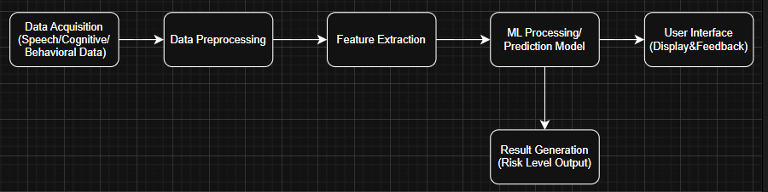
Fig 5.1 Marketing and Sales System Block Diagram

5.3 System Flow Chart
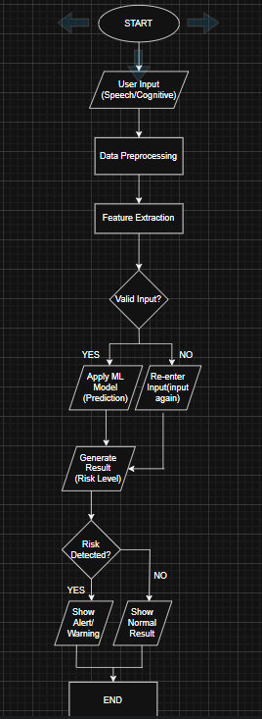
Fig 5.2 System Flow Chart
Functional Hardware Unit Design Phase
- Identify Hardware Components
  - Microphone – for capturing speech input.
  - Laptop/PC – for processing and running ML models.
  - Storage (HDD/SSD) – for storing datasets and results.
  - Internet/Network Module – for cloud access and data transfer.

- Hardware Component Datasheets
  - Refer to specifications such as:
    - CPU speed (GHz), RAM capacity (GB) for processing performance.
    - Microphone sensitivity and frequency range for audio quality.
    - Storage capacity and read/write speed.
    - Network bandwidth and latency for connectivity.
  - Datasheets help ensure components meet system requirements.
- Compare Components
  - Compare different hardware options based on:
    - Performance (speed, efficiency).
    - Cost and affordability.
    - Compatibility with system/software.
  - Example: Compare i5 vs i7 processors, or basic vs high-quality microphones.
- Unit Design and Analysis
  - Design how each hardware unit functions independently.
  - Analyze whether each unit can handle its assigned task efficiently.
  - Ensure proper coordination between input → processing → storage/output.
  - Evaluate performance under expected workload.
- Develop a Unit Test Plan
  - Test each hardware component separately:
    - Microphone test → Check audio clarity and noise levels.
    - System test → Verify processing speed and ML execution.
    - Storage test → Check data read/write performance.
    - Network test → Verify connectivity and data transfer.
  - Ensure each unit performs reliably before integration.

Functional Software Unit Design Phase
1. Identify Software Components
  - Data Collection Module – handles input (speech, cognitive data).
  - Data Preprocessing Module – cleans and normalizes data.
  - Feature Extraction Module – extracts meaningful features.
  - ML Model Module – performs prediction/classification.
  - User Interface Module – displays results to users.
  - Database/Storage Module – stores input and output data.
2. Software Component Specifications
  - Define specifications such as:
    - Programming language (Python).
    - Libraries (TensorFlow, Scikit-learn, NumPy, Pandas).
    - Frameworks (Flask/Streamlit for UI).
    - Performance requirements (accuracy, response time).
  - Ensure compatibility between all software components.
3. Unit Design and Analysis
  - Design each module independently (modular design).
  - Analyze how each unit processes input and produces output.
  - Ensure proper interaction between modules (data flow).
  - Evaluate performance in terms of accuracy, speed, and efficiency.
4. Develop a Unit Test Plan
  - Test each module separately:
    - Data collection test → Validate input correctness.
    - Preprocessing test → Check data cleaning accuracy.
    - Feature extraction test → Verify feature quality.
    - ML model test → Evaluate prediction accuracy.
    - UI test → Ensure proper display of results.
  - Fix errors before integrating modules.

5.4 Communication model
Based on the requirements of the DPD Journals Web System — which involves user requests, content delivery, admin updates, and periodic analytics generation — the following communication models are applicable:

1. Request–Response Model
Where it is used:
- Between User Interface (client) and Backend/ML server.
- When user submits input data and expects prediction output.
Why suitable:
- Provides instant response for user queries.
- Simple and efficient for real-time prediction.
- Forms the core communication mechanism of the system.
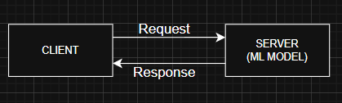
Fig 5.3 Request-Response Model Diagram

2. Publish–Subscribe Model
Where it is used:
- For sending notifications/alerts to users or doctors.
- For broadcasting model updates or system alerts.
Why suitable:
- Supports multiple users simultaneously.
- Decouples sender and receiver (no direct dependency).
- Efficient for real-time notifications and monitoring.
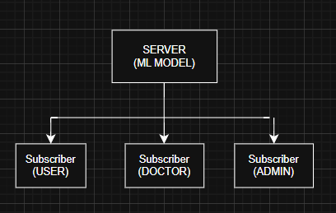
Fig 5.4 Publish-Subscribe Model Diagram

3. Push–Pull Model
Where it is used:
- Between data collection module and ML processing module.
- During background data processing and training
Why suitable:
- Improves system scalability.
- Handles large data efficiently.
- .Enables load balancing and asynchronous processing.
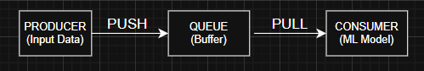
Fig 5.5 Push-Pull Model Diagram

4. Exclusive Pair Model (Limited use)
Where it is used:
- Between user device and server during secure sessions.
- For sensitive data transfer (health-related data).
Why suitable:
- Ensures secure and dedicated communication.
- Reduces risk of data leakage.
- Suitable for confidential healthcare applications.
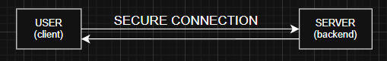
Fig 5.6 Exclusive Pair Model Diagram
5.5 Process Specification
a. Data Acquisition and Preprocessing:
- Collect raw input data from the user and ensure proper formatting and storage.
- Remove noise from audio data.
- Handle missing or inconsistent values.
- Normalize and standardize input data.
b. Feature Extraction & Model Processing:
- Extract relevant features such as speech patterns and cognitive metrics.
- Input features are fed into machine learning models.
- Model analyses patterns and predicts dementia risk.

c. Decision Making & Output Specification:
- Classify results into categories into low, medium or high risks.
- Display results via user interface/dashboard.
- Provide alerts or recommendations if required.
- Store output data for future analysis.
d. Control and Validation & Storage and Logging:
- Validate input data before processing and handle errors.
- Ensure consistency and accuracy of results.
- Store input and output data securely.
- Maintain logs for tracking system activity.
- Enable data retrieval for future reference.
d. Control and Validation & Storage and Logging:
- Dependent on data quality and input accuracy.
- Requires sufficient computational resources.
- Cannot replace clinical diagnosis.
- data flows back into the Analytics Repository for trend identification.
5.6 Service Specification
a. Input Service
- Accepts speech input (audio).
- Takes cognitive test responses and collects behavioural data.
- Ensures valid and properly formatted inputs.
b. Processing Service
- Performs data preprocessing (cleaning, normalization).
- Executes feature extraction.
- Applies machine learning models for prediction.

c. Output Service
- Displays dementia risk levels (Low/Medium/High).
- Provides alerts or recommendations and store’s results for future analysis.
d. Control & Validation Service
- Validates input data before processing.
- Handles errors and exceptions and ensures consistency and accuracy.
e. Storage Service
- Securely stores input and output data.
- Maintains logs for monitoring and support’s data retrieval.
f. Security Service
- Ensures data privacy and confidentiality and protect’s data using encryption.
- Implements authentication and access control.
g. User Interface Service
- Ensures data privacy and confidentiality.
- Implements authentication and access control.
- Protects data using encryption.

Chapter 6
HARDWARE, SOFTWARE AND SIMULATION
6.1 Hardware
- Laptop/PC are used for processing, running ML models, and application execution.
- Microphone captures speech input from the user.
- Storage (HDD/SSD) are used to Stores datasets, models, and results.
- Internet Connection enables data transfer and cloud access.
- Cloud Server supports scalable storage and deployment.

6.2 Software development tools
- Integrated Development Environment (IDE)
  - Tool: Visual Studio Code.
  - Used for writing, editing, and debugging code efficiently.
- Frontend Framework / Styling
  - Tool: Tailwind CSS.
  - Used for designing responsive and modern user interfaces.
- Programming Language
  - Tool: JavaScript.
  - Used for implementing logic, validation, and interactivity.
- Version Control System
  - Tool: Git.
  - Used for tracking code changes and collaboration.
- Browser Testing Tool
  - Tool: Google Chrome.
  - Used for testing, debugging, and running the application.
- Speech Recognition API
  - Tool: Web Speech API.
  - Used for converting voice input into text.

- PDF Generation Tool
  - Tool: html2pdf.js
  - Used to generate downloadable reports.
- Storage Mechanism
  - Tool: LocalStorage.
  - Used to store patient data and results locally.
6.3 Software code
QUESTION DATASET (CORE LOGIC):
Stores questions, answers, and domain and drives the entire assessment system:
const qa = [
{ q: "Remember: Apple, Table, River.", a: ["apple","table","river"], d:"memory" }
];
SECTION NAVIGATION:
function showSection(id) {
document.querySelectorAll('.section').forEach(s => s.classList.add('hidden'));
document.getElementById(id + '-section').classList.remove('hidden'); }
TEST INITIALIZATION:
function startTest() {
pData = {
name: document.getElementById('pName').value,
age: document.getElementById('pAge').value,
date: new Date().toLocaleString() };
currentIdx = 0;
sessionData = [];
showSection('assessment');
renderQuestion(); }
QUESTION RENDERING:
function renderQuestion() {
const qObj = qa[currentIdx];
document.getElementById('qText').innerText = qObj.q; }
ANSWER EVALUATION:
function handleNext() {
const input = document.getElementById('userInput').value.toLowerCase();
const qObj = qa[currentIdx];
const isCorrect = qObj.a.some(ans => input.includes(ans));
}
RISK CALCULATION (MOST IMPORTANT):
const score = sessionData.filter(s => s.correct).length;
const risk = score > 8 ? "Low" : score > 5 ? "Moderate" : "High";
DOMAIN ANALYSIS:
const breakdown = {
memory: sessionData.filter(s => s.d === 'memory' && s.correct).length,
attention: sessionData.filter(s => s.d === 'attention' && s.correct).length,
orientation: sessionData.filter(s => s.d === 'orientation' && s.correct).length
};
SPEECH RECOGNITION:
const rec = new (window.SpeechRecognition || window.webkitSpeechRecognition)();
rec.start();
DATA STORAGE:
localStorage.setItem('pu_clinical_v3', JSON.stringify(records));
ADMIN DASHBOARD:
function renderLedger() {
document.getElementById('adminRecords').innerHTML = records.map(...)
}
PDF GENERATION:
html2pdf().from(element).save();
Chapter 7
EVALUATION AND RESULTS
7.1 Test points
Software Test Points:
- Input Module (Patient Intake & Speech Input)
    - Test Points:
      - Text input field (name, age).
      - Speech recognition output.
    - Scenarios:
      - Valid input (correct name/age).
      - Empty input → should default to “Anonymous”.
      - Speech misrecognition / no response.
    - Measurements:
      - Input accuracy (%).
      - Response time (ms).
      - Signal type: Text (string), Audio → Text.
- Question Rendering Module
    - Test Points:
      - Question display (renderQuestion()).
    - Scenarios:
      - Correct question sequence.
      - UI update failure.
    - Measurements:
      - Rendering time (ms).
      - Correct question index.
- Evaluation Logic Module
    - Test Points:
      - Score calculation.
      - Risk classification logic.

    - Scenarios:
      - Score = 9 → Low risk.
      - Score = 6 → Moderate risk.
      - Score = 3 → High risk.
    - Measurements:
      - Score value (integer).
      - Risk category (string).
- Evaluation Logic Module
    - Test Points:
      - Answer validation (handleNext()).
    - Scenarios:
      - Correct answer match.
      - Partial match (e.g., “apple fruit”).
      - Wrong answer.
    - Measurements:
      - Accuracy of comparison logic.
      - Boolean output (True/False).
- Storage Module
    - Test Points:
      - Local storage (localStorage).
    - Scenarios:
      - Data saved correctly.
      - Data retrieval failure.
    - Measurements:
      - Data integrity (JSON format).
      - Storage success/failure.
- Admin Dashboard
    - Test Points:
      - Record display (renderLedger()).
    - Scenarios:
      - Multiple records.
      - Empty dataset.

    - Measurements:
      - Load time.
      - Data correctness.
- PDF Generation
    - Test Points:
      - Report export (html2pdf).
    - Scenarios:
      - Successful download.
      - UI rendering mismatch.
    - Measurements:
      - File size (KB/MB).
      - Export success rate.
Hardware Test Points
- Microphone (Input Device)
    - Test Points:
      - Audio capture.
    - Scenarios:
      - Clear speech.
      - Background noise.
      - No input.
    - Measurements:
      - Sampling accuracy.
      - Signal type: Analog → Digital.
      - Noise level.
- Processing Unit (Laptop/PC)
    - Test Points:
      - Execution of JS code.
    - Scenarios:
      - Smooth execution.
      - Lag due to low RAM.
    - Measurements:
      - CPU usage (%).
      - Memory usage (MB).
- Network (Optional Cloud Use)
    - Test Points:
      - Data Transfer.
    - Scenarios:
      - Stable Connection.
      - Network failure.
    - Measurements:
      - Data transfer rate.
      - Latency (ms).
Troubleshooting Scenarios
- Speech not detected → Check microphone permissions.
- Wrong answers detected → Improve matching logic.
- UI not updating → Check DOM rendering.
- Data not saving → Verify localStorage access.
- PDF not downloading → Check library loading.
7.2 Test plan
- Testing categories to include:
  - Functional Testing: Testing ensures all modules like input, speech recognition, question display, evaluation, risk analysis, storage, and output work correctly under normal conditions.
  - Black-box tests: Tests the system’s functional behaviour by providing inputs and checking outputs without seeing internal code.
  - White-box tests: Tests internal code logic, paths, branches, and data flows to ensure every line executes correctly.
  - Hardware tests: Checks performance of microphone, system processing, and device compatibility.
  - Unit tests: Individual functions (like question rendering, evaluation, and storage) are tested independently to ensure correct operation.
  - Integration tests: Verifies smooth interaction between modules such as input → processing → output → storage.
  - Performance Testing: Evaluates accuracy, response time (latency), consistency, and resource usage.
  - System tests and validation: Tests the complete system workflow from patient input to final result generation. Ensures the system meets user requirements, is easy to use, and provides reliable results.
7.3 Test Result
Table 7.1 Test results
SI No. | Test Scenario | Condition | Expected Output | Observed Output | Pass / Fail | Notes
1 | Patient Input Entry | Valid name & age entered | Data accepted and stored | Input captured correctly | Pass | Works as expected
2 | Enpty Input Handling | No name/age provided | Default values assigned | “Anonymous” assigned | Pass | Proper validation
3 | Speech Recognition | Clear speech input | Accurate text conversion | Mostly accurate | Pass | Slight noise sensitivity
4 | Speech recognition (noise) | Background noise present | Partial/incorrect text | Reduced accuracy | PartialPass | Needs noise filtering
5 | Question Rendering | Sequential Test flow | Questions displayed correctly | Proper sequence shown | Pass | UI responsive
6 | Answer evaluation | Correct answer input | Marked correct | Correctly evaluated | Pass | Case-insensitive works
7 | Answer Evaluation (Wrong) | Incorrect input | Marked incorrect | Correctly flagged | Pass | Works properly
8 | Risk classification | Score = 9 | Low risk | Low risk shown | Pass | Threshold correct
9 | Risk Classification | Score = 6 | Moderate risk | Moderate risk shown | Pass | Accurate
10 | Risk Classification | Score = 3 | High risk | Hish risk shown | Pass | Accurate
11 | Data storage | After test completion | Data saved in storage | Stored in localStorage | Pass | Persistent storage
12 | Admin Dashboard | Multiple records | Display all entries | Records displayed | Pass | No lag
13 | PDF Generation | Download report | PDF file generated | File downloaded | Pass | Layout maintained
14 | System Performance | Multiple runs | Smooth execution | No lag observed | Pass | Lightweight app

7.4 Insights
- Common issues, likely causes and mitigation:
  - Speech Recognition Errors:
    - Cause: Background noise, accents, low mic quality.
    - Detection: Incorrect or incomplete text output.
    - Mitigation: Use noise filtering, allow manual input fallback.
  - Inaccurate Evaluation:
    - Cause: Simple keyword matching logic.
    - Detection: Wrong answers marked correct/incorrect.
    - Mitigation: Improve logic using NLP/ML models.
  - Low Clinical Reliability:
    - Cause: No trained medical dataset/model.
    - Detection: Results not aligning with real diagnosis.
    - Mitigation: Integrate clinical datasets and expert validation.
  - Data Loss/Storage Loss:
    - Cause: Use of localStorage (limited & temporary).
    - Detection: Missing or reset records.
    - Mitigation: Use cloud database (Firebase, SQL).
  - Scalability Issues:
    - Cause: No backend/server architecture.
    - Detection: Slow or failure with multiple users.
    - Mitigation: Implement cloud/server-based system.
  - Browser Compatibility Issues:
    - Cause: Dependency on browser APIs.
    - Detection: Features not working in some browsers.
    - Mitigation: Add cross-browser support & fallback methods.
  - User Input Errors:
    - Cause: Users giving incorrect/random answers.
    - Detection: Inconsistent or unrealistic results.
    - Mitigation: Add validation checks and guided inputs.
  - Security and Privacy Risks:
    - Cause: No encryption/authentication.
    - Detection: Unauthorized access to data.
    - Mitigation: Implement encryption, authentication, secure storage.
  - Performance issues:
    - Cause: Limited system resources.
    - Detection: Lag or slow response.
    - Mitigation: Optimize code and reduce processing load.
- Improvements per functional unit:
  - Input Module: Improve validation and add multilingual + noise-resistant input.
  - Speech Recognition & System Performance: Better accuracy with better nois handling and advanced APIs. Optimize speed, compatibility and scalability.
  - Question Rendering: Introduce adaptive questions and progress indicators.
  - Evaluation Module: Use NLP/ML instead of simple keyword matching.
  - Risk Analysis: Replace fixed thresholds with data-driven predictive models.
  - Data Storage: Move from localStorage to secure cloud-based storage.
  - Output Module: Add graphical reports and clearer clinical insights.
  - Admin Dashboard: Enable search, filtering, and analytics features.
  - PDF Generation: Improve formatting with structured and professional reports.
Chapter 8
SOCIAL, LEGAL, ETHICAL, SUSTAINABILITY AND SAFETY ASPECTS
Who is responsible?
- Developers (Project Team): Responsible for building a secure, accurate, and reliable system and preventing misuse.
- Healthcare Professionals: Responsible for using the system only as a screening tool, not for final diagnosis.
- Organization/Institution: Responsible for data protection, compliance, and ethical deployment.
- End Users (Patients/Admin): Responsible for providing honest input and using results responsibly.
8.1 Social Aspects
Positive impacts:
- Early Awareness: Promotes early detection of cognitive decline, encouraging timely medical consultation.
- Accessibility: Makes screening available to a wider population without needing immediate clinical access.
- Ease of Use: Simple interface improves usability for elderly users and caregivers.
- Healthcare Support: Assists professionals by providing preliminary insights and reducing workload.
- Cost Effective: Reduces dependency on expensive initial diagnostic procedures.
- Data-Driven Insights: Helps in tracking cognitive trends over time for better care.
Negative impacts:
- Misinterpretation of Results: Users may treat results as a final diagnosis, leading to anxiety or negligence.
- Privacy Concerns: Handling sensitive health data may risk misuse or exposure.
- Digital Divide: Elderly or rural users may face difficulty accessing or using the system.
- Over-Reliance on Technology: Reduces direct consultation with medical professionals.
- Bias & Inaccuracy: Simplified logic may not account for cultural, linguistic, or educational differences.
- Social Stigma: Incorrect labelling may lead to stress or discrimination.
8.2 Legal Aspects
Data protection and privacy:
Legal aspects of the project primarily focus on data privacy, compliance, and responsible handling of sensitive information in the digital environment. Since the system processes personal and health-related data, it must adhere to regulations such as the Information Technology Act 2000 and the Digital Personal Data Protection Act 2023. These laws define how data should be collected, stored, processed, and shared, ensuring that user information is protected against misuse and unauthorized access.
Rights and Obligations:
Users of the system are granted several important rights under these laws. They have the right to give informed consent before their data is collected, the right to access and review their data, and the right to correct or delete inaccurate information. Additionally, users have a fundamental right to privacy, meaning their personal health data must be kept confidential and used only for the intended purpose of the system. On the other hand, developers and organizations have clear obligations to ensure compliance. They must implement secure storage mechanisms, such as encryption and access control, and follow the principle of data minimization by collecting only necessary information. Transparency is also essential, requiring clear communication about how data is used, along with proper terms, conditions, and disclaimers. Ensuring protection against data breaches and unauthorized access is a key legal responsibility.

Challenges:
there are several challenges in maintaining data privacy. These include risks of data breaches, limitations of using local storage mechanisms, and the difficulty of ensuring compliance with constantly evolving regulations. Additionally, users may lack awareness about how their data is being used, which can affect informed consent. Addressing these challenges is crucial for maintaining trust and ensuring that the system operates in a legally compliant and secure manner.
8.3 Ethical Aspects
Fairness:
Ensure questions are unbiased and suitable for all users. Avoid discrimination based on language, education, or background.
Transparency:
Clearly state that the system is only a screening tool, not a diagnosis. Inform users how their data is collected and used.
Accountability:
Developers and organizations are responsible for system accuracy and data handling. Follow ethical standards like those from IEEE.
Privacy & Confidentiality:
Protect sensitive health data from misuse. Ensure secure storage and restricted access.
Minimizing Harm:
Avoid presenting results in a way that causes panic or stress. Provide supportive guidance instead of alarming conclusions.
Informed Content:
Users must be aware of how the system will use their data. Obtain consent before data collection.
Responsible Use:
Ensure the system is used for early screening only. Prevent misuse as a final medical diagnosis tool.
8.4 Sustainability Aspects
Sustainability aspects relate to the environmental impact of a product or process, especially throughout its lifecycle.
Sustainable design is a kind of design meant to yield products that are made only of renewable resources. Furthermore, products made, though sustainable design is intended not to seriously impact the environment either when they are being created or when they are being used. These products are also often designed to allow the users to feel more connected or to relate more closely to the natural environment. This design is based on economic, ecological, and social principles regarding the importance of sustainability.
Environmental Sustainability:
- Being a web-based system, it reduces paper usage (reports, records).
- Minimal hardware requirements lower energy consumption.
- Efficient code design helps reduce computational load and power usage.
Economic Sustainability:
- Low-cost implementation compared to traditional medical screening tools.
- Reduces initial healthcare costs by enabling early detection.
- Scalable for wider use without heavy infrastructure investment.
Social Sustainability:
- Improves accessibility to cognitive screening for a larger population.
- Supports healthcare systems by reducing workload.
- Promotes awareness about early-stage dementia detection.

Technical Sustainability:
- Modular design allows easy updates and maintenance.
- Can be enhanced with future technologies like AI/ML models.
- Supports long-term usability with minimal upgrades.
Data Sustainability:
- Enables digital storage and tracking of patient history over time.
- Can be integrated with cloud systems for long-term data preservation.
- Requires proper data management to ensure integrity and security
8.5 Safety Aspects
Safety aspects focus on preventing harm and ensuring the security and reliability of products and systems.

User Safety:
The system should not cause panic or stress through results.Provide clear disclaimers that it is only a screening tool. Present results in a supportive and understandable manner.
Data Safety:
Protect sensitive health data using secure storage and access control. Prevent unauthorized access or data breaches. Ensure safe handling in line with laws like the Digital Personal Data Protection Act 2023.
System Reliability:
Ensure the system works consistently without crashes or errors. Validate inputs to avoid incorrect processing. Maintain accurate and stable performance.
Operational Safety:
Ensure safe usage across different devices and browsers. Avoid dependency failures (e.g., microphone or network issues).Provide fallback options like manual input.

Clinical Safety:
Avoid using the system as a final diagnostic tool. Encourage consultation with medical professionals. Prevent misleading conclusions that may affect health decisions.

Security Safety:
Implement authentication and authorization mechanisms. Protect against cyber threats like data theft or misuse.

Chapter 9
CONCLUSION
The project successfully demonstrates a web-based cognitive screening system designed for the early detection of dementia through speech input and interactive assessment. It highlights how modern web technologies can be leveraged to create a solution that is accessible, cost-effective, and easy to use, especially for preliminary health evaluation. By integrating key functionalities such as patient data collection, real-time question processing, response evaluation, risk classification, and report generation, the system provides quick and structured insights into a user’s cognitive condition. At the same time, the project acknowledges certain limitations, including dependence on speech recognition accuracy, simplified rule-based evaluation, and the absence of clinical-grade validation, which may affect precision. These challenges open avenues for future enhancement, such as incorporating advanced AI/ML models, multilingual support, secure cloud-based data storage, and stronger privacy mechanisms aligned with regulations like the Digital Personal Data Protection Act 2023. Overall, the project serves as a scalable and impactful prototype that can aid early awareness and support healthcare professionals, provided it is used responsibly, ethically, and as a supplementary tool rather than a definitive diagnostic system.

APPENDIX
A.1 USER INTERFACE/EXPERIENCE SCREENSHOTS
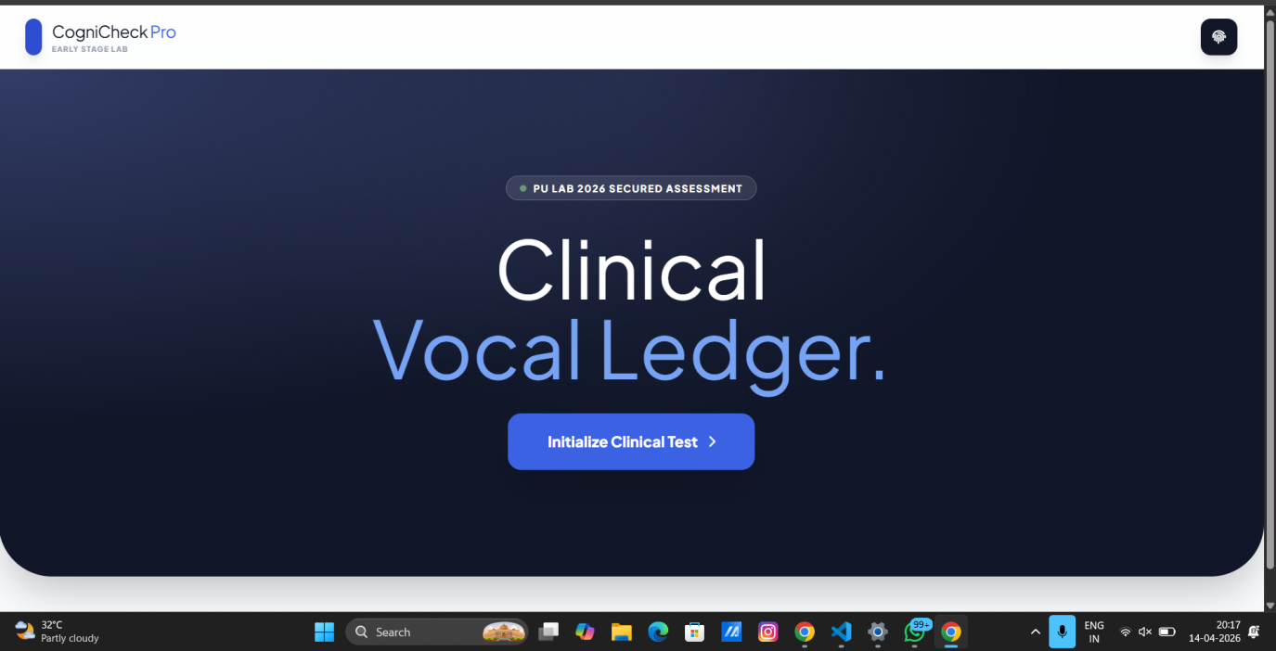
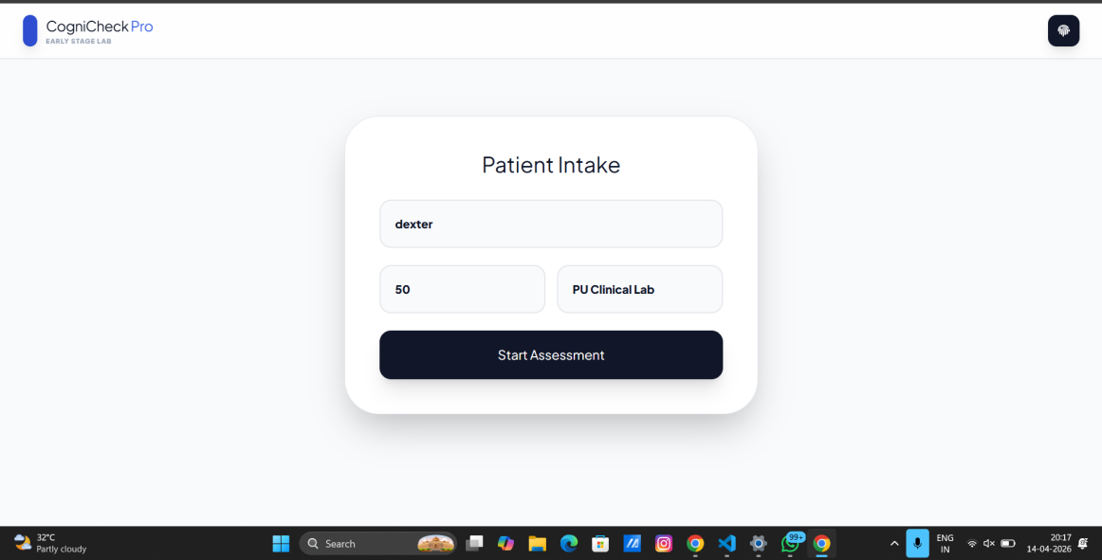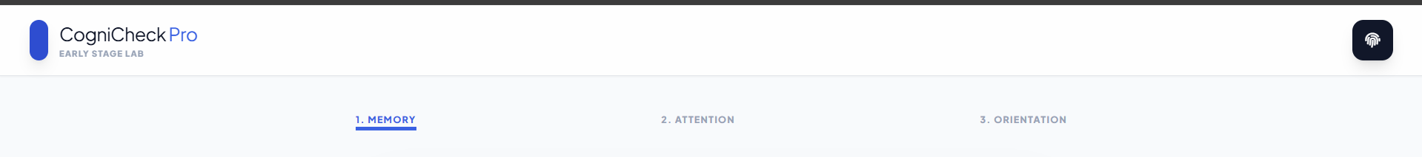

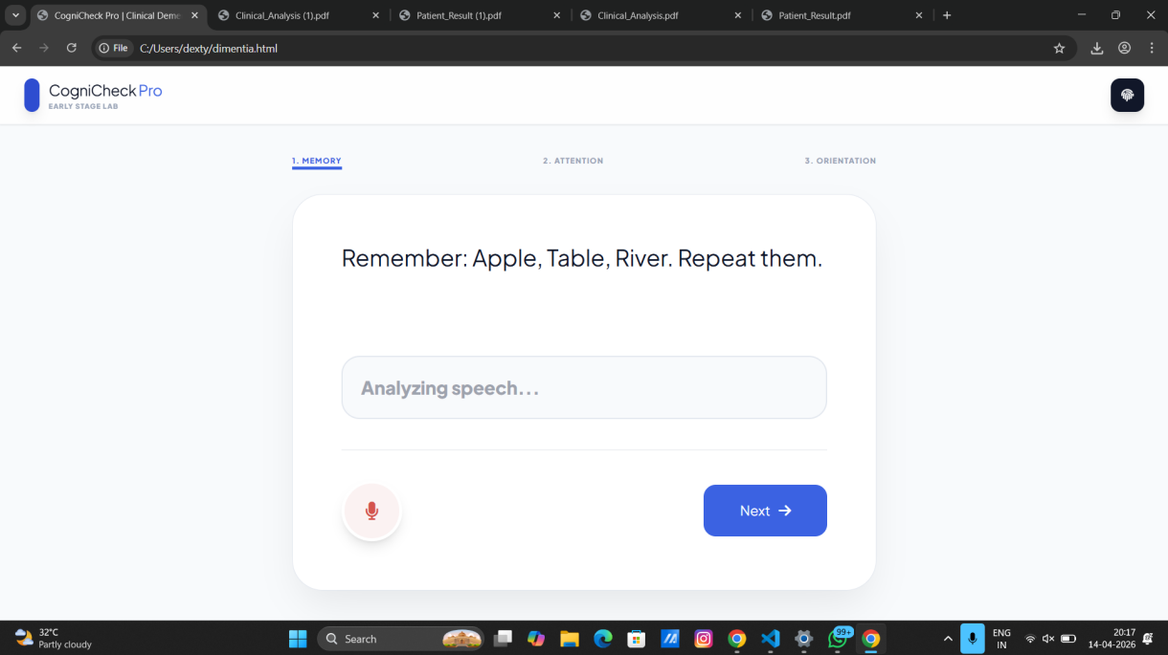
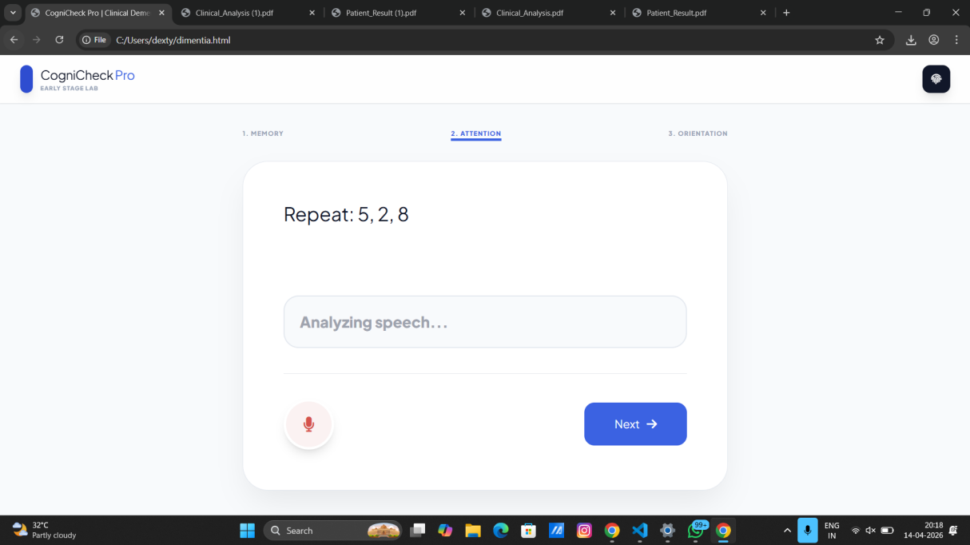
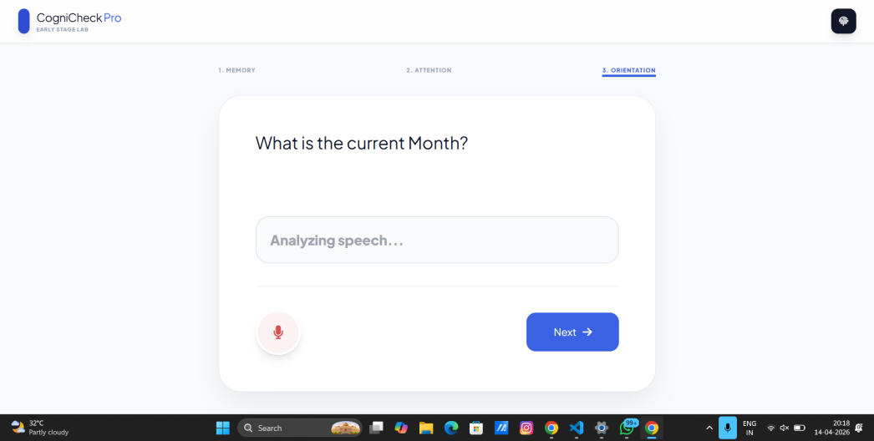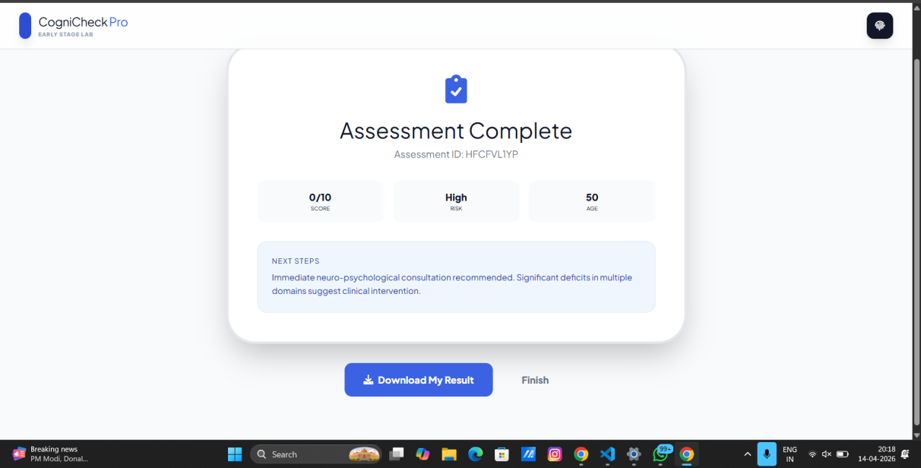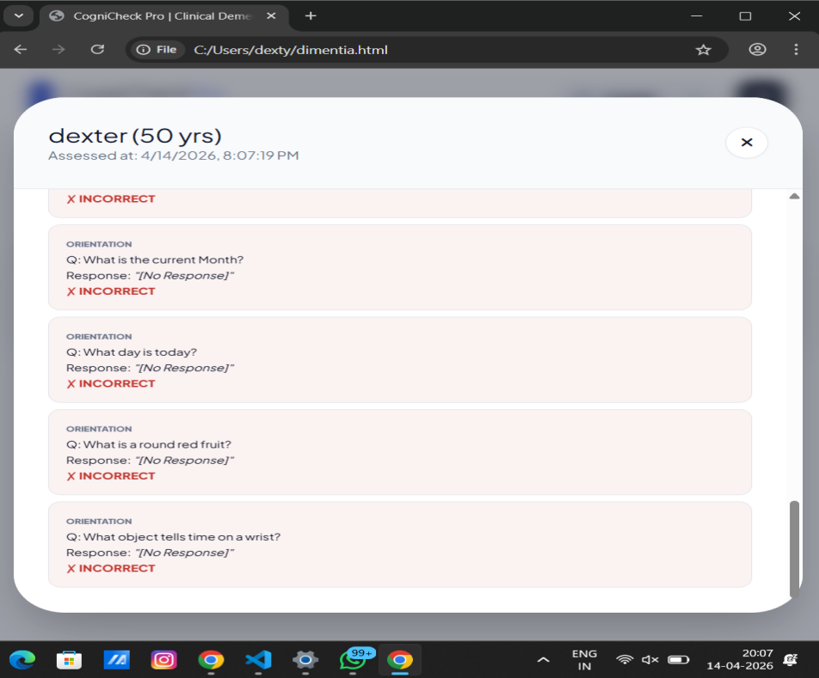
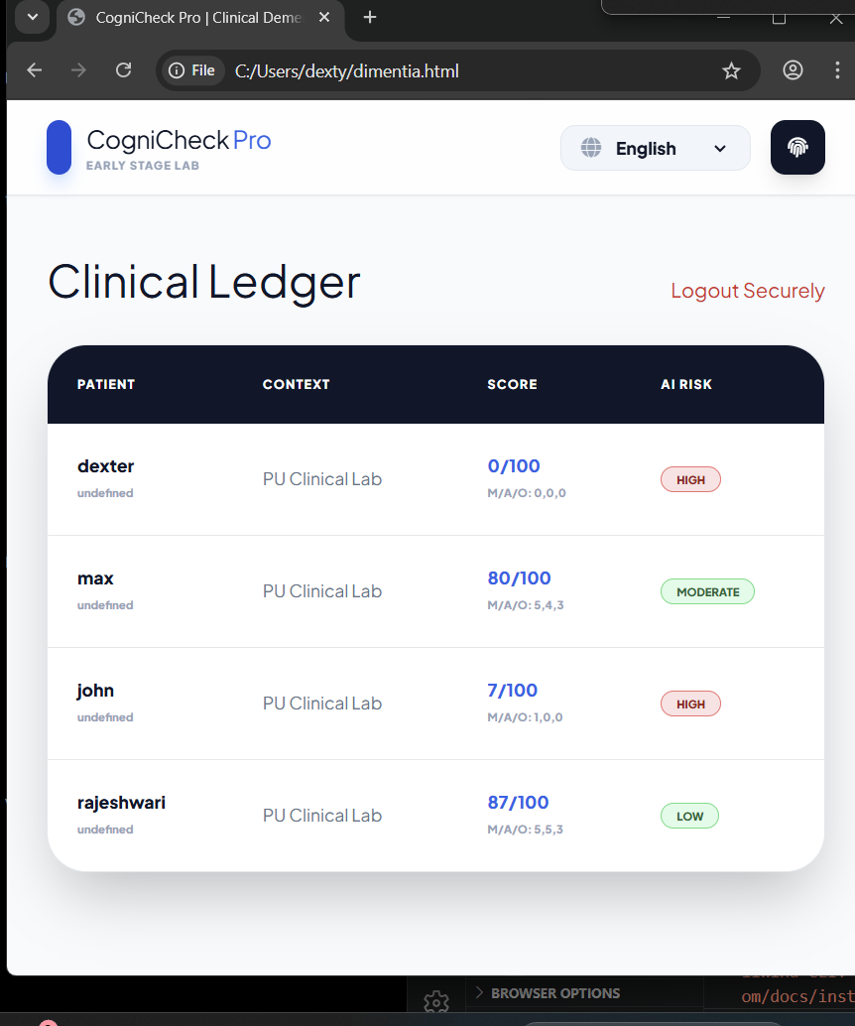
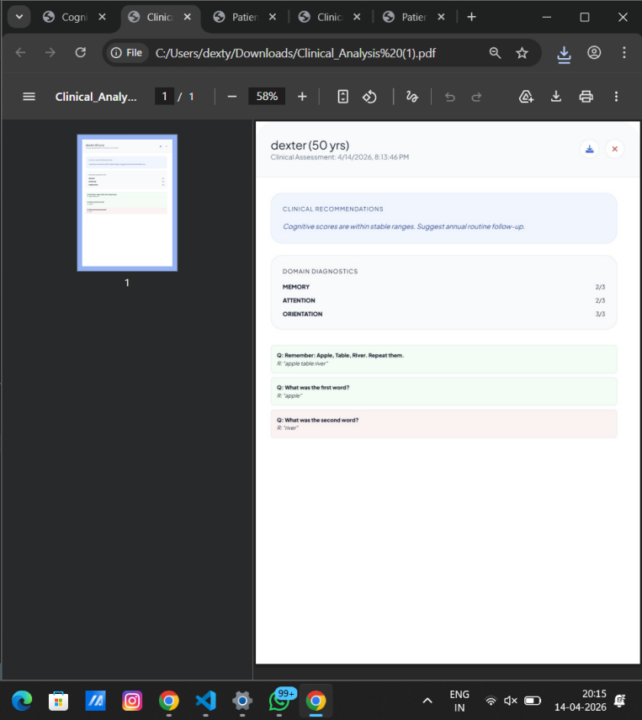

A.2 Project Report - Similarity Index
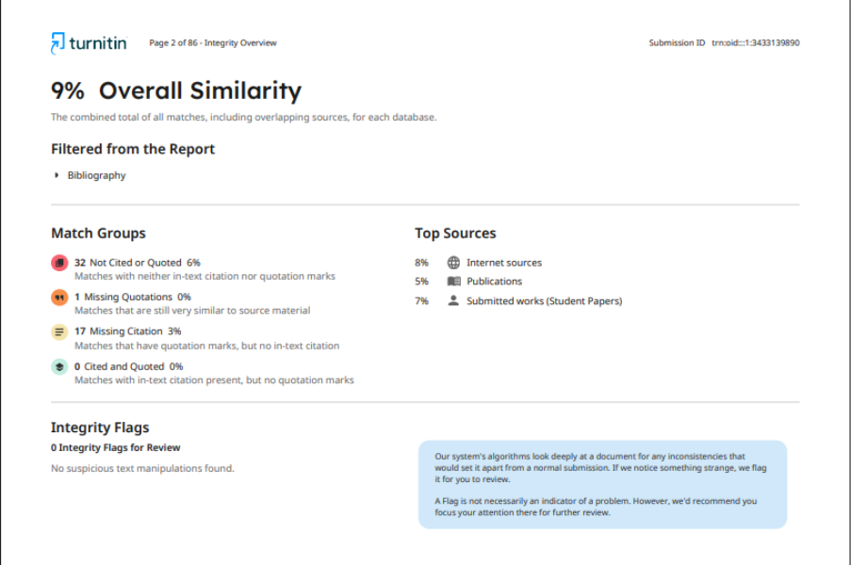
A.3 Project Report –GitHub Repository
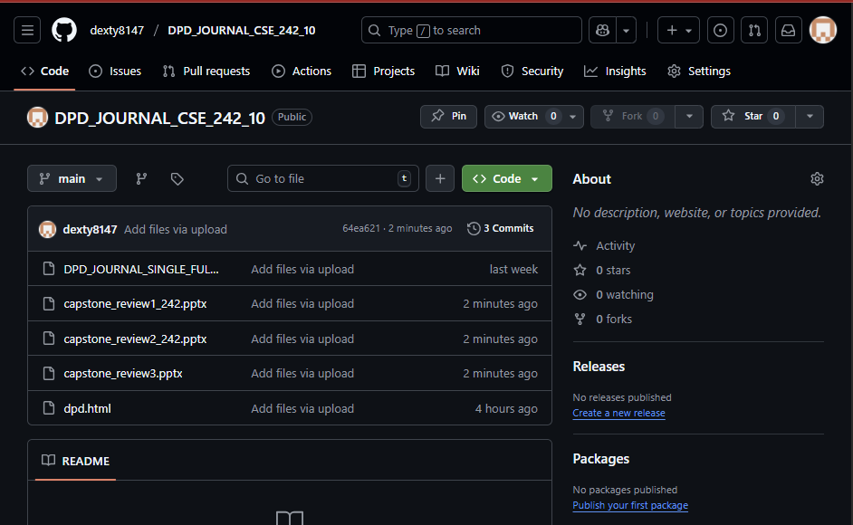
A.4 Project Report –Research Paper Submission


References
- World Health Organization, “Dementia Fact Sheet,” 2023. [Online]. https://www.who.int/news-room/fact-sheets/detail/dementia.
- Alzheimer's Association, “Early Signs and Symptoms of Alzheimer’s,” 2024. [Online]. https://www.alz.org.
- IEEE, “IEEE Code of Ethics,” 2020. [Online]. https://www.ieee.org.
- Information Technology Act 2000, Government of India, 2000.
- Digital Personal Data Protection Act 2023, Ministry of Electronics and Information Technology, Government of India, 2023.
- Web Speech API, MDN Web Docs. [Online]. https://developer.mozilla.org.
- Tailwind CSS, Official Documentation. [Online]. https://tailwindcss.com.
- html2pdf.js, GitHub Repository. [Online]. https://github.com/eKoopmans/html2pdf.js
- Mozilla Developer Network (MDN), “JavaScript Documentation,” [Online]. https://developer.mozilla.org
- World Wide Web Consortium (W3C), “Web Accessibility Guidelines,” [Online]. https://www.w3.org

