Project “Tetris game”

Team name: “Chipmunk”



Members:

Vanina Nenova – vanina_nenova
Deyan Yosifov – d_p_y
Danail Panayotov – DanailPanayotov
Ivaylo Parvanov - wicked
Bader Imad Bader – baderimad.bader

Project purpose:

For our project we have chosen to experience object-oriented modeling and OOP over a Tetris game. It’s a very popular game in which different types of figures fall down on a field and the player can arrange them. We implemented this problem with C# code, trying to follow the best practices in OOP design.

Project URL:

https://teamchimpmunk.visualstudio.com/DefaultCollection/tetrisGame

Class Diagram:

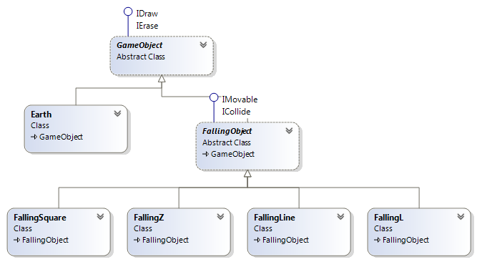

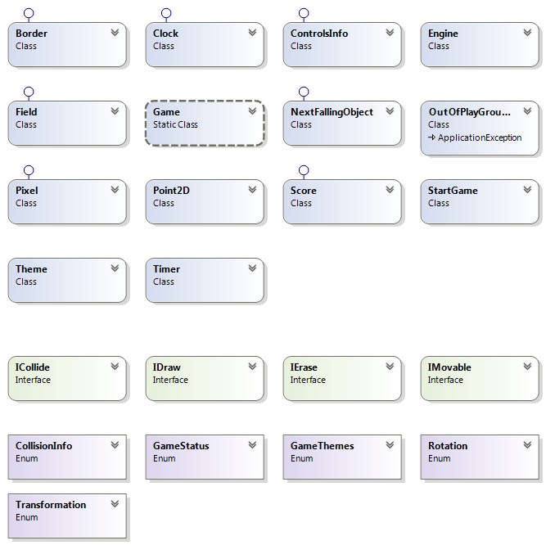

Description:

GameObject is the base class for our project. It is abstract and inherits interfaces IDraw and IErase.
FallingObject inherits GameObject and interfaces IMovable and ICollide. It is the base class for all game figures and contains important functionalities, such as Move(), Rotate(), ReCalculateBody(), Collide().
Classes FallingL, FallingLine, FallingSquire and FallingZ inherit it and draw their own body with specific parameters.
Earth inherits Game Object, adds falling objects to its body and erases rows when they are full.
Field draws all the other elements on the console – the field’s borders, the result, the clock, the next figures and the controls’ info.
Engine contains the game’s logic - what happens when a command key is pressed, when collision occurs and so on.
The static class Game holds the field’s dimensions and has a Start() method to begin playing.
Our project also has the following enumerations: GameStatus, CollisionInfo, GameThemes, Rotation and Transformation, and a class to handle exceptions, called OutOfPlayGroundException.

