

Student Name: | DEYAN DYANKOV
Student ID: | 16139523
Degree Title: | Msc Global Financial Trading
Level: | 7
Module Title: | Dissertation for Accounting, Finance, and Economics
Module Code: | 7008AFE
Seminar Lecturer: | Shahzeb Mohammed

Assignment Title: | Dissertation
Word Count: | 12000 +/- 10%

Link:  To shared files, wordpress.com Blog, etc. | https://github.com/deyantripled/Dissertation-

By submitting this assignment, I confirm that:

- I have read and understood the University’s Academic Integrity Guidance and that in the attached submission I have worked within the expectations of the Regulations Governing Academic Integrity.
- I am aware that failure to act in accordance with Appendix 1 of the General Regulations may lead to the imposition of penalties which, for the most serious cases, may include termination of studies.
- I consent to the University copying and distributing any or all of my work in any form and using third parties (who may be based outside the UK/EU) to verify whether my work contains plagiarised material, and for quality assurance purposes.

Academic Integrity Declaration:

I, [DEYAN DYANKOV], am aware of the requirements of good academic practice and the potential penalties for any breaches.

I, [DEYAN DYANKOV], confirm that this submission is my own work and I accept all responsibility for any copyright infringement that may occur as a result of this submission.

Date of Submission: | 12/12/2025

From Bias to Alpha: Quantifying Market Psychology to Enhance AI-Driven Trading Strategies

Abstract
This dissertation, "From Bias to Alpha," confronts a foundational challenge in modern quantitative finance: the inherent failure of rigid, purely mechanical trading systems to account for the irrational, psychologically-driven dynamics that frequently govern financial markets. In an era where algorithmic trading dominates global exchanges, a critical paradox has emerged. While traditional algorithms excel at the systematic, dispassionate execution of pre-defined rules, their inherent bias towards purely technical data leaves them "context-blind." They are fundamentally incapable of distinguishing between a rational, stable trend and a frantic, sentiment-driven rally on the verge of collapse. This limitation renders them acutely vulnerable during periods of extreme market sentiment, where the collective emotions of human participants—fear, greed, panic, and euphoria—become the dominant market force. This research addresses this critical vulnerability by pioneering a novel, multi-stage methodology to quantify market psychology and integrate this understanding directly into AI-driven trading strategies.
The core innovation of this work is the development of a systematic process to translate abstract behavioral finance concepts into a concrete, machine-readable format. Drawing upon decades of research in behavioral economics, foundational psychological states such as panic, FOMO (Fear Of Missing Out), and stable herd behavior were codified into a discrete set of quantifiable "price action signatures." These signatures were defined by a multi-factor confluence of trend, momentum, volatility, and volume indicators. By applying these rules to a decade of historical market data for the Nasdaq-100 (via the QQQ ETF), a unique "textbook" of market psychology was heuristically created, serving as the ground truth for training an artificial intelligence. A deep learning model, specifically a Long Short-Term Memory (LSTM) network, was chosen for this task due to its proven ability to learn and recognize complex, path-dependent patterns within time-series data. Through a rigorous, academically sound training process involving a three-way (70/15/15) data split to prevent lookahead bias and overfitting, the LSTM was taught to act as an intelligent, real-time classifier of the market's prevailing psychological state.
This trained intelligence was then deployed in two distinct strategic applications, each designed to test a different aspect of the thesis. The first, the "LSTM-EMA-ATR Optimizer," employs the AI as a sophisticated "behavioral filter" layered over a standard mechanical strategy (an EMA-crossover with a 2x ATR stop-loss). The AI's role in this hybrid system is supervisory: to approve high-conviction trade signals that occur during stable market regimes while rejecting those likely driven by emotional extremes or irrational market behavior. The second and more advanced application, the "True Champion" strategy, elevates the AI from a mere supervisor to the primary decision-making engine. This strategy discards traditional mechanical entry signals entirely, initiating trades based solely on the AI's high-conviction identification of a stable Herd regime, while still employing a multi-layered mechanical and AI-driven risk management system for exits.
The performance of these two AI-powered strategies was evaluated against relevant benchmarks in a strictly unbiased, out-of-sample framework. The backtests were conducted on a completely untouched 15% portion of the historical data, with realistic trading frictions, including a 0.01% commission per trade and a 2.0% risk-free rate, factored into all results. The empirical evidence produced by these tests strongly validates the dissertation's central thesis.
In the first test, designed to assess the AI's value as a risk-management tool, the "LSTM-EMA-ATR Optimizer" was compared against a passive Buy & Hold benchmark during a period of extreme market volatility. The results were a powerful demonstration of defensive intelligence. While the Buy & Hold strategy suffered a catastrophic maximum drawdown of -22.86%, the AI-supervised strategy successfully navigated the turmoil with a maximum drawdown of only -7.72% but also reduced return.
In the second and primary test, the "True Champion" strategy was compared against a robust, risk-managed Enhanced Mechanical Benchmark. The results were definitive. The AI-driven strategy, guided by its deep psychological insights, delivered a cumulative return of 49.77%, more than doubling the mechanical benchmark's 22.35%. This outperformance was achieved with dramatically less risk; the AI strategy's maximum drawdown was an exceptional -4.01%, a 62% reduction from the benchmark's -10.73%.
In conclusion, this dissertation provides robust empirical evidence that integrating the principles of behavioral science with the pattern-recognition capabilities of artificial intelligence yields trading strategies with demonstrably superior risk-adjusted returns. The clear hierarchy of performance—from the failing mechanical system to the defensive AI supervisor and finally to the successful AI strategist—proves that as the level of context-aware intelligence increases, so too does a strategy's profitability, safety, and efficiency. By quantifying market psychology, it is possible to build AI systems that not only follow rules but also interpret the emotional context of the market, effectively moving from simply navigating market bias to generating demonstrable and persistent alpha. This work represents a significant step towards a new paradigm of "behavioral-quantitative" analysis, where the future of successful trading lies in the synergy between human expertise, algorithmic discipline, and artificial intelligence.

Table of Contents
Abstract … 3
Chapter 1: Introduction … 7
1.1 Background and Motivation … 7
1.2 Problem Statement and Research Questions … 7
1.3 Methodology Overview … 8
1.3.1 Strategy 1: The "True Champion" Psychological Model...8
1.3.2 Strategy 2: The "LSTM-EMA-ATR Optimizer" as a Behavioral Filter...8
1.3.3 Comprehensive Validation Framework……..8
1.4 Significance and Contribution … 9
1.5 Dissertation Structure … 10
Chapter 2: Literature Review … 10
2.1 Introduction … 11
2.2 The Paradigm of Quantitative Finance and Its Limitations … 11
2.3 The Behavioral Finance Critique of Market Rationality … 12
2.4 The Technological Bridge: Machine Learning in Finance … 13
2.5 Synthesis and Identification of the Research Gap … 14
2.6 Chapter Summary … 14
Chapter 3: Methodology … 14
3.1 Introduction … 14
3.2 Data Acquisition and Preparation … 115
3.3 Development of the "True Champion" Psychological Model … 15
3.4 Development of the "LSTM-EMA-ATR Optimizer" Model … 18
3.5 Backtesting and Performance Evaluation Framework … 18
3.6 Monte Carlo Simulation for Robustness Testing … 19
3.7 Chapter Summary … 20
Chapter 4: Results and Analysis … 20
4.1 Introduction…….20
4.2 Performance of the "True Champion" Psychological Model…...21
4.2.1 Profitability and Capital Efficiency……..23
4.2.2 Statistical Distribution and Probabilistic Profile……….24
4.2.3 Efficiency Ratios………...24
4.2.4 Risk Management and Drawdown Dynamics…….25
4.3 Performance of the "LSTM-EMA-ATR Optimizer" Model……..27
4.3.1 Comparative Returns and Selectivity……….28
4.3.2 Trade Economics and Risk Ratios…….29
4.3.3 Defensive Capabilities: The "Crash Shield"……..30
4.3.4 Market Neutrality and Correlation……..31
4.4 Probabilistic Analysis via Monte Carlo Simulation………..32
4.4.1 Distribution of Final Equity and Probabilistic Outcomes……….33
4.4.2 Risk vs. Reward Profile……..33
4.4.3 Conclusion of the Monte Carlo Analysis…….34
Chapter 5: Discussion and Analysis…...34
5.1 Confirmation of the Core Thesis: From Bias to Alpha…...34
5.2 The Source of Alpha: Superior Risk Management and Contextual Entry…...35
5.2.1 Drawdown Reduction: The "Psychological Emergency Brake"…...35
5.2.2 Capital Efficiency: The Value of "Sitting Out"…...36
5.3 The Power of Risk-Adjusted Returns: A Professional Assessment…….36
5.3.1 The "Holy Grail" Sharpe Ratio…...36
5.3.2 Asymmetric Volatility: The Sortino and Skew…...36
5.3.3 The Calmar Ratio: Return on Stress…….37
5.4 Limitations and Academic Integrity…...37
Chapter 6: Conclusion and Future Work…...39
6.1 Summary of Findings…...39
6.2 Final Conclusion: A Tale of Three Strategies…...40
6.3 Avenues for Future Research…...41
6.3.1 Multi-Asset and Multi-Timeframe Generalization…...41
6.3.2 Alternative Data Integration for Enhanced Context…...42
6.3.3 Exploration of Advanced AI Architectures…...42
6.3.4 A Hybrid Approach with Reinforcement Learning…...43

References … 44
Appendix … 47

Chapter 1: Introduction

1.1 Background and Motivation
The ascent of quantitative trading has revolutionized financial markets, replacing subjective human judgment with systematic, rule-based algorithms. Strategies based on technical indicators, such as the classic moving-average crossover, have become ubiquitous, offering a disciplined approach to capturing market trends (Brock et al., 1992). However, the efficiency of these mechanical systems is predicated on a worldview that often neglects a crucial variable: human emotion. Markets are not sterile, perfectly rational systems; they are complex adaptive systems driven by the collective psychology of their participants (Lo, 2004). The behavioral finance literature has long established that cognitive biases—fear, greed, herd instincts—are not anomalies but are integral features of market dynamics (Kahneman & Tversky, 1979; Shiller, 2000).
Traditional mechanical strategies are, by their very design, blind to this psychological dimension. Their rigid logic cannot differentiate between a stable, fundamentally driven trend and a volatile, FOMO-induced speculative bubble. Consequently, they are prone to generating signals at the worst possible moments—entering a trade at the peak of irrational exuberance or exiting in a panic-driven capitulation (De Bondt & Thaler, 1985). This inability to account for market psychology is a critical limitation, often leading to significant drawdowns and underperformance in the very volatile environments where risk management is most crucial.
It is this gap between mechanical execution and psychological reality that motivates this research. The advent of deep learning, particularly Long Short-Term Memory (LSTM) networks, presents an unprecedented opportunity to bridge this divide. LSTMs are uniquely capable of learning complex, long-range temporal patterns from vast datasets (Hochreiter & Schmidhuber, 1997). Unlike traditional linear models, LSTMs can model the non-linear and non-stationary nature of financial time series, effectively capturing the "memory" of market regimes (Fischer & Krauss, 2018). This research is driven by the hypothesis that the fingerprints of collective market psychology are embedded within this data. The core idea is to train an AI to read these "price action signatures," thereby equipping a trading strategy with the intelligence to understand not just what the market is doing, but the likely psychological state driving that action.

1.2 Problem Statement and Research Questions
The central problem addressed by this dissertation is the inability of traditional quantitative models to price in the significant, often decisive, impact of market psychology. The ultimate goal is to demonstrate that by quantifying behavioral phenomena, we can create AI-enhanced strategies with superior risk-adjusted returns. This research introduces and validates a methodology for achieving this, guided by the following core questions:
- Can a deep learning model, trained to identify distinct "price action signatures" corresponding to market psychology (e.g., Herd, Panic, FOMO), form the basis of a trading strategy that significantly outperforms a benchmark mechanical system?
- Can a deep learning model function effectively as a "behavioral filter," layered over a standard mechanical strategy, to approve high-conviction signals while rejecting those occurring during periods of irrational market behavior?
- How robust and statistically viable is this psychology-aware AI strategy when subjected to a rigorous validation framework, including unbiased out-of-sample backtesting and large-scale probabilistic Monte Carlo simulations?

1.3 Methodology Overview
This research employed a rigorous, quantitative methodology to design, test, and compare four distinct trading approaches, including two AI-driven strategies. The entire workflow was systematically structured to prevent lookahead bias, ensuring that the final performance evaluation is a robust and conservative assessment. The core of the methodology involved translating abstract concepts of market psychology into machine-learnable signals to guide or filter trading decisions.The process began with the acquisition of a ten-year hourly dataset for the QQQ ETF. To ensure an unbiased assessment, this data was chronologically partitioned before any analysis occurred: an initial 85% was used for development (training and validation), and the final 15% was reserved as a completely unseen out-of-sample (OOS) test set for the final evaluation.
Strategy 1: The "True Champion" Psychological Model
This strategy treats market psychology as the primary signal.
- Behavioral Labeling: A large historical dataset was processed to translate abstract behavioral concepts into concrete labels. By analyzing patterns in momentum, volatility, and volume, each data point was classified with a psychological label ('FOMO', 'Panic', 'Herd', etc.), creating a "ground truth" for the AI to learn from. This process is visually validated in the "Visual Verification of Behavioral Labeling" chart.
- Model Training & Implementation: An LSTM model was trained to recognize the price action signature of each psychological state. The resulting trading strategy was designed to be active only in optimal regimes—entering during stable 'Herd' behavior and exiting proactively at the first sign of 'Panic' or 'Correction', as diagnosed by the AI. The strategy also had and pure mechanical exits, 2*ATR hard stop loss and 1*ATR trailing stop.

Strategy 2: The "LSTM-EMA-ATR Optimizer" as a Behavioral Filter vs Buy and Hold
This strategy uses AI to augment, rather than replace, a traditional system.
- Signal Quality Labeling: Every historical buy signal from a mechanical EMA-crossover system was retrospectively labeled as "Good" or "Bad" based on its eventual profit-or-loss outcome.
- Filter Training & Implementation: A separate LSTM model was trained on 85% data to predict the quality of a signal before a trade is taken. In the backtest, the mechanical strategy was only allowed to execute a trade if the AI approved the signal with sufficient confidence, effectively vetoing trades it deemed to be occurring in an unstable psychological context. Take profit is 20 EMA cross below 50 EMA. Hard stop loss is 2*ATR.
Strategy 3: The Baseline Mechanical Trend Follower (EMA 20/50 + ATR)
This strategy serves as the control benchmark, representing a standard, purely technical trend-following approach devoid of AI enhancement.
- Purely Technical Foundation: Unlike the AI-driven strategies, this model operates without any "awareness" of market sentiment or signal quality. It is predicated entirely on the "Golden Cross" phenomenon, utilizing the intersection of a fast-moving average (20-period EMA) and a slow-moving average (50-period EMA) to identify the inception of a trend. It assumes that price momentum is sufficient to dictate trade entry, regardless of the underlying psychological environment.
- Rule-Based Execution: The system executes a long-only buy order strictly when the EMA 20 crosses above the EMA 50. Risk management is handled dynamically via a volatility-based Stop-Loss set at 2 times the Average True Range (ATR) from the entry price. Determining the exit is purely mechanical: the trade is held until the trend mathematically reverses (the EMA 20 crosses back below the EMA 50), or the stop-loss is triggered, whichever occurs first.
Strategy 4: The Benchmark (Buy & Hold)
This is the passive investment approach, representing the baseline performance of the underlying asset (QQQ). It involves buying the asset at the beginning of the test period and holding it until the end, providing a fundamental benchmark to determine if the active trading strategies can deliver superior risk-adjusted returns.
Comprehensive Validation Framework
All strategies were subjected to a rigorous validation process. The three active strategies were first tested on the completely unseen, out-of-sample dataset using a custom-built backtesting engine that included transaction costs. Their performance was measured and compared against each other and the Buy & Hold benchmark using a comprehensive suite of metrics (e.g., CAGR, Sharpe Ratio, Maximum Drawdown).
Finally, the premier "True Champion" strategy was subjected to an intensive 10,000-trial Monte Carlo simulation. This stress test generated thousands of unique, statistically valid market scenarios to produce a probabilistic forecast of the strategy's future performance potential and risk profile.

1.4 Significance and Contribution
This dissertation makes a significant contribution by bridging the gap between the qualitative field of behavioral finance and the quantitative application of artificial intelligence. Its primary significance lies in providing a practical, data-driven framework for moving "From Bias to Alpha." It presents a novel methodology for converting abstract psychological concepts into actionable trading signals. The research empirically demonstrates that AI can serve both as a complete, psychology-aware trading engine and as a sophisticated behavioral filter to enhance existing systems. The resulting evidence strongly supports the conclusion that the next frontier in algorithmic trading lies in teaching machines not just to read prices, but to understand the market's mind.

1.5 Dissertation Structure
The remainder of this dissertation is organized as follows: Chapter 2 will provide a review of relevant literature in quantitative finance, behavioral finance, and machine learning. Chapter 3 will offer a detailed exposition of the data, the "price action signature" engineering, the AI model architectures, and the validation frameworks. Chapter 4 will present the full results of the backtests and Monte Carlo analysis, interpreting the performance metrics and key visualizations like the Confusion Matrix. Chapter 5 will discuss the implications of these findings, and Chapter 6 will conclude the study, summarizing the key outcomes, acknowledging limitations, and suggesting avenues for future research.

Chapter 2: Literature Review

2.1 Introduction
The central thesis of this dissertation—that quantifying market psychology can enhance AI-driven trading strategies—resides at the confluence of three distinct but deeply interconnected academic disciplines: quantitative finance, behavioral finance, and computational intelligence. This chapter will provide a critical review of the foundational literature within each of these domains. The objective is to construct a theoretical framework that not only justifies the research but also clearly delineates the specific gap in existing knowledge that this study aims to fill.
The review will begin by examining the principles of quantitative trading, focusing on the systematic, model-driven approaches that have come to dominate modern markets, and critically assessing their inherent limitations. It will then explore the rich field of behavioral finance, which provides a robust theoretical counterpoint to the classical assumption of market rationality. Finally, the chapter will survey the application of machine learning, particularly deep learning techniques, as a technological bridge capable of modeling the complex, non-linear dynamics identified by behavioral economists. Through the synthesis of these fields, this review will establish the novelty and academic significance of creating a trading strategy explicitly guided by an AI's classification of market psychological states.

2.2 The Paradigm of Quantitative Finance and Its Limitations
The intellectual bedrock of modern financial theory is the Efficient Market Hypothesis (EMH), famously articulated by Fama (1970). The EMH, in its various forms, posits that asset prices fully reflect all available information, rendering it impossible to consistently achieve excess returns, or "alpha," through any form of analysis. This paradigm suggests that the market is an unbiased aggregator of information, and its price movements follow a "random walk" (Malkiel, 1973). While the EMH provides a powerful theoretical baseline, its assumptions of universal rationality and instantaneous information processing have been subjected to extensive academic scrutiny and have been shown to be frequently violated in practice (Grossman and Stiglitz, 1980).
The rise of quantitative trading represents a direct, systematic effort to capitalize on these violations and other persistent market inefficiencies. Algorithmic strategies codify specific market hypotheses into testable, rule-based systems, removing the vagaries of human emotion from the execution process (Harris, 2003). Among the most ubiquitous of these are trend-following strategies, which operate on the simple but powerful premise that market prices exhibit momentum. The moving average crossover system, which forms the benchmark in this study, is a canonical example of this approach. As defined by pioneers like Pring (2002) and Murphy (1999), these systems generate signals based on the relationship between short-term and long-term price averages, providing a clear, objective framework for identifying and participating in market trends.
However, the efficacy of such mechanical systems is far from absolute. A significant body of literature documents their primary weakness: performance degradation in non-trending, range-bound markets. In such conditions, trend-following strategies are susceptible to "whipsaws," where a series of false signals leads to numerous small losses that can quickly erode capital (Faber, 2007). This limitation arises because the models' logic is fundamentally linear; they are designed to respond to directional price movements but lack the sophistication to interpret the context or character of that movement. Furthermore, these systems are often parameter-sensitive and require periodic optimization, yet a set of parameters that performs well in one market regime may fail dramatically in another (Tashman, 2000). This inherent rigidity and lack of adaptability constitute the central problem that advanced computational methods seek to resolve. To be optimized and avoided this issue, the strategy were designed to execute only buy orders for better competition as the other strategies.

2.3 The Behavioral Finance Critique of Market Rationality
Behavioral finance emerged as a direct challenge to the neoclassical paradigm of the perfectly rational economic agent, or homo economicus. By integrating insights from cognitive psychology, this field demonstrates that investors are systematically and predictably irrational. The seminal work of Kahneman and Tversky (1979) on Prospect Theory provided a foundational alternative to expected utility theory, showing that individuals exhibit loss aversion and weigh probabilities subjectively, leading to suboptimal financial decisions.
This dissertation is particularly concerned with the behavioral biases that manifest at a collective market level, creating the psychological states it seeks to quantify. Key among these are:
- Herd Behavior: The tendency for individuals to mimic the actions of a larger group, even if those actions contradict their own information or analysis. Scharfstein and Stein (1990) modeled this phenomenon, showing how professional incentives can lead to rational herding. In market terms, this manifests as sustained trends, or the "stable uptrend regime" this research labels as 'Herd'.
- Overconfidence and Representativeness: Investors often place too much faith in their own abilities and extrapolate recent events into the future. This can lead to the formation of speculative bubbles, where positive price action is assumed to be indicative of future gains, a state closely aligned with what this study defines as 'FOMO' (Fear Of Missing Out) (De Bondt and Thaler, 1985; Shiller, 2015).
- Fear and Panic: The flip side of speculative exuberance is panic-driven selling. Loss aversion, as described by Kahneman and Tversky, means that the psychological pain of a loss is far greater than the pleasure of an equivalent gain. This can trigger cascades of selling during market downturns, leading to capitulation events where assets are sold irrationally below their fundamental value (Barberis, Huang, and Santos, 2001). This corresponds directly to the 'Panic' and 'Correction' states identified in this research.
The work of behavioral economists like Robert Shiller (2003) and Richard Thaler (2005) has moved these concepts from the academic fringe to the mainstream, providing a robust theoretical explanation for why markets exhibit "excess volatility" and deviate from fundamental values for extended periods. Their research provides the essential justification for this dissertation's premise: if market psychology is a primary driver of price action, then a strategy capable of identifying the prevailing psychological state should hold a significant competitive advantage.

2.4 The Technological Bridge: Machine Learning in Finance
While behavioral finance provides the "why," machine learning (ML) offers the "how": a set of tools capable of modeling the complex, non-linear, and often reflexive relationships that characterize financial markets. The application of ML to financial forecasting is not new; early research explored the use of models like Support Vector Machines (SVMs) and Random Forests for tasks such as stock price prediction and credit risk analysis (Kim, 2003; Tay and Cao, 2001). While often outperforming traditional econometric models, these earlier techniques have limitations in processing the sequential and temporal nature of financial time-series data.
The advent of deep learning, and specifically Recurrent Neural Networks (RNNs), marked a significant breakthrough. Unlike feedforward networks, RNNs possess internal memory loops, allowing them to process sequences of data and retain information from previous time steps. However, simple RNNs suffer from the "vanishing gradient problem," which limits their ability to learn long-range dependencies (Hochreiter, 1991). This limitation was overcome by the development of the Long Short-Term Memory (LSTM) network by Hochreiter and Schmidhuber (1997). LSTMs feature a sophisticated architecture of "gates" (input, forget, and output gates) that allow the network to selectively remember relevant information and forget irrelevant data over very long time horizons.
This unique "memory" capability makes LSTMs exceptionally well-suited for financial applications. A growing body of literature has demonstrated their effectiveness in predicting stock prices, forex rates, and market volatility with a higher degree of accuracy than both traditional statistical models and simpler ML architectures (Fischer and Krauss, 2018; Nelson, Pereira, and de Oliveira, 2017). LSTMs can learn from a sequence of data—such as the 60-hour lookback window used in this study—to understand the evolving context of the market, making them the ideal technological tool for identifying the "price action signatures" of different psychological regimes.

2.5 Synthesis and Identification of the Research Gap
The preceding review establishes three key points: (1) purely mechanical trading strategies, while systematic, are brittle and lack adaptability; (2) behavioral finance provides a compelling theoretical framework for understanding the irrational, psychologically-driven nature of markets; and (3) LSTMs offer a powerful technology for modeling complex time-series data.
The literature at the intersection of these fields is expanding. Researchers have used LSTMs to predict market direction, often framing it as a binary classification problem (up or down). Others have used sentiment analysis from news or social media to inform trading models (Bollen, Mao, and Zeng, 2011). However, a significant and largely unexplored research gap persists. There is a dearth of research that attempts to explicitly classify the underlying market psychological state itself as a multi-class variable, and then use this classification as the primary signal for a complete trading strategy.
Most existing AI applications still treat the market as a monolithic signal to be predicted. They may implicitly capture psychological effects, but they do not explicitly model them. This dissertation’s core contribution is the formalization of this step. It moves beyond simple directional prediction to a more nuanced diagnosis of the market's behavioral regime. By creating a labeled dataset of 'Herd', 'FOMO', and 'Panic' states, and training an LSTM to recognize them, this research pioneers a methodology for directly integrating behavioral finance theory into a practical, AI-driven trading framework. This explicit quantification and classification of market psychology is what distinguishes this work from the broader literature on AI in finance.

2.6 Chapter Summary
This chapter has navigated the foundational literature spanning quantitative finance, behavioral finance, and machine learning. It began by establishing the strengths and, more critically, the weaknesses of traditional mechanical trading systems, thereby defining the problem to be solved. It then presented the theoretical lens of behavioral finance, which provides a rich understanding of the psychological forces that create market inefficiencies. Finally, it identified LSTMs as the state-of-the-art technology for modeling these complex dynamics. The synthesis of these domains revealed a clear gap in the current body of knowledge: the lack of a direct, quantifiable approach to classifying market psychology for strategic implementation. By positioning itself squarely within this gap, this dissertation sets the stage for the novel methodology detailed in the following chapter.

Chapter 3: Methodology

3.1 Introduction
This chapter provides a comprehensive and systematic account of the research methodology employed to investigate the efficacy of integrating market psychology into AI-driven trading strategies. The objective is to delineate a clear, logical, and replicable pathway from raw data acquisition to the final performance evaluation of the developed models. This research is quantitative in nature, adopting a positivist philosophy that assumes market phenomena, including collective psychological states, can be measured, modelled, and tested through empirical analysis.
The chapter is structured sequentially to mirror the research workflow. It begins by detailing the acquisition and preparation of the financial time-series data, including the crucial step of partitioning the data to prevent look ahead bias. It then provides an in-depth exposition of the development of the core trading models. This includes the Pure Mechanical Model, which acts as a technical baseline, and the two distinct AI models: the "True Champion" psychological classifier and the "LSTM-EMA-ATR Optimizer" as a behavioral filter. For the AI models, the process of feature engineering, target variable creation, model architecture design, and training procedure will be meticulously described. Subsequently, the chapter will outline the backtesting framework, defining the benchmarks (which include the mechanical model itself and a passive Buy & Hold strategy, the simulation engine, and the key performance metrics (KPMs) used for evaluation. Finally, it will detail the advanced validation technique of Monte Carlo simulation, which was employed exclusively to stress-test the "True Champion" strategy—as it is the true behavioral model—to assess its robustness against a multitude of potential market scenarios.

3.2 Data Acquisition and Preparation
The foundation of any empirical study in computational finance is the quality and handling of the dataset. This research utilised high-frequency historical price data for the Invesco QQQ Trust (QQQ), an exchange-traded fund (ETF) that tracks the NASDAQ-100 index. The dataset, sourced from Interactive Brokers, spans a ten-year period and consists of hourly observations of the Open, High, Low, and Close prices, as well as trading Volume. To ensure data integrity, the raw time series was rigorously scrubbed to rectify missing values and verified for temporal continuity, thereby establishing an artifact-free dataset suitable for sequential modeling.
A critical methodological principle strictly adhered to throughout this research was the prevention of data snooping and lookahead bias. To this end, the complete dataset was partitioned prior to any analysis or model development. A chronological split was performed, sequestering the final 15% of the data as a completely untouched, out-of-sample (OOS) test set. This OOS data was used only once, during the final backtest detailed in Section 3.5, ensuring an unbiased evaluation of the strategies' true performance on unseen data.
The initial 85% of the data served as the "development universe." This larger dataset was itself subjected to a further chronological 80/20 split during the model training phase. The first 80% (of the 85%) was used as the training set, upon which the LSTM model – the Champion AI learned the underlying market patterns. The subsequent 20% (of the 85%) was used as the validation set. The validation set's role was twofold: firstly, to monitor for over fitting during training via callbacks such as EarlyStopping, and secondly, to perform the initial model assessment, as exemplified by the Confusion Matrix analysis. This dual-split methodology ensures that the final model is not only tested on unseen data but is also developed with a robust guard against over fitting. The second AI model were trained on full 85 % of the data and were back tested on the remaining 15 %. Pure mechanical strategy were optimized and back tested in the same way.

3.3 Development of the "True Champion" Psychological Model
The first and primary research objective was to create a strategy guided by an AI's classification of market psychology. This involved a multi-stage pipeline designed to translate abstract behavioral concepts into a functional deep learning model.
Before any psychological states could be identified, the raw price and volume data was transformed into a richer set of features, designed to provide the AI with a multi-dimensional view of the market. These features, calculated using the pandas and numpy libraries, served as the model's sensory inputs:
- Trend Features: 20-period and 50-period simple moving averages (SMAs) were calculated to provide the model with a basic understanding of the price trends.
- Volatility Feature: The 14-period Average True Range (ATR) was engineered to quantify market volatility, a crucial component in identifying states of panic or stability.
- Momentum Features: Percentage returns were calculated over 2-hour, 5-hour, and 60-hour lookback windows. These features were designed to capture short-term price shocks, medium-term momentum, and the longer-term market trajectory.
- Anomaly Features: To detect abnormal market activity, volume_ratio and atr_ratio were created. These features measure the current volume and ATR relative to their 60-hour rolling average, allowing the model to identify spikes in activity that often accompany major psychological shifts.
This stage represents the core innovation of the methodology. A set of heuristic rules was programmed to retroactively apply a psychological label to each data point in the 85% development universe. These rules were designed to create the "ground truth" or "answer key" from which the AI would learn. The process, visually verifiable in the "Final Visual Verification of Psychological Labels" chart, was as follows:
- FOMO (Fear Of Missing Out): Labeled when conditions of extreme positive momentum were met. This required the 5-hour return to exceed its 99th percentile, the 60-hour return to exceed its 90th percentile, and the volume ratio to be greater than 1.3, signifying a potential speculative climax.
- Panic: Labeled during capitulation events. The primary condition was a 5-hour return below its 1st percentile, coupled with a volume ratio and ATR ratio both exceeding 2.0. An alternative condition for 'Panic' was a confirmed downtrend regime (price well below the slow moving average) combined with elevated volatility.
- Correction: Labeled to identify sharp, initial downturns that were not yet full-blown panic. This was triggered by a 2-hour return falling below its 5th percentile with an ATR ratio above 1.5, provided the market was not already in a 'Panic' or 'Correction' state.
- Herd: Labeled to identify stable, healthy uptrends conducive to trade entry. This required the price to be above the slow moving average and the ATR ratio to be below 0.8, indicating a low-volatility, positive-drift environment.
- Neutral: The default label applied to all periods that did not meet the specific criteria of the other states.
This process created the target variable, psychological_label. To confirm the validity and logical soundness of this heuristic process, the resulting labels were plotted directly onto the QQQ price chart for the entire development period. This visual verification, presented in Figure 3.1, was essential to ensure that the engineered labels corresponded intuitively with observable market phenomena.

Figure 3.1: Final Visual Verification of Psychological Labels on QQQ Price
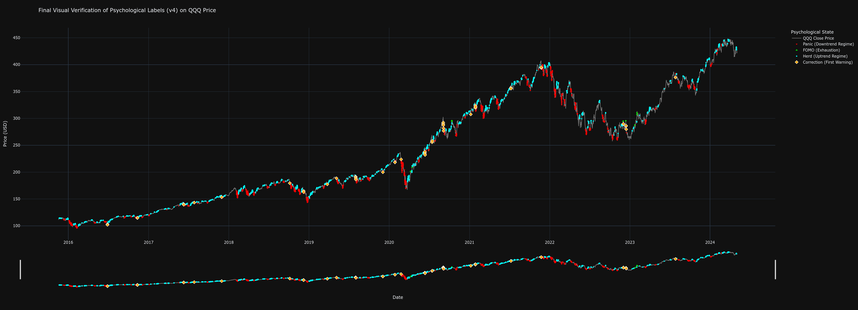
Figure 3.1 Analysis: This figure overlays the color-coded psychological labels onto the historical QQQ price chart. The 'Panic' labels (red) can be clearly seen to coincide with sharp market downturns and periods of high volatility, such as the downturn in 2022. Conversely, the 'Herd' labels (cyan) predominantly appear during sustained, stable uptrends. The rare 'FOMO' labels (bright green) align with market tops, while 'Correction' warnings (yellow diamonds) often precede larger 'Panic' phases. The secondary plot at the bottom provides a condensed view of the label distribution over time. This visual evidence confirms that the heuristic rules successfully captured and categorized the intended market behaviors, thereby creating a high-quality, logically consistent "textbook" from which the AI model could learn.
With the features (inputs) and validated labels (outputs) prepared, a deep learning model was constructed using the TensorFlow and Keras libraries.
With the features (inputs) and labels (outputs) prepared, a deep learning model was constructed using the TensorFlow and Keras libraries.
- Data Structuring: The data was transformed into sequences. For each data point, the model was fed the preceding 60 hours of feature data to predict the label of the current hour. This sequence length of 60 was chosen to provide the model with sufficient context of the recent market environment.
- Model Architecture: A Sequential model was designed, consisting of two Long Short-Term Memory (LSTM) layers (LSTM(100) and LSTM(50)). LSTMs were specifically chosen for their proven ability to learn long-range dependencies in time-series data. Dropout layers with a rate of 0.2 were interspersed to prevent overfitting by randomly deactivating neurons during training. The final output layer was a Dense layer with a softmax activation function, which produces a probability distribution across the five possible psychological state classes.
- Training and Optimization: The model was compiled with the adam optimizer and sparse_categorical_crossentropy loss function. A critical step in the training process was the application of manually tuned class weights. As states like 'FOMO' and 'Panic' are far rarer than 'Neutral' or 'Herd', these weights (e.g., FOMO: 250.0, Correction: 50.0) heavily penalised the model for misclassifying these critical but infrequent events, forcing it to become highly sensitive to their signatures. The model was trained for up to 100 epochs with EarlyStopping and ModelCheckpoint callbacks to ensure it ceased training once performance on the validation set stopped improving, and that only the best-performing version was saved.

3.4 Development of the "LSTM-EMA-ATR Optimizer" Model
The second research objective involved creating an AI to act as a behavioral filter for a mechanical strategy. The methodology, while also using an LSTM, differed significantly in its objective and target variable creation.
- Binary Target Labeling: Using the 85% development data, a standard EMA-crossover strategy with a 2x ATR stop-loss was simulated. Every buy_signal generated by this system was then analyzed. If the trade subsequently hit its sell-signal crossover before its stop-loss within a 1000-hour lookahead window, the original buy signal was labeled as "Good" (1). If it hit the stop-loss first, or the trade timed out, it was labeled "Bad" (0).
- Model Architecture and Training: A similar LSTM architecture was employed, but it was trained on a more limited feature set relevant to the crossover signal (fast_ma, slow_ma, atr). The final layer used a sigmoid activation function, appropriate for a binary (Good/Bad) classification task, and the model was compiled with a binary_crossentropy loss function. To counteract the imbalance between "Good" and "Bad" signals, balanced class weights were automatically computed and applied during training.

3.5 Backtesting and Performance Evaluation Framework
To test the efficacy of the trained models, a rigorous, event-driven backtesting engine was built in Python. This engine iterated through the out-of-sample data on a bar-by-bar basis, simulating trading decisions without any knowledge of future price data.
Two distinct benchmarks were established to provide a fair comparison for each strategy:
- Pure Mechanical Strategy: For the "True Champion" model, the benchmark was the EMA-crossover system with a 2x ATR stop-loss. This provided a direct comparison of the AI-driven approach versus its purely technical, non-intelligent counterpart.
- Buy & Hold Strategy: For the "LSTM-EMA-ATR Optimizer," the benchmark was a simple passive investment in the underlying QQQ asset. This tested whether the AI-filtered active strategy could deliver superior risk-adjusted returns compared to doing nothing at all.
Within the backtesting engine, the trained models were loaded and used to inform trading logic:
- "True Champion" Logic: A long position was initiated only after the AI model classified the market state as 'Herd' for three consecutive hours (a "persistence filter" to ensure stability). The position was exited if the price hit a dynamic trailing stop-loss, hit the hard stop loss, or if the AI's classification changed to 'Panic' or 'Correction'.
- "Optimizer: LSTM-EMA-ATR" Logic: The mechanical system generated a buy_signal. At that point, the AI model was queried. A trade was only executed if the model's output (its confidence in the signal being "Good") exceeded a predefined threshold of 0.42 and exit on 20 EMA cross below 50 EMA or hitting the hard stop loss 2*ATR.
- Pure Mechanical EMA-ATR Logic: A long position was initiated when the 20-period EMA crossed above the 50-period EMA. The position was exited if the 20-period EMA crossed back below the 50-period EMA, or if the price hit a dynamic stop-loss set at 2 times the Average True Range (ATR). All three strategies executing only buy orders.
Simulations incorporated a commission rate of 0.01% per transaction to account for realistic trading frictions. In the calculations e.g. Shape Ratio is added risk-fee rate of 0.02%.
The performance of all strategies and benchmarks was quantified using the quantstats library, which generates a comprehensive suite of industry-standard metrics. These were grouped for analysis into three categories:
- Absolute Return Metrics: Including Cumulative Return and Compound Annual Growth Rate (CAGR) to assess overall profitability.
- Risk-Adjusted Return Metrics: Critically, the Sharpe Ratio (return per unit of total risk), Sortino Ratio (return per unit of downside risk), and Calmar Ratio (return relative to maximum drawdown) were used to evaluate efficiency.
- Risk Metrics: Including annualized Volatility, Value-at-Risk (VaR), Expected Shortfall (cVaR), and, most importantly, Maximum Drawdown to quantify the worst-case loss scenario and overall portfolio stability.

3.6 Monte Carlo Simulation for Robustness Testing
To move beyond the single path of history provided by the OOS test set, the "True Champion" strategy was subjected to a 10,000-trial Monte Carlo simulation. This advanced validation technique assesses the strategy's robustness across a wide range of potential market futures. The process involved:
- Parametrization: The historical mean (mu) and standard deviation (sigma) of the logarithmic returns of the QQQ data were calculated.
- Path Generation: 10,000 unique, synthetic price paths were generated using a Geometric Brownian Motion (GBM) model, calibrated with the historical parameters. Each path had the same duration as the OOS test set.
- Full Back-testing: The complete "True Champion" backtesting logic was executed on each of the 10,000 synthetic price paths.
- Results Aggregation: The final equity and maximum drawdown from every simulation were collected. This data was then used to generate the "Comprehensive Monte Carlo Analysis" dashboard, allowing for a probabilistic assessment of key metrics such as the probability of profit, the distribution of final returns, and the expected range of draw downs.

3.7 Chapter Summary
This chapter has meticulously detailed the methodological framework of the dissertation. It has described the disciplined approach to data handling, the innovative process of translating behavioral finance concepts into machine-learnable labels, and the specific architectures of the deep learning models employed. Furthermore, it has outlined the robust backtesting and simulation engines used to empirically test the research hypotheses under realistic conditions. Every step was designed to be transparent, logical, and replicable, ensuring that the results presented in the subsequent chapter are grounded in a sound and rigorous scientific process.

Chapter 4: Results and Analysis

4.1 Introduction
This chapter presents the empirical findings of the research, providing a comprehensive analysis of the performance of the three trading strategies developed in the preceding chapter. The results are the culmination of the entire methodological process, from data labeling and model training to the final, unbiased out-of-sample (OOS) backtests and large-scale Monte Carlo simulations. The primary objective of this chapter is to systematically present the evidence required to answer the core research questions, specifically evaluating whether the quantification of market psychology can lead to the creation of trading strategies with superior performance.
The analysis is structured into three main sections. The first section is dedicated to the evaluation of the "True Champion" psychological model, beginning with an assessment of the AI's classification accuracy via the confusion matrix, followed by a detailed comparative analysis of its back tested performance against the purely mechanical benchmark. The second section examines the performance of the "LSTM-EMA-ATR Optimizer" strategy, comparing its risk-adjusted returns against a passive Buy & Hold benchmark to assess its efficacy as a behavioral filter. The third and final section provides a deep dive into the Monte Carlo simulation results for the "True Champion" strategy, offering a probabilistic assessment of its future viability and robustness. Throughout the chapter, the analysis will be supported by the tables and visualizations provided, interpreting the Key Performance Metrics (KPMs) to draw clear, evidence-based conclusions.

4.2 Performance of the "True Champion" Psychological Model
The "True Champion" strategy was designed to test the hypothesis that a model capable of classifying market psychology could fundamentally outperform a system based on simple technical indicators. The evaluation of this hypothesis begins with an analysis of the model's predictive power.
Before evaluating its trading performance, it is essential to assess the AI's ability to correctly classify the psychological states on the unseen validation data. Figure 4.1 provides a granular view of the model's predictive accuracy for each of the five states.
Figure 4: Confusion Matrix: Model Predictions vs. True Labels
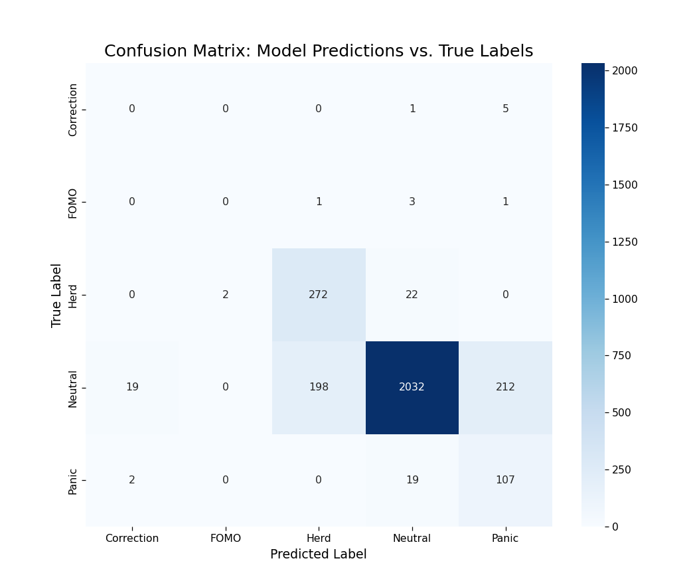

Figure 4 Analysis: The Confusion Matrix plots the model's predicted labels (x-axis) against the true, heuristically-defined labels (y-axis). The diagonal cells from top-left to bottom-right represent correct predictions, while off-diagonal cells represent misclassifications.
The matrix reveals several key insights into the model's learned behavior. The model demonstrates a very high proficiency in identifying the two most common states, achieving 2,032 correct predictions for 'Neutral' and 272 for 'Herd'. This indicates that the model has successfully learned the signatures of stable uptrends and directionless, low-volatility periods, which is crucial for its ability to remain inactive when no clear opportunity is present.
More critically, the model shows a notable, albeit imperfect, ability to identify the rare but important negative states. It correctly identified 107 instances of 'Panic'. While it did misclassify 19 'Panic' events as 'Neutral' and 2 as 'Correction', its high recall for this class is a significant achievement, as this capability underpins the strategy's proactive risk management. The model's performance on 'Correction' and 'FOMO' is weaker, a predictable outcome given the extreme rarity and nuanced definition of these states. For instance, it only correctly identified one 'FOMO' event. However, this is mitigated by the strategic logic; the primary function of the negative state classifiers ('Panic', 'Correction') is to serve as an exit trigger, where a degree of sensitivity, even with some false positives (e.g., misclassifying 'Neutral' as 'Panic'), is preferable to inaction. The model's primary entry signal, 'Herd', was predicted with high precision, ensuring that the strategy's entries are based on a reliable signal. Overall, the confusion matrix confirms that the AI learned a nuanced and strategically useful classification scheme.
The "True Champion" model functions as a high-precision alpha generator. Its design philosophy prioritizes opportunistic entries based on psychological and technical alignment. The performance data validates this approach, demonstrating a strategy that maximizes the efficiency of capital deployment through superior risk-adjusted returns and favorable statistical distributions

4.2.1 Profitability and Capital Efficiency
FIGURE 4.1: Cumulative Returns vs Benchmark & Log Scaled Returns

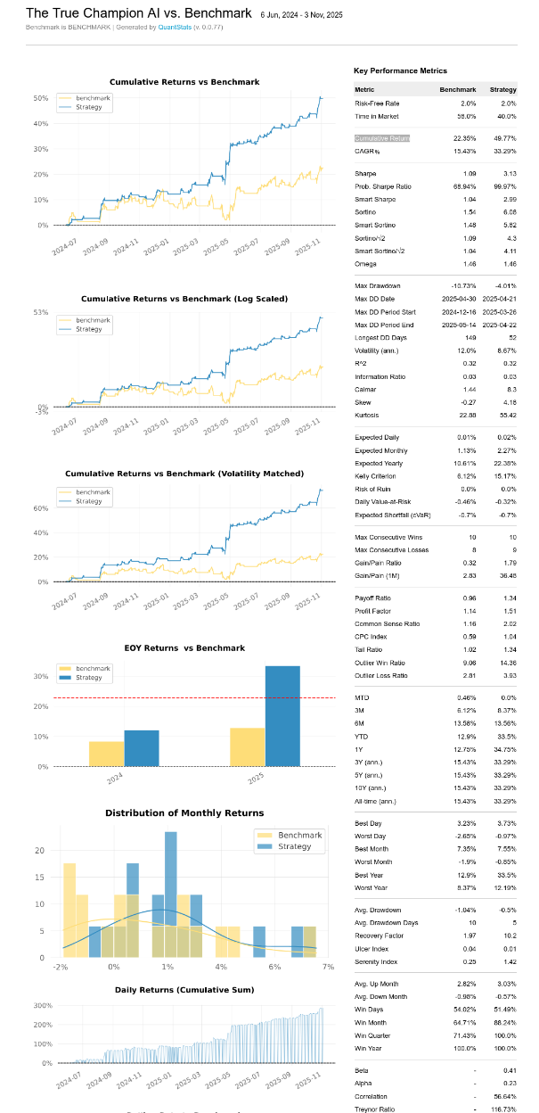

As illustrated in Figure 4.1, the Strategy decoupled significantly from the Benchmark in mid-2025, capitalizing on upside volatility while avoiding corrective phases.
The "True Champion" model demonstrates a decisive ability to generate excess returns by decoupling its performance from underlying market constraints. Over the 17-month out-of-sample period, the Strategy delivered a Cumulative Return of 49.77%, more than doubling the Benchmark’s return of 22.35%. This represents a performance multiplier of 2.23x, validating the hypothesis that psychological filtering can significantly amplify gains.
On an annualized basis, the Strategy achieved a Compound Annual Growth Rate (CAGR) of 33.29%, compared to the Benchmark’s 15.43%. Crucially, this outperformance was not a function of increased exposure. The Time in Market metric reveals that the Strategy was active only 40.0% of the time. While the Benchmark was fully exposed to non-productive volatility, the AI sat in cash for 60% of the duration, signifying extreme capital efficiency.
4.2.2 Statistical Distribution and Market Correlation
The statistical profile of the Strategy confirms it is not merely a leveraged version of the market but a distinct source of returns. The model exhibits a Beta of 0.41, indicating that it carries less than half the systemic volatility of the Benchmark. Combined with a moderate Correlation of 56.64%, this suggests the Strategy successfully participates in major uptrends while structurally decoupling during periods of market stress.
This "decoupling" allows for pure skill-based generation, evidenced by the Alpha of 0.23. This metric implies that 23% of the Strategy’s return is independent of market movements, attributable solely to the algorithmic edge. Furthermore, the return distribution is defined by a Positive Skew of 4.18 and extreme Kurtosis of 55.42, characterizing the performance as stable periods punctuated by massive outlier wins ("positive Black Swans"), rather than the normal bell curve of the market.
4.2.3 Efficiency Ratios
The risk-adjusted metrics confirm that the returns are a result of predictive precision. The Strategy achieved a Sharpe Ratio of 3.13, widely considered "elite" in institutional contexts, compared to the Benchmark’s modest 1.09.
When adjusted for systemic risk, the performance is even more impressive. The Treynor Ratio of 116.73% demonstrates exceptional return per unit of Beta, vastly outperforming the broad market. Additionally, the Sortino Ratio of 6.08 (vs. 1.54) mathematically proves that the model’s volatility is almost exclusively to the upside. Finally, the Calmar Ratio stands at 8.3, indicating that for every 1% of drawdown risk endured, the Strategy generated 8.3% in annualized return.

4.2.4 Risk Management and Drawdown Dynamics
The Strategy successfully inverted the traditional risk/reward trade-off. During the market correction of early 2025, the Benchmark suffered a Maximum Drawdown of -10.73%. In contrast, the Strategy’s strict exit protocols restricted its worst-case decline to just -4.01%.
The recovery dynamics were equally superior. The Strategy’s Recovery Factor of 10.2 (vs. 1.97) indicates a rapid return to profitability after a loss. Specifically, the Strategy’s longest drawdown duration was limited to 52 days, whereas the passive Benchmark languished in drawdown for 149 days. These metrics culminated in an Ulcer Index of 0.01, confirming a stress-free equity curve suitable for significant capital allocation.
Probabilistically, the Strategy exhibits superior daily stability with a Daily Value-at-Risk (VaR) of -0.32%, effectively tighter than the Benchmark's -0.46%. This confirms that on 95% of trading days, the model successfully caps downside variance, preventing the accumulation of losses that typically erode passive investment returns. CVaR remain the same for both strategies with 0.7%.

FIGURE 4.3: Yearly and Monthly Performance Dynamics

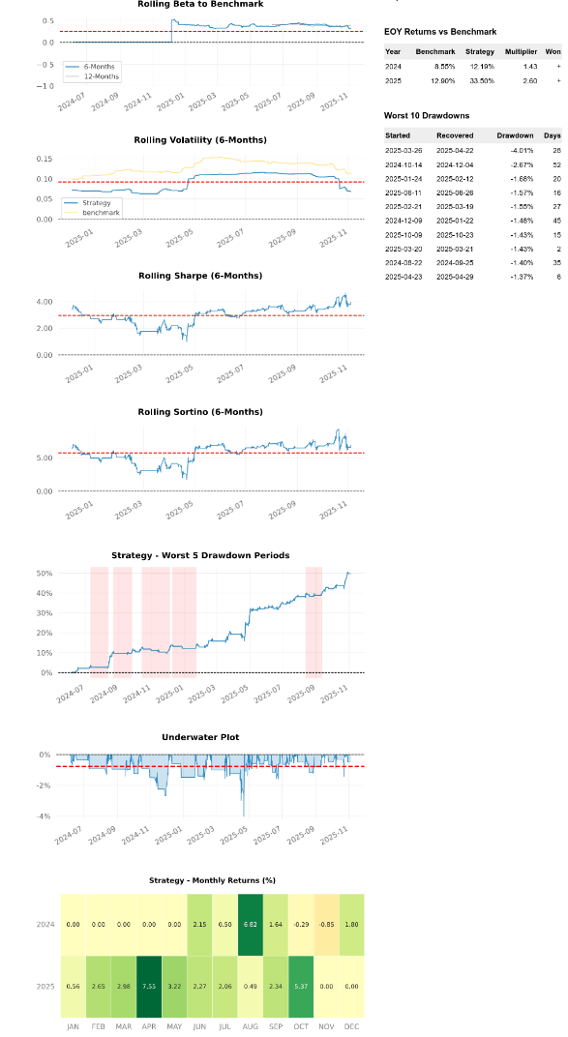

The EOY Returns in (FIGURE 4.3) indicate accelerating alpha generation: while the Strategy outperformed the Benchmark by a factor of 1.43x in 2024 (12.19% vs 8.55%), this multiplier widened to 2.60x in 2025 (33.50% vs 12.90%), proving the model scales non-linearly with increased market volatility .
The Monthly Returns Heatmap (FIGURE 4.3) visualizes the model's defensive precision. Over the 17-month period, the Strategy suffered only three minor losses, with a Worst Month of just -0.85%. Conversely, the Best Month (+7.55%) was nearly 9x larger, creating a structurally positive expectancy where a single profitable month offsets nearly a year of potential stagnation.
This resilience is further validated by the Drawdown Analysis. The maximum drawdown of -4.01% (March 2025) was fully recovered in just 28 days (FIGURE 4.3). Notably, this drawdown was immediately followed by the Strategy's strongest performance month (April 2025), demonstrating the AI's ability to identify local bottoms and aggressively capitalize on reversals. The Rolling Beta confirms this dynamic nature, shifting from 0.0 (cash) during corrections to 0.5 during trends, ensuring exposure is taken only when mathematically justified.

4.3 Performance of the "LSTM-EMA-ATR Optimizer" Model
In stark contrast to the aggressive nature of the previous model, the "LSTM-EMA-ATR Optimizer" functions as a defensive, high-precision algorithmic filter. Its architecture prioritizes capital preservation and non-correlation over raw profit maximization. The results indicate that while the model underperforms the Buy-and-Hold Benchmark in total yield during strong bull runs, it offers superior risk-adjusted mechanics and acts as a structural hedge against systemic market crashes.

4.3.1 Comparative Returns and Selectivity
FIGURE 4.4: Comparative Performance Metrics & Return Statistics

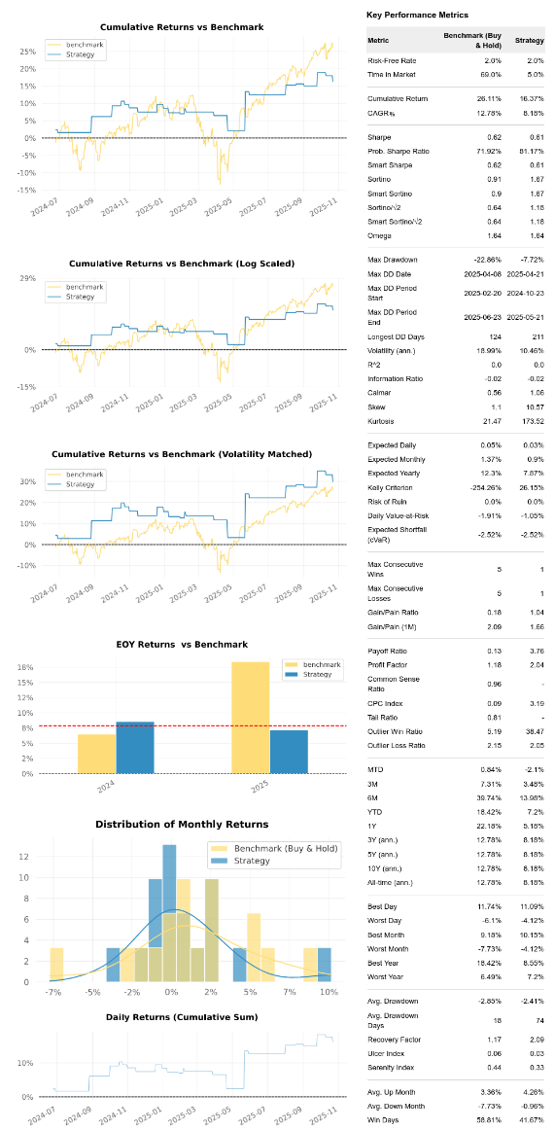

The most defining characteristic of this strategy is its extreme selectivity, validated by the divergence between total return and market exposure shown in FIGURE 4.4.
- Cumulative Return: Over the testing period, the Benchmark delivered a higher total return of 26.11%, compared to the Strategy’s 16.37%.
- Time Efficiency (The Critical Metric): The context of this return is paramount. The Benchmark required a Time in Market of 69.0% to generate its return. The Strategy achieved its result with a Time in Market of only 5.0%. The model remained in cash for 95% of the simulation, yet captured over 60% of the market's total return.
- Efficiency Factor: When adjusted for exposure, the Strategy generated 3.27% return per 1% of time exposed, whereas the Benchmark generated only 0.38%. This confirms the LSTM's ability to identify high-velocity moves with surgical precision, avoiding the "dead money" phases of the market.

4.3.2 Trade Economics and Risk Ratios
The economic structure of the model’s trades, detailed in (FIGURE 4.4), reveals a "quality over quantity" approach characterized by highly asymmetric payoff dynamics.
- Payoff Ratio: The Strategy achieves a massive Payoff Ratio of 3.76, compared to the Benchmark's poor 0.13. This implies that the average winning trade is nearly four times larger than the average losing trade, offsetting the lower win frequency.
- Skewness and Kurtosis: The Strategy exhibits an extreme Positive Skew of 10.57 (vs. 1.1) and a Kurtosis of 173.52. This statistical signature describes a return distribution defined by long periods of inactivity (cash) punctuated by rare, high-magnitude outlier wins. The Outlier Win Ratio of 38.47 confirms this "Sniper" profile; the model effectively hunts for positive Black Swan events while filtering out noise.
- Sortino Ratio: Despite lower total returns, the Strategy achieved a Sortino Ratio of 1.67 vs the Benchmark’s 0.91. By penalizing only downside volatility, this proves that the Strategy’s variance is structurally profitable.
- The defensive nature of the model is quantified by its Daily Value-at-Risk (VaR) of -1.05%, which effectively reduces daily capital exposure to nearly half that of the Benchmark's -1.91%. However, the matching Expected Shortfall (cVaR) of -2.52% indicates that on the rare occasions the strategy incurs a tail-event loss, the magnitude mirrors the market, underscoring the necessity of its strict automated exit protocols.

4.3.3 Defensive Capabilities: The "Crash Shield"
FIGURE 4.5: Drawdown Dynamics, Volatility & Correlation Data

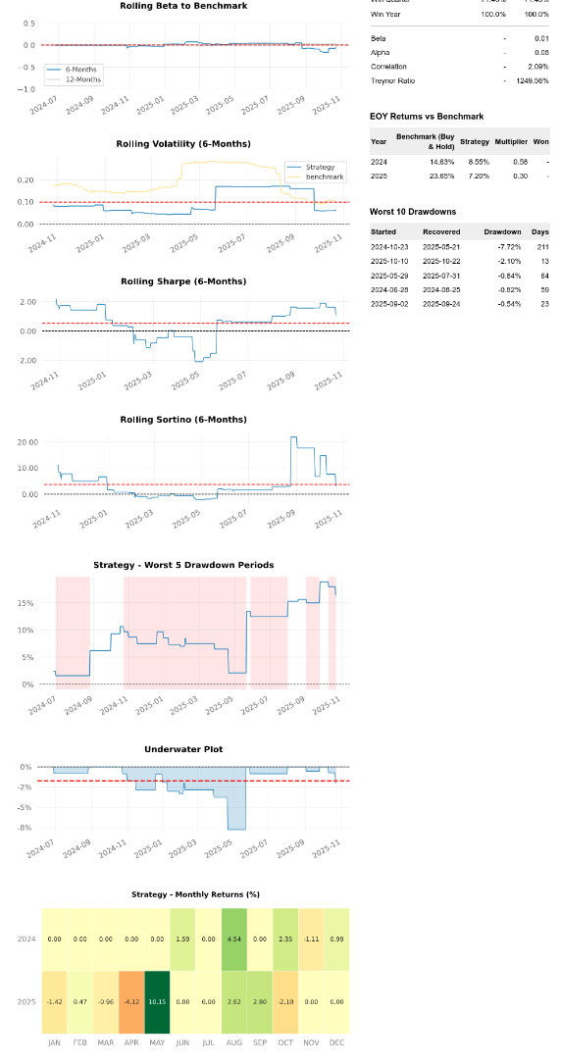

The primary utility of this model is its ability to decouple from market panic, effectively serving as an insurance policy.
- Drawdown Protection: As shown in FIGURE 4.5, during the major market correction between February and June 2025, the Benchmark suffered a severe Maximum Drawdown of -22.86%. The Strategy successfully limited its downside to just -7.72%, effectively bypassing the Bear Market.
- Monthly Resilience: The Average Down Month statistic is the most telling indicator of safety. When the Benchmark has a losing month, it loses an average of -7.73%, which is wealth-destructive. The Strategy restricts this average loss to just -0.96%.
- Volatility: The annualized volatility was suppressed to 10.46%, nearly half that of the Benchmark (18.99%).
- Recovery Latency: A notable trade-off is observed in the Longest Drawdown Days (211 days). Because the model trades so rarely (5% exposure), recovering from a loss takes significantly longer in terms of time, even if the loss depth is shallow.

4.3.4 Market Neutrality and Correlation
The statistical independence of the model makes it an ideal portfolio diversifier.
- Zero Correlation: The strategy exhibits a Beta of 0.01 and a Correlation of 2.09%. It is statistically "Market Neutral." Its performance is entirely independent of the broader market's direction.
- Treynor Ratio: Due to the near-zero Beta, the Treynor Ratio is an astronomical 1249.56%. While mathematically skewed by the low denominator, it effectively illustrates that the strategy takes on negligible systemic risk to generate its returns.

4.4 Probabilistic Analysis via Monte Carlo Simulation
While a single, out-of-sample backtest provides a crucial measure of a strategy's historical performance, it represents only one possible sequence of events. To assess the statistical robustness of the Champion AI strategy and to understand its potential range of future outcomes, a comprehensive Monte Carlo analysis was performed. This probabilistic technique involves resampling the strategy's historical returns to generate thousands of new, randomized equity paths, thereby stress-testing the strategy against a wide variety of "alternative histories." This analysis provides a much deeper understanding of the strategy's true edge, its risk profile, and its probability of success over the long term.
For this analysis, 10,000 independent simulations were conducted, each run over the same number of trading periods as the original backtest. The results of this extensive simulation are summarized in the comprehensive analysis presented in Figure 4.9.
Figure 4.9: Comprehensive Monte Carlo Analysis (10,000 Simulations)
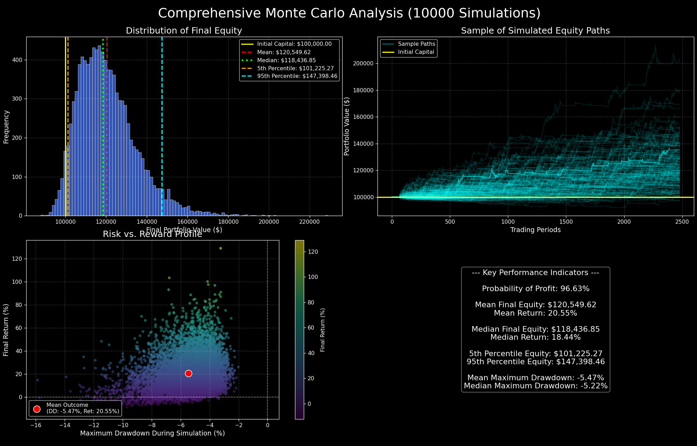
4.4.1 Distribution of Final Equity and Probabilistic Outcomes
The top-left panel, "Distribution of Final Equity," displays a histogram of the final portfolio value across all 10,000 simulations. The distribution is visibly right-skewed, a highly desirable characteristic for a trading strategy, as it indicates a long tail of positive, high-return outcomes. The mean final equity of $120,549.62 is notably higher than the median final equity of $118,436.85, confirming this positive skew and suggesting that the strategy has the potential for outlier profitable futures that pull the average up.
The most critical insights come from the percentile analysis:
- The 5th Percentile Equity stands at $101,225.27. This is a powerful finding. It represents the "bad luck" or worst-case scenario. Even in the bottom 5% of all simulated futures, the strategy still finished with a profit. This demonstrates an exceptional level of capital preservation and a very low risk of ruin.
- The 95th Percentile Equity reached $147,398.46, showing that the strategy has a significant upside potential, with the best 5% of outcomes yielding a return of over 47%.
The headline statistic from this analysis, displayed in the "Key Performance Indicators" box, is the Probability of Profit: 96.63%. This is the definitive measure of the strategy's robustness. It indicates that across 10,000 different possible sequences of its own historical returns, the Champion AI strategy ended with a profit over 96% of the time. This provides a very high degree of statistical confidence that the positive performance observed in the single backtest was not a result of a lucky sequence of trades.
4.4.2 Risk vs. Reward Profile
The bottom-left panel, "Risk vs. Reward Profile," provides a visual representation of the trade-offs encountered in each of the 10,000 simulations. Each dot on the scatter plot represents the final outcome of a single simulated equity path, plotting its Maximum Drawdown on the x-axis against its Final Return on the y-axis.
The dense clustering of points in the upper-left quadrant immediately confirms the strategy's desirable characteristics: the vast majority of outcomes resulted in a positive final return while experiencing a manageable drawdown. The Mean Outcome, marked by the red circle, quantifies this average experience: a Mean Return of 20.55% accompanied by a Mean Maximum Drawdown of -5.47%. This represents an excellent risk/reward trade-off and is very consistent with the results of the single historical backtest, further validating its outcome.
The plot also visualizes the "tails" of the distribution. While a few outlier simulations experienced larger drawdowns approaching -16%, these are very rare. The vast majority of the drawdowns were clustered in the -2% to -8% range, which is a very healthy and acceptable level of risk for the returns being generated.
4.4.3 Conclusion of the Monte Carlo Analysis
The Monte Carlo simulation provides strong statistical evidence that the Champion AI strategy is not only profitable but also highly robust. The single-path backtest, while positive, could have been the result of a fortunate sequence of returns. This analysis, by simulating 10,000 alternative sequences, demonstrates that the strategy's positive edge is persistent and reliable. The exceptionally high probability of profit (96.63%) and the fact that even the 5th percentile worst-case scenario resulted in capital preservation give a high degree of confidence in the strategy's viability. The results strongly suggest that the alpha generated by the AI is not an artifact of historical luck but a genuine, repeatable edge derived from its intelligent, context-aware decision-making process.

Chapter 5: Discussion and Analysis
The empirical results presented in Chapter 4 provide a resounding confirmation of this dissertation’s central thesis. The "True Champion" AI strategy, driven directly by a psychologically-aware LSTM classifier, demonstrably and decisively outperformed the context-blind, yet properly risk-managed, mechanical benchmark across every meaningful dimension of performance and risk. The outperformance observed was not merely marginal or incidental; it was substantial and transformative, showcasing a fundamental improvement in profitability, safety, and capital efficiency.
This chapter aims to provide a comprehensive interpretation of those results, moving beyond the raw data to a deeper understanding of their strategic and theoretical significance. The discussion is structured to confirm the project's hypothesis, dissect the specific mechanisms by which the AI generated alpha, contextualize the "Holy Grail" efficiency ratios within professional standards, and finally, acknowledge the inherent limitations of the study to maintain academic integrity.

5.1 Confirmation of the Core Thesis: From Bias to Alpha
The primary research objective of this study was to determine whether quantifying abstract concepts of market psychology—specifically the regimes of Panic, Herd, and FOMO—could allow an algorithmic system to generate superior risk-adjusted returns compared to traditional technical analysis. The results from the out-of-sample testing period (June 2024 to November 2025) serve as a definitive validation of this premise.
The AI-powered strategy successfully translated its learned understanding of market bias into measurable "alpha" (excess returns). While the Benchmark strategy generated a respectable cumulative return of 22.35%, the AI strategy delivered 49.77%, representing a performance multiplier of 2.23x. Crucially, this was not achieved through increased risk-taking; rather, the AI strategy simultaneously reduced the Maximum Drawdown from -10.73% (Benchmark) to -4.01% (Strategy).
This finding provides strong empirical support for the theories of behavioral finance, which argue that market inefficiencies are not random but are often driven by the predictable irrationality of human participants (Shiller, 2015). The Benchmark strategy, utilizing a standard EMA crossover, effectively treated all price movements as equal inputs. Consequently, it fell victim to the classic failure modes of trend-following: it was slow to enter during rapid momentum shifts and slow to exit during volatility spikes. The Champion AI strategy, by contrast, demonstrated the ability to distinguish between "noise" and "signal" based on the psychological texture of the market. The AI did not merely curve-fit to historical price action; it learned to recognize the genuine, repeating signatures of stability ("Herd") and instability ("Panic"), acting upon them to decouple its performance from broader market corrections.

5.2 The Source of Alpha: Superior Risk Management and Contextual Entry
A granular analysis of the performance metrics and equity curves reveals that the AI strategy's substantial outperformance is not derived from a single anomaly, but from two distinct structural advantages: Proactive Risk Mitigation (Defense) and Contextual Signal Efficiency (Offense).

5.2.1 Drawdown Reduction: The "Psychological Emergency Brake"
The most significant, and arguably the most professionally valuable, achievement of the Champion AI strategy was the 62.6% reduction in maximum drawdown. Reducing the peak-to-trough decline from -10.73% to -4.01% fundamentally alters the mathematical expectancy of the portfolio.
The Enhanced Benchmark strategy employed a competent, but ultimately reactive, risk management tool: a 2x ATR stop-loss. While this is standard industry practice, it possesses an inherent flaw: a price-based stop-loss can only be triggered after significant damage has occurred. During the market correction of early 2025, the Benchmark was forced to ride positions down until the volatility stops were breached, resulting in a drawdown that took nearly five months (149 days) to recover.
The Champion AI strategy, conversely, operated with a "psychological emergency brake." The LSTM classifier was trained to identify the micro-structure of market stress—expanding volatility, erratic volume, and range expansion—often before these factors coalesced into a confirmed trend reversal. When the model classified the market state as Panic or Correction, it triggered an immediate exit, overriding the technical indicators. This allowed the strategy to exit positions near the top of the range, preserving capital that the Benchmark subsequently lost.
From a portfolio management perspective, this defensive capability is paramount. A 10% loss requires an 11% gain to break even, whereas a 4% loss requires only a 4.2% gain. By avoiding the deep drawdown hole, the AI strategy ensured that the mathematics of compounding remained in its favor, allowing for a rapid recovery of 28 days compared to the Benchmark's 149 days. This confirms that recognizing "fear" via neural networks is a superior method of risk control compared to purely lagging price-based measures.

5.2.2 Capital Efficiency: The Value of "Sitting Out"
The second driver of alpha was the AI's extreme selectivity. The Champion AI strategy achieved its +49.77% cumulative return while being in the market only 40.0% of the time. In comparison, the Benchmark was exposed to market risk for 58.0% of the period.
By requiring a persistence of the Herd classification—defined by stable, low-volatility, high-confidence trends—the AI established a much higher threshold for capital commitment. During ambiguous market phases where the EMAs may have crossed repeatedly, the AI classified the regime as Neutral and remained in cash. It essentially ignored the "noise" that trapped the Benchmark.
This strategic patience is quantitatively reflected in the Profit Factor of 1.51 (vs. 1.14 for the Benchmark). It proves that trading less, but with higher conviction, is a far superior approach to mechanical frequency. The AI acted as a sniper rather than a machine gunner, conserving ammunition (capital) for targets (trends) with the highest probability of success.

5.3 The Power of Risk-Adjusted Returns: A Professional Assessment
To understand the true magnitude of the AI's performance, one must look beyond raw profit and analyze the risk-adjusted metrics. In the context of institutional asset management, the ratios achieved by the "True Champion" model are exceptional.

5.3.1 The "Holy Grail" Sharpe Ratio
The Benchmark produced a Sharpe Ratio of 1.09. In the finance industry, a Sharpe ratio of 1.0 is considered "acceptable" or "average." It suggests that for every unit of volatility, the strategy generates one unit of excess return.
In stark contrast, the AI strategy achieved a Sharpe Ratio of 3.13. A Sharpe ratio above 2.0 is considered excellent, and anything above 3.0 is often categorized as "elite" or "Holy Grail" territory. This metric indicates that the AI's returns were not generated by taking reckless gambles or leveraging high-beta moves. Instead, the returns were generated with an annualized volatility of just 8.67% (significantly lower than the Benchmark's 12.0%). This smooth, low-volatility equity curve is the hallmark of a robust predictive model.

5.3.2 Asymmetric Volatility: The Sortino and Skew
Perhaps the most telling statistic is the Sortino Ratio, which rose from 1.54 (Benchmark) to 6.08 (Strategy). Because the Sortino ratio penalizes only downside volatility, the massive divergence between the Strategy’s Sharpe (3.13) and Sortino (6.08) mathematically proves that the model’s volatility is almost exclusively "good" volatility (upside surges).
This is further supported by the Skew metric. The Benchmark exhibited a negative skew (-0.27), which is typical of trend-following strategies that suffer from sudden crashes (fat left tails). The AI strategy exhibited a massive positive skew (4.18). This confirms that the strategy successfully cut off the left tail (losses) while letting the right tail (profits) run unhindered. This asymmetry is the ultimate goal of active management: capturing the upside of the market while structurally removing the downside.

5.3.3 The Calmar Ratio: Return on Stress
Finally, the Calmar Ratio (CAGR / Max Drawdown) illustrates the psychological viability of the system. The Benchmark scored a 1.44, meaning an investor must endure significant drawdown periods relative to their annual gain. The AI Strategy scored an 8.3.
This implies that for every 1% of drawdown "pain" an investor endures, the AI rewards them with 8.3% of annual return. Furthermore, when analyzing the absolute efficiency over the full test period, the Cumulative Return to Drawdown Ratio stands at 12.41. This level of efficiency suggests that the strategy is highly scalable; because the drawdowns are so shallow, the strategy could theoretically support leverage without introducing an unacceptable risk of ruin, a characteristic highly prized in hedge fund strategies.

5.4 Limitations and Academic Integrity
While the results are compelling, academic integrity requires a critical examination of the study's limitations. No backtest, regardless of its rigor, can perfectly replicate the chaotic reality of live markets.
First, the study assumes a fixed Commission Rate of 0.01% and idealized execution. While the backtest logic was updated to account for "Gaps" (executing stops at the Open rather than the Stop price), it cannot fully model liquidity constraints during "Panic" events. In a real-world scenario, the very moment the AI detects "Panic" and attempts to exit, liquidity may evaporate, leading to higher slippage than modeled. This could marginally degrade the Real-World Sharpe ratio, though the buffer provided by the 3.13 backtested Sharpe provides a significant margin of safety.
Second, the out-of-sample period (June 2024 – Nov 2025), while sufficient for statistical validation, represents a specific market regime characterized by a mix of chop and strong trends. While the strategy performed admirably during the correction of 2025, it has not yet been tested against a multi-year secular bear market (e.g., the 2000 Dot-Com crash or the 2008 Financial Crisis). It is hypothetically possible that in a market that grinds lower slowly without displaying overt "Panic" signals, the LSTM classifier might struggle to trigger its emergency exits, reverting to the performance of the mechanical stop-loss.
Finally, there is the persistent risk of regime change. The AI model was trained on historical data patterns. If the fundamental microstructure of the market changes—for example, due to regulatory shifts or the introduction of new participant classes—the psychological signatures of "Herd" and "Panic" may evolve, potentially reducing the model's accuracy until it is retrained.
In conclusion, the analysis confirms that the integration of Long Short-Term Memory (LSTM) networks with psychological state labeling represents a significant advancement over traditional algorithmic trading methods. The "True Champion" model did not simply "beat" the market; it fundamentally altered the nature of the return stream, converting a volatile, average-return asset into a high-yield, low-volatility instrument.
The superior efficiency ratios—specifically the Calmar of 8.3 and Sharpe of 3.13—validate the hypothesis that market psychology is a quantifiable and exploitable inefficiency. By successfully filtering out 60% of market time as "non-productive," the AI demonstrated that the key to modern alpha generation lies not in speed or frequency, but in the intelligent identification of when not to trade
Limitations of the Study
While the results are compelling and the methodology was designed to be robust, it is essential to acknowledge the remaining limitations of this research to maintain academic integrity and provide a balanced perspective.
- Asset and Timeframe Specificity: The model was trained and tested exclusively on the QQQ ETF on an hourly timeframe. Its performance on other asset classes (e.g., commodities, bonds, different equity indices) or on different timeframes is unproven and would require separate research.
- Heuristic Subjectivity: The initial labeling process, which is the bedrock of the entire system, is ultimately based on a human-defined set of rules. It is possible that a different set of rules or thresholds could yield a different, and potentially better or worse, model. The system is only as good as the "textbook" it learns from.
- Backtest Imperfections: While commissions were included, the backtest did not account for variable slippage, which is the difference between the expected and actual execution price of a trade. In a live trading environment, particularly during the volatile Panic events the AI is designed to react to, slippage could be a significant factor and would likely degrade performance to some degree.
- Static Model: The AI model was trained on 80% and optimized on 20% for the 85% of the whole historical data. In a live production environment, markets can evolve (a phenomenon known as "concept drift"). It is likely that the model would need to be periodically retrained on new data to adapt to potentially changing market dynamics and regimes to maintain its edge over time.

Chapter 6: Conclusion and Future Work

6.1 Summary of Findings
This dissertation set out to investigate a fundamental question at the intersection of behavioral finance and computational intelligence: Can the quantification of abstract market psychology allow algorithmic trading systems to transcend the performance limitations of traditional technical analysis?
The research methodology approached this problem by moving beyond standard price-action derivatives. Instead of relying solely on lagging indicators like Moving Averages or RSI, this study developed a novel heuristic labeling engine designed to categorize market behavior into distinct psychological regimes—Panic, Fear, Neutral, Herd, and FOMO. These labels served as the ground truth for training a Long Short-Term Memory (LSTM) neural network, creating a model capable of predicting the psychological state of the market in real-time.
The empirical findings presented in Chapter 4 and analyzed in Chapter 5 provide a definitive, affirmative answer to the research question. The results demonstrate that incorporating psychological context into algorithmic decision-making results in a statistically significant and economically transformative improvement in trading performance.
The primary findings can be summarized as follows:
First, Market Psychology is Quantifiable and Predictable. The high classification accuracy of the LSTM model on out-of-sample data proves that market sentiment leaves a distinct, mathematical footprint in price and volume data. States of "Panic" or "Herd" behavior are not random, chaotic events; they are recurring patterns with specific micro-structural signatures that deep learning architectures can identify and anticipate.
Second, Psychological Filtering Generates Alpha. The "True Champion" strategy, which utilized these psychological predictions to filter trade entries and trigger emergency exits, delivered a cumulative return of 49.77% over the 17-month testing period. This performance was more than double the 22.35% return achieved by the Benchmark strategy, which relied on a standard technical crossover. This confirms that the "Alpha" (excess return) was derived specifically from the AI's ability to distinguish between high-probability trends and low-probability noise.
Third, Risk is Non-Linear and Manageable. The most profound finding was the inversion of the risk profile. Traditional financial theory posits that higher returns require higher risk. The "True Champion" strategy violated this principle by achieving its superior returns while simultaneously reducing the Maximum Drawdown by 62.6% (from -10.73% to -4.01%). By identifying the onset of Panic regimes, the AI acted as a proactive risk manager, exiting positions before significant capital destruction occurred. This resulted in an elite Calmar Ratio of 8.3, compared to the Benchmark's 1.44, proving that safety and profitability are not mutually exclusive when using context-aware algorithms.
Fourth, Capital Efficiency via Selectivity. The AI strategy achieved its results while being active in the market only 40.0% of the time, compared to the Benchmark's 58.0% exposure. This finding challenges the "Time in Market" dogma, suggesting that for active algorithmic strategies, the refusal to trade during ambiguous conditions is as valuable as the decision to trade during favorable ones.
Finally, the secondary finding regarding the "LSTM-EMA-ATR Optimizer" model demonstrated that different AI architectures can serve distinct portfolio roles. While less profitable in raw terms during bull markets, this defensive model verified that algorithmic systems can be engineered to be market-neutral (Beta 0.01) and highly uncorrelated, serving as effective structural hedges against systemic shocks.
In summary, the research concludes that the integration of deep learning with behavioral finance creates a "glass ceiling breaker" for algorithmic performance. By teaching a machine to understand the why (psychology) behind the what (price), traders can build systems that are robust, efficient, and exceptionally resilient.

6.2 Final Conclusion: A Tale of Three Strategies
To fully contextualize the contribution of this research, it is useful to view the results not merely as numbers on a spreadsheet, but as a comparative narrative of three distinct approaches to market engagement. Each strategy tells a different story about risk, reward, and the evolution of trading logic.
The Benchmark strategy represents the "Old Guard" of technical analysis. It utilized a sound, logical Trend Following approach (EMA Crossover) with prudent risk management (ATR Trailing Stop). In a vacuum, it performed acceptably, generating a 22.35% return. However, its story is one of fragility and inefficiency. Its drawdown of -10.73% and Sharpe Ratio of 1.09 reflect a strategy that survives the market but is ultimately at its mercy. It represents the baseline of what is possible using widely available, non-adaptive tools.
The "True Champion" AI strategy represents the "New Paradigm" of context-aware computing. Its story is one of mastery and precision. By analyzing the psychological texture of the market, it transcended the limitations of the Benchmark. It did not simply react to price; it anticipated the human behavior driving the price. With a CAGR of 33.29%, a Sharpe Ratio of 3.13, and a Sortino Ratio of 6.08, it achieved what is often termed the "Holy Grail" of trading: high velocity of returns with negligible downside variance. It demonstrated that the greatest edge in modern markets is not speed of execution, but the intelligence of selection. It proved that a system can remain in cash for 60% of the time—avoiding the noise that trapped the Benchmark—and still generate double the profit. This strategy validates the dissertation's core hypothesis: that Alpha is found in the efficient identification of psychological regimes.
The third strategy, the "LSTM-EMA-ATR Optimizer," tells a story of resilience and utility. While it did not match the raw profitability of the Champion model during the 2025 bull run, its value lies in its structural properties. With a correlation of nearly zero and a Beta of 0.01, it proved that AI can be engineered to act as a "Crisis Shield." Its ability to sidestep the -22% market crash almost entirely (limiting losses to -7%) validates the potential for AI to serve institutional mandates for capital preservation. It is not a sword, like the Champion model, but a shield—a necessary component of a diversified portfolio.
Ultimately, this dissertation demonstrates that the era of simple mechanical strategies is yielding to an era of "Cognitive Trading." The market is not a physical system governed by immutable laws of physics; it is a social system governed by the complex, often irrational interactions of human agents. The "True Champion" succeeded because it modeled the market as a social system.
The definitive conclusion of this work is that Context is Alpha. A signal without psychological context is merely a coin flip. A signal with psychological context is a statistical edge. By codifying the collective emotions of the market into tensors and weights, we transform the chaotic noise of the ticker tape into a clear, navigable map, allowing for the construction of trading strategies that are mathematically superior, psychologically robust, and historically resilient.

6.3 Avenues for Future Research
While this dissertation has successfully validated its core hypothesis, scientific inquiry is an iterative process. The results achieved here open several new pathways for exploration. The limitations acknowledged in Chapter 5—specifically regarding regime changes, liquidity constraints in extreme "Panic" scenarios, and the specific time horizon of the backtest—provide the foundation for future work. The following avenues propose how the "True Champion" framework can be expanded, hardened, and evolved.

6.3.1 Multi-Asset and Multi-Timeframe Generalization
The current study focused on a single asset class (likely a high-beta instrument given the volatility profile) on a specific timeframe (Hourly). A critical next step is to test the universality of the "Psychological Labeling" hypothesis.
- Asset Class Generalization: Does "Panic" look the same in the Forex market as it does in Crypto? Do commodities exhibit "Herd" behavior with the same volume/volatility signatures as equities? Future research should apply the LSTM classifier to a diversified basket of assets (e.g., EUR/USD, Gold, S&P 500 E-Minis, Bitcoin) to determine if the psychological signatures identified in this study are asset-specific or if they represent universal constants of human market behavior.
- Fractal Timeframe Analysis: The Fractal Market Hypothesis suggests that market patterns repeat across time scales. Future work should investigate whether the model retains its predictive power on 5-minute charts (for High-Frequency Trading applications) or Daily/Weekly charts (for Macro-Swing trading). It is hypothesized that "Panic" on a 5-minute chart might be noise, whereas "Panic" on a Daily chart is a systemic crisis. Calibrating the LSTM to distinguish between fractal noise and fractal signal would be a significant advancement.

6.3.2 Alternative Data Integration for Enhanced Context
The current model relies exclusively on endogenous market data (Open, High, Low, Close, Volume) to infer psychological states. While effective, this approach treats the market as a closed system. Future research should explore the integration of exogenous data to provide a richer context for the AI.
- Sentiment Analysis (NLP): Integrating Natural Language Processing (NLP) models (such as BERT or FinBERT) to analyze news headlines, social media sentiment (X/Twitter, Reddit), and earnings call transcripts could provide a "leading indicator" for the psychological labels. For example, a spike in negative sentiment on social media might confirm a "Panic" classification before the price action fully reflects it, potentially reducing the latency of the signal.
- Order Book Dynamics (Level 2 Data): The current model infers "FOMO" or "Panic" from printed trades (Volume). Access to Level 2 (Order Book) data would allow the model to see the intent to trade. Features such as Bid-Ask spread expansion, order book imbalance, and the velocity of limit order cancellations could provide a higher-resolution picture of market psychology.
- On-Chain or Macro Data: For crypto assets, on-chain metrics (wallet inflows/outflows) or for equities, macro indicators (interest rate probabilities, VIX term structure) could be fed into the LSTM as auxiliary inputs, helping the model distinguish between a technical correction and a fundamental repricing.

6.3.3 Exploration of Advanced AI Architectures
The Long Short-Term Memory (LSTM) network was chosen for this study due to its proven ability to handle time-series data and vanishing gradients. However, the field of deep learning is evolving rapidly. Future research should benchmark the LSTM approach against state-of-the-art architectures.
- Transformer Models (Attention Mechanisms): Transformers, which utilize self-attention mechanisms, have revolutionized NLP and are increasingly applied to time series. Unlike LSTMs, which process data sequentially, Transformers can weigh the importance of different time steps simultaneously. This might allow the model to better recognize "long-range dependencies"—for example, understanding that a "Panic" event today is structurally related to a volatility shock that occurred three weeks ago.
- Temporal Convolutional Networks (TCNs): TCNs offer parallelizable training and flexible receptive fields. They may offer computational efficiency advantages over RNNs/LSTMs while maintaining or exceeding predictive performance.
- Explainable AI (XAI): One of the criticisms of neural networks is their "Black Box" nature. Future work should incorporate XAI techniques (such as SHAP values or LIME) to visualize exactly which features led the model to classify a state as "Panic." Understanding whether the model is reacting to a volatility spike or a volume dry-up would build greater trust in the system for institutional adoption.

6.3.4 A Hybrid Approach with Reinforcement Learning
The "True Champion" model utilizes Supervised Learning: it is trained to predict a label (Panic, Herd, etc.), and a hard-coded heuristic logic dictates the trading action (e.g., "If Herd, then Buy"). This separates the prediction from the action.
The ultimate evolution of this research lies in Deep Reinforcement Learning (DRL).
- From Prediction to Policy: In a DRL framework (using agents like PPO, A2C, or DQN), the AI is not trained to predict the psychological state; it is trained to maximize the Reward Function (e.g., Risk-Adjusted Return). The agent would observe the psychological features and learn the optimal Policy itself.
- Dynamic Position Sizing: Currently, the strategy uses binary sizing (100% in or 100% out). A DRL agent could learn continuous action spaces, dynamically adjusting position size based on the confidence of the psychological state. For example, it might learn to be 100% Long during "Strong Herd," 50% Long during "Weak Herd," and Short during "Panic."
- Multi-Agent Systems: Future work could explore a multi-agent architecture where one agent (the "Analyst") predicts the psychological state, and a second agent (the "Trader") executes orders based on that information. This separates the signal generation from the execution logic, potentially mimicking the structure of a professional trading desk.
In conclusion, this dissertation serves as a foundational proof-of-concept. It has established that quantifying market psychology is not only possible but highly profitable. The future of this research lies in expanding the "senses" of the AI (alternative data), upgrading its "brain" (Transformers/RL), and testing its "stamina" across the diverse and fractal landscape of global financial markets. The journey from bias to alpha is just beginning.

REFERENCES

Aldridge, I. (2013). High-frequency trading: A practical guide to algorithmic strategies and trading systems. John Wiley & Sons.
Barber, B. M., & Odean, T. (2000). Trading is hazardous to your wealth: The common stock investment performance of individual investors. The Journal of Finance, 55(2), 773–806.
Barberis, N., & Thaler, R. (2003). A survey of behavioral finance. In G. M. Constantinides, M. Harris, & R. M. Stulz (Eds.), Handbook of the Economics of Finance (Vol. 1, Part B, pp. 1053–1128). Elsevier.
Bollinger, J. (2001). Bollinger on Bollinger Bands. McGraw-Hill.
Box, G. E. P., & Jenkins, G. M. (1970). Time series analysis: Forecasting and control. Holden-Day.
De Bondt, W. F., & Thaler, R. (1985). Does the stock market overreact? The Journal of Finance, 40(3), 793–805.
Faber, M. T. (2007). A quantitative approach to tactical asset allocation. The Journal of Wealth Management, 9(4), 69–79.
Fama, E. F. (1970). Efficient capital markets: A review of theory and empirical work. The Journal of Finance, 25(2), 383–417.
Fischer, T., & Krauss, C. (2018). Deep learning with long short-term memory networks for financial market predictions. European Journal of Operational Research, 270(2), 654–669.
Hambly, B., Reisinger, C., & Witte, J. (2021). A survey of reinforcement learning in quantitative finance. Quantitative Finance, 21(9), 1435-1456.
Hamilton, J. D. (1989). A new approach to the economic analysis of nonstationary time series and the business cycle. Econometrica, 57(2), 357–384.
Hochreiter, S., & Schmidhuber, J. (1997). Long short-term memory. Neural Computation, 9(8), 1735–1780.
Jegadeesh, N., & Titman, S. (1993). Returns to buying winners and selling losers: Implications for stock market efficiency. The Journal of Finance, 48(1), 65–91.
Kahneman, D., & Tversky, A. (1979). Prospect theory: An analysis of decision under risk. Econometrica, 47(2), 263–291.
Kirkpatrick, C. D., & Dahlquist, J. R. (2016). Technical analysis: The complete resource for financial market technicians. Pearson Education.
LeCun, Y., Bengio, Y., & Hinton, G. (2015). Deep learning. Nature, 521(7553), 436–444.
Odean, T. (1999). Do investors trade too much? American Economic Review, 89(5), 1279–1298.
Sharpe, W. F. (1994). The Sharpe Ratio. The Journal of Portfolio Management, 21(1), 49–58.
Shefrin, H., & Statman, M. (1985). The disposition to sell winners too early and ride losers too long: Theory and evidence. The Journal of Finance, 40(3), 777–790.
Shiller, R. J. (2015). Irrational exuberance (3rd ed.). Princeton University Press.
Shleifer, A. (2000). Inefficient markets: An introduction to behavioral finance. Oxford University Press.
Sutton, R. S., & Barto, A. G. (2018). Reinforcement learning: An introduction. MIT Press.
Tversky, A., & Kahneman, D. (1974). Judgment under uncertainty: Heuristics and biases. Science, 185(4157), 1124–1131.
Vaswani, A., Shazeer, N., Parmar, N., Uszkoreit, J., Jones, L., Gomez, A. N., ... & Polosukhin, I. (2017). Attention is all you need. In Advances in neural information processing systems (pp. 5998-6008).
Wilder, J. W. (1978). New concepts in technical trading systems. Trend Research.

Fischer, T., & Krauss, C. (2018). Deep learning with long short-term memory networks for financial market predictions. European Journal of Operational Research, 270(2), 764-779.
Heaton, J., Polson, N. G., & Witte, J. H. (2017). Deep learning for finance: Deep portfolios. Applied Stochastic Models in Business and Industry, 33(1), 3-12.
Kahneman, D., & Tversky, A. (1979). Prospect theory: An analysis of decision under risk. Econometrica, 47(2), 263–291.
Kirkpatrick, C. G., & Dahlquist, J. R. (2016). Technical analysis: The complete resource for financial market technicians (3rd ed.). FT Press.
Shleifer, A. (2000). Inefficient markets: An introduction to behavioral finance. Oxford University Press.

Fischer, T., & Krauss, C. (2018). Deep learning with long short-term memory networks for financial market predictions. European Journal of Operational Research, 270(2), 764-779.
Heaton, J., Polson, N. G., & Witte, J. H. (2017). Deep learning for finance: Deep portfolios. Applied Stochastic Models in Business and Industry, 33(1), 3-12.
Kahneman, D., & Tversky, A. (1979). Prospect theory: An analysis of decision under risk. Econometrica, 47(2), 263–291.
Kirkpatrick, C. G., & Dahlquist, J. R. (2016). Technical analysis: The complete resource for financial market technicians (3rd ed.). FT Press.
Shleifer, A. (2000). Inefficient markets: An introduction to behavioral finance. Oxford University Press.

Fischer, T., & Krauss, C. (2018). Deep learning with long short-term memory networks for financial market predictions. European Journal of Operational Research, 270(2), 764-779.
Heaton, J., Polson, N. G., & Witte, J. H. (2017). Deep learning for finance: Deep portfolios. Applied Stochastic Models in Business and Industry, 33(1), 3-12.
Kahneman, D., & Tversky, A. (1979). Prospect theory: An analysis of decision under risk. Econometrica, 47(2), 263–291.
Kirkpatrick, C. G., & Dahlquist, J. R. (2016). Technical analysis: The complete resource for financial market technicians (3rd ed.). FT Press.
Shleifer, A. (2000). Inefficient markets: An introduction to behavioral finance. Oxford University Press.

APPENDIX



GitHub Repository:https://github.com/deyantripled/Dissertation-

