Bored and Bookless

First sprint report

Development team:

Deyar Idhilie

Dana Abushaqdam

Seema Ihbeesheh

Nada Abuhantash

Marah Qubbaj

Rahaf Melhem

# Sprint planning

A meeting have been hold with the customer Dr.Amjad Abuhasan to prioritize the backlogs and tasks which he wants to be in the 1st sprint

## 1st Sprint Backlogs

|  |  |  |  |  |
| --- | --- | --- | --- | --- |
| ID | Backlog | Backlog Tasks | Sprint Number | Point Story |
| B1 | Registration |  | 1 | 9 |
| B2 | Login |  | 1 | 2 |
| B3 | Add book/s |  | 1 | 8 |
| B4 | Delete book/s |  | 1 | 1 |
| B5 | Home page |  | 1 | 8 |
| B6 | Search |  | 1 | 21 |

## 1st Sprint tasks:

|  |  |  |  |  |
| --- | --- | --- | --- | --- |
| priority | ID | tasks | Sprint Number | Task level |
|  | T1 | As a customer, I want to enter information(phone number, first name, last name, user name, email, city, created password) to be saved after registration so there should be a suitable interface | 1 | User Interface |
|  | T2 | As an admin/customer, I want the information of a customer to be saved in tables in a database | 1 | Database |
|  | T3 | As a customer, I want the information that I have entered to be saved after pressing a button | 1 | Connect interface and database |
|  | B4 | As an admin I want to have an interface to login to my account using my username, id, password | 1 | User interface |
|  | B5 | As an admin I want the system to recognize my unique id that is saved in the database | 1 | 8 |
|  | B6 | Search | 1 | 21 |

# Design

## Use case diagram

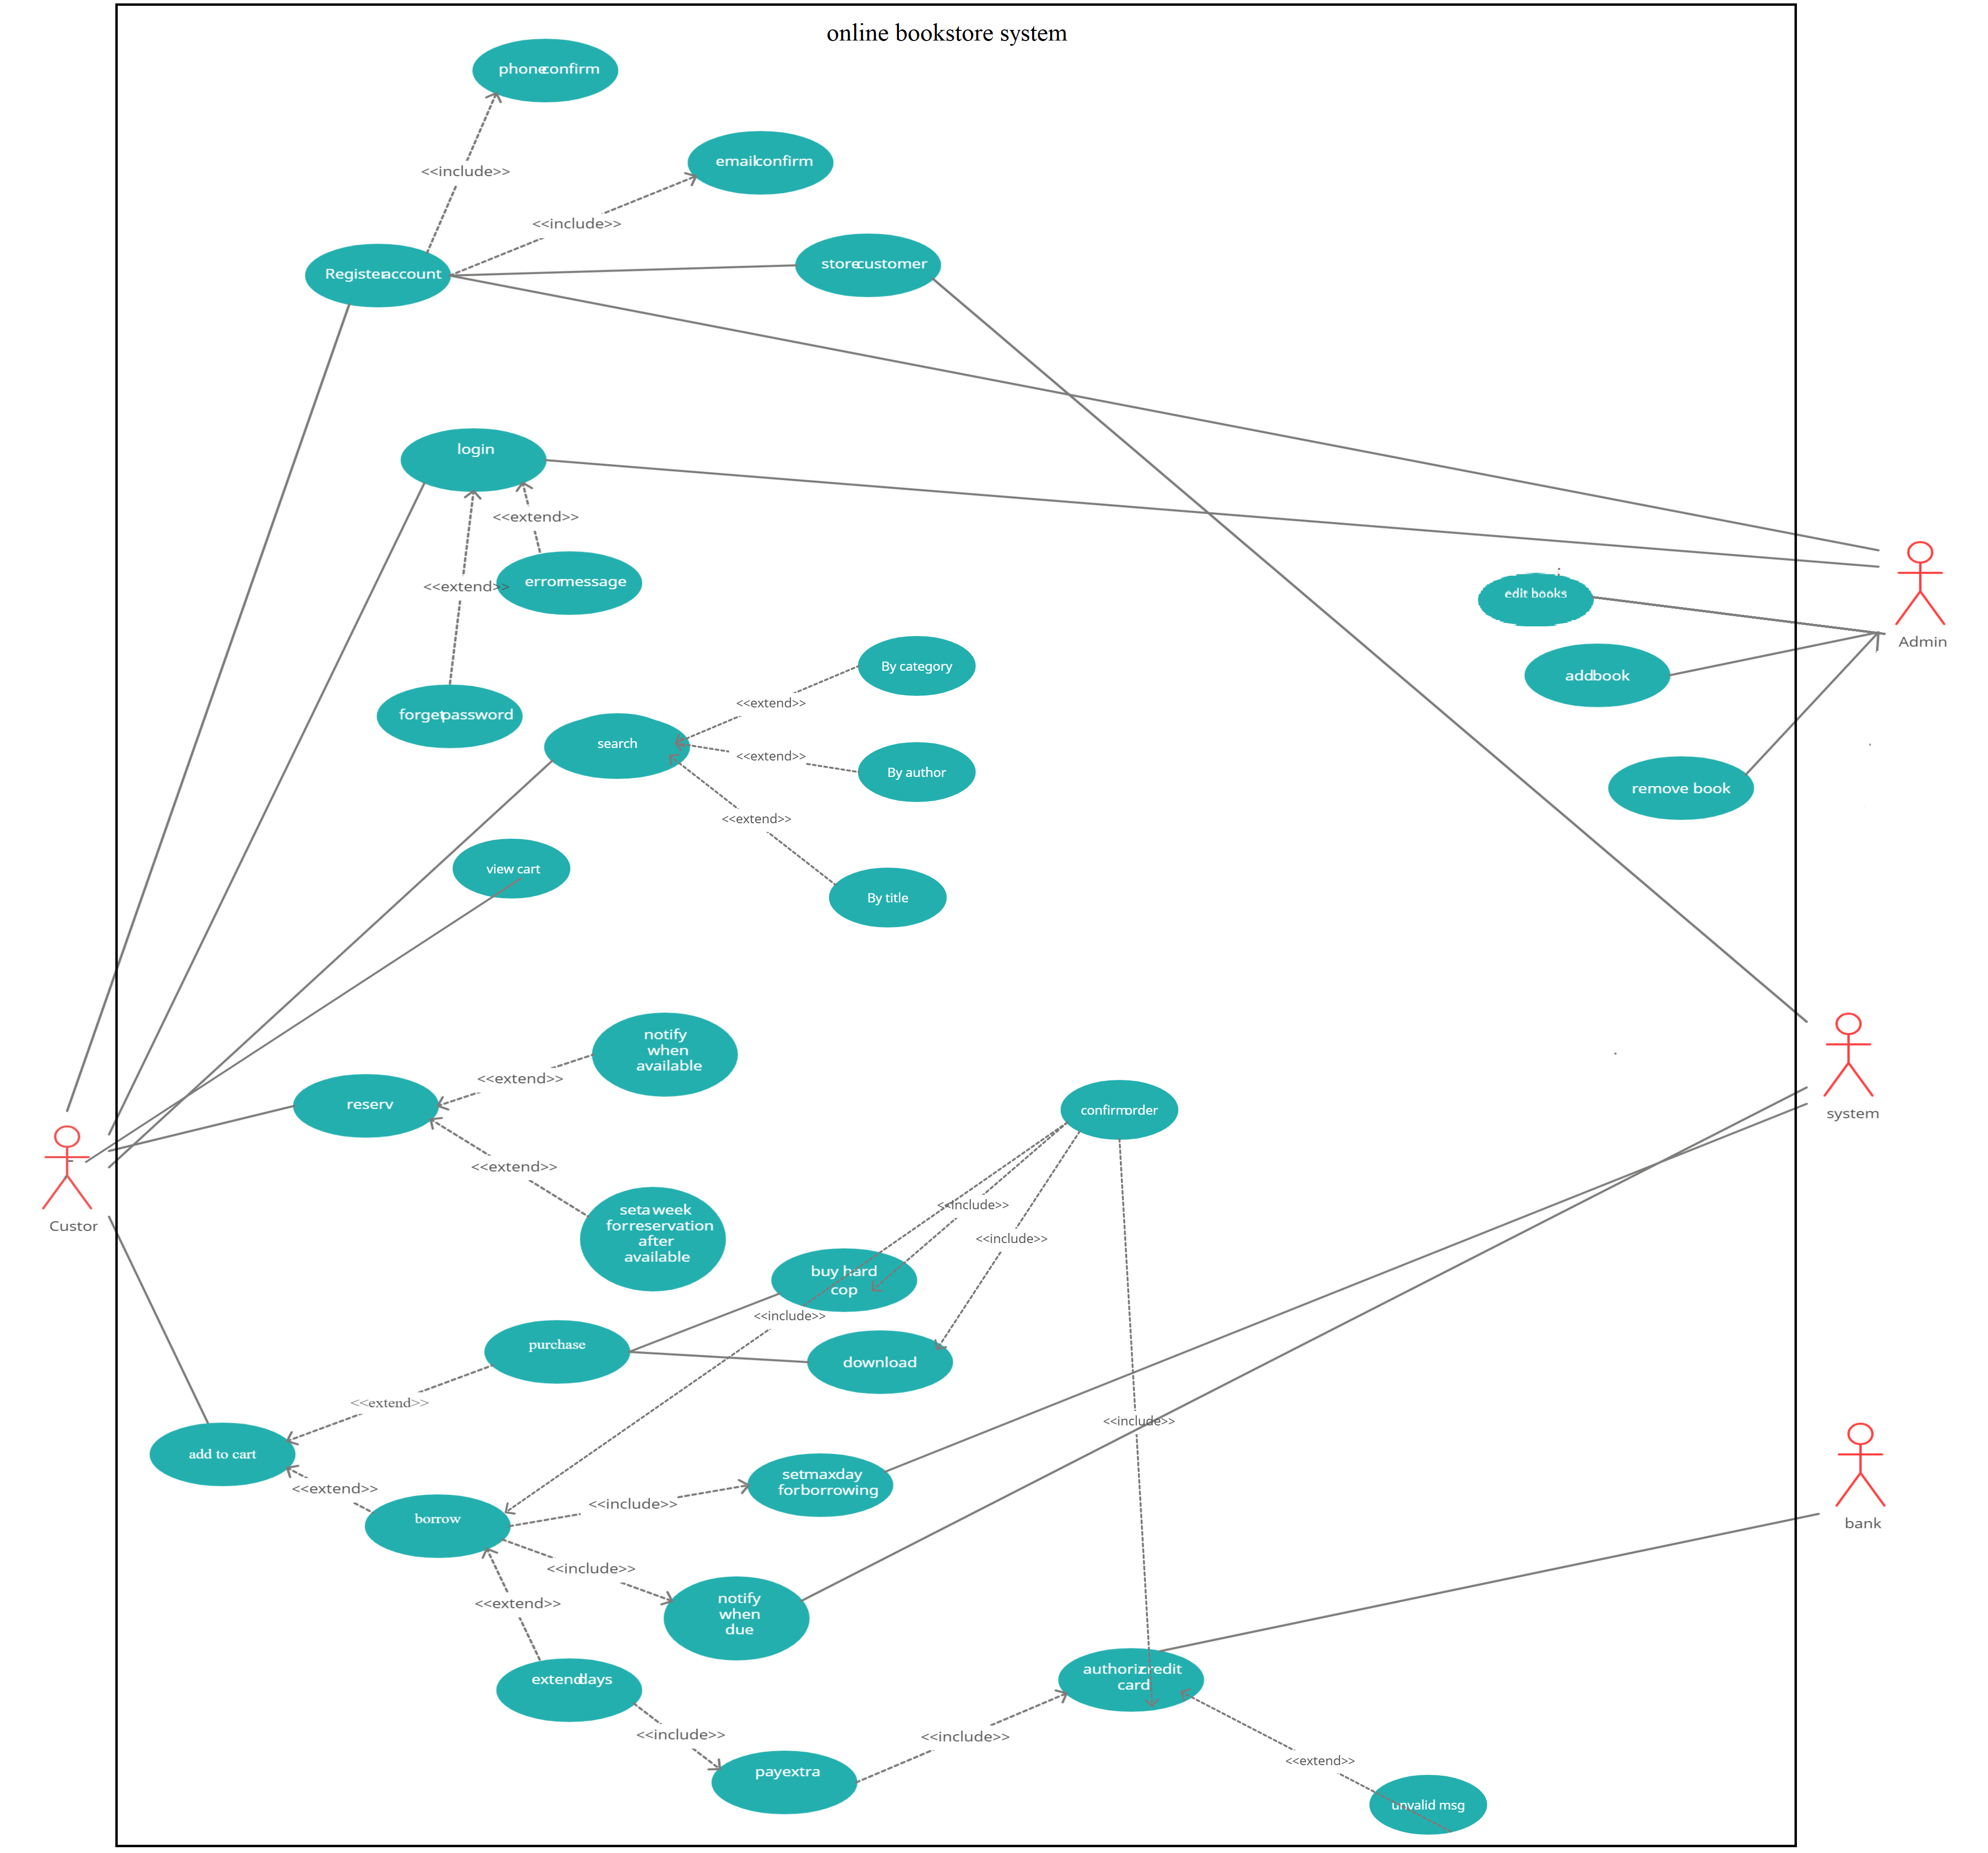F

## Class diagram

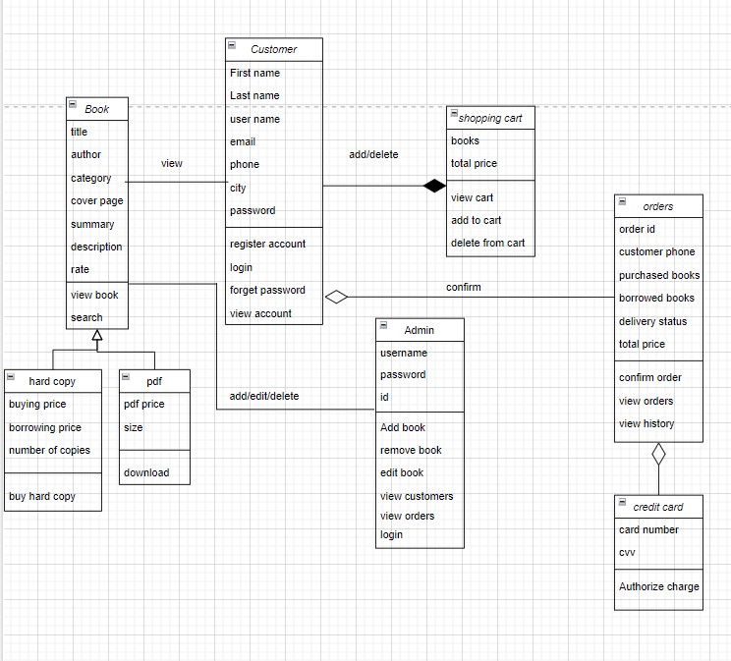

## Sequence diagram:

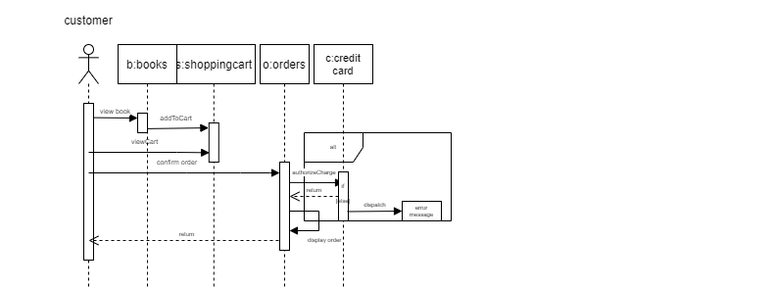

# Burn-down Chart:

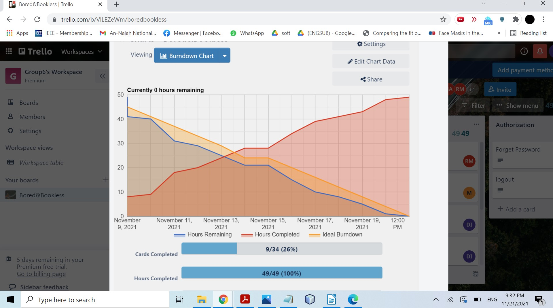

# Daily Scrum Meetings:

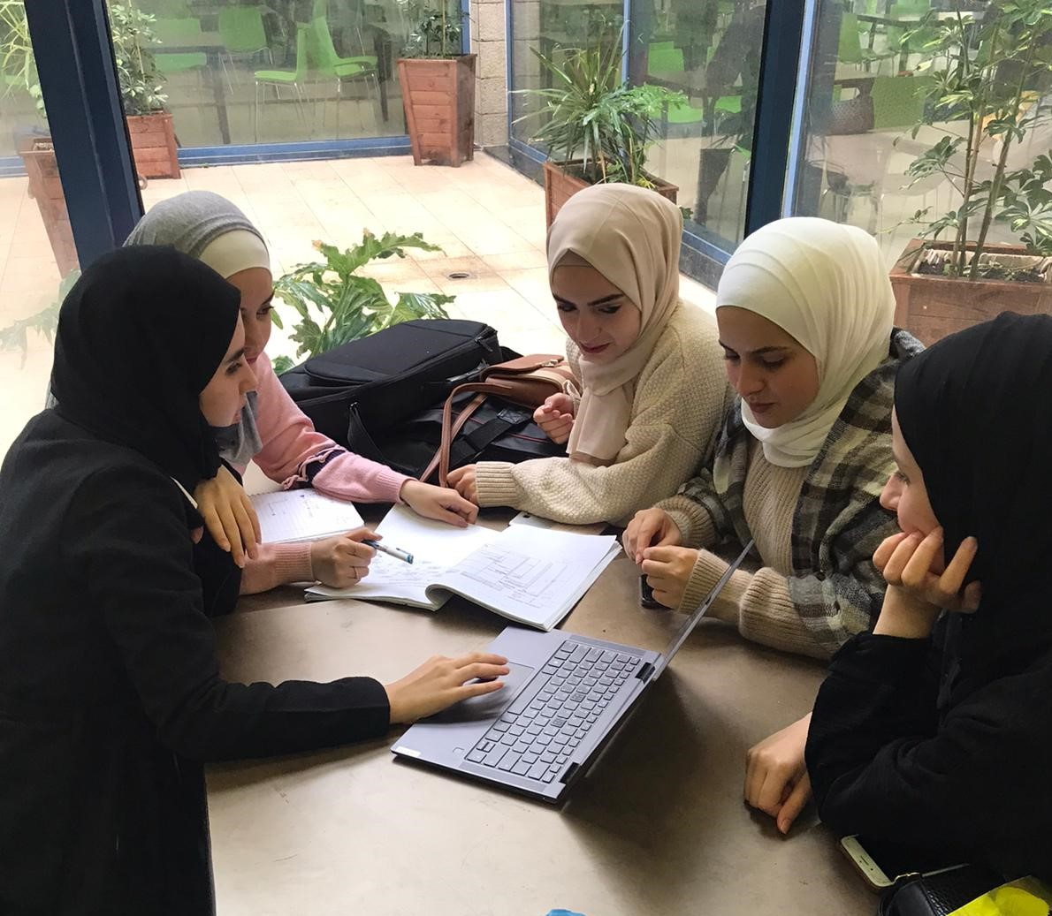Figure: While holding one of our scrum daily meetings

|  |  |
| --- | --- |
| Done in the last 24 hours | Will be done in the next 24 hours |

# Pair programming

One of the methods we used in the sprint development . Where on of the team is coding and there another member reviewing the code immediately

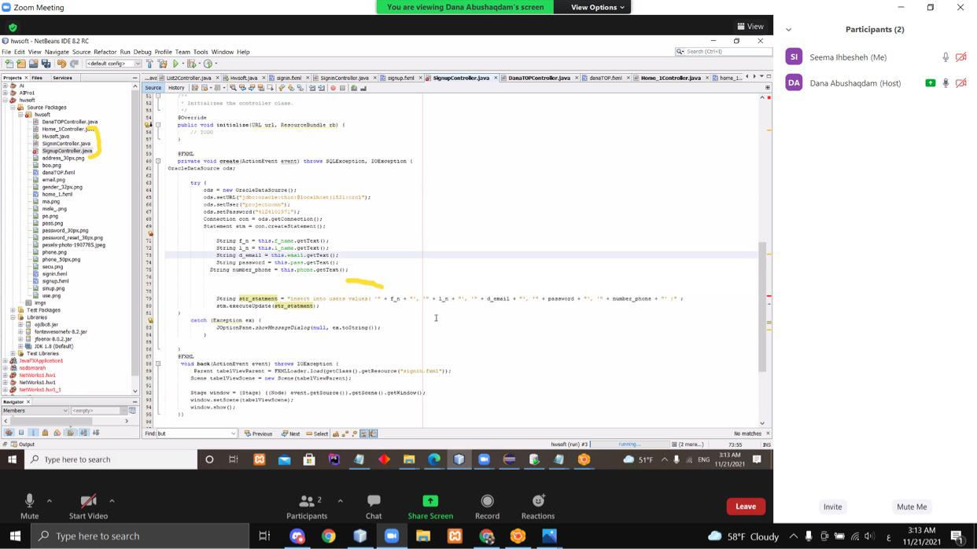Figure: Dana is coding while Seema is reviwing