**Predicting Four drug Combination Cytotoxicity with Autonomous Robotic Platform Driven by an Active Deep Learning Algorithm**

### Eric Li, Brittany Gomez, Matthew Mo

**Introduction** (Brittany)

**Results**

**Simulations** (Matt)

**Experiments**

According to what drugs are available in the lab and previous researches, we identified 4 drugs to construct the experimental space and decide the concentration range to test. Their names, pharmacology and experiment concentrations are described in **Table 1**.

**Table 1:** Four drugs used to construct combinations, their pharmacology and experiment concentrations

|  |  |  |
| --- | --- | --- |
| **Drugs** | **Pharmacology** | **Concentrations (μM)** |
| (+)-Griseofulvin | Griseofulvin is used to treat skin infections, especially fungal infections. Yih-Huei Uen *et al.* reported that it can induce apoptosis in HL-60 cells.2 | 128, 64, 32, 16, 8, 4, 2, 1, 0.5, 0.25, 0.125, 0 |
| (S)-(+)-Camptothecin | Camptothecin is a topoisomerase inhibitor. It showed anticancer activity in preliminary clinical trials. T Shimizu *et al.* found that it can induce apoptosis in p53-null human leukemia HL60 cells.3 | 32, 16, 8, 4, 2, 1, 0.5, 0.25, 0.125, 0.0625, 0.03125, 0 |
| Chloramphenicol | Chloramphenicol is an antibiotic useful for the treatment of a number of bacterial infections. CT Kong *et al.* reported that it induce toxicity of human bone marrow and HL-60 cells.4 | 3200, 1600, 800, 400, 200, 100, 50 ,25, 12.5, 6.25, 3.125, 0 |
| Metformin | Metformin is an oral diabetes medicine that helps control blood sugar levels. Aycan Asik *et al. reported it* antileukemic effect when combined with paclitaxel.5 | 512, 256, 128, 64, 32, 16, 8, 4 ,2, 1, 0.5, 0 |

We used Z-prime score to measure whether our positive control was truly effective. The four positive controls were 8 times the highest experiment concentration of the corresponding drug. The results are summarized in **Table 2**.

**Table 2:** Z-prime value for positive controls

|  |  |  |  |
| --- | --- | --- | --- |
| **(+)-Griseofulvin** | **(S)-(+)-Camptothecin** | **Chloramphenicol** | **Metformin** |
| 0.467 | 0.115 | 0.258 | -1.116 |

We can conclude that (+)-Griseofulvin had obvious effects against cancer cells; (S)-(+)-Camptothecin and Chloramphenicol had only moderate effect; Metformin did not have obvious cytotoxicity against cancer cells. However, there is report that when Metformin is combined with other cancer drugs, it can enhance the anti-cancer effects.5

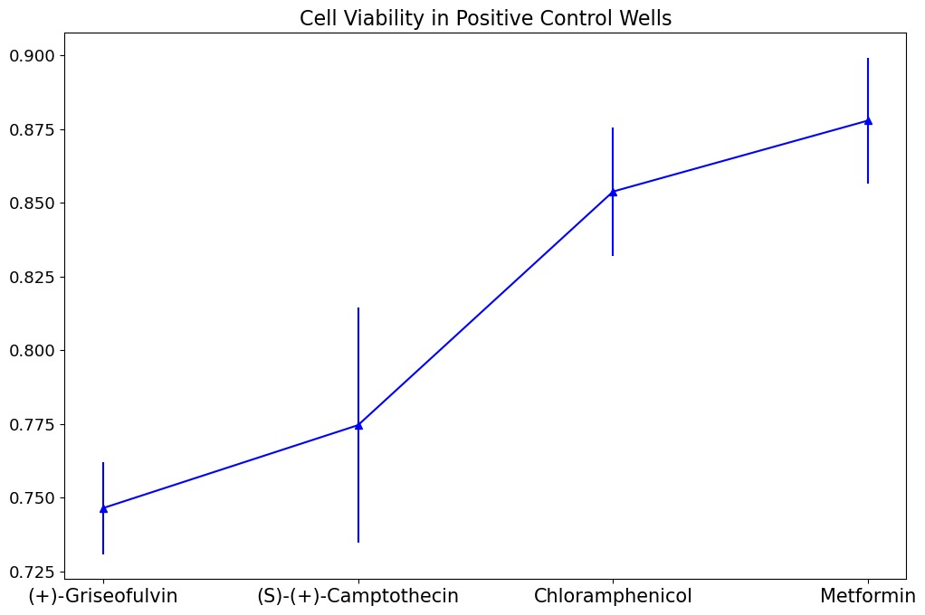

**Figure 1:** Cell viability in positive control wells. (+)-Griseofulvin had obvious cytotoxicity with reasonable standard deviation. (S)-(+)-Camptothecin had higher mean potency than other 2 drugs. However, large standard deviation makes its potency suspicious. This is confirmed in Z-prime values.

We carried out 2 rounds of experiment in total. The first round experiment was for initialization of the model and setting up the test set. Then the active learning model was trained on the initial data points (**Table 3**) and evaluated on the test set.

**Table 3**: First 5 rows of the first round training data

|  |  |  |  |  |
| --- | --- | --- | --- | --- |
| **X** | | | | **Y** |
| (+)-Griseofulvin | (S)-(+)-Camptothecin | Chloramphenicol | Metformin | Cell viability |
| 0.25 | 1.00 | 0.00 | 4.00 | 0.932 |
| 1.00 | 4.00 | 12.50 | 512.00 | 0.908 |
| 0.00 | 1.00 | 3200.00 | 1 | 0.849 |
| 16.00 | 8.00 | 50.00 | 64.00 | 0.783 |
| 16.00 | 32.00 | 200.00 | 1 | 0.722 |

Next, we used the model to query next set of experiments with a batch size of 54 and a constrain that one concentration of one drug will not be queried more than 10 times due to the limited volume of prepared treatment reagents. Finally, queried experiments were executed by CybioFelix and Momentum automation platform in the next round. The model will be retrained and evaluated on the test set again. For each round of experiment we maintained a replicate number of 2. Cell Counting Kit-8 (CCK-8) assay was used to measure cell viability in each well. Workflow, plate design and physical run Gantt chart are described in **Figure 2**.

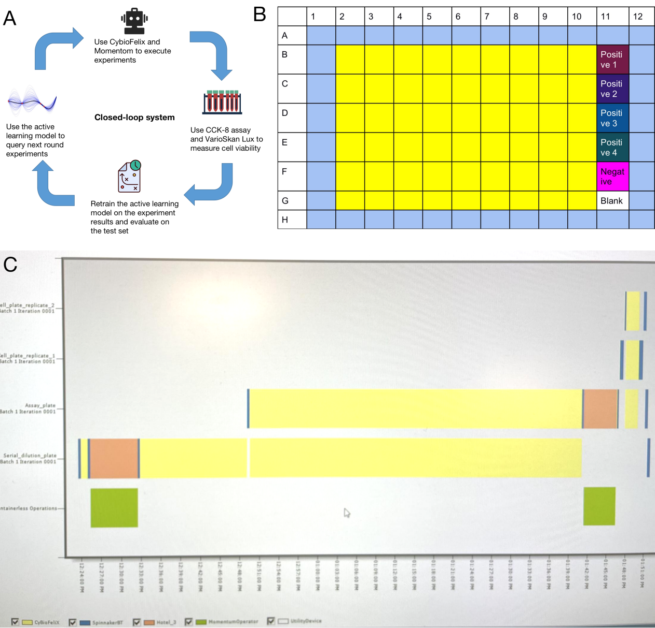

**Figure 2:** Experiment design. (A) The workflow of the closed-loop system. Each iteration contains 4 critical parts: model query experiments, autonomous robotic platform executes experiments, model fits the results again and model query next round experiments. (B) Plate design. Bright yellow is the experiment zone. Cells are treated with different concentration combinations of 4 drugs in the experiment zone. Positive control well 1-4 contains experiment drugs with 8 times the highest experiment concentration of the corresponding drug. Negative control well only contains cell culture medium and cells. Blank well only contains cell culture medium. (C) Gantt chart of the physical run of the experiment. Preparing treatment at CybioFelix took the longest time.

We measured our model’s performance on test set in each experiment round. Firstly, we measured the error between model prediction and true test set values on well-scale. The results are summarized in **Figure 3**. We can conclude that for those wells that the model performed badly on in the first round, the model performed much better on them after incorporating the data from the second round. We also check the overall improvement by calculating MSE on plate-scale. The MSE dropped from 0.0194 to 0.0128, which is a 33.83% accuracy improvement (**Figure 4**).

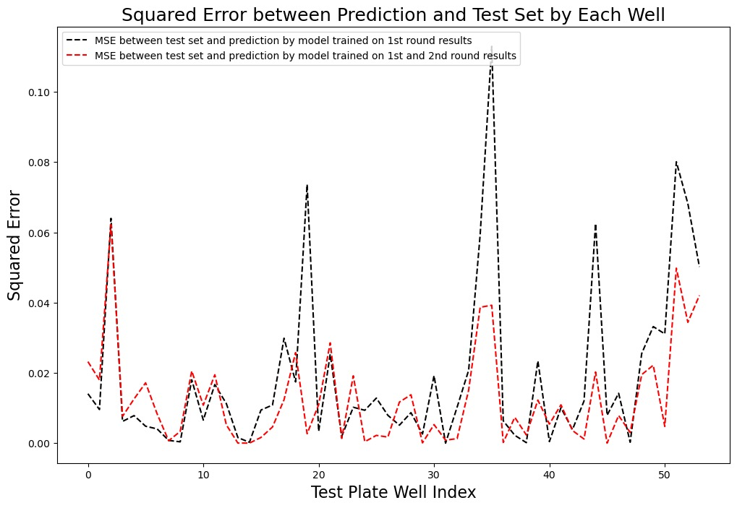Figure 3: A comparison between the first round and the second round model accuracy on test set on well-scale

Figure 4: A comparison between the first round and the second round model accuracy on test set on plate-scale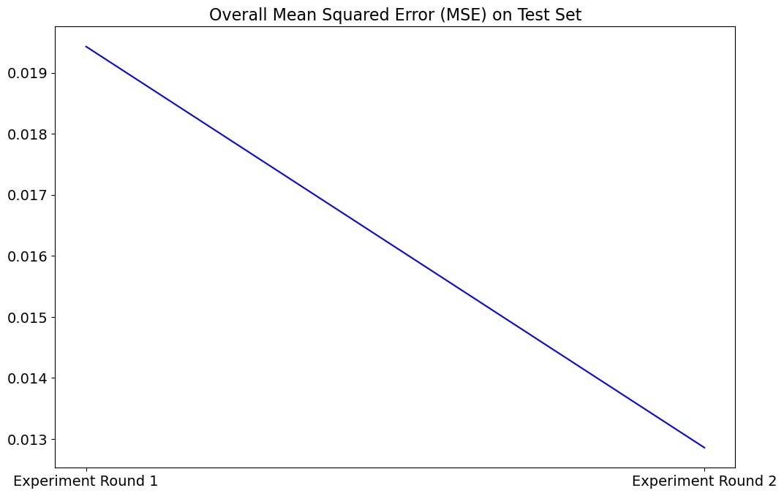

**Materials and methods**

**Cell culture**

Cancer cells were seeded in 96-well plates by CybioFelix platform 3 days before the experiment. Cells were incubated in Dulbecco’s Modified Eagle’s Medium (DMEM) with 10% fetal bovine serum (FBS, Gibico), 1% Penicillin-Streptomycin and incubated at 37 °C with 5% CO2.

**Drugs and reagents**

We started with the stock solutions, whose concentrations were 8-times of the highest experiment concentrations and used CybioFelix platform to do serial dilution for different experiment concentrations.

**CCK-8 assay**

CCK-8 (GLPBIO) was employed to measure cell viability in each well. After the cells were incubated with the experiment drugs for 24 hours, 10μL CCK-8 kit was manually added to each well and then incubate for 1.5 hours in the cell incubator. Then, Thermo Scientific Shaker was employed to make sure the dye was evenly distributed in each well (2 minutes). At last, the absorbance of each well was measured at 450nm by VarioSkan Lux. Then cell viability was measured as following:

As = absorbance of the experimental well (absorbance of cells, medium, CCK8 and wells of the test drugs).

Ab = blank well absorbance (absorbance of wells containing medium and CCK8).

Ac = control well absorbance (absorbance of wells containing cells, medium and CCK8).

**Discussion** (together, wait for Matt’s simulation results)

**Reference**

1. Griner, Lesley A. Mathews, et al. "High-throughput combinatorial screening identifies drugs that cooperate with ibrutinib to kill activated B-cell–like diffuse large B-cell lymphoma cells." Proceedings of the National Academy of Sciences 111.6 (2014): 2349-2354.
2. Uen, Y. H., et al. "NF-kappaB pathway is involved in griseofulvin-induced G2/M arrest and apoptosis in HL-60 cells." Journal of Cellular Biochemistry 101.5 (2007): 1165-1175.
3. Shimizu, T., and Y. Pommier. "Camptothecin-induced apoptosis in p53-null human leukemia HL60 cells and their isolated nuclei: effects of the protease inhibitors Z-VAD-fmk and dichloroisocoumarin suggest an involvement of both caspases and serine proteases." Leukemia 11.8 (1997): 1238-1244.
4. Kong, C. T., et al. "Effects of antioxidants and a caspase inhibitor on chioramphenicol-induced toxicity of human bone marrow and HL-60 cells." Human & experimental toxicology 19.9 (2000): 503-510.
5. Asik, Aycan, et al. "Antileukemic effect of paclitaxel in combination with metformin in HL-60 cell line." Gene 647 (2018): 213-220.