Developer Guide
A frontend-only admin panel: React 19 + TypeScript + Vite, React Router 7, CSS Modules, recharts, lucide-react. No backend: all data is mock data held in memory.

Mental model
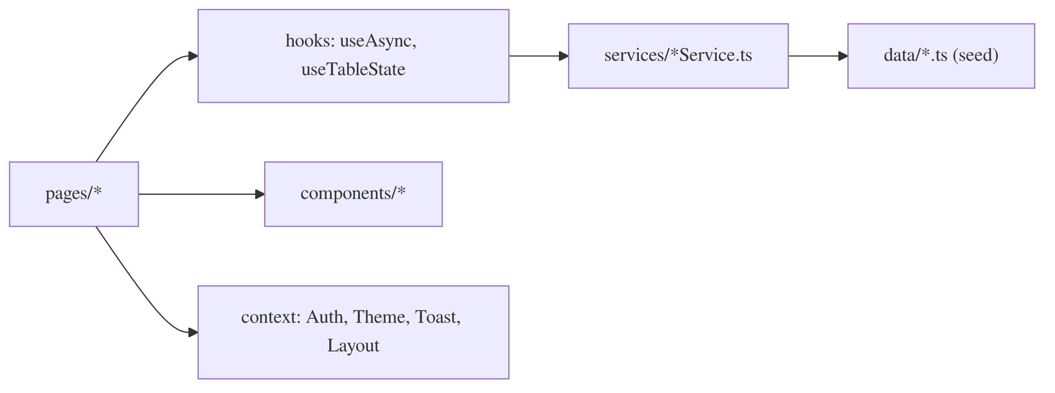
Architecture: how pages reach data and UI
- Pages own screen logic. They never import data/ directly.
- Services are the only data layer. Each keeps a module-level copy of its seed data and returns Promises after a 400 ms fake delay (services/mockDelay.ts). Changes survive navigation but reset on refresh. To add a real backend, rewrite only the service function bodies.
- Components are generic and know nothing about users, roles or records.

Where things live
Folder | Contents
routes/ | AppRoutes (route table), ProtectedRoute / PublicRoute (auth guards), routeTitles (header titles)
context/ | xContext.ts (the context object) + XProvider.tsx (state). Read them with hooks/useX.ts
components/common | Button, Input, Select, Modal, ConfirmDialog, Card, Badge, Toast, Empty/Error states, ErrorBoundary
components/table | DataTable (columns config, sorting, loading/empty/error), TableToolbar, TablePagination, TableActions
components/layout | AdminLayout = Sidebar + Header + <Outlet/>
pages/ | One folder per screen; Roles and Data use modals instead of sub-routes
types/, utils/ | Shared types; formatting, validation, safe localStorage helpers

Where state lives
- Auth flag: stored in localStorage (Remember me) or sessionStorage under the key isAuthenticated. There is no real authentication. See context/AuthProvider.tsx.
- Profile, theme, sidebar collapsed, preferences: stored in localStorage through useLocalStorage. Invalid stored JSON falls back to the defaults.
- Users / roles / records: held in memory inside the services.
- Toasts: kept in ToastProvider. Call showToast('success' | 'error' | 'warning' | 'info', message) to show one.

Example: deleting a user
UserListPage loads the list with useAsync(userService.getUsers) and passes the result to useTableState (search, filter, sort, pagination). The trash icon sets pendingDelete, which opens a ConfirmDialog. Confirming calls await userService.deleteUser(id), then showToast(...), then reload(). While the reload runs, isFetching dims the table instead of replacing it with a spinner.

Adding a new CRUD module (recipe)
- Add a type in types/, seed data in data/, and a fooService copied from recordService.ts.
- Create pages/Foo/FooListPage.tsx by copying pages/Data/RecordListPage.tsx, the simplest full CRUD example.
- Register the route in routes/AppRoutes.tsx, the title in routes/routeTitles.ts, and the nav item in components/layout/Sidebar.tsx.

Rules the linter will enforce (and why)
- Component files may only export components. This is the React Fast Refresh rule, and it’s why each context lives in a .ts file separate from its Provider.tsx.
- Pass useAsync a stable function: a service method, or useCallback(() => service.get(id), [id]). An inline arrow would refetch on every render.
- Define searchKeys / filterKeys arrays outside the component. New arrays on every render defeat useTableState’s memoisation.
- Use import type for type-only imports (required by verbatimModuleSyntax). Don’t use enums; use union types plus as const arrays instead.
- Use design tokens: only CSS variables from src/index.css. Dark mode works because <html data-theme="dark"> swaps those variables.

Commands
npm run dev starts the dev server, npm run build type-checks and builds, and npm run lint runs ESLint. Log in with any non-empty username and password.

