CSC309 Phase 2

2.1 Feature and Functionality Specification

Here's some functional requirements in the form of user stories. We plan to implement the most important functionalities and if we have extra time we will implement more functionalities but for now we are sticking with the following:

User Stories

* As an initiator, I would like to post project ideas so that funders may be appealed to support my project.
* As a user, I would like to see the current funding progress of the project so that I can see interests of the community on my project.
* As a user, i would like to have a profile to keep track of my own projects and projects I have funded to keep things organized.
* As a user, I would like to be able to modify my own profile so that the information is always accurate.
* As a user, I would like to see the projects that’s in my local area because some projects may be limited to certain areas.
* As a user, I would like to interact with the people in the projects that I am currently participating because project qualities and execution may improve by the feedbacks I get.
* As a user, I would like a rating system to give me the reputation of the people that i am interacting with so I can see if someone is known for being reliable or disturbing other people.
* As a funder, I would like to browse projects within a certain category so that I may rule out subjects that I am not interested it.
* As an initiator, I would like to be able to modify my project so that I can make changes according to the community
* As an admin, I would like a view of the system information to keep track of analytics of the website so that I can improve the website knowing some statistics of the system.

Here’s some possible user interactions with the system:

Every webpage of our system comes with a header and a footer (the footer is not shown here) to make navigation simple like many other websites out there.

Landing page [p1]:

There are several things that the users would do starting at the landing page. A familiar user is most likely to start by logging into her account to see the progress of her own project or the ones that she’s funding. Which takes us to the user dashboard page [p2]. On the other hand, new users and for those that are just browsing to see what’s interesting would either choose to sign up or start browsing the projects available. Users can click on the “more" or "explore" buttons to get to the project exploration page [p4]. We plan to put some “featured” projects on the landing page helping some projects to get recognition.

User dashboard page [p2]:

At the dashboard, users can easily navigate the projects that they are currently participating in.

Sign up/login page [p3]:

The signup and login page would most likely be very similar with simple text fields for user inputs.

Project Exploration Page [p4]:

At the Project Exploration Page, users can easily navigate through all the projects that are currently up and running and get more information about the projects. Users can click on any project and see more detailed information about the project at the Project Detail Page [p5].

Project Detail Page [p5]:

In this page, users can watch a short clip about the project as well as reading some details and the progress about the project. Below the project title, we can see the project initiator along with his reputation rating in past projects that he has participated in. There will be a discussion board for users to interact and give feedbacks or comments about the project. You may also see updates of the project from time to time or follow ups from the initiator.

User profile page [p6]:

This page provides some information about the user as well as some options to update his or her password and perhaps some other information.

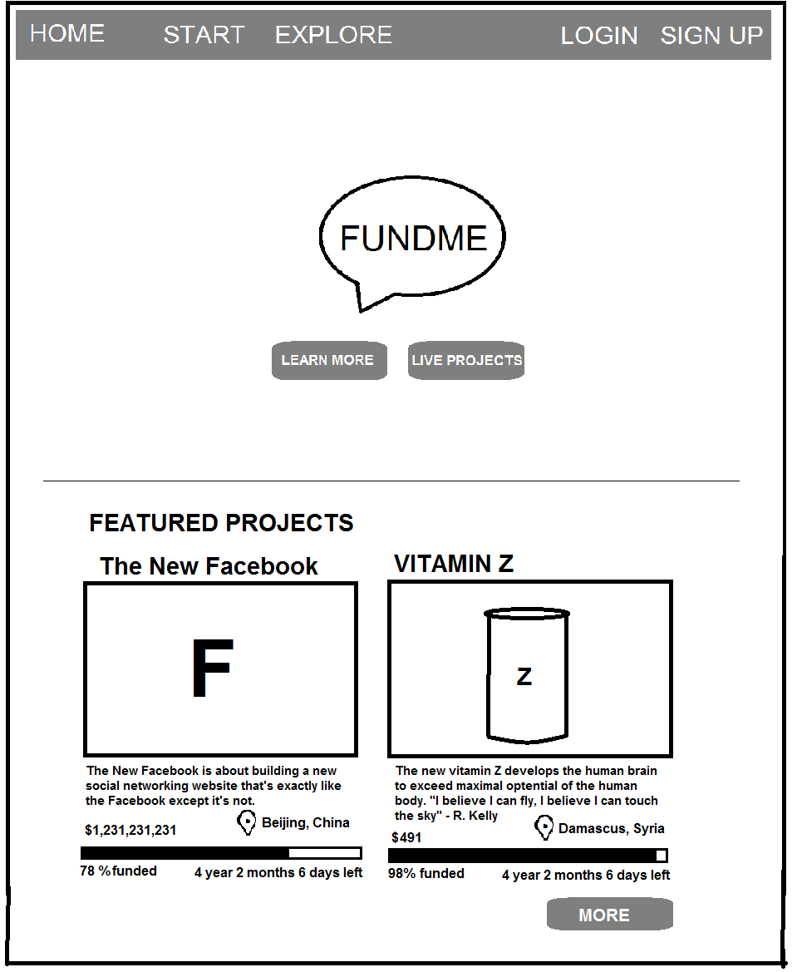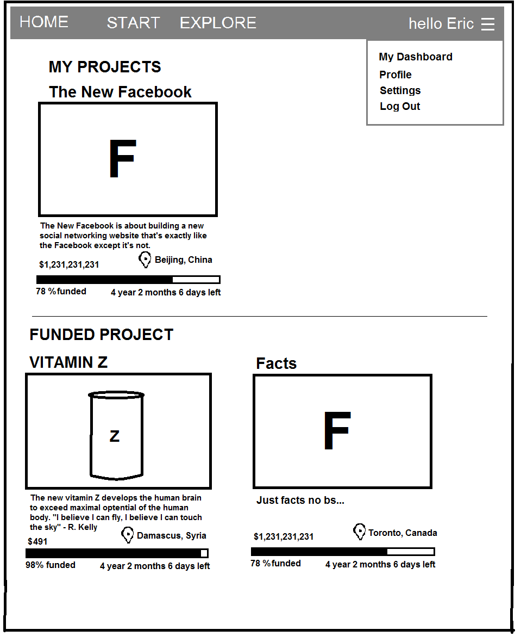[p1] [p2]

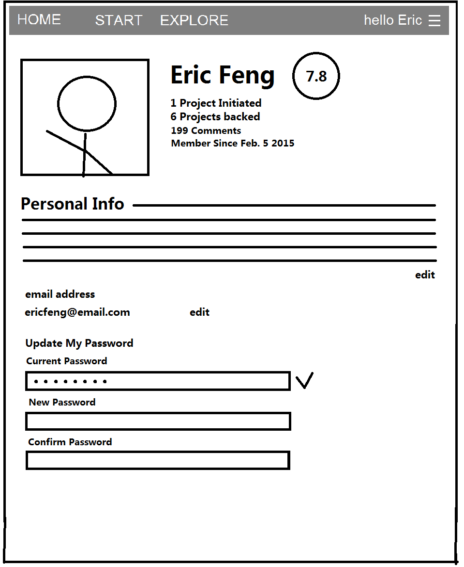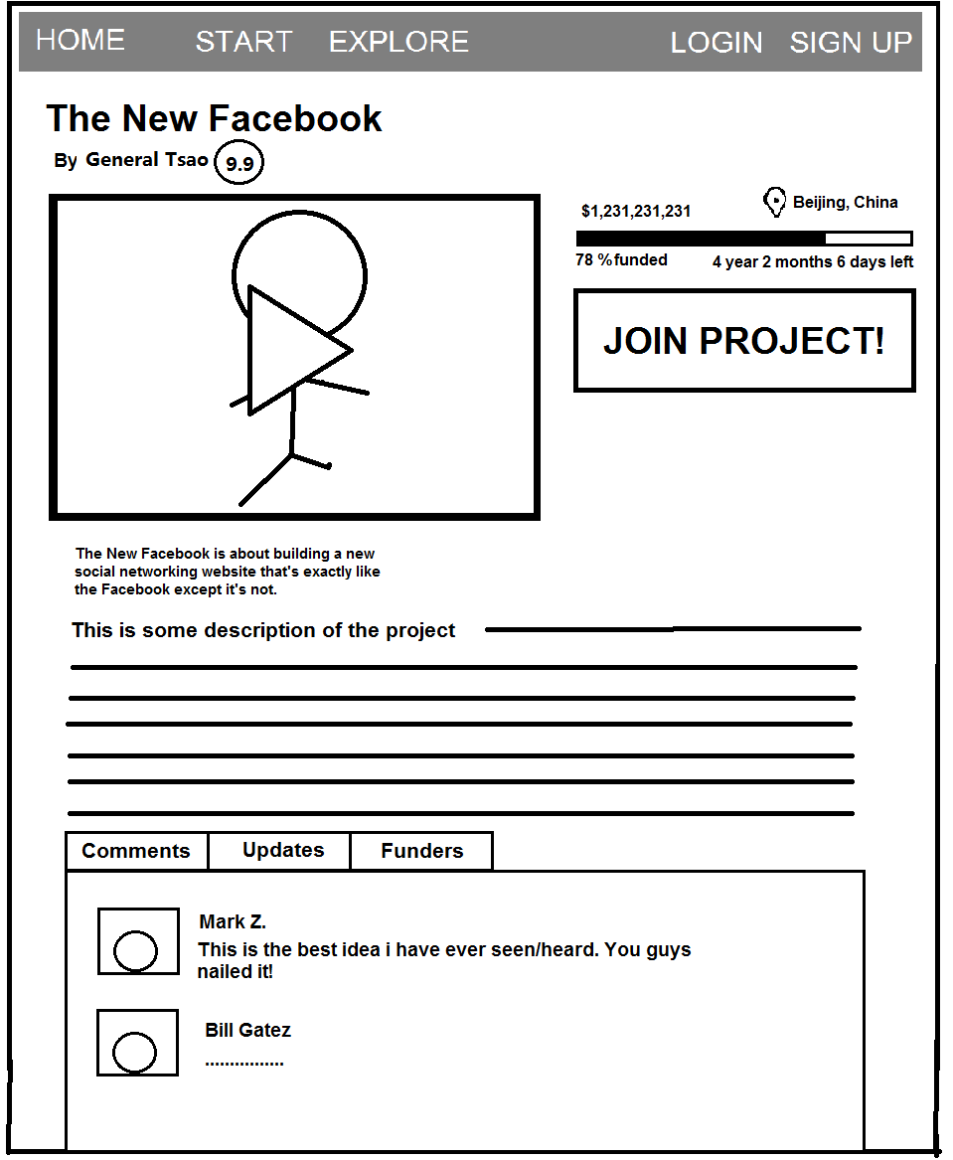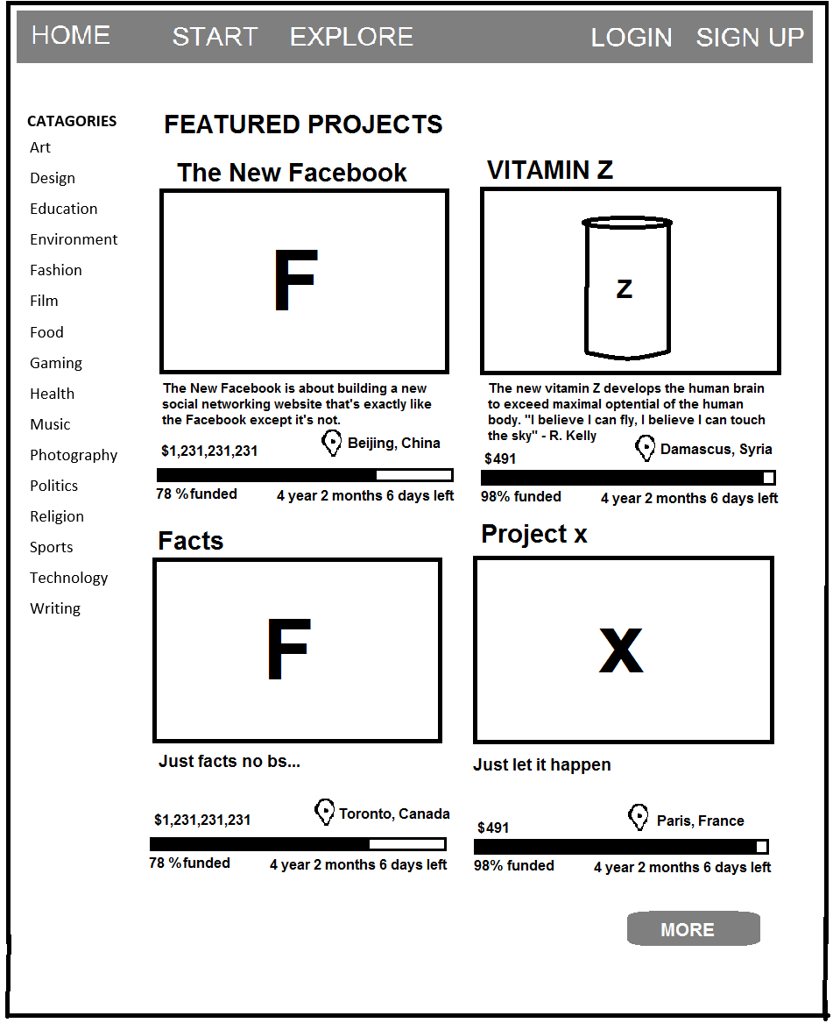[p4] [p5]

[p6]

2.2 Project Plan

2.3 Software Architecture and High-level Design

2.4 information Representation

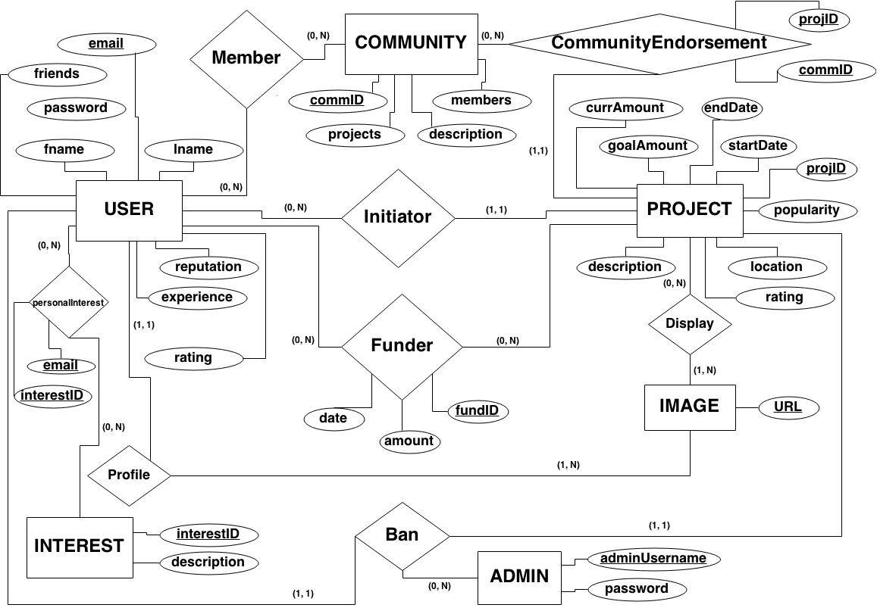Data Model

Schema

Admin

* adminUsername
* password

User

* email
* fname
* lname
* password
* reputation
* profession

Interests

* interestID
* description

PersonalInterests

* email
* interestID

Project

* projID
* goalAmount
* currAmount
* startDate
* endDate
* description
* location
* popularity
* rating

Community

* commID
* members
* description

CommunityEndorsement

* commID
* projectID

Image

* URL

Initiator

* email
* projID

Funder

* fundID
* date
* amount