TELECOM SECTOR AI CHATBOT
Chatbot Architecture & NLP Module Planning
Week 2 Task Deliverable
Internship Program — AI Chatbot Developer (Telecom Sector)

Prepared by | Tiyas Dey
Academic Affiliation | B.Tech, Computer Science & Engineering, University of Engineering & Management (UEM), Kolkata
Document Type | Architecture Design Document — Component Analysis, Block Diagrams, NLP Tool Selection & Integration Strategy
Scope | Week 2 — Chatbot Architecture & NLP Module Planning
Builds On | Week 1 — Conversational Design & Requirement Analysis (personas, use cases, intent catalogue, flow diagrams)
Effort Allocation | Approximately 30–35 hours

Contents
Executive Summary
1. Introduction & Objective
2. Component Analysis — Critical Modules
2.1 Core NLP Modules
2.2 Supporting Platform Modules
2.3 Telecom Backend Integration Modules
3. High-Level System Architecture
4. NLP Module Architecture & Data Flow
4.1 NLP Processing Pipeline
4.2 Inter-Module Data Contracts
5. End-to-End Request Data Flow — Worked Example
6. Telecom Backend Integration Architecture
7. Deployment & Infrastructure Architecture
8. NLP Library & Tool Selection — Technical Justification
8.1 Candidate Technology Comparison
8.2 Recommended Stack & Justification
8.3 Why a Hybrid, Open-Source-First Approach
9. Integration Strategy for Public NLP Libraries
10. Technical Rationale & Design Trade-offs
11. Potential Challenges & Risk Mitigation
12. Conclusion & Next Steps
References

Executive Summary
This document is the Week 2 deliverable for the Telecom Sector AI Chatbot Developer internship. Where Week 1 established what the chatbot needs to do — the personas, use cases, intents, and conversation flows — this document specifies how it will be built: the software architecture, the internal structure of the NLP engine, the data contracts between modules, the integration pattern used to reach telecom backend systems, and the deployment topology.
Six block/architecture diagrams are provided: a layered high-level system architecture, an internal NLP processing pipeline, an inter-module data-contract diagram, a worked end-to-end data-flow example (a billing inquiry traced through every component), a telecom backend integration architecture, and a deployment/infrastructure view covering microservices, data stores, and MLOps. Each diagram is followed by a written explanation of the design choices it embodies.
The document also compares candidate public NLP libraries and frameworks (Rasa, spaCy, Hugging Face Transformers, Dialogflow CX, Microsoft CLU, DeepPavlov) against the requirements derived in Week 1, recommends a specific hybrid open-source stack, and sets out a step-by-step integration strategy for adopting it. It closes with a technical-rationale table recording the trade-offs considered for each major decision, and a risk register covering the architecture-level challenges most likely to arise (latency, multilingual accuracy, model drift, data-privacy compliance, and backend downtime).

1. Introduction & Objective
The Week 1 document produced a complete conversational design: four user personas, seven use case scenarios, a 22-intent catalogue tiered by priority, and six conversation-flow diagrams showing exactly how the bot should behave turn by turn. That design assumed certain capabilities — intent classification, entity extraction, dialogue state tracking, backend lookups, human handoff — without specifying how those capabilities are implemented or how they fit together as a software system. That is the gap this Week 2 document closes.
The objective of this task is to:
- Identify and list every critical module required for the chatbot to function, from NLP components to platform infrastructure to backend integration points.
- Produce block/architecture diagrams that show how those modules are layered, how data flows between them, and how the system connects to telecom-specific backend systems.
- Select and justify specific public NLP libraries and models for intent detection, entity recognition, dialogue management, and response generation.
- Define an integration strategy — the concrete steps to adopt those libraries into a production-ready pipeline.
- Document the technical rationale behind each major design decision and the challenges the architecture must be built to withstand.
Every module, diagram, and decision in this document is traceable back to a specific requirement, persona need, or flow from Week 1 — referenced throughout as “Week 1, Section X” or “UC-0X” — so that the architecture is demonstrably built to satisfy the conversational design rather than designed independently of it.

2. Component Analysis — Critical Modules
This section inventories every module required for the chatbot to operate end-to-end, grouped into three categories: the core NLP modules that understand and respond to language, the supporting platform modules that every conversation passes through regardless of topic, and the telecom backend integration modules each domain flow (Week 1, Section 6) depends on.

2.1 Core NLP Modules
Module | Responsibility | Input | Output
Preprocessing | Normalise raw input, detect language (including code-mixed text), tokenise | Raw user text | Cleaned tokens + detected language
Intent Classification | Map an utterance to one of the 22 intents in the Week 1 catalogue with a confidence score | Tokens | {intent, confidence}
Entity Recognition (NER) | Extract structured and free-text entities (account_id, plan_name, issue_type, etc.) | Tokens | {entities[], types[]}
Dialogue Manager | Track session state/slots, decide the next action (ask, call backend, respond, escalate) per Week 1 flows | {intent, entities, session state} | {action, slots}
Response Generation (NLG) | Render the chosen action into a customer-facing message in the right language and tone | {action, slots, backend data} | {response_text, quick_replies[]}

2.2 Supporting Platform Modules
Module | Responsibility
API Gateway | Single entry point for all channels; routing, TLS termination, rate limiting
Auth & Session Manager | OTP/login authentication (Week 1, FR-1) and session-state persistence across turns
Business Logic Orchestrator | Applies per-domain rules on top of the Dialogue Manager's decisions (e.g., eligibility checks in the plan-change flow, Week 1 Fig. 3)
Integration Adapter / Middleware | Normalises calls to and responses from every backend system behind one internal contract
Conversation & Transaction Store | Persists every turn, resolution outcome, and transaction for audit, analytics, and retraining (Week 1, FR-9)
Training Data Store & Model Registry | Versions NLU training data and deployed models; source for periodic retraining
Analytics / BI Dashboard | Surfaces the KPIs defined in Week 1, Section 8 (containment rate, FCR, CSAT, etc.)
Live Agent Desktop & Queue Manager | Receives warm handoffs from the Escalation flow (Week 1, Fig. 6) with full conversation context

2.3 Telecom Backend Integration Modules
Backend System | Purpose | Used By (Week 1)
Billing & CRM System | Bill data, ledger, dispute tickets | UC-01, UC-02
BSS / OSS | Plan catalogue, usage data, provisioning, network diagnostics | UC-03, UC-04, UC-05
Payment Gateway | UPI / card / wallet transactions | UC-01
e-KYC / ID Verification Service | Identity verification for SIM activation and porting | UC-06
Number Portability Database | Port-in/port-out request submission and status tracking | UC-06
Ticketing / Helpdesk System | Tracks escalated issues and field-engineer tickets | UC-02, UC-04, UC-07
SMS / Notification Gateway | Outbound confirmations, reminders, restoration alerts (Week 1, FR-10) | All domain flows

3. High-Level System Architecture
The diagram below is a layered block diagram of the complete chatbot system. Each shaded cluster is one architectural layer; arrows show the direction of data flow. Solid arrows are the main request path (a customer message moving down through the stack to a backend system and a response moving back up); dashed arrows are secondary paths — escalation, logging, and periodic model retraining.
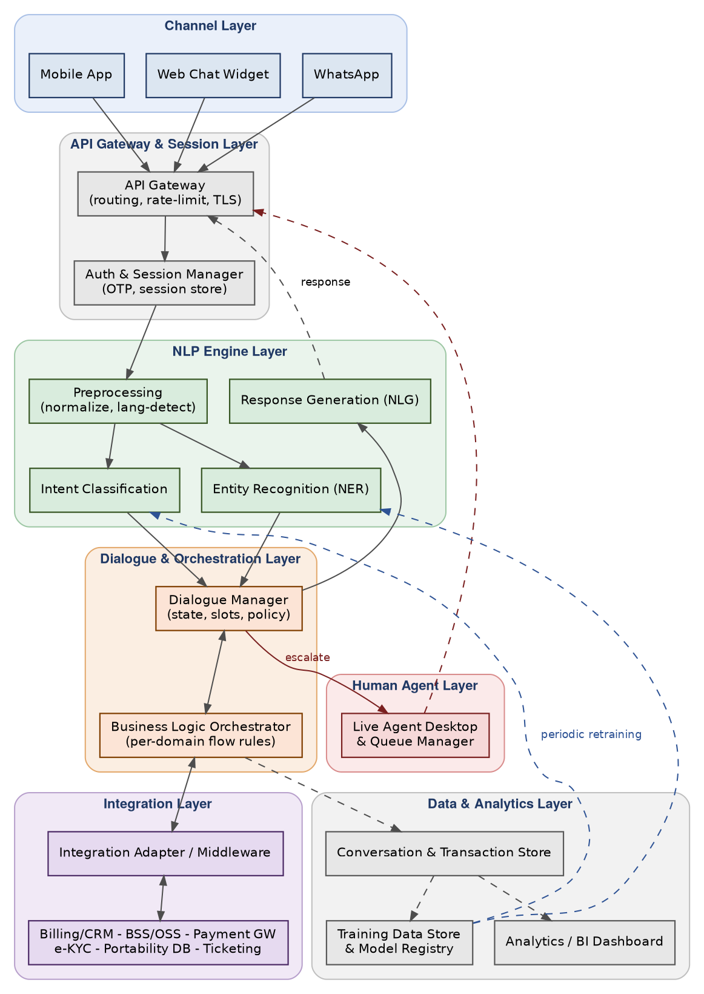
Fig. 1. High-Level Layered System Architecture.
Design notes:
- The Channel Layer is deliberately thin — it only forwards messages to the API Gateway — so that app, web, and WhatsApp traffic share one backend implementation instead of three, keeping the omnichannel consistency required by Week 1, NFR-8.
- Authentication happens once, directly after the gateway and before any NLP processing, mirroring the master flow's design in Week 1, Fig. 1, so every downstream module can assume an authenticated session.
- The NLP Engine Layer and the Dialogue & Orchestration Layer are kept as separate layers rather than one monolithic module: NLP modules are stateless and purely language-focused, while the Dialogue Manager owns session state and business rules. This separation lets the NLU models be retrained or swapped independently of the conversation logic.
- The Integration Layer sits behind a single adapter rather than letting the Orchestrator call each backend system directly, so that a backend API change (e.g., Billing & CRM switching versions) touches one adapter, not every flow that uses billing data.
- Escalation (Week 1, Fig. 6) is modelled as a direct path from the Dialogue Manager to the Human Agent Layer, bypassing NLG, since a human agent — not a template — composes the next message once handoff occurs.
- The Data & Analytics Layer receives data passively (dashed arrows) from the Orchestrator and feeds back into the NLP Engine Layer only through a controlled, periodic retraining path, never in real time, so that a single bad conversation cannot immediately alter live model behaviour.

4. NLP Module Architecture & Data Flow

4.1 NLP Processing Pipeline
This diagram zooms into the NLP Engine and Dialogue Management layers from Fig. 1 and shows the internal stage-by-stage pipeline a single utterance passes through, including the point at which a backend call is made and the feedback loop that logs every turn for future retraining.
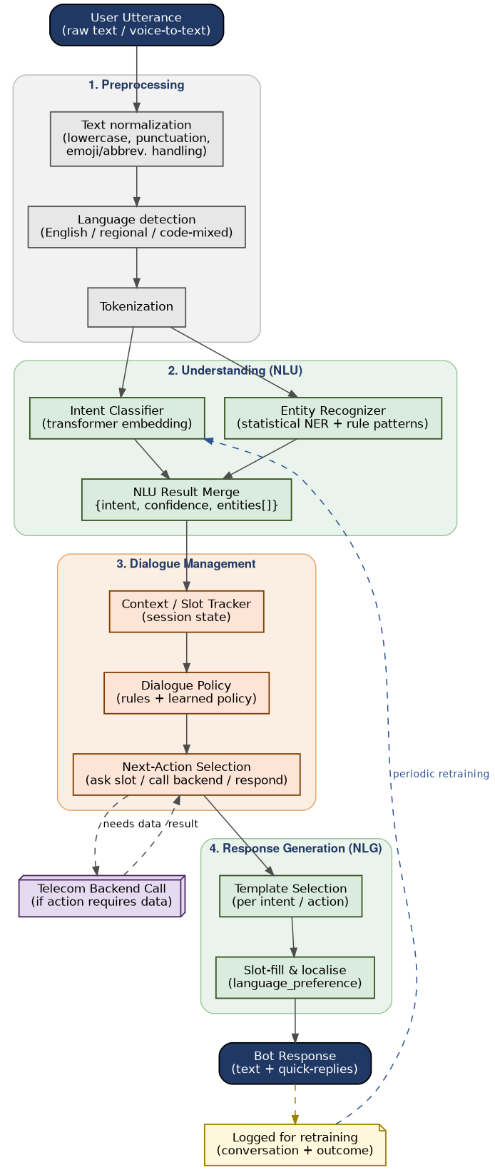
Fig. 2. NLP Processing Pipeline.
Design notes:
- Language detection happens before intent classification rather than being assumed from account settings, because Week 1's multilingual requirement (FR-7) and personas (e.g., Meera Iyer switching between English and a regional language on WhatsApp) mean the language of a given message cannot be assumed to be static for a customer.
- Intent classification and entity recognition run in parallel on the same tokenised input rather than sequentially, since the two tasks are largely independent and running them in parallel reduces latency — directly supporting the sub-2-second response target in Week 1, NFR-2.
- The Context/Slot Tracker is a distinct stage from the Dialogue Policy: the tracker is a simple state store, while the policy is the decision logic, so the policy can be upgraded (e.g., from rule-based to a learned model) without changing how state is stored.
- A backend call is modelled as an explicit, optional branch out of “Next-Action Selection” rather than being embedded inside the Dialogue Manager itself, keeping the Dialogue Manager backend-agnostic and testable without live systems.
- Every completed turn is logged for retraining as a side effect of producing the response, not as a separate process a developer has to remember to wire up — this is what feeds the Training Data Store in Fig. 1.

4.2 Inter-Module Data Contracts
Where Fig. 2 shows the processing stages, this diagram makes the data contract between each core module explicit — the exact payload shape passed from one module to the next — together with the specific technology recommended for each (justified in full in Section 8).
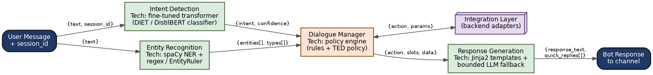
Fig. 3. Inter-Module Data Contracts and Recommended Technology.
Design notes:
- Defining the contract as a small, stable JSON-like object between each module (rather than passing a single large mutable session object everywhere) allows each module to be unit-tested and independently replaced, which matters most for the NLP modules (Section 8) that are most likely to be upgraded as better models become available.
- The Dialogue Manager is the only module with a two-way arrow to the Integration Layer, keeping “who is allowed to call a backend system” restricted to one place in the architecture for auditability (Week 1, NFR-5).
- Response Generation receives the same {action, slots} shape regardless of whether the action required a backend call, which keeps the NLG module simple — it never needs to know why a slot has a particular value, only how to render it.

5. End-to-End Request Data Flow — Worked Example
To verify that the architecture in Figs. 1–3 actually supports the conversational design from Week 1, this section traces a single real request — UC-01, “Check Current Bill and Pay Online” — through every component it touches, from the customer's message to the logged outcome. The same pattern applies to every other use case in Week 1, Section 4; this one is worked through in full as a representative example.
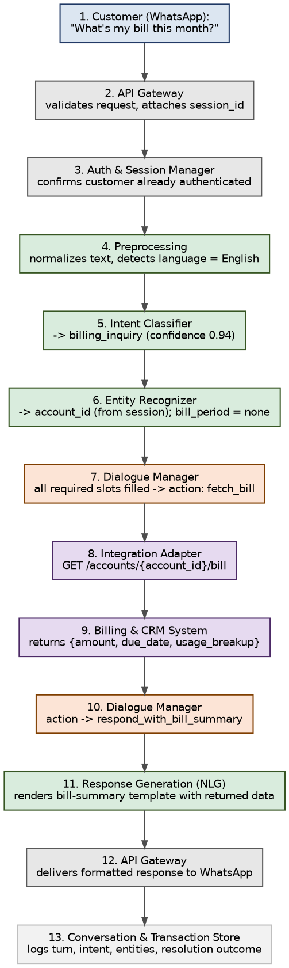
Fig. 4. End-to-End Data Flow for a Billing Inquiry (UC-01).
Design notes:
- Steps 2–3 (Gateway, Auth) add no NLP processing — they exist purely to establish that the request is legitimate and who it is from, before any language understanding happens.
- Steps 5–6 run intent classification and entity recognition independently, as shown in Fig. 2, and step 7 shows the Dialogue Manager making a decision based on their combined output plus session state (the account_id entity is resolved from the session rather than re-asked, honouring Week 1's “never repeat information” principle, Section 7.3).
- Steps 8–9 are the only point where the Integration Adapter and an external system (Billing & CRM) are involved — isolated to two steps out of thirteen, which is what keeps this flow fast and keeps backend failures easy to isolate and retry (Section 6).
- Step 13 is not optional instrumentation bolted on afterward; it is the mechanism that populates both the Analytics Dashboard (Week 1, Section 8 metrics) and the retraining loop (Fig. 1, Fig. 2), so every production conversation continuously improves the model.

6. Telecom Backend Integration Architecture
This diagram expands the single “Integration Layer” box from Fig. 1 into its internal structure, showing how the Chatbot Core reaches every telecom backend system listed in Section 2.3 through one consistent adapter pattern rather than one bespoke client per system.
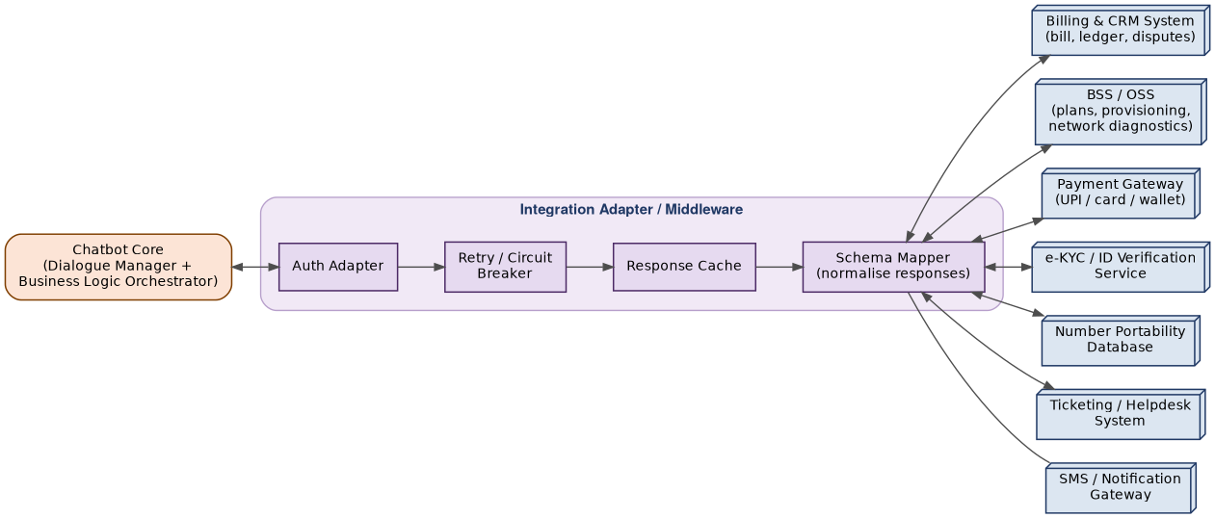
Fig. 5. Telecom Backend Integration Architecture.
Design notes:
- The Auth Adapter attaches system-specific credentials (API keys, mutual-TLS certificates, OAuth tokens) for each backend separately, so a credential rotation on one system never requires changes to the Dialogue Manager or any conversation flow.
- Retry / Circuit Breaker sits immediately after authentication so that a slow or failing backend (e.g., the BSS during a regional outage — precisely when Week 1's troubleshooting flow, Fig. 4, needs it most) degrades gracefully: after a defined failure threshold, the circuit opens and the Dialogue Manager is told immediately that the backend is unavailable rather than left waiting on a timeout.
- Response Cache is scoped only to read-heavy, low-volatility calls (e.g., plan catalogue lookups) and is explicitly never applied to payment, KYC, or portability calls, where a stale cached result would be a compliance and trust problem.
- The Schema Mapper is what lets every backend return data in its own native format while the Dialogue Manager and NLG modules only ever see one normalised internal schema — the same {amount, due_date, usage_breakup} shape referenced in Fig. 4 regardless of which underlying Billing/CRM product is deployed.
- SMS/Notification Gateway is drawn as a one-way call (bot → gateway only) since it is used purely for outbound confirmations and reminders (Week 1, FR-10) and never returns data the conversation depends on.

7. Deployment & Infrastructure Architecture
This final architecture diagram shows how the logical modules in Figs. 1–3 map onto deployable infrastructure: containerised microservices behind a load balancer, their data stores, and the observability/MLOps loop that keeps the deployed models current.
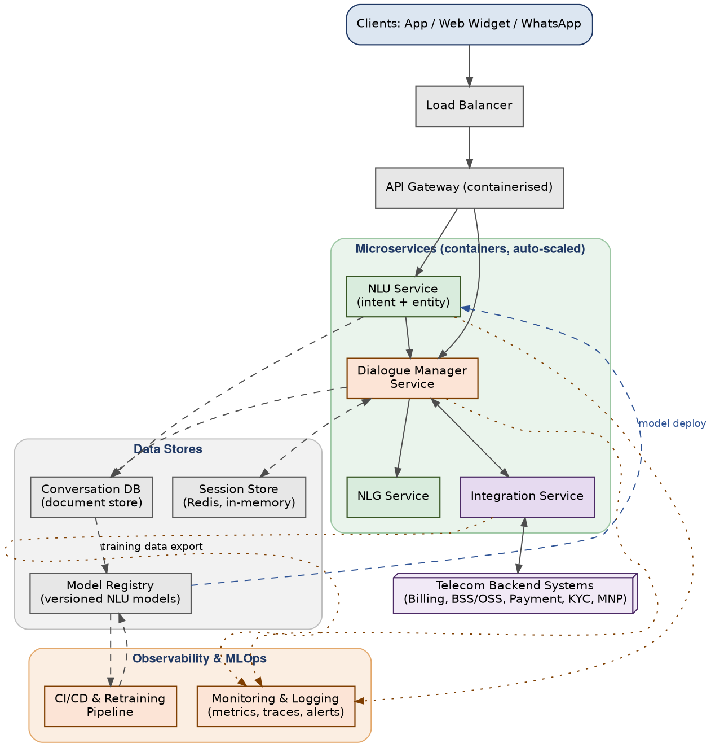
Fig. 6. Deployment & Infrastructure View.
Design notes:
- NLU, Dialogue Manager, NLG, and Integration are deployed as four independently-scaled services rather than one application, because they have very different load profiles — NLU is CPU/GPU-bound and spikes with conversation volume, while Integration is I/O-bound and limited by backend response time; independent auto-scaling (Week 1, NFR-4) lets each scale on its own metric.
- Session state lives in Redis (fast, in-memory, short-lived) while conversation history lives in a separate document store (durable, queried for analytics and retraining) — deliberately two different stores with two different durability/performance trade-offs rather than one database serving both purposes.
- The Model Registry is the single hand-off point between the offline training/CI-CD pipeline and the live NLU Service: a new model version is only ever picked up through a controlled “model deploy” step, never by the live service reading training data directly, so a bad retraining run cannot silently degrade production.
- Monitoring and Logging receives signals from every microservice independently, so a degradation in one service (e.g., Integration Service latency rising during a backend incident) is visible without needing to infer it from end-user complaints.

8. NLP Library & Tool Selection — Technical Justification

8.1 Candidate Technology Comparison
Six publicly available NLP/conversational-AI options were evaluated against the requirements established in Week 1 (FR-2, FR-3, FR-5, FR-7, NFR-3, NFR-7): open-source conversational-AI frameworks, standalone NLP libraries, and managed cloud NLU services.
Option | What It Is | Strengths for This Project | Limitations
Rasa Open Source | End-to-end conversational AI framework (NLU + dialogue management) | Combines intent/entity extraction with a trainable dialogue policy (forms, slots) that maps directly onto Week 1's flows; self-hostable, keeping customer data on-premises | Smaller pretrained-model ecosystem than Hugging Face; dialogue policies need enough example conversations to train well
spaCy | Industrial-strength NLP library (tokenisation, NER, pipelines) | Fast, production-grade NER with an easy rule-based EntityRuler — ideal for structured telecom entities (IMEI, port codes, account IDs) | Not a dialogue-management or intent-classification framework by itself; needs pairing with a classifier
Hugging Face Transformers | Library + hub of pretrained transformer models | Best-in-class accuracy for intent classification via fine-tuning (e.g., DistilBERT); large selection of multilingual and Indic-language models (e.g., MuRIL) | Larger models increase latency/infrastructure cost; needs careful model-size selection to meet Week 1's NFR-2 latency target
Dialogflow CX | Google's managed conversational-AI platform | Fast to prototype; built-in multilingual support and hosting | Fully managed — customer utterances leave the operator's infrastructure, a concern under Week 1's NFR-3 data-compliance requirement; less control over model internals and retraining cadence
Microsoft CLU (Language Understanding) | Azure's managed intent/entity service | Similar strengths to Dialogflow CX; integrates well in Azure-hosted environments | Same data-residency trade-off as Dialogflow CX; vendor lock-in for the core NLU layer
DeepPavlov | Open-source conversational AI library (research-oriented) | Good out-of-the-box pipelines for several NLU tasks | Smaller community and slower release cadence than Rasa/Hugging Face; less enterprise production track record

8.2 Recommended Stack & Justification
The recommended approach is hybrid rather than single-vendor: use Rasa Open Source as the dialogue-management backbone (it already maps cleanly onto Week 1's slot-based flows), but replace its default lightweight intent classifier with a fine-tuned Hugging Face transformer for higher accuracy, and use spaCy for structured/rule-based entity extraction alongside Rasa's own entity extractors. This mirrors the module boundaries already established in Figs. 2 and 3.
Intent Classification
- Recommended: a fine-tuned transformer classifier (e.g., distilbert-base-multilingual-cased for a lean, low-latency model, or bert-base-multilingual-cased where accuracy is prioritised over latency), trained on the Tier 1 intents from Week 1, Section 5.
- For regional-language and code-mixed utterances (e.g., Hindi–English mixed text, a realistic pattern for Indian telecom customers), Google's MuRIL model is a strong publicly available starting checkpoint, since it is pretrained specifically on Indian languages including transliterated/code-mixed text.
- Justification: transformer-based classification consistently outperforms bag-of-words/rule-based classifiers on intents with lexical overlap (e.g., billing_inquiry vs. billing_dispute, Week 1 Section 7.1), which was flagged as a specific risk.
Entity Recognition
- Recommended: a hybrid pipeline — spaCy's statistical NER (fine-tuned on telecom-domain examples) for free-text entities such as complaint_category, combined with spaCy's EntityRuler (regex/pattern-based) for structured entities with fixed formats: mobile_number, otp, imei, port_code.
- Justification: pattern-based extraction is near-100% accurate and instant for fixed-format entities, so it is wasteful and riskier to rely on a statistical model for them; reserving the statistical model for genuinely free-text entities keeps overall entity-extraction F1 (Week 1, Section 8 target: ≥ 0.85) achievable with a smaller training-data burden.
Dialogue Management
- Recommended: Rasa Core's policy stack — a Rule Policy for deterministic, must-follow-exactly steps (OTP verification, payment confirmation) and the TED (Transformer Embedding Dialogue) Policy for the more flexible parts of a conversation (e.g., a customer jumping from a billing question into a plan-change request mid-session).
- Justification: Week 1's flows (Figs. 2–6) contain both kinds of step — strictly ordered sub-flows (KYC before SIM details, Fig. 5) and flexible branching (the billing flow's three-way fork, Fig. 2) — and a single policy type cannot serve both well; Rasa's mixed-policy architecture matches this directly.
Response Generation (NLG)
- Recommended: template-based generation (Jinja2-style templates mapped one-to-one to actions) for every transactional flow (billing, payments, plan changes, SIM/porting), with a bounded large-language-model fallback used only for the general_faq intent, constrained to a fixed knowledge base so it cannot fabricate account-specific facts.
- Justification: in regulated, money-affecting flows, a template guarantees the exact wording (amounts, dates, terms) that was actually returned by the backend — free-generation NLG risks subtly altering a figure. Reserving open-ended generation for FAQ content only contains that risk to where it cannot cause a billing or compliance error.

8.3 Why a Hybrid, Open-Source-First Approach
Three considerations, all traceable to Week 1 non-functional requirements, drove the preference for an open-source-first stack over a fully-managed cloud NLU service:
- Data residency & compliance (NFR-3): self-hosted Rasa/spaCy/Hugging Face models mean customer utterances — which can include account numbers, OTPs, and billing disputes — never need to leave the operator's own infrastructure, simplifying compliance with telecom data-protection obligations.
- Extensibility (NFR-7): open checkpoints can be fine-tuned directly on telecom-specific language and new intents added via retraining, without waiting on a vendor's managed-service roadmap or being limited to the vendor's supported entity types.
- Cost predictability at scale: self-hosted inference has a fixed infrastructure cost that does not grow per-API-call, which matters for a chatbot expected to absorb large, unpredictable spikes in volume during network outages (Week 1, Section 2.1).
This is a starting recommendation, not a permanent constraint: because the architecture in Fig. 3 isolates each NLP module behind a stable data contract, a managed cloud NLU service could be substituted behind the Intent Classification or Entity Recognition module later without changing the Dialogue Manager, NLG, or any downstream integration — the trade-offs would simply need to be re-evaluated against NFR-3 at that time.

9. Integration Strategy for Public NLP Libraries
The stack recommended in Section 8 is adopted in six staged steps rather than all at once, consistent with Week 1's finding that successful deployments start narrow (Tier 1 intents only) and expand. Each step has a concrete exit condition before the next begins.
Step | What Happens | Exit Condition
1. Environment & project scaffolding | Set up a Rasa Open Source project; install spaCy and the Hugging Face transformers library in the same Python environment; configure the NLU pipeline to call a custom transformer-based intent classifier component. | Pipeline runs end-to-end on a “hello world” utterance.
2. Seed training data from Week 1 | Convert the Tier 1 intents and example utterances (Week 1, Section 5) into Rasa NLU training-data format; add spaCy EntityRuler patterns for every structured entity (mobile_number, otp, imei, port_code).
3. Fine-tune the intent classifier | Fine-tune the chosen transformer checkpoint (Section 8.2) on the seed data; for regional-language coverage, extend with MuRIL-based training examples. | Classification accuracy on a held-out set meets the ≥ 90% target (Week 1, Section 8).
4. Build dialogue policies per flow | Implement each Week 1 flow (Figs. 2–6) as Rasa stories/rules and forms; Rule Policy for deterministic sub-flows, TED Policy for flexible branching (Section 8.2). | Each use case (UC-01 to UC-07) passes a scripted end-to-end conversation test.
5. Wire the Integration Adapter | Implement the adapter pattern from Fig. 5 (auth, retry/circuit breaker, cache, schema mapper) against sandbox/mock versions of each backend system. | A simulated billing-inquiry conversation (Fig. 4) completes using mocked backend responses.
6. Pilot, monitor, and expand | Deploy Tier 1 intents to a limited pilot channel; monitor the metrics from Week 1, Section 8 via the Analytics Dashboard; use pilot conversation logs to retrain and then add Tier 2/3 intents. | Pilot metrics meet or exceed Week 1's indicative targets before wider rollout.

10. Technical Rationale & Design Trade-offs
The table below records the major architectural decisions embedded in Sections 3–7, the alternative that was considered, and why the alternative was not chosen — so the reasoning remains auditable as the system evolves.
Decision | Trade-off Considered
Microservices (Fig. 6) vs. a single monolithic service | A monolith is simpler to deploy initially but forces every module to scale together; since NLU and Integration have very different load profiles (Section 7), independent services were chosen despite the added deployment complexity.
Hybrid rule + learned dialogue policy vs. a single learned policy | A fully learned policy (e.g., end-to-end neural dialogue) is more flexible but is non-deterministic, which is unacceptable for strictly ordered, compliance-sensitive steps like OTP/KYC verification; a rule policy guarantees those steps execute exactly as specified in Week 1's flows.
Template-based NLG vs. free-generation NLG for transactional flows | Free generation reads more naturally but can subtly alter a returned amount, date, or term; templates trade some linguistic variety for an exact-wording guarantee, which was judged necessary for billing/payment/legal content (Section 8.2).
Self-hosted open-source NLU vs. managed cloud NLU | Managed services are faster to stand up, but customer utterances leaving operator infrastructure conflicts with Week 1's data-compliance requirement (NFR-3); self-hosting was chosen, with the data contract in Fig. 3 left open to revisit this later.
Synchronous backend calls vs. fully asynchronous/event-driven integration | A fully async design would handle backend latency more gracefully but adds significant complexity (message queues, correlation IDs) that is not justified for a first version; synchronous calls with a retry/circuit-breaker layer (Fig. 5) were chosen as a simpler design that still degrades gracefully.
Separate Redis session store vs. one shared database for session + history | A single database is simpler, but session state needs millisecond, high-churn reads/writes while conversation history needs durable, query-friendly storage; splitting them (Fig. 6) optimises each for its actual access pattern.
Caching only read-heavy/low-volatility backend calls vs. caching broadly | Caching every backend call would reduce load further, but caching payment, KYC, or portability responses risks serving stale, compliance-relevant data; caching was scoped narrowly (Fig. 5) to avoid that risk entirely rather than managing it with short TTLs.

11. Potential Challenges & Risk Mitigation
These risks are specific to the architecture described in this document (as distinct from the conversational-design risks already catalogued in Week 1, Section 9.3).
Risk | Impact | Mitigation
Code-mixed / regional-language utterances reduce intent-classification accuracy | Medium | Use a model pretrained on Indian languages and code-mixed text (e.g., MuRIL) rather than a purely English checkpoint; expand training data with real code-mixed examples from the pilot (Section 9, Step 6).
Backend API latency or downtime degrades response time (NFR-2) or blocks a flow entirely | High | Retry / circuit-breaker layer in the Integration Adapter (Fig. 5); defined timeout budgets per backend; graceful-degradation messaging instead of an indefinite wait, consistent with Week 1's no-dead-end principle.
Model drift as real customer language diverges from training data over time | Medium | Continuous logging of every turn (Fig. 1, Fig. 2) into the Training Data Store, with periodic retraining through the Model Registry (Fig. 6) rather than a one-time training pass.
Customer PII exposure in logs or training data | High | Self-hosted NLU stack (Section 8.3) keeps data on operator infrastructure; conversation logs should be subject to field-level redaction/encryption for sensitive entities (mobile_number, otp) before long-term storage.
Traffic spikes during a network outage overwhelm the NLU/Integration services | Medium | Independent auto-scaling per microservice (Fig. 6, NFR-4); the troubleshooting flow's outage-check path (Week 1, Fig. 4) is itself designed to resolve many of these contacts without a backend round-trip, reducing load at the exact moment it spikes.
Intent overlap between closely related Tier 1/Tier 2 intents persists even after fine-tuning | Medium | Monitor the confusion matrix during the pilot (Section 9, Step 6) and route the most-confused intent pairs through additional clarification quick-replies, as already planned in Week 1, Section 7.4.
Template rigidity in NLG produces repetitive or awkward phrasing at scale | Low | Maintain multiple template variants per action and rotate them, while keeping the exact-wording guarantee (Section 10) for any numeric or legal content within the template.

12. Conclusion & Next Steps
This document has turned the Week 1 conversational design into a concrete architecture: a layered system diagram, an internal NLP pipeline with explicit data contracts, a worked end-to-end example, a telecom backend integration pattern, and a deployment topology — six block diagrams in total, each annotated with the reasoning behind its structure. Section 8 selected and justified a specific hybrid, open-source-first NLP stack (Rasa + Hugging Face transformers + spaCy), Section 9 laid out how to adopt it in six verifiable stages, and Sections 10–11 recorded the trade-offs and risks so later decisions can be revisited with full context.
Recommended next steps beyond this Week 2 deliverable:
- Execute Integration Strategy Steps 1–3 (Section 9): stand up the Rasa/spaCy/Transformers environment and fine-tune the intent classifier on the Week 1 Tier 1 seed data.
- Confirm concrete API contracts with each telecom backend system owner so the Schema Mapper (Fig. 5) can be implemented against real, not assumed, response formats.
- Build the scripted end-to-end conversation tests for UC-01 through UC-07 referenced in Section 9, Step 4, directly from the Week 1 use case definitions.
- Stand up the observability stack (Fig. 6) before the pilot begins, so Week 1's success metrics are measurable from the very first live conversation.

References
This document's architecture and technology recommendations draw on the publicly documented capabilities of the following open-source projects and platforms. All diagrams, data contracts, and design rationale are original work produced for this task.
- Rasa Open Source — conversational AI framework (NLU + Core dialogue management), rasa.com/docs
- spaCy — industrial-strength NLP library, spacy.io
- Hugging Face Transformers — pretrained transformer models and fine-tuning library, huggingface.co/docs/transformers
- Google Research — MuRIL: Multilingual Representations for Indian Languages, huggingface.co/google/muril-base-cased
- Google Cloud — Dialogflow CX documentation, cloud.google.com/dialogflow/cx/docs
- Microsoft Azure — Conversational Language Understanding (CLU) documentation, learn.microsoft.com/azure/ai-services/language-service
- DeepPavlov — open-source conversational AI library, deeppavlov.ai

