TELECOM SECTOR AI CHATBOT
Conversational Design & Requirement Analysis
Week 1 Task Deliverable
Internship Program — AI Chatbot Developer (Telecom Sector)

Prepared by | Tiyas Dey
Academic Affiliation | B.Tech, Computer Science & Engineering, University of Engineering & Management (UEM), Kolkata
Document Type | Requirement Analysis Report, User Personas, Use Case Scenarios & Conversational Flow Design
Scope | Week 1 — Conversational Design & Requirement Analysis
Effort Allocation | Approximately 30–35 hours

Contents
Executive Summary
1. Introduction & Objective
2. Requirement Analysis Report
2.1 Research Methodology & Sources
2.2 Common Telecom Customer Inquiry Categories
2.3 Functional Requirements
2.4 Non-Functional Requirements
3. User Personas
4. Use Case Scenarios
5. Intent & Entity Catalogue
6. Conversational Flow Design
6.1 Master Conversation Flow
6.2 Billing & Payment Flow
6.3 Plan Change / Upgrade Flow
6.4 Network & Service Troubleshooting Flow
6.5 SIM / Number Services Flow
6.6 Escalation & Human Handoff Flow
7. NLP & Conversational Design Decisions
8. Evaluation Criteria & Success Metrics
9. Assumptions, Constraints & Risks
10. Conclusion & Next Steps
References

Executive Summary
This document is the Week 1 deliverable for the Telecom Sector AI Chatbot Developer internship. It captures the requirement-gathering and conversational design work needed before any model training or platform integration begins. The chatbot under design is intended to sit across a telecom operator's app, website and WhatsApp channel, and to handle the high-volume, repetitive queries that make up the bulk of telecom support contact volume — billing and payments, plan changes and recharges, network troubleshooting, SIM and number services, complaint logging, and general FAQs — while escalating cleanly to a human agent whenever the conversation needs judgement the bot cannot provide.
The analysis draws on publicly available industry research on telecom customer support automation (see the References section) as well as common patterns observed across telecom operator self-care apps and IVR menus. It translates that research into four user personas representing typical subscriber profiles, seven detailed use case scenarios covering the primary support journeys, a catalogue of 22 candidate intents with their associated entities, and six conversational flow diagrams that show exactly how the bot should behave turn-by-turn, including its escalation logic.
The intent of this stage is to produce a design that a conversational-AI or NLU engineering team could pick up directly: every intent maps to an entity set, every entity maps to a backend system it needs to query, and every flow diagram shows the decision points where the bot must check confidence, eligibility, or authentication before proceeding. Section 7 explains the reasoning behind the NLU approach, fallback strategy, personalization, and multilingual handling, and Section 8 proposes the metrics against which the finished chatbot should be evaluated.

1. Introduction & Objective
Telecom operators handle an exceptionally high volume of repetitive customer contacts — checking a bill, recharging a prepaid account, reporting a dropped call, or activating a new SIM. Public industry research consistently finds that leading telecom operators now automate the large majority of these routine interactions through AI chatbots, and that difficult or unresolved issues are strongly correlated with customer churn, which makes fast, accurate self-service a retention lever rather than just a cost-saving one. Effective deployments are reported to start narrow — automating the top 10 to 15 most common intents well — rather than attempting full automation on day one.
The objective of this Week 1 task is to lay the design foundation for such a chatbot before any implementation begins. Concretely, the task requires:
- Investigating and documenting the categories of inquiry a telecom subscriber is most likely to bring to a chatbot.
- Building user personas that represent the range of telecom customers the bot must serve, from a budget-conscious student to a low-digital-literacy senior citizen.
- Writing detailed use case scenarios for the primary support journeys — billing, plan management, troubleshooting, SIM/number services, and escalation.
- Producing a conversational flow diagram set that shows exactly how the bot routes, questions, and resolves each journey, down to individual decision points.
- Cataloguing the intents and entities an NLU model would need to recognise to support those flows.
Together these artefacts form the requirement-analysis and design baseline that later weeks (NLU training, backend integration, and testing) will build on. The document is organised so that a reader can move from "why" (research and personas) to "what" (use cases and intents) to "how" (flow diagrams and design decisions) in sequence.

2. Requirement Analysis Report

2.1 Research Methodology & Sources
Requirements were gathered through desk research on publicly available material describing telecom customer-service automation: vendor and analyst write-ups on telecom chatbot use cases, an industry consumer-research summary on AI in UK telecoms, and general 2026 conversational-AI adoption commentary (full references are listed at the end of this document). Because the underlying customer journeys — bill, plan, network, SIM — are broadly consistent across telecom operators worldwide, these sources were treated as representative of the domain rather than of any single company, and the specific inquiry categories, personas and flows in this document were synthesised from that broader pattern rather than copied from any one source.
Three recurring findings from this research directly shaped the design choices in this document:
- The majority of inbound telecom contacts are repetitive and low-complexity (billing, balance, plan, basic troubleshooting), which is why the flow design in Section 6 optimises heavily for fast self-service on these paths.
- Poor resolution of a difficult issue is strongly linked to a customer's intent to switch providers, which is why every flow in this document has an explicit escalation path (Section 6.6) rather than letting the bot dead-end.
- Successful rollouts start with a focused set of top intents rather than full-domain coverage, which is why the intent catalogue in Section 5 is organised by priority tier.

2.2 Common Telecom Customer Inquiry Categories
The table below groups the inquiry types most frequently reported across telecom self-care channels into six domains. These six domains become the six top-level routing branches of the master conversation flow in Section 6.1.
Domain | Typical Customer Inquiries | Priority
Billing & Payments | Current bill amount, due date, last payment status, pay bill now, download invoice, dispute an unrecognised charge, auto-pay setup/cancellation | High
Plans & Recharges | Current plan details, compare/upgrade/downgrade plan, buy a data add-on, prepaid recharge, check remaining data/talktime balance | High
Network & Service Troubleshooting | No signal, call drops, slow mobile data, no internet on broadband/Wi-Fi, device not connecting after SIM swap, outage in my area | High
SIM & Number Services | New SIM activation, SIM replacement (lost/damaged), number portability (port-in/port-out), eSIM provisioning, change mobile number | Medium
Complaints & Feedback | Register a service complaint, check complaint/ticket status, escalate an unresolved issue, general feedback or rating | Medium
General / Account Information | Store locator, offers and promotions, KYC/document update, plan terms & conditions, contact human support | Low–Medium

2.3 Functional Requirements
The chatbot system shall satisfy the following functional requirements:
ID | Requirement
FR-1 | Authenticate the customer (registered mobile number + OTP, or account login) before disclosing or acting on account-specific data.
FR-2 | Classify free-text user input into one of the defined intents (Section 5) with an associated confidence score.
FR-3 | Extract relevant entities (account ID, plan name, issue type, SIM number, etc.) from user utterances using named-entity recognition.
FR-4 | Integrate with backend systems — Billing/CRM, BSS/OSS, Payment Gateway, Number-Portability database, and an ID-verification service — to fetch or update customer data in real time.
FR-5 | Maintain multi-turn context within a session so the user does not have to repeat information already provided.
FR-6 | Support quick-reply buttons and menus alongside free-text input to speed up common paths and reduce misclassification.
FR-7 | Support at least English and one regional language, with the language configurable per customer profile or detected from input.
FR-8 | Escalate to a human agent — on explicit request, low NLU confidence after repeated attempts, or detected negative sentiment — while carrying the full conversation context forward.
FR-9 | Log every conversation, resolution outcome, and customer satisfaction rating for analytics and continuous improvement.
FR-10 | Send outbound confirmations (payment receipt, plan-change confirmation, ticket ID, porting status) via SMS and/or chat after a completed transaction.

2.4 Non-Functional Requirements
ID | Category | Requirement
NFR-1 | Availability | The chatbot shall be available 99.5% or higher, including during network-outage spikes when demand is highest.
NFR-2 | Performance | 95th-percentile bot response latency shall be under 2 seconds for standard intents (excluding third-party payment gateway round-trips).
NFR-3 | Security & Compliance | Customer data shall be encrypted in transit and at rest; payment flows shall be PCI-DSS compliant; data handling shall comply with applicable telecom and data-protection regulations.
NFR-4 | Scalability | The system shall scale horizontally to absorb demand spikes (e.g., during a regional outage) without degrading response time.
NFR-5 | Auditability | Every conversation and backend transaction shall be logged with a retrievable audit trail for the retention period defined by policy.
NFR-6 | Accessibility | The web/app chat widget shall meet WCAG 2.1 AA guidelines to remain usable for customers with visual or motor impairments.
NFR-7 | Extensibility | New intents, entities, and flows shall be addable through configuration/training data updates without a full platform re-deployment.
NFR-8 | Omnichannel Consistency | Conversation state and resolution history shall be consistent whether the customer starts on the app, website widget, or WhatsApp.

3. User Personas
The four personas below were constructed to span the realistic range of a telecom operator's subscriber base along the two axes that most affect chatbot design: digital comfort and account complexity (single prepaid connection vs. multi-line / business account). Each persona feeds directly into the use case scenarios (Section 4) and the tone/personalization guidance in Section 7.
Persona 1 — The Budget-Conscious Student
Ananya Das
“Just tell me the cheapest way to get more data before my recharge runs out.”
Age / Profile | 20, undergraduate student
Plan Type | Prepaid, low-value recharges, frequent data add-on purchases
Digital Comfort | High — comfortable with apps and chat, impatient with long menus
Primary Channel | WhatsApp and mobile app
Goals | • Recharge quickly without calling customer care  • Find the cheapest plan/add-on for her usage  • Get instant confirmation that a recharge succeeded
Frustrations | • Long IVR trees before reaching a useful option  • Being shown plans that don't match her budget  • Recharge failures with no clear reason given
Design Implications | • Recharge and add-on purchase must be reachable within 1–2 taps/messages from the greeting menu  • Plan recommendations should be filtered by price sensitivity, not just data usage  • Payment failure messages must state the reason (bank decline, gateway timeout, insufficient balance) and offer an immediate retry
Persona 2 — The Small-Business Owner (Multi-Line Postpaid)
Rajesh Sarkar
“I manage six lines for my shop staff — I need billing sorted fast, I don't have time for back-and-forth.”
Age / Profile | 40, owns a retail store, manages a 6-line business postpaid account
Plan Type | Postpaid, multiple linked connections, monthly consolidated billing
Digital Comfort | Medium — prefers chat for simple things but switches to a phone call for anything money-related
Primary Channel | Mobile app, falls back to voice call
Goals | • Get a fast, accurate answer on a billing discrepancy across multiple lines  • Add or suspend a line without visiting a store  • Avoid service disruption for his staff's lines
Frustrations | • Having to repeat his account details to every new channel  • Bots that can only handle a single line, not an account with several connections  • Vague dispute timelines
Design Implications | • Authentication and entity extraction must support an account tied to multiple mobile numbers, not just one  • Billing dispute flow must give a concrete ticket ID and resolution SLA (Section 6.2)  • Escalation to a human agent must be one step away given his low tolerance for extended bot conversations
Persona 3 — The Senior Citizen with Limited Digital Literacy
Meera Iyer
“I just want to know why my phone stopped working, in simple words, and I want to talk to a person if it gets complicated.”
Age / Profile | 68, retired schoolteacher
Plan Type | Prepaid, single connection, infrequent top-ups
Digital Comfort | Low — uses WhatsApp for family chats only, uneasy about sharing OTPs or payment details in chat
Primary Channel | WhatsApp, prefers voice call as a fallback
Goals | • Understand in plain language why her service isn't working  • Recharge with help, without fear of being scammed  • Reach a human quickly if the bot's answers are confusing
Frustrations | • Technical jargon (e.g., ‘APN’, ‘eSIM profile’) with no plain-language explanation  • Uncertainty about whether the chatbot asking for an OTP is legitimate  • Being stuck with the bot when she wants a person
Design Implications | • Bot copy must default to plain language, with technical terms explained only if she asks for detail  • Every OTP/authentication prompt must clearly state it will never be asked for the OTP by a human agent  • A visible, one-tap ‘Talk to a person’ option must be present at every step, not only after failure (Section 6.6)
Persona 4 — The Tech-Savvy Heavy Data User
Karan Agarwal
“My speeds have been inconsistent all week — I want real diagnostics, not ‘please restart your device’.”
Age / Profile | 26, software professional, urban postpaid subscriber
Plan Type | Postpaid, high-data unlimited plan, early adopter of 5G/new plans
Digital Comfort | Very high — expects self-service and dislikes being routed to a human for anything solvable in-app
Primary Channel | Mobile app and web self-care portal
Goals | • Get a real diagnostic (tower load, known outage, device-side issue) instead of generic scripted steps  • Try new plans/add-ons proactively based on his usage pattern  • Resolve issues himself without waiting for a callback
Frustrations | • Troubleshooting flows that skip straight to generic advice without first checking for a known outage  • Being offered plans irrelevant to his heavy-data usage  • No visibility into ticket status after escalation
Design Implications | • Troubleshooting flow must run an automated outage/diagnostic check before showing generic self-help steps (Section 6.4)  • Plan recommendations must be personalised using actual usage data, not generic upsell  • Post-escalation, the bot should let him check ticket status conversationally rather than only via SMS

4. Use Case Scenarios
The seven use cases below cover the primary journeys identified in Section 2.2. Each is written to a consistent template (actor, preconditions, trigger, main flow, exceptions, postcondition) so that it can be handed directly to conversation designers and NLU engineers, and each links back to the flow diagram in Section 6 that implements it step by step.
UC-01 — Check Current Bill and Pay Online
Primary Actor | Registered postpaid or prepaid customer
Related Persona(s) | Ananya Sharma, Rajesh Verma
Preconditions | Customer has an active account; chatbot session started.
Trigger | Customer asks about their bill, balance due, or wants to pay (e.g., “what's my bill this month”, “pay my bill”).
Main Flow | 1. Bot authenticates the customer (mobile number + OTP, or recognised logged-in session).  2. Bot classifies intent as billing_inquiry and fetches the latest bill/ledger from the Billing & CRM system.  3. Bot presents the bill summary: amount due, due date, and a brief usage break-up.  4. Customer chooses to pay now.  5. Bot shows saved payment methods (UPI, card, wallet) and the customer selects one.  6. Bot invokes the Payment Gateway API and confirms success.  7. Bot sends an e-receipt via chat and SMS.
Alternate / Exception Flow | If payment fails, the bot shows the decline reason where available and offers an immediate retry with the same or a different method (see Fig. 2). If the customer instead asks to download the invoice or dispute a charge, the bot branches to those sub-flows without re-authenticating.
Postcondition | Customer has a clear view of their bill and, if applicable, a successful payment with a receipt on record.

UC-02 — Dispute a Billing Charge
Primary Actor | Postpaid customer who does not recognise a charge
Related Persona(s) | Rajesh Verma
Preconditions | Customer has viewed their bill summary (typically continues from UC-01).
Trigger | Customer states a specific charge looks wrong (e.g., “I didn't make this call”, “why am I charged for roaming”).
Main Flow | 1. Bot asks the customer to identify the disputed charge (amount and/or line item) and the reason.  2. Bot creates a billing dispute ticket in the CRM with the captured details and the account context.  3. Bot shares the ticket ID and the expected resolution timeframe.
Alternate / Exception Flow | If the customer cannot clearly identify the charge, the bot offers to show the full itemised bill again before capturing the dispute. If the customer becomes frustrated or asks for a person, the bot escalates immediately with the dispute context attached (see Fig. 6).
Postcondition | A traceable dispute ticket exists in the CRM and the customer has a reference ID and timeline.

UC-03 — Upgrade or Downgrade a Mobile Plan
Primary Actor | Prepaid or postpaid customer
Related Persona(s) | Karan Mehta, Ananya Sharma
Preconditions | Customer is authenticated; account is in good standing or the bot can explain why it isn't.
Trigger | Customer wants to change their plan (e.g., “I want more data”, “switch me to a cheaper plan”).
Main Flow | 1. Bot fetches the customer's current plan and recent usage pattern from the BSS.  2. Bot shows the current plan alongside 2–3 personalised recommendations.  3. Customer selects a new plan or add-on.  4. Bot checks eligibility: outstanding dues cleared, lock-in period elapsed, and coverage/availability in the customer's area.  5. If eligible, bot shows the cost and billing impact and asks for confirmation.  6. On confirmation, bot submits the change to the BSS/OSS and confirms the effective date via chat and SMS.
Alternate / Exception Flow | If the customer is not eligible (e.g., dues pending or still in lock-in), the bot explains the specific reason and offers an alternative — a smaller add-on that doesn't require a plan change, or a payment link to clear dues first (see Fig. 3). If the customer declines to confirm, the request is cancelled with no changes made.
Postcondition | The customer is on the plan they intended, or clearly understands why the change could not be made and what their options are.

UC-04 — Troubleshoot “No Internet” / Slow Data
Primary Actor | Any connected customer experiencing a service issue
Related Persona(s) | Karan Mehta, Meera Iyer
Preconditions | Customer has an active connection with a data plan.
Trigger | Customer reports no signal, slow data, dropped calls, or no internet.
Main Flow | 1. Bot captures the issue type and, where relevant, the customer's location.  2. Bot runs an automated diagnostic against the OSS (tower/line status, known incidents in the area).  3. If a known outage is found, bot shares the cause and estimated restoration time and offers an SMS alert on restoration.  4. If no outage is found, bot walks the customer through guided self-help steps (restart device, toggle airplane mode, check APN settings, reseat SIM).  5. Bot asks whether the issue is resolved.
Alternate / Exception Flow | If the issue persists after self-help steps, the bot raises an L2 support or field-engineer ticket and shares the ticket ID and SLA (see Fig. 4) instead of repeating the same steps. For a low-digital-literacy customer, the bot offers to connect to a human at any point rather than insisting on completing every self-help step.
Postcondition | The service issue is resolved, or a tracked ticket exists with a clear next step for the customer.

UC-05 — Check Outage Status in My Area
Primary Actor | Any customer during a service disruption
Related Persona(s) | Meera Iyer, Karan Mehta
Preconditions | A network incident may or may not be active in the customer's area.
Trigger | Customer asks if there is an outage (e.g., “is the network down near me”).
Main Flow | 1. Bot requests or infers the customer's location (registered address or shared location).  2. Bot queries the OSS for active incidents in that area.  3. Bot reports the incident status, cause (if disclosed), and estimated restoration time, or confirms no known issue.  4. Bot offers to notify the customer by SMS once service is restored.
Alternate / Exception Flow | If no outage is found but the customer insists there is an issue, the bot transitions into the troubleshooting flow (UC-04) rather than closing the conversation.
Postcondition | Customer has an accurate, current status of network health in their area.

UC-06 — Activate a New SIM / Port In a Number (MNP)
Primary Actor | New customer or customer switching from another operator
Related Persona(s) | Ananya Sharma, Rajesh Verma
Preconditions | Customer has a new SIM in hand or wants to port an existing number.
Trigger | Customer wants to activate a SIM, request an eSIM, or port their number from another operator.
Main Flow | 1. Bot requests ID proof (upload or e-KYC) and OTP verification.  2. System verifies the KYC documents via the ID-verification service.  3. Bot collects service-specific details: SIM/IMEI number, and for porting, the donor operator and UPC/porting code.  4. Bot submits the request to the BSS / number-portability database.  5. Bot shares a tracking ID and the expected activation or porting window, and sends a reminder SMS closer to the date.
Alternate / Exception Flow | If KYC verification fails or details are inconsistent, the bot explains the specific issue and asks for correction, or directs the customer to the nearest store when identity cannot be verified digitally (see Fig. 5).
Postcondition | The SIM is activated, or the port-in request is submitted and being tracked with a known timeline.

UC-07 — Escalate to a Human Agent After Failed Self-Service
Primary Actor | Any customer whose issue the bot cannot resolve
Related Persona(s) | Meera Iyer, Rajesh Verma
Preconditions | Customer is mid-conversation in any of the above flows.
Trigger | The bot's confidence stays low after repeated attempts, the customer explicitly asks for a person, or negative sentiment is detected.
Main Flow | 1. Bot packages the conversation context — intents attempted, entities captured, customer profile — for handoff.  2. Bot checks live-agent availability.  3. If an agent is available, the bot performs a warm handoff with full context attached and informs the customer.  4. If no agent is available, the bot shares the expected wait time and offers a callback or a tracked offline ticket instead of an indefinite wait.
Alternate / Exception Flow | If the customer prefers to end the session rather than wait, the bot still raises a ticket so the issue is not lost (see Fig. 6).
Postcondition | The customer is connected to a human with full context, or has a scheduled callback / tracked ticket so no information needs to be repeated.

5. Intent & Entity Catalogue
This catalogue lists the 22 intents required to support the use cases in Section 4, grouped by priority tier as recommended by the research in Section 2.1 (start with the highest-volume intents). Entity names use snake_case so they map directly onto NLU training-data schema fields (e.g., Rasa/Dialogflow entity slots).

Tier 1 — Core / Highest Volume
Intent | Example Utterances | Entities Extracted | Flow / Domain
greeting | hi, hello, good morning | — | Master flow
authentication_otp | my number is 98xxxxxxxx, otp is 4821 | mobile_number, otp | Master flow
billing_inquiry | what's my bill, how much do I owe | account_id, bill_period | Billing (Fig. 2)
bill_payment | pay my bill, pay now | amount, payment_method | Billing (Fig. 2)
plan_inquiry | what plan am I on, show my plan details | account_id | Plans (Fig. 3)
plan_change | upgrade my plan, switch to a cheaper plan | plan_name, plan_type | Plans (Fig. 3)
recharge | recharge my number, top up 199 | amount, mobile_number | Plans (Fig. 3)
network_issue | no signal, internet not working, call keeps dropping | issue_type, location | Troubleshooting (Fig. 4)

Tier 2 — Frequent
Intent | Example Utterances | Entities Extracted | Flow / Domain
invoice_download | send me the invoice, I need a bill copy | bill_period | Billing (Fig. 2)
billing_dispute | I didn't make this charge, this bill is wrong | amount, complaint_category | Billing (Fig. 2)
data_addon_purchase | buy a 2GB data pack | data_addon, amount | Plans (Fig. 3)
balance_check | how much data do I have left, check my balance | account_id | Plans (Fig. 3)
outage_status | is there an outage near me, is the network down | location | Troubleshooting (Fig. 4)
sim_activation | activate my new SIM | sim_number, imei | SIM Services (Fig. 5)
number_port_in | port my number from another operator | donor_operator, port_code | SIM Services (Fig. 5)
agent_handoff_request | talk to a person, connect me to an agent | — | Escalation (Fig. 6)

Tier 3 — Supporting
Intent | Example Utterances | Entities Extracted | Flow / Domain
auto_pay_setup | set up auto-pay, cancel auto-debit | payment_method | Billing (Fig. 2)
sim_replacement | my SIM is lost, I need a replacement SIM | id_proof_type | SIM Services (Fig. 5)
esim_request | I want an eSIM | device_type | SIM Services (Fig. 5)
complaint_registration | I want to file a complaint | complaint_category | Complaint logging
complaint_status_check | what's the status of my complaint | ticket_id | Complaint logging
feedback_rating | rate this conversation, that was helpful | rating_value | Master flow (CSAT)
general_faq | store near me, current offers, what is KYC | faq_topic | FAQ / knowledge base
goodbye | bye, thanks, that's all | — | Master flow

Note: language_preference is a cross-cutting entity that can be detected or explicitly set at any point (e.g., “reply in Hindi”) and is carried in session context rather than tied to a single intent; it affects response generation across every flow described in Section 6.

6. Conversational Flow Design
The six diagrams in this section implement the use cases from Section 4 as explicit, decision-by-decision conversation flows. Shape conventions are kept consistent across all diagrams: rounded rectangles are bot messages/actions, parallelograms are user input or captured entities, diamonds are decisions, 3-D boxes are backend system/API calls, and dark ellipses are session start/end points. The master flow (6.1) is the entry point; every other flow is reached from it and returns to its resolution check.

6.1 Master Conversation Flow
The master flow is the top-level router every session passes through: it greets the customer, authenticates them, classifies intent, and dispatches to one of six domain flows before checking resolution and either closing the session or escalating.
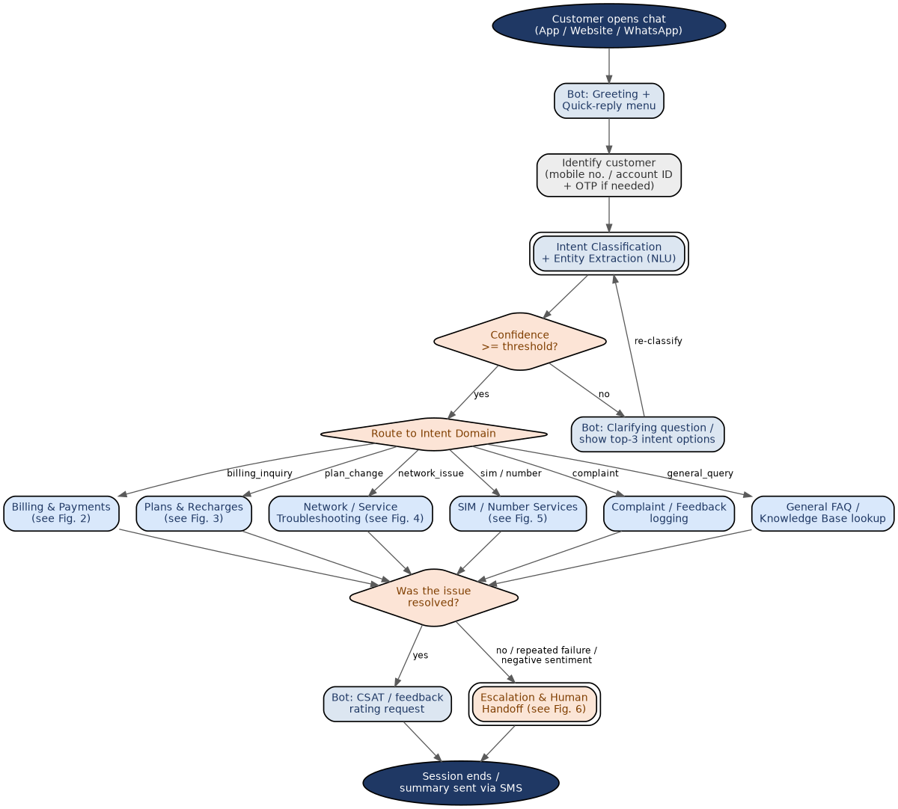
Fig. 1. Master Conversation Flow.
Design notes:
- Authentication happens once, immediately after greeting, so every downstream domain flow can assume an identified customer rather than re-asking for account details (directly addresses Rajesh Verma's frustration in Section 3).
- A confidence threshold gate sits before routing: below threshold, the bot asks a clarifying question and re-classifies rather than guessing and routing incorrectly.
- Every domain flow converges back to a single “was the issue resolved” check, which keeps the escalation logic (Fig. 6) in one place instead of duplicating it inside each domain flow.

6.2 Billing & Payment Flow
Implements UC-01 (check bill and pay) and UC-02 (dispute a charge). After the bill summary is shown, the flow forks into three independent paths — pay, download invoice, or dispute — each converging back to the master flow's CSAT check.
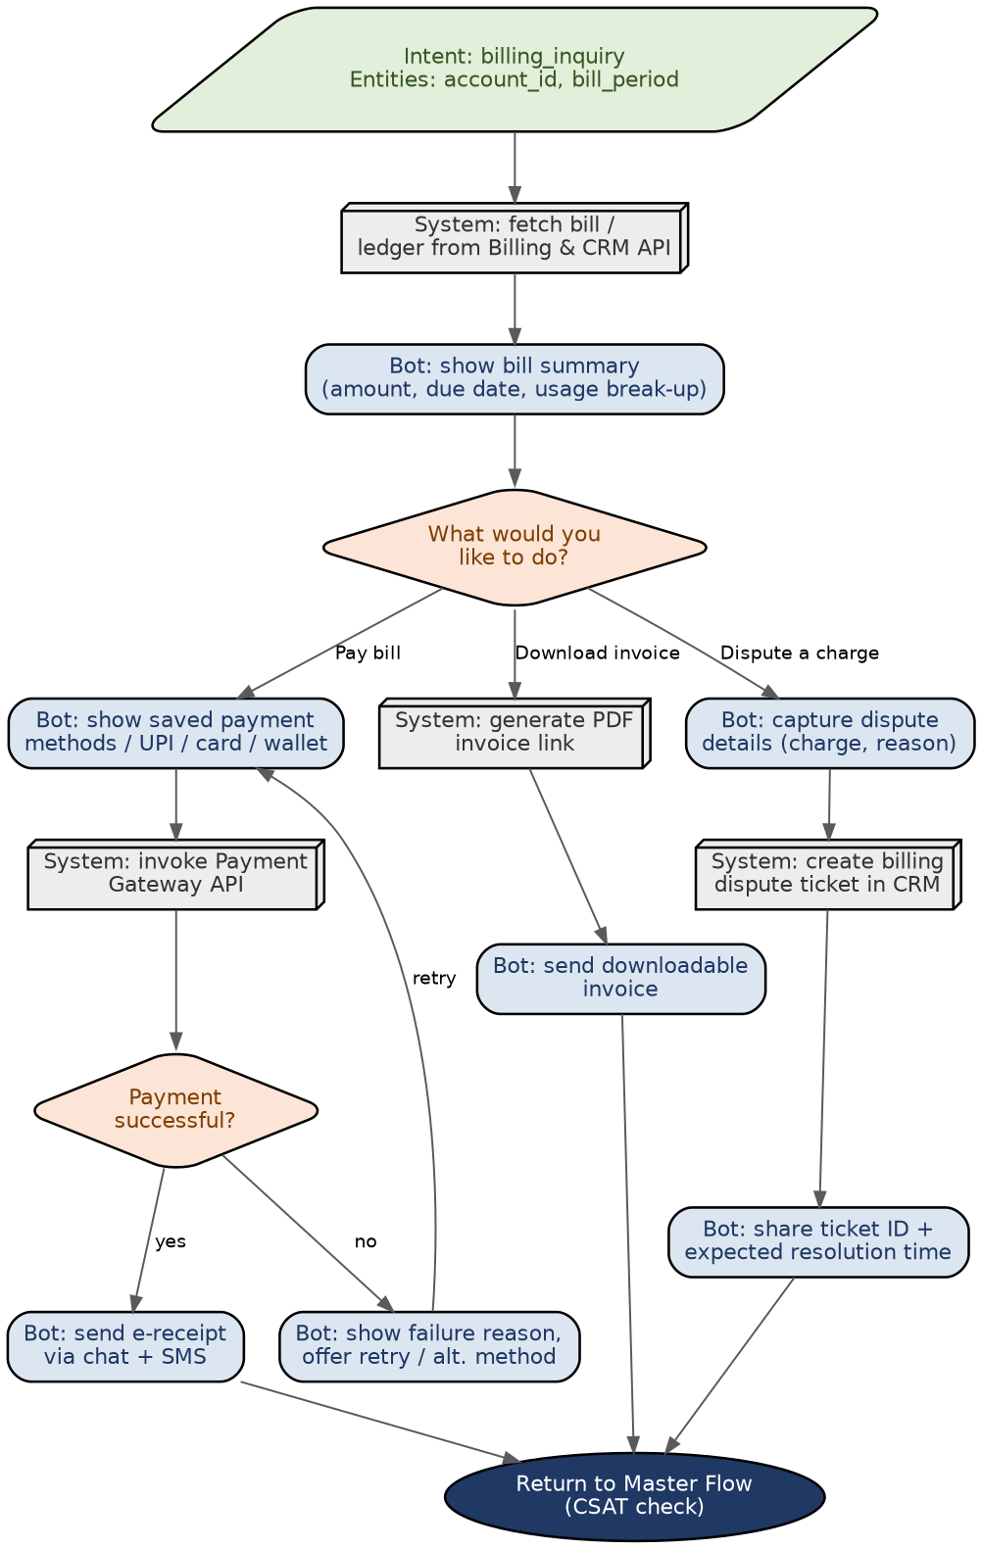
Fig. 2. Billing & Payment Flow.
Design notes:
- The pay-now path includes an explicit failure branch with a stated reason and a retry loop, rather than a dead end, addressing Ananya Sharma's frustration with unexplained recharge/payment failures.
- Disputing a charge always produces a ticket ID and a resolution timeframe — never just an acknowledgement — because vague timelines were flagged as a specific pain point for the small-business persona.
- Invoice download is kept as a separate, one-step path so a customer who only wants a document is not funnelled through the payment flow.

6.3 Plan Change / Upgrade Flow
Implements UC-03. The flow fetches usage data before recommending plans, checks eligibility before allowing a change, and explains — rather than simply blocking — when a change cannot be made.
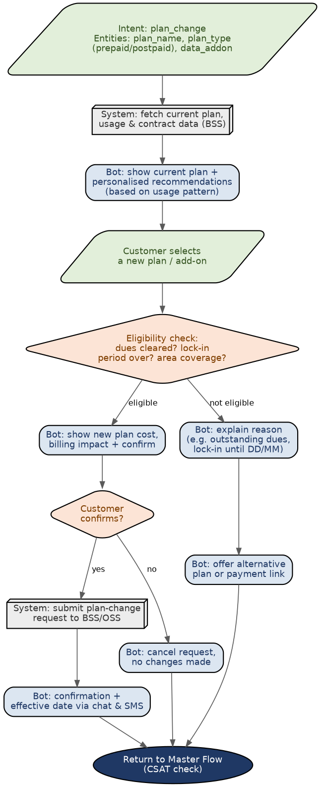
Fig. 3. Plan Change / Upgrade Flow.
Design notes:
- Recommendations are generated after fetching real usage data, not shown generically, directly addressing Karan Mehta's frustration with irrelevant upsell offers.
- The eligibility check (dues, lock-in, coverage) happens before the cost/confirmation step, so the customer never confirms a change that will later fail silently on the backend.
- The “not eligible” branch always ends in either an alternative offer or a payment link, never a bare rejection, in keeping with the no-dead-end principle established in Fig. 1.

6.4 Network & Service Troubleshooting Flow
Implements UC-04 and UC-05. An automated diagnostic check runs first; only when no known outage is found does the bot move to guided self-help steps, and only after those steps fail does it raise a ticket.
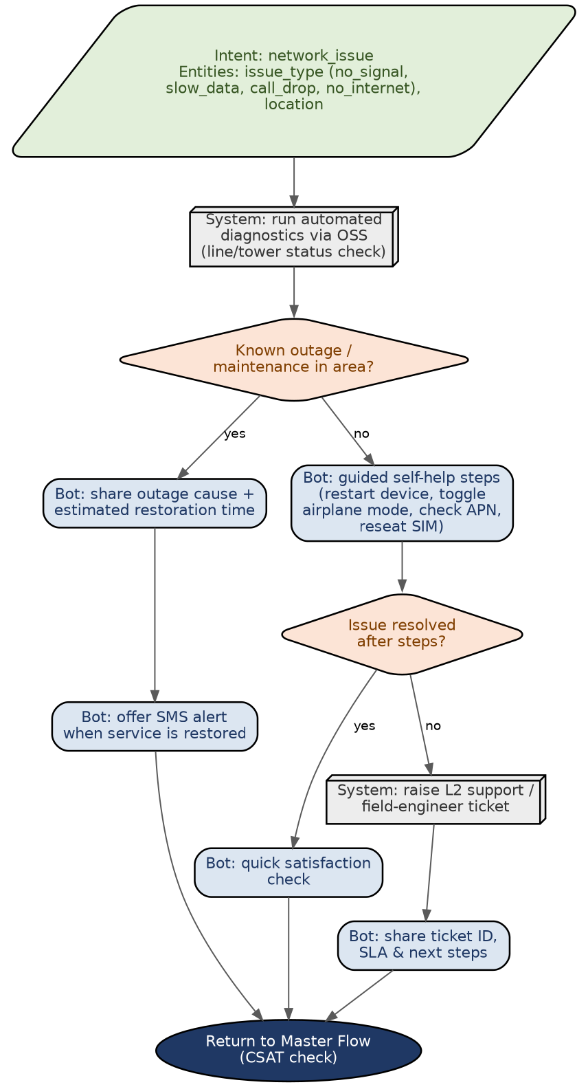
Fig. 4. Network & Service Troubleshooting Flow.
Design notes:
- Checking for a known outage before offering generic self-help steps directly answers Karan Mehta's complaint that troubleshooting scripts skip diagnostics and jump straight to “restart your device”.
- When a real outage is found, the flow ends in a proactive SMS-on-restoration offer rather than asking the customer to keep checking back.
- Self-help steps are shown as a single guided block (not one bot turn per step) to keep the conversation short for customers with low patience, while still allowing a low-digital-literacy customer to exit to a human agent at any point.

6.5 SIM / Number Services Flow
Implements UC-06. Identity verification (e-KYC) happens before any service-specific details are collected, since SIM and porting requests are the most regulation-sensitive flows in the catalogue.
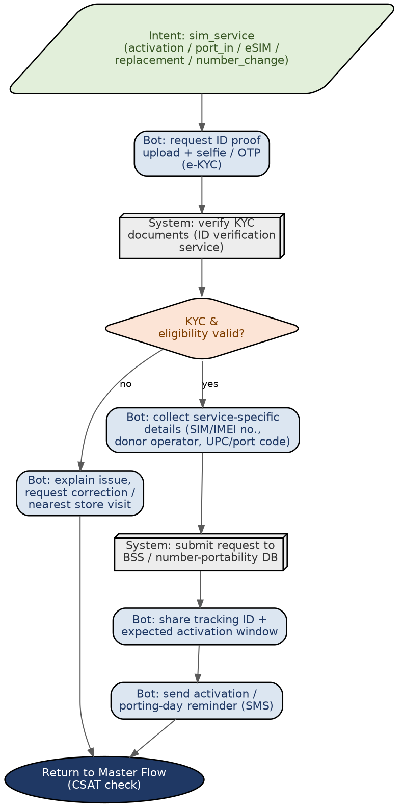
Fig. 5. SIM / Number Services Flow.
Design notes:
- KYC/eligibility verification is a hard gate before proceeding — a failed verification routes to correction or an in-store visit rather than allowing the flow to continue with unverified identity.
- Porting and activation both share the same downstream structure (collect details → submit to backend → track → remind) so the two journeys can reuse a single implementation with different entity sets.
- A reminder SMS closer to the activation/porting date was included because number-portability delays are a common source of repeat contacts in telecom support.

6.6 Escalation & Human Handoff Flow
This flow is entered from every domain flow in this section whenever the resolution check fails, and implements UC-07. It is deliberately the only place in the whole design where a human agent is brought in, so escalation behaviour stays consistent across all journeys.
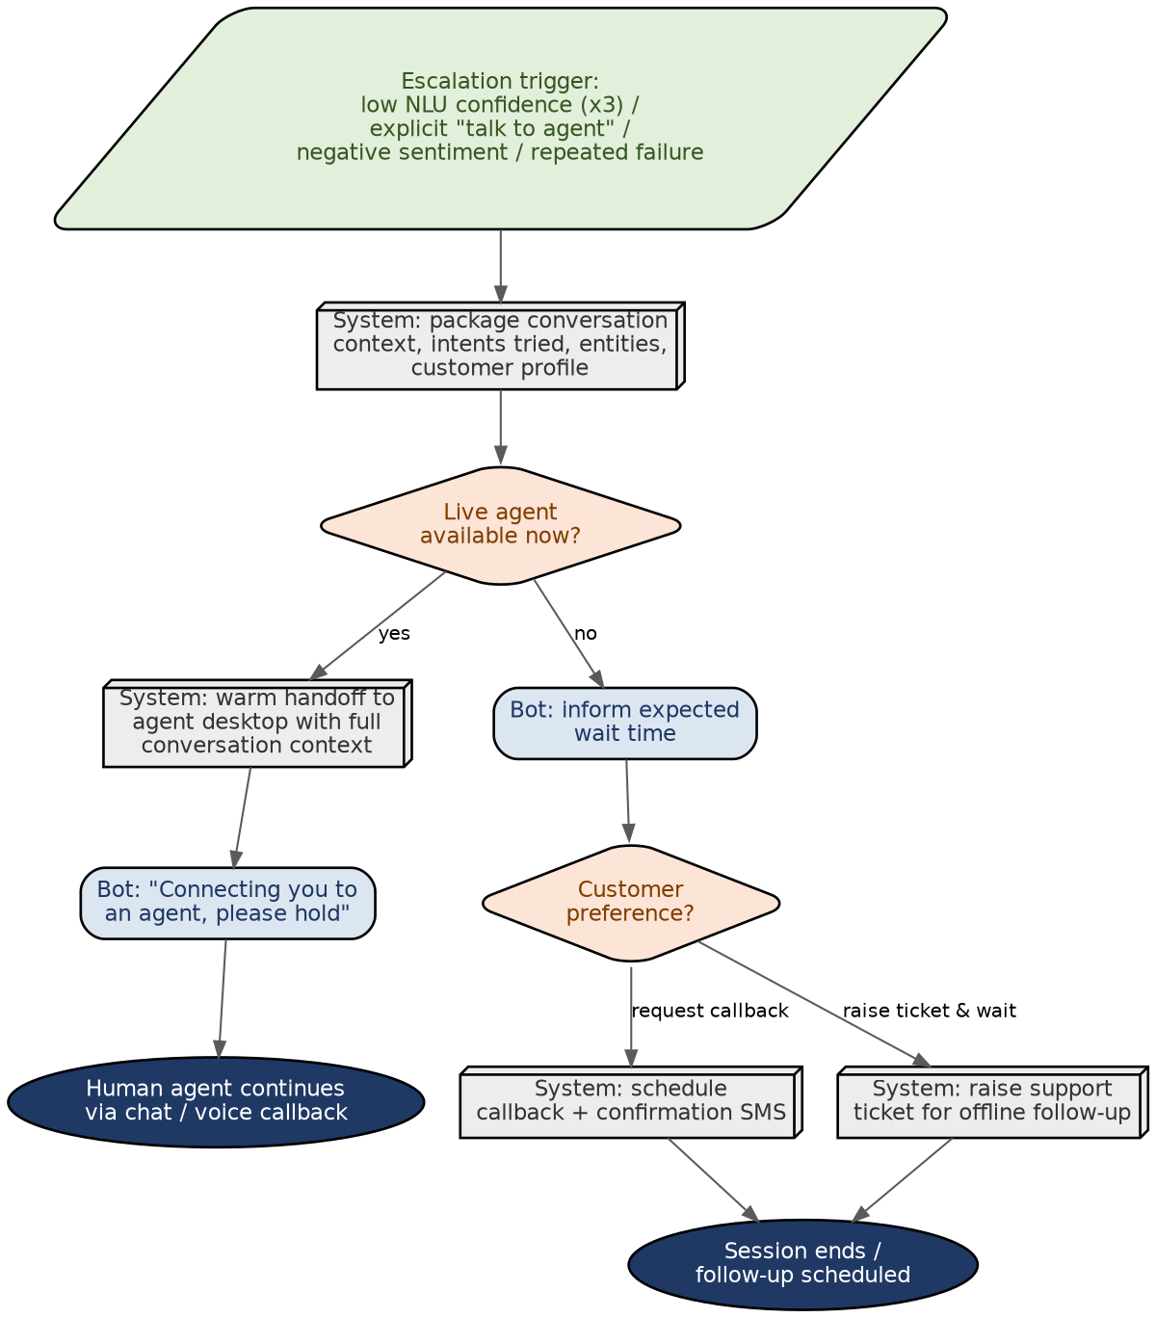
Fig. 6. Escalation & Human Handoff Flow.
Design notes:
- Four explicit triggers are defined (repeated low confidence, explicit request, negative sentiment, repeated failure) so escalation is not left to ad-hoc judgement during implementation.
- Context is packaged and attached before handoff so the customer is never asked to repeat what they already told the bot — the single most consistent complaint about bot-to-human handoff in the underlying research.
- When no agent is available, the customer is given a real choice (callback or an offline ticket) rather than an indefinite hold, which matters most for lower-patience personas such as Ananya Sharma and Rajesh Verma.

7. NLP & Conversational Design Decisions
This section documents the reasoning behind the design choices embedded in the flows above, organised by topic, so that the engineering team implementing them understands not just what to build but why.

7.1 Intent Classification Approach
Given the tiered intent catalogue in Section 5, the recommended approach is to train the initial NLU model on Tier 1 intents only, validate accuracy and confusion patterns in a pilot, and then progressively add Tier 2 and Tier 3 intents. This mirrors the research finding that successful telecom bot deployments start with 10–15 high-volume intents rather than full-domain coverage on day one. A confidence threshold (Fig. 1) should be tuned per intent rather than globally, since some intents (e.g., greeting) are inherently easier to classify with high confidence than others (e.g., billing_dispute, which overlaps linguistically with billing_inquiry).

7.2 Entity Extraction Strategy
Entities fall into three categories that should be extracted differently: (a) structured entities with a fixed format — mobile_number, otp, imei, port_code — which are best handled with pattern/regex-based extraction backed by NER as a fallback; (b) catalogue entities — plan_name, data_addon, issue_type — which should be matched against a live, regularly-synced list from the BSS rather than a static training-time list, so a new plan is recognisable the day it launches; and (c) free-text entities — complaint_category, dispute reason — which need NER/LLM-based extraction with a human-reviewable fallback when confidence is low.

7.3 Dialogue Management & Context Retention
Each flow diagram in Section 6 assumes a session-level context object that persists the customer's identity, the active domain flow, and any entities already captured. This avoids the single most common source of customer frustration identified in the personas — being asked to repeat information. Context should be explicitly cleared only at goodbye or explicit topic-switch, not on every bot turn, so a customer can say “actually, change that to the 2GB pack” mid-flow without restarting.

7.4 Fallback & Clarification Strategy
Rather than a single generic “I didn't understand that” fallback, the master flow's clarification step (Fig. 1) shows the top-3 candidate intents as quick replies. This converts a dead-end into a one-tap recovery and reduces the number of re-classification attempts, which in turn reduces unnecessary escalations. A hard cap (recommended: 2 failed clarification attempts) should trigger escalation automatically rather than letting the loop continue indefinitely.

7.5 Personalization
Two levels of personalization are embedded in the flows: account-level (fetching actual usage/billing data before making a recommendation, as in Fig. 3) and persona-level (tone and verbosity). The latter should be inferred lightly from observable signals — channel used, plan type, past escalation frequency — rather than requiring the customer to self-declare a persona, since Meera Iyer's persona in particular would not respond to being asked to categorise her own digital literacy.

7.6 Tone, Language & Multilingual Support
Default bot copy should be plain-language first, with technical terms (APN, eSIM profile, UPC code) explained inline in parentheses rather than assumed, directly addressing the jargon frustration surfaced for the senior-citizen persona. English plus at least one regional language should be supported at launch, with language detected from the customer's first message or profile setting and carried as session context (see Section 5 note on language_preference) so it does not need to be re-specified inside a domain flow.

7.7 Security, Authentication & Trust Signals
Every OTP request should be paired with an explicit trust message (e.g., “we will never call or message you asking for this code”), since unease about sharing OTPs in chat was a specific concern raised for the senior-citizen persona and is a well-documented telecom fraud vector. Authentication (Fig. 1) is deliberately placed once at the top of the master flow rather than repeated per domain, both for user experience and to keep the point of security enforcement centralised and auditable.

7.8 Integration Architecture
The flows assume five backend integration points: Billing & CRM (bill data, dispute tickets), BSS/OSS (plan data, network diagnostics, provisioning), Payment Gateway (transactions), ID-verification service (e-KYC for SIM/porting), and the Number-Portability database. Each is called synchronously within its flow so the bot can react to the result immediately (e.g., branch on payment success/failure); for the OSS diagnostic check in Fig. 4, a timeout fallback should route to guided self-help rather than block the conversation if the diagnostic call is slow.

8. Evaluation Criteria & Success Metrics
The following metrics are recommended to evaluate both the conversational design quality and, once implemented, the live chatbot's performance. Baseline targets are indicative and should be revisited after the initial pilot referenced in Section 7.1.
Metric | Definition | Indicative Target
Intent classification accuracy | % of live utterances correctly classified against the intent catalogue (Section 5) | ≥ 90% for Tier 1 intents
Entity extraction F1 score | Precision/recall balance for structured and catalogue entities | ≥ 0.85
Containment rate | % of conversations resolved without human escalation | ≥ 70% for Tier 1 intents
First Contact Resolution (FCR) | % of issues resolved within a single session, no repeat contact within 7 days | ≥ 80%
Average handling time | Median time from greeting to resolution or handoff, per domain flow | Track per flow (Figs. 2–6)
Fallback rate | % of turns where confidence fell below threshold and clarification was triggered | ≤ 10%
Escalation rate | % of sessions ending in human handoff (Fig. 6) | Track by trigger type
Customer Satisfaction (CSAT) | Post-session rating captured via feedback_rating intent | ≥ 4.2 / 5
These metrics also map directly back to the design-quality criteria for this document itself: clarity and depth of analysis are best judged by whether a reader unfamiliar with the project could implement Section 6's flows without further clarification, and creativity in conversational design is reflected in the no-dead-end principle applied throughout (every branch in every flow leads to either resolution or a tracked escalation, never a silent stop).

9. Assumptions, Constraints & Risks

9.1 Assumptions
- The telecom operator has existing Billing/CRM, BSS/OSS, Payment Gateway, and ID-verification systems that expose (or can expose) APIs; this design does not assume a specific vendor.
- The chatbot will be deployed across at least app, web, and WhatsApp, with a shared backend so conversation state and history are channel-agnostic.
- A human-agent desk-top/queueing system exists or is planned, since the escalation flow (Fig. 6) depends on live-agent availability data.
- Regional language support beyond English will be prioritised based on the operator's actual subscriber-language distribution, not assumed in this document.

9.2 Constraints
- Payment-related flows must remain within PCI-DSS scope; the bot should never itself store raw card details, only orchestrate the payment gateway.
- SIM activation and number-portability flows are subject to telecom regulatory KYC requirements, which constrains how much of that journey can be fully automated versus requiring document verification.
- Response latency for OSS diagnostic calls (Fig. 4) may vary by region/infrastructure, requiring a timeout and fallback path rather than an assumed fixed response time.

9.3 Risks
Risk | Impact | Mitigation
Intent overlap / misclassification between closely related intents (e.g., billing_inquiry vs. billing_dispute) | Medium | Use confusion-matrix analysis during pilot; add clarifying quick replies for the most-confused intent pairs.
Over-automation eroding trust for low-digital-literacy customers | Medium | Keep a persistent, one-tap human-agent option visible at every step (Section 7.5, Fig. 1).
Backend integration latency degrading conversational experience | Medium | Define per-integration timeout budgets and fallback behaviour (Section 7.8).
Fraud risk from OTP-sharing social engineering that mimics the bot | High | Explicit trust messaging on every authentication prompt (Section 7.7); never request OTP twice in one flow.
Regional language quality gaps at launch | Medium | Launch with English plus the operator's top regional language; expand based on usage data.

10. Conclusion & Next Steps
This document has translated public research on telecom customer-support automation into a concrete, implementable design baseline: four personas spanning the realistic range of telecom subscribers, seven use case scenarios covering the highest-value journeys, a 22-intent catalogue tiered by priority, and six conversational flow diagrams that specify exact bot behaviour at every decision point, including a single consistent escalation path. Every design choice in Section 7 is traceable back to either a persona pain point (Section 3) or a research finding (Section 2.1), which should make the reasoning easy to audit and revise as real usage data becomes available.
Recommended next steps beyond this Week 1 deliverable:
- Validate the intent catalogue and utterance examples against a sample of real historical customer queries, if available, and refine Tier 1 boundaries accordingly.
- Build NLU training data (utterances + entity annotations) for the Tier 1 intents and run an initial classification accuracy benchmark against the targets in Section 8.
- Confirm the exact API contracts for the five backend integration points listed in Section 7.8 with the systems team.
- Pilot the master flow and the billing flow (the two highest-volume paths) end-to-end before extending to the remaining domain flows.
- Define the regional language(s) to launch with, based on actual subscriber demographics.

References
The following publicly available sources were consulted while researching common telecom chatbot use cases, benefits, and industry trends referenced in Section 2.1 and throughout this document. All content in this document is original analysis and design work; these sources informed the general domain understanding only.
- LiveChatAI — “Telecom Chatbot: Use Cases, Benefits & How to Build One” (2026), livechatai.com/blog/telecom-chatbot
- Kommunicate — “AI Customer Service in Telecom: Use Cases, Benefits, and How it Works in 2026”, kommunicate.io/blog/tag/ai-customer-service-in-telecom
- Codewave — “Chatbot for Telecom: Use Cases, Benefits and Examples”, codewave.com/feeds/blog/chatbot-telecom
- Streebo — “Top AI Agent Development Companies for Telecom in 2026” (July 2026), streebo.com
- Which? / Ofcom-referenced consumer research — “AI in Telecoms” (UK consumer opportunities and risks briefing), media.product.which.co.uk
- Robylon AI — “Proven AI Chatbot Use Cases for Business in 2026”, robylon.ai/blog/ai-chatbot-use-cases-2026
- RetellAI — “Conversational AI for Telecom: Use Cases, Benefits and How It Works”, retellai.com/blog/conversational-ai-for-telecom

