**大数据项目**

**电商分析系统**

**V2.0**

# 需求五：

实时数据分析： 广告点击量实时统计

# 1 需求简介

每天各地区各城市各广告的点击流量实时统计。

数据源字段：

*timestamp province city userid adid*

|  |  |
| --- | --- |
| 字段名 |  |
| timestamp | **当前时间毫秒** |
| area | **地区：华北、华南** |
| city | **城市名： 北京、上海、广州、深圳、天津** |
| userid | **用户id 1-6** |
| adid | **广告id 1-6** |

kafka消息队列主题：

topic: ads_log

# 3 目标数据字段

redis保存为一条hash结构 的kv

|  |  |
| --- | --- |
| key |  |
| date:area:city:ads | field: 2018-11-26:华北:北京:5 value: 12001 |

**Redis中key,value的限制**

|  |
| --- |
| **What is the maximum number of keys a single Redis instance can hold? and what the max number of elements in a Hash, List, Set, Sorted Set?**  Redis can handle up to 2^32 keys, and was tested in practice to handle at least 250 million keys per instance.  Every hash, list, set, and sorted set, can hold 2^32 elements.  In other words your limit is likely the available memory in your system. |

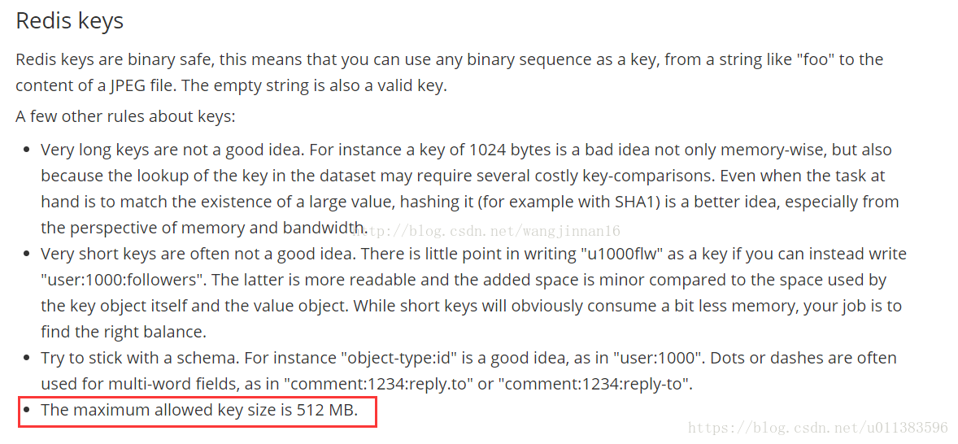

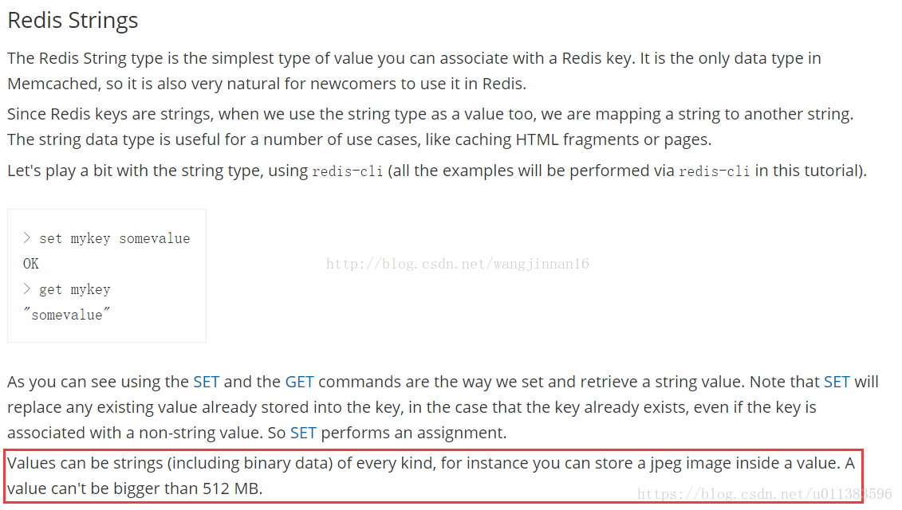

# 4 思路：

# 5 代码