**高等積體電路設計 Advanced VLSI Final Report**

Group 13

電子所R10943170 連德宇, R10943028 趙彥安

* Model architecture
* Improvement:   
  With only using our model for training, we can only obtain accuracy about 80%. This is really not good enough, so we apply a few strategies to improve our performance:
  1. Data argument:

By generating additional training data through data image rotation and shifting, we can get more accurate with the increasing variation of training data.

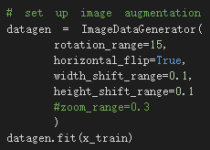  
Figure 1: Valid data accuracy improved from 80% to 85%.

* 1. Dropout & Learning rate Scheduler

Since training data and valid data’s accuracy has a very large disparity (about 10%), we use dropout to decrease overfitting. Moreover, we apply learning rate scheduler to decrease learning by epoch.

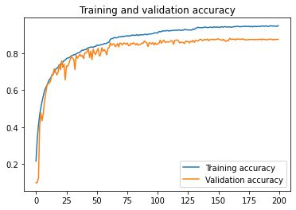

Figure 2: Training and Valid accuracy

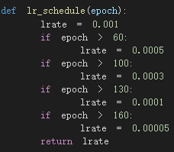

Figure 3: Learning rate scheduler

Finally, we get valid data accuracy improved from 85% to 88%.



Figure 4: Screenshot of accuracy

* Parameters
* Figure 4: Screenshot of model.summary():

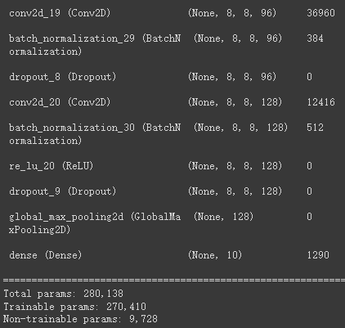

* Figure 4: Screenshot of Bytes after quantized:

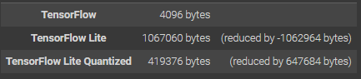

* Figure 4: Screenshot of memory resource:

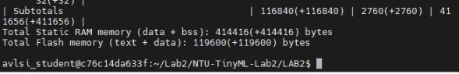

* MCU performance