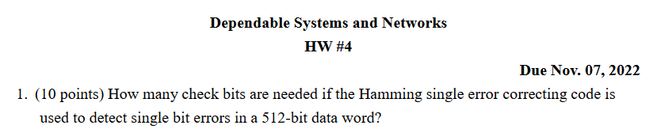

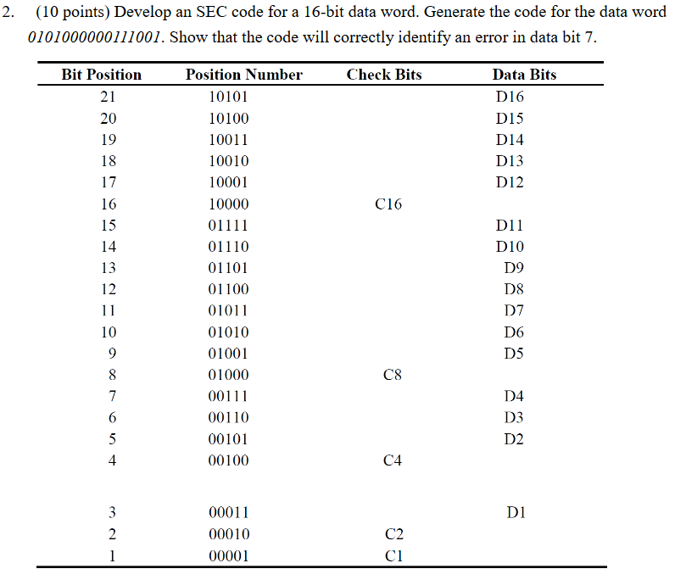

$$Sol: \\ Check bits K要滿足 512 + K ≤ 2^{K}– 1 ⇒ K ≥ 10 \\ 故check bits 至少要=10$$

$$Sol:$$

|  |  |  |  |  |  |  |  |  |  |  |  |  |  |  |  |  |  |  |  |  |  |
| --- | --- | --- | --- | --- | --- | --- | --- | --- | --- | --- | --- | --- | --- | --- | --- | --- | --- | --- | --- | --- | --- |
|  | **1** | **2** | **3** | **4** | **5** | **6** | **7** | **8** | **9** | **10** | **11** | **12** | **13** | **14** | **15** | **16** | **17** | **18** | **19** | **20** | **21** |
|  | **C1** | **C2** | **D1** | **C4** | **D2** | **D3** | **D4** | **C8** | **D5** | **D6** | **D7** | **D8** | **D9** | **D10** | **D11** | **C16** | **D12** | **D13** | **D14** | **D15** | **D16** |
| **data** | **1** | **0** | **1** | **0** | **0** | **0** | **1** | **0** | **1** | **1** | **0** | **0** | **0** | **0** | **0** | **0** | **0** | **1** | **0** | **1** | **0** |
| **C1** | **\*** |  | **\*** |  | **\*** |  | **\*** |  | **\*** |  | **\*** |  | **\*** |  | **\*** |  | **\*** |  | **\*** |  | **\*** |
| **C2** |  | **\*** | **\*** |  |  | **\*** | **\*** |  |  | **\*** | **\*** |  |  | **\*** | **\*** |  |  | **\*** | **\*** |  |  |
| **C4** |  |  |  | **\*** | **\*** | **\*** | **\*** |  |  |  |  | **\*** | **\*** | **\*** | **\*** |  |  |  |  | **\*** | **\*** |
| **C8** |  |  |  |  |  |  |  | **\*** | **\*** | **\*** | **\*** | **\*** | **\*** | **\*** | **\*** |  |  |  |  |  |  |
| **C16** |  |  |  |  |  |  |  |  |  |  |  |  |  |  |  | **\*** | **\*** | **\*** | **\*** | **\*** | **\*** |
| **error data** | **1** | **0** | **1** | **0** | **0** | **0** | **1** | **0** | **1** | **1** | **1** | **0** | **0** | **0** | **0** | **0** | **0** | **1** | **0** | **1** | **0** |
|  | **0** | **1** |  |  |  |  |  | **1** |  |  |  |  |  |  |  |  |  |  |  |  |  |

C16=0, C8=0, C4=0, C2=0, C1=1

因此，code word = 010100000001101000101

如果data bit 7 發生錯誤，則變為C16=0, C8=1, C4=0, C2=1,C1=0

00001⊕01010 = 01011，表示在1+2+8個bit 發現錯誤，也就是D7

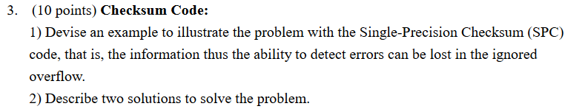

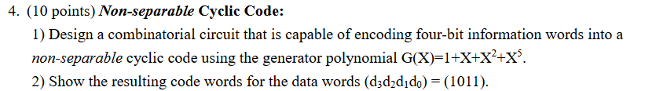





Sol:



$$Sol: \\ N bits中有 M 個bits為 1$$

因此 $m+1 or m-1 bits為1時都可以被detected$

故 $Hamming distance d= e + 1= 1 + 1 = 2$

$$Capability :1. correct a single bit error$$

2.

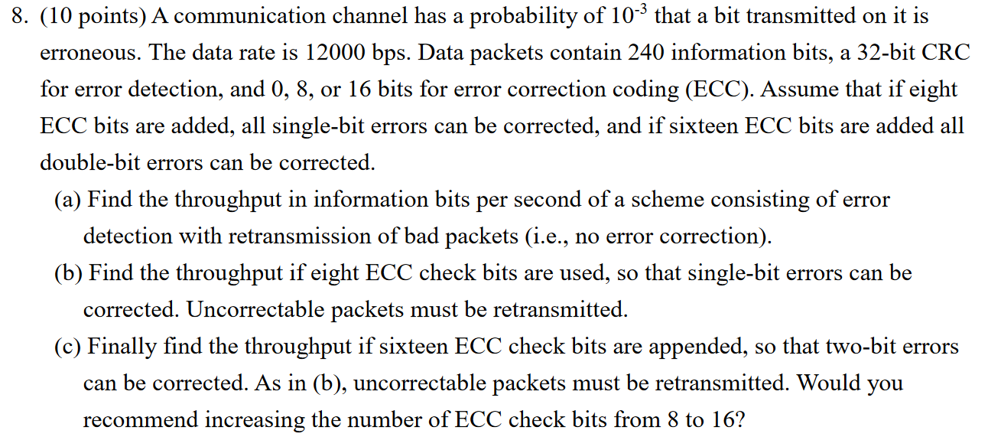



|  |  |  |
| --- | --- | --- |
| Data word | non-separable code word | separable code word |
| 0000 | 00000 | 00000 |
| 0001 | 00011 | 00011 |
| 0010 | 00110 | 00101 |
| 0011 | 00101 | 00110 |
| 0100 | 01100 | 01001 |
| 0101 | 01111 | 01010 |
| 0110 | 01010 | 01100 |
| 0111 | 01001 | 01111 |
| 1000 | 11000 | 10001 |
| 1001 | 11011 | 10010 |
| 1010 | 11110 | 10100 |
| 1011 | 11101 | 10111 |
| 1100 | 10100 | 11000 |
| 1101 | 10111 | 11011 |
| 1110 | 10010 | 11101 |
| 1111 | 10001 | 11110 |

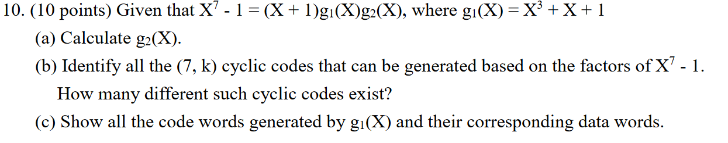

$$Sol:$$ $\left(a\right) g_{2}\left(x\right)=x^{3}+x^{2}+1$.

$$\left(b\right)$$

|  |  |
| --- | --- |
| Generator | Cyclic code |
| X+1 | (7,6) code |
| $$g_{1}\left(x\right)$$ | (7,4) code |
| $$g_{2}\left(x\right)$$ | (7,4) code |
| $$(X+1)*g_{1}\left(x\right)$$ | (7,3) code |
| $$(X+1)*g_{2}\left(x\right)$$ | (7,3) code |
| $${g_{1}\left(x\right)g}_{2}\left(x\right)$$ | (7,1) code |

|  |  |  |
| --- | --- | --- |
| Data word | non-separable code word | separable code word |
| 0000 | 0000000 | 0000000 |
| 0001 | 0001011 | 0001011 |
| 0010 | 0010110 | 0010110 |
| 0011 | 0011101 | 0011101 |
| 0100 | 0101100 | 0100111 |
| 0101 | 0100111 | 0101100 |
| 0110 | 0111010 | 0110001 |
| 0111 | 0110001 | 0111010 |
| 1000 | 1011000 | 1000101 |
| 1001 | 1010011 | 1001110 |
| 1010 | 1001110 | 1010011 |
| 1011 | 1000101 | 1011000 |
| 1100 | 1110100 | 1100010 |
| 1101 | 1111111 | 1101001 |
| 1110 | 1100010 | 1110100 |
| 1111 | 1101001 | 1111111 |