Business Analysis Document
Aurum / ORM Production Deployment – Access & Architecture Strategy

Document Version: 1.0
Date: 11 March 2026
Status: Draft – Pending InfoSec Review
Prepared By: Deyuran Moodly (Project Lead)
Distribution: IT Architecture · InfoSec · Project Team

Table of Contents
- 1. Executive Summary
- 2. Project Background & Context
- 3. Current State Analysis
- 4. Future State Architecture
- 5. Options Analysis
- 6. Recommendations
- 7. Risk Register
- 8. Action Items & Next Steps
- 9. Glossary
- 10. Contact List
- 11. Approvals

1. Executive Summary
This document captures the analysis and recommendations arising from the architecture review meeting held on 10 March 2026 regarding the production deployment of the Aurum/ORM platform. The primary objective of the meeting was to determine the most appropriate and policy-compliant method by which 5–10 end-users will access the application in the live environment, targeting an April 2026 go-live date.
Three access options were evaluated: (1) direct client installation on user endpoints, (2) Remote Desktop Protocol (RDP) access to a centralised application server (DUB-ORUM-01), and (3) a Virtual Desktop Infrastructure (VDI) solution. Based on the discussion, Option 2 is the technically preferred approach from a latency and performance perspective, while Option 3 provides stronger security controls. A formal InfoSec review is required before the final architecture decision is confirmed.
Key outcome: Marco Van Der Rheede will initiate a discussion with the Information Security team, including Jean-Pierre Lishman and Server Core representatives, to validate the chosen option against company policy prior to the production go-live.

2. Project Background & Context
The Aurum/ORM platform was initially scoped with an IT architecture review conducted in September/October 2024, at which time Option 2 (RDP to application server) was approved and deployed for user-acceptance testing (UAT). The development and testing environment has been functioning under this arrangement, and users are accustomed to the RDP-based access model.
Closer to the planned production go-live, it was flagged that the direct-RDP approach may conflict with current company IT access policies. Users do not connect to other business applications via RDP, and this anomaly was escalated to prompt a formal review.

2.1 System Components
Component | Hostname / Identifier | Role
Application Server | DUB-ORUM-01 | Hosts Aurum client, Aurum Scheduler, application logic
Database Server | WDV05 | SQL Server holding Aurum/ORM data (no direct user access)
File Share | TBD | Stores licence files, product configuration files
Finance System | Back-Office ERP | Target of financial data integration via API
AWS S3 | Cloud (via Firewall) | External data source accessed outbound

3. Current State Analysis
In the current UAT/pre-production environment, users connect directly via RDP to the application server DUB-ORUM-01. The Aurum client is installed on that server, which in turn communicates with the back-end database (WDV05), file shares, and external finance/back-office systems.
Remote workers access the environment through Palo Alto Prisma SASE gateways deployed geographically close to users, minimising VPN latency. The arrangement has been operationally satisfactory, with only occasional RDP connectivity issues resolved via IT support tickets.

3.1 Current State Architecture Diagram
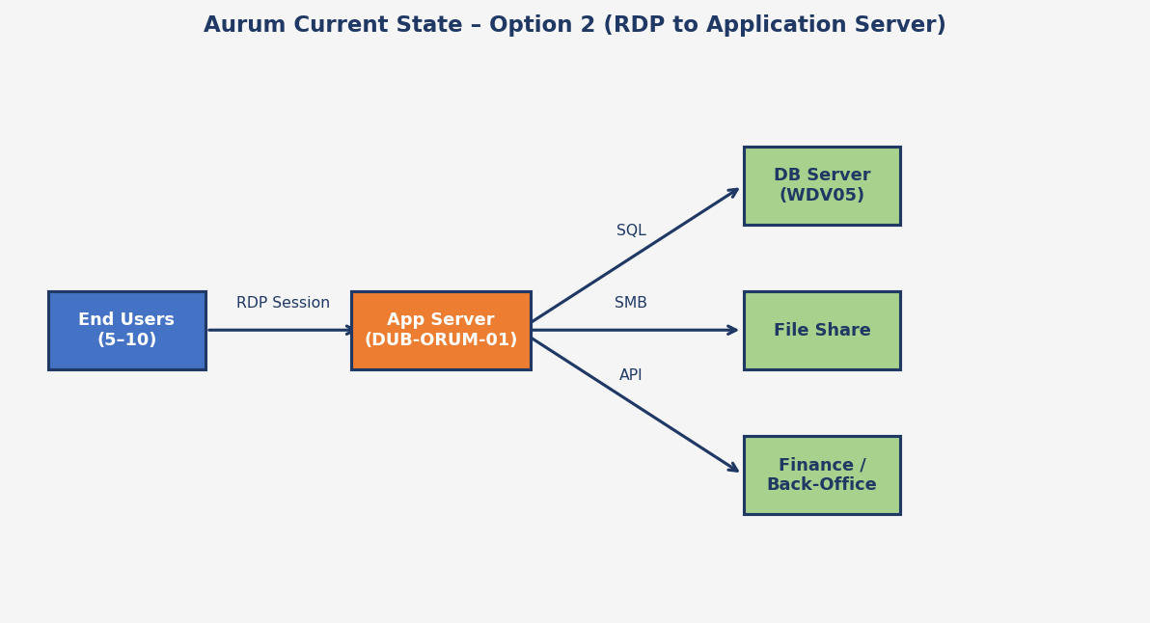
Figure 1 – Aurum Current State: End-users connect via RDP to the application server, which communicates with back-end systems directly.

3.2 Current State Pain Points
- Potential conflict with company IT access-control policy (RDP to production servers).
- SOX and ISO compliance concerns: direct access paths from user sessions to financial databases are flagged as a risk by InfoSec.
- Scalability: current setup has not been load-tested for concurrent RDP sessions.
- Audit trail: user actions on the application server require enhanced logging.

4. Future State Architecture
The future state establishes a policy-compliant, secure pathway for end-users to access the Aurum/ORM platform in production. Two candidate architectures remain under consideration, pending the outcome of the InfoSec review:
Option 2 (Preferred – Jump Box/RDP): Users connect via Palo Alto Prisma SASE to a dedicated application/jump-box server (DUB-ORUM-01). All back-end connectivity originates from the server, not from user endpoints. This model keeps the existing UAT topology, requires minimal rework, and offers the best performance for the 5–10 user base.
Option 3 (Under Review – VDI): A ring-fenced Virtual Desktop Infrastructure is provisioned. Users connect to a managed virtual desktop, further isolating endpoint risk. This provides stronger security controls but introduces higher cost and potentially greater latency versus Option 2.

4.1 Future State Architecture Diagram
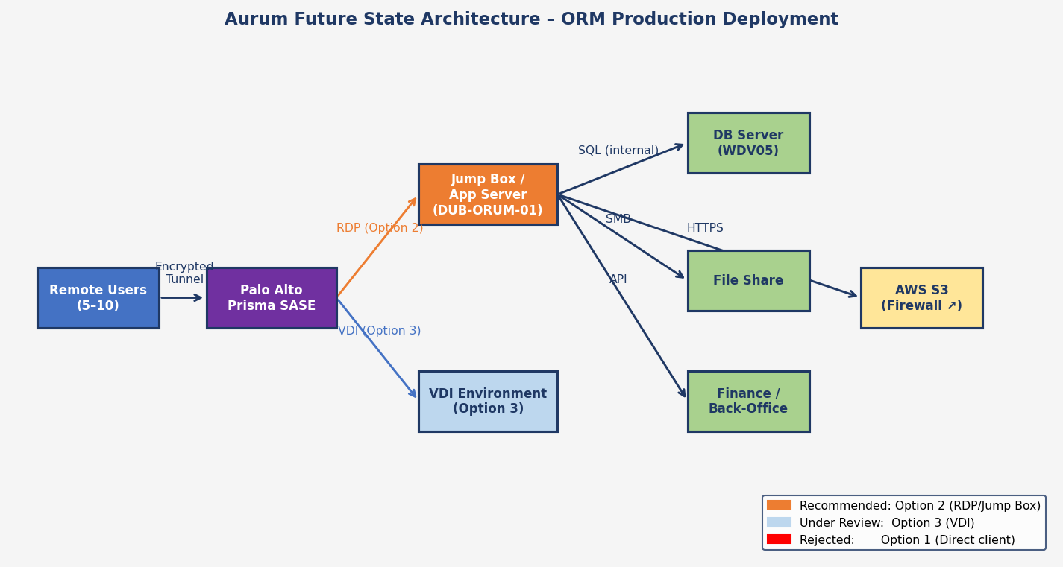
Figure 2 – Aurum Future State: Remote users connect through Palo Alto Prisma SASE, then via RDP (Option 2) or VDI (Option 3) to the application server.

4.2 Aurum Scheduler Job Flow
In the future state, individual users do not require direct network access to back-end data sources. Instead, they trigger scheduled import jobs via the Aurum UI. The Aurum Scheduler (running on the application server) fetches data from external sources and populates the Aurum interface. Users then view the results. The only direct user access required is to the folder containing licence and product configuration files.
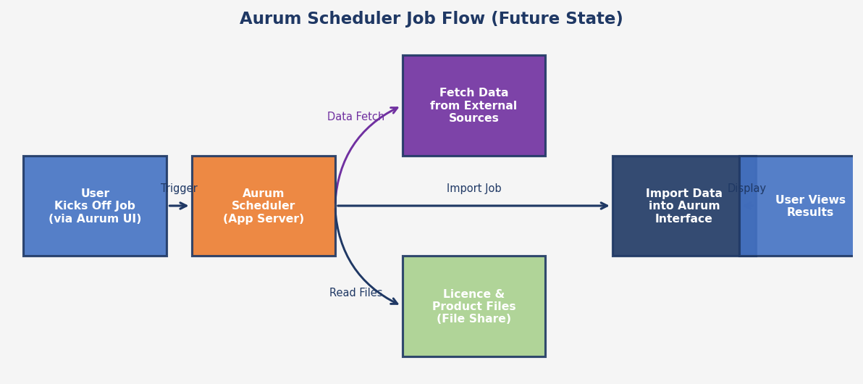
Figure 3 – Aurum Scheduler Job Flow: users trigger import jobs; the scheduler handles all back-end data access.

5. Options Analysis

5.1 Comparison Diagram
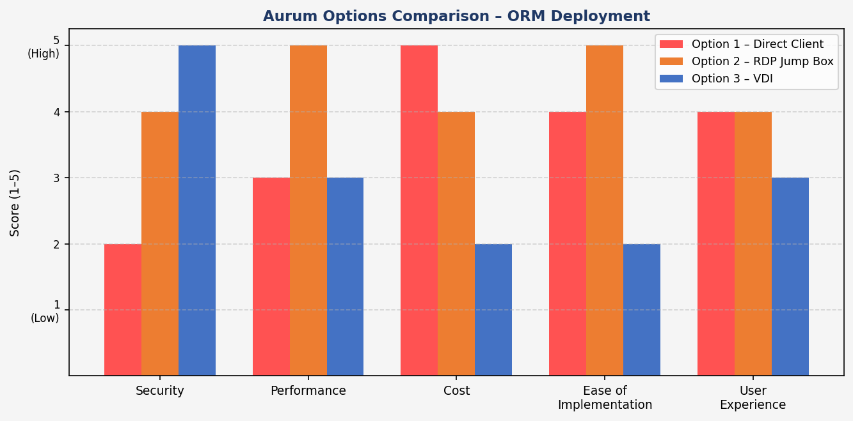
Figure 4 – Aurum Options Comparison: scored 1 (low) to 5 (high) across key criteria.

5.2 Detailed Options Table
Option | Description | Pros | Cons | Recommendation
Option 1  Direct Client | Aurum client installed on user endpoints; users connect directly to DB, file share, and finance systems. | • Familiar desktop experience  • No additional server needed | • Direct DB/financial system access from endpoints  • High SOX/ISO risk  • Latency on slow home Wi-Fi  • Complex network rules | ❌ Rejected
Option 2  RDP Jump Box  (Recommended) | Aurum client on centralised app server (DUB-ORUM-01); users RDP in via Prisma SASE. | • Low latency (client next to DB)  • Already deployed for UAT  • Minimal rework  • Small user base (5–10) suits this model  • Users familiar with the setup | • RDP policy conflict – requires InfoSec sign-off  • Less isolated than VDI  • All users share one server session space | ✅ Preferred  (pending InfoSec)
Option 3  VDI | Ring-fenced Virtual Desktop Infrastructure; users connect to a managed VDI session. | • Strongest security isolation  • Better access controls (SOX/ISO)  • Portable, auditable sessions | • Significant additional cost  • Provisioning lead time  • Higher latency than Option 2  • Overkill for 5–10 users | ⚠️ Under Review  (cost/benefit)

6. Recommendations
ID | Recommendation | Priority | Rationale
R1 | Proceed with Option 2 (RDP Jump Box) | High | Option 2 offers the best balance of performance, cost, and implementation speed for a 5–10 user deployment.
R2 | Obtain InfoSec sign-off before production go-live | Critical | Marco Van Der Rheede to convene a session with InfoSec, Server Core, and Jean-Pierre Lishman to confirm policy compliance.
R3 | Enable Aurum Scheduler for all import jobs | Medium | Reduce end-user network exposure by routing all data-fetch jobs through the Aurum Scheduler.
R4 | Restrict user file-share access to licence/product folder only | Medium | Apply least-privilege controls so RDP users can only access the specific folder required.
R5 | Implement enhanced audit logging on DUB-ORUM-01 | High | Ensure all user activity is logged and retained in compliance with SOX and ISO requirements.

7. Risk Register
Risk ID | Description | Likelihood | Impact | Severity | Mitigation
RSK-01 | InfoSec rejects Option 2; delay to go-live | Medium | High | High | Commence InfoSec discussion immediately; prepare Option 3 contingency estimate
RSK-02 | April go-live missed due to unresolved policy issue | Medium | High | High | Escalate to project sponsor; agree revised timeline if Option 3 is required
RSK-03 | Latency degradation for remote users on Option 3 (VDI) | High | Medium | High | Conduct performance benchmarking before committing to VDI
RSK-04 | Concurrent RDP sessions cause performance issues (Option 2) | Low | Medium | Low | Monitor server resource usage during UAT peak load; right-size server if needed
RSK-05 | SOX/ISO non-compliance if audit logging is insufficient | Low | High | Medium | Implement logging framework on app server per InfoSec requirements
RSK-06 | Scope creep if user numbers exceed 10 | Low | Medium | Low | Re-evaluate architecture if user count exceeds 10; consider VDI at that scale

8. Action Items & Next Steps
Action ID | Action | Owner | Due Date | Status
AI-01 | Initiate InfoSec discussion on Option 2 policy compliance; include Server Core and JP Lishman | Marco Van Der Rheede | ASAP / Week of 16 Mar 2026 | Open
AI-02 | JP Lishman to review the full architecture design document prior to InfoSec meeting | Jean-Pierre Lishman | 16 Mar 2026 | Open
AI-03 | Deyuran Moodly to liaise with Chris (IT) to provide inputs for InfoSec discussion | Deyuran Moodly | 16 Mar 2026 | Open
AI-04 | Confirm production server name and network path for Option 2 jump-box topology | Luis Silva | 16 Mar 2026 | Open
AI-05 | Prepare contingency estimate for Option 3 (VDI) in case InfoSec requires it | Marco Van Der Rheede / JP Lishman | 23 Mar 2026 | Open
AI-06 | Circulate approved architecture decision to project team | Marco Van Der Rheede | Post InfoSec meeting | Open
AI-07 | Confirm final user list (names + locations) for production access provisioning | Kerri Bersella | 23 Mar 2026 | Open
AI-08 | Validate Aurum Scheduler configuration for scheduled import jobs in production | Tim Andrews | 30 Mar 2026 | Open

9. Glossary
Term / Acronym | Definition
Aurum / ORM | The enterprise planning and analytics platform being deployed to production.
RDP | Remote Desktop Protocol – a Microsoft protocol enabling users to connect to and control a remote computer over a network.
VDI | Virtual Desktop Infrastructure – a technology that hosts desktop environments on centralised servers, delivered to users over a network.
Jump Box / Bastion Host | A dedicated, hardened server through which users connect to access other systems, reducing direct exposure of back-end infrastructure.
Palo Alto Prisma SASE | A cloud-delivered Secure Access Service Edge platform providing secure, low-latency network access to remote users via geographically distributed gateways.
DUB-ORUM-01 | The application server hosting the Aurum client and Aurum Scheduler.
WDV05 | The SQL Server database server for Aurum/ORM (no direct user access permitted).
Aurum Scheduler | A built-in job scheduler within the Aurum platform used to automate data-import tasks from external sources.
SOX | Sarbanes-Oxley Act – US legislation imposing controls on financial data access, storage, and audit trails.
ISO 27001 | International information security management standard governing IT security controls.
InfoSec | Information Security team responsible for evaluating and approving IT architecture decisions.
Server Core | Internal team responsible for server infrastructure, provisioning, and management.
SASE | Secure Access Service Edge – a network architecture combining WAN capabilities and network security functions into a single cloud service.
UAT | User Acceptance Testing – the phase of testing where end-users validate the system against business requirements.
Go-Live | The date on which the system transitions from testing to production use.

10. Contact List
Name | Role / Title | Organisation | Responsibilities
Deyuran Moodly | Project Lead | FreshTake | Overall project ownership; liaison between business and IT; April go-live target
Jean-Pierre Lishman | IT Architect / Infrastructure Lead | IT Department | Architecture design; InfoSec escalation point; RDP/VDI technical guidance
Marco Van Der Rheede | IT Project Manager / Coordinator | IT Department | Action owner – InfoSec discussion; Server Core coordination
Kerri Bersella | Business Analyst / UAT Lead | FreshTake | UAT coordination; user access requirements; go-live readiness
Tim Andrews | Technical Consultant (Aurum) | Aurum Vendor | Aurum Scheduler configuration; application architecture advice
Luis Silva | Infrastructure / Server Admin | IT Department | Server naming and network topology; production server details
Chris (surname TBC) | IT Security / Access Management | IT Department | RDP access policy enforcement; initial policy flag that triggered this review

11. Approvals
This document requires the following approvals before the recommended architecture is implemented in the production environment. All signatories confirm that they have read the document and agree with the recommendations contained herein.
Name | Role | Decision | Signature | Date
Deyuran Moodly | Project Lead / Business Owner | ☐ Approved ☐ Rejected ☐ Changes Required
Jean-Pierre Lishman | IT Architecture Lead | ☐ Approved ☐ Rejected ☐ Changes Required
Marco Van Der Rheede | IT Project Manager | ☐ Approved ☐ Rejected ☐ Changes Required
InfoSec Representative | Information Security | ☐ Approved ☐ Rejected ☐ Changes Required
Kerri Bersella | Business Analyst / UAT Lead | ☐ Approved ☐ Rejected ☐ Changes Required

11.1 Document Version History
Version | Date | Author | Changes
1.0 | 11 Mar 2026 | Deyuran Moodly | Initial draft – based on meeting transcript of 10 Mar 2026
1.1 | 11 Mar 2026 | Deyuran Moodly | Diagram titles updated to Aurum branding
1.2 | TBD | TBD | Post InfoSec review updates

