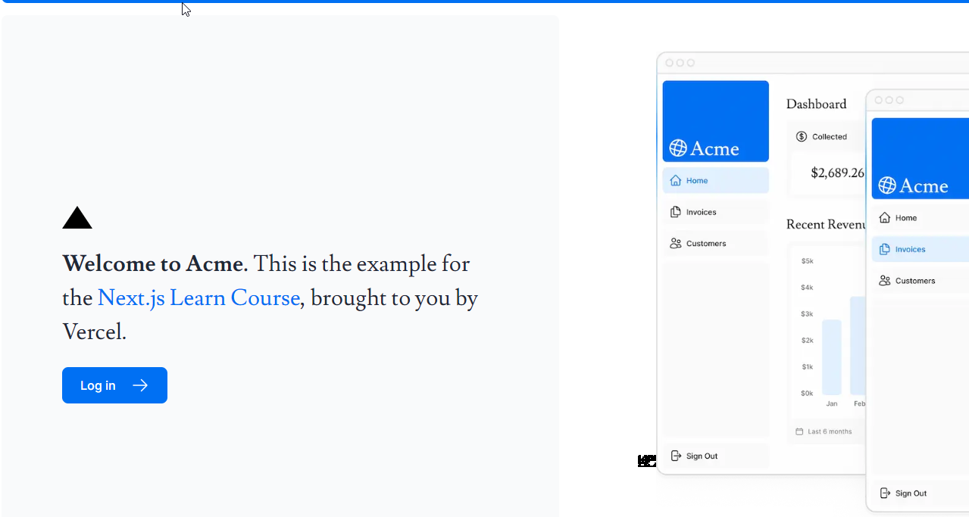

import { lusitana } from '../app/ui/fonts.js';
import AcmeLogo from '@/app/ui/acme-logo';
import { ArrowRightIcon } from '@heroicons/react/24/outline';
import Link from 'next/link';
import styles from '../app/ui/home.module.css';
import Image from 'next/image';

export default function Page() {
return (
<main className="flex min-h-screen flex-col p-6">
<div className="flex h-20 shrink-0 items-end rounded-lg bg-blue-500 p-4 md:h-52">
{/* <AcmeLogo /> */}
</div>
<div className="mt-4 flex grow flex-col gap-4 md:flex-row">
<div className="flex flex-col justify-center gap-6 rounded-lg bg-gray-50 px-6 py-10 md:w-2/5 md:px-20">
<div className={styles.shape} />
<p
className={`${lusitana.className} text-xl text-gray-800 antialiased md:text-3xl md:leading-normal`}
>
<strong>Welcome to Acme.</strong> This is the example for the{' '}
<a href="https://nextjs.org/learn/" className="text-blue-500">
Next.js Learn Course
</a>
, brought to you by Vercel.
</p>
<Link
href="/login"
className="flex items-center gap-5 self-start rounded-lg bg-blue-500 px-6 py-3 text-sm font-medium text-white transition-colors hover:bg-blue-400 md:text-base"
>
<span>Log in</span> <ArrowRightIcon className="w-5 md:w-6" />
</Link>
</div>
<div className="flex items-center justify-center p-6 md:w-3/5 md:px-28 md:py-12">
{/* Add Hero Images Here */}
<Image
src="/hero-desktop.png"
width={1000}
height={760}
className="hidden md:block"
alt="Screenshots of the dashboard project showing desktop version"
/>
</div>
</div>
</main>
);
}

