NET3720 - Fall 2021 – Jenkins

Lab 3 – 802.11 Frame Capture

Erika Hernandez

Lab Objectives:
- Capture packets from the configured AP

Hardware needed:
- Cisco Aironet 3700 AP
- ZYCEL PoE Switch
- USB to RS232 cable
- Computer

Software:
- Console application
- PuTTY http://the.earth.li/~sgtatham/putty/latest/x86/putty.exe
- Instructions on how to download PuTTY
  - https://www.weber.edu/CS/remote-access.html
- Wire-shark
  - https://www.wireshark.org/index.html#download
Instructions:
In this lab you will learn how to configure a Cisco AP unit using the CLI. You will also learn how to capture packets from your network.

Method:
Internet is connected to the ZYXEL switch with Cat.6 cables. The switch is then connected to the Cisco AP unit with Cat.6 cables. In order to configure the AP it needs to be controlled by a computer. You are able to do this with USB to RS232 + VGA to RJ-45, green light on the AP unit means its on. Open up PuTTY and click on Serial then type COM4 and then open.

Connections:
Get Cat.6 cable connect one end to modem and other to ZYXEL switch port 5. connect the power to the switch. Get Cat.6 cable and connect one end to port 1 on switch and the other end to Ethernet port on the Cisco switch. The RJ-45 end connect to Console connect the VGA to RS232, then the USB to a USB port on the computer. See Figure 1 for layout of how things are connected.

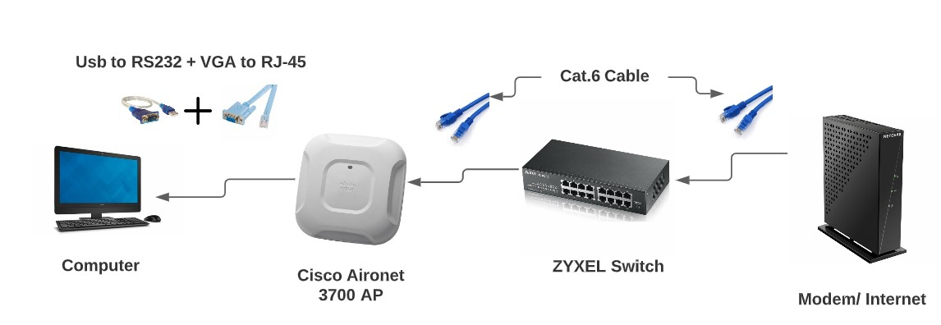
Figure 1

Turn on the ZYXEL swtich on, and make sure the USB is plug and play and picks up on the computer.
Go to the Start menu on your windows computer
click on the Device Manager
Go down on ports for my device it is on (COM4)

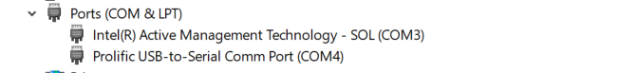

Figure 2

Open PuTTY Configuration
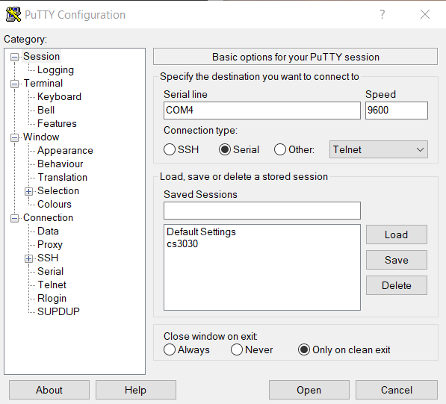

Figure 3

Access Cisco AP
Click on Serial
on Serial line you put COM4 (or whatever yours says)
Speed 9600
Then click on Open

This is what will show up press Enter
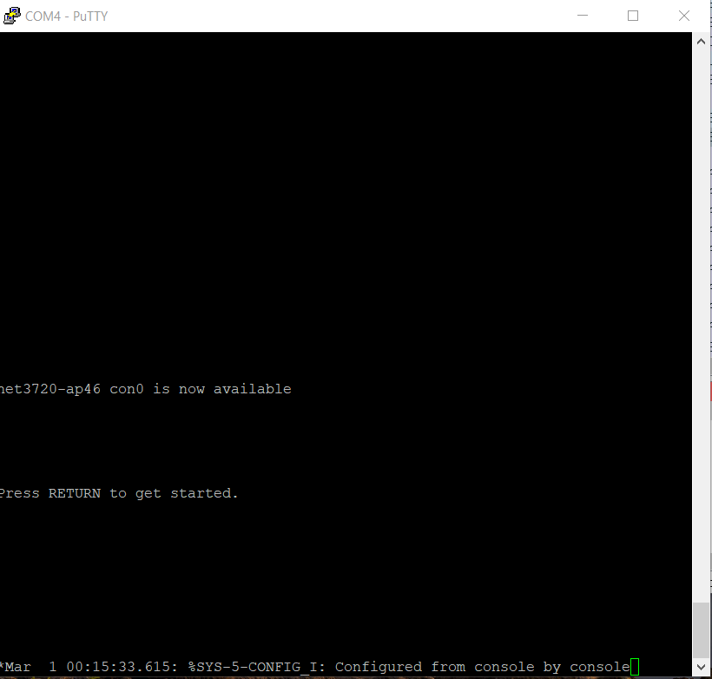

Figure 4

This is what will show up when you Press Enter

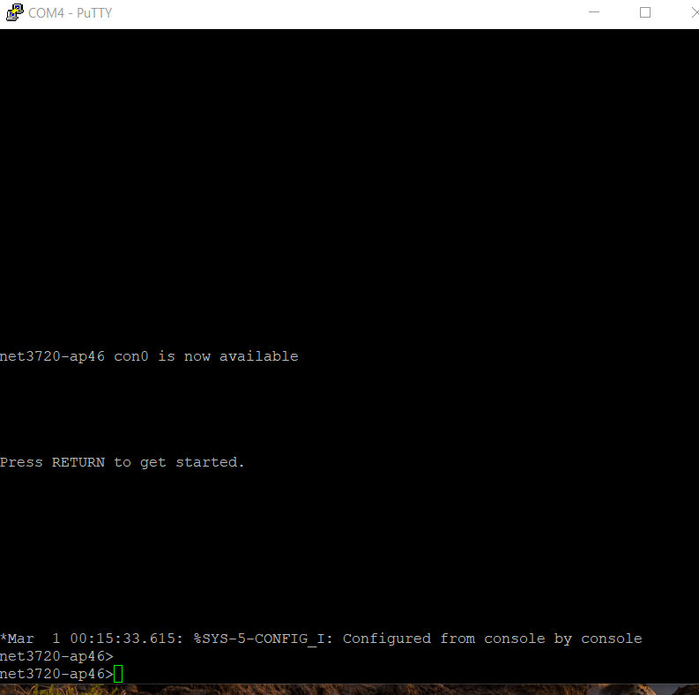

Figure 5

Type in password: Cisco

then type enable
net3720-ap46> enable
password: Cisco
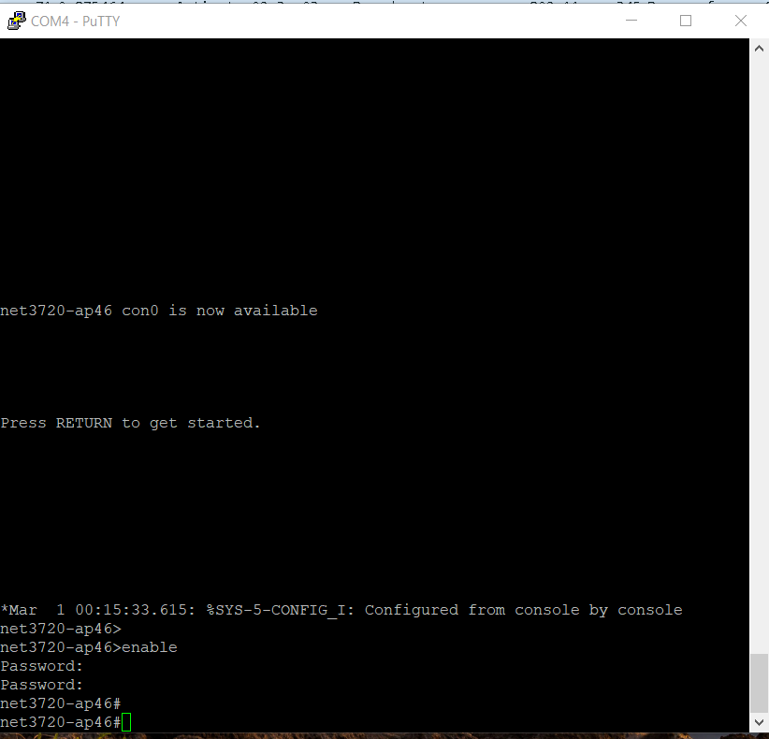

Figure 6

Open PowerShell or CMD to get your IPv6 address and your default address

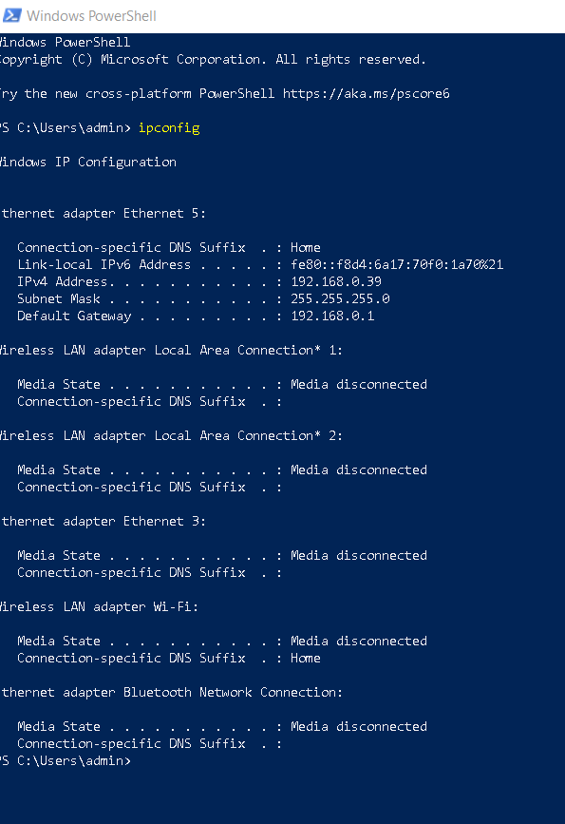

net3720-ap46#show run
Building configuration...

Current configuration : 1556 bytes
!
version 15.3
no service pad
service timestamps debug datetime msec
service timestamps log datetime msec
service password-encryption
!
hostname net3720-ap46
!
!
logging rate-limit console 9
enable secret 5 $1$S15Q$GxOM3JNohU0hWnUdqIYtx0
!
no aaa new-model
no ip source-route
no ip cef
!
!
!
!
dot11 pause-time 100
dot11 syslog
!
!
no ipv6 cef
!
!
username Cisco password 7 13261E010803
!
!
bridge irb
!
!
!
interface Dot11Radio0
no ip address
shutdown
antenna gain 0
station-role root
bridge-group 1
bridge-group 1 subscriber-loop-control
bridge-group 1 spanning-disabled
bridge-group 1 block-unknown-source
no bridge-group 1 source-learning
no bridge-group 1 unicast-flooding
!
interface Dot11Radio1
no ip address
shutdown
antenna gain 0
peakdetect
no dfs band block
channel dfs
station-role root
bridge-group 1
bridge-group 1 subscriber-loop-control
bridge-group 1 spanning-disabled
bridge-group 1 block-unknown-source
no bridge-group 1 source-learning
no bridge-group 1 unicast-flooding
!
interface GigabitEthernet0
no ip address
duplex auto
speed auto
bridge-group 1
bridge-group 1 spanning-disabled
no bridge-group 1 source-learning
!
interface BVI1
mac-address 5c83.8f44.4634
ip address dhcp client-id GigabitEthernet0
ipv6 address dhcp
ipv6 address autoconfig
ipv6 enable
!
ip forward-protocol nd
no ip http server
no ip http secure-server
ip http help-path http://www.cisco.com/warp/public/779/smbiz/prodconfig/help/eag
!
!
bridge 1 route ip
!
!
!
line con 0
line vty 0 4
login local
transport input all
!
end

net3720-ap46#copy fl
net3720-ap46#copy flash:?
flash:ap3g2-k9w7-mx.153-3.JPK2 flash:config.txt
flash:config.txt.bak flash:crashinfo_19930301-000753-UTC
flash:default-config flash:env_vars
flash:event.log flash:event.r0
flash:info flash:private-config
flash:private-multiple-fs

net3720-ap46#copy flash:exit
% Incomplete command.

net3720-ap46#conf t
Enter configuration commands, one per line. End with CNTL/Z.
net3720-ap46(config)#int d0
net3720-ap46(config-if)#shut
net3720-ap46(config-if)#exit
net3720-ap46(config)#snif
net3720-ap46(config)#sniffer ip
net3720-ap46(config)#sniffer ip-address 192.168.0.39 sour
net3720-ap46(config)#sniffer ip-address 192.168.0.39 source-port 5555 dest
net3720-ap46(config)#$address 192.168.0.39 source-port 5555 dest-port 5000
net3720-ap46(config)#int d0
net3720-ap46(config-if)#stat
net3720-ap46(config-if)#station-role sniffer
net3720-ap46(config-if)#
*Mar 1 00:05:12.379: %DOT11-5-EXPECTED_RADIO_RESET: Restarting Radio interface Dot11Radio0 due to the reason code 10
*Mar 1 00:05:12.379: %DOT11-5-EXPECTED_RADIO_RESET: Restarting Radio interface Dot11Radio0 due to the reason code 40
net3720-ap46(config-if)#
net3720-ap46(config-if)#no shut
net3720-ap46(config-if)#
*Mar 1 00:05:22.687: %DOT11-5-EXPECTED_RADIO_RESET: Restarting Radio interface Dot11Radio0 due to the reason code 10
*Mar 1 00:05:22.691: %LINK-5-CHANGED: Interface Dot11Radio0, changed state to reset
*Mar 1 00:05:23.767: %DOT11-6-FREQ_SCAN: Interface Dot11Radio0, Scanning frequencies for 24 seconds
*Mar 1 00:05:23.779: %LINK-6-UPDOWN: Interface Dot11Radio0, changed state to up
*Mar 1 00:05:24.779: %LINEPROTO-5-UPDOWN: Line protocol on Interface Dot11Radio0, changed state to up
net3720-ap46(config-if)#exit

References
IT Support People. (2020, December 29). Configure Cisco Access Point using CLI with WPAv2 Authentication [Video]. Retrieved from https://www.youtube.com/watch?v=JkUfTXuwj2U

