NET3720 - Fall 2021 – Jenkins

Lab 3 – 802.11 Frame Capture

Erika Hernandez

Lab Objectives:
- Capture packets from the configured AP

Hardware needed:
- Cisco Aironet 3700 AP
- ZYCEL PoE Switch
- USB to RS232 cable
- Computer

Software:
- Console application
- PuTTY http://the.earth.li/~sgtatham/putty/latest/x86/putty.exe
- Instructions on how to download PuTTY
  - https://www.weber.edu/CS/remote-access.html
- Wire-shark
  - https://www.wireshark.org/index.html#download
Instructions:
In this lab you will learn how to configure a Cisco AP unit using the CLI. You will also learn how to capture packets from your network.

Method:
Internet is connected to the ZYXEL switch with Cat.6 cables. The switch is then connected to the Cisco AP unit with Cat.6 cables. In order to configure the AP it needs to be controlled by a computer. You are able to do this with USB to RS232 + VGA to RJ-45, green light on the AP unit means its on. Open up PuTTY and click on Serial then type COM4 and then open.

Connections:
Get Cat.6 cable connect one end to modem and other to ZYXEL switch port 5. connect the power to the switch. Get Cat.6 cable and connect one end to port 1 on switch and the other end to Ethernet port on the Cisco switch. The RJ-45 end connect to Console connect the VGA to RS232, then the USB to a USB port on the computer. See Figure 1 for layout of how things are connected.

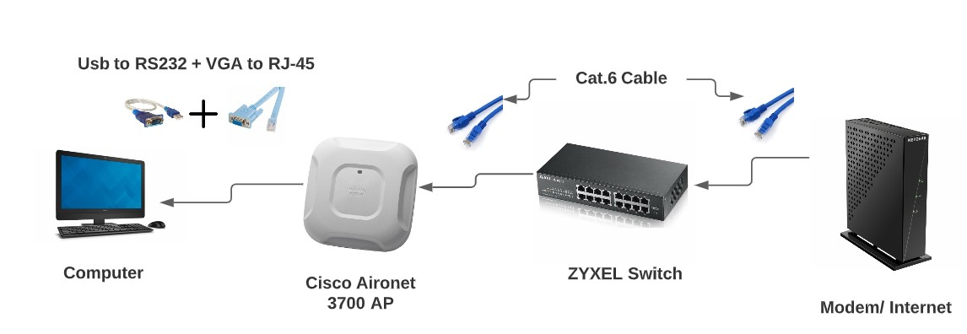Illustration 1: Network layout

Turn on the ZYXEL swtich on, and make sure the USB is plug and play and picks up on the computer.
Go to the Start menu on your windows computer
click on the Device Manager
Go down on ports for my device it is on (COM4)

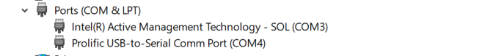Figure 1: Device Manager getting ports

Open PuTTY Configuration
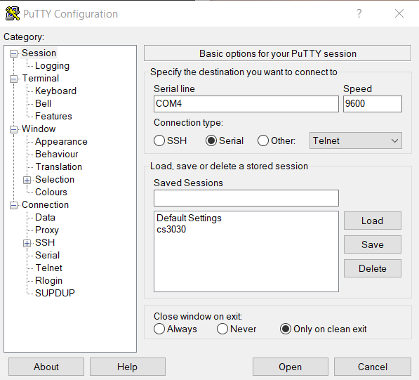Figure 2: PuTTY- Entering COM4

Access Cisco AP
Click on Serial
on Serial line you put COM4 (or whatever yours says)
Speed 9600
Then click on Open

This is what will show up press Enter
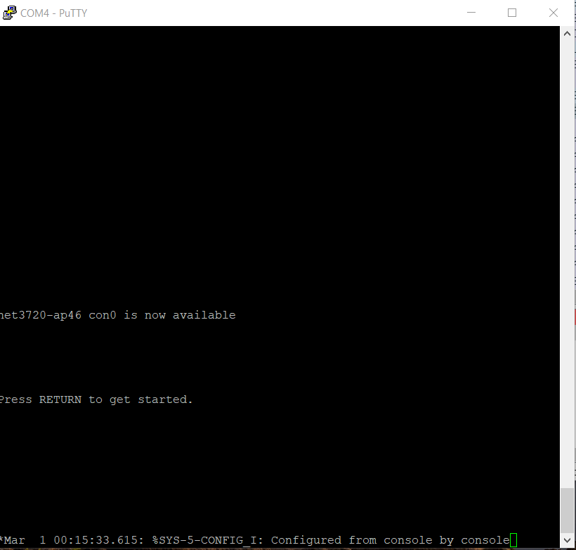Figure 3: Start up on PuTTY

This is what will show up when you Press Enter

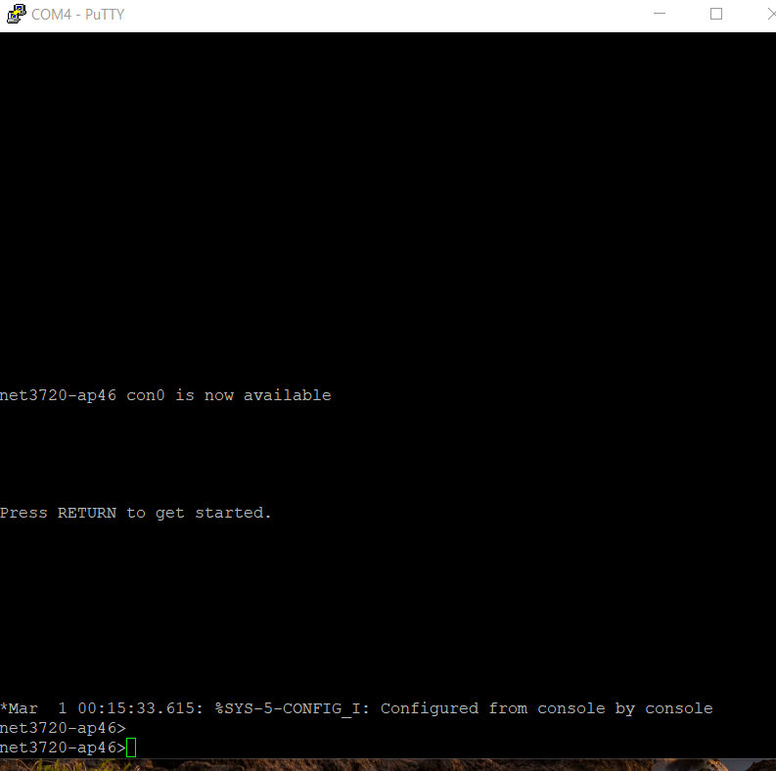Figure 4: Press Enter and this is what it should look like

Type in password: Cisco

Then type enable
net3720-ap46> enable
password: Cisco
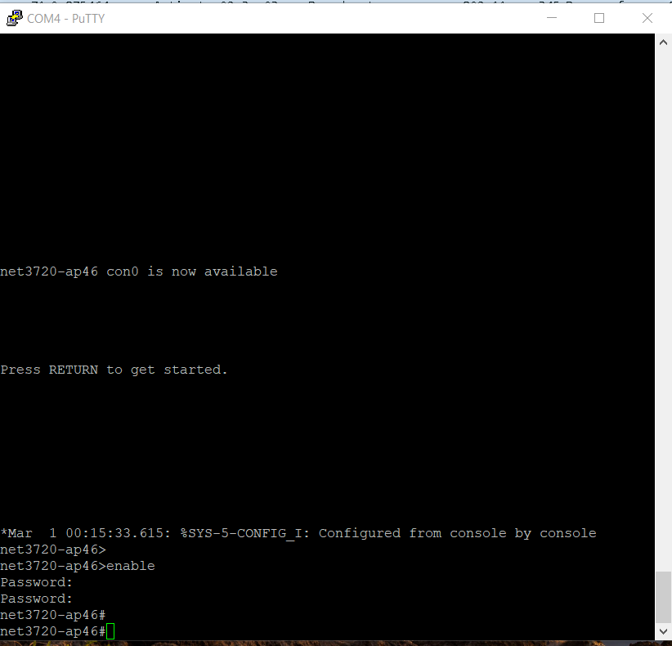Figure 5: Look for the # this shows you are in configuration mode

Open PowerShell or CMD to get your IPv6 address and your default address
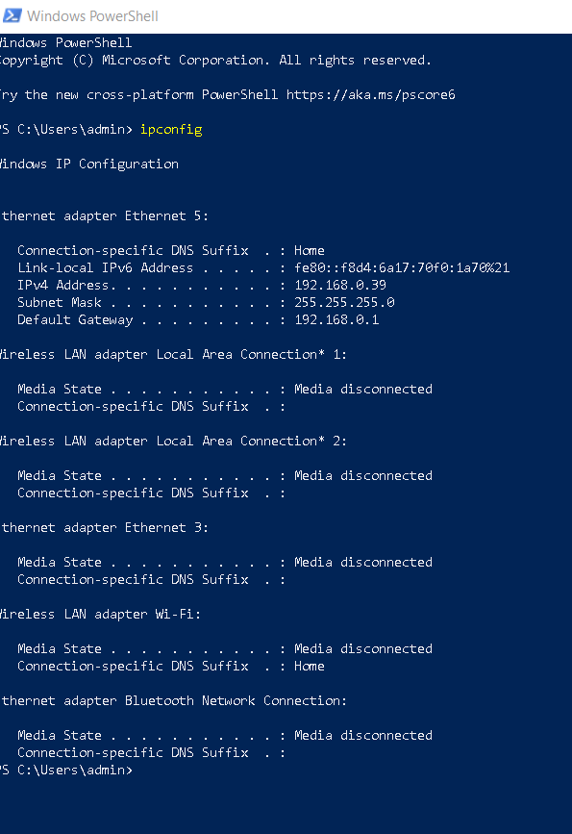Figure 6: PowerShell

net3720-ap46#show run
Building configuration...

Current configuration : 1556 bytes
!
version 15.3
no service pad
service timestamps debug datetime msec
service timestamps log datetime msec
service password-encryption
!
hostname net3720-ap46
!
!
logging rate-limit console 9
enable secret 5 $1$S15Q$GxOM3JNohU0hWnUdqIYtx0
!
no aaa new-model
no ip source-route
no ip cef
!
!
!
!
dot11 pause-time 100
dot11 syslog
!
!
no ipv6 cef
!
!
username Cisco password 7 13261E010803
!
!
bridge irb
!
!
!

net3720-ap46# conf terminal

net3720-ap46(config)# interface Dot11Radio0
net3720-ap46(config-if)# no ip address
net3720-ap46(config-if)# shutdown
net3720-ap46(config-if)# antenna gain 0
net3720-ap46(config-if)# station-role root

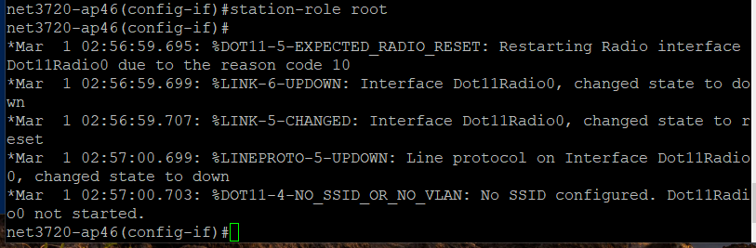Figure 7

net3720-ap46(config -if)# bridge-group 1
net3720-ap(config-if)# bridge-group 1 subscriber-loop-control
net3720-ap46(config -if)# bridge-group 1 spanning-disabled
net3720-ap46(config -if)# bridge-group 1 block-unknown-source
net3720-ap46(config -if)# no bridge-group 1 source-learning
net3720-ap46(config -if)# no bridge-group 1 unicast-flooding

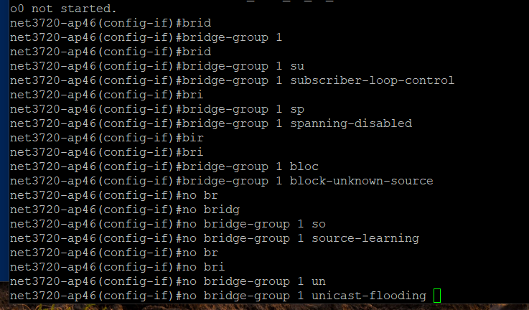Figure 8

!
net3720-ap46(config)# interface dot11Radio1
net3720-ap46(config -if)# no ip address
net3720-ap46(config -if)# shutdown
net3720-ap46(config -if)# antenna gain 0
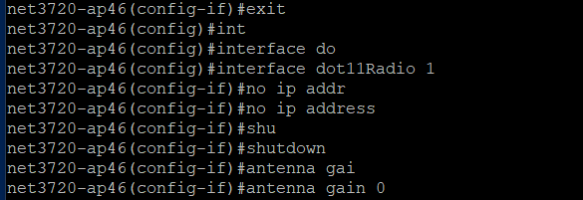Figure 9

net3720-ap46(config -if)# peakdetect

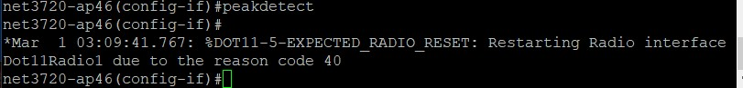Figure 10

net3720-ap46(config -if)# no dfs band block
net3720-ap46(config -if)# channel dfs
net3720-ap46(config -if)# station-role root
net3720-ap46(config -if)# bridge-group 1
net3720-ap46(config -if)# bridge-group 1 subscriber-loop-control
net3720-ap46(config -if)# bridge-group 1 spanning-disabled
net3720-ap46(config -if)# bridge-group 1 block-unknown-source
net3720-ap46(config -if)# no bridge-group 1 source-learning
net3720-ap46(config -if)# no bridge-group 1 unicast-flooding

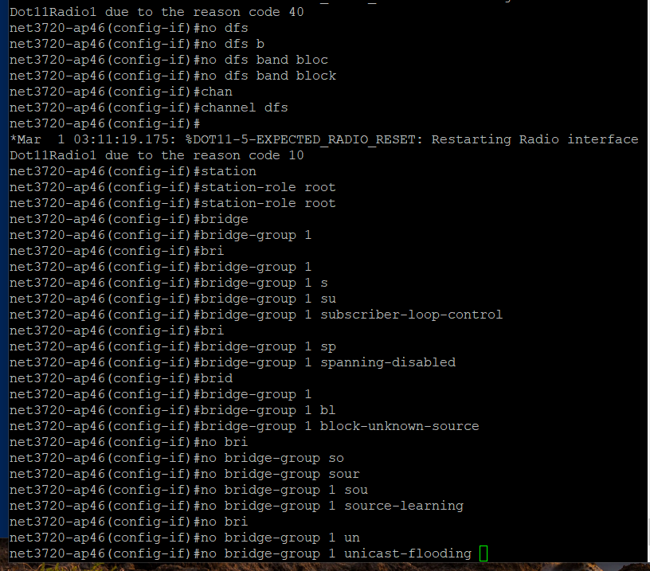Figure 11
!
net3720-ap46(config -if)# exit
net3720-ap46(config -if)# interface GigabitEthernet0
net3720-ap46(config -if)# no ip address
net3720-ap46(config -if)# duplex auto
net3720-ap46(config -if)# speed auto
net3720-ap46(config -if)# bridge-group 1
net3720-ap46(config -if)# bridge-group 1 spanning-disabled
net3720-ap46(config -if)# no bridge-group 1 source-learning

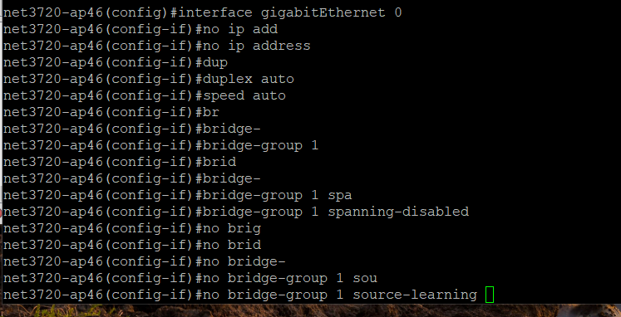Figure 12
!
net3720-ap46(config -if)# interface BVI1
net3720-ap46(config -if)# mac-address 5c83.8f44.4634
net3720-ap46(config -if)# ip address dhcp client-id GigabitEthernet0

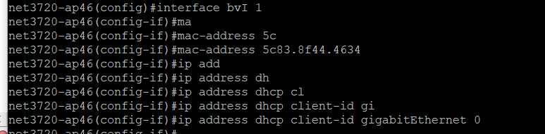Figure 13
net3720-ap46(config -if)# ipv6 address dhcp
net3720-ap46(config -if)# ipv6 address autoconfig
net3720-ap46(config -if)# ipv6 enable

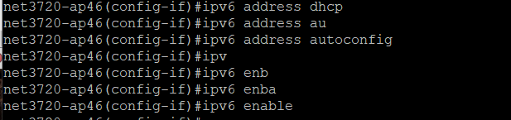Figure 14
!
net3720-ap46(config -if)# exit
net3720-ap46(config )# ip forward-protocol nd
net3720-ap46(config)# no ip http server
net3720-ap46(config)# no ip http secure-server
net3720-ap46(config)# ip http help-path http://www.cisco.com/warp/public/779/smbiz/prodconfig/help/eag

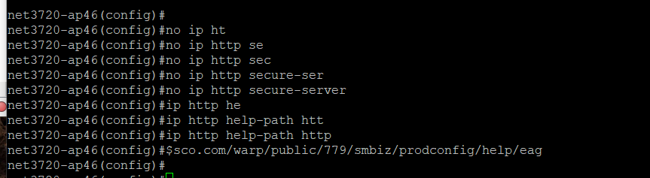Figure 15
!
!
net3720-ap46(config)#bridge 1 route ip
!
!
!
net3720-ap46(config)#line con 0
net3720-ap46(config -line)# line vty 0 4
net3720-ap46(config -line)# login local
net3720-ap46(config -line)# transport input all

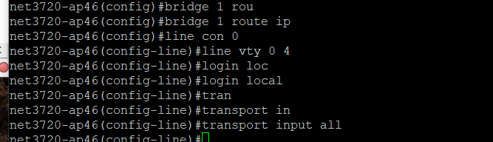Figure 16
!
end

net3720-ap46#copy fl
net3720-ap46#copy flash:?

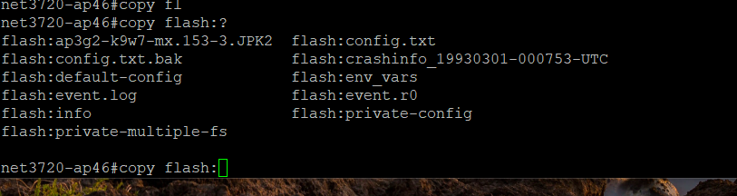Figure 17
flash:ap3g2-k9w7-mx.153-3.JPK2 flash:config.txt
flash:config.txt.bak flash:crashinfo_19930301-000753-UTC
flash:default-config flash:env_vars
flash:event.log flash:event.r0
flash:info flash:private-config
flash:private-multiple-fs

net3720-ap46#copy flash:exit
% Incomplete command.

net3720-ap46#conf t
Enter configuration commands, one per line. End with CNTL/Z.c
net3720-ap46(config)#int d0
net3720-ap46(config-if)#shut
net3720-ap46(config-if)#exit
net3720-ap46(config)#snif
net3720-ap46(config)#sniffer ip
net3720-ap46(config)#sniffer ip-address 192.168.0.39 sour
net3720-ap46(config)#sniffer ip-address 192.168.0.39 source-port 5555 dest
net3720-ap46(config)#$address 192.168.0.39 source-port 5555 dest-port 5000
net3720-ap46(config)#int d0
net3720-ap46(config-if)#stat
net3720-ap46(config-if)#station-role sniffer
net3720-ap46(config-if)#
*Mar 1 00:05:12.379: %DOT11-5-EXPECTED_RADIO_RESET: Restarting Radio interface Dot11Radio0 due to the reason code 10
*Mar 1 00:05:12.379: %DOT11-5-EXPECTED_RADIO_RESET: Restarting Radio interface Dot11Radio0 due to the reason code 40
net3720-ap46(config-if)#
net3720-ap46(config-if)#no shut
net3720-ap46(config-if)#
*Mar 1 00:05:22.687: %DOT11-5-EXPECTED_RADIO_RESET: Restarting Radio interface Dot11Radio0 due to the reason code 10
*Mar 1 00:05:22.691: %LINK-5-CHANGED: Interface Dot11Radio0, changed state to reset
*Mar 1 00:05:23.767: %DOT11-6-FREQ_SCAN: Interface Dot11Radio0, Scanning frequencies for 24 seconds
*Mar 1 00:05:23.779: %LINK-6-UPDOWN: Interface Dot11Radio0, changed state to up
*Mar 1 00:05:24.779: %LINEPROTO-5-UPDOWN: Line protocol on Interface Dot11Radio0, changed state to up
net3720-ap46(config-if)#exit

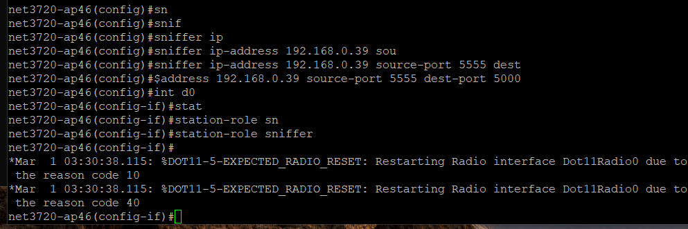Figure 18

net3720-ap46(config -if)#exit
net3720-ap46#

Wireshark Section

Open – The application Wireshark now. For me the Ethernet5 is where I will be doing the packet trace

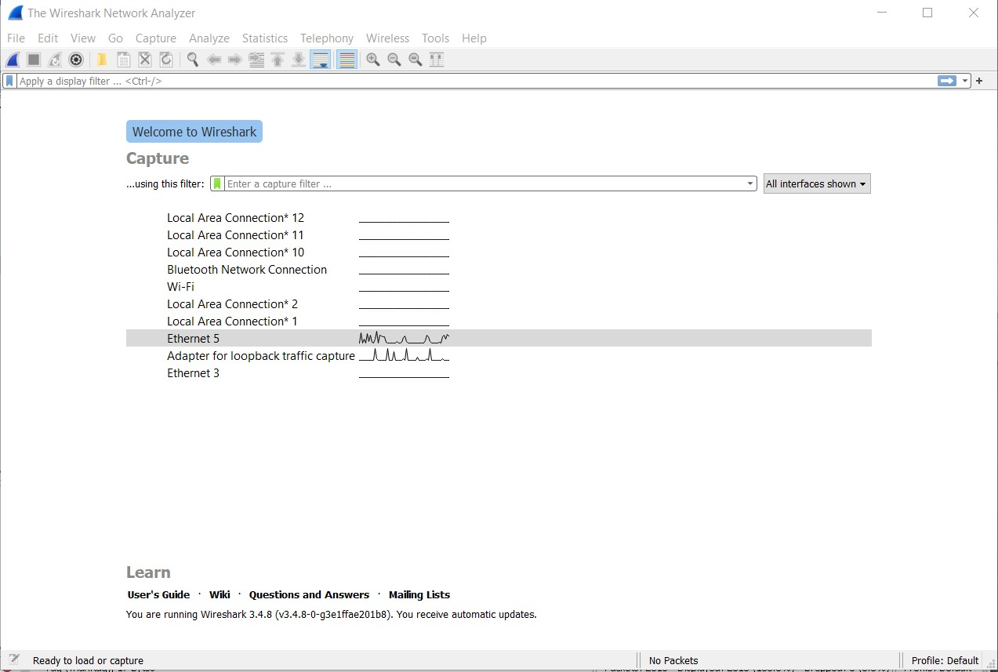Figure 19: Wireshark- Start up

Click on the blue shark fin, o start capturing packets. Run this for about 5 minutes.

Once you have ran that for about 5 minutes click on the red box to stop the capturing.

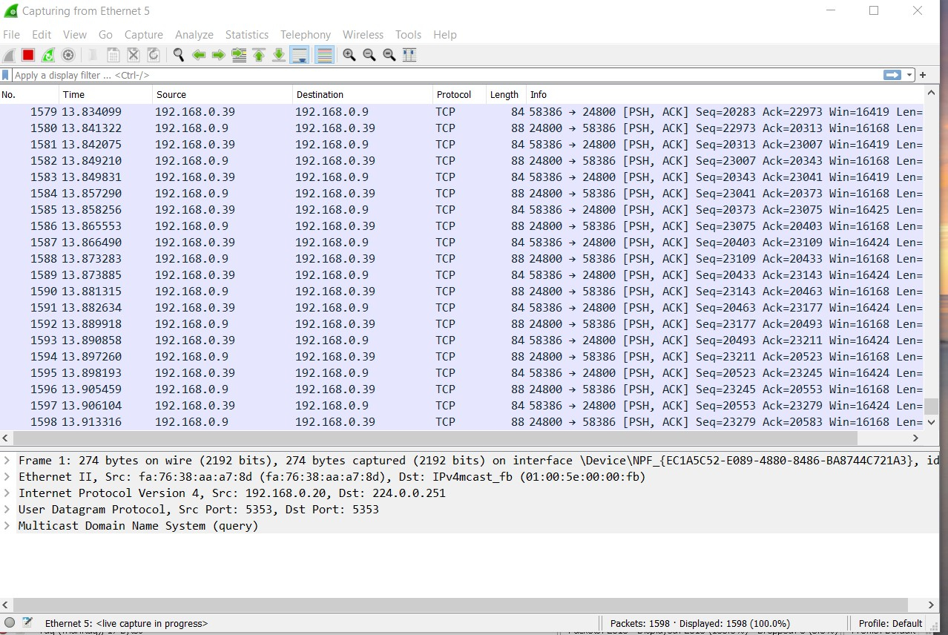Figure 20: Wireshark- Stop button

Click on the Analyze tab on the top of the Wireshark.

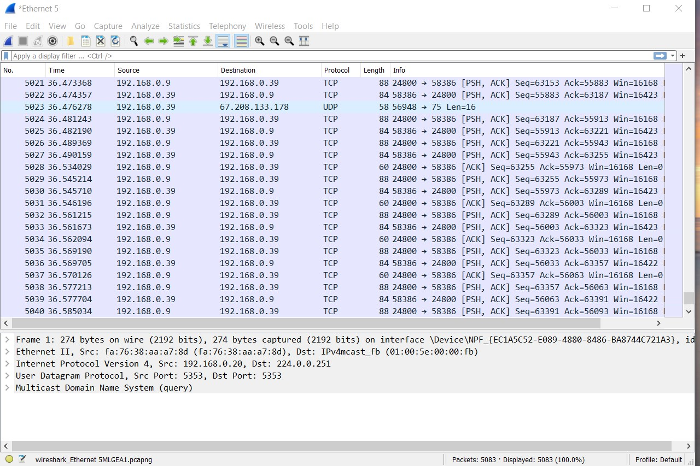Figure 21: Wireshark- Analyze tab

Here you will see that you have port 5555 open and you are capturing you network.

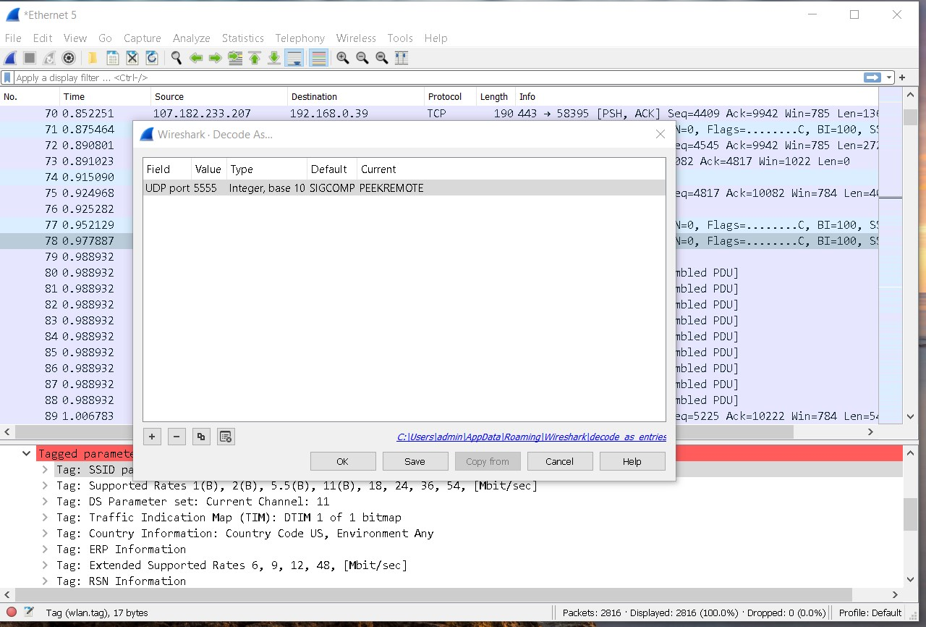Figure 22: Wireshark- UDP port 5555

Here you will see that you have my wifi and that we are getting the 802.11 as well.

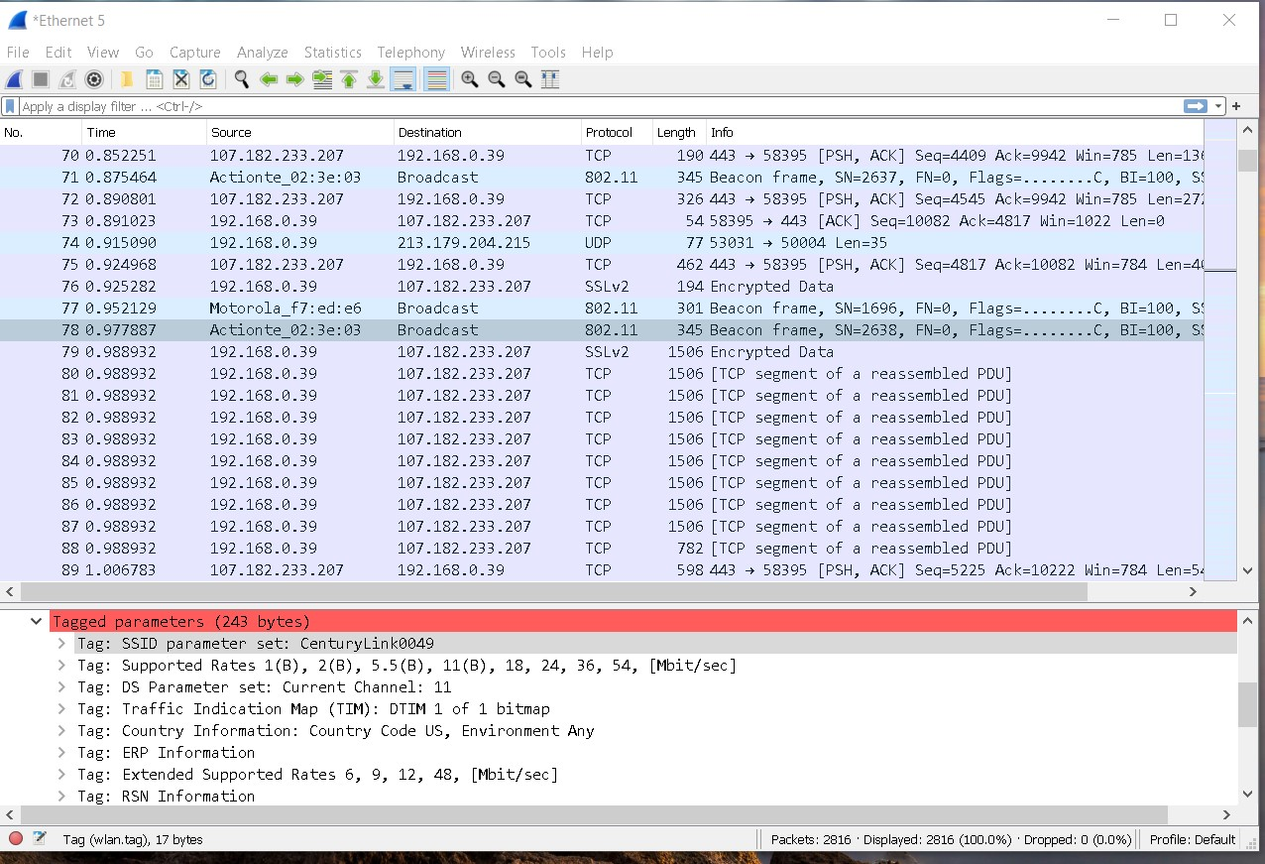Figure 23: Wireshark- 801.11 and on my network

Here you see that SSID tag is on my network and able to get the packets.

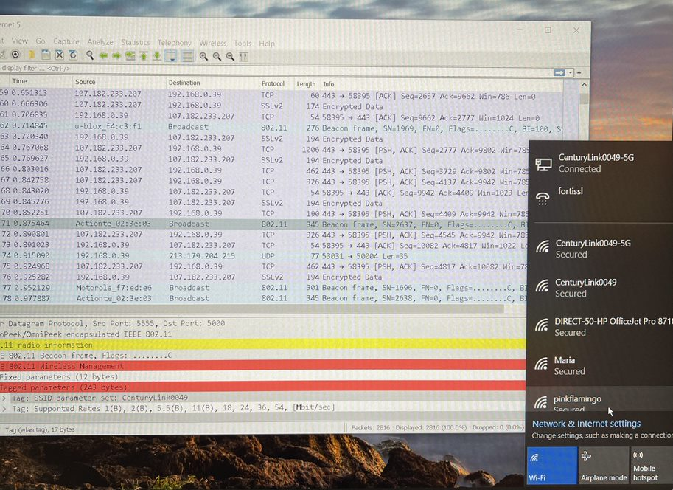Figure 24: Wireshark - Showing up in capture

References
IT Support People. (2020, December 29). Configure Cisco Access Point using CLI with WPAv2 Authentication [Video]. Retrieved from https://www.youtube.com/watch?v=JkUfTXuwj2U

802.11 Wlan Packets (WiFi Hacking Series Part -5) [Video]. (2013, December 16). Retrieved from https://duckduckgo.com/?q=802.11+Frame+Capture&iax=videos&ia=videos&iai=https%3A %2F%2Fwww.youtube.com%2Fwatch%3Fv%3Dzn5FJHua1a4

WiFi captures with sniffer mode AP. (2018, April 8). Retrieved from https://mrncciew.com/2018/04/07/wifi-captures-with-sniffer-mode-ap/

