NET3720 - Fall 2021 – Jenkins

Lab 5– Autonomous AP Bridge

Erika Hernandez

Lab Objectives:
- Connect (2) Cisco AP’s and give WiFi to a computer with no WiFi

Hardware needed:
- (2) Cisco Aironet 3700 AP
- (2) ZYCEL PoE Switch
- (1) USB to RS232 cable
- Computer 1 – Console
- Computer 2- Internet off and getting internet from computer 1

Software:
- Console application
- PuTTY http://the.earth.li/~sgtatham/putty/latest/x86/putty.exe
- Instructions on how to download PuTTY
  - https://www.weber.edu/CS/remote-access.html

Instructions:
In this lab you will learn how to configure a Cisco AP unit using the CLI. You will connect Cisco AP 1 to computer 1 and then have Cisco AP 2 give WiFi to computer 2.

Method:
Internet is connected to the ZYXEL switch with Cat.6 cables. The switch is then connected to the Cisco AP unit with Cat.6 cables. In order to configure the AP it needs to be controlled by a computer. You are able to do this with USB to RS232 + VGA to RJ-45, green light on the AP unit means its on. Open up PuTTY and click on Serial then type /dev/ttyUSB0 and then open.

Connections:
Setup 1: Get a cat.6 cable can plug into the CenturyLink modem. Get another cat6 cable connect to the ZYXEL switch, connect the switch to power. Get a cat 6 cable and connect to Cisco AP. Get a USB to RS232 and a VGA to RJ-45 cable and connect to Computer1. Setup 2: Connect ZYXEL switch to power. Then get a cat6 cable and connect to Cisco AP and when you are done configuring Setup 1 you will then connect the RS232 and a VGA to RJ-45 cable and connect to Computer2, that has no WiFi.

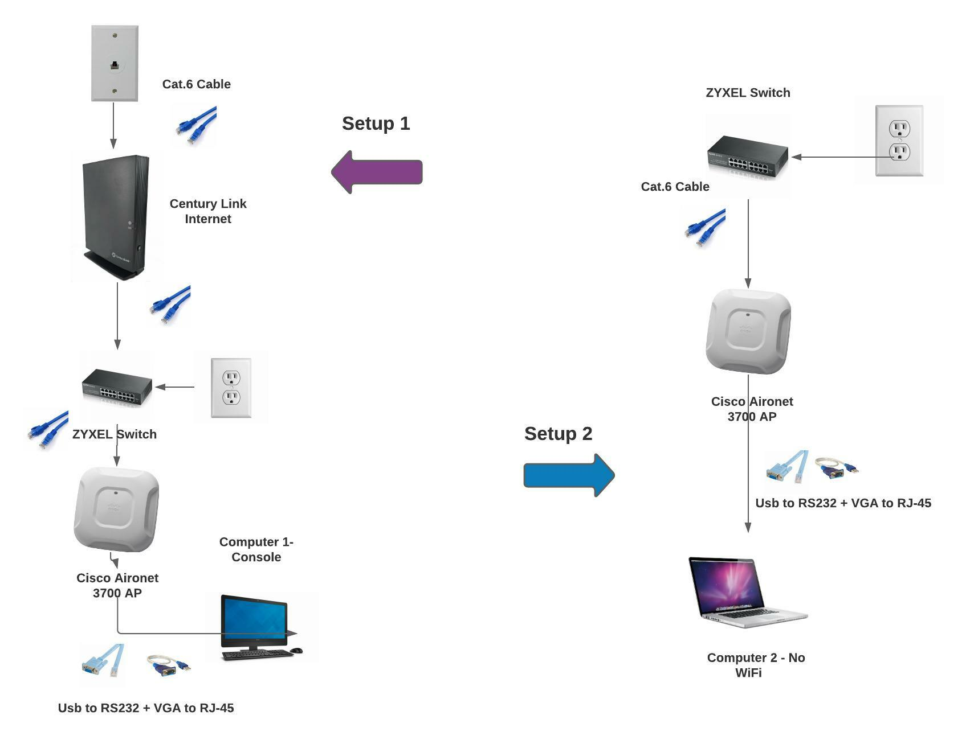
Illustration 1: Network layout – For Setup 1 and Setup 2
Turn on the ZYXEL swtich on, and make sure the USB is plugged in and make sure the computer pickups the USB.

Open up you Linux Terminal

Type sudo putty in Terminal

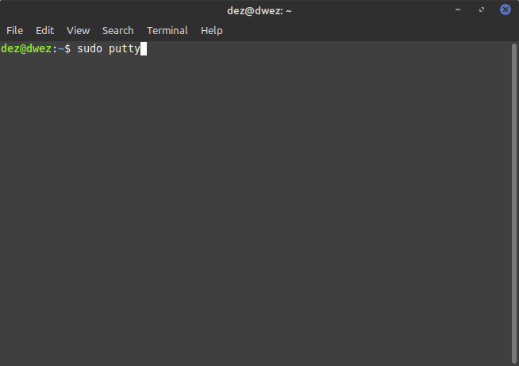Figure 1: Terminal - sudo putty

Type your password ----

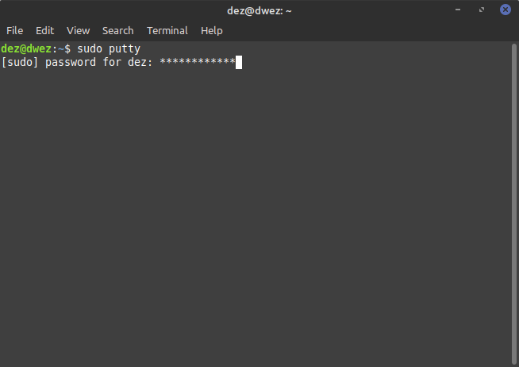Figure 2: Type password

After your putty should open up.
Serial Line – Location should be open
Speed – 9600

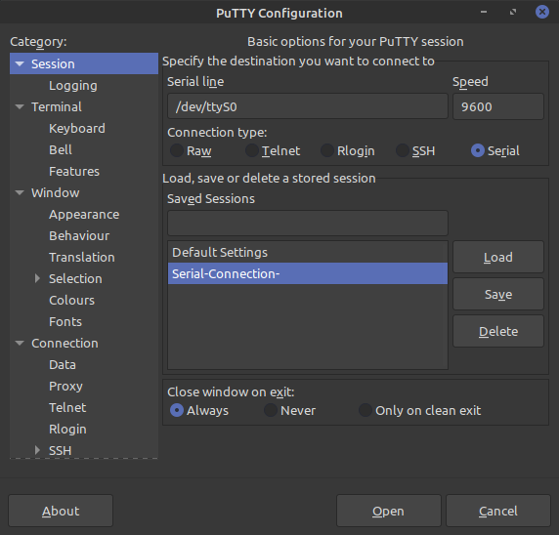Figure 3: PuTTY - Make sure these are the same

Setup 1 – This is the first part of this process. Input the following commands:

ap> enable
Password: Cisco
ap# show running-config

(See if anything is configure- Move on if ok)

ap# hostname net3720-ap46

ap# config-term

net3720-ap46(config)#dot11 ssid net3720-Hernandez-bridge

net3720-ap46(config-ssid)#authentication open

net3720-ap46(config-ssid)#authentication key-management wpa version

net3720-ap46(config-ssid)#wpa-psk ascii 0 8012592236 (NOTE: This is a password and needs to be a number )

net3720-ap46(config-ssid)#interface Dot11Radio1

net3720-ap46(config-if)#encryption mode ciphers aes-ccm

net3720-ap46(config-if)#ssid net3720-Hernandez-bridge

net3720-ap46(config-if)#channel 165

net3720-ap46(config-if)#station-role root bridge

net3720-ap46(config-if)#no shutdown

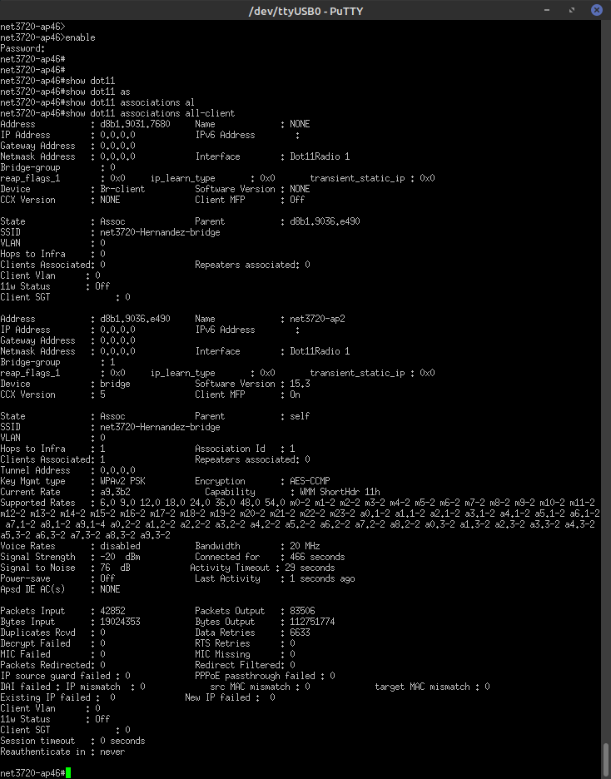Figure 4: Output: "Show dot11 association all-client"

Setup 2 – Unplug Console cable from the Cisco AP 1 and plug into Cisco AP 2. Make sure switch 2 is powered up. Switch 2 should be plugged into your computer that has no WiFi. (See Illustration 1)

Input the following commands:

ap>enable
Password: Cisco

ap(config)#hostname net3720-ap2

net3720-ap2(config)#dot11 ssid net3720-Hernandez-bridge

net3720-ap2(config-ssid)#authentication open

net3720-ap2(config-ssid)#authentication key-management wpa version 2

net3720-ap2(config-ssid)#wpa-psk ascii 0 8012592236

net3720-ap2(config-ssid)#interface Dot11Radio1

net3720-ap2(config-if)#encryption mode ciphers aes-ccm

net3720-ap2(config-if)#ssid net3720-Hernandez-bridge

net3720-ap2(config-if)#channel 165

net3720-ap2(config-if)#station-role non-root bridge

net3720-ap2(config-if)#no shut

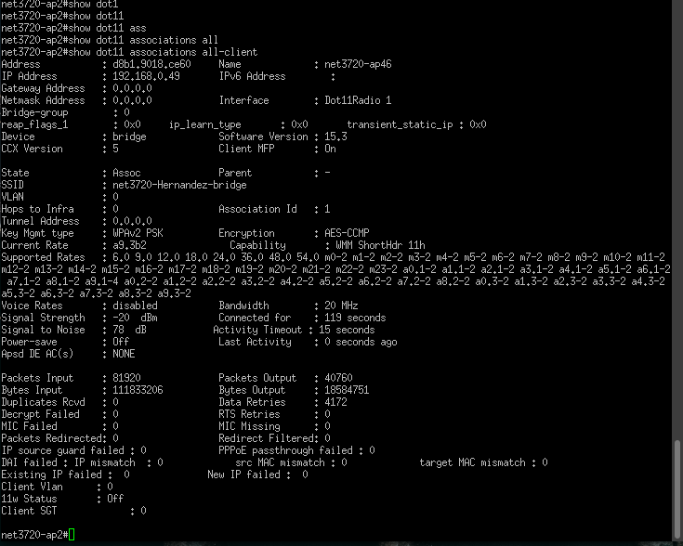Figure 5: Output: "Show dot11 associations all-client"

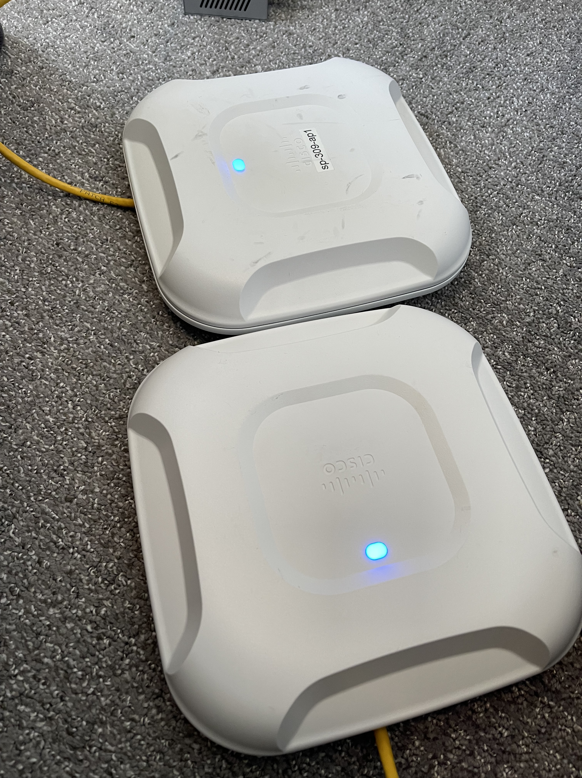Figure 6: Blue- Both APs have a blue light on, it means its working!

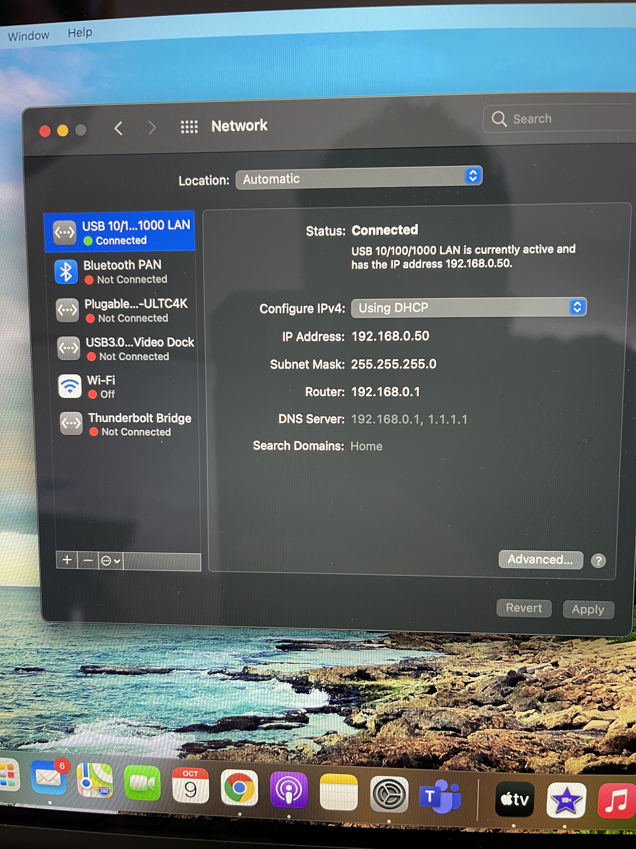Illustration 2: Network- You are connected to WiFi
This has an IP address this means you are connected to WiFi now.
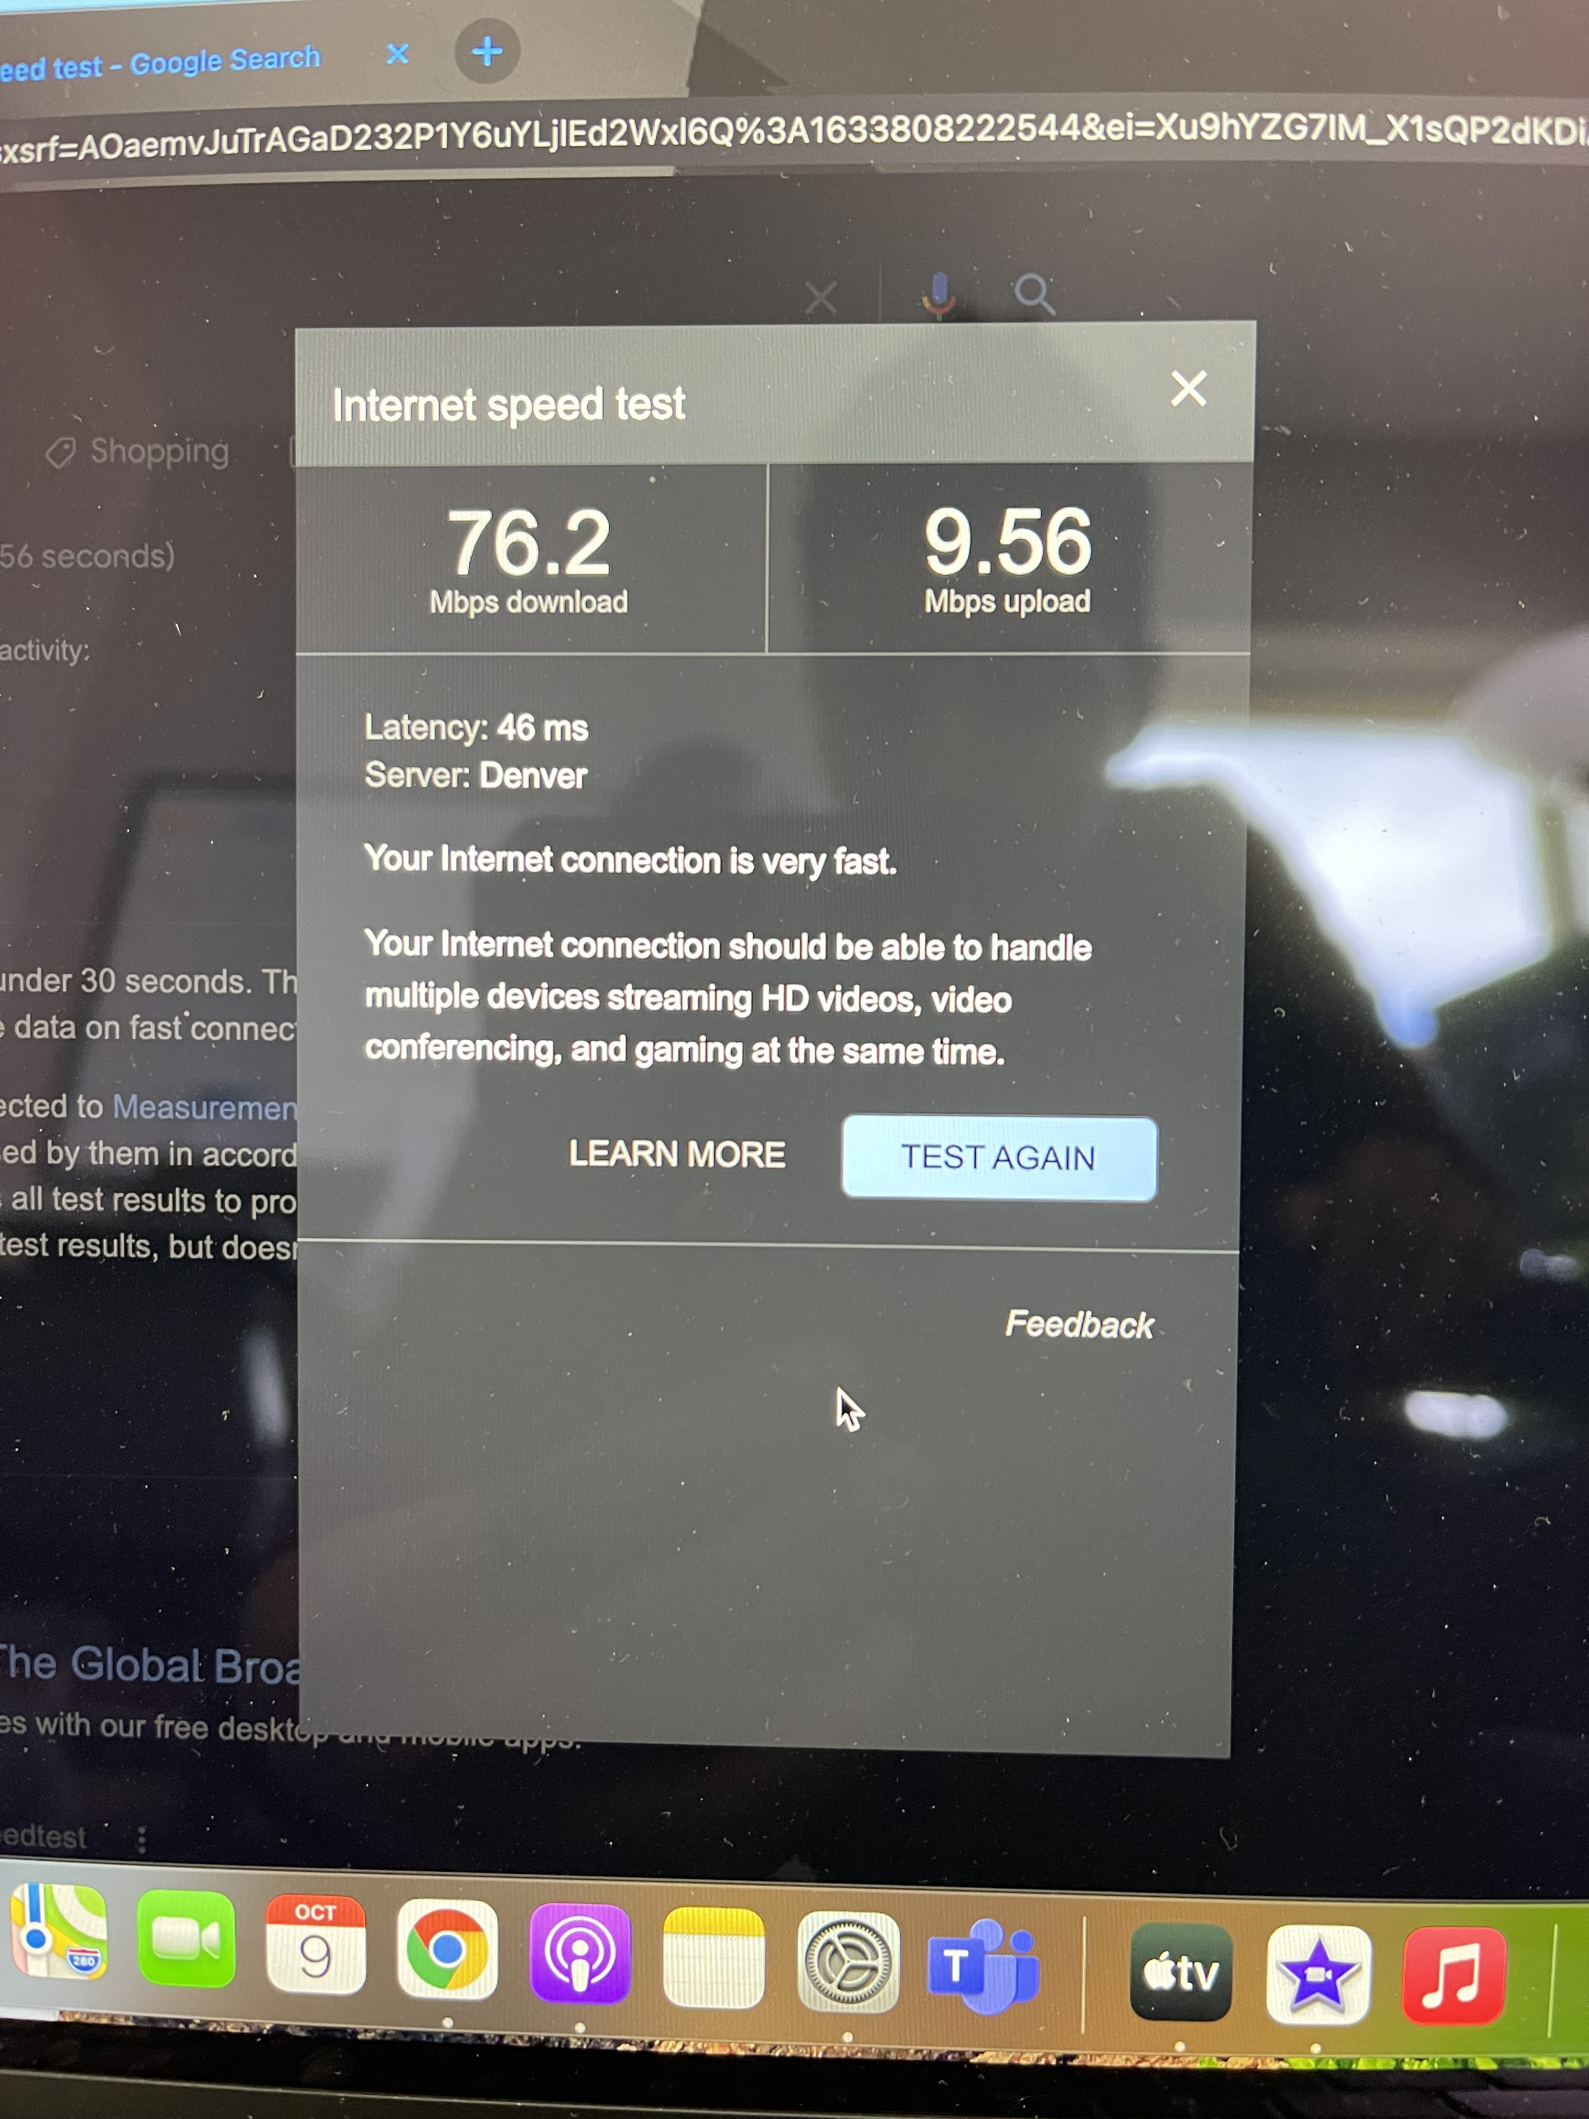Illustration 3: Speed- Test the speed
You can open up your favorite internet browser and see the internet speed.

After you are done with all of the configurations run the following commands on both AP’s to output the following:

net3720-ap2#show tech-support

------------------ show running-config ------------------

Building configuration...

Current configuration : 1603 bytes
!
! Last configuration change at 00:14:52 UTC Mon Mar 1 1993
version 15.3
no service pad
service timestamps debug datetime msec
service timestamps log datetime msec
service password-encryption
!
hostname net3720-ap2
!
!
logging rate-limit console 9
enable secret 5 <removed>
!
no aaa new-model
no ip source-route
no ip cef
!
!
!
!
dot11 pause-time 100
dot11 syslog
!
dot11 ssid net3720-Hernandez-bridge
authentication open
authentication key-management wpa version 2
wpa-psk ascii 7 065E5F701E1B504B574444
!
!
!
no ipv6 cef
!
!
username Cisco password 7 <removed>
!
!
bridge irb
!
!
!
interface Dot11Radio0
no ip address
shutdown
antenna gain 0
station-role root
bridge-group 1
bridge-group 1 subscriber-loop-control
bridge-group 1 spanning-disabled
bridge-group 1 block-unknown-source
no bridge-group 1 source-learning
no bridge-group 1 unicast-flooding
!
interface Dot11Radio1
no ip address
!
encryption mode ciphers aes-ccm
!
ssid net3720-Hernandez-bridge
!
antenna gain 0
peakdetect
station-role non-root bridge
bridge-group 1
bridge-group 1 spanning-disabled
!
interface GigabitEthernet0
no ip address
duplex auto
speed auto
bridge-group 1
bridge-group 1 spanning-disabled
!
interface BVI1
mac-address d8b1.9038.86a0
ip address dhcp client-id GigabitEthernet0
ipv6 address dhcp
ipv6 address autoconfig
ipv6 enable
!
ip forward-protocol nd
no ip http server
no ip http secure-server
ip http help-path http://www.cisco.com/warp/public/779/smbiz/prodconfig/help/eag
!
!
bridge 1 route ip
!
!
!
line con 0
line vty 0 4
login local
transport input all
!
end

net3720-ap46#show tech-support

------------------ show running-config ------------------

Building configuration...

Current configuration : 1633 bytes
!
! Last configuration change at 00:52:38 UTC Mon Mar 1 1993
version 15.3
no service pad
service timestamps debug datetime msec
service timestamps log datetime msec
service password-encryption
!
hostname net3720-ap46
!
!
logging rate-limit console 9
enable secret 5 <removed>
!
no aaa new-model
no ip source-route
no ip cef
!
!
!
!
dot11 pause-time 100
dot11 syslog
!
dot11 ssid net3720-Hernandez-bridge
authentication open
authentication key-management wpa version 2
wpa-psk ascii 7 115149544547525E56797D
!
!
!
no ipv6 cef
!
!
username Cisco password 7 <removed>
!
!
bridge irb
!
!
!
interface Dot11Radio0
no ip address
shutdown
antenna gain 0
station-role root
bridge-group 1
bridge-group 1 subscriber-loop-control
bridge-group 1 spanning-disabled
bridge-group 1 block-unknown-source
no bridge-group 1 source-learning
no bridge-group 1 unicast-flooding
!
interface Dot11Radio1
no ip address
!
encryption mode ciphers aes-ccm
!
ssid net3720-Hernandez-bridge
!
antenna gain 0
peakdetect
no dfs band block
channel 5825
station-role root bridge
bridge-group 1
bridge-group 1 spanning-disabled
!
interface GigabitEthernet0
no ip address
duplex auto
speed auto
bridge-group 1
bridge-group 1 spanning-disabled
!
interface BVI1
mac-address d8b1.9043.08bc
ip address dhcp client-id GigabitEthernet0
ipv6 address dhcp
ipv6 address autoconfig
ipv6 enable
!
ip forward-protocol nd
no ip http server
no ip http secure-server
ip http help-path http://www.cisco.com/warp/public/779/smbiz/prodconfig/help/eag
!
!
bridge 1 route ip
!
!
!
line con 0
line vty 0 4
login local
transport input all
!
end
References

How to open ports in Linux server firewall. (2011, September 2). Retrieved from https://www.wikihow.com/Open-Ports-in-Linux-Server-Firewall
Jenkins, L. (2021, October 7). Lecture. Interview. Layton, UT.
Take a screenshot on your Mac. (2021, March 6). Retrieved from https://support.apple.com/en- us/HT201361

