NET3720 - Fall 2021 – Jenkins

Lab 6 – Rate Vs. Range

Erika Hernandez

Lab Objectives:
- Connect (2) Cisco AP’s and find the Rate Vs. Range

Hardware needed:
- (2) Cisco Aironet 3700 AP
- (2) ZYCEL PoE Switch
- (1) USB to RS232 cable
- Computer 1 – Console

Software:
- Console application
- PuTTY http://the.earth.li/~sgtatham/putty/latest/x86/putty.exe
- Instructions on how to download PuTTY
  - https://www.weber.edu/CS/remote-access.html

Instructions:
In this lab you will learn how to configure a Cisco AP unit using the CLI. You will connect Cisco AP 1 to computer 1 and then configure the range and rate between both AP’s

Method:
Power up two ZYXEL switches, and open up lab 5 commands after that. Open up PuTTY and click on Serial then type /dev/ttyUSB0 and then open.

Connections:
Get a cat6 cable connect to the ZYXEL switch, Do this twice to both switches. Get your console computer and connect the USB to RS232 to your computer. Connect a bridge between both AP’s. So make sure your AP’s are connected to their own switch.

Turn on the ZYXEL swtich on, and make sure the USB is plugged in and make sure the computer pickups the USB.

Open up you Linux Terminal

Type sudo putty in Terminal
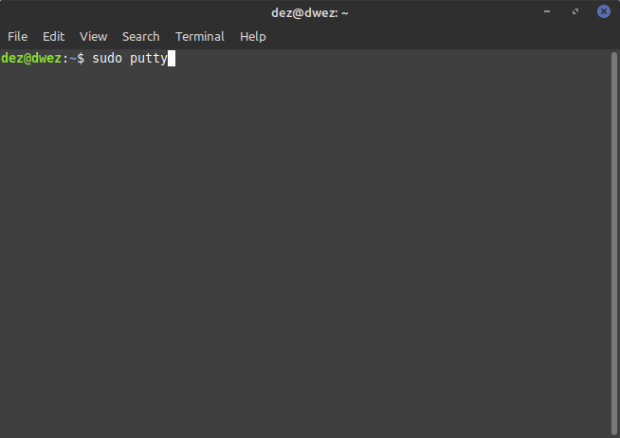Figure 1: Terminal - sudo putty

Type your password ----

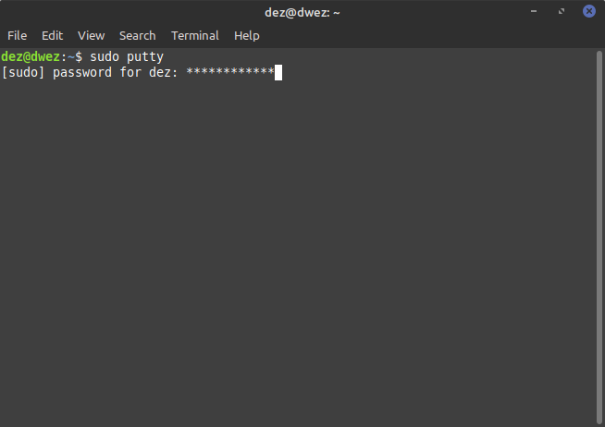Figure 2: Type password

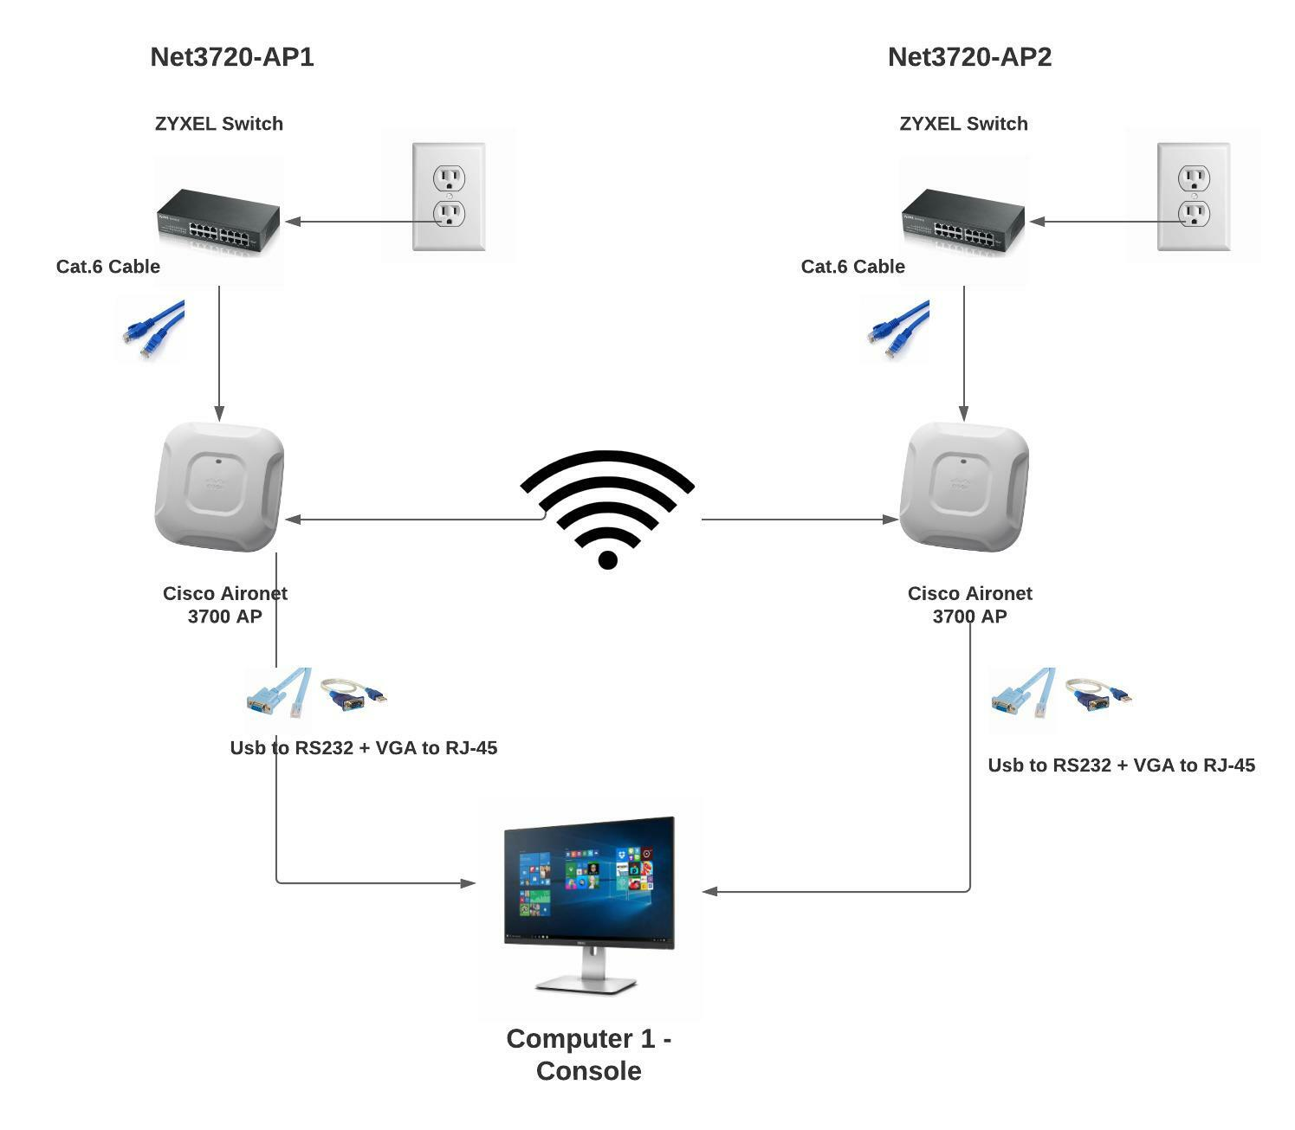Figure 3: Network layout

After your putty should open up.
Serial Line – Location should be open
Speed – 9600

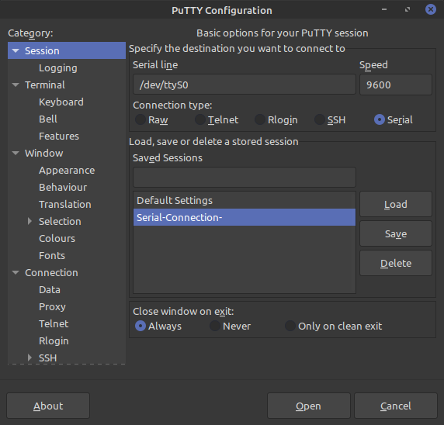Figure 4: PuTTY - Make sure these are the same

Setup 1 – This is the first part of this process. Input the

AP1 Configuration

Following commands:

ap> enable
Password: Cisco
ap# show running-config

(See if anything is configure- Move on if ok)

ap# hostname net3720-ap1

ap# config-term

net3720-ap1(config)#dot11 ssid net3720-Hernandez-bridge

net3720-ap1(config-ssid)#authentication open

net3720-ap1(config-ssid)#authentication key-management wpa version

net3720-ap1(config-ssid)#wpa-psk ascii 0 8012592236 (NOTE: This is a password and needs to be a number )

net3720-ap1(config-ssid)#interface Dot11Radio1

net3720-ap1(config-if)#encryption mode ciphers aes-ccm

net3720-ap1(config-if)#ssid net3720-Hernandez-bridge

net3720-ap1(config-if)#channel 165

net3720-ap1(config-if)#station-role root bridge

net3720-ap1(config-if)#no shut

net3720-ap1(config)#interface BVI 1

net3720-ap1(config-if)#ip address 10.1.1.1 255.255.255.0 (NOTE: I picked 10.1.1.1)

AP2 Configuration

Setup 2 – Unplug Console cable from the Cisco AP 1 and plug into Cisco AP 2. Make sure switch 2 is powered up.

Input the following commands:

ap>enable
Password: Cisco

ap(config)#hostname net3720-ap2

net3720-ap2(config)#dot11 ssid net3720-Hernandez-bridge

net3720-ap2(config-ssid)#authentication open

net3720-ap2(config-ssid)#authentication key-management wpa version 2

net3720-ap2(config-ssid)#wpa-psk ascii 0 8012592236

net3720-ap2(config-ssid)#interface Dot11Radio1

net3720-ap2(config-if)#encryption mode ciphers aes-ccm

net3720-ap2(config-if)#ssid net3720-Hernandez-bridge

net3720-ap2(config-if)#channel 165

net3720-ap2(config-if)#station-role non-root bridge

net3720-ap2(config-if)#no shut

Net3720-ap2(config)#interface BVI1

Net3720-ap2(config-if)#ip address 10.1.1.1 255.255.255.0

Capturing the packet rates

We are now going to do 4 different test and see how we are able to get the rates of each packets. From on top each other. 10 ft away, 20 ft away and over 30 ft away.

Input the following commands after each attempt:

net3720-ap1# clear counters dot11radio 1

net3720-ap1#ping ip 10.1.1.2 size 18024 repeat 60000

net3720-ap1# show dot11 associations all-client

net3720-ap1#show controllers dot11Radio 1 radio-stats

Attempt 1: AP’s stacked on top of each other with AP1

The following input will be the packet rates of the AP’s when they are stacked on top of each other
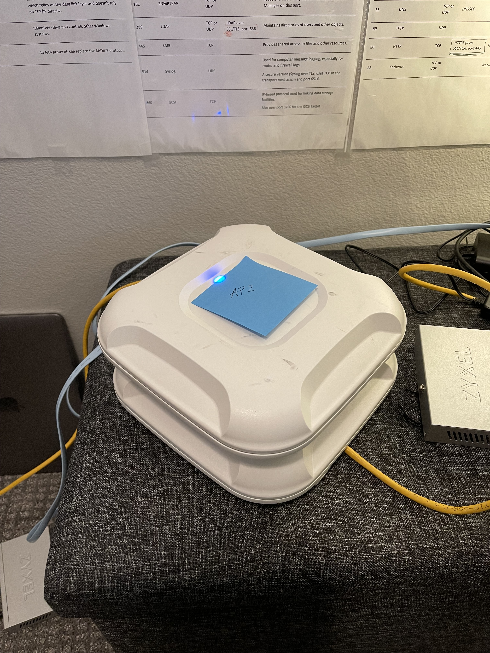Figure 5: AP's stacked on top of each other- Blue light means they are communicating
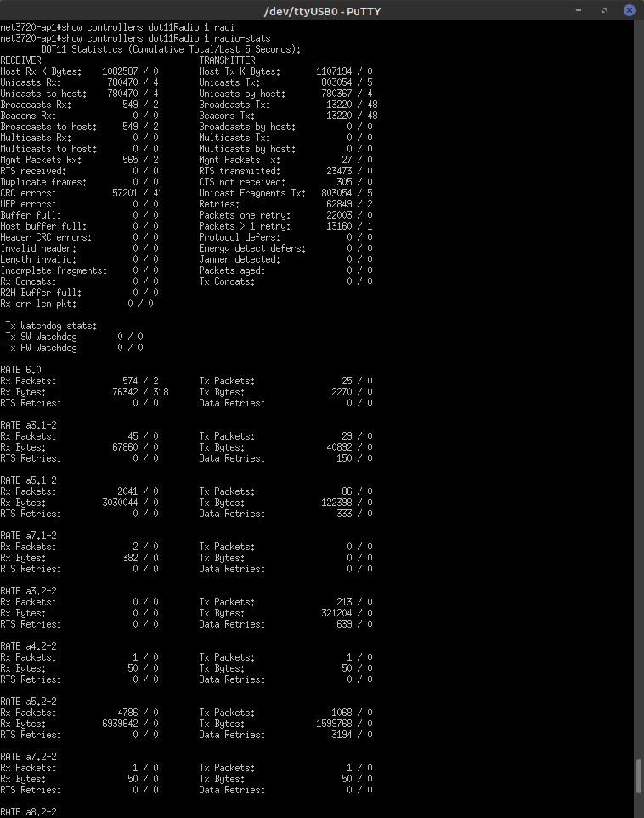Figure 6: Phase 1- Rates print out
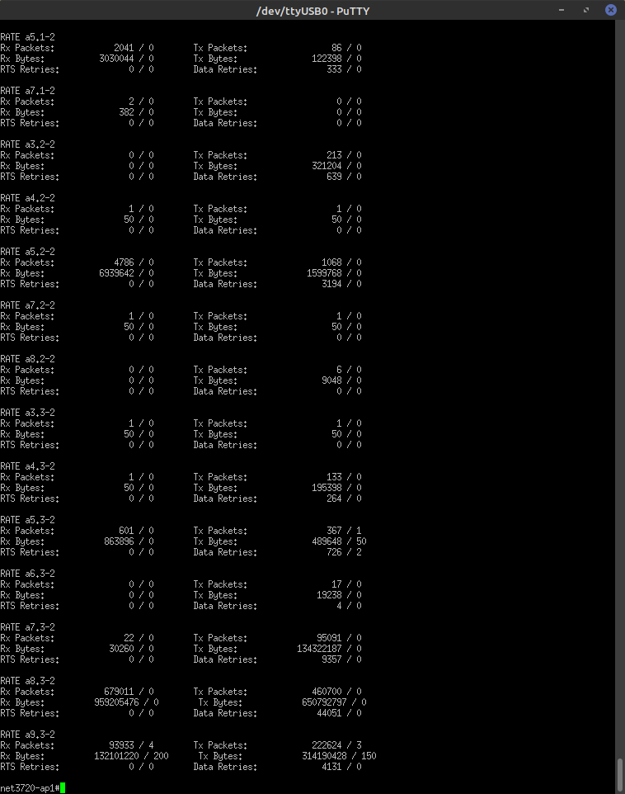Figure 7: Continuing with Phase 1

net3720-ap1# clear counters dot11radio 1

net3720-ap1#ping ip 10.1.1.2 size 18024 repeat 60000

net3720-ap1# show dot11 associations all-client

net3720-ap1#show controllers dot11Radio 1 radio-stats

Attempt 2: 10 feet away with AP1
Run the commands above and we will run the attempt from 10 feet away.
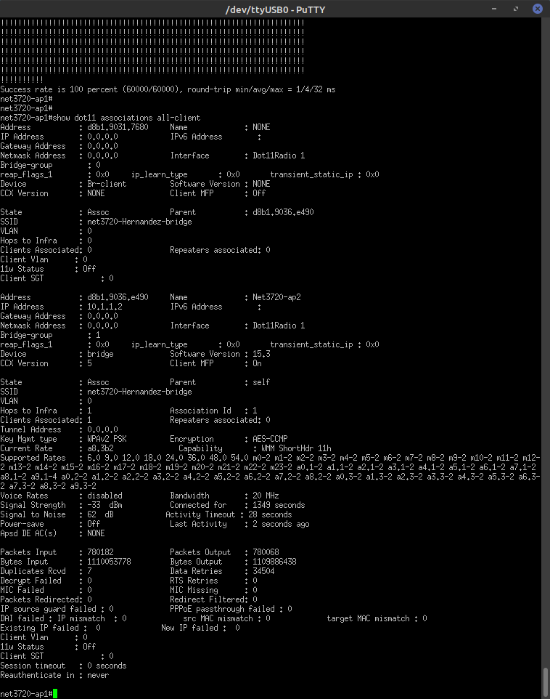Figure 8: Show dot11 associations all-client print out

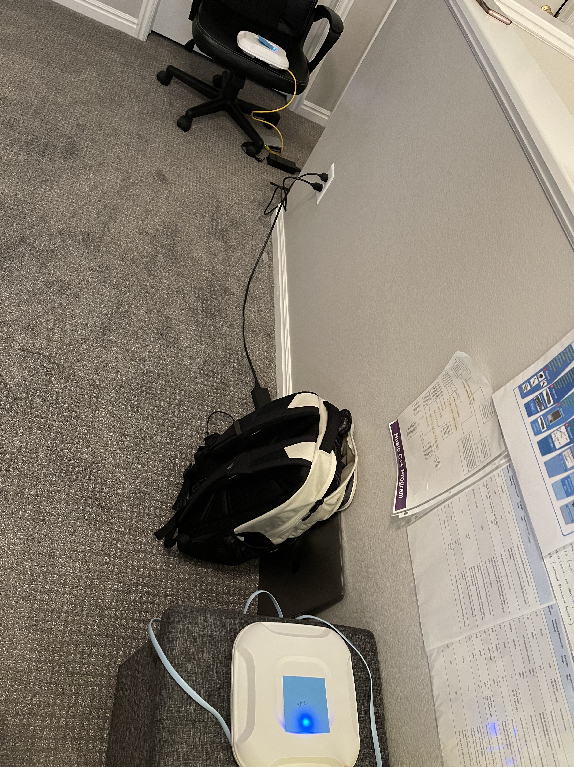Figure 9: Phase 2 - AP's 10 feet away
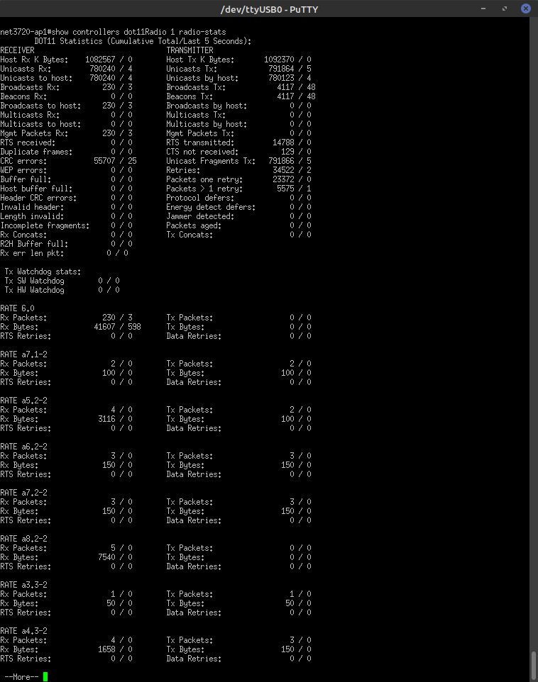Figure 10: Phase 2 - Rates print out

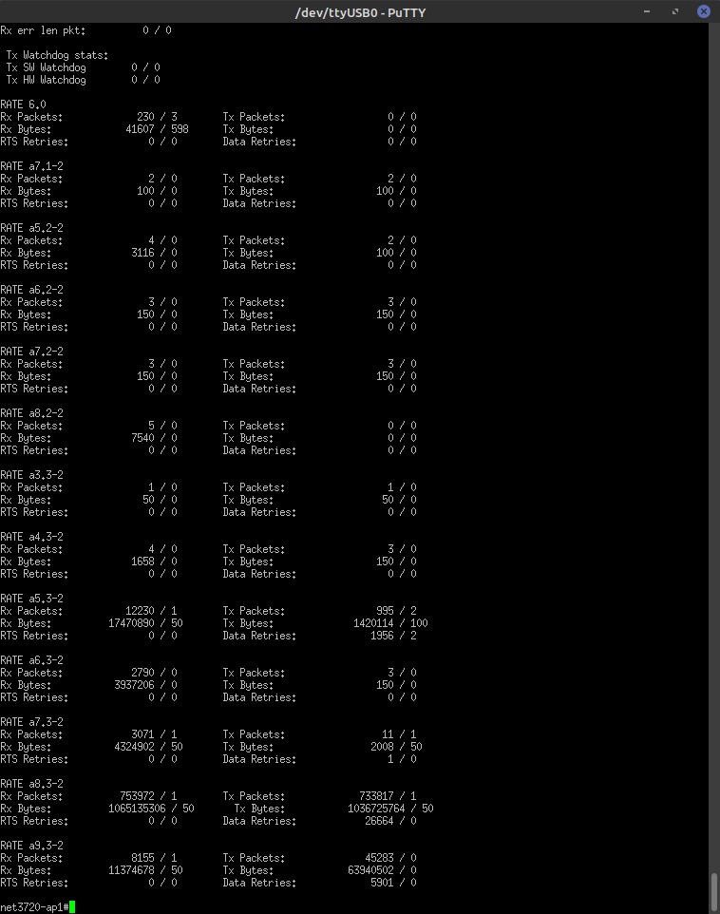Figure 11: Continuing with phase 2

net3720-ap1# clear counters dot11radio 1

net3720-ap1#ping ip 10.1.1.2 size 18024 repeat 60000

net3720-ap1# show dot11 associations all-client

net3720-ap1#show controllers dot11Radio 1 radio-stats

Attempt 3: 20 feet away with AP1
Run the commands above and we will run the attempt from 20 feet away.

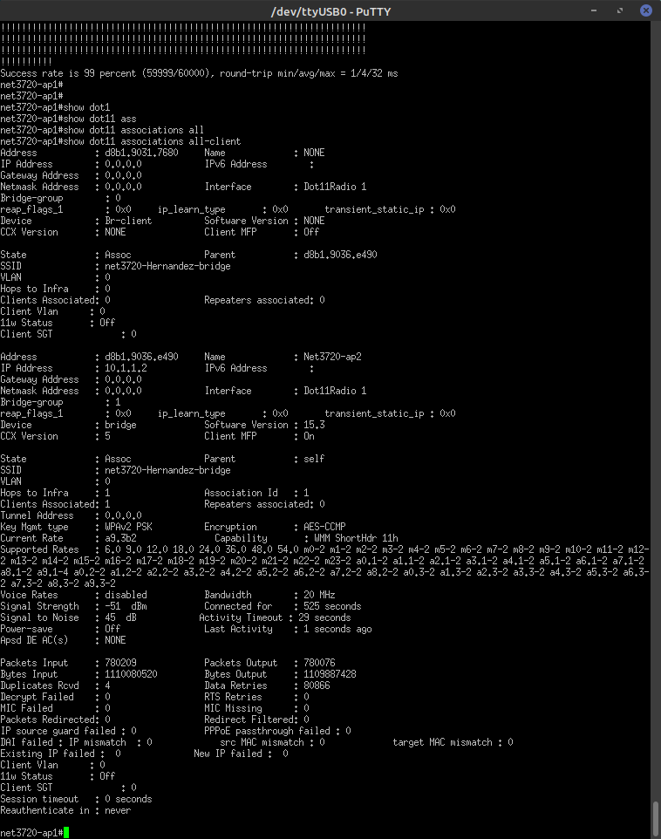Figure 12: Show dot11 associations all-client print out

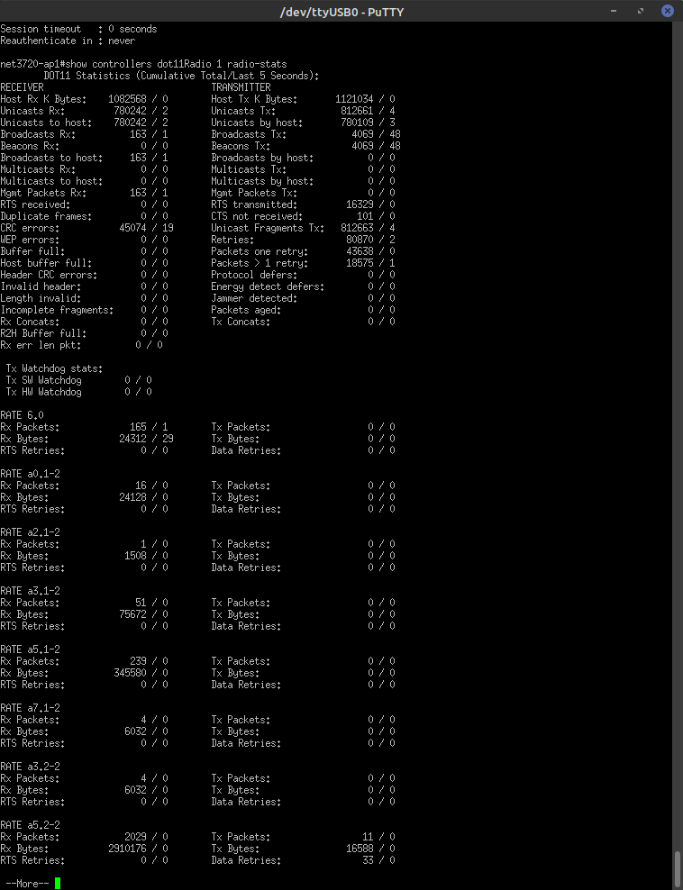Figure 13: Phase 3 Rates print out
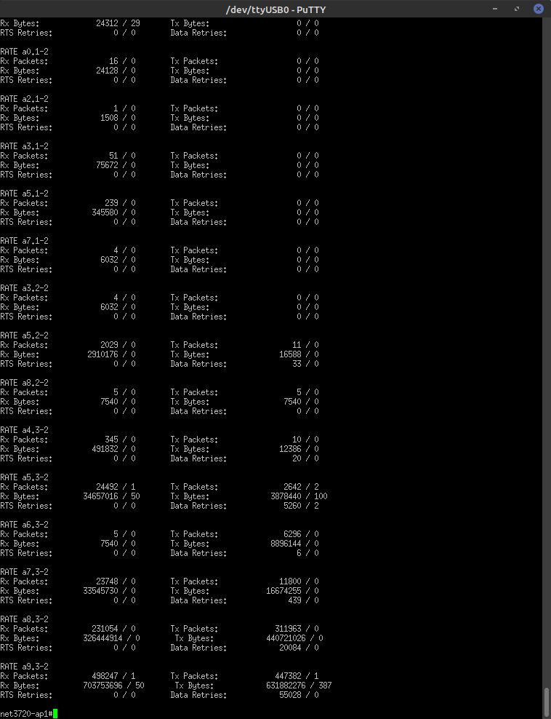Figure 14: Continuing phase 3 print out
net3720-ap1# clear counters dot11radio 1

net3720-ap1#ping ip 10.1.1.2 size 18024 repeat 60000

net3720-ap1# show dot11 associations all-client

net3720-ap1#show controllers dot11Radio 1 radio-stats

Attempt 4: 30 feet + away with AP1
Run the commands above and we will run the attempt from 30 feet + away.
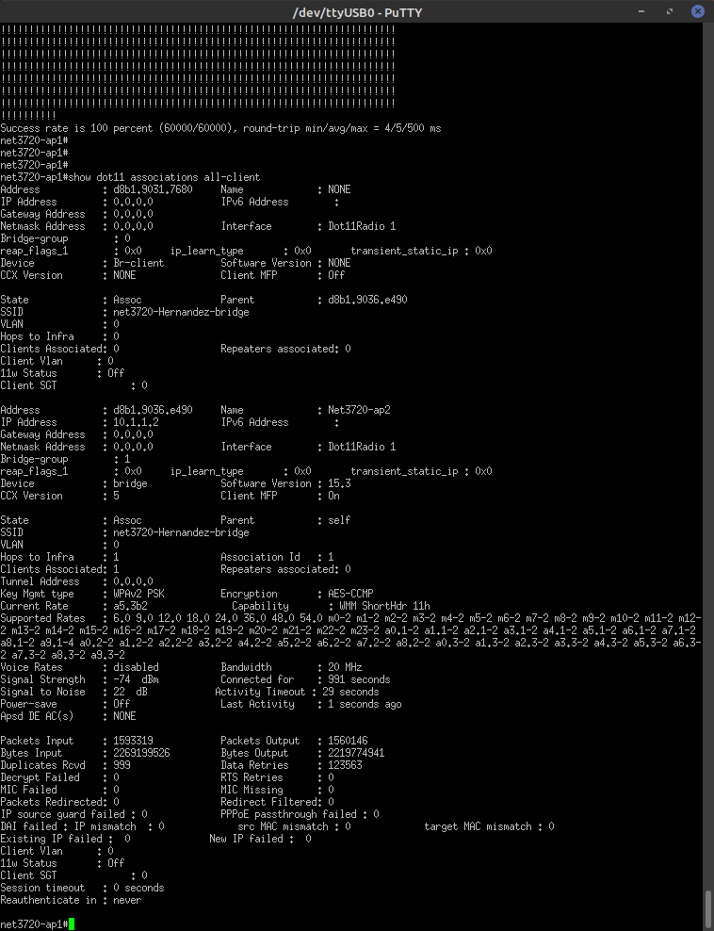Figure 15: show dot11 associations all-client print out
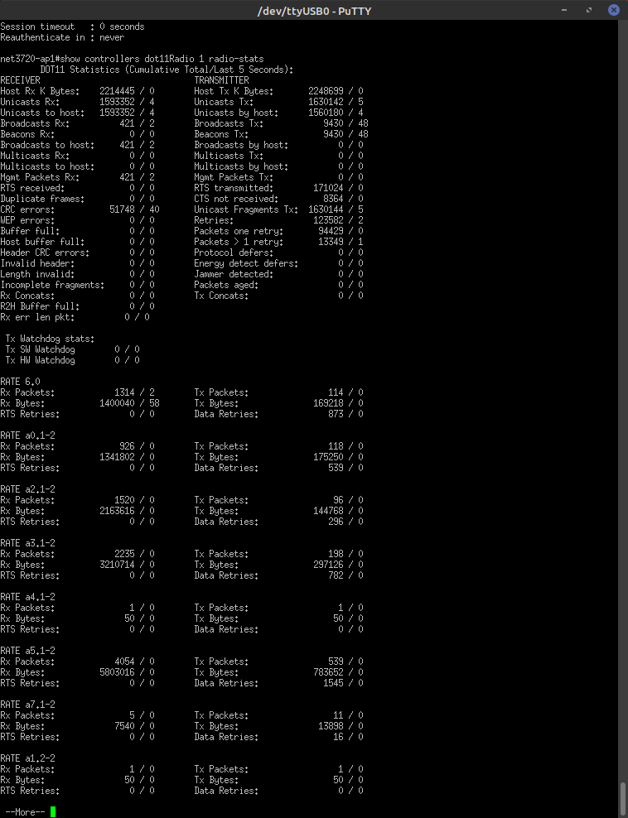Figure 16: Phase 4 rates print out
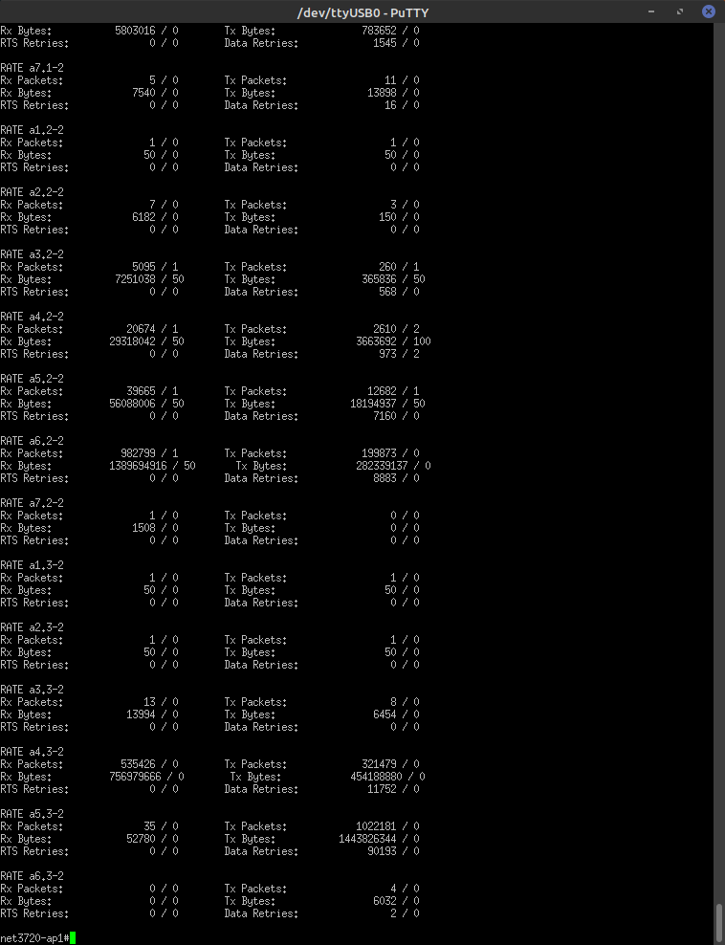Figure 17: continuing with Phase 4 print out

Continued with part 2 of Attempt 4

Attempt 4: 30 feet + away with AP1
Run the following command when you have the AP at the furthest away. The goal is to get about a Success rate of 99 or 100. My office is upstairs and my AP was upstairs. I put the second AP downstairs in the garage and I ran this command and this was my output.

net3720-ap1#ping ip 10.1.1.2 size 18024 repeat 60000

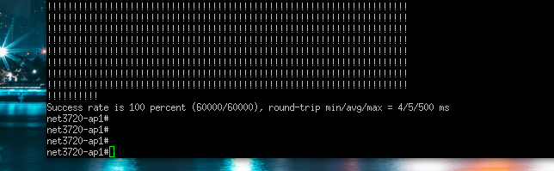Figure 18: Success rate 100% - What you would like to have

Rates graph
Here we have a chart that is showing the different phases.
Phase 1 – On top of each other
Phase 2 – 10 feet away
Phase 3 – 20 feet away
Phase 4 – Over 20 feet away
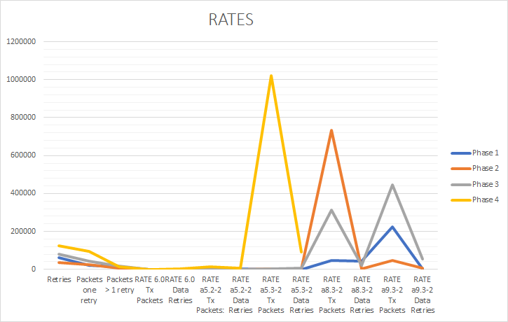Figure 19: Graph of all the numbers combined of the rates

Phase 1 Phase 2 Phase 3 Phase 4
Retries: 62849 / 2 Retries: 34522 / 2 Retries: 80870/20 Retries: 123582/ 2
Packets one retry: 22003 / 0 Packets one retry: 23370 /0 Packets one retry: 43638/ 0 94429/0
Packets > 1 retry: 13160 / 1 Packets > 1 retry: 5575 / 1 Packets > 1 retry: 1875/1 13349/ 1

Rate 6.0 Rate: 6.0 Rate 6.0 Rate 6.0
Tx Packets: 25 / 0 Tx Packets: 0/0 Tx Packets: 0/0 Tx Packets: 114/ 0
Data Retries: 0 / 0 Data Retries: 0/0 Data Retries: 0/0 Data Retries: 873/ 0

Rate a5.2-2 Rate: a5.2-2 Rate: a5.2-2 Rate a5.2-2
Tx Packets: 1068 / 0 Tx Packets: 2/0 Tx Packets: 11/0 Tx Packets: 12682/ 1
Data Retries: 3194 / 0 Data Retries: 0/0 Data Retries: 33/0 Data Retries: 7160/ 0

Rate a5.3-2 Rate a5.3-2 Rate a5.3-2 Rate a5.3-2
Tx Packets: 367 / 1 Tx Packets: 995/2 Tx Packets: 2642/2 Tx Packets:1022181/0
Data Retries: 726 / 2 Data Retries: 1956 / 2 Data Retries: 5260/ 2 Data Retires:90193/ 0

Rate a8.3-2 Rate a8.3-2 Rate a8.3-2 Rate a8.3-2
Tx Packets: 46070 / 0 Tx Packets: 733817/1 Tx Packets: 311963/ 0 Tx Packets: No data
Data Retries: 44051 / 0 Data Retires: 2664/0 Data Retires: 20084/ 0 Data Retries: No data

Rate a9.3-2 Rate a9.3-2 Rate a9.3-2 Rate a9.3-2
Tx Packets: 222624 / 3 Tx Packets: 45282/0 Tx Packets: 447382/ 1 Tx Packets: No data
Data Retries: 4131 / 0 Data Retries: 5901/0 Data Retries: 55028/ 0 Data Retries: No data

Closing- Tech-support for both AP’s

AP1 – Report
net3720-ap1#show tech-support

------------------ show running-config ------------------

Building configuration...

Current configuration : 1623 bytes
!
! Last configuration change at 00:00:38 UTC Mon Mar 1 1993
version 15.3
no service pad
service timestamps debug datetime msec
service timestamps log datetime msec
service password-encryption
!
hostname net3720-ap1
!
!
logging rate-limit console 9
enable secret 5 <removed>
!
no aaa new-model
no ip source-route
no ip cef
!
!
!
!
dot11 pause-time 100
dot11 syslog
!
dot11 ssid net3720-Hernandez-bridge
authentication open
authentication key-management wpa version 2
wpa-psk ascii 7 0757711D1C5C405745415D
!
!
!
no ipv6 cef
!
!
username Cisco password 7 <removed>
!
!
bridge irb
!
!
!
interface Dot11Radio0
no ip address
shutdown
antenna gain 0
station-role root
bridge-group 1
bridge-group 1 subscriber-loop-control
bridge-group 1 spanning-disabled
bridge-group 1 block-unknown-source
no bridge-group 1 source-learning
no bridge-group 1 unicast-flooding
!
interface Dot11Radio1
no ip address
!
encryption mode ciphers aes-ccm
!
ssid net3720-Hernandez-bridge
!
antenna gain 0
peakdetect
no dfs band block
channel 5825
station-role root bridge
bridge-group 1
bridge-group 1 spanning-disabled
!
interface GigabitEthernet0
no ip address
duplex auto
speed auto
bridge-group 1
bridge-group 1 spanning-disabled
!
interface BVI1
mac-address d8b1.9043.08bc
ip address 10.1.1.1 255.255.255.0
ipv6 address dhcp
ipv6 address autoconfig
ipv6 enable
!
ip forward-protocol nd
no ip http server
no ip http secure-server
ip http help-path http://www.cisco.com/warp/public/779/smbiz/prodconfig/help/eag
!
!
bridge 1 route ip
!
!
!
line con 0
line vty 0 4
login local
transport input all
!
end
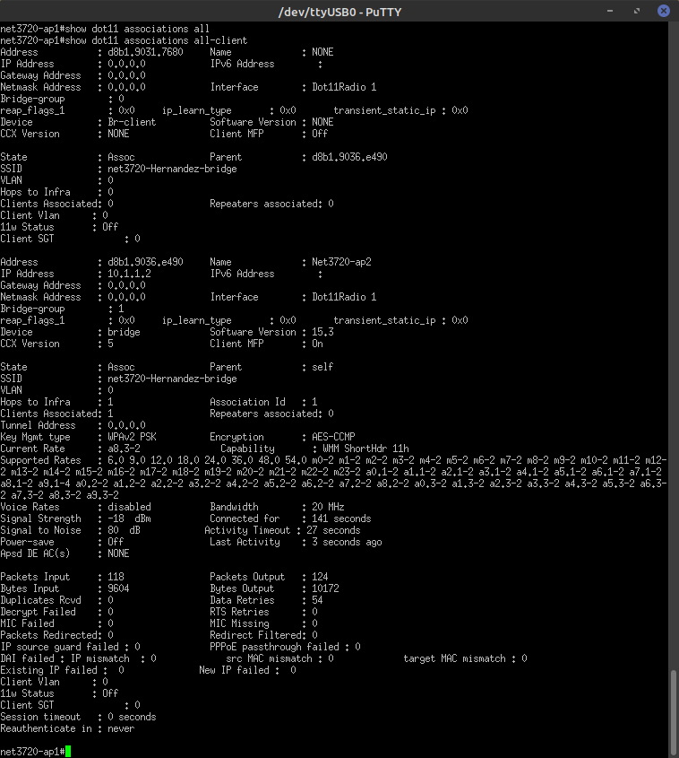

AP2 – Show tech support Report
Net3720-ap2#show tech-support

------------------ show running-config ------------------
Building configuration...

Current configuration : 1535 bytes
!
version 15.3
no service pad
service timestamps debug datetime msec
service timestamps log datetime msec
service password-encryption
!
hostname Net3720-ap2
!
!
logging rate-limit console 9
enable secret 5 <removed>
!
no aaa new-model
no ip source-route
no ip cef
!
!
!
!
dot11 pause-time 100
dot11 syslog
!
dot11 ssid net3720-Hernandez-bridge
authentication open
authentication key-management wpa version 2
wpa-psk ascii 7 065E5F701E1B504B574444
!
!
!
no ipv6 cef
!
!
username Cisco password 7 <removed>
!
!
bridge irb
!
!
!
interface Dot11Radio0
no ip address
shutdown
antenna gain 0
station-role root
bridge-group 1
bridge-group 1 subscriber-loop-control
bridge-group 1 spanning-disabled
bridge-group 1 block-unknown-source
no bridge-group 1 source-learning
no bridge-group 1 unicast-flooding
!
interface Dot11Radio1
no ip address
!
encryption mode ciphers aes-ccm
!
ssid net3720-Hernandez-bridge
!
antenna gain 0
peakdetect
station-role non-root bridge
bridge-group 1
bridge-group 1 spanning-disabled
!
interface GigabitEthernet0
no ip address
duplex auto
speed auto
bridge-group 1
bridge-group 1 spanning-disabled
!
interface BVI1
mac-address d8b1.9038.86a0
ip address 10.1.1.2 255.255.255.0
ipv6 address dhcp
ipv6 address autoconfig
ipv6 enable
!
ip forward-protocol nd
no ip http server
no ip http secure-server
ip http help-path http://www.cisco.com/warp/public/779/smbiz/prodconfig/help/eag
!
!
bridge 1 route ip
!
!
!
line con 0
line vty 0 4
login local
transport input all
!
end
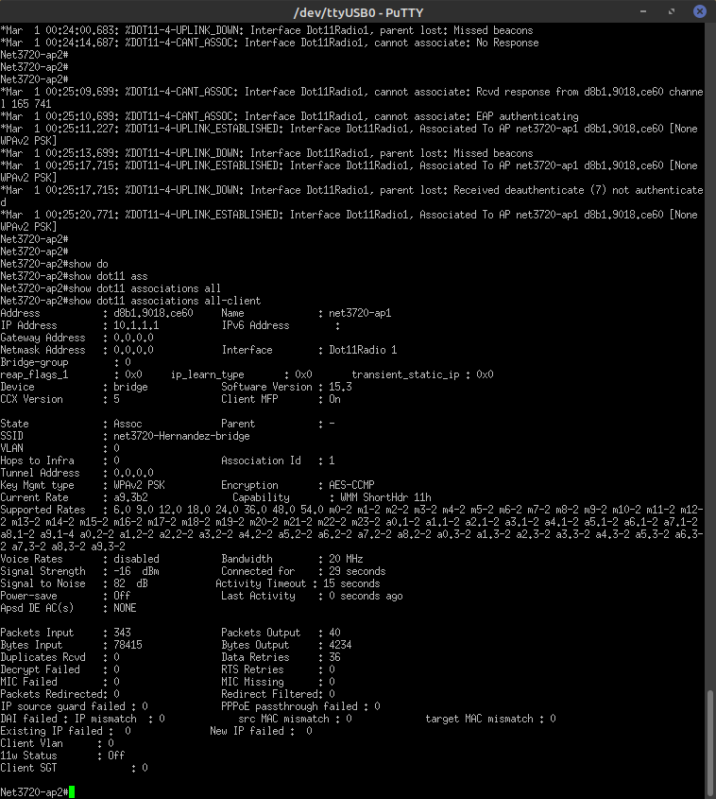
References

Jenkins, L. (2021, October 13). Lecture. Interview. Layton, UT.

