NET3720 - Fall 2021 – Jenkins

Lab 7 – Attenuation Measurement

Erika Hernandez

Lab Objectives:
- Connect (2) Cisco AP’s and find the Attenuation measurements

Hardware needed:
- (2) Cisco Aironet 3700 AP
- (2) ZYCEL PoE Switch
- (1) USB to RS232 cable
- Computer 1 – Console

Software:
- Console application
- PuTTY http://the.earth.li/~sgtatham/putty/latest/x86/putty.exe
- Instructions on how to download PuTTY
  - https://www.weber.edu/CS/remote-access.html

Instructions:
In this lab you will learn how to configure a Cisco AP unit using the CLI. You will connect Cisco AP 1 to computer 1. Then you will get the dB distance between the two AP’s and see what ratings you get from when communicating from each other. I will be testing 3 different things. 1 window, 2 metal doors and 1 wood door. We will testing these with the doors open and closed and see what we get.

Method:
Power up two ZYXEL switches, and open up lab 6 commands after that. Open up PuTTY and click on Serial then type /dev/ttyUSB0 and then open.

Connections:
Get a cat6 cable connect to the ZYXEL switch, Do this twice to both switches. Get your console computer and connect the USB to RS232 to your computer. Connect a bridge between both AP’s. So make sure your AP’s are connected to their own switch.

Turn on the ZYXEL swtich on, and make sure the USB is plugged in and make sure the computer pickups the USB.

Open up you Linux Terminal

Type sudo putty in Terminal
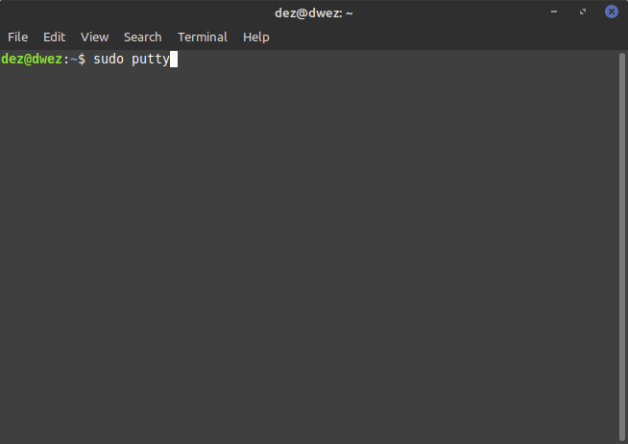Figure 1: Terminal - sudo putty

Type your password ----

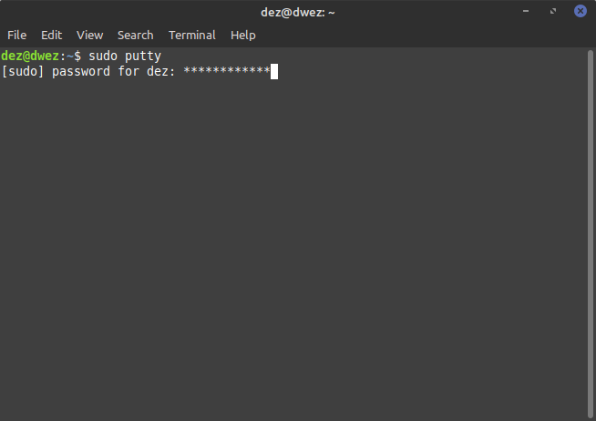Figure 2: Type password

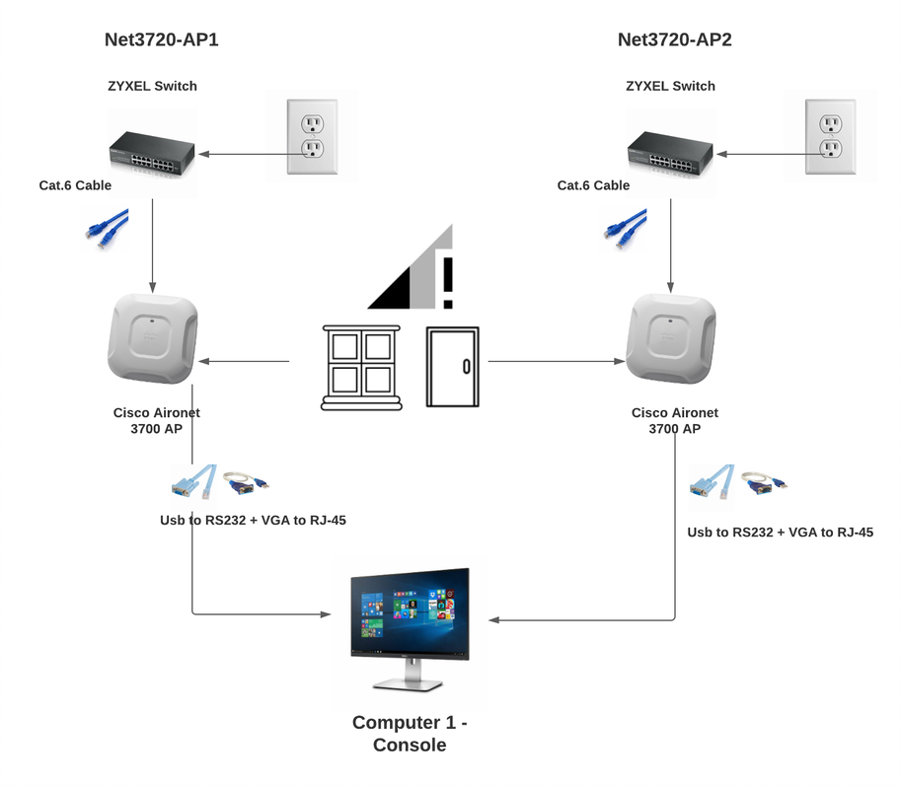Figure 3: Network layout- Finding the dB

After your putty should open up.
Serial Line – Location should be open
Speed – 9600

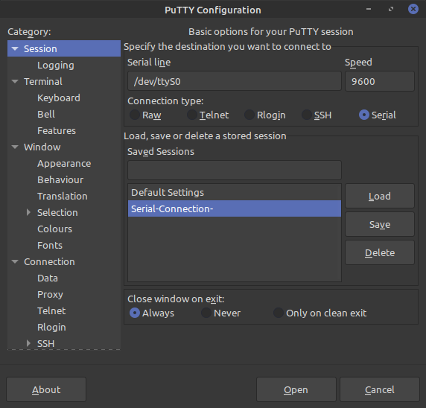Figure 4: PuTTY - Make sure these are the same

Setup 1 – This is the first part of this process. Input the

AP1 Configuration

Following commands:

ap> enable
Password: Cisco
ap# show running-config

(See if anything is configure- Move on if ok)

ap# hostname net3720-ap1

ap# config-term

net3720-ap1(config)#dot11 ssid net3720-Hernandez-bridge

net3720-ap1(config-ssid)#authentication open

net3720-ap1(config-ssid)#authentication key-management wpa version

net3720-ap1(config-ssid)#wpa-psk ascii 0 8012592236 (NOTE: This is a password and needs to be a number )
net3720-ap1(config-ssid)#guest-mode

net3720-ap1(config-ssid)#interface Dot11Radio1

net3720-ap1(config-if)#encryption mode ciphers aes-ccm

net3720-ap1(config-if)#ssid net3720-Hernandez-bridge

net3720-ap1(config-if)#channel 165

net3720-ap1(config-if)#station-role root bridge

net3720-ap1(config-if)#no shut

net3720-ap1(config)#interface BVI 1

net3720-ap1(config-if)#ip address 10.1.1.1 255.255.255.0 (NOTE: I picked 10.1.1.1)

AP2 Configuration

Setup 2 – Unplug Console cable from the Cisco AP 1 and plug into Cisco AP 2. Make sure switch 2 is powered up.

Input the following commands:

ap>enable
Password: Cisco

ap(config)#hostname net3720-ap2

net3720-ap2(config)#dot11 ssid net3720-Hernandez-bridge

net3720-ap2(config-ssid)#authentication open

net3720-ap2(config-ssid)#authentication open

net3720-ap2(config-ssid)#authentication key-management wpa version 2

net3720-ap2(config-ssid)#wpa-psk ascii 0 8012592236

net3720-ap2(config-ssid)#interface Dot11Radio1

net3720-ap2(config-if)#encryption mode ciphers aes-ccm

net3720-ap2(config-if)#ssid net3720-Hernandez-bridge

net3720-ap2(config-if)#channel 165

net3720-ap2(config-if)#station-role non-root bridge

net3720-ap2(config-if)#no shut

Net3720-ap2(config)#interface BVI1

Net3720-ap2(config-if)#ip address 10.1.1.1 255.255.255.0

Capturing the dB

We are now going to do 6 different tests. Test 1: we are going to test the dB 13 feet away, with door open. Test 2: 13 ft away with door closed. Test 3: 10 ft away with a wall and distance. Test 4: through a window that is 20 years old. Test 5: with one drywall, two wood door, and one metal doors – closed. Test 6: with one drywall, one wood door, and 2 metal doors open.

Input the following commands after each attempt:

net3720-ap1#show dot11 associations all-client | include dBm

Test 1: 13ft door open

Signal strength –48 dBm
Here I had the door open and got -48 dBm.
Signal Strength : -48 dBm Connected for : 47 seconds

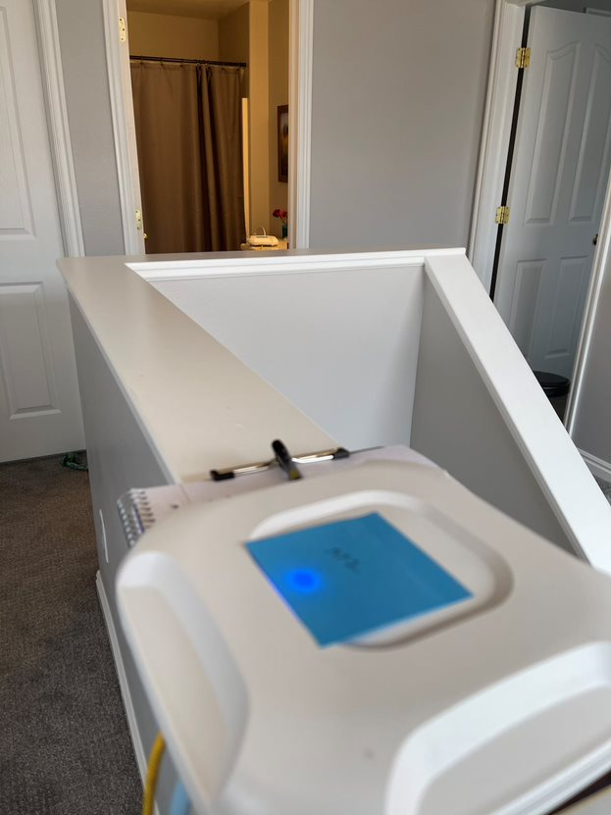

Test 2: 13ft door closed

Signal strength –49 dBm
Here I had the door closed. I measured this length with a tape measure to get my numbers on length.
Signal Strength : -49 dBm Connected for : 60 seconds

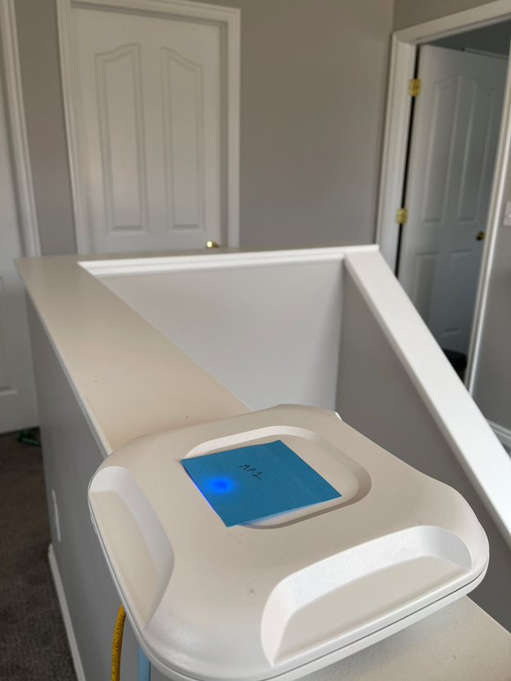

Test 3: 10ft door closed

Signal strength –38 dBm
This was 10ft away and they are directly from each other.
Signal Strength : -38 dBm Connected for : 50 seconds

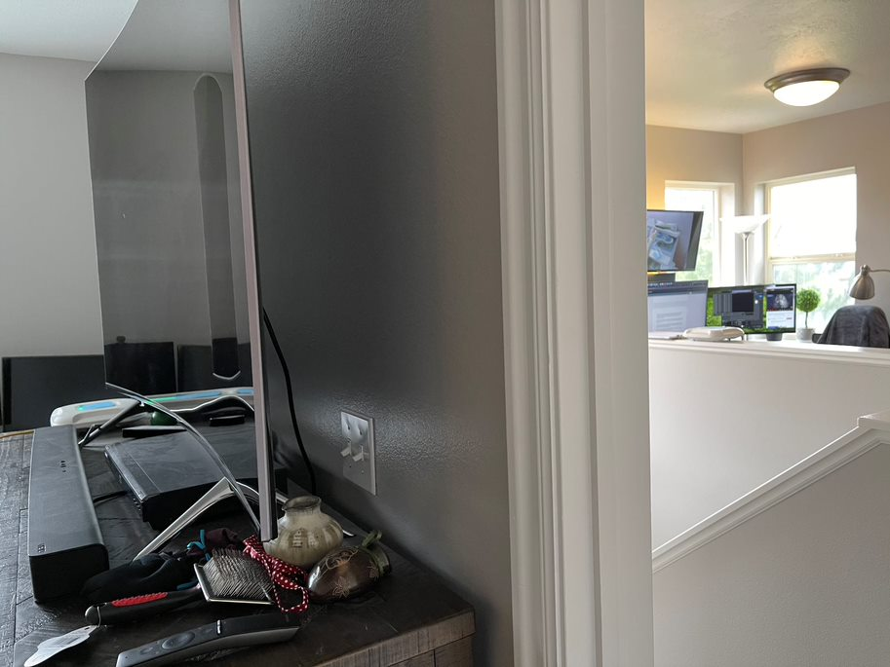

Test 4: 10 ft Through a window

Signal strength –44 dBm
This was 10 ft away and through a window. My house is about 20 yrs old.
Signal Strength : -44 dBm Connected for : 52 seconds
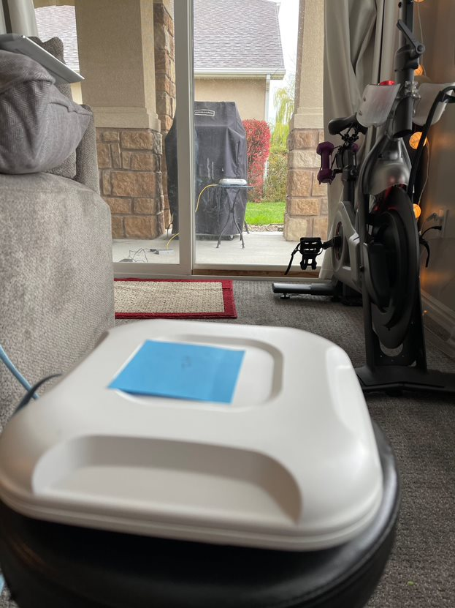

Test 5: 15ft one dry wall and 2 doors – closed

Signal strength –58 dBm
Test 5 was through one dry wall, and two wood door, and one metal doors.
Signal Strength : -58 dBm Connected for : 47 seconds
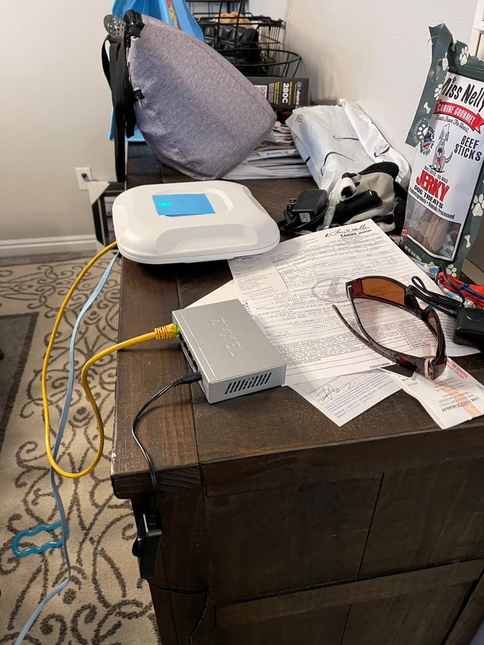
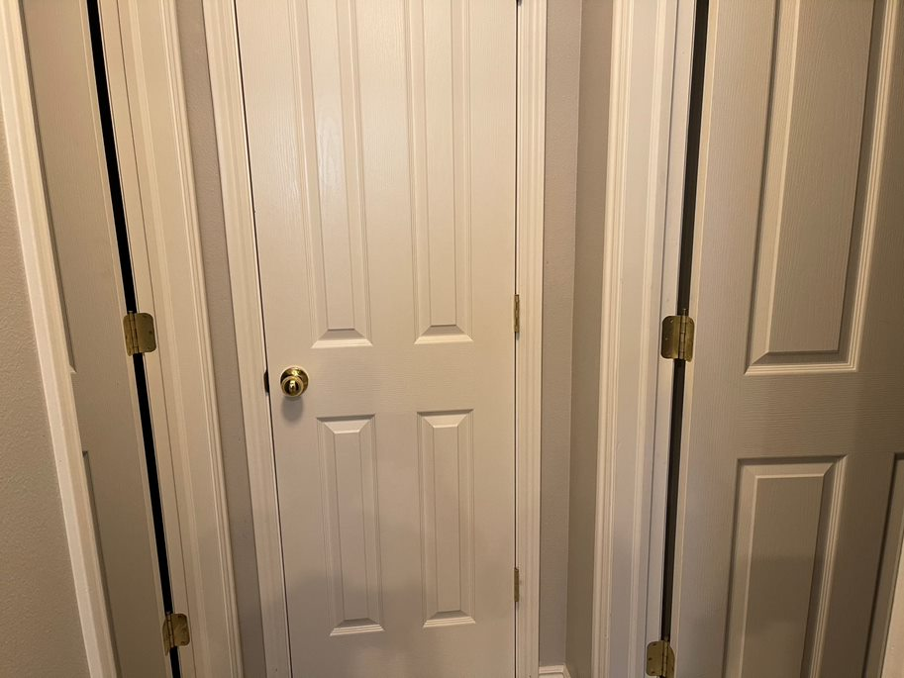

Test 6: 15ft one dry wall and 2 doors – open

Signal strength –50 dBm
Test 6 was through one dry wall, and two wood door, and one metal doors, these were open.
Signal Strength : -50 dBm Connected for : 47 seconds

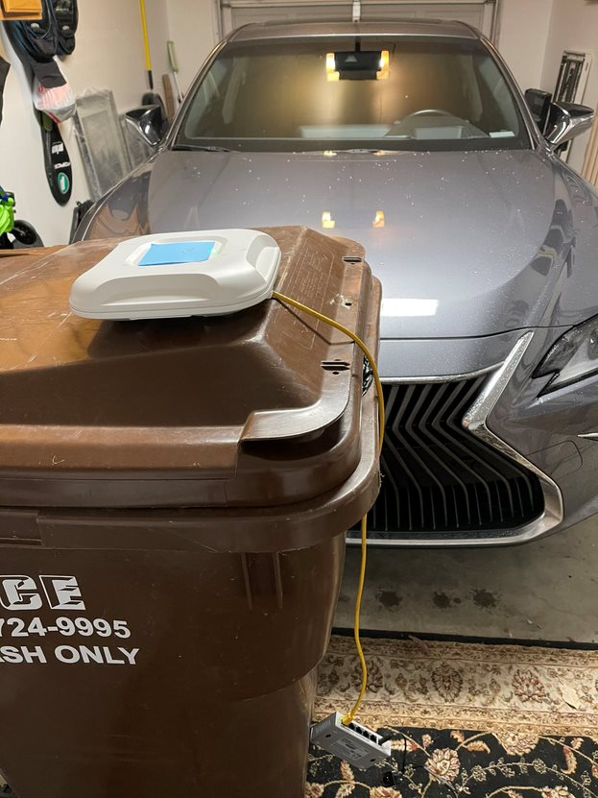
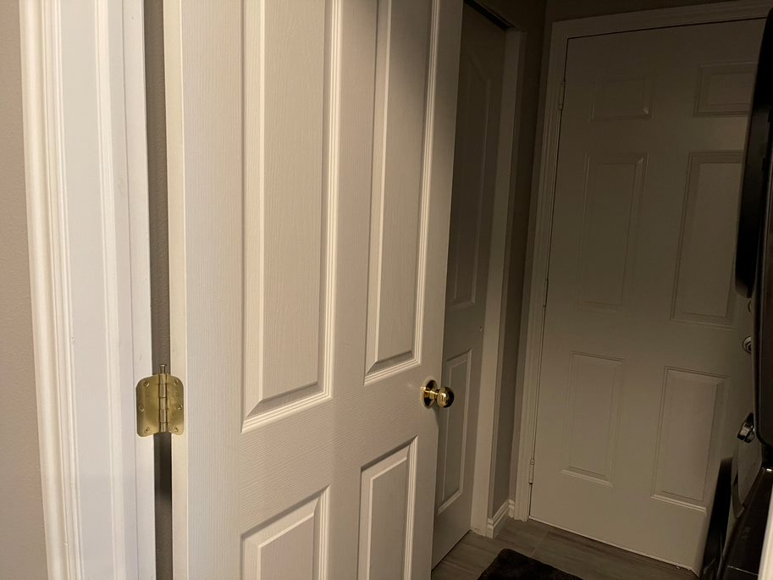

AP1 – Show tech-support

------------------ show running-config ------------------

Building configuration...

Current configuration : 1623 bytes
!
! Last configuration change at 00:00:36 UTC Mon Mar 1 1993
version 15.3
no service pad
service timestamps debug datetime msec
service timestamps log datetime msec
service password-encryption
!
hostname net3720-ap1
!
!
logging rate-limit console 9
enable secret 5 <removed>
!
no aaa new-model
no ip source-route
no ip cef
!
!
!
!
dot11 pause-time 100
dot11 syslog
!
dot11 ssid net3720-Hernandez-bridge
authentication open
authentication key-management wpa version 2
wpa-psk ascii 7 0757711D1C5C405745415D
!
!
!
no ipv6 cef
!
!
username Cisco password 7 <removed>
!
!
bridge irb
!
!
!
------------------ show running-config ------------------

Building configuration...

Current configuration : 1623 bytes
!
! Last configuration change at 00:00:36 UTC Mon Mar 1 1993
version 15.3
no service pad
service timestamps debug datetime msec
service timestamps log datetime msec
service password-encryption
!
hostname net3720-ap1
!
!
logging rate-limit console 9
enable secret 5 <removed>
!
no aaa new-model
no ip source-route
no ip cef
!
!
!
!
dot11 pause-time 100
dot11 syslog
!
dot11 ssid net3720-Hernandez-bridge
authentication open
authentication key-management wpa version 2
wpa-psk ascii 7 0757711D1C5C405745415D
!
!
!
no ipv6 cef
!
!
username Cisco password 7 <removed>
!
!
bridge irb
!
!
!
interface Dot11Radio0
no ip address
shutdown
antenna gain 0
station-role root
bridge-group 1
bridge-group 1 subscriber-loop-control
bridge-group 1 spanning-disabled
bridge-group 1 block-unknown-source
no bridge-group 1 source-learning
no bridge-group 1 unicast-flooding
!
interface Dot11Radio1
no ip address
!
encryption mode ciphers aes-ccm
!
ssid net3720-Hernandez-bridge
!
antenna gain 0
peakdetect
no dfs band block
channel 5825
station-role root bridge
bridge-group 1
bridge-group 1 spanning-disabled
!
interface GigabitEthernet0
no ip address
duplex auto
speed auto
bridge-group 1
bridge-group 1 spanning-disabled
!
interface BVI1
mac-address d8b1.9043.08bc
ip address 10.1.1.1 255.255.255.0
ipv6 address dhcp
ipv6 address autoconfig
ipv6 enable
!
ip forward-protocol nd
no ip http server
no ip http secure-server
ip http help-path http://www.cisco.com/warp/public/779/smbiz/prodconfig/help/eag
!
!
bridge 1 route ip
!
!
!
line con 0
line vty 0 4
login local
transport input all
!
endinterface Dot11Radio0
no ip address
shutdown
antenna gain 0
station-role root
bridge-group 1
bridge-group 1 subscriber-loop-control
bridge-group 1 spanning-disabled
bridge-group 1 block-unknown-source
no bridge-group 1 source-learning
no bridge-group 1 unicast-flooding
!
interface Dot11Radio1
no ip address
!
encryption mode ciphers aes-ccm
!
ssid net3720-Hernandez-bridge
!
antenna gain 0
peakdetect
no dfs band block
channel 5825
station-role root bridge
bridge-group 1
bridge-group 1 spanning-disabled
!
interface GigabitEthernet0
no ip address
duplex auto
speed auto
bridge-group 1
bridge-group 1 spanning-disabled
!
interface BVI1
mac-address d8b1.9043.08bc
ip address 10.1.1.1 255.255.255.0
ipv6 address dhcp
ipv6 address autoconfig
ipv6 enable
!
ip forward-protocol nd
no ip http server
no ip http secure-server
ip http help-path http://www.cisco.com/warp/public/779/smbiz/prodconfig/help/eag
!
!
bridge 1 route ip
!
!
!
line con 0
line vty 0 4
login local
transport input all
!
end

AP2- Show tech-support

------------------ show running-config ------------------

Building configuration...

Current configuration : 1594 bytes
!
! Last configuration change at 00:01:44 UTC Mon Mar 1 1993
version 15.3
no service pad
service timestamps debug datetime msec
service timestamps log datetime msec
service password-encryption
!
hostname Net3720-ap2
!
!
logging rate-limit console 9
enable secret 5 <removed>
!
no aaa new-model
no ip source-route
no ip cef
!
!
!
!
dot11 pause-time 100
dot11 syslog
!
dot11 ssid net3720-Hernandez-bridge
authentication open
authentication key-management wpa version 2
wpa-psk ascii 7 065E5F701E1B504B574444
!
!
!
no ipv6 cef
!
!
username Cisco password 7 <removed>
!
!
bridge irb
!
!
!
interface Dot11Radio0
no ip address
shutdown
antenna gain 0
station-role root
bridge-group 1
bridge-group 1 subscriber-loop-control
bridge-group 1 spanning-disabled
bridge-group 1 block-unknown-source
no bridge-group 1 source-learning
no bridge-group 1 unicast-flooding
!
interface Dot11Radio1
no ip address
!
encryption mode ciphers aes-ccm
!
ssid net3720-Hernandez-bridge
!
antenna gain 0
peakdetect
station-role non-root bridge
bridge-group 1
bridge-group 1 spanning-disabled
!
interface GigabitEthernet0
no ip address
duplex auto
speed auto
bridge-group 1
bridge-group 1 spanning-disabled
!
interface BVI1
mac-address d8b1.9038.86a0
ip address 10.1.1.2 255.255.255.0
ipv6 address dhcp
ipv6 address autoconfig
ipv6 enable
!
ip forward-protocol nd
no ip http server
no ip http secure-server
ip http help-path http://www.cisco.com/warp/public/779/smbiz/prodconfig/help/eag
!
!
bridge 1 route ip
!
!
!
line con 0
line vty 0 4
login local
transport input all
!
end
References

Jenkins, L. (2021, October 20). Lecture. Interview. Layton, UT.

