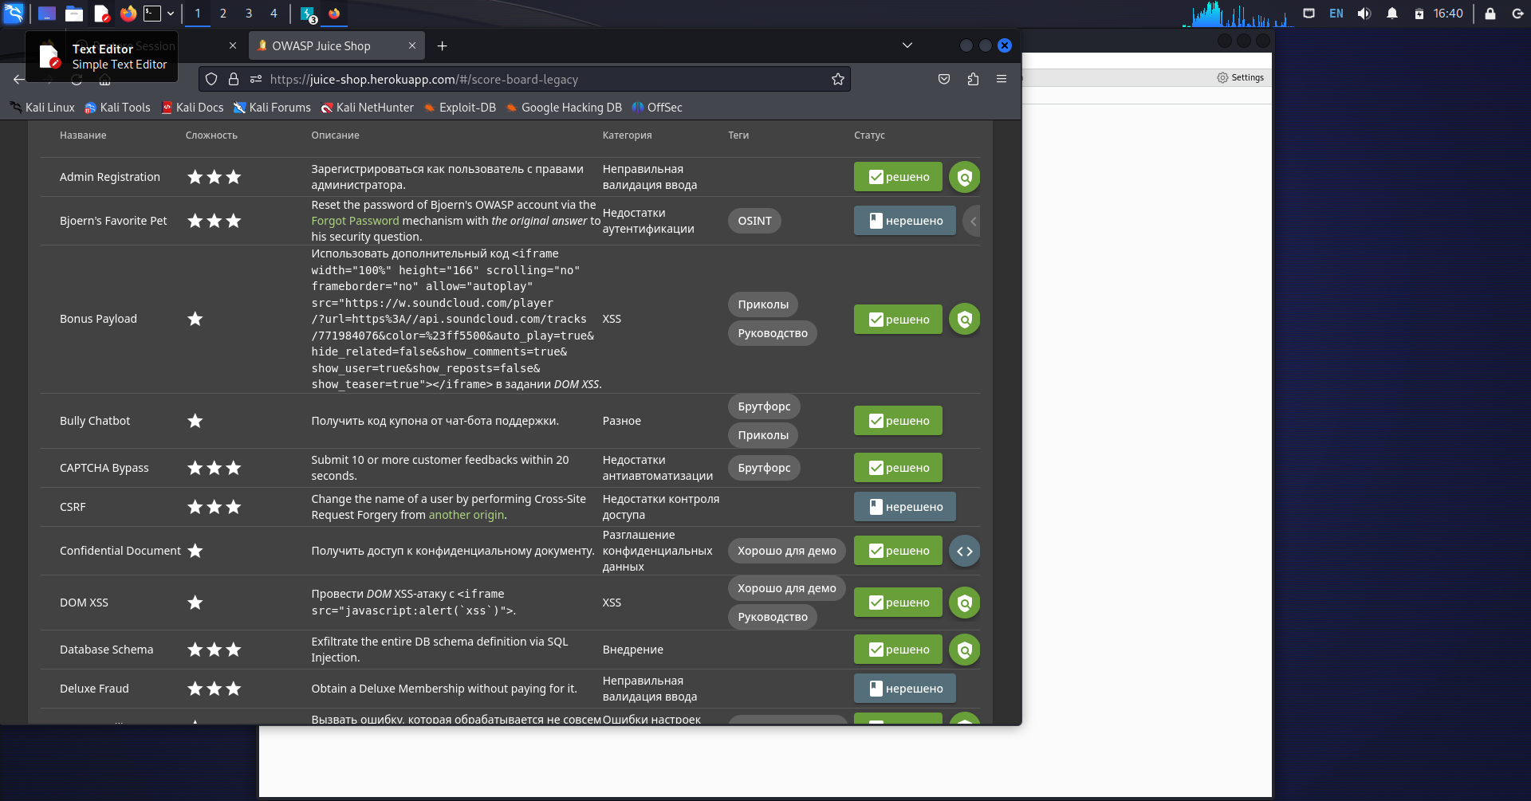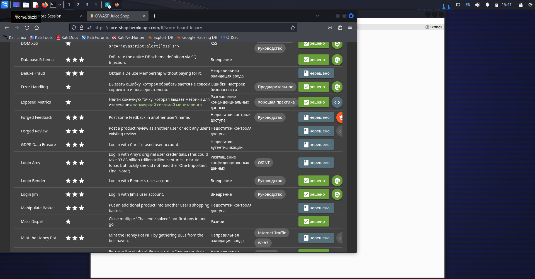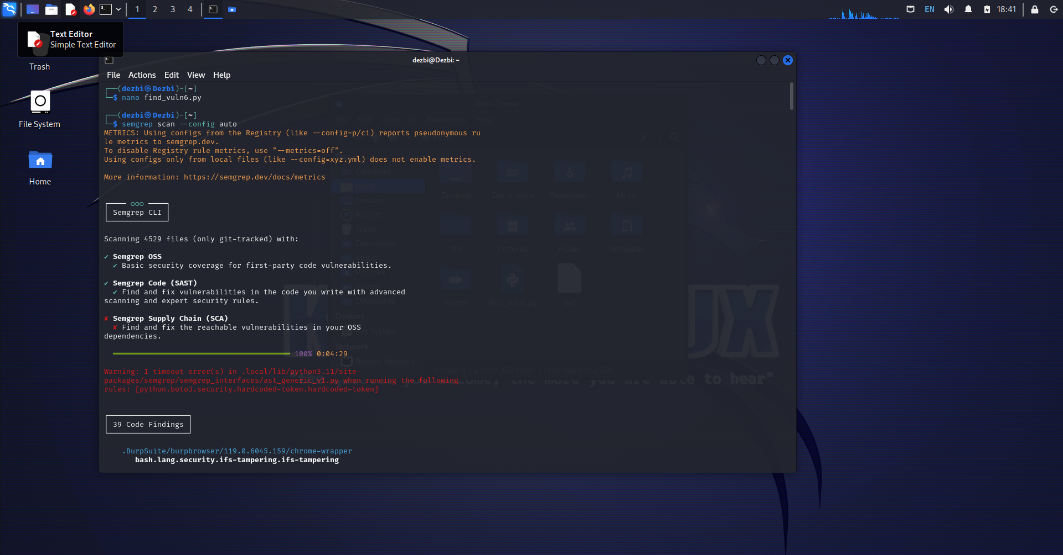

find_vuln6.py ----- os command injection

find_vuln7.js ----- express-child-process

find_vuln8.php ----- tainted-command-injection