Making fiscal space policy-responsive
  - Reform proposal for potential output estimation in the DSA

p.2:
Authors: Saskia Gottschalk, Sven von Wangenheim
Cyprien Batut, Cara Dabrowski, Meryem Gökten, Philipp Heimberger, Lauri Holappa, Otto Kyyrönen, Florian Schuster-Johnson, Bernhard Schütz, Ludovic Suttor-Sorel, Lennard Welslau, Francesco Zezza, Vinzenz Ziesemer
Institution Names: Dezernat Zukunft, Institut Avant-Garde (IA), Instituut voor Publieke Economie (IPE), Sapienza University of Rome, The Finnish Centre for New Economic Analysis (UTAK), The Vienna Institute for International Economic Studies (wiiw)

[+ LOGOS]

Executive Summary
Europe’s fiscal framework must evolve to support investment and growth. Member States face overlapping pressures — ageing populations, the energy transition, and new security imperatives — that demand reforms and sustained public and private investment. Yet the EU’s current fiscal rules incentivise short-term fiscal consolidation over long term growth-enhancing policies.
The core issue is technical but consequential: While the EU fiscal rules – primarily via the Debt Sustainability Analysis (DSA) and the EU Commonly Agreed Methodology (EUCAM) – acknowledge the impact of policies on short-term growth, they largely ignore the more structural, long-run effects of policies on potential output which is used to approximate long term growth and serves as key input for debt projections. The result is a systematic bias against long term growth-enhancing policies.
A minimally invasive methodological adjustment could correct this technical flaw. This paper proposes to make potential output estimates policy-responsive through a Policy-Responsive European Method (PREM) — a slightly modified version of the EUCAM. Policy-responsive potential output estimates should then be used to estimate fiscal space via debt sustainability analysis. This modification would allow structural policies — such as public investment, R&D expenditure, and labour-supply reforms — to affect potential output and thus fiscal space.
Simulations demonstrate its fiscal and analytical relevance. Applying this method using measures from five national medium-term fiscal-structural plans (Austria, Finland, France, Germany and Italy) shows that growth-enhancing measures increase potential output and thus expand fiscal space, while growth-reducing measures do the opposite. The approach also proposes a climate extension to integrate transition policies and physical risks into debt-sustainability assessments.
The aim are smart fiscal rules that make fiscal space policy-responsive and ensure more sustainable public finances. Making potential output responsive to policy would ensure that fiscal sustainability assessments account for the quality of fiscal measures, not only their short-term costs. It would also align incentives with the EU’s investment, competitiveness, and climate objectives — while maintaining the DSA’s rigour and comparability across Member States.
Policy recommendations
- Estimate policy-responsive potential output with the PREM and use these estimates to estimate fiscal space in the DSA.
- Integrate a climate module and climate stress tests into the DSA to capture transition policies and physical-damage risks in potential-growth projections.
- Ensure transparency and replicability by publishing assumptions, elasticities, and model updates on a regular and auditable basis.

1. Introduction
Europe urgently needs higher growth. Although being one of the EU’s central promises alongside peace, economic growth has been strikingly weak in the past decades compared to other regions of the world. Europe may still be prosperous, but it also risks falling behind; thus far, European integration has failed to deliver on that very promise. Today, ageing societies, the decarbonization of the economy, technological backlog, and heightened defence and geopolitical risks are an additional drag on growth.
To address these challenges and fulfil the European growth promise, large-scale and long-lived investments are required, spanning both the public and private sector (Draghi 2024). However, fiscal space is critically constrained in many member states: Germany’s budgetary debate centres on a sizeable gap in future budgets, amounting to €172 billion until 2029 with fiscal space dwindling even further after (Schuster-Johnson & Sigl-Glöckner 2025a). Similarly, in France, recent budget tensions underscore how dire the current investment outlook has become. Financing the required level of investment and reform needs through budget cuts alone is not only implausible; in light of rising political tensions and weak economic activity it is also likely to lack political support and to further slow down growth.
That is why fiscal rules deserve closer attention once again. Even after the 2024 reform, the EU fiscal framework is not designed to accommodate the public investments and reforms Europe so desperately needs – and policymakers across the political landscape demand. Thus, fiscal rules and political objectives are barely compatible. This is in part because the Stability and Growth Pact (SGP) simply fails to provide sufficient fiscal space. Its main flaw is, however, that it weakens incentives to adopt growth-enhancing policies. As a result, the rules miss their own objective – ensuring debt sustainability – which ultimately depends on stronger long-term growth.
The reason for these shortcomings is an inherent technical flaw of the framework: during debt sustainability analyses, potential output – the level of GDP achievable when all productive capacities of the economy are utilised sustainably, i.e., without accelerating inflation – is treated as exogenous and therefore policy-independent. Since long-term growth is approximated by potential output, this assumption implies that the long-run level of GDP is independent of policy as well. In simpler terms: regardless of the policy mix assumed in the EU’s debt sustainability analyses, the economy is projected to converge to the same long-term level of GDP.
While the EU fiscal rules – primarily via the Debt Sustainability Analysis (DSA) and the EU Commonly Agreed Methodology (EUCAM) – acknowledge the impact of policies on short-term growth, they largely ignore the more structural, long-run effects of reforms and investment on potential output. Therefore, the costs of such policies show up immediately in higher required budget adjustments, while their benefits are not fully recognised. Thus, adopting growth-enhancing policies does not necessarily yield more fiscal space. This asymmetry nudges governments toward austerity today at the expense of growth tomorrow.
To correct this technical flaw in the current framework, we propose a practical, transparent, and minimally invasive adjustment to the EUCAM and DSA so that fiscal space systematically reflects relevant policy measures. The paper is structured as follows:
- First, we lay out the current fiscal framework and argue that potential output – and therefore fiscal space – should be policy-responsive when used in debt sustainability analyses.
- Second, we set out a two-step reform, feasible within the existing framework: (i) enable policy-responsive potential output estimates via a modified version of the EUCAM, which we dub the Policy-Responsive European Method – in short: the PREM; and (ii) feed the resulting long-term growth rates into the DSA to assess debt sustainability and fiscal space.
- Third, we illustrate the implications of the modified methodology using a set of policy measures drawn from five national Medium-Term Fiscal-Structural Plans (going forward: medium-term plans) plus a climate extension. Instead of estimating potential output anew, we replicate the potential output growth rates resulting from the EUCAM using the PREM system of equations to ensure comparability with EUCAM and the DSA (see Annex I: The PREM). We show that properly incorporating growth-enhancing policies expands fiscal space, while growth-reducing measures shrink it. This illustration is exemplary and is not intended to estimate the potential output impact of the entire medium-term plans.

2. The problem: EU fiscal rules are largely independent of policy effects

2.1. The current framework
According to the recently revised version of the SGP (Regulation (EU) 2024/1263), member states negotiate net expenditure paths (NEP) with the European Commission for four to seven years. These paths must meet core criteria – notably a plausible decline in debt ratios, a deficit under three percent, and compliance with certain safeguards – while the recent activation of the National Escape Clause (NEC) temporarily suspends these safeguards and allows to exempt up to 1.5 percent of GDP in defence spending from the deficit and expenditure calculations. For most countries, the binding criterion is for the debt-to-GDP ratio to decline in the long-term (Darvas et al. 2024).
These core criteria are assessed via debt sustainability analysis. The DSA projects future debt ratios using assumptions about key macroeconomic variables, such as growth, interest rates, and primary balances. The most crucial inputs in the DSA are actual growth (GDP) and potential growth. Potential growth is the growth rate of potential output, i.e., the level of GDP achievable if all productive capacities of the economy were utilised without accelerating inflation. Since potential output is unobservable, it is estimated (and forecasted) based on the EUCAM; the EUCAM decomposes GDP into its structural (or trend) components – labour, capital, and total factor productivity (TFP) – and filters out cyclical fluctuations (Havik et al. 2014). These key variables are then forecasted into the future while simultaneously accounting for short-term policy effects (currently until 2026).
Both, actual GDP growth and potential output growth rates resulting from the EUCAM, are then used as an input to the DSA. However, in the DSA actual and potential growth are treated very differently: GDP growth rates are estimated to respond to fiscal policy – modelled via structural primary balance (SPB) adjustments – through a constant fiscal multiplier affecting the output gap. GDP growth is thus endogenous to policy changes. Potential growth rates on the other hand are assumed to be fully exogenous. They are unaffected by policy. Figure 1 depicts these steps of the estimation process.
Two technical flaws thus exist within the EU fiscal rules: first, the EUCAM fails to adequately capture the impact of policies on potential growth; and second, perhaps more importantly, the DSA assumes that policy does not affect potential growth. Thus, with growth being largely exogenous in the DSA, debt sustainability and fiscal space are mismeasured.

Figure 1: How GDP and potential output are estimated and treated within the EUCAM and DSA

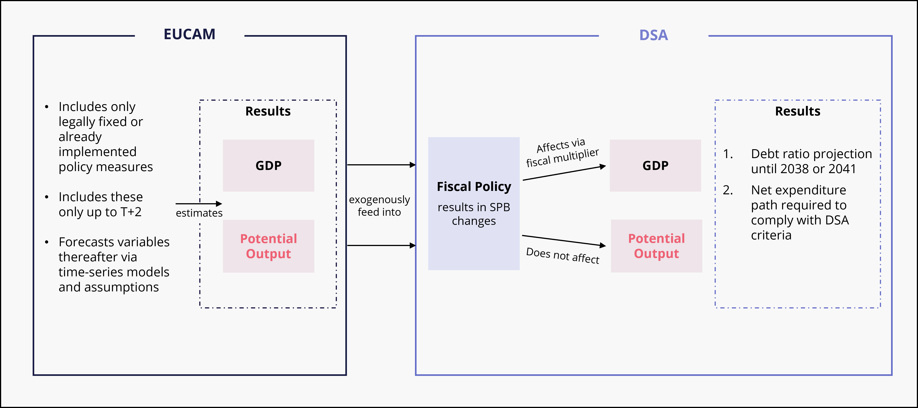

2.2. Why EUCAM growth estimates are implausible
The EUCAM’s limited policy dependence results from the fact that it incorporates only legally fixed or already implemented policy measures, and primarily up to two years into the future. Beyond this point, the framework forecasts the key variables determining potential output (e.g., investment, TFP, participation rate, etc.) via time-series models rather than explicitly estimating the long-term impact of policies on these variables.
There are two critical issues with this approach. First, where forecasters deem the implementation timing or specifics of proposed policies to be too uncertain, these policies are disregarded in the short-term forecasts entirely. A recent example is Germany’s infrastructure investment fund: a substantial €500 billion investment package was publicly known to be spent over the next decade yet excluded from EUCAM due to uncertainty about the specific details of the investment plans (European Commission 2025a).
Second, if measures are legislated but take effect only at some point in the future beyond the two-year horizon, the EUCAM estimates do not reflect these measures. Similarly, if the effect of policies will increase substantially over the long-term but have smaller short-term effects, forecasting via autoregressive time-series models may severely underestimate these dynamics. A good example are investments in childcare infrastructure or schools: such policies may only lead to higher labour force participation of parents and positive productivity impacts over the medium to long term, even though the respective policies are implemented today.
On its own, the use of EUCAM could be defended as a deliberate choice to base projections only on observable or measurable effects of policies that are already legislated or otherwise certain: It explicitly assumes that there will be no additional policy changes after year two of the forecast (currently 2026). However, this also means that both expansionary and contractionary policy changes beyond the forecast horizon are excluded. This is not an issue per se if the EUCAM were only used for growth projections. However, the problem arises in the next step: when the DSA assesses debt sustainability and fiscal space based on these estimates. That is where a biased growth projection results in misguided policy rules.

2.3. The implications for the DSA
The EUCAM-produced growth estimates are fed exogenously into the DSA to assess debt sustainability and calculate fiscal space. Within the DSA, fiscal policy – modelled via changes in the SPB – affects GDP and potential output very differently: on the one hand, GDP is modelled to react to changes in the SPB through a constant multiplier affecting the output gap (Darvas et al. 2024). On the other hand, potential output remains unaffected by changes in the SPB (see Figure 1).
This introduces two fundamental problems. First, there is a clear inconsistency in how the EU fiscal rules deal with growth: while EUCAM – which provides the baseline for the DSA’s growth assumptions – allows fiscal policy to influence both GDP and potential output (at least in the short term), the DSA assumes policy to only affect GDP. This inconsistency is particularly relevant in the case of investment: While the production function assumed in the EUCAM implies that investment affects both GDP and potential output, the DSA assumes that changes in public investment only affect the cyclical component of GDP but leaves the long-run level of GDP unaffected.
Second, this assumption in the DSA is not only inconsistent with the EUCAM, but also highly questionable economically. The DSA effectively assumes that fiscal policy can only influence cyclical, demand-driven fluctuations, while having no lasting effect on the economy’s productive capacities. This logic implies that, regardless of the policy choices made in member states’ medium-term plans, potential output, and therefore long-term GDP, will result in exactly the same level. Taken to its extreme, a government could, for example, cut all public investment to meet the DSA criteria without any estimated impact on potential growth or long-run GDP in the context of the DSA.
Germany’s recent fiscal package is a good example of this discrepancy: the respective investments are part of the medium-term plan and therefore the DSA estimations, even though they are not included in the current EUCAM forecast (European Commission 2025a). Thus, while short-term demand-side impacts of the investments as well as their costs are reflected in the DSA, their effects on supply-side factors determining potential output are ignored. This is especially problematic as the planned public infrastructure investments increase the public capital stock and may also raise productivity in the long-term (Ramey 2020), both of which would increase potential output. The same holds true for other policy measures mentioned in national medium-term plans, e.g., childcare reforms, policies aiming at fostering R&D expenditure, or tax reforms stimulating private investment.
Crucially, these dynamics reduce incentives for structural, growth-enhancing reforms: while growth-enhancing policies may influence the business cycle and thus raise short- to medium-term GDP growth, they have no impact on the economy’s structural, sustainable level of the economy (i.e., potential output). Therefore, the increase in spending associated with such reforms is captured by the DSA, but large parts of their growth impacts are ignored. Because costs are fully captured, but not the corresponding growth impacts, the SPB adjustments required to meet the DSA criteria must then be larger than what would be necessary if potential growth responded to policy. Similarly, the effects of policies hampering potential growth are also not accurately reflected in the DSA.
In practice, these DSA dynamics can even be self-defeating by incentivising austerity over structural reforms: for instance, if increasing investment spending has the same effect on potential output and long-term growth as decreasing it, spending cuts are more effective at reducing debt ratios by design. However, empirical evidence shows that in advanced economies, fiscal consolidations that suppress growth tend to increase, rather than reduce, debt-to-GDP ratios, whereas successful consolidations have historically coincided with stronger output growth (International Monetary Fund 2023).
Recognising these concerns, the EU and some of its member states have started to incorporate the effects of policies on potential output. Both Italy and Spain have used the QUEST model to assess the impact of relevant policies on potential output in their respective medium-term plans (Italian medium-term plan, Italian Ministry of Finance 2024; Spanish medium-term plan, Spanish Government 2025). Similarly, the EU Commission itself recognises that policies may impact potential output: in the Debt Sustainability Monitor 2022, the EU Commission states that the Recovery and Resilience Facility will lift potential growth and therefore reduce debt sustainability (European Commission 2022).
Most recently, Germany has argued that its fiscal package will lead to higher potential growth, therefore applying alternative potential growth assumptions in line with Article 36(1)(f) of Regulation (EU) 2024/1263: when economically justified, member states may use a more stable potential output series than that resulting from EUCAM as long as cumulative growth remains unchanged. By accepting this argument, the EU Commission recognises that policies, and public investment in particular, may affect potential output even in the context of the DSA.
However, this approach of using a smoothed potential output series to reflect policy impacts on potential growth is economically implausible. Since the long-term level of potential output must remain unchanged, higher short-term potential growth is only possible if long-term potential growth is lower. While the German fiscal package should theoretically have a larger impact in the medium- to long-term (von Wangenheim et al. 2025), it results in lower long-term growth rates in the medium-term plan. We argue that instead of simply using a smoothed potential output path, the DSA should systematically evaluate the impact of policies on potential output – for example by using the PREM approach set out in this paper.
On a more general basis, the EU fiscal rules have the problem that they are based on a definition of sustainable public finances which centres strongly on a debt to GDP ratio of 60 percent, a benchmark which lacks plausible scientific justification. In practice, this can force governments to implement fiscal consolidation merely to satisfy the metric even though it diverges from what would be considered economically sustainable and advisable. This is in particularly implausible for countries that have debt ratios only slightly above the 60 percent benchmark. Hence, a more general reform of the EU rules and a new definition of fiscal sustainability should be considered. As laid out by Schuster-Johnson & Sigl-Glöckner (2025b) this alternative definition could build upon the proposal of the International Monetary Fund (2021) whereby the target debt ratio should not simply be a fix number but should be compatible with appropriate potential output growth and low refinancing risk.
In summary, the current framework does not fully capture economic effects of policy and, as a result, offers little fiscal incentive to adopt reforms that aim at increasing an economy’s supply-side capacities. Good policies are therefore disincentivised by a framework that recognises their costs but not the entirety of their benefits. Making potential output responsive to policy within the DSA would realign incentives: growth-enhancing policies would expand measured fiscal space compared to the current framework, while growth-reducing policies would narrow it. That would much better serve the fiscal rules’ purpose of ensuring long-term debt sustainability, as debt sustainability heavily depends on growth.

3. Reform proposal: Reward growth-enhancing policy, through estimating policy-responsive potential output
When policy scenarios are being analysed in the context of the DSA, the impact of the proposed policy changes on potential output must be considered. This requires two practical steps: explicitly estimating the long-term impacts of different policies on the components of potential output; and recognising these impacts within the DSA framework. To this end, we construct a modified version of the EUCAM – the Policy-Responsive European Method (PREM). The proposed model is certainly not the only approach to make potential output policy-responsive; it is chosen due to requiring the least number of changes to the EUCAM.
Importantly, the proposed modification of the methodology requires no change in the core growth-accounting framework applied by EUCAM. GDP is decomposed into capital, labour, and productivity using a Cobb-Douglas production function, with potential output being estimated via the trend components of these variables. At its core, the reform simply extends the trend estimation method currently used for productivity (TFP) and unemployment (NAWRU) in EUCAM to other variables, while allowing fiscal, economic, and labour market policies to affect these trend components – and thus potential output.
We propose the following targeted adjustments to the EUCAM:
- Capital: The capital stock is split into public and private capital following the approach of the British Office for Budget Responsibility (OBR, see Annex I) to better capture the effects of public investment on potential output. Private investment may be influenced by policies such as changes in the corporate income tax rate.
- Productivity: Exogenous policy variables – such as R&D spending – are introduced into the TFP trend equations so that potential output reflects structural policy changes in such areas. In the EUCAM, exogenous variables are already used to inform the cyclical components TFP and unemployment, so this is only a small methodological adjustment.
- Labour: The same modelling strategy already used to decompose TFP and unemployment rates into trend and cycle is extended to participation rate and hours worked to allow for policy effects to be incorporated (see Annex I). This represents a simple way to introduce economic intuition into the estimation of unobservable trend variables, which specifically allows for the inclusion of policy channels into the trend equations. Under this set up, childcare expansions that structurally raise (female) labour force participation, or structural social security reforms that increase average hours worked, would be systematically reflected in potential output.
Annex I provides a detailed account of the PREM used in this paper. As done in EUCAM, each component (TFP, participation rate, etc.) is estimated and forecasted separately, before potential output is calculated based on these estimates. When conducting debt sustainability analyses, every policy measure’s impact on both GDP growth and potential growth should then be estimated and passed to the DSA.

4. Illustration: Fiscal space under policy-responsive EU rules
4.1. Setup
We illustrate how policy-responsive potential output can be integrated into the DSA through case studies of five EU member states – Austria, Finland, France, Germany, and Italy. Using the PREM, we estimate how selected measures from each country’s medium-term plan affect potential output and, in turn, the size of the target SPB required to comply with DSA criteria. Each case focuses on one (or a small bundle of) reforms that are already part of the national plans such as public investment packages, expansions of childcare, or active labour-market policies (ALMPs). Because these measures are embedded in EU-endorsed medium-term plans, it is generally acknowledged that they affect actual GDP growth: as part of the broader policy package of the medium-term plan, they change the SPB and therefore affect GDP growth in the DSA framework. However, in the current framework the selected policy measures do not affect potential growth, even though they have obvious effects on potential output (see above).
To quantify the impact of these policies on the components of potential output, we draw on evaluations published by the respective ministries and national research institutes and, where necessary, applied empirical estimates from the wider academic literature. The measures and their estimated impacts are presented in detail in Annex II.
For each country, we compare two scenarios:
- In the baseline scenario, we use the macroeconomic conditions stated in the medium-term plan, including an EUCAM-based, policy-independent potential output path, inflation, and the SPB assumed for 2024, to base our analysis on similar assumptions as those used in the medium-term plan. After calibrating the model to meet these conditions, we compute the SPB targets that satisfy the DSA criteria.
- In the policy-responsive scenario, potential output reflects the estimated effects of the selected medium-term plan measures. As is standard in the analysed medium-term plans (except for Italy), we also smooth the resulting potential output growth path for better comparability and then recompute the SPB path and target consistent with the DSA criteria.
We then compare the resulting potential growth rates and required SPB adjustments and SPB targets across these two scenarios for each country. In the DSA, countries may adjust their SPB over a period of four or seven years (i.e., the adjustment period), after which the SPB remains unchanged. This final SPB ratio is referred to as the SPB target. Since higher potential growth would require less fiscal consolidation to meet the same DSA criteria, this would result in lower required SPB adjustment steps and subsequently a lower SPB target. In comparing the SPB targets for the two scenarios, we illustrate how policy-responsive potential output affects fiscal space, i.e., how far the required SPB target shifts once medium- to long-term growth impacts are recognised in the DSA.
Importantly, the resulting effects compared to the baseline are often small because we pick only one or a small bundle of measures and estimate their effect on potential output. By contrast, the impact of the full set of policies specified in each medium-term plan would likely be much larger. Our results should therefore be read as illustrative simulations, not as alternative forecasts of potential output under the entire medium-term plan. Their purpose is to show that incorporating policy effects on potential output in debt sustainability analysis is both technically feasible and highly relevant: whenever a growth-relevant measure is not adequately featured in the EUCAM baseline, the required SPB adjustments do not reflect the full impacts of the respective policy.

4.2. Results
We compare the SPB targets and debt ratios for five countries under two assumptions: (i) baseline potential output growth is as presented in the medium-term plans, and (ii) policy-responsive potential output growth is as estimated using the PREM. The case studies are used to illustrate how different policy measures – such as public investment or R&D spending – can affect potential output in different ways, depending on their nature and magnitude. Together, these examples demonstrate a range of possible outcomes and their implications for fiscal space: growth-enhancing policies tend to expand fiscal space, while growth-reducing measures can diminish it.
Table 1 presents the smoothed potential output growth rates assumed in the medium-term plans (baseline) and the estimated policy-responsive growth rates (scenario) while Figure 2 shows the corresponding SPB adjustment paths and SPB targets. In Germany, we look at infrastructure investments, while we focus on R&D investments in Finland affecting TFP. In Italy, Austria and France, we simulate the possible impacts of policies affecting labour force participation. The largest impact for potential output growth and consequently the difference in SPB target is observed in Germany, followed by Italy and Finland. The observed effects in Austria and France are negligible which is primarily a consequence of the small magnitude of the analysed policies.
The German example perfectly demonstrates the relevance of policy-responsive potential output in the context of the DSA: we estimate that Germany’s infrastructure investment package raises smoothed potential output growth from 0.90% to 1.15% per year, causing the required SPB target to fall from 0.99% to 0.84% of GDP. The channels that lead to higher growth rates are straightforward. First, raising the investment rates results in a larger public capital stock. We further assume additional labour input, e.g. to carry out the new infrastructure projects (Moszoro 2021), and modest long-run TFP effects caused by better infrastructure (Ramey 2020). In today’s framework, those supply-side gains are largely ignored particularly in the long-term, even as the current spending is fully included in the SPB assumed in the medium-term plan. Our proposal removes this inconsistency and recognises both the short-term costs and long-term benefits of the investment package.

Table 1: Annual (smoothed) real potential output growth, baseline and policy-responsive scenario
Country | Policy | Baseline Growth | Scenario Growth
Germany | Infrastructure Investment Package | 0.90% | 1.15%
Finland | Increased R&D expenditure | 0.90% | 0.97%
Italy | Active Labour Market Policies | 0.78% | 0.85%
Austria | Childcare expansion, higher retirement entry age, simplification of work permit process | 1.10% | 1.12%
France | Social Security Contribution Reform | 1.20% until 2028  1.00% until 2041 | 1.16% until 2028  1.00% until 2041
Notes. Measures are drawn from each country’s medium-term plan and assumed not to be embedded in the EUCAM baseline. If a given measure is already embedded, the same exercise can be conducted with another growth-relevant measure. Results are exemplary simulations consistent with the DSA constraints; they are not alternative growth forecasts for entire plans. See Annex II for channels, elasticities, and sources.

Similarly, Finland’s Act on R&D Funding aims to raise R&D expenditure towards 4% of GDP, with the medium-term plan explicitly stating long-term productivity impacts following these investments. The higher capital stock and the increases in trend TFP starting in 2030 raises smoothed potential output growth from 0.90% to 0.97% in the scenario, with the SPB target easing from 2.27% to 2.15% of GDP.
Italy’s medium-term plan states Active Labour Market Policies (ALMPs) to increase participation and the Italian government committed to extend these labour market initiatives envisaged in the medium-term plan (see Annex II). We estimate smoothed potential growth to increase from 0.78% to 0.85% The SPB target drops from 2.95% to 2.84% of GDP. This demonstrates the importance of acknowledging policies activating the labour force in the DSA context: ALMPs, childcare programmes, and similar social policies are often cut first in economic downturns. However, as they have important implications for the labour supply, their effects on potential growth must be considered when making such decisions.
Our exemplary simulations for Austria show that if policies do not have substantial growth impacts, they do not lead to more fiscal space. Because the chosen policy measures – childcare expansion, a higher retirement entry age, and easier work permits – are very modest in scale, they produce only a marginal boost to potential growth. We estimate smoothed potential output to increase from 1.10% to 1.12% over the horizon from 2025 to 2041. As a result, the SPB target decreases slightly from 1.06% to 1.04% of GDP. Policies with negligible effects on potential output (either due to being small in scale or because they do not affect potential output) generate little additional fiscal space under a policy-responsive method; the proposed reform does not “create” fiscal space where it does not have reason to.
Importantly, policy-responsive potential output can also reduce fiscal space. In France, e.g., social security reforms raising the labour costs around the minimum wage could be assumed to increase unemployment. It is important to note that there is an ongoing empirical debate on whether an increase in social security contributions has a negative effect on labour demand. For the purpose of this simulation, we assume that such a reform could slightly increase unemployment, which could reduce potential growth from 1.20% to 1.16% up to 2028 (leaving it unchanged thereafter). As a result, the SPB target increases slightly from 2.236% to 2.239% of GDP. Crucially, this is only one element of the French medium-term plan, which also includes growth-enhancing measures. Our estimates are therefore illustrative – not a net assessment of the medium-term plan – and serve to show how potentially growth-reducing measures can tighten fiscal space.
Figure 2 compares SPB and debt ratio paths between the baseline and policy-responsive scenario for all countries. It illustrates how SPB adjustment requirements (and therefore fiscal consolidation requirements) change when potential output is allowed to respond to policy: less consolidation is required in Germany, Finland, and Italy manifesting in lower SPBs in the policy scenario. Fiscal consolidation remains essentially unchanged in Austria, and slightly higher consolidation is required in France. After the adjustment period the final SPB – the SPB target – remains unchanged since this is one of the DSA’s assumptions.
By design, debt ratios remain close to the baseline in all cases. This is mechanical since in both scenarios, we compute the “optimal” SPB path that exactly meets the DSA constraints. These DSA constraints require the debt to GDP ratio to decrease and reach a similar target point in 2041 in the baseline and policy scenario respectively.
If the criteria must be met in both scenarios, the level of debt cannot diverge by much; what changes is how much fiscal policy must respond to meet the same criteria. This results in different SPB adjustment steps under the baseline versus the policy-responsive scenario. Smaller required adjustments allow a larger structural deficit, meaning less consolidation being required to comply with the DSA criteria – i.e., fiscal space increases. Thus, under the proposed reform, smart policies that lift potential growth reduce the amount of consolidation required.
Consequently, the policies chosen to achieve the SPB adjustments matter once potential output is policy-responsive. Currently, countries face pressure to meet the SPB adjustments through broad cuts and tax rises, regardless of whether those policies endanger future potential growth. In our proposal, the DSA would instead reward a set of policies that combines disciplined net expenditure with policies that raise potential output. Thus, the PREM approach reflects the fact that across-the-board cuts are a poor substitute for measures that increase employment, incomes, and sustainable growth (Schuster-Johnson & Sigl-Glöckner 2025a).
In short, once the DSA properly accounts for potential growth, fiscal space stops being indifferent to the quality of policies. Growth enhancing measures may lower the required SPB target while achieving the same level of debt sustainability. Instead, growth-diminishing measures can raise the SPB target. While debt paths remain anchored by the DSA criteria in both cases, the fiscal space available to countries changes. That is the incentive the reformed method is meant to achieve: well-designed policies can increase (long-term) growth and reduce the need for excessive savings elsewhere.
Figure 2: SPB (in percent of GDP) paths and debt to GDP ratio paths under baseline and policy-responsive scenarios
Structural Primary Balance Debt Ratio
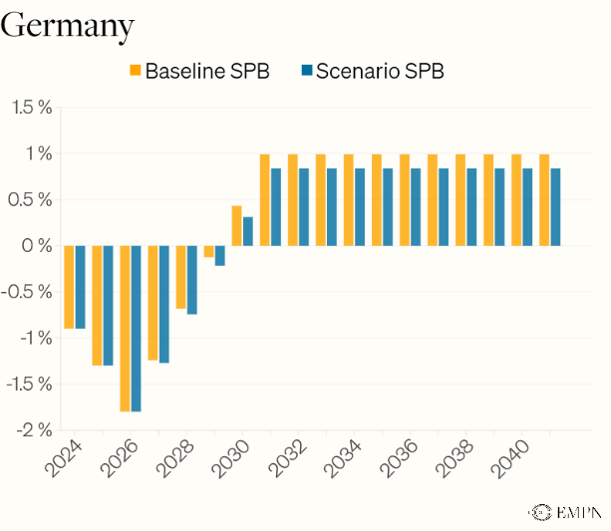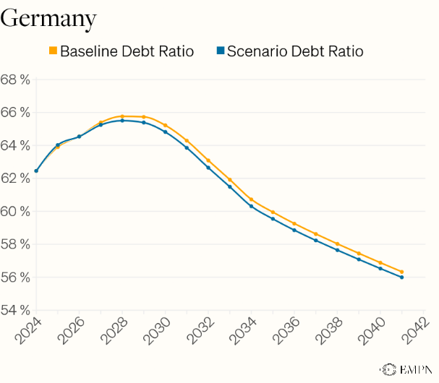
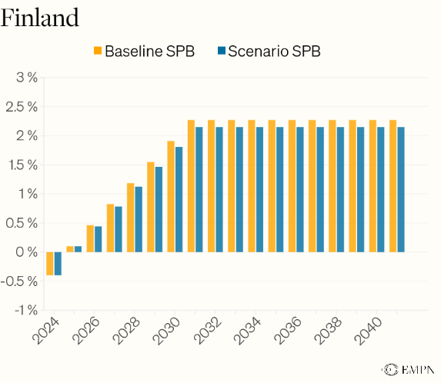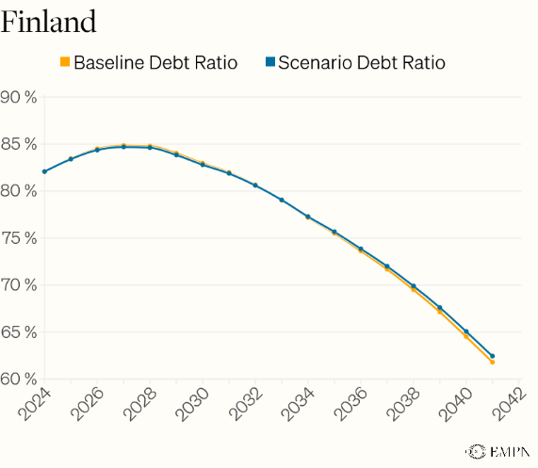
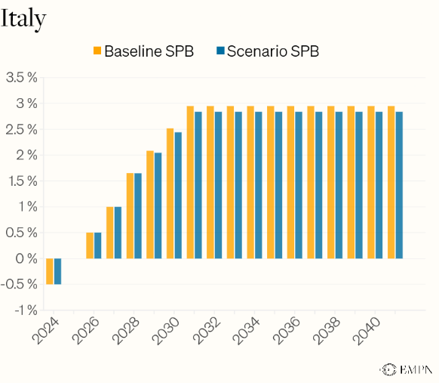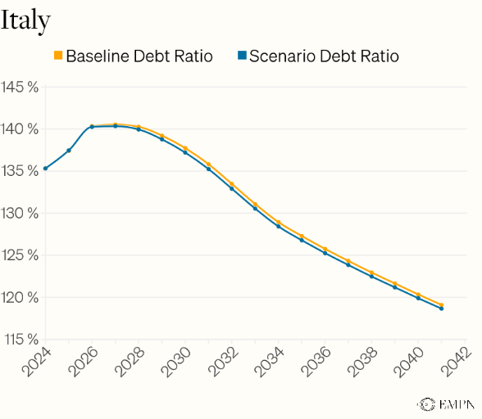
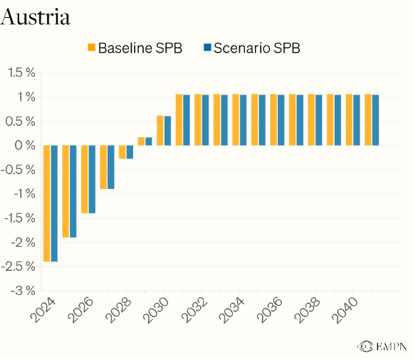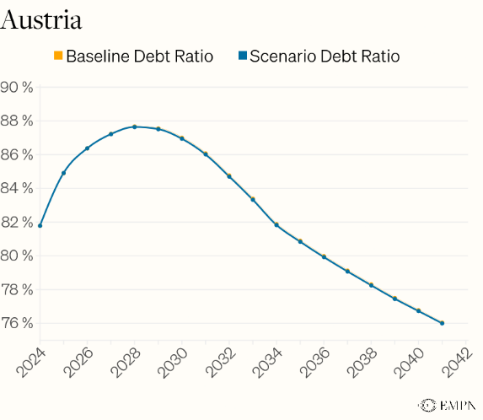
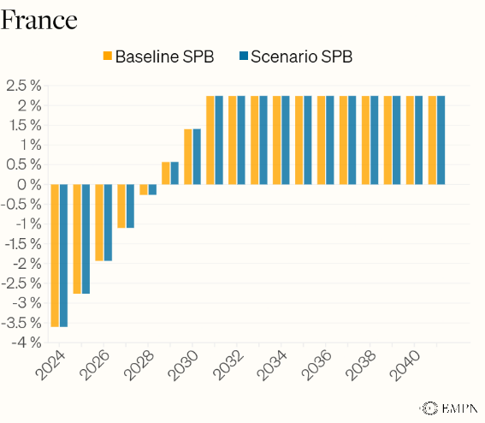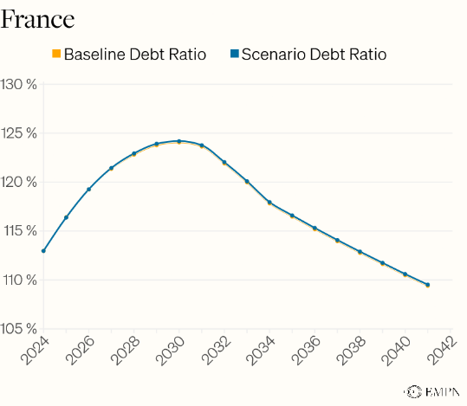
Notes: The graphs compare the SPB paths and debt to GDP ratio paths of the baseline scenario with the policy scenario. The policy scenario only includes one or a small bundle of policies and does not represent the net effect of the entire medium-term plan of a country.
We assume a non-linear adjustment path for Germany due to the additional spending planned in 2025 and 2026 (in line with the German medium-term plan, see footnote 5).

Sources: own calculations, AMECO, Darvas et al. (2024), EUCAM, European Commission (2025b), national medium-term plans, Welslau (2025).

4.3. Climate Extension
Making potential output policy-responsive does also require the incorporation of climate damages and climate policy effects into the estimations. Physical and transition risks have direct implications for debt sustainability and should therefore be included in DSAs in general (Laskaridis & Zha 2025) and, as we propose, in the EU’s DSA in particular. Practically, this requires correcting the EUCAM baseline growth path so that climate aspects are reflected in the estimates subsequently passed to the DSA.
How this can be implemented in principle is demonstrated by Ziesemer et al. (2025). They use climate scenarios from the Network for Greening the Financial System (NGFS), which quantify the growth effects of acute and long-term physical climate damages as well as climate policy in the form of increasing carbon prices, the main policy instrument to reach climate neutrality in the EU. Ziesemer et al. (2025) adjust the EUCAM baseline growth path by these effects resulting in lower growth estimates. Feeding this adjusted path into the DSA results in higher debt to GDP ratios and, consequently, larger required SPB adjustments to comply with DSA criteria.
Ziesemer et al. (2025) also show how different climate policy mixes may imply different growth trajectories and thus different SPB requirements. For instance, assuming the EU’s climate target of 55 percent emissions reduction will be reached, a policy mix that includes higher public green investment as opposed to stronger reliance on carbon pricing may result in higher growth rates, according to existing literature. Relatedly, increasing emissions reduction in Europe in the next decade will likely result in higher fiscal requirements, but may also accelerate global climate efforts, ultimately resulting in lower climate damages. Accounting for both climate policy mix choices as well as potential damage-avoidance benefits in the growth estimates would lower required SPB adjustments and enable fast and growth-friendly climate policies to better comply with the DSA criteria. By contrast, under the current framework only the high upfront costs and short-term demand effects of such a policy feed into the DSA, mechanically tightening fiscal space and discouraging effective climate policies.
As part of our reform proposal, we therefore suggest evaluating climate policies – just like other structural reforms – for their impact on potential output. This would allow for additional fiscal space to finance good climate policies, which reduce the growth losses that would otherwise materialize from one-sided climate policy and climate damages. Conversely, the absence of effective climate policy would result in higher climate damages, lower growth, and thus tighter fiscal space.
Additionally, we propose the implementation of specific climate stress tests within the DSA to account for the risk of more drastic climate damages than assumed in the baseline. Work in this direction has already begun at the European Commission by conducting first stylized country specific climate stress tests (European Commission 2021).
Finally, the EU should develop a method to operationalize the incorporation of the growth effects of climate damages and climate policies into the EUCAM – and thus into the DSA. This requires a model tailored to European policy realities and could potentially build on the PREM.

5. Conclusion
Under the current EU fiscal framework, potential output and, as a result, fiscal space is largely policy-independent: While actual growth estimates and thus fiscal space respond to the short-term impacts of policies, potential growth does not reflect the effects of growth-enhancing policies that expand the productive capacities of the economy. This policy independence is not only a highly unrealistic assumption since it does not reflect economic realities, but it also leads to adverse incentives when it comes to growth-enhancing policies and budgetary choices. Short-term costs of growth-enhancing policies show up immediately in increased SPB requirements and tighter fiscal space, while their (long-term) benefits for potential output are not accounted for and thus do not alleviate fiscal consolidation pressures. This asymmetry favours short-term austerity over long-term growth.
To correct this technical flaw, we propose a small modification within the existing architecture of the EUCAM and DSA: making potential output and thus fiscal space policy-responsive. Our case studies show the implications of such a reform, illustrating how required SPB targets change when the effects of policies on both (short-term) GDP and (long-term) potential growth are properly accounted for. Our estimations illustrate that growth-enhancing policies can expand fiscal space, while policies that reduce growth narrow it. Additionally, growth promising measures that are small in magnitude only increase fiscal space minimally.
Crucially, our reform proposal introduces an incentive for governments to implement smart, growth-enhancing policies: structural reforms increasing potential growth would be accompanied by the additional fiscal space required to implement them. Accounting for their growth effects could make these policies compatible with the DSA criteria and thus debt sustainability even when upfront implementation costs are high. Fiscal space would no longer be neutral to policy quality but would systematically respond to it.
Providing space for growth-enhancing measures is especially important in the current context, where European economies urgently need higher growth and sustained investment to navigate overlapping challenges of ageing societies, the climate crisis, and heightened security risks. Consequently, a more general reform of the EU fiscal rules should be considered. Instead of defining fiscal sustainability through a fix and scientifically implausible target for the debt ratio, a new framework should centre around a benchmark debt ratio that depends on realistic potential output growth expectations and refinancing risks.
The message is straightforward: fiscal space should be policy-responsive. This requires smart fiscal rules which reward good, growth-enhancing policies by adequately increasing fiscal space – and penalise the opposite by narrowing fiscal space. One step toward this end is to make potential output policy-responsive, thereby making EU fiscal rules smarter and better fit to address today’s challenges.

Appendix

Annex I: The PREM
The PREM (Policy-Responsive European Method) is a policy-responsive extension of the EUCAM. Its macroeconometric core is a multivariate unobserved components model (UCM) that decomposes observed time series into a slow-moving trend (structural, e.g. potential output or trend unemployment) and a cyclical component (e.g., business cycle, unemployment gap) within a state-space/Kalman-filter framework. Using UCMs has the advantage of separating trend and cycle while allowing economic structure to shape the equations: trend and cycle follow economically motivated dynamics, and policy variables can enter the trend equations directly – thus making potential output policy-responsive. PREM is conceptually multivariate to allow for cross-variable linkages (e.g., linking the output and unemployment gap via an Okun’s law-type relationship), but each block can also be estimated as a stand-alone univariate UCM to follow EUCAM as closely as possible.
In comparison to the EUCAM, we make two key improvements. First, we split the capital stock into private and public capital, which allows us to directly model the impact of public investment on potential output. This mirrors how the UK’s OBR accounts for public investment in their fiscal forecasts (Suresh et al. 2024). Secondly, we express all individual components of potential output in form of separate state equations, which enables us to directly model the impact of structural policies on the trend level of these variables.
To guarantee comparability with EUCAM and DSA, we calibrate PREM to replicate the potential growth path implied by EUCAM and reported in national medium-term plans. Concretely, we use PREM’s system of equations (see below) and fix parameters to replicate EUCAM series for trend and cyclical components rather than estimating parameters:
- The labour-supply components – working-age population, participation rate, unemployment rate, and average hours worked – follow the EUCAM series exactly to 2029.
- While we split the total capital stock into private and public capital, we ensure that the aggregate capital stock remains closely aligned with EUCAM’s total capital stock until 2029. Private investment follows the EUCAM-style autoregressive process and public investment is assumed to be a constant share of potential output in the absence of policy changes.
- Residual TFP is calibrated so that implied potential output matches the EUCAM series for potential output.
Beyond 2029, the level of individual components is not reported publicly. Therefore, we adopt EUCAM conventions for projecting each variable: the working-age population series remains exogenous; labour-force participation is guided by Ageing Working Group (AWG) projections (we anchor growth rates rather than levels); the unemployment rate follows EUCAM’s projection rule; changes in average hours worked half each year; and private capital accumulation converges over ten years to potential output growth. Given these anchors, TFP is again recovered as the Solow residual so that the implied potential growth profile reproduces potential output growth stated in the national MTPs or the respective EC’s prior guidance files (European Commission 2025b).
Starting from this calibrated baseline, we model the impact of policies reported in national MTPs. We first quantify the effects of the selected policies on individual components of potential output using evaluations from ministries and national research institutes and, where necessary, applied estimates from the broader academic literature. These effects shift the trend level or growth rate of the relevant components (e.g., TFP via public-R&D intensity, participation via childcare reform), producing an alternative path for potential output (growth). In future, non-exemplary applications, we suggest estimating PREM with policy variables entering the state equations directly.
State-space system in the PREM
Below, we introduce the state-space system used to decompose the components of potential output into trend and cycle. We model a UCM similar to the multivariate UCM developed by the ECB (Tóth 2021). The entire system can be estimated either as a single, multivariate UCM or a combination of separate, univariate UCMs for each component. In both cases, the UCMs are estimated using a Bayesian Kalman filter, with informative priors based on EUCAM. Where EUCAM provides no guidance (e.g., any parameters linked to policy variable), priors are informed by the relevant literature.
Using this approach, each variable can be decomposed into separate trend and cycle equations. Thus, structural reforms can be directly incorporated into the trend dynamics of different variables. For example, (public) R&D intensity can be included as an exogenous regressor to inform the trend-cycle decomposition of TFP. While the below system of equations simply translates the EUCAM into a Tóth (2021)-style UCM, future versions of the PREM will directly incorporate relevant policy-variables.
Unless noted, variables are in natural logs; a bar denotes trend components (e.g., ${\overline{y}}_{t}$ represents potential output) and a hat denotes cyclical components (e.g., ${\hat{y}}_{t}$ represents the output gap). Further background information on the model and the intuition behind equations can be found in Havik et al. (2014) and Tóth (2021).
Potential output and the output gap
As in EUCAM, potential output ($\overline{y}$) is modelled as the trend components of TFP ($\overline{sr}$), labour input ($\overline{l}$), and capital following a Cobb-Douglas production function. We extend the EUCAM production function by explicitly differentiating between private ($\overline{k^{M}}$) and public capital ($\overline{k^{G}}$). In the univariate setup used in this paper, one can simply compute potential output from the trend components. In the multivariate setup, we follow Tóth (2021) in decomposing observed GDP into a trend (potential output) and a cycle (output gap). The output gap is modelled as an AR(2) cycle and is connected to inflation via a Phillips curve-type relationship.
$$y_{t}={\overline{y}}_{t} +{\hat{y}}_{t}$$
$${\overline{y}}_{t}={\overline{sr}}_{t}+0.65⋅{\overline{l}}_{t}+0.25⋅{\overline{k^{M}}}_{t}+0.1⋅{\overline{k^{G}}}_{t}$$

Total factor productivity
TFP is specified exactly as in the EUCAM: it follows a local-linear trend with a persistent drifting slope and a cyclical AR(2) process parameterised by amplitude and period. Moreover, a capacity utilisation measure is included to help identify the TFP cycle (for a detailed explanation of all variables, see Havik et al. (2014)). Future extensions can add innovation-relevant variables, such as R&D intensity, directly to the slope equation to make trend growth systematically policy-responsive. As with all other blocks, the decision on which variables to include should be based on economic intuition and (future) academic literature assessing the impacts of policy channels on trend components of GDP.
$$sr_{t}={\overline{sr}}_{t}+{\hat{sr}}_{t}$$
$${\overline{sr}}_{t}={\overline{sr}}_{t-1}+{\tilde{sr}}_{t-1}+ε_{\overline{sr},t}$$
$${\tilde{sr}}_{t}=\left(1-ρ_{sr}\right)⋅ω_{sr}+ρ_{sr}⋅{\tilde{sr}}_{t-1}+ε_{\tilde{sr},t}$$
$${\hat{sr}}_{t}= ϕ_{\hat{sr},1}⋅{\hat{sr}}_{t-1}-ϕ_{{\hat{sr}}_{t-2}}⋅{\hat{sr}}_{t-2} +ε_{\hat{sr},t}$$
$$cu_{t} = μ_{cu}+β_{cu}⋅{\hat{sr}}_{t}+e_{cu,t}$$
$$e_{cu,t}=ϕ_{cu}⋅e_{cu,t-1}+ε_{cu,t}$$
Labour input
As in EUCAM, labour input is approximated by the product of working-age population ($wp$), participation rate, the employment rate (as the complement of the unemployment rate $u$), and average hours worked ($ah$). However, while the EUCAM relies on HP filters to decompose trend and cycle for participation rate and average hours worked, we again use the Kalman filter to estimate all trend and cycle components. The trend component of labour supply is then aggregated via the trend estimates of each component.
$$l_{t} = wp_{t} + lp_{t} - u_{t} + ah_{t}$$
$${\overline{l}}_{t}={\overline{wp}}_{t}+{\overline{lp}}_{t}-{\overline{u}}_{t}+{\overline{ah}}_{t}$$
Working-age population
As the working-age population is independent of the business cycle, it is simply treated as an exogenous variable in EUCAM. In the multivariate version of the PREM, we therefore treat working-age population as an observable variable that is not decomposed into trend and cycle (as is standard in the literature). We still define working-age population via the following set of state equations for modelling purposes.
$$wp_{t}={\overline{wp}}_{t}$$
$${\overline{wp}}_{t}={\overline{wp}}_{t-1}+{\tilde{wp}}_{t-1}$$
$${\tilde{wp}}_{t}={\tilde{wp}}_{t-1}+ε_{\tilde{wp},t}$$
Participation rate
To minimise the deviation from EUCAM, we use a simple UCM to estimate the trend component of the labour force participation rate. As shown by Harvey and Jaeger (1993), the HP filter output can be replicated by a UCM given specific parameter restrictions. Thus, the only practical implication of this methodological change is the possibility of including exogenous policy variables into the trend equation. Such policy variables could include labour tax rates, social security contributions, or ALMPs. Moreover, when forecasting the model, we anchor labour force participation (growth) rates to the detailed projections of the EU’s Ageing Working Group (AWG).
$$lp_{t}={\overline{lp}}_{t}+ε_{lp,t}$$
$${\overline{lp}}_{t}={\overline{lp}}_{t-1}+{\tilde{lp}}_{t-1}+ε_{\overline{lp},t}$$
$${\tilde{lp}}_{t}={\tilde{lp}}_{t}+ε_{\tilde{lp},t}$$
Unemployment rate, NAWRU, and wage inflation
The decomposition of the unemployment rate follows the EUCAM specification: the unemployment rate is separated into the NAWRU and a cyclical unemployment gap tied to wage inflation via a Phillips curve. The wage indicator $w_{t}$ further depends on exogenous variables $z_{t}$, such as acceleration in labour productivity changes. Moreover, when forecasting the model, we use the same projection rule applied in the EUCAM. Future extensions could also directly incorporate structural variables, such as ALMPs, into the trend equations instead of affecting the NAWRU solely through its long-term anchor, as is currently the case in the EUCAM.
$$u_{t}={\overline{u}}_{t}+{\hat{u}}_{t}$$
$${\overline{u}}_{t}={\overline{u}}_{t-1}+{\tilde{u}}_{t-1}+ε_{\overline{u},t}$$
$${\tilde{u}}_{t}={\tilde{u}}_{t-1}+ε_{\tilde{u},t}$$
$${\hat{u}}_{t}=ϕ_{\hat{u},1}⋅{\hat{u}}_{t-1}+ϕ_{\hat{u},2}⋅{\hat{u}}_{t-2}+ε_{\hat{u},t}$$
$$w_{t}=μ_{w}+ϕ_{w}⋅w_{t-1}+β_{w,1}⋅{\hat{u}}_{t}+β_{w,2}⋅{\hat{u}}_{t-1}+γ_{w}^{'}⋅Δ^{2}z_{t}+ε_{w,t}$$
When estimating the PREM as a multivariate UCM, we suggest exploiting empirical relationships between different variables. As an example, one could subject cyclical component of the unemployment rate to the output gap, i.e., an Okun’s law type relationship. Furthermore, hysteresis effects may also affect the NAWRU.
Average hours worked
Similar to the participation rate decomposition, we estimate trend hours worked via a simple UCM to minimise the deviation from the EUCAM. Again, when modelling the PREM using a multivariate UCM, we propose to exploit empirical relationships across variables and, e.g., link the cyclical component of average hours worked to the output gap.
$$ah_{t}={\overline{ah}}_{t}+ε_{ah,t}$$
$${\overline{ah}}_{t}={\overline{ah}}_{t-1}+{\tilde{ah}}_{t-1}+ε_{\overline{ah},t}$$
$${\tilde{ah}}_{t}={\tilde{ah}}_{t}+ε_{\tilde{ah},t}$$
Public and private capital
While we deviate from the EUCAM by distinguishing between public and private capital, we continue to calculate both capital stocks using the Perpetual Inventory Method. Accordingly, public and private capital each equal their previous year’s level plus investment minus depreciation. As in the EUCAM, depreciation rates are approximated from historical data, and investment is expressed as a share of potential output. The private investment rate follows an autoregressive process, consistent with the EUCAM specification; the public investment rate is instead assumed to remain constant in the absence of policy shocks, consistent with the SPB assumptions used in the DSA framework. In addition, exogenous variables such as corporate income tax rates or interest rates can be introduced to inform the evolution of the private investment ratio. Finally, we adapt the EUCAM capital accumulation rule, which anchors long-run capital growth to potential output growth.
$$k_{t}^{G}=\ln{K_{t}^{G} ; k_{t}^{M}=\ln{K_{t}^{M}}}$$
$$K_{t}^{G}=\left(1-δ_{G}\right)⋅K_{t-1}^{G}+I_{t}^{G} ; K_{t}^{M}=\left(1-δ_{M}\right)⋅K_{t-1}^{M}+I_{t}^{M}$$
$$I_{t}^{G}=s_{I^{G}}⋅{\overline{Y}}_{t} ; I_{t}^{M}=s_{I^{M}}⋅{\overline{Y}}_{t}$$
When solving the PREM via the multivariate UCM, the following state equations for public and private capital are included in the overall system of equations.
$$k_{t}^{G}={\overline{k^{G}}}_{t}{ ; k_{t}^{M}={\overline{k^{M}}}_{t}}$$
$${\overline{k^{G}}}_{t}={\overline{k^{G}}}_{t-1}+{\tilde{k^{G}}}_{t-1} ; {\overline{k^{M}}}_{t}={\overline{k^{M}}}_{t-1}+{\tilde{k^{M}}}_{t-1}$$
$${\tilde{k^{G}}}_{t}={\tilde{k^{G}}}_{t-1}+ε_{\tilde{k^{G}},t} ; {\tilde{k^{M}}}_{t}={\tilde{k^{M}}}_{t-1}+ε_{\tilde{k^{M}},t}$$

Annex II: Policy Measures
Country | Policy Measure | Modelling | Sources
Austria | Expansion of Childcare Provision | The reform aims to create 2,000 additional childcare spots and implement a second mandatory year of kindergarten by the end of 2027 in all federal states in Austria. The costs are estimated to be around €80 million per year according to the medium-term plan. For our calculations we assume 1,000 additional spots to be created in 2026 and 2027 respectively. Each additional spot in childcare relates to one additional person in employment that would have stayed home and cared for the child otherwise. We model this gradual increase in the participation rate in 2026 and 2027 and a higher level of the participation rate thereafter. | (Austrian medium-term plan, Austrian Federal Ministry of Finance 2025)
 | Corridor Pension Reform | This reform increases the entry age for corridor pensions, which allow for entering retirement before the statutory retirement age, from 62 years to 63 years and increases the minimum number of months of insurance to 504. According to the medium-term plan this will lead to approximately 11,000 people entering retirement later thereby increasing labour force participation in old age. The measure is estimated to increase government revenue by €360 million per year once fully implemented. Since the entry age will be gradually increased until 2027 and the required insurance months until 2028, we assume a gradual increase in the participation rate in 2027, 2028 and 2029 and a constantly higher level thereafter. | (Austrian medium-term plan, Austrian Federal Ministry of Finance 2025)
 | Red-White-Red Card | The reform aims at reforming the process of attaining work-permits for third-country citizens to address labour shortages. The medium-term plan assumes 10,000 vacancies to be filled between 2028 and 2029 by this measure. We model a gradual increase in the participation rate in 2028 and 2029 and a constantly higher level thereafter. There are no significant costs related to this measure reported. | (Austrian medium-term plan, Austrian Federal Ministry of Finance 2025)
Finland | Increase in R&D Funding | Under the Act on R&D Funding (1092/2022), Finland’s R&D expenditure will be increased to 4% of GDP by 2030. The Government will raise central government funding for R&D activities to 1.33% of GDP, provided that private sector investments increase to 2.67%. Finland's Ministry of Finance has estimated that this will have an immediate effect on GDP via increased aggregate demand from 2025 to 2030 as well as a 5-year delayed growth effect through the resulting increase in productivity between 2030 and 2035. The reported elasticity of productivity with regard to R&D expenditures equals 0.02. | (Finnish Ministry of Finance 2021; Finnish medium-term plan, Finnish Ministry of Finance 2024; Statistics Finland 2024)
France | Social Security Contribution Reform | The reform aims to avoid a low wage trap by reducing the exemptions from social security contributions around the minimum wage level. The measure is phased in over the years 2025 and 2026 and as a result, revenues from social security contributions are expected to increase by €5 billion per year once fully implemented according to the medium-term plan. We assume a labour demand elasticity of  -0.7 which is lower than the average labour demand elasticity of -0.5 found for France, but higher than the labour demand elasticity found specifically for the low wage sector. This seems justified for the purpose of this exercise since the measure is expected to affect particularly people working in the lower wage sector and thus to produce a stronger unemployment response than the average elasticity would suggest. We assume a gradual increase in unemployment of 42,000 people in 2025 and 2026 respectively and for unemployment to remain at this higher level thereafter. However, it is likely to be more complicated in reality, as the reform aimed at correcting an uneven payroll-tax schedule while also raising revenue, which means it also lowered labour costs for some categories. A 2024 report estimated that a broader reform raising payroll-tax revenue by €12 billion would lead to an increase of unemployment by only about 60,000 people. Importantly, this is only one measure from the French medium-term plan which includes growth enhancing measures as well. Thus, our estimations do not represent an evaluation of the overall effect of the medium-term plan but rather serve as an example of how growth diminishing measures can affect fiscal space under a reformed EUCAM/DSA. | (Burgert et al. 2017; Bozio & Wasmer 2024; French medium-term plan, French Government 2024)
Germany | Infrastructure Investment | According to the draft Budget 2026, allocations of €271 billion from the Special Fund for Infrastructure and Climate Neutrality (SVIK; total volume €500 billion) are planned for 2025–2029. We subtract the funds transferred to the federal states amounting to €8.3 billion annually as well as the transfers to the Climate and Transformation Fund (KTF) of €10 billion annually, since for these funds the principle of investment additionality is not binding. This leaves a sum of €180 billion of additional investments planned between 2025-2029. We model this as an increase in the public investment rate over 2025–2029 and assume the rate remains at the higher level from 2029 onwards. This persistence is justified by the remaining SVIK resources – whose budgetary costs are likely already reflected in the German medium-term plan – and the assumption that most of the residual funds will finance additional investment.  Additionally, the International Monetary Fund estimates that public infrastructure investments of one million U.S. dollars (constant 2015 prices) in advanced economies create about three to seven jobs (Moszoro 2021). For simplicity, we assume that real public investments of one million Euro (constant 2015 prices) in Germany lead to five additional labour force participants. Furthermore, based on Bom & Ligthart (2014), who find a public capital elasticity of productivity of 0.08 in the short term and 0.12 in the long term, we include modest long-run TFP gains arising from better infrastructure. | (Bom & Ligthart 2014; Moszoro 2021; Draft LuKIFG 2025; German Federal Ministry of Finance 2025)
Italy | Active Labour Market Policies | The GOL programme and New Skills Plan aim to qualify, upskill and reskill at least 2.7 million inactive and unemployed people. The initial target for 2022–2026 was to activate 1.5 million inactive and 1.2 million unemployed people, and the medium-term plan announces a prolongation of the programme. The medium-term plan conservatively assumes only 500,000 people of the 1.5 million people target to be successfully activated until 2026. For our calculations, we therefore assume that a further 500,000 people are activated between 2026 and 2029. We model this as a gradual increase in the participation rate that settles at a higher level from 2029 onward. The total costs of the program are estimated at around €3.6 billion. | (Italian medium-term plan, Italian Ministry of Finance 2024)

Bibliography
Austrian medium-term plan, Austrian Federal Ministry of Finance (2025): "National Medium-Term Fiscal-Structural Plan Austria".
Bom, P. R. D. / Ligthart, J. E. (2014): "What Have We Learned From Three Decades Of Research On The Productivity Of Public Capital?", Journal of Economic Surveys, 28 (5), p. 889–916.
Bozio, A. / Wasmer, É. (2024): "Mission Bozio-Wasmer | Les politiques d’exonérations de cotisations sociales : une inflexion nécessaire | Haut-commissariat à la stratégie et au plan", https://www.strategie-plan.gouv.fr/publications/mission-bozio-wasmer-politiques-dexonerations-de-cotisations-sociales-une-inflexion, [accessed on: 14.10.2025].
Burgert, M. / Granelli, L. / Naudts, H. / Economic, E. C. (2017): "An Assessment of the “Crédit d’Impôt pour la Compétitivité et l’Emploi” and the “Pacte de Responsabilité et Solidarité”", (032).
Darvas, Z. / Welslau, L. / Zettelmeyer, J. (2024): "The implications of the European Union’s new fiscal rules", Bruegel, https://www.bruegel.org/policy-brief/implications-european-unions-new-fiscal-rules, [accessed on: 16.1.2025].
Draft LuKIFG (2025): "Entwurf eines Gesetzes zur Finanzierung von Infrastrukturinvestitionen von Ländern und Kommunen", https://dserver.bundestag.de/btd/21/010/2101085.pdf, [accessed on: 29.9.2025].
Draghi, M. (2024): "The Draghi report on EU competitiveness", https://commission.europa.eu/topics/eu-competitiveness/draghi-report_en, [accessed on: 29.9.2025].
European Commission (2021): "Fiscal Sustainability Report 2021 - European Commission", https://economy-finance.ec.europa.eu/publications/fiscal-sustainability-report-2021_en, [accessed on: 29.9.2025].
European Commission (2022): "Debt Sustainability Monitor 2022 - Economy and Finance", https://economy-finance.ec.europa.eu/publications/debt-sustainability-monitor-2022_en, [accessed on: 15.10.2025].
European Commission (2025a): European Economic Forecast: Spring 2025., LU, Publications Office.
European Commission (2025b): "National medium-term fiscal-structural plans", https://economy-finance.ec.europa.eu/economic-and-fiscal-governance/stability-and-growth-pact/preventive-arm/national-medium-term-fiscal-structural-plans_en, [accessed on: 13.10.2025].
Finnish medium-term plan, Finnish Ministry of Finance (2024): "National Medium-Term Fiscal-Structural Plan Finland".
Finnish Ministry of Finance (2021): "Memorandum on R&D Funding by the Finnish Ministry of Finance", https://api.hankeikkuna.fi/asiakirjat/d736ba5a-420e-43f2-82a5-44bad3410bd8/f23bfb29-f6b0-4b36-80b3-5affd991ac88/POYTAKIRJA_20211125135641.PDF, [accessed on: 23.9.2025].
French medium-term plan, French Government (2024): "National Medium-Term Fiscal-Structural Plan France".
German Federal Ministry of Finance (2025): "Regierungsentwurf des Bundeshaushalts 2026".
Harvey, A. / Jaeger, A. (1993): "Detrending, Stylized Facts and the Business Cycle", Journal of Applied Econometrics, 8 (3), p. 231–47.
Havik, K. / Morrow, K. M. / Orlandi, F. / Planas, C. / Raciborski, R. / Roeger, W. / Rossi, A. / Thum-Thysen, A. / Vandermeulen, V. (2014): "The Production Function Methodology for Calculating Potential Growth Rates & Output Gaps", Europäische Kommission, 535, Economic Papers (Citation Key: Havik2014tex.group_id: outputtex.owner: leonatex.ranking: rank4), https://doi.org/10.2765/71437, [accessed on: 2.5.2024].
International Monetary Fund (2021): "Review of The Debt Sustainability Framework For Market Access Countries", IMF, https://www.imf.org/en/Publications/Policy-Papers/Issues/2021/02/03/Review-of-The-Debt-Sustainability-Framework-For-Market-Access-Countries-50060, [accessed on: 20.10.2025].
International Monetary Fund (2023): "World Economic Outlook, April 2023: A Rocky Recovery", IMF, https://www.imf.org/en/Publications/WEO/Issues/2023/04/11/world-economic-outlook-april-2023, [accessed on: 15.10.2025].
Italian medium-term plan, Italian Ministry of Finance (2024): "National Medium-Term Fiscal-Structural Plan Italy", https://economy-finance.ec.europa.eu/document/download/0a88fcbe-1df2-44c6-aec2-f9727b47399e_en?filename=national_medium-term_fiscal-structural_plan_italy_en.pdf, [accessed on: 29.9.2025].
Laskaridis, C. / Zha, A. (2025): "Are debt sustainability frameworks compatible with climate and nature action?".
Moszoro, M. (2021): "The Direct Employment Impact of Public Investment", IMF, https://www.imf.org/en/Publications/WP/Issues/2021/05/06/The-Direct-Employment-Impact-of-Public-Investment-50251, [accessed on: 31.3.2025].
Office for Budget Responsibility (2022): "Forecasting potential output – the supply side of the economy".
Ramey, V. A. (2020): "The Macroeconomic Consequences of Infrastructure Investment".
Regulation (EU) 2024/1263 (2024): "Regulation - 2024/1263 - EN - EUR-Lex", Doc ID: 32024R1263Doc Sector: 3Doc Title: Regulation (EU) 2024/1263 of the European Parliament and of the Council of 29 April 2024 on the effective coordination of economic policies and on multilateral budgetary surveillance and repealing Council Regulation (EC) No 1466/97Doc Type: RUsr_lan: en, https://eur-lex.europa.eu/eli/reg/2024/1263/oj/eng, [accessed on: 2.10.2025].
Schuster-Johnson, D. F. / Sigl-Glöckner, P. (2025a): "Zero fiscal space".
Schuster-Johnson, F. / Sigl-Glöckner, P. (2025b): "Eine Agenda für die Expertenkommission zur Schuldenbremse".
Spanish medium-term plan, Spanish Government (2025): "National Medium-Term Fiscal-Structural Plan Spain", https://economy-finance.ec.europa.eu/document/download/45e0463e-1216-459a-820a-c7eb9381f27d_es?filename=national_medium-term_fiscal-structural_plan_spain_es.pdf&prefLang=en, [accessed on: 15.10.2025].
Statistics Finland (2024): "Share of research and development expenditure of gross domestic product 3.1 per cent in 2023 | Statistics Finland", https://stat.fi/en/publication/clmyhpabwjb5h0aunugh0htp5, [accessed on: 29.9.2025].
Suresh, N. / Rachel Ghaw / Ronnie Obeng-Osei / Tom Wickstead (2024): "Public investment and potential output", Office for Budget Responsibility, https://obr.uk/public-investment-and-potential-output/, [accessed on: 31.3.2025].
Tóth, M. (2021): "A Multivariate Unobserved Components Model to Estimate Potential Output in the Euro Area: A Production Function Based Approach", SSRN Electronic Journal, https://doi.org/10.2139/ssrn.3797143, [accessed on: 29.9.2025].
Wangenheim, S. von / Gottschalk, S. / Schuster-Johnson, F. (2025): "Wie viel Potenzialwachstum steckt im Koalitionsvertrag?".
Welslau, L. (2025): "Github DSA".
Ziesemer, V. / Sigl-Glöckner, P. / Steitz, J. (2025): "The baseline is wrong. How debt sustainability analyses used in the EU ignore climate change", Instituut voor Publieke Economie & Dezernat Zukunft.

Throughout this paper, the terms productive capacities and supply-side capacities refer to the economy’s sustainable rate of capacity utilisation—i.e. the level at which all resources are fully employed without generating upward pressure on inflation.
With growth-enhancing policies, we refer to structural reforms and productive spending that affect the sustainable productive capacities of an economy, i.e., potential output. While potential output approximates the sustainable level of supply, actual GDP shows how much is actually produced or demanded in an economy (Office for Budget Responsibility 2022). As GDP equals the sum of potential output and the output gap (which is the cyclical component of GDP), and potential output is exogenously fixed in the DSA, policies can only affect the cyclical part of GDP but not structural potential output.
The forecasts of the trend components are anchored based on EUCAM assumptions. NAWRU forecasts follow the same calculations applied by EUCAM.
Since the following analyses are exemplary, we continue with the simplified version of the model whereby each component (TFP, participation rate, etc.) is estimated and forecasted separately, before potential output is calculated based on these estimates. If data availability allows, future versions of the PREM model should form a single multivariate unobserved-components model with exogenous fiscal-policy variables explicitly entering both trend and cycle equations. Future research should also systematically estimate the dynamics between structural policy changes and medium- to long-term growth to inform the policy transition channels in such a model.
To calculate the optimal SPB adjustments under the relevant macroeconomic assumptions, we use Darvas et al. (2024) replication of the DSA (Darvas et al. 2024; Welslau 2025). We assume the same baseline values (“no-fiscal-policy-change” scenario) for actual growth, potential growth, and inflation as stated in the respective medium-term plans (for Italy, we rely on information stated in the Excel-based “prior guidance calculation sheet” published by the EU Commission). We then use the DSA replication to calculate the optimal, linear SPB adjustment path necessary to meet DSA criteria for each country. For Germany, we acknowledge the costs of the fiscal package and therefore follow the national medium-term plan in increasing spending in 2025 and 2026. Only starting 2027, we assume a linear adjustment path with an increasing SPB as this is the year SPB starts to increase in the German medium-term plan. Please note that this adjustment path is not exactly the same as in the medium-term plan since we assume optimal linear paths (starting 2027) to ensure comparability between our baseline and scenario estimates (similar to the analyses for all other countries). The resulting adjustment paths can differ from the ones stated in the medium-term plans as we rely on updated data for other relevant variables included in the DSA. Therefore, our analysis assumes that the policy bundles named in the medium-term plans are the exact policies sufficient to meet DSA criteria, independent of the exact SPB adjustment steps.
The policies are chosen based on their likelihood of being included in the EUCAM. To avoid double-counting growth impacts, we try to include only policies that are likely not yet included in the EUCAM forecasts of each country, such as Germany’s investment package.
In the policy-responsive scenario analysis we allow structural measures – such as public investment or labour-market reforms – to affect potential output. We then pass these changes to potential output into the DSA model and evaluate the difference in required SPB targets.
The resulting changes in potential growth are largely based on assumptions regarding the impact of specific policy measures on the structural components of GDP (trend participation rate, trend TFP, etc.). This highlights the need for studies assessing the impacts of structural reforms on long-term GDP, i.e., potential output. The results of these studies can then directly inform the PREM model and be incorporated into the state equations of the model.
Importantly, we do not claim that this type of reform necessarily increases unemployment. The specification is a modelling choice intended to demonstrate that the PREM works symmetrically to capture both positive and negative policy effects. Hence, the PREM does not automatically imply higher potential output.
Since NGFS scenarios were not designed specifically for EU fiscal surveillance in the context of the DSA, the magnitudes of deviations from the baseline in that exercise are not necessarily informative. This is related to the fact that the NGFS scenarios do not reflect EU-specific policy realities. This holds despite the selected NGFS scenario being chosen based on minimizing this policy gap and thus measured effect between the EU reality and the scenario. Accordingly, the contribution is primarily methodological: the paper demonstrates how climate damages and transition policies can, in principle, be incorporated into the DSA by adjusting the EUCAM baseline.
In the EUCAM production function, the output elasticity of capital is assumed to be 0.35. Following the wider empirical literature, the OBR assumes an output elasticity of 0.1 for public capital, and output elasticities of 0.67 and 0.23 for labour and private capital, respectively (Suresh et al. 2024). We follow this approach while maintaining the output elasticity for labour assumed in the EUCAM (0.65), therefore assigning output elasticities of 0.25 and 0.1 for private and public capital, respectively.

