Dezprox – LLP
E- COMMERCE WEBSITE PROJECT
LAKSHMAN VIJAY V I
WEB DEVELOPMENT INTERN
10-6-2026

ABSTRACT:
Build an exact React-based clone of the provided E-Commerce website template.
The implementation should closely match the
- original design-DONE
- layout-DONE
- styling-DONE
- responsiveness-YET TO DO
- animations-YET TO DO
- overall user experience-
Develop all frontend pages and components according to the reference template, along with a simple backend for basic product, user, and order management.
TECH STACK:
Frontend: Any suitable technology (React, Next.js, Vue.js, etc.)
Backend: Any suitable technology (Node.js, Express.js, PHP, Laravel, etc.)
Database: Any suitable database (MongoDB, MySQL, PostgreSQL, etc.)
Requirements: Match the reference template design as closely as possible.
- Fully responsive for desktop, tablet, and mobile devices.
- Product listing and product details pages. Shopping cart functionality.
- User authentication (Login/Register).
- Basic order management.
- Admin product management. Clean, maintainable, and reusable code structure.
- Cross-browser compatibility and testing.
CONTRIBUTION 1 (9-6-26 to 10-6-26)
1) Extracted the Design from figma over Antigravity to gain information on overall theme, primary colors used, styling techniques, and the liost of all features and requirements
2) Developed the frontend for the E-commerce website which primarily now functions to
- Display sample products stored as json
- Adding a product onto wishlist
- Predefined Counter timed for 3 days to depict the live sale duration
- Overall cloned the design just as requested

SAMPLE SCREENSHOTS
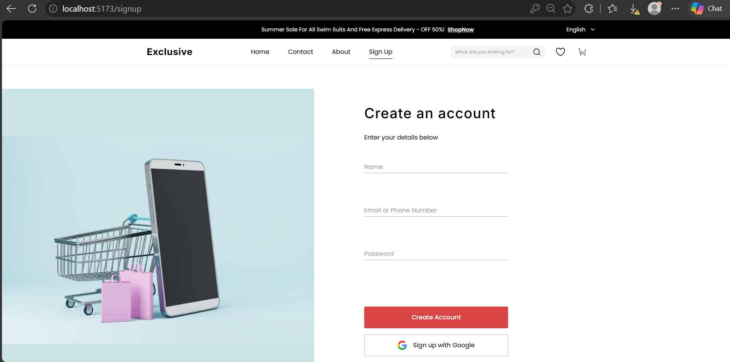
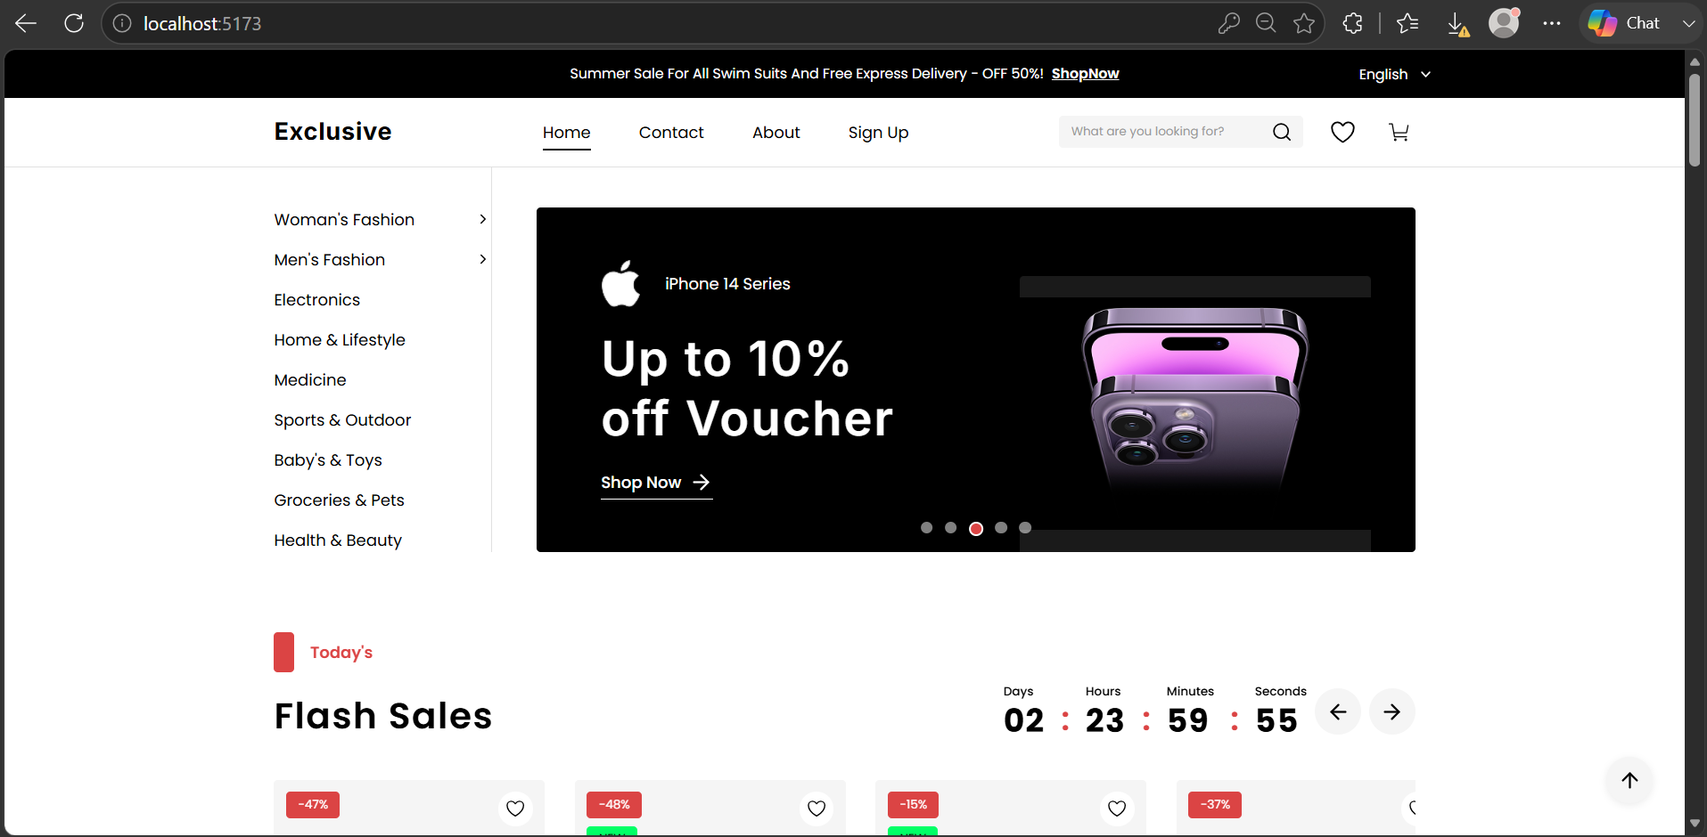
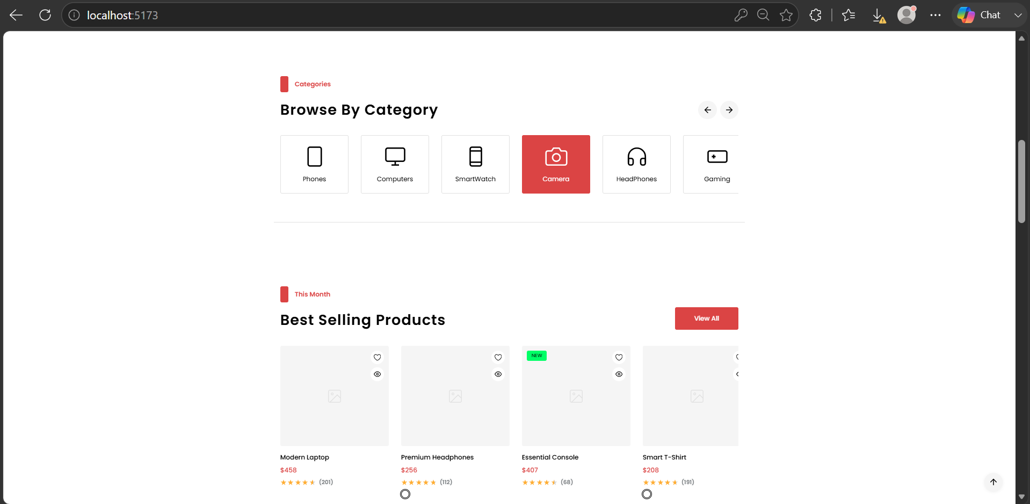

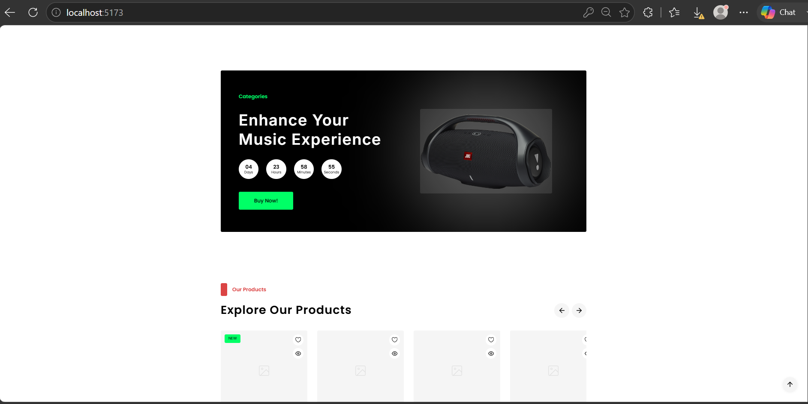
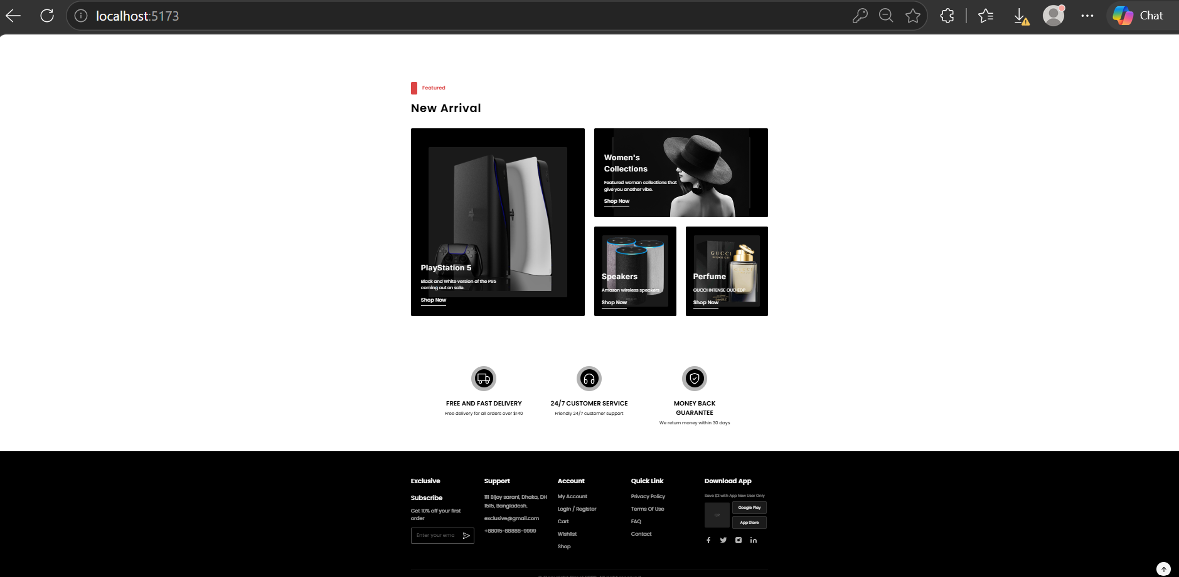
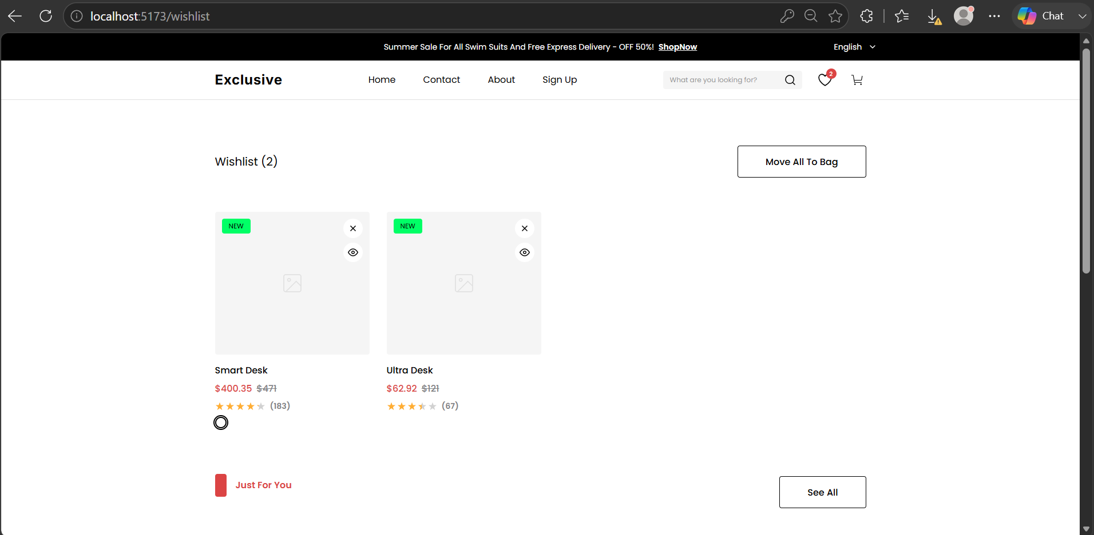
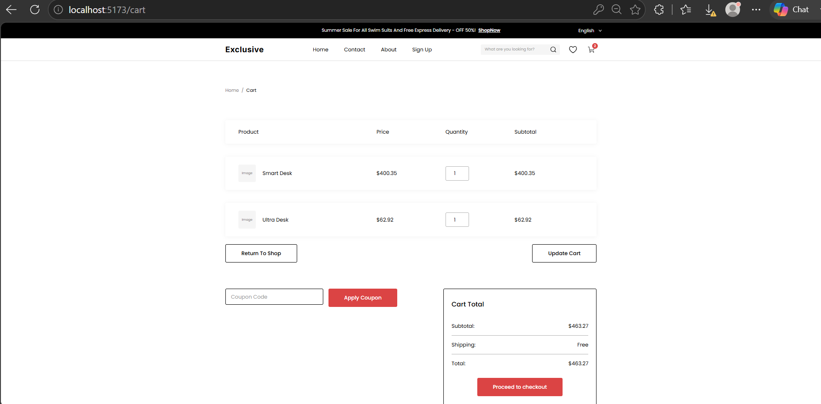
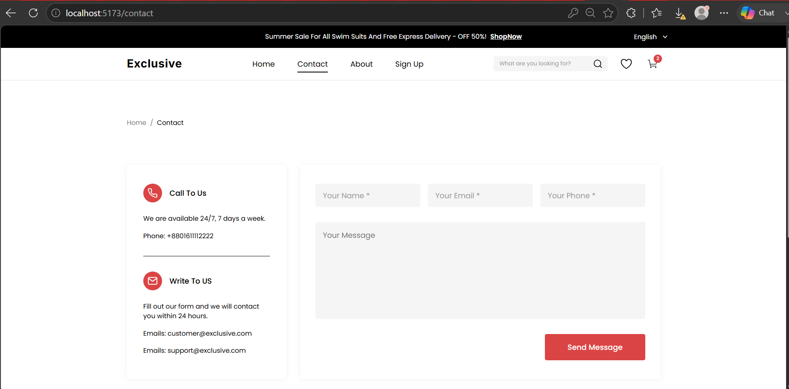

IMPROVEMENTS TO MAKE:
- Add necessary images to the products stored
- Make the Website Responsive to mobiles and tablet devices
- Start designing the database schema for the E-commerce website
- Planning on using Prisma to push the json defined products to the PostGreSQL Database easily
- Begin to develop the Backend functionalities including JWT Authentication, Cart Functionality, and Ordering items. (Simple CRUD)

