**Pricing Guide**

*You will need a Pricing DB, the MDS List, and “Template Research Format.xlsm” for this walkthrough*

# 1. Run Multi-Pricing Tool

1. Obtain a current copy of “Template Research Format.xlsm”, the MDS List, and a project-specific pricing database. Store your copies of the Research Format template, MDS List and project-specific pricing database in a new folder, with a folder name of your choosing.
2. If there is no database available, you may need to generate one yourself.
3. See the Pricing DB Creation Guide for more details. (Guide_Pricing_DB.docx)

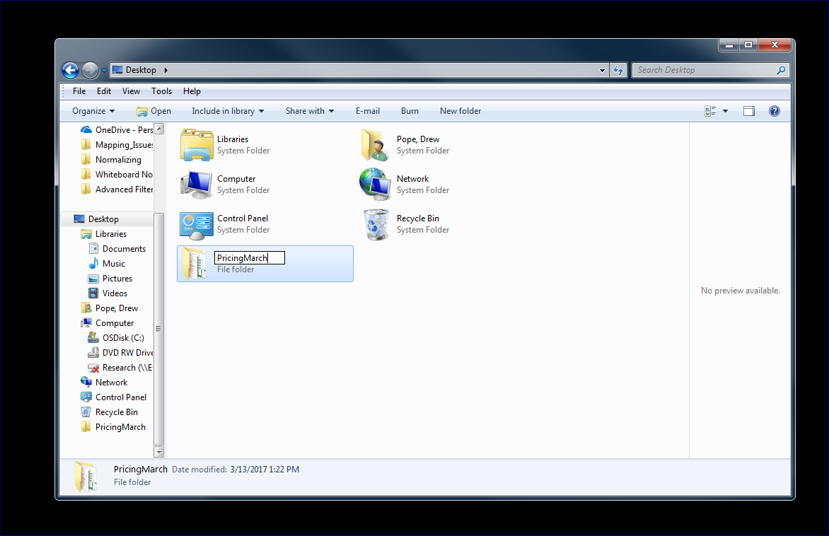

1. Make a copy of the Research Format template and rename the copy to better reflect the set of products you intend to generate pricing for. (Ex: “Carprofen DP Mar2017.xlsm”)

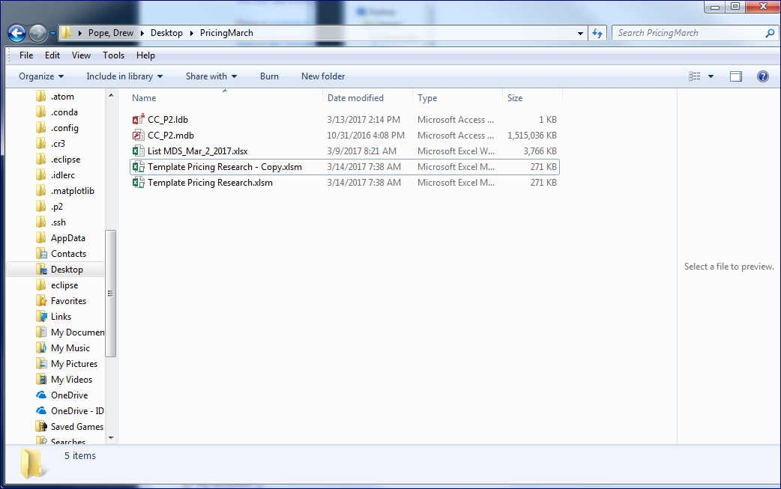

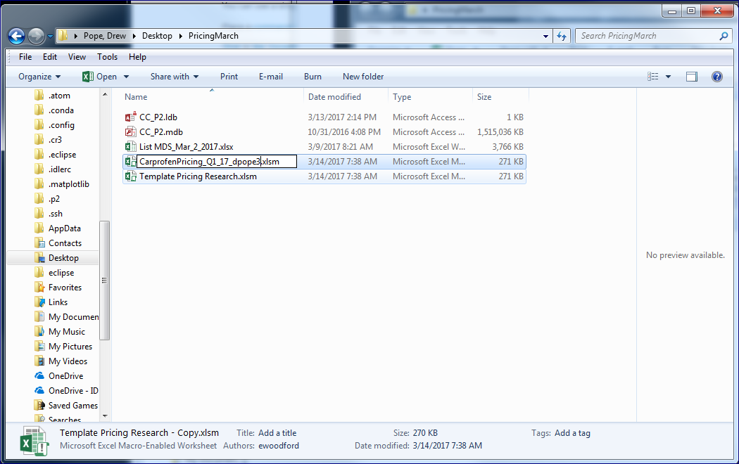

1. Open both the MDS List and the newly renamed pricing template file. For most projects, you will want to use the **bold** “Multi-Pricing” button to run your pricing queries. The rest of this portion covers the usage of this “Multi-Pricing” button. The “Single-Pricing” button is available, in case one needs it, however it’s usage is not covered here. The most common use is re-running lines with specific min or max prices to avoid outliers.

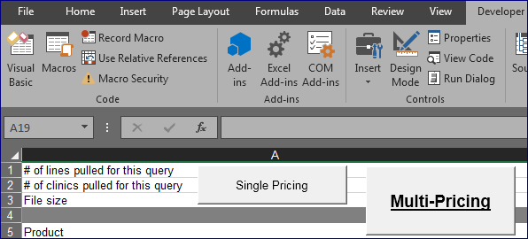

1. Within the MDS List, search for, and find, the products you wish to determine average pricing of. Copy each row that you want to price from the MDS List, then paste the row into the “REVISED DESCRIPTION” sheet. For a proper copy, start from the top-left cell you want to price and drag until you reach the bottom-right cell, then press Ctrl+C. The bottom-right cell should be in column AC. To ensure a proper paste, click the gray cell in the “REVISED DESCRIPTION” sheet, then press Ctrl+V.

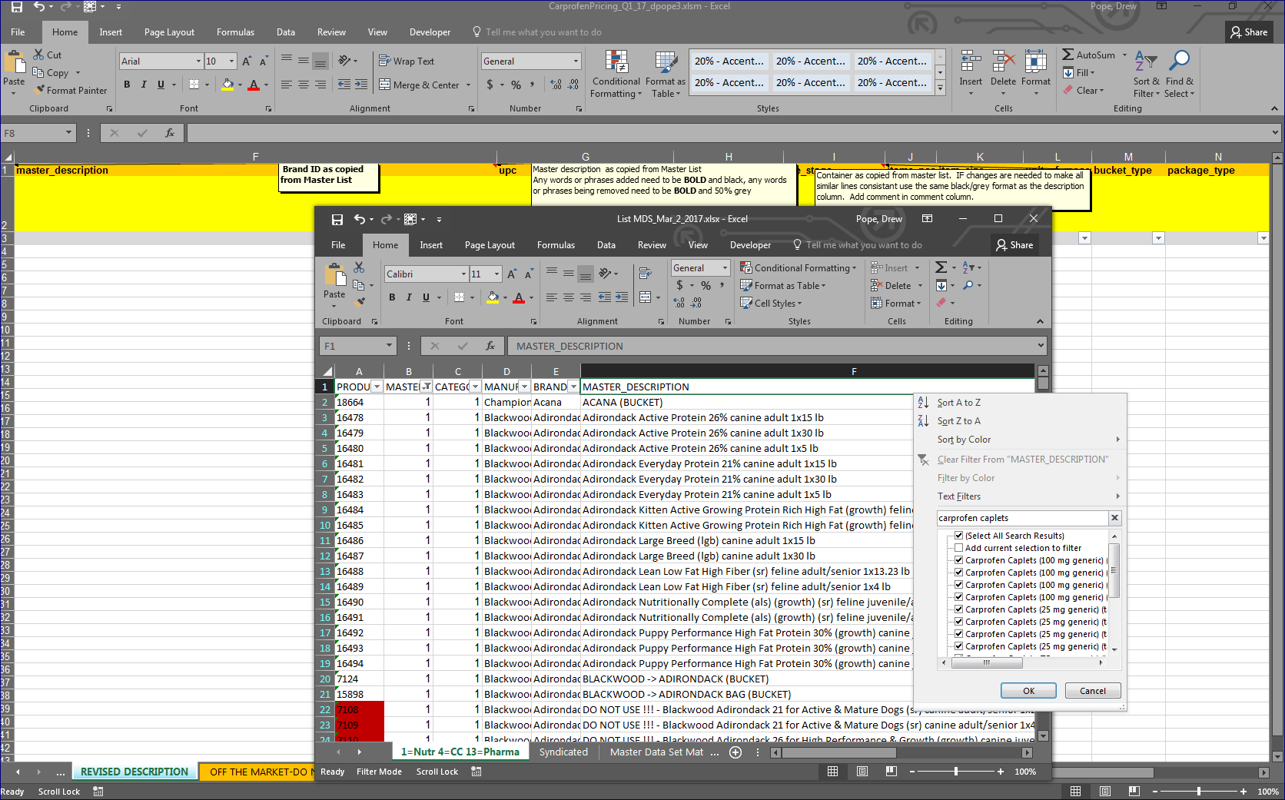

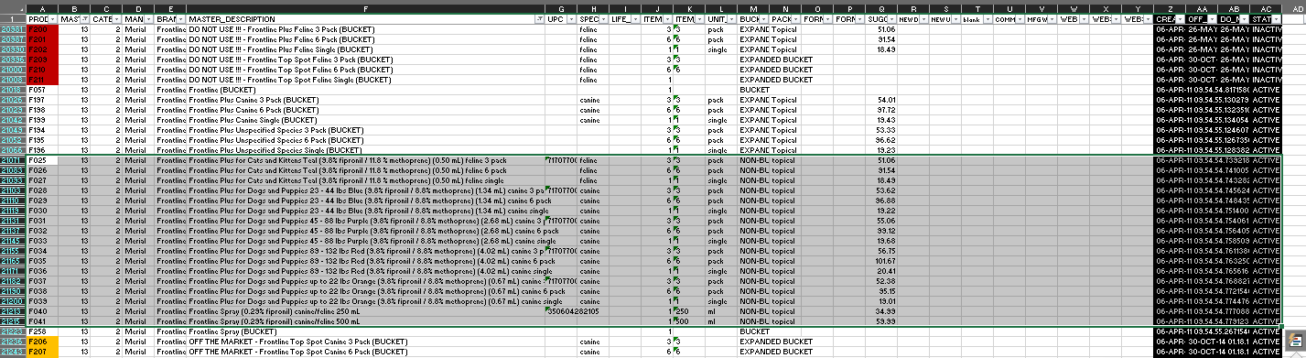

1. The Analysis ToolPak must be enabled in order for the Pricing Template to function.

This ToolPak is included in Microsoft Excel and can be enabled by the following:

* 1. Click File -> Options
  2. Within the Excel Options window, click Add-ins
  3. On the bottom of the Add-ins window, select “Excel Add-ins” and click “Go…”
  4. Check Analysis ToolPak and Analysis ToolPak – VBA, then hit “OK”

1. At this point, it’s time to run the pricing queries. This kind of operation is very CPU-intensive, so it’s highly suggested to close or minimize all non-critical applications and windows. This is especially true for other office applications, like Outlook or Skype. If you have all of the items you need copied from the MDS List, then that could be closed as well. When you are ready, go to the “Pricing” sheet, press the **bold** “Multi-Pricing” button at the top of the sheet to begin.

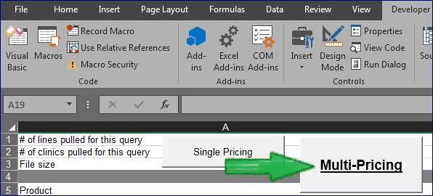

1. A “Database Select” window will pop up, allowing you to choose a database. Ensure you have chosen the correct database, then press “Run Query”. The query will be run against the selected database immediately upon hitting ‘OK’, so be sure that you are ready to begin before pressing this button. The operation may take some time to complete. Try to avoid clicking or using the computer too much while the operation is ongoing, because that could cause errors.
   1. In the given example of pricing 15 Carprofen Caplet types, it took this user’s computer 6 minutes to complete the necessary calculations. During this time this user’s screen displayed partial information multiple times, and the Excel application also went back and forth between responding and (not responding) at least a half dozen times.
   2. Near the bottom of this guide are multiple example of screens one may see as Excel attempts to complete your query. Keep calm and query on.

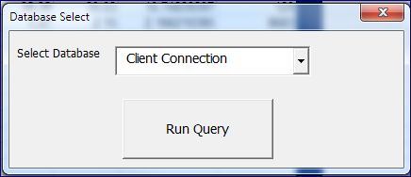

1. After some time, the pricing tool should complete and you will be left with the “Pricing” sheet activated. Feel free to work on other important tasks while you wait. When done, you’ll see the median, mean, median/unit, count, and original suggested price for each line that was priced. The Suggested Price field is already populated with the median values and is ready for individual evaluation and modification. There’s also a “Proof_Table” sheet, which contains more detailed metrics and graphs to assist in evaluating the results and determining final suggested prices.

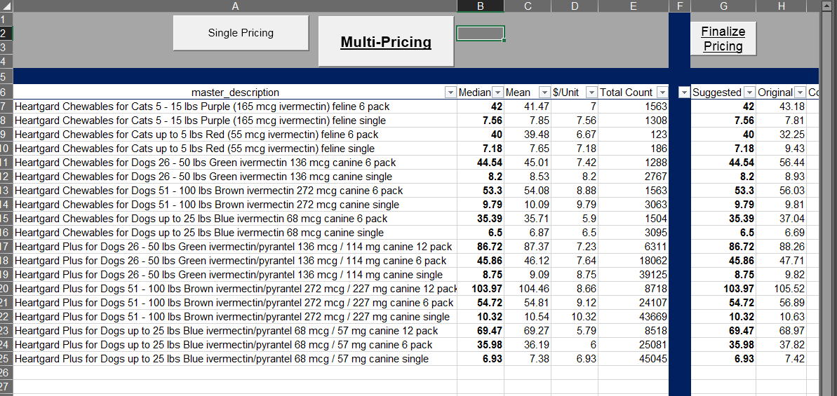

# 2. Evaluate Averaged Pricing Data

-Once one has ran the auto-pricing tool on some amount of lines, the question quickly transitions to:

**How do I interpret this data?**

-The main numbers to interpret are the median and count. In general, the median price is the most accurate price for our purposes. As long as the count is sufficient, we generally accept this number.

-It’s also important to consider the difference between the median and mean. If the difference is high, then it may be worth investigating the cause in the “Proof_Table”.

-Another thing to check is to scan the “Proof_Table” for anomalies before Finalizing. Check for graphs with strange data, irregular slopes, peaks that don’t appear to center around the majority of points, etc. Be sure to check the X axis, to understand the range of values being displayed. Be aware that what appears as a single data point *could* be any number of data points that are overlapping the same space.

-Ideally, a random set of data points will present as a standard Bell curve. A ‘tall’ curve may mean that the data strongly centers at a specific price. A ‘wide’ graph could signify an anomalous data point, a wide range of prices, or a variety of other things. Be careful making decisions regarding ‘wide’ graphs. If the data appears to be irregular, then examine the complete metrics of the item to assist in decision-making. Often, the median price is still very accurate. Minor modifications are usually the most that is needed.

-The last main metrics to frequently consider is the price difference between pack sizes and between weight ranges. (6-packs, 3-packs, 30 counts, orange, blue, green, etc.) You should monitor that the $/Unit goes down as the pack size increases and goes up as weight ranges increase. For example, if a single Frontline is $20/unit, then it’s expected that a 6-pack/unit would be less $20, $16 for instance. Products almost always follow this ‘rule’, and you should expect that they do, however supply-and-demand can sometimes create situations where certain products do not. Be aware of this and proceed with caution.

**Counts**

-Counts less than 10: We generally do not use this data. There are simply too few records to be able to form a reliable analysis. On very rare occasions, one might use the data gathered from less than 10 records— however there should be a very specific need and the full data from the “Proof_Table” should be heavily scrutinized first.

-Counts between 10 and 30: These should also be closely scrutinized and individually examined within the “Proof_Table” before accepting the suggested price. Unlike with counts under 10, which are excluded until given reason not to, counts between 10 and 30 should generally be considered initially accurate, and examined to check for reasons to doubt this initial assumption.

-Counts over 30: These still need manual review, however, there are enough records to have some modicum of faith in the results. It’s expected that you will at least individually compare these records against their original suggested prices, validate that the ranges/pack sizes scale appropriately, and determine that the difference between mean and median is reasonable.

**Proof Table Metrics Definitions**

-Below is the last piece of advisement that is occasionally required in order to make pricing decisions. It is a definition of each metric gathered in the Proof_Table.

-These metrics are rarely needed; however, they can occasionally be very useful.

Mean: The average of the set, susceptible to influence from outliers. Sum / Count

Standard Error: Estimates the variability of the data set by comparing the Standard Deviation against sample size. Standard Deviation / Square Root of Count

Median: The value in the middle of the set. The value of the data point Count/2, or the midpoint between two items if the Count is even.

Mode: The value that appears most often in the data set.

Standard Deviation: Estimates the spread of the numbers. Square root of Variance.

Sample Variance: The average of the squared differences from the mean. The difference from the Mean to each data point is squared and then those results are summed together for the set and divided by Count.

Kurtosis: A measure of the weight of a distribution’s tails, the amount of outliers. Higher kurtosis means heavier tails, a higher likelihood of outliers. A perfect normal distribution has a Kurtosis of 3.

Skewness: A measure of the asymmetry of a distribution. If this number is negative, the data is left-skewed and there are more points to the right than would be expected in a normal Bell distribution.

Range: The difference between the Minimum and Maximum values. May occasionally be useful to compare against Standard Deviation and Error.

Minimum: The smallest value in the data set.

Maximum: The largest value in the data set.

Sum: The value obtained when every data point is summed.

Count: The number of data points.

Confidence Level (95.0%): This value is the margin from the Mean that we’re fairly sure the True Mean lies within, also known as the Margin of Error. 95% of all "95% Confidence Levels" will include the true mean within +/- this value from the mean. If the mean calculated from a sample was 50, and confidence was 1.75, then one can assume that for 95% of the time, the true mean of the population the sample represents is within 1.75 of 50, between 48.25 and 51.75.

# 3. Finalize Pricing for Submission

Once you’ve ran the multi-pricing tool, evaluated the results, and made modifications in order to ensure the results are reasonable, you must now submit your pricing. On the Pricing sheet, column G is named “Suggested Price”, it was automatically populated with the median value for all descriptions with counts greater than 10. Your modifications to the suggested pricing results should have been done on this column. If not, then you must manually copy your new suggested prices to the appropriate column in the Revised Sheet (Col. Q, suggested_retail_price) with whatever methods you prefer.

If your new prices are already in column G of the Pricing sheet, the “Finalize Pricing” button directly above these values will go from top-down on the Pricing page and copy the new suggested price to the first row with a matching description on the Revised Description page. It is important that you don’t have duplicates on either page, as only the last copy on the Pricing Sheet will be copied to the first copy on the Revised Description sheet.

Simply press “Finalize Pricing”, then “Yes” to the warning, confirm the results, and then you are complete.

# - Examples of the Excel.exe ‘thinking’

