Harmattan Display Applet Architecture
Subsystem Architecture Specification

Document code: | DSAXXXXX-EN
Version: | V0.1
Status: | Draft
Save date:
Author: | David Kedves
Approver:
File: | 0000.doc
Lotus Notes Database:

Change history:

Version | Date | Status | Author | Comments
0.1 | 01/02/10 | Draft | David Kedves | First draft

Table of contents:

1 Document control 4
1.1 References 4
1.2 Glossary 4
2 Introduction 5
3 Architecture 6
3.1 System Context 6
3.1.1 Software 6
3.1.1.1 Interfaces provided 6
3.1.1.2 Interfaces required 6
3.2 Structural View 7
3.3 Behavioral View 7
3.4 Licensing and IPR view 7
3.5 Development 7
3.6 User Data, Settings, and Configurability 7
4 Performance 8
4.1 General Performance Considerations 8
4.2 Memory 8
4.3 Runtime 8
4.4 Power Consumption 8
5 Security Impact 9
6 Open items 10

Document control

References

Tag | Document name | Repository (with hyperlinks)
[DUI ControlPanel Arch.] | Direct UI ControlPanel Application Architectural Specification

Glossary

Acronym or term | Description
API | Application Programming Interface
DUI | Direct UI

Introduction
This document is subsystem architecture specification of Display applet. Display applet is part of Harmattan and it implements a DUI Controlpanel applet to let users configure the display brightness, and the back-light timeout parameters.

Architecture

System Context
Display applet does not contribute to Maemo API.
Display applet uses DUI framework to implement user interfaces.

Software

Interfaces provided

No interfaces provided by Display applet.

Interfaces required

Subsystem | Interface name | Description
QmSystem | libqmsystem-dev | A library for accessing different system functionality and hardware through Qt API.
DirectUI Framework | libdui-dev | The user interface libraries

Table 1: Interfaces used

Structural View

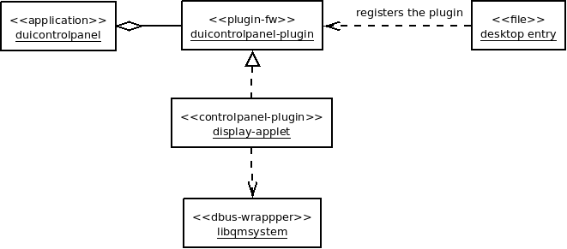
Figure 1. - Structural view of Display applet

Behavioral View
Display applet is loaded by DUI Control panel application, it can be started by tapping on “Display” entry in “Look & Feel” category. Its has only one page with two sliders (display brightness, back-light time-out) and one switch for staying lit when charging.
No notifications/banners shown by Display applet.

Licensing and IPR view
TBD

Development
Development can be done in scratchbox, because DUI controlpanel and QmSystem works fine in scratchbox, but QmSystem doesn't do the real brightness/back-light timeout setting.

User Data, Settings, and Configurability
Settings saved to Gconf via the qmsystem library, the applet does not store any other data.
Backup application is saving/restoring the Gconf database, so backup/restore is done in this way.

Performance

General Performance Considerations
According to Direct UI requirements and performance targets:
- Open a sub view or a popup target is <100 ms. Notes:
  - OK
- Change UI rotation target is <1 s. Notes:
  - The layout is the same for both orientation.

Memory
It is basically a small applet, it doesn't have big memory impact at all.
 | Explanation | Size [kB]
Flash/OneNAND | The built Display applet size (uncompressed),  libdisplayapplet.so ~ 855K | ~ 855 kB
Flash/eMMC | Applet doesn't store any data on eMMC. | 0 kB
RAM/Idle | Applet not loaded. | 0 kB
RAM/Peak | DUI Controlpanel application should be loaded. | TBD

Runtime
Display applet only loaded when Dui Controlpanel is running.

Power Consumption
Display applet doesn't have so much CPU impact because its only uses the QmDisplayState interface from libqmsystem, only on user interaction (changing slider values, switching the button).

Security Impact
No security threats.

Open items

# | Item | Status | Description
1 | Licensing | TBD | Licensing need to be determined
2 | RAM/Peak | TBD | Should be do some measurements....
3
4

