Harmattan Led Applet Architecture
Subsystem Architecture Specification

Document code: | DSAXXXXX-EN
Version: | V0.1
Status: | Draft
Save date:
Author: | David Kedves
Approver:
File: | 0000.doc
Lotus Notes Database:

Change history:

Version | Date | Status | Author | Comments
0.1 | 02/03/10 | Draft | David Kedves | First draft

Table of contents:

1 Document control 4
1.1 References 4
1.2 Glossary 4
2 Introduction 5
3 Architecture 6
3.1 System Context 6
3.1.1 Software 6
3.1.1.1 Interfaces provided 6
3.1.1.2 Interfaces required 6
3.2 Structural View 7
3.3 Behavioral View 7
3.4 Licensing and IPR view 7
3.5 Development 7
3.6 User Data, Settings, and Configurability 7
4 Performance 8
4.1 General Performance Considerations 8
4.2 Memory 8
4.3 Runtime 8
4.4 Power Consumption 8
5 Security Impact 9
6 Open items 10

Document control

References

Tag | Document name | Repository (with hyperlinks)
[DUI Control Panel Arch. Spec.] | Direct UI Control Panel Application Architecture Specification | https://projects.maemo.org/svn/teamh/docs/DcpArch.doc
[System UI Arch. Spec.] | System UI Architecture Specification | https://projects.maemo.org/svn/teamh/ssw-arch-docs/SysUIArch.doc

Glossary

Acronym or term | Description
API | Application Programming Interface
DUI | Direct UI
DCP | DUI Control Panel

Introduction
This document is subsystem architecture specification of Led applet. Led applet is part of Harmattan and it implements a DUI Control Panel applet to let users to turn on/off the illumination light or the incoming events light.

Architecture

System Context
Led applet does not contribute to Maemo API.
Led applet uses DUI framework to implement user interfaces.

Software

Interfaces provided

No interfaces provided by Led applet.

Interfaces required

Subsystem | Interface name | Description
QmSystem | libqmsystem-dev | A library for accessing different system functionality and hardware through Qt API.
DirectUI Framework | libdui-dev | The user interface libraries
DUI Control Panel | libduicontrolpanel-dev | Contains interfaces for creating DCP Applets.
QmSystem Led API | libqmsystem-dev,  QmLed | QmLed provides information and actions on device LED.

Table 1: Interfaces used

Structural View

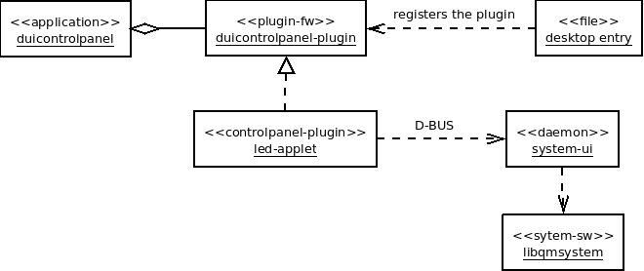
Figure 1. - Structural view of Led applet

Behavioral View
Led applet is loaded by DUI Control panel application, it can be started by tapping on “Led light” entry in “Device system” category. Currently its has only one page with two switches (Illumination light, Incoming events).
No notifications/banners shown by Led applet.

Licensing and IPR view
TBD

Development
Development can be done in scratchbox, because DUI controlpanel and QmSystem works fine in scratchbox, but QmSystem doesn't do the real led device setting.
Issues currently:
- No UI specification (neither a design brief)
- Currently there is no way to control the illumination led settings.

User Data, Settings, and Configurability
Settings are stored in GConf (via the System UI daemon, also restores these on bootup).
GConf keys: - /systemui/settings/leds/allLedsEnabled
- /systemui/settings/leds/eventsLedEnabled
- /systemui/settings/leds/illuminationLedEnabled
Backup application is saving/restoring the GConf database, so backup/restore is done in this way.

Performance

General Performance Considerations
According to Direct UI requirements and performance targets:
- Open a sub view or a popup target is <100 ms. Notes:
  - OK
- Change UI rotation target is <1 s. Notes:
  - The layout is the same for both orientation.

Memory
It is basically a small applet, it doesn't have big memory impact at all.
 | Explanation | Size [kB]
Flash/OneNAND | The built Led applet size (uncompressed),  libledapplet.so ~ 875K | ~ 875 kB
Flash/eMMC | Applet doesn't store any data on eMMC. | 0 kB
RAM/Idle | Applet not loaded. | 0 kB
RAM/Peak | DUI Control Panel application should be loaded.  (Also System UI daemon should be running) | TBD

Runtime
Led applet only loaded when Dui Controlpanel is running.
System UI daemon sets the Led states once when its loaded (at bootup), and when its explicitly asked over D-BUS

Power Consumption
Led applet doesn't have so much CPU impact because its only uses the QmLed interface from libqmsystem to set Led states (When something changed). And the settings are loaded/saved from/to GConf.

Packages
All packages from this list are in “nokia-closed” repository.
Source package | Binary package
system-ui | system-ui  system-ui-dbg  system-ui-tests  systemui-l10n-engineering-english
systemui-applets | duicontrolpanel-usbapplet  duicontrolpanel-batteryapplet  duicontrolpanel-displayapplet  duicontrolpanel-profileapplet  duicontrolpanel-ledapplet  duistatusindicatormenu-volumeplugin  duistatusindicatormenu-batteryplugin  duistatusindicatormenu-profileplugin  systemui-applets-tests  systemui-applets-l10n-engineering-english

Security Impact
No security threats.

Open items

# | Item | Status | Description
1 | Licensing | TBD | Licensing need to be determined
2 | RAM/Peak | TBD | Should be do some measurements....
3 | UI-spec | ?? | When an UI spec arrives for this arch. may change a bit.
4 | Illumination Led | TODO | Get more information about controlling the illumination led.

