Harmattan USB UI Architecture
Subsystem Architecture Specification

Document code: | DSAXXXXX-EN
Version: | 0.1
Status: | Draft
Save date:
Author: | David Kedves
Approver: | ??
File: | 0000.doc
Lotus Notes Database: | ??

Change history:

Version | Date | Status | Author | Comments
0.1 | 03/03/10 | Draft | David Kedves | First draft

Table of contents:

1 Document control 4
1.1 References 4
1.2 Glossary 4
1.3 Summary of changes in current version 4
2 Introduction 5
3 Architecture 6
3.1 System Context 6
3.1.1 Hardware 6
3.1.2 Software 6
3.1.2.1 Interfaces provided 6
3.1.2.2 Interfaces required 6
3.2 Structural View 7
3.3 Behavioral View 7
3.4 Licensing and IPR view 7
3.5 Development 7
3.6 User Data, Settings, and Configurability 7
3.7 Packages 8
4 Performance 9
4.1 General Performance Considerations 9
4.2 Memory 9
4.3 Runtime 9
4.4 Power Consumption 9
5 Security Impact 10
6 Open items 11

Document control

References

Tag | Document name | Repository (with hyperlinks)
[ArchGoals] | Architecture Goals | http://wikis.in.nokia.com/MaemoSoftware/ArchitectureGoals
[Performance] | Direct UI requirements & performance targets | http://eslns42.ntc.nokia.com/nmp/osso/maemoswdm.nsf/4194c016f5a4d810c225668c004d6c25/a81a1c1aed0d89e5c22575710031d101?OpenDocument
[DCP] | Dui Control Panel Architecture Specification | https://projects.maemo.org/svn/teamh/docs/DcpArch.doc
[SystemUI] | System UI daemon Architecture Specification | https://projects.maemo.org/svn/teamh/ssw-arch-docs/SysUIArch.doc

Glossary

Acronym or term | Description
API | Application Programming Interface
DUI | Direct UI
DCP | DUI Control Panel
HAL | Hardware Abstraction Layer
D-BUS | An IPC implementation, message bus system.
USB | Universal Serial Bus

Summary of changes in current version

Introduction
This document is subsystem architecture specification of the USB UI of Harmattan. It implements user interfaces to set the default mode for USB connection, and to change the USB modes on demand when connection happened.
USB UI split to two parts, one part is in the System UI daemon, its shows notifications about connection events, and if set it shows the USB mode selection dialog.
The other part is the DCP Applet which let users to configure the default USB mode on connection.

Architecture

System Context
USB UI Contributes some D-BUS API for querying the current USB cable-status, and for popping up the mode-selection dialog. (FIXME: This will change when the USB backend coming)
USB UI uses DUI framework to implement user interfaces, and uses HAL to find hardware devices and query their properties.

Hardware
An OTG (On The Go) compliant USB hardware necessary for the proper result (cable-detection etc...), because any other hardware cannot be detected with this software.

Software

Interfaces provided
(Its provided by the System UI daemon:)
Subsystem | Interface name | Description
UsbBusinessLogicAdaptor | com.nokia.systemui.usb | D-BUS Session Bus  Implements interface for the USB mode selection UI, and for getting/setting the USB state.

Interfaces required

Subsystem | Interface name | Description
[? Providing Subsystem ?] | [? Using naming convention link to package name ?] | [? A reference, a short description of the interface, or the rational of using the interface. ?]
DirectUI Framework | Notifications Framework | Provides non-interactive notifications rendering.  Provides missed events API for calls, messages and chats.
DirectUI Framework | libdui-dev | The user interface libraries
Freedesktop  Essentials | HAL | Accessed via dbus, provides interface to query hardware devices and its properties.

Table 1: Interfaces used

Structural View
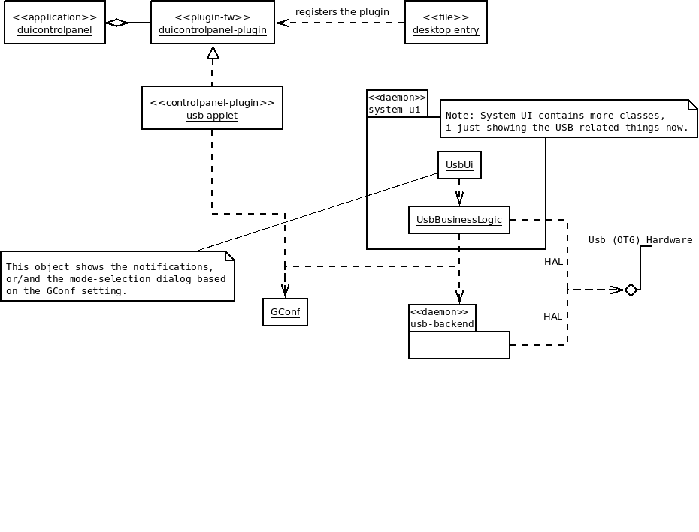
Figure 1. - Structural view of USB UI

Behavioral View
The USB Applet available from Dui Control Panel (“Settings”) application in “Connectivity” category.
Its lets user to set the default behaviour on USB cable connection (eg.: switch to some mode by default, or Ask on connection...).
The other part (daemon) is running always, and its shows notifications and the USB mode selection dialog if it set.

Licensing and IPR view
TBD

Development
Development can be done in both armel/i386 targets, I created some methods in com.nokia.systemui.usb to simulate the USB connection events for GUI.
(Matti test for USB UI uses these to trigger the cable plug-in/-out events.)

User Data, Settings, and Configurability
USB Setting currently stored in the following GConf key:
/Dui/System/UsbMode
Backup done via GConf database saving/restoring.

Packages
All packages from this list are in “nokia-closed” repository.
Source package | Binary package
system-ui | system-ui  system-ui-dbg  system-ui-tests  systemui-l10n-engineering-english
systemui-applets | duicontrolpanel-usbapplet  duicontrolpanel-batteryapplet  duicontrolpanel-displayapplet  duicontrolpanel-profileapplet  duicontrolpanel-ledapplet  duistatusindicatormenu-volumeplugin  duistatusindicatormenu-batteryplugin  duistatusindicatormenu-profileplugin  systemui-applets-tests  systemui-applets-l10n-engineering-english

Performance

General Performance Considerations
According to Direct UI requirements and performance targets:
- Open a sub view or a popup target is <100 ms. Notes:
  - OK
- Change UI rotation target is <1 s. Notes:
  - The layout is the same for both orientation.

Memory
It is basically a small plugin, it doesn't have big memory impact at all.
 | Explanation | Size [kB]
Flash/OneNAND | The built USB applet size (uncompressed),  libusbapplet.so ~ 603K | 603 kB
Flash/eMMC | EMMC not used. | 0 kB
RAM/Idle | System-ui daemon should be running, to listen for HAL signals.
RAM/Peak | System-ui daemon should be running, to listen for HAL signals, when its triggered and the GConf key is set to “ask”, it shows a dialog to select mode, else it do a query to backend to do the necessary steps for mode-change.

Runtime
Deamon part: Its running all the time, at startup its find the device via HAL, and registers to some signals on it (property changes..etc), these are triggered on USB cable events. And when set the daemon shows the mode selection dialog, else its just asks the backend for change the USB mode.
Applet part: Applet is just a small plugin for DCP, which changes a GConf key. Its only loaded when Dui Control Panel is running.

Power Consumption
TBD
[? List here all known or estimated impacts this subsystem has to power consumption. Estimate actual talk/standby time changes in minutes or %. Are there any configuration options or user settings related to this subsystem having impact on talk/standby time? What is the estimated battery life time when this subsystem is running continuously (e.g. MP3 playback time). ?]

Security Impact
Currently no security threats.
TBD when the new Backend is alive.

Open items

# | Item | Status | Description
1 | Backend | Open | An USB handler backend which does the real usb-mode change (and mounts/unmounts the volumes etc...).  Promised to [TM → INC_19]
2 | Security | Open | Need to be re-checked...
3
4

