Harmattan Profile UI
Architecture Specification
Subsystem Architecture Specification

Document code: | DSAXXXXX-EN
Version: | 0.1
Status: | Draft
Save date:
Author: | David Kedves
Approver: | ??
File: | 0000.doc
Lotus Notes Database: | ??

Change history:

Version | Date | Status | Author | Comments
0.1 | 02/03/10 | Draft | David Kedves | First draft

Table of contents:

1 Document control 5
1.1 References 5
1.2 Glossary 5
1.3 Summary of changes in current version 5
2 Introduction 6
3 Architecture 7
3.1 System Context 7
3.1.1 Software 7
3.1.1.1 Interfaces provided 7
3.1.1.2 Interfaces required 7
3.2 Structural View 8
3.3 Behavioral View 8
3.4 Licensing and IPR view 8
3.5 Development 8
3.6 User Data, Settings, and Configurability 8
4 Performance 9
4.1 General Performance Considerations 9
4.2 Memory 9
4.3 Runtime 9
4.4 Power Consumption 9
5 Security Impact 10
6 Open items 11

Document control

References

Tag | Document name | Repository (with hyperlinks)
[ArchGoals] | Architecture Goals | http://wikis.in.nokia.com/MaemoSoftware/ArchitectureGoals
[Performance] | Direct UI requirements & performance targets | http://eslns42.ntc.nokia.com/nmp/osso/maemoswdm.nsf/4194c016f5a4d810c225668c004d6c25/a81a1c1aed0d89e5c22575710031d101?OpenDocument

Glossary

Acronym or term | Description
API | Application Programming Interface
DUI | Direct UI
DCP | DUI Control Panel

Summary of changes in current version

Introduction
This document is subsystem architecture specification of Profile UI. The Profile UI is part of Harmattan and it implements a Status-indicator-menu plugin, and a Dui Control panel applet.
The Status indicator menu plugin (later profile-plugin) only let users to switch between the available profiles, the DCP applet (later profile-applet) let users also configure these profiles settings (volume / vibration setting in each profile).

Architecture

System Context
Profile applet, and Profile plugin does not contribute any API to Maemo.
Profile applet and plugin uses DUI framework to implement user interfaces, and uses the Qt api for profiles.

Software

Interfaces provided

No interfaces provided by Profile UI.

Interfaces required

Subsystem | Interface name | Description
[? Providing Subsystem ?] | [? Using naming convention link to package name ?] | [? A reference, a short description of the interface, or the rational of using the interface. ?]
Profile Qt API | libprofile-qt[-dev] | Qt library for profiles. It contains interfaces to control device profiles, and for setting current profile.
DirectUI Framework | libdui[-dev] | The user interface libraries
DCP | libduicontrolpanel[-dev] | Provides interfaces for creating Dui Control Panel applets.
DUI Status-indicator-menu | duistatusindicatormenu | Provides a plugin interface for creating status-menu items.

Table 1: Interfaces used

Structural View

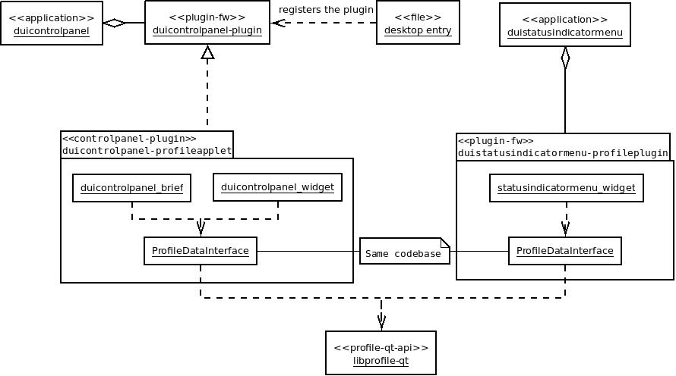
Figure 1. - Structural view of Profile UI.

Behavioral View
No notifications/banners shown by Profile UI.

Profile plugin
Profile plugin can be opened by tapping on status-area (provided by DUI Home application), its starts the DUI Status Indicator Menu (which loads the libprofile.so plugin), and it shows the Profile plugin main widget.

Profile applet
Profile applet available in Dui Control Panel, in “Look & Feel” category.

Licensing and IPR view
TBD

Development
Development in scratchbox2 is possible, profiled (profile daemon), and libprofile-qt0, libprofile-qt-dev should be installed.

User Data, Settings, and Configurability
Profile UI doesn't stores any user data and setting directly, it is done by profiled.

Performance

General Performance Considerations
According to Direct UI requirements and performance targets:
- Open a sub view or a popup target is <100 ms. Notes:
  - OK
- Change UI rotation target is <1 s. Notes:
  - The layout is the same for both orientation.

Memory

 | Explanation | Size [kB]
Flash/OneNAND | Applet binary (uncompressed): 188 kB  Plugin binary (uncompressed): 104 kB | 292 kB
Flash/eMMC | Profile UI doesn't store any data on eMMC. | 0 kB
RAM/Idle | Profile applet and plugin aren't loaded. | 0 kB
RAM/Peak | Profile-applet: Dui Control Panel and profiled should be running.  Profile-plugin: Dui Status Indicator Menu and profiled should be running. | TBD

Runtime
Profile plugin only running when the DUI Status Indicator Menu opened by user, libprofile-qt0 listens on profiled DBUS signals (about profile changes).
Profile applet only loaded when DCP running, and its also listens on some profiled DBUS signals.

Power Consumption
TBD
[? List here all known or estimated impacts this subsystem has to power consumption. Estimate actual talk/standby time changes in minutes or %. Are there any configuration options or user settings related to this subsystem having impact on talk/standby time? What is the estimated battery life time when this subsystem is running continuously (e.g. MP3 playback time). ?]

Security Impact
No security threats.

Open items

# | Item | Status | Description
1 | Licensing | TBD | Licensing need to be determined (currently nokia-closed)
2 | RAM/Peak | TBD | Need to do some measurements about memory consumptions.
3 | Power Consumption | TBD | TODO: Check CPU utilization...
4

