Harmattan Battery UI System
Subsystem Architecture Specification

Document code: | DSAXXXXX-EN
Version: | [?Version?]
Status: | Draft
Save date:
Author: | David Kedves
Approver: | ??
File: | 0000.doc
Lotus Notes Database: | ??

Change history:

Version | Date | Status | Author | Comments
0.1 | 16.02.2010 | Draft | David Kedves | First draft
0.2 | 01/03/10 | Draft | David Kedves | Some small fixes (typos, etc...)

Table of contents:

1 Document control 4
1.1 References 4
1.2 Glossary 4
1.3 Summary of changes in current version 4
2 Introduction 5
3 Architecture 6
3.1 System Context 6
3.1.1 Software 6
3.1.1.1 Interfaces provided 6
3.1.1.2 Interfaces required 6
3.1.1.3 Interfaces provided 7
3.2 Structural View 8
3.3 Behavioral View 8
3.4 Licensing and IPR view 8
3.5 Development 8
3.6 User Data, Settings, and Configurability 9
4 Performance 10
4.1 General Performance Considerations 10
4.2 Memory 10
4.3 Power Consumption 10
4.4 Security Impact 10
5 Open items 11

Document control

References

Tag | Document name | Repository (with hyperlinks)
[ArchGoals] | Architecture Goals | http://wikis.in.nokia.com/MaemoSoftware/ArchitectureGoals
[Performance] | Direct UI requirements & performance targets | http://eslns42.ntc.nokia.com/nmp/osso/maemoswdm.nsf/4194c016f5a4d810c225668c004d6c25/a81a1c1aed0d89e5c22575710031d101?OpenDocument
[System UI daemon architecture] | System User Interface Subsistem Architecture Documentation | https://dvcs.projects.maemo.org/git/?p=af/systemui;a=blob;f=doc/SysUIArch.doc;hb=HEAD

Glossary

Acronym or term | Description
API | Application Programming Interface
DUI | Direct UI
SysUId | System UI daemon

Summary of changes in current version

Introduction
This document is subsystem architecture specification of battery UI. Battery UI is part of Harmattan and it implements UI interface for battery events (via DUI Notification system), and let the user to query the current battery states, and user able to control the power saving system (user can set whether how many battery percentage should activate the power save mode, and user can force the power save anytime). The battery UI split to 3 parts, one is in the System UI daemon, it provides interfaces (on DBUS) to query/set the battery and power-save informations, and there is a DUI Control panel applet which lets user to configure the automatic power save threshold value. And there is a DUI Status Indicator Menu plugin which is showing the remaining time and battery status. The Battery UI may be referred in some places as Energy UI.

Architecture

System Context
Battery UI does not contribute to Maemo API.
Battery applet and plugin uses DUI framework to implement user interfaces.

Software

Interfaces provided

UI interfaces provided by Battery UI:
- Battery DUI Control Panel Applet
- Battery DUI Status Indicator Menu plugin
- System UI Energy UI notifications

Interfaces required

Subsystem | Interface name | Description
[? Providing Subsystem ?] | [? Using naming convention link to package name ?] | [? A reference, a short description of the interface, or the rational of using the interface. ?]
DCP | libduicontrolpanel-dev | Provides interface for control panel plugin
DUI Status Indicator Menu | duistatusindicatormenu-dev | Provides interface for dui status indicator menu
DirectUI Framework | libdui-dev | The user interface libraries
System UI daemon | system-ui | Provides interfaces via DBUS for DuiControlPanel applet and DuiStatusIndicatorMenu plugin
Qmsystem | libqmsystem-dev | Provides API to query the actual hardware values. (Its used inside the System UI daemon)
Table 1: Interfaces used

Interfaces provided
Subsystem | Interface name | Description
System UI daemon | com.nokia.systemui.battery | A DBus API interface for the battery charging status, the power  save mode system and the remaining use time system so that the applications  can get the information and change the settings through the DBus system.

Structural View

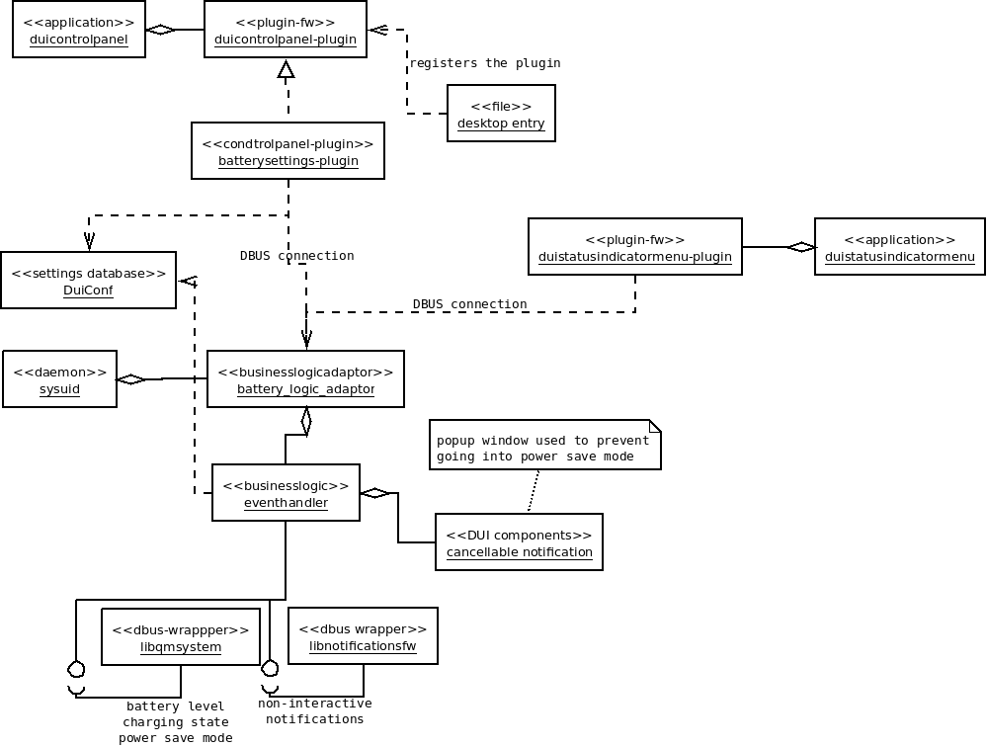
Figure 1. - Structural view of the Energy UI

Behavioral View
The System UI daemon showing general notifications about battery state changes via the DUI Notification Framework.
Battery Applet available trough the DUI Control Panel. Its let user to set the battery percentage threshold value which is used for activating automatic power-save mode.
Battery Plugin available in DUI Status Indicator Menu, its shows some basic information about battery status (Remaining time/talk-time/and battery value or charging values).

Licensing and IPR view

TBD

Development
Basic development can be done in scratchbox, but qmsystem library returns for battery/charging values “Not Available”, real testing needs to be done on the device.
Unit/Functional tests are done by some qmsystem stubs, which emits some battery state change signals.

User Data, Settings, and Configurability
Automatic power-save (bool), and battery threshold value for automatic power-save feature is stored in Gconf in “/systemui/settings/battery” key.
QmSystem not stores these values, System UI daemon handles these settings storing/restoring.

Performance

General Performance Considerations
According to Direct UI requirements and performance targets:
- Open a sub view or a popup target is <100 ms. Notes:
  - OK
- Change UI rotation target is <1 s.

Memory

 | Explanation | Size [kB]
Flash/OneNAND | There are three packages for UI:  - system-ui (System UI daemon)  - duicontrolpanel-batteryapplet  - duistatusindicatormenu-batteryplugin | TBD
Flash/eMMC | Battery UI does not stores any user data.
RAM/Idle | System UI daemon always running, its listens on QmSystem signals, and its showing notifications about battery change states.
RAM/Peak | - DuiControlPanel must be run to open the Battery Applet  - DuiStatusIndicatorMenu must be run to see the battery informations  - System UI daemon always running (its uses libdui and DBUS)

Power Consumption
TBD
[? List here all known or estimated impacts this subsystem has to power consumption. Estimate actual talk/standby time changes in minutes or %. Are there any configuration options or user settings related to this subsystem having impact on talk/standby time? What is the estimated battery life time when this subsystem is running continuously (e.g. MP3 playback time). ?]

Security Impact
The battery D-Bus API contains void setPSMThresholdValue (const QString &value);.
- There could be a security threat in handling the string value...

Open items

# | Item | Status | Description
1
2
3

