**Introduction**

In this short report, I will be explaining what tools and techniques I used to create my website. I will show screenshots of the pages and the coding within the webpage. I will also finalise this report by evaluating the website.

Development process

Before starting my webpage, I was inspired by the NFL.com page. The colours are function were very extravagant which gave me and idea of what website I wanted to create. Before starting the webpage, I sketched out a few drawings of the prototype would look like. The sketches can be found in the Readme file. Below I will post the NFL website annotating the features, functions and colours and styles I enjoyed.

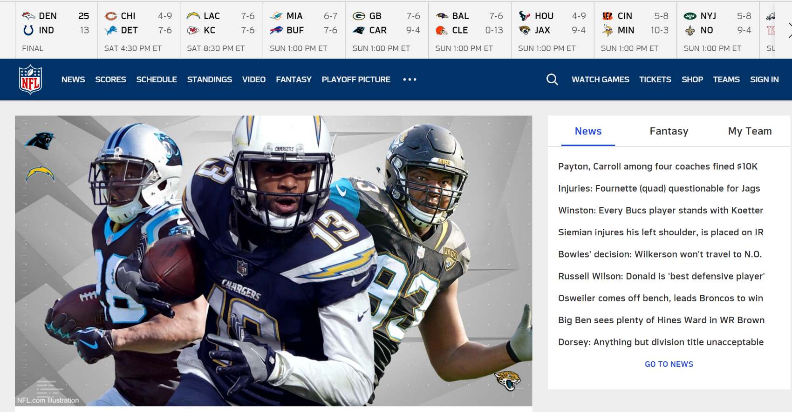

Red: The NFL Logo tells us the owner of the website which is the “National Football League”. The logo has bright and outstanding colours which appeal to the target audience.

Orange: The image tells us the top plays of the NFL currently at their best and the upcoming games they have. The image used has 3 team logos, which tells us what team each player plays for.

Yellow: The yellow is the navigation bar that has news, shops, tickets and the latest scores. It also has a search function to be able to search anything about the sport or the league

Purple: This part shows a short tab with the latest news. When a thread is clicked by a user the news will expand onto another page.

**Prototype/ WireFrame**

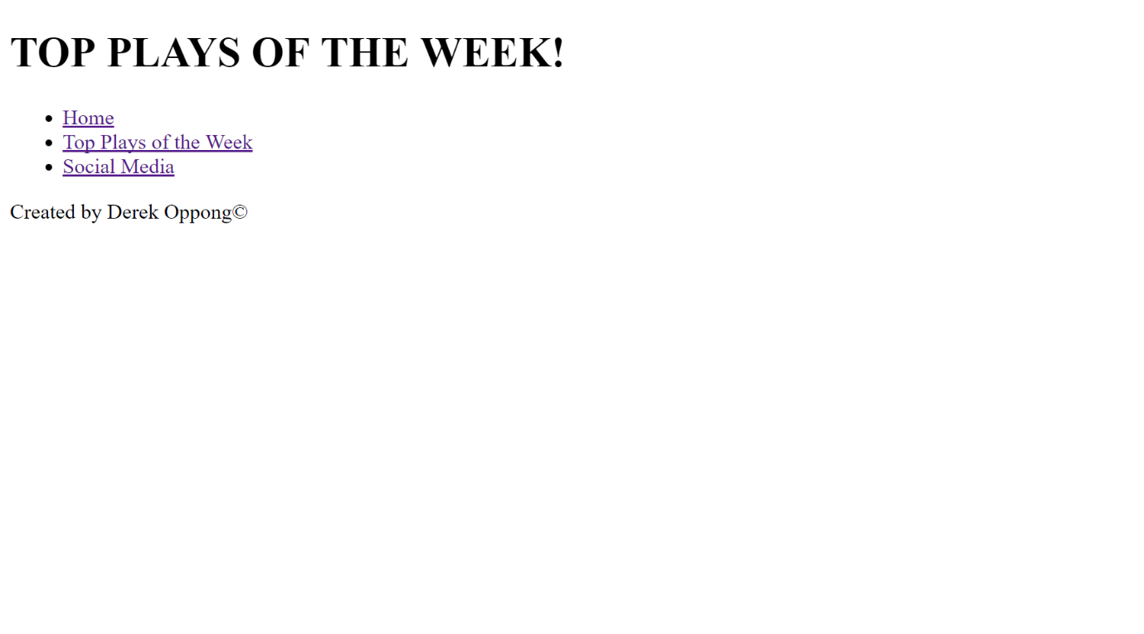

This is the wireframe of the website, it includes the navigation bar, the header and the footer. The pages are all linked in the read me file.

**My Website**

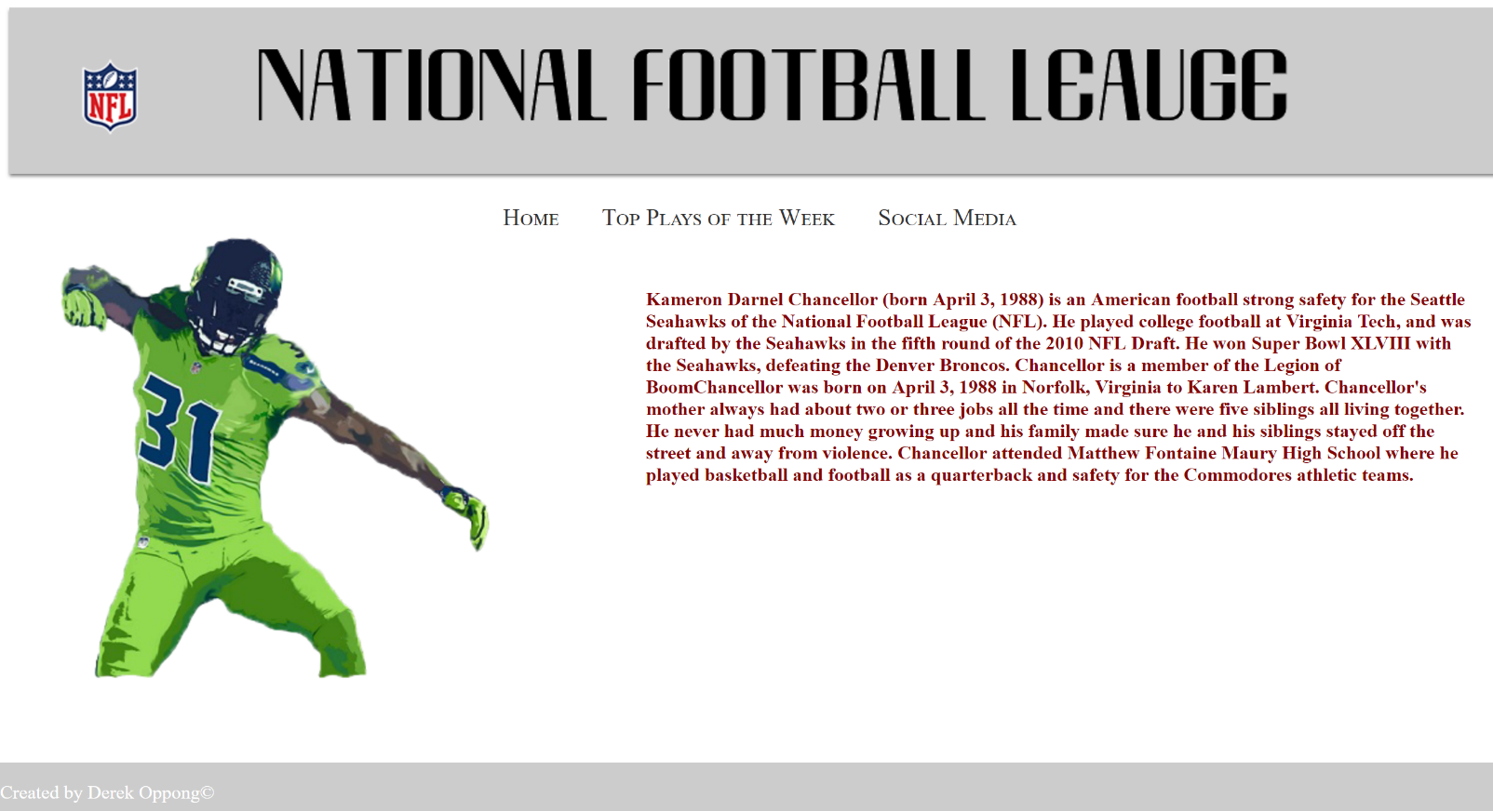Page #1

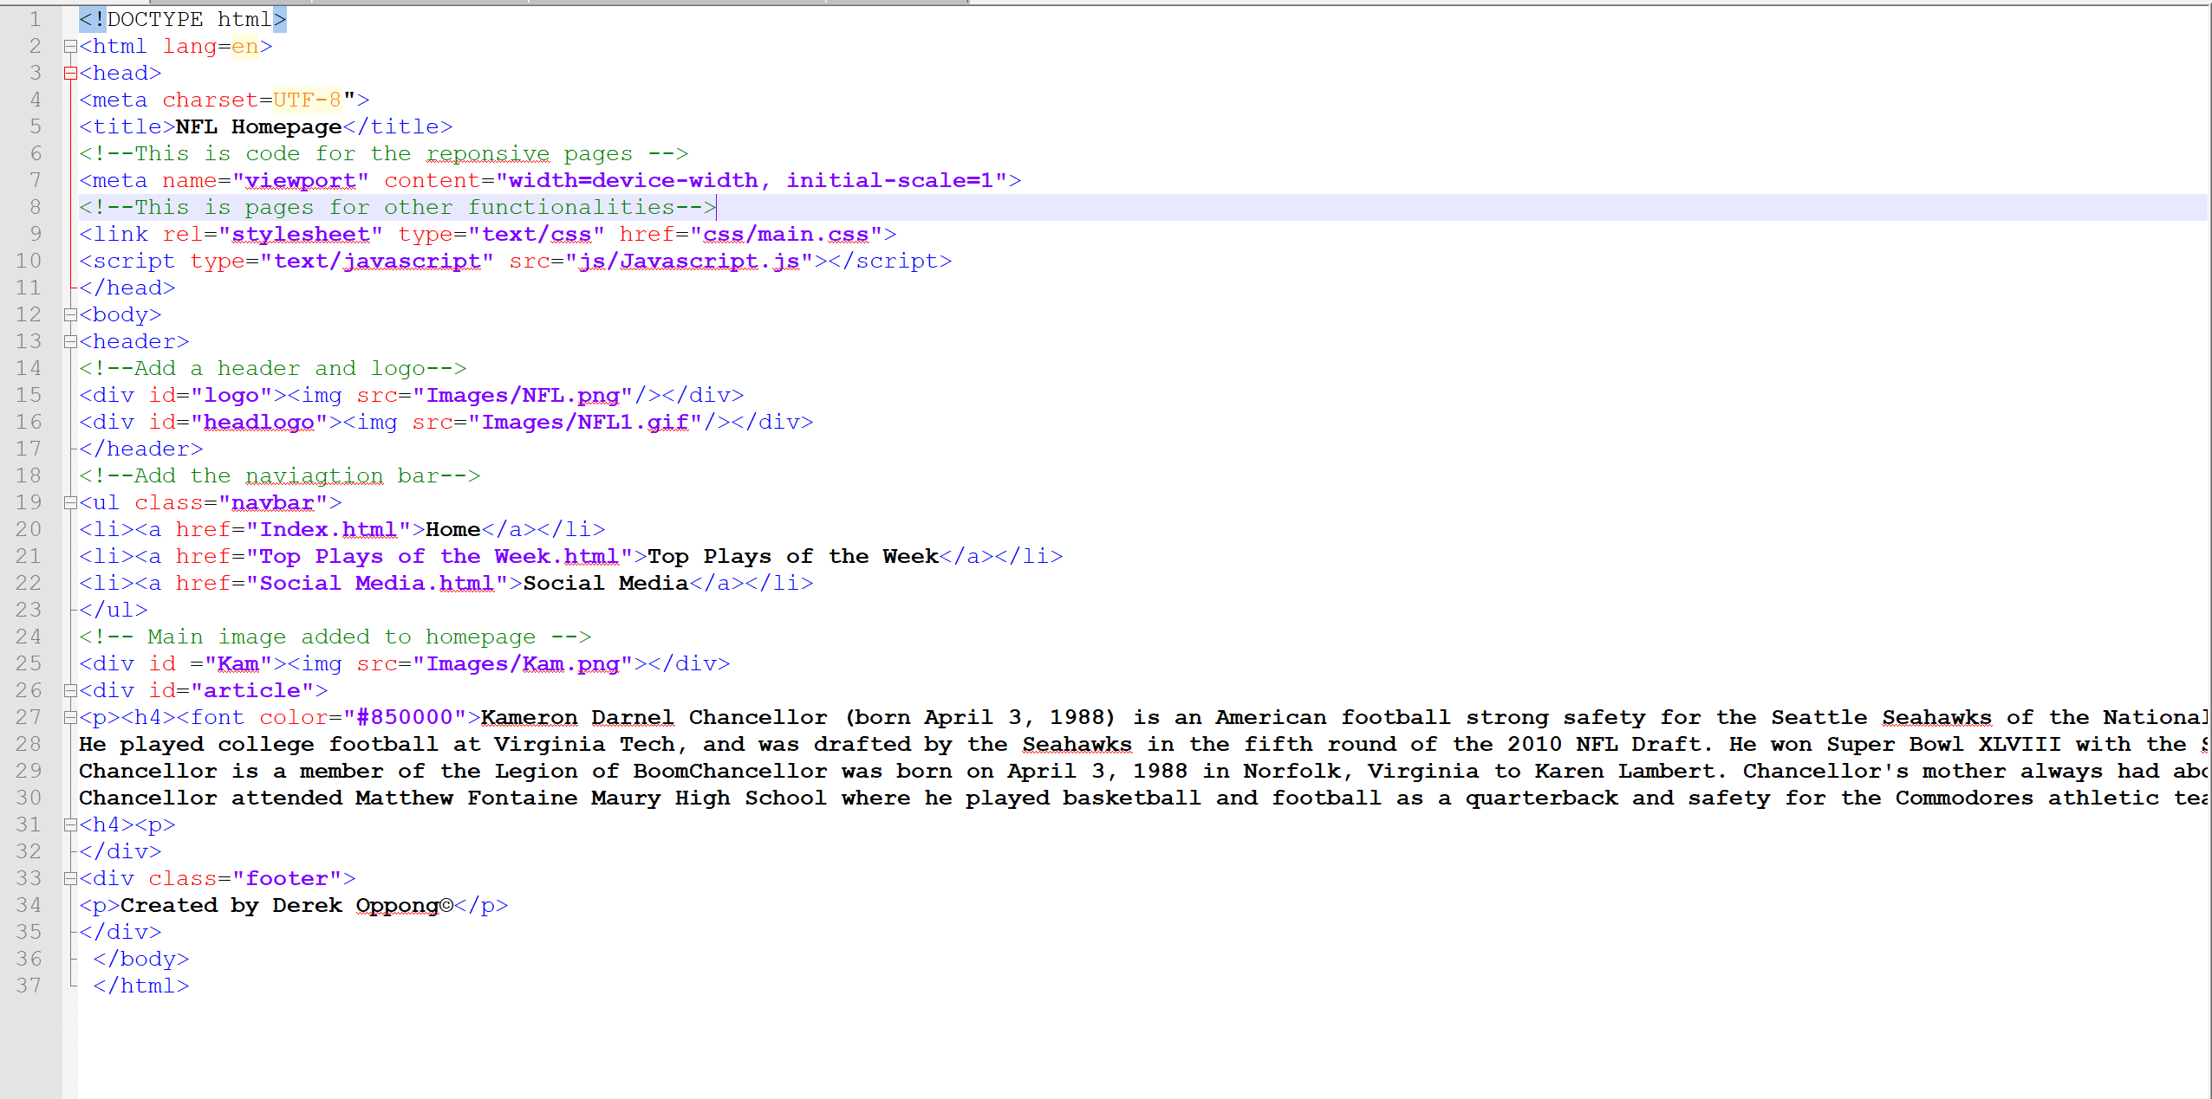Coding

Issues solved

Code comments