Practical 2, 3

Natya Vidhan Biswas
25771 B.Sc. (H) C.S.

2. Execute various LINUX Commands for:
- Information maintenance
  - Wc
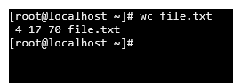
  - Clear
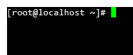
  - cal
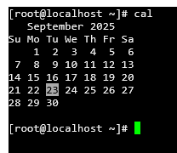
  - who
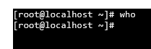
  - date
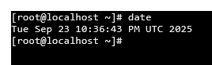
  - pwd
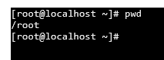

- File management
  - cat
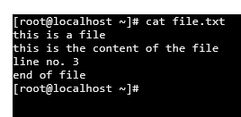
  - cp
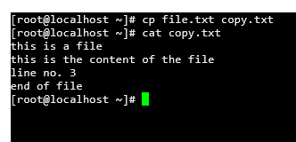
  - rm
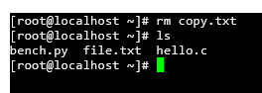
  - mv
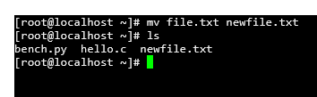
  - cmp
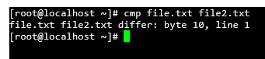
  - comm
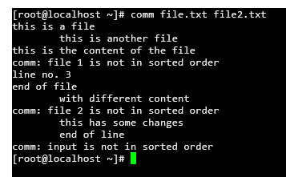
  - diff
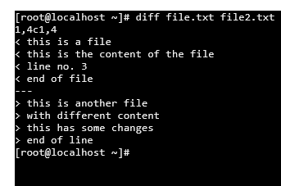
  - find
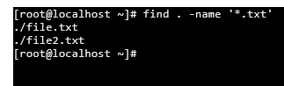
  - grep
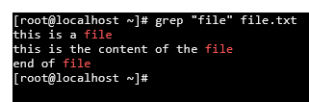
  - awk
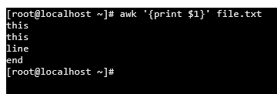

- Directory management
  - cd
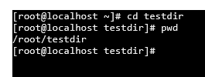
  - mkdir
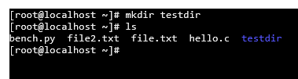
  - rmdir
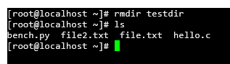
  - ls
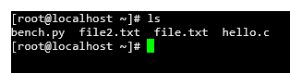

3. Execute various LINUX commands for:
- Process Control
  - fork
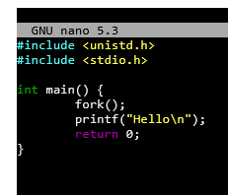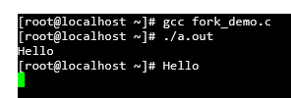
  - getpid
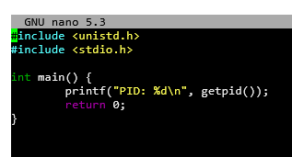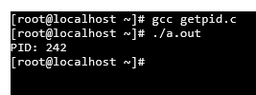
  - ps
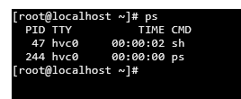
  - kill
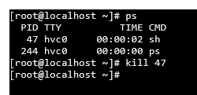
  - sleep
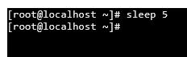

- Communication
  - Input-direction
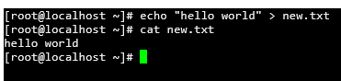
  - Pipe
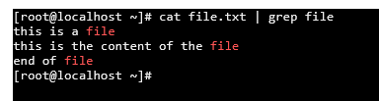

- Protection Management
  - chmod
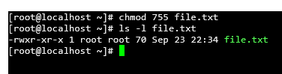
  - chown
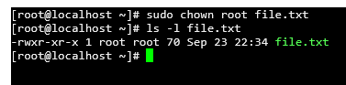
  - chgrp
