

University of Delhi
Keshav Mahavidyalaya
Department of Computer Science
Software Engineering
Project Report
Enigma
Social Challenges with Real Outcomes
Submitted by: | Supervisor:
Vansh Garg ([Roll No.]) | Prof. Anjali Thukral
Natya Vidhan Biswas ([Roll No.])
Sarthak Maurya ([Roll No.])
Sehej Arora ([Roll No.])

2026

CERTIFICATE

This is to certify that the work embodied in this project entitled “Enigma — Social Challenges with Real Outcomes” has been carried out in the Department of Computer Science, Keshav Mahavidyalaya, University of Delhi. The work presented in this project is original and has not been submitted in part or full to this or any other University for any diploma or degree.

_______________________ | _______________________
Candidate | Supervisor
Abstract
Modern social media rewards content, not outcomes. People spend hours posting and scrolling but rarely finish the goals they set. Goal-focused communities do exist, yet they struggle with three problems: members report their own progress with no proof, goals have no enforced deadline, and busy feeds distract from the real task. Enigma is a mobile-first social app where communities run real, time-boxed challenges, such as losing five kilograms, learning Python, reading ten books or building a startup in thirty days. Every progress proof is checked first by AI and then, if needed, by peers at Level 3 or above and finally by an admin. Posts are allowed only while a challenge is Live, while Stories and Notes stay available at all times. Experience points, levels and badges reward effort. Two pilot communities, Hackathon A and Anytime Fitness, guide the design. This report covers the problem statement, the process model, requirements, design, estimation, scheduling, risk management and testing for the project.
Table of Contents
Problem Statement 6
Background and Context 6
The Three Structural Failures 6
Why Existing Platforms Fall Short 6
The Enigma Solution 6
Objectives and Scope 7
Significance and Expected Impact 7
Process Model 8
Choice of Process Model 8
The Iterative Loop 8
Iterations and Scope 9
Activities per Phase 10
Roles and Responsibilities 10
Entry/Exit Criteria and Feedback 10
1. Software Requirement Specification 11
1.1 Overall Description 11
1.2 External Interface Requirements 11
1.3 Functional Requirements 14
1.4 Performance Requirement 17
1.5 Design Constraints 17
1.6 Data Flow Diagram 18
1.7 Data Dictionary 19
2. Estimations 20
2.1 Function Points 20
2.2 Efforts 21
3. Scheduling 22
3.1 Milestones 22
3.2 Work Breakdown and Sequencing 23
3.3 Resource Allocation 23
4. Risk Management 24
4.1 Risk Identification 24
4.2 Risk Register 24
4.3 Mitigation Plans 24
5. Design 26
5.1 System Design 26
5.2 Data Design 28
6. Coding 31
6.1 Technology Stack 31
6.2 Project Structure 31
6.3 Coding Approach 31
6.4 Sample Code 31
7. Testing 33
7.1 Test Strategy 33
7.2 Unit Testing 33
7.3 Integration Testing 33
7.4 System / End-to-End Testing 33
7.5 Performance Testing 34
7.6 Acceptance Criteria 34
8. References 35

Problem Statement

Background and Context
Modern social platforms reward attention, not achievement. Their feeds promote short videos and memes, so a user can spend hours each day without gaining a skill or improving health. Goal-focused groups do form on WhatsApp, Telegram, Reddit and Discord, which shows people want accountability. These groups, however, lack infrastructure: progress is free text, deadlines move, and proof is scattered.

The Three Structural Failures
This gap comes from three repeated problems.

The Self-Report Problem
Progress is usually self-reported. A member types "lost two kilograms this week" and the group must trust it with no evidence. False claims go unchallenged because challenging a friend is awkward. Enigma avoids this: AI reviews every submission first, and peers decide when unsure.

The No-Deadline Problem
Goals are announced as wishes, not commitments, so there is no moment when a goal is met or missed. A member who falls behind can always promise to catch up, so early effort never builds. Enigma gives every challenge a fixed, server-enforced deadline.

The Engagement-without-Distraction Problem
The features that keep a community active also pull it off course. Reddit-style threads are good for discussion but are not tied to a goal, so a fitness group fills with memes. Discord-style servers are lively but noisy, and the important message gets buried. Enigma allows mission posts only during a live challenge, while social features stay open.

Why Existing Platforms Fall Short
Platform | Strength | Gap
Reddit | Strong communities and discussion | No goals, deadlines or proof; threads drift
Discord | Real-time chat, roles and levels | Rewards activity, not achievement; noise buries the mission
Duolingo | Streaks and XP motivate daily practice | Single-user, single-subject; no community proof
Strava | Club challenges with device-verified activity | Fitness only; no general challenges or peer checks
Habitica | Gamified habits with levels and rewards | Solo tracking; no shared real-world deadlines
Social apps are weak on outcomes, while goal apps are narrow. Enigma combines both.

The Enigma Solution
Enigma is a mobile-first social app where communities run time-boxed challenges and progress must be proved, not claimed. Four rules define it.
• Liveness: posts only while a challenge is Live; Stories and Notes stay open.
• Dual verification: AI reviews each submission; low confidence goes to peers at Level 3 or above, and a split goes to an admin.
• Deadlines: challenges move through Draft → Announced → Live → Ending → Archived and close submissions on time.
• Progression: XP, levels and badges reward real activity.

Objectives and Scope
The objectives are measurable: run at least two challenge cycles, support both verification paths, enforce the liveness rule and deadlines, and move a pilot user up three levels through verified activity. Targets include completion of at least 45 per cent and day-seven retention of at least 25 per cent.
Enigma is not a general social network and does not allow anonymous posting. Cash staking, payments, e-commerce, dating and advertising are excluded; chat rooms, wearable integrations and a marketplace are left for later versions.

Significance and Expected Impact
The main benefit is restored accountability: when proof is required and goals have real deadlines, honest effort counts for more than confident talk. Verified work also builds reputation, showing a community or employer what a member has done. The project is also a useful engineering exercise in authentication, state machines, AI pipelines, feeds and moderation.

Process Model

Choice of Process Model
Enigma uses an iterative process model: the team builds a small part of the system, shows it, collects feedback, and repeats. Many design questions, such as how strict the posting rule should be and whether peer checks are fast enough, can only be answered by building and testing. Waterfall finishes all requirements before coding, so a wrong assumption is found late and is expensive to fix.

The Iterative Loop
The loop starts with Communication, which decides what to build and why. It then moves to Planning, Modeling and Construction, and returns to Communication after a demonstration. Each full pass is one iteration.
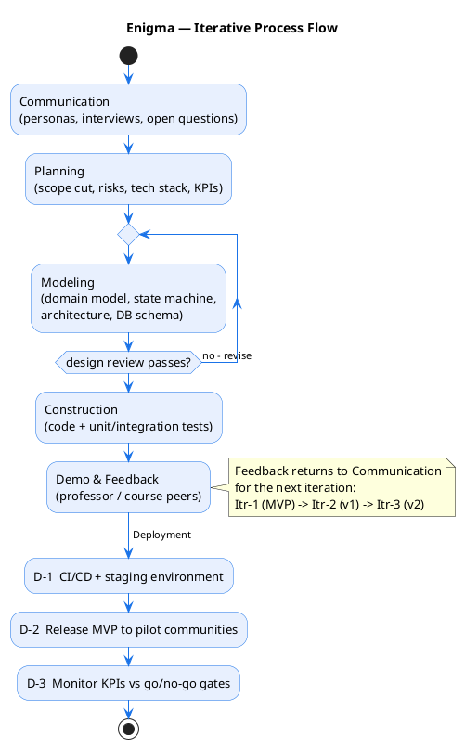
Figure 2.1 — Iterative process flow
Communication gathers needs from the two pilot communities and chooses a realistic scope. Planning turns that into a schedule and a risk list. Modeling draws the designs before coding. Construction writes and tests the software. The iteration ends with a demonstration, where the supervisor and course peers give feedback that shapes the next pass.

Iterations and Scope
Three iterations are planned, following priority levels P0 for the MVP, P1 for the first release and P2 for later work.
Iteration | Scope | Duration | Main deliverables | Exit gate
Itr-1 — P0 MVP | Core challenge lifecycle and verification | 6–8 weeks | Challenge engine, evidence upload, AI pre-screen, peer queue, liveness rule, Stories, Notes, XP and levels | End-to-end demo; completion ≥ 45%, D7 ≥ 25%
Itr-2 — P1 v1 | Depth and integrations | 3–4 months | Chat rooms, GitHub and wearable links, appeals, analytics | Retention and verification targets met
Itr-3 — P2 v2 | Scale and revenue | Next term | Marketplace, sponsored challenges, extra proof types | Two viable revenue streams
Each iteration builds on the last, so every exit gate decides whether the next begins.

Activities per Phase
Communication collects requirements and feedback. Planning sets scope, schedule and risks. Modeling produces the designs. Construction implements and tests the software. Deployment releases the MVP and tracks results.

Roles and Responsibilities
This is a single-developer course project, so there is no internal team: the student does all engineering work and keeps the risk list. The supervisor checks scope and design, as an internal team would. Course peers act as test users during demonstrations, and the two pilot communities become the first users.

Entry/Exit Criteria and Feedback
Each iteration starts only after the previous one passes its exit gate. The main gate is the demonstration: a working end-to-end path, from joining a live challenge to a verdict and an archived result. Numbers form the second gate: the MVP advances only if completion reaches 45 per cent and day-seven retention reaches 25 per cent. If a gate fails, the team replans. All feedback returns through Communication into the next Planning pass.

1. Software Requirement Specification
Enigma is a mobile-first app where communities run time-boxed challenges verified by AI and peers; this SRS lists its functional and external-interface requirements.

1.1 Overall Description
A community runs a calendar of challenges with targets. Members join, submit evidence, and get a verdict from AI, peers, or an admin.

1.1.1 Product Functions
• Accounts: signup, login, profiles, privacy.
• Communities: discovery, joins, settings.
• Challenges: server-enforced lifecycle.
• Participation: join, progress, gated posts, Stories/Notes.
• Verification: AI/peer/admin verdicts; XP and badges.
• Moderation: feeds, reporting, anti-cheat.

1.1.2 User Characteristics
Persona | Who | Action
Riya | CS student, Hackathon A | Python challenges
Arjun | Gym member, Anytime Fitness | Loses 5 kg
Sara | Admin and trainer | Creates challenges
Dev | Junior member | Votes, levels up

1.1.3 General Constraints
• Mobile-first. Android/iOS app; web for admins.
• Server time. UTC controls deadlines.
• No cash staking. Paid stakes deferred.

1.1.4 Assumptions and Dependencies
• AI under US$0.03 per check-in.
• OAuth and wearables keep data contracts.
• Pilots supply moderators and verifiers.

1.2 External Interface Requirements

1.2.1 User Interfaces
• Home: live challenges, countdowns, streaks, check-in.
• Community: threads, channels, stories, members, boards.
• Verify: peer-verification queue.
• Discover: communities, trends, proof walls.
• Profile: level, XP, badges, histories.

1.2.2 Hardware Interfaces
Enigma reads cameras, scales, wearables, and push.
Device | Interface
Camera | Evidence capture; GPS stripped
Scale | Weight read by AI OCR
Wearables | Steps, workouts, weight via APIs
Notifications | Push (APNs / FCM)

1.2.3 Software Interfaces
Enigma integrates identity, GitHub, AI, and data stores.
Interface | Protocol / Contract | Purpose
OAuth / email | OAuth 2.0 / OIDC | Auth and JWT sessions
GitHub | REST API | Repo checks
AI service | HTTP queue | Media checks
PostgreSQL | SQL | Relational data

1.2.4 Communication Interfaces
• REST, WebSocket, push carry feeds, chat, verdicts, and reminders.
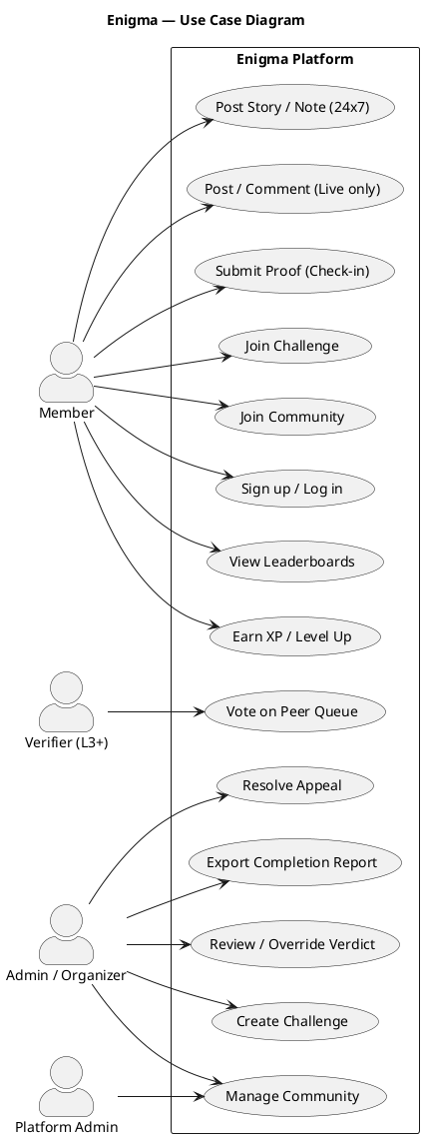
Figure 1.1 — Enigma use-case diagram

Use Case Overview
Enigma's use cases link members, verifiers, and admins to the challenge lifecycle. Actors act within their roles.
Use case | Actor | Description
Sign up / Log in | Member | Authenticate
Join Challenge | Member | Enrol and track
Submit Proof | Member | Send evidence
Post / Comment | Member | Post while Live
Vote on Peer Queue | Verifier (L3+) | Review submissions
Create Challenge | Admin | Set targets and proof

1.3 Functional Requirements
P0 is MVP, P1 next, P2 later.

1.3.1 FR 1 — User Accounts & Authentication
ID | Requirement | Priority
FR-1.1 | OAuth/email login, JWT sessions | P0
FR-1.2 | Profile: handle, avatar, level, XP | P0
FR-1.3 | Privacy for sensitive data | P0
FR-1.4 | GDPR/DPDP export and deletion | P1
FR-1.5 | Offline drafts sync with timestamps | P1

1.3.2 FR 2 — Communities
ID | Requirement | Priority
FR-2.1 | Browse public; private need invite | P0
FR-2.2 | Profile: name, tags, level | P0
FR-2.3 | Admins set join and verification policy | P0
FR-2.4 | Channels like #build-logs, #general | P1
FR-2.5 | Pin threads; level perks | P1/P2

1.3.3 FR 3 — Challenge Engine
ID | Requirement | Priority
FR-3.1 | Create: target, dates, milestones, proof | P0
FR-3.2 | Lifecycle Draft → Announced → Live → Ending → Archived | P0
FR-3.3 | One-tap join, progress bar | P0
FR-3.4 | Numeric, binary, checklist targets | P0
FR-3.5 | Milestones: due dates, miss flags | P0
FR-3.6 | Close at cutoff; late needs approval | P0
FR-3.7 | Countdown, members, top members | P0
FR-3.8 | Admin grace period for late entries | P1
FR-3.9 | Reusable recurring templates | P1
FR-3.10 | Export completion reports as CSV | P1
FR-3.11 | Invite-only challenges | P1

1.3.4 FR 4 — Content Rules (Liveness Rule)
ID | Requirement | Priority
FR-4.1 | Posts only while Live; comments open | P0
FR-4.2 | Post belongs to challenge or board | P0
FR-4.3 | Stories: photo/video, 24 h expiry | P0
FR-4.4 | Notes: text up to 500 chars | P0
FR-4.5 | Posts: text, media, links, proof | P0
FR-4.6 | Post voting only while Live | P1
FR-4.7 | Archived challenges are proof walls | P1
FR-4.8 | Link Story/Note to milestone for streak | P1

1.3.5 FR 5 — Verification Pipeline
ID | Requirement | Priority
FR-5.1 | Valid proof type required | P0
FR-5.2 | AI checks photo, video, link, quiz, wearable | P0
FR-5.3 | AI: verdict, confidence, explanation | P0
FR-5.4 | ≥0.90 auto-verify; 0.50–0.89 peers; <0.50 admin | P0
FR-5.5 | L3+ vote; three agree decide, split to admin | P0
FR-5.6 | Verifiers earn XP, Trusted Verifier badge | P0
FR-5.7 | Admins override any verdict; logged | P0
FR-5.8 | Rejections appealable to admin | P1
FR-5.9 | Anti-cheat: duplicates, metadata, devices, limits | P0
FR-5.10 | Weight proof vs wearable trends | P1
FR-5.11 | AI 30 s, peers 24 h, admin 72 h | P0

1.3.6 FR 6 — Progression (XP / Levels / Badges)
ID | Requirement | Priority
FR-6.1 | XP for joins, check-ins, milestones, completion, votes | P0
FR-6.2 | Global level from XP: XP ≈ 100 × L^1.5 | P0
FR-6.3 | Level-gated privileges via roles | P0
FR-6.4 | Streaks with a flame; missed day resets | P0
FR-6.5 | One-time badges (First Blood, Verification Guru) | P1
FR-6.6 | Weekly, all-time, per-challenge, global leaderboards | P0
FR-6.7 | Daily XP caps; vote XP only when correct | P1
FR-6.8 | Level-up celebration and shareable card | P1

1.3.7 FR 7 — Feed & Discovery
ID | Requirement | Priority
FR-7.1 | Live challenge threads from joined communities | P0
FR-7.2 | Sort hot, new, top-verified, burned | P0
FR-7.3 | Mark verified posts and boost ranking | P0
FR-7.4 | Discovery: categories, trends, proof walls | P1
FR-7.5 | Typo-tolerant search across all content | P1
FR-7.6 | Suggest communities from activity | P2

1.3.8 FR 8 — Notifications
ID | Requirement | Priority
FR-8.1 | Deadline reminders at 24 h, 6 h, 1 h | P0
FR-8.2 | Notify on AI verdicts, peer requests, reviews | P0
FR-8.3 | Social replies, reactions, mentions | P1
FR-8.4 | Streak reminders with quiet hours | P1
FR-8.5 | Admin broadcasts to members or roles | P1

1.3.9 FR 9 — Roles & Permissions
ID | Requirement | Priority
FR-9.1 | Roles: Member, Verifier, Organizer, Moderator, Admin, Platform Admin | P0
FR-9.2 | RBAC on every endpoint; log unauthorized calls | P0
FR-9.3 | Moderators: approvals, warnings, overrides, queues | P0
FR-9.4 | Admins: community config, roles, reports | P0

1.3.10 FR 10 — Moderation & Anti-Cheat
ID | Requirement | Priority
FR-10.1 | AI moderation: profanity, harassment, self-harm; disclaimers | P0
FR-10.2 | Flagged content to moderator report queue | P0
FR-10.3 | Graduated strikes leading to suspension or ban | P0
FR-10.4 | Strip EXIF/GPS; detect duplicate images | P0
FR-10.5 | Fingerprint devices; check timestamp chronology | P0
FR-10.6 | Detect AI-generated media; rotate quiz questions | P0
FR-10.7 | Prevent self-verification; revoke bad verifiers | P0
FR-10.8 | Plain explanations; log the model version | P0
FR-10.9 | Underage and medical safety controls | P0

1.4 Performance Requirement

Response Time
Metric | Target
App launch | under 2.5 s
Feed load | under 1 s
AI verdict | at most 30 s
Peer verdict | at most 24 h
Admin review | at most 72 h

Throughput
Metric | Target
Concurrent users (MVP) | 1,000
Peer votes per user per day | at most 20
Check-in limit | one per 6 hours
AI cost | under $0.03 per check-in

Capacity and Reliability
The API is stateless and scales; AI runs on queue-backed workers. A 99.9% uptime objective applies during challenge periods.

1.5 Design Constraints
Area | Constraint
Technology | Next.js/T3, tRPC, Prisma, PostgreSQL, Redis, S3, AI
Platform | Mobile-first iOS/Android, plus web admin
Time integrity | Server-enforced UTC; atomic cutoffs
Security and privacy | OAuth/JWT, RBAC, upload scanning, GDPR/DPDP
Regulatory and cost | No cash staking; health disclaimers; AI under $0.03 per check-in

1.6 Data Flow Diagram
A data flow diagram (DFD) shows how data moves between processes, external entities, and data stores. It exposes a system's inputs, processes, and outputs.
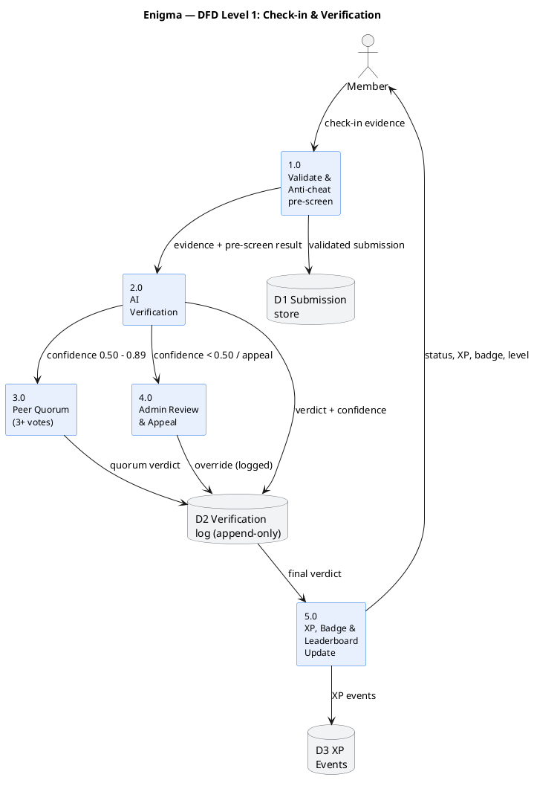
Figure 1.2 — DFD Level 1: check-in and verification

Challenge Lifecycle Flow
A challenge moves only through Draft, Announced, Live, Ending, and Archived, and posts are allowed only while it is Live.

1.7 Data Dictionary
Data | Meaning
status | Challenge lifecycle state.
verdict | accept, needs_review, reject.
confidence | AI score from 0 to 1.
User | Platform account with level and XP.
Community | Group owning challenges and channels.
Challenge | Time-boxed, verifiable goal.
Milestone | Checkpoint inside a challenge.
Post | Challenge-thread contribution.
Note | Short channel message, up to 500 chars.
Story | Ephemeral media; 24-hour life.
Submission | Proof for a milestone.
Verification | Append-only decision.
PeerVote | Verifier's peer-queue decision.
XP_Event | Immutable experience-point award.

2. Estimations
This chapter estimates the size of Enigma and turns it into effort. Function Point Analysis measures functional size, and the Constructive Cost Model (COCOMO) converts size into effort. The results are a planning baseline, reviewed after each iteration.

2.1 Function Points
Function Point Analysis counts the information a system stores and moves, rather than lines of code. Each function is placed in one of five classes and given a complexity weight:
• ILF (Internal Logical File) — data the system keeps and maintains.
• EIF (External Interface File) — data the system reads but does not maintain.
• EI (External Input) — an action that brings data in and updates internal data.
• EO (External Output) — a process that produces derived output for users.
• EQ (External Inquiry) — a read-only lookup that displays data.
Applying these classes to the requirements, with average complexity, gives the counts below.
Class | Description | Count | Weight | FP
ILF | User, Community, Membership, Challenge, Submission, Verification, XP/Badge | 7 | 10 | 70
EIF | Read-only wearable and health data from vendor APIs | 1 | 7 | 7
EI | Join/leave, check-in, create community or challenge, post/comment, vote, upload evidence, report | 8 | 6 | 48
EO | Feed, leaderboard, search, discovery, reports, proof wall | 6 | 5 | 30
EQ | Challenge queries, verification queue, notification lookup, profile/history, leaderboard | 5 | 4 | 20
The subtotals give the Unadjusted Function Points (UFP):
• UFP = 70 + 7 + 48 + 30 + 20 = 175 FP.
The UFP ignores non-functional factors such as performance and ease of use. The standard model captures these through fourteen General System Characteristics (GSC), each rated from 0 to 5. For Enigma the ratings total a Degree of Influence (DI) of 25, reflecting a mobile-first, networked product with strong performance and online-entry needs. The Value Adjustment Factor is then:
• TDI = 0.65 + 0.01 × 25 = 0.90.
• AFP = 175 × 0.90 = 157.5 ≈ 158 FP.
The full product is therefore about 158 function points; small changes in the GSC ratings move it by a few points.

2.2 Efforts
The COCOMO organic model suits Enigma, a small, self-contained product in a familiar domain. For a TypeScript and Next.js codebase that reuses framework code, about 45 lines of code are counted per function point:
• KLOC = 158 FP × 45 LOC/FP = 7,110 LOC ≈ 7.1 KLOC.
The organic COCOMO effort equation gives:
• Effort = 2.4 × KLOC^1.05 = 2.4 × 7.1^1.05 ≈ 18 person-months.
This is the effort for a full product built by a normal team, far more than one student can build in a semester. The project therefore cuts scope to the P0 MVP, which keeps roughly 55 to 60 per cent of the full size. Framework reuse, managed services and reduced non-functional depth mean the real effort is far below a second COCOMO run. In practice the P0 MVP is planned at about 6 to 8 person-weeks for a single student.
Iteration | Duration | Deliverable
Itr-1 — P0 MVP | 6–8 person-weeks | Challenge engine, AI pre-screen, peer verification, gated feed, XP/badges, moderation
Itr-2 — v1 | 2–3 person-weeks | Chat, integrations, analytics, leaderboards
Itr-3 — v2 | 2–3 person-weeks | Marketplace, sponsored challenges, native apps
The dominant recurring cost is AI inference, kept below $0.03 per check-in. Hosting at pilot scale is modest, so direct cash cost for the semester is small; the main cost is developer time. Estimates are checked again once coding starts.

3. Scheduling
This chapter turns the iterative process into a dated plan. The project repeats four process blocks — Communication, Planning, Modeling and Construction — once per iteration. The developer works part-time, so durations are in working weeks with weekends closed.
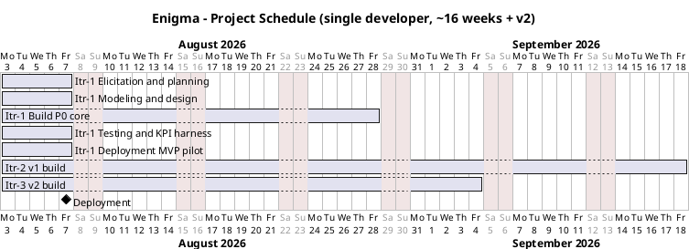
Figure 3.1 — Project schedule (Gantt)
Figure 3.1 shows the Gantt chart starting 3 August 2026. Itr-1 holds one week of elicitation and planning, one week of modeling, four weeks building the P0 core, one week of testing, and one week to deploy to two pilot communities. Itr-2 runs in weeks 9 to 16, and Itr-3 is planned for the next term. The bars are sequential, so a delay in the P0 build pushes everything after it.

3.1 Milestones
Each milestone has a deliverable and a gate.
# | Milestone | Deliverable | Weeks | Gate
1 | Elicitation and planning | Personas, risk register, KPI plan | 1 | Open questions resolved
2 | Modeling | Domain model, state machine, architecture, schema | 2 | Design review
3 | Itr-1 build (P0 core) | Challenge engine, AI pre-screen, peer votes, gated feed, XP | 3–6 | End-to-end demo
4 | Itr-1 testing | Unit, integration and end-to-end tests, KPI harness | 7 | Completion ≥ 45%, D7 ≥ 25%, dispute < 2%
5 | Deployment (MVP) | CI/CD, pilot release, load test | 8 | 1,000 concurrent users, AI cost < $0.03
Milestones 4 and 5 use the go/no-go targets. If a gate fails, scope is cut rather than dates extended.

3.2 Work Breakdown and Sequencing
Work follows the dependency order below.
1. Communication and Planning: personas, interviews, user stories, iteration plan, risk register, technology choice and KPI plan.
2. Modeling: domain model, state machine, verification pipeline, architecture, schema and XP economy.
3. Construction: authentication and roles, then community create/read/update/delete and join/leave.
4. Construction: the challenge engine, then check-in, AI pre-screen, peer queue and anti-abuse flow.
5. Construction: the posting gate, feed and badges, Stories and Notes, then XP, notifications and profiles.
6. Construction: the moderation panel, tests and the KPI harness.
7. Demo, re-plan and deploy through CI/CD to the two pilot communities.
8. Itr-2 and Itr-3 features, which extend the MVP and are not on the critical path.
The critical path runs through the Itr-1 build, testing and deployment. The check-in and verification paths must exist before tests are meaningful, and deployment gates cannot be checked until those tests pass.

3.3 Resource Allocation
The project is a single-developer effort supported by a supervisor and pilot stakeholders.
Resource | Role | Allocation
Developer | Architect, developer, designer, tester, DevOps | 15–20 hours per week; 6–8 weeks for Itr-1, then 2–3 weeks per iteration
Supervisor | Reviewer, gatekeeper, mentor | Weekly review and demo evaluation
Course peers | Reviewers and demo users | Periodic demos and feedback
Pilot captains | Stakeholders and product owners | Biweekly elicitation during Itr-1
AI provider | Verification compute | Metered, below $0.03 per check-in
The developer sits on every critical-path task, which is why scope is kept small.

4. Risk Management
This chapter describes how Enigma identifies, scores and controls risk. Because the project is iterative, the risk register is reviewed at each iteration demo and updated when pilot feedback changes a risk.

4.1 Risk Identification
Risks were drawn from the requirements, the process document and talks with the two pilot communities. Most come from the parts of Enigma that are genuinely new. Outcomes are certified by AI and peers instead of self-report, which creates both false-positive and false-negative risk. The main feed opens only while a challenge is Live, which risks quiet periods between challenges. Ordinary members also carry part of the verification and moderation load, so community health matters, and verifier inactivity is watched because an empty peer queue delays every check-in. Common execution risks apply too: the developer is the only full-time resource, health and legal claims need care, and evidence can contain private health data.

4.2 Risk Register
Probability is rated 1 (rare) to 5 (almost certain). Impact is rated 1 (negligible) to 5 (severe). Priority is the product of the two: 20–25 Critical, 12–19 High, 6–11 Medium, 1–5 Low.
ID | Risk | Probability | Impact | Priority
R-01 | Cheating and framed evidence corrupt the leaderboard | 4 | 5 | Critical
R-02 | AI wrongly rejects a valid proof | 4 | 5 | Critical
R-03 | Low activity between challenges | 4 | 4 | High
R-04 | Privacy breach of health and evidence data | 3 | 5 | High
R-05 | Community toxicity drives members away | 3 | 4 | High
R-06 | Scope creep delays the MVP | 4 | 3 | High
The two Critical risks attack the trust the product exists to create. The High risks are likely or damaging enough to need active management.

4.3 Mitigation Plans
• R-01 Cheating: strip metadata, detect duplicate and near-duplicate images, limit one check-in per challenge per six hours, and apply a three-strike rule.
• R-02 AI false rejection: prefer recall over precision, send medium-confidence cases to peer review, and give every rejection an appeal path.
• R-03 Low activity: keep Stories and Notes open all day, and use short recurring challenge templates to avoid quiet periods.
• R-04 Privacy: default evidence to community-only, mark health fields as sensitive, encrypt data, and keep audit logs append-only.
• R-05 Toxicity: use AI moderation, reporting, muting and a moderation panel, with warnings leading to bans.
• R-06 Scope creep: enforce the P0 cut, defer P1 and P2 features, and cut scope before extending a deadline.
A failed KPI gate triggers re-planning and a scope review, so the plan stays realistic.

5. Design
This chapter describes the structure of Enigma. Section 5.1 explains the system architecture, and Section 5.2 describes the data model. The guiding rule is that the server decides everything; clients only render state.

5.1 System Design
Enigma is a mobile-first application with a typed API. A React client sits at the front and also works as a progressive web app. The API layer is the only entry point for requests: it handles login, checks permissions, and routes each command to the correct service.
Behind the API lie small services that each own one part of the system, such as users, communities, challenges, or verification. They share one PostgreSQL database, so the whole system keeps a consistent view. Redis provides queues for background work and caches frequently read data, while AWS S3 stores media that users upload through short-lived signed links.

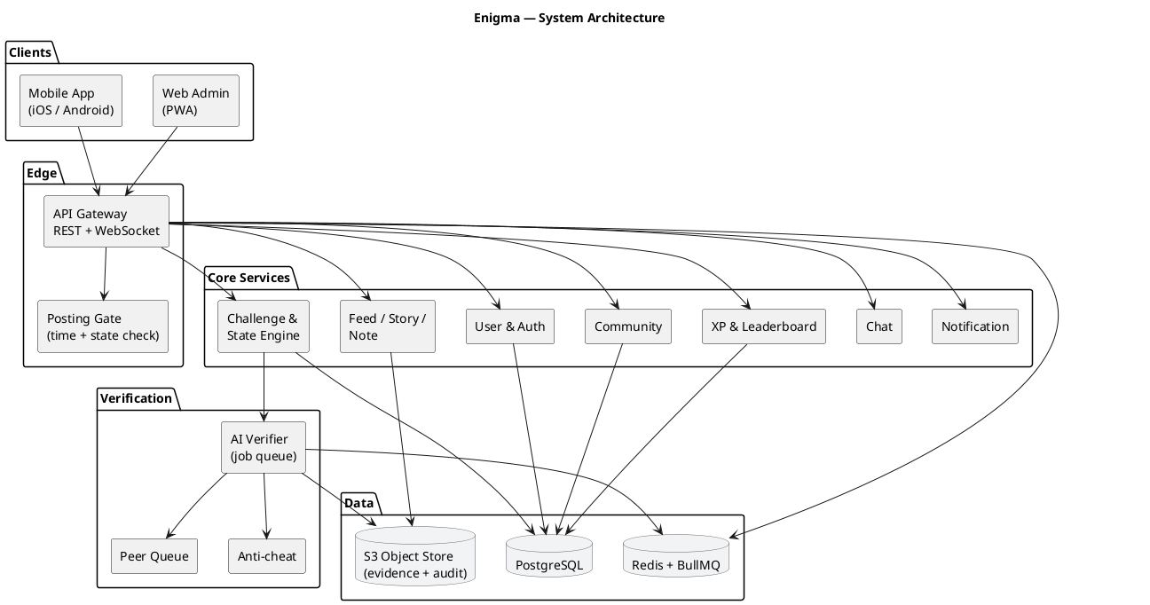
Figure 5.1 — System architecture

Figure 5.1 shows the client, the API layer, the core services, the data stores, and the external AI provider. The main modules are listed below.
Module | Responsibility
API Gateway | Login, sessions, rate limits, request routing
Challenge & State Engine | Owns the challenge lifecycle and its transitions
Posting Gate | Allows posts only while a challenge is Live
User & Community | Profiles, levels, communities, memberships, roles
Verification Service | Runs AI checks, peer votes, and admin review
Feed & Notification | Feed, comments, stories, notes, alerts
A challenge moves through fixed states in one direction: Draft → Announced → Live → Ending → Archived. The state engine is the only component that may change a state, and it rejects any illegal move, such as going from Archived back to Live.
Every submission is checked before it counts. Anti-cheat first rejects obvious fraud, then an AI model returns a verdict with a confidence score: high confidence is auto-verified, medium confidence goes to peers at Level 3 or higher, and low confidence or fraud goes to an administrator.
A long-form Post is allowed only while the challenge is Live, and the posting gate reads server state so a changed device clock cannot bypass a deadline. Stories and notes remain available at all times, so the community stays active between challenge windows.

5.2 Data Design
PostgreSQL is the main database and holds all important records, including users, communities, challenges, submissions, and verification results. Keeping them in one database protects the relationships between records, so the data stays consistent.
Redis holds short-lived data such as queues and rate limits, and S3 stores media files. The core tables are kept small and focused. Each challenge belongs to a community, each submission belongs to an author and a challenge, and each verification belongs to one submission.

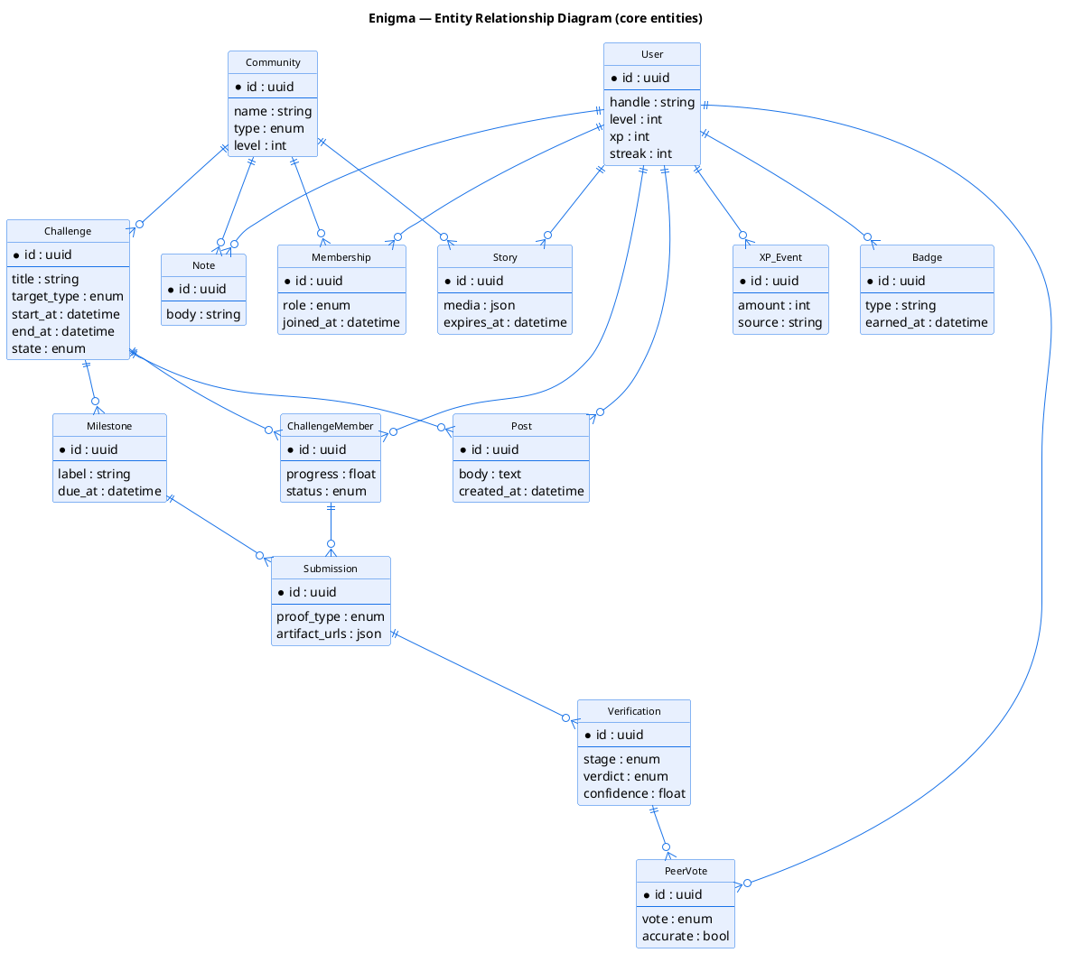
Figure 5.2 — Entity relationship diagram

Table | Purpose
users | Profile, level, XP, streak
communities | Community details and settings
challenges | Rules, dates, and current state
submissions | Proof uploaded by a member
verifications | AI, peer, or admin result for a submission
posts | Content created while a challenge is Live
All dates are stored as UTC timestamps and compared with the server clock, never the client clock, so the boundary of a challenge is decided once.

6. Coding
This chapter explains how the design is implemented. Section 6.1 lists the technology stack, Section 6.2 shows the project structure, Section 6.3 describes the coding approach, and Section 6.4 gives two short code samples.

6.1 Technology Stack
Layer | Technology
Language | TypeScript (strict mode)
Web framework | Next.js with the T3 stack (React, tRPC, Prisma)
Database | PostgreSQL with the Prisma ORM
Cache and queues | Redis with BullMQ
Object storage | AWS S3
Authentication | OAuth 2.0 with JWTs
The same TypeScript types flow from the database to the client, which catches many errors at compile time.

6.2 Project Structure
The project is a monorepo with one application and a few shared packages.
enigma/
├── apps/web/ Next.js app and admin dashboard
├── packages/core/ state machine, posting gate
├── packages/verification/ AI and peer logic
├── packages/db/ Prisma schema
├── packages/ui/ shared components
└── package.json
The core package holds the domain rules, while the db package holds the Prisma schema and client.

6.3 Coding Approach
• Domain rules are pure functions that do not touch the database.
• All time comes from the server, so clients cannot affect deadlines.
• State changes and verdicts are appended, never edited.
• Every retryable write is idempotent, and tests are written with each rule.

6.4 Sample Code
The examples below show two central rules in simplified TypeScript.

Valid State Transitions
A challenge may only move to the next allowed state.
const VALID_TRANSITIONS = {
DRAFT: ['ANNOUNCED'],
ANNOUNCED: ['LIVE'],
LIVE: ['ENDING'],
ENDING: ['ARCHIVED'],
ARCHIVED: [],
} as const;

The Posting Gate
Posts and votes are allowed only while the challenge is Live.
function canPost(surface: Surface, challenge: { state: State }) {
if ((surface === 'POST' || surface === 'VOTE') && challenge.state !== 'LIVE') {
return { allowed: false, reason: 'CHALLENGE_NOT_LIVE' };
}
return { allowed: true };
}

7. Testing

7.1 Test Strategy
Enigma is tested at four levels. Unit tests check small pieces of logic, integration tests check that separate services work together, system tests replay complete user journeys, and performance tests measure speed, cost and accuracy under load. Every test is linked to a requirement, so a feature is treated as delivered only when a test exercises it.

7.2 Unit Testing
Unit tests cover the core logic that decides routing, deadlines and rewards. These rules are precise, so they are tested at boundary values as well as on the normal path.
TC | Tests what | Expected result
TC-01 | Valid state order only | Invalid move rejected
TC-02 | Submission exactly at deadline | Accepted until cutoff; rejected after
TC-03 | Post when no challenge Live | Rejected; feed locked
TC-04 | Story after 24 hours | Auto-deleted
TC-05 | AI confidence high, medium, low | Auto-approve, peer quorum or admin
TC-06 | Duplicate image (pHash) | Rejected; fraud flag
TC-05 shows the 0.90 and 0.50 thresholds divide verdicts into auto-verification, peer quorum and admin review without gaps. TC-01 proves the state machine cannot run backwards.

7.3 Integration Testing
Integration tests check the seams between components, where most defects appear. Each case runs against disposable PostgreSQL and Redis instances filled with test data.
TC | Tests what | Expected result
TC-10 | Repository link via GitHub REST API | Valid repo verified; empty sent to review
TC-11 | Quiz with anti-plagiarism and timing | Unique passing attempt verified
TC-12 | Scale photo vs wearable trend | Consistent credited; inconsistent reviewed
TC-13 | OAuth signup, JWT and roles | Session valid; roles enforced
TC-12 shows a weight-loss claim cannot pass on a photo alone, because the direction of change must match the wearable data. TC-13 confirms authentication and permissions hold across service boundaries.

7.4 System / End-to-End Testing
System tests run the whole application along the five user scenarios. Each scenario follows one persona across several screens and checks the resulting state changes.
TC | Scenario | Expected result
TC-20 | Scenario 1 — first-time user finishes "Learn Python" | Full lifecycle; Level 4 and First Blood
TC-21 | Scenario 2 — weight-loss win with wearable proof | Submissions verified; proof wall updated
TC-22 | Scenario 3 — active member verifies peers | XP awarded; Level 5 unlocks creation
TC-23 | Scenario 4 — admin runs a challenge with a dispute | Override audited; cheaters rejected
TC-24 | Scenario 5 — dropped member stages a comeback | Comeback Kid badge; progress resumes
Together these cases cover all five app tabs, both verification branches, and the archive and proof-wall lifecycle.

7.5 Performance Testing
Performance tests measure the targets that decide whether the system is ready for the pilot. Load and soak tests run against a staging system with pilot-scale data.
TC | Tests what | Expected result
TC-30 | Feed load, 1000 concurrent users | p95 under 1 s; live feed under 150 ms
TC-31 | AI verdict latency | At most 30 s; at most 10 s async
TC-32 | Load and soak through a Live challenge | 99.9% availability; no degradation
TC-33 | Inference cost and AI accuracy | Below $0.03; precision ≥ 95%, recall ≥ 90%
The KPI gates are completion of at least 45 per cent, day-seven retention of at least 25 per cent, and a dispute rate below 2 per cent.

7.6 Acceptance Criteria
The MVP is accepted for the two pilot communities only when all of the following hold.
• All unit and integration cases pass with no open critical or high defects.
• All five end-to-end scenarios pass, including their state changes.
• Performance targets are met, including 1000 concurrent users, 99.9 per cent availability, and AI precision of at least 95 per cent with recall of at least 90 per cent.
• Pilot KPIs meet their gates: completion at least 45 per cent, day-seven retention at least 25 per cent, and a dispute rate below 2 per cent.
If any criterion fails, deployment is blocked until the issue is fixed.

8. References
1. V. Garg, N. V. Biswas, S. Maurya, and S. Arora, "Enigma — Product Requirements Document," Software Engineering Project Report, Semester 5, Keshav Mahavidyalaya, University of Delhi, 2026.
2. V. Garg, N. V. Biswas, S. Maurya, and S. Arora, "Enigma — Software Requirement Specification," Software Engineering Project Report, Semester 5, Keshav Mahavidyalaya, University of Delhi, 2026.
3. V. Garg, N. V. Biswas, S. Maurya, and S. Arora, "Enigma — Iterative Process Flow Breakdown," Software Engineering Project Report, Semester 5, Keshav Mahavidyalaya, University of Delhi, 2026.
4. Habitica — Gamified Habit and Task Tracking, Habitica, Inc. [Online]. Available: https://habitica.com/. [Accessed: October 2026].
5. Strava — Clubs, Challenges and Device-Verified Activity, Strava, Inc. [Online]. Available: https://www.strava.com/. [Accessed: October 2026].
6. Duolingo — Streaks, XP and Leagues, Duolingo, Inc. [Online]. Available: https://www.duolingo.com/. [Accessed: October 2026].
7. Reddit — Communities, Threaded Posts and Voting, Reddit, Inc. [Online]. Available: https://www.reddit.com/. [Accessed: October 2026].
8. Discord — Servers, Channels, Roles and Community Chat, Discord, Inc. [Online]. Available: https://discord.com/. [Accessed: October 2026].
9. BeReal — Daily Ephemeral Authenticity, BeReal. [Online]. Available: https://bere.al/. [Accessed: October 2026].
10. GitHub, "GitHub REST API Documentation," GitHub, Inc. [Online]. Available: https://docs.github.com/rest. [Accessed: October 2026].
11. International Organization for Standardization, ISO/IEC 25010:2011, Systems and Software Quality Requirements and Evaluation (SQuaRE) — System and Software Quality Models. Geneva: ISO, 2011.
12. Institute of Electrical and Electronics Engineers, IEEE Std 830-1998, IEEE Recommended Practice for Software Requirements Specifications. New York: IEEE Computer Society, 1998.
13. OWASP Foundation, "OWASP Top 10:2021 — The Ten Most Critical Web Application Security Risks," OWASP Foundation. [Online]. Available: https://owasp.org/www-project-top-ten/. [Accessed: October 2026].
14. European Union, "Regulation (EU) 2016/679 — General Data Protection Regulation (GDPR)," Official Journal of the European Union. [Online]. Available: https://gdpr-info.eu/. [Accessed: October 2026].
15. R. S. Pressman and B. R. Maxim, Software Engineering: A Practitioner's Approach, 9th ed. New York: McGraw-Hill Education, 2019.
16. I. Sommerville, Software Engineering, 10th ed. Harlow: Pearson Education Limited, 2016.

