DNA

4 nucleotides
- transcription rna to dna – making a copy (recording music)
- translation – ribosomes read the code and transfer the rna – protein is made

mutation – 1 out of 100 million replications
enzymes – fix error in code

greatest medical challenges of our times – antibiotic resistant evolution

penicillin – weakens cell wall

chernoble – 1986 explosion 15000 people died
reactor #4 – radioactivity causes mutations

soil different bc different microbial community

plasmid – genetic info transferred from one

regulation – turn off and on when need
- repression --- prevents transcription

helicase – splits

DNA – Sugar, Phosphate, Base

RNA – sugar is ribose, base uricell

mRNA – messenger

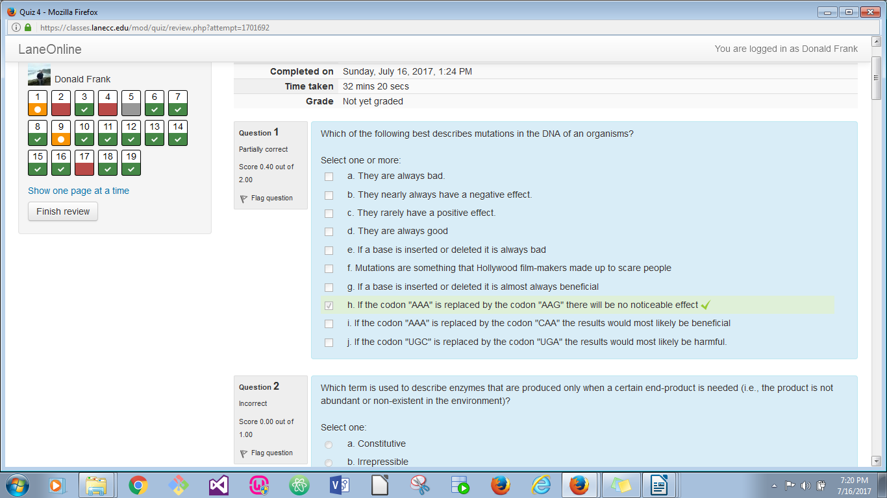
rRNA – ribosomal

