Donald Frank
Interpersonal Communication (COMM 218)
D.A. Hermach
Assignment: Interpersonal Journal #2
Date Due: 7/6/2017
Date Submitted: 7/6/2017

Interpersonal Journal Entry #2

Context: July 2, Sunday, 12:30 p.m. - 4 p.m., virtual connection Home/Amazon Pool

Situation: I am home taking care of my father while communicating with my mother via text message about my oldest daughter’s swim races.

Description of Interaction:
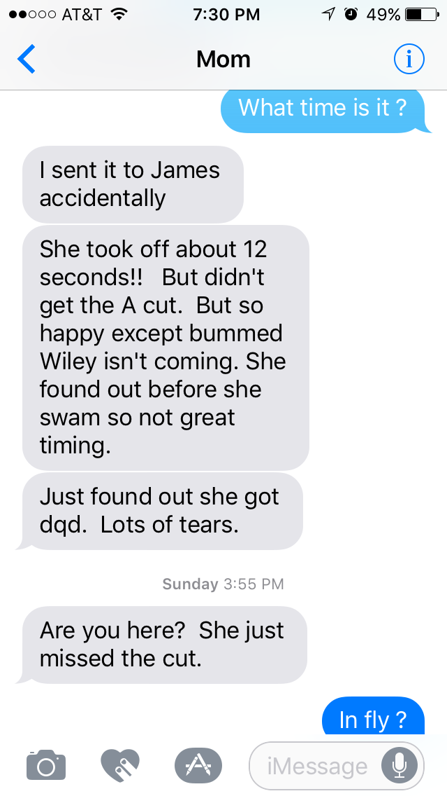
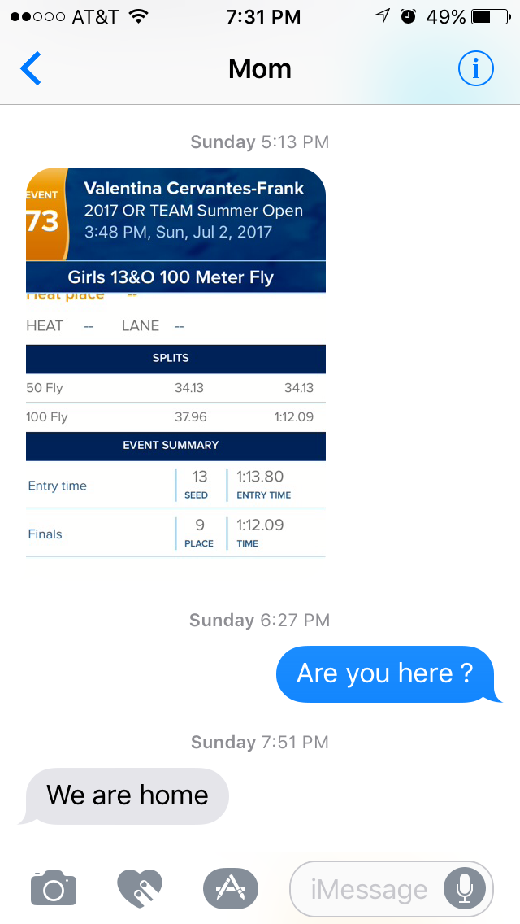
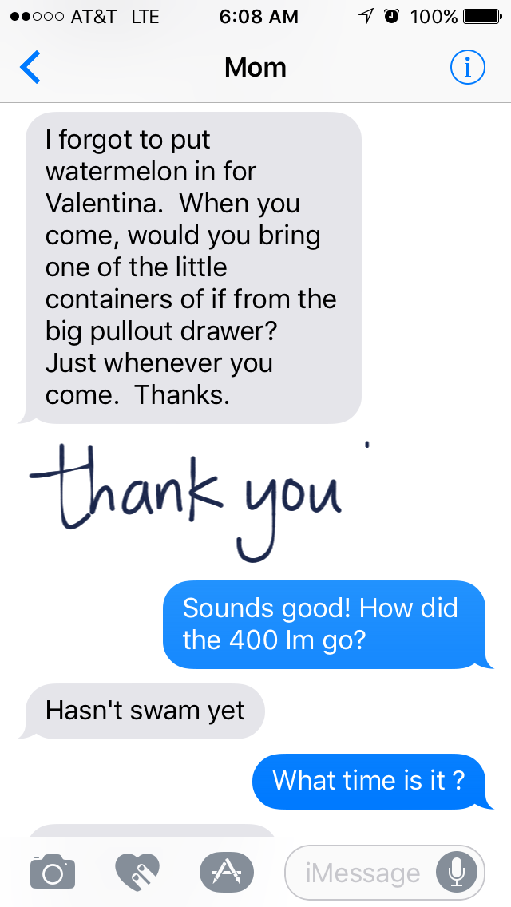

Evaluation/Improvements of Interaction
Many aspects of this interaction went wrong! First, I missed both of my daughter’s races, which made me feel sad and like a bad dad. Due to family dynamics and care needs, one adult needs to be available for my father’s needs, while the other adult is chaperoning child activities. I am responsible for my eight year old, and mother handles my fifteen year old. In this instance, the eight year old swam in the morning and the fifteen year old swam in the afternoon. The pool is in close proximity to the house; which meant I would have been able to make the oldest’s events, but lack of communicating resulted in disaster.
My perception (pg. 75) of the situation was wrong. My interpretation (pg. 78) was that my mother was unwilling to communicate times of events. I attributed (pg. 79) this to the noise caused by virtual communication and my mother working the event. However, the reality is that my mother sent the times to another person by accident.
I could have improved this interaction by planning and coordinating in advance. I know that tentative event times are available on the team website. I could have looked up the schedule myself, but sometimes I rely on “ole’ mom” to handle the planning, since that is up her alley. Also virtual communication might not have been the best channel for precise communication. A lot of the message was lost throughout the communication process

Interpersonal Journal Entry #2

Context: July 5, Wednesday, 12:30 p.m., virtual connection Home/Daughter’s Work

Situation: My fifteen year old is inquiring about my afternoon plans via text message.

Description of Interaction:
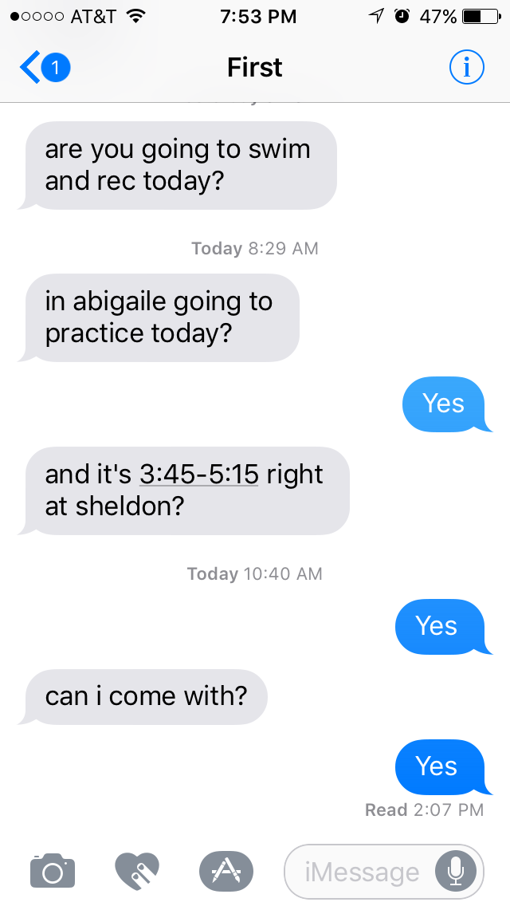

Evaluation/Improvements of Interaction:
Once again, there are many problems with this virtual exchange. First off, I thought I was being very direct with my answers to her close ended questions. I value directness, and absolutely despise beating around the bush! My daughter’s perception of my one word answers was that she was interrupting me and that I didn’t want to communicate with her. Full disclosure, she was at work and I did not want her to get in trouble for texting. It’s her first job, and I explained that her focus needs to be on work.
Where I did the worst parenting ever was in the decoding of her message. First she never wants to go to her sister’s practices, so I should have understood that some ulterior motive was in play. Her boyfriend is a lifeguard at Sheldon Pool. The real message was that she wanted to go see Wiley (the bf). He was supposed to join us for our Independence Day celebration, but was unable. He was supposed to go to my daughter’s swim meet, but was unable. The developing pattern of “unables” has my daughter’s mood a little in the dumps. He is getting ready to go to Canada for a whole two weeks. My daughter felt like this was one of her last opportunities to see the bf before he leaves.
I could have improved on this interaction by putting 2 and 2 together a little quicker! But really, I should have offered empathy (pg. 99). I am not a fifteen year old girl; but I do love my daughter, and need to make more of an attempt to feel into her thoughts and emotions. After I observed her encounter with the bf, I realized what was happening. We talked face-to-face – imagine that – on the ride home. I offered my taxi services for this evening that way the two of them can be together before the great divide. I like Wiley (the bf) and love to see my daughter smile.

Interpersonal Journal Entry #3

Context: July 5, Wednesday, 6 p.m., virtual connection Home/ Girlfriend’s Home

Situation: My girlfriend and I are texting about a perceived phone call.

Description of Interaction:
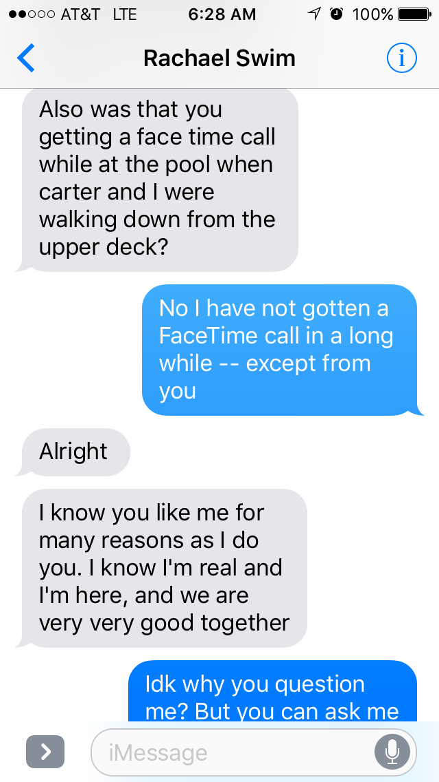
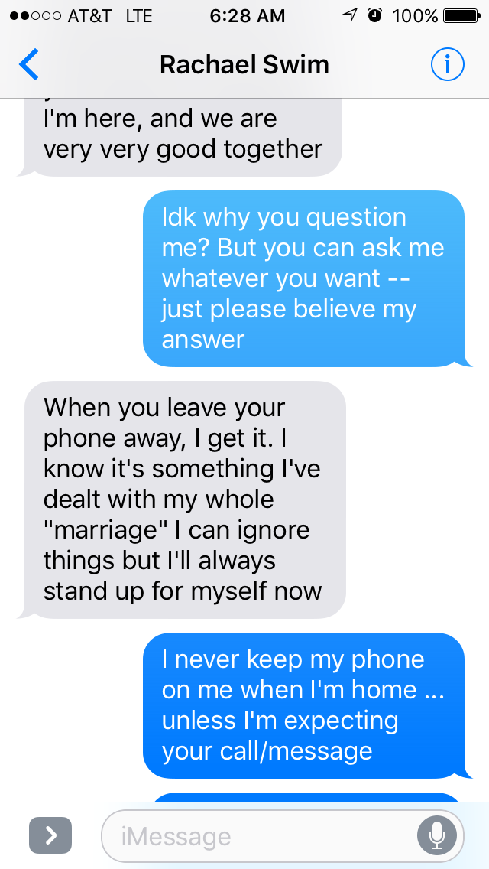

Evaluation/Improvements of Interaction:
This exchange did not sit well with me at all. Our relationship is in its beginning stages, and some attachment anxiety (pg. 47) is to be expected. I need to understand that my girlfriend is recently divorced from an unhealthy marriage, and I need to be supportive during the healing process. I also need to make sure that this relationship doesn’t form from a preoccupied attachment (pg. 48), where high anxiety and low avoidance exists. A relationship of that nature will not last long.
I could have improved on this interaction by not have presenting myself online (pg. 55). After rereading the delivered message, I feel that I was on the defensive. This is not the public self or face (pg. 52) that I was trying to portray. I should have asked to handle this conversation in a more intimate and private setting. I am very comfortable and sincere with my role in this relationship. If I can find away to convey my true intentions I believe that my girlfriend will show more intimacy and less anxiety; leading to a secure attachment (pg. 49) – the ultimate goal. Definitely some conversation needs to be had – not online!

