LOW-FI PROTOTYPE

Phung Minh Chien, Ma Khoa Hoc, Nguyen Danh Huy

INTRODUCTION 1

SKETCHES 2

SELECTED STORYBOARDS 2

FINAL INTERFACE 2

LOW-FIDELITY PROTOTYPE 3

TESTING METHODOLOGY 3

RESULTS 5

DISCUSSION 5

APPENDIX 6

## INTRODUCTION

**MISSION STATEMENT**

Our mission is to empower users by providing an intuitive chatbot that answers questions based on uploaded documents, offering efficient, context-aware support for real-world applications.

**PROBLEM AND SOLUTION OVERVIEW**

Through user research, we identified that many individuals face challenges in quickly accessing relevant information from their documents, such as legal contracts, medical forms, or official paperwork. Our chatbot solves this problem by allowing users to upload their documents and engage in context-specific, question-and-answer sessions. This approach helps users navigate complex information with ease and confidence in real-world scenarios.

## SKETCHES

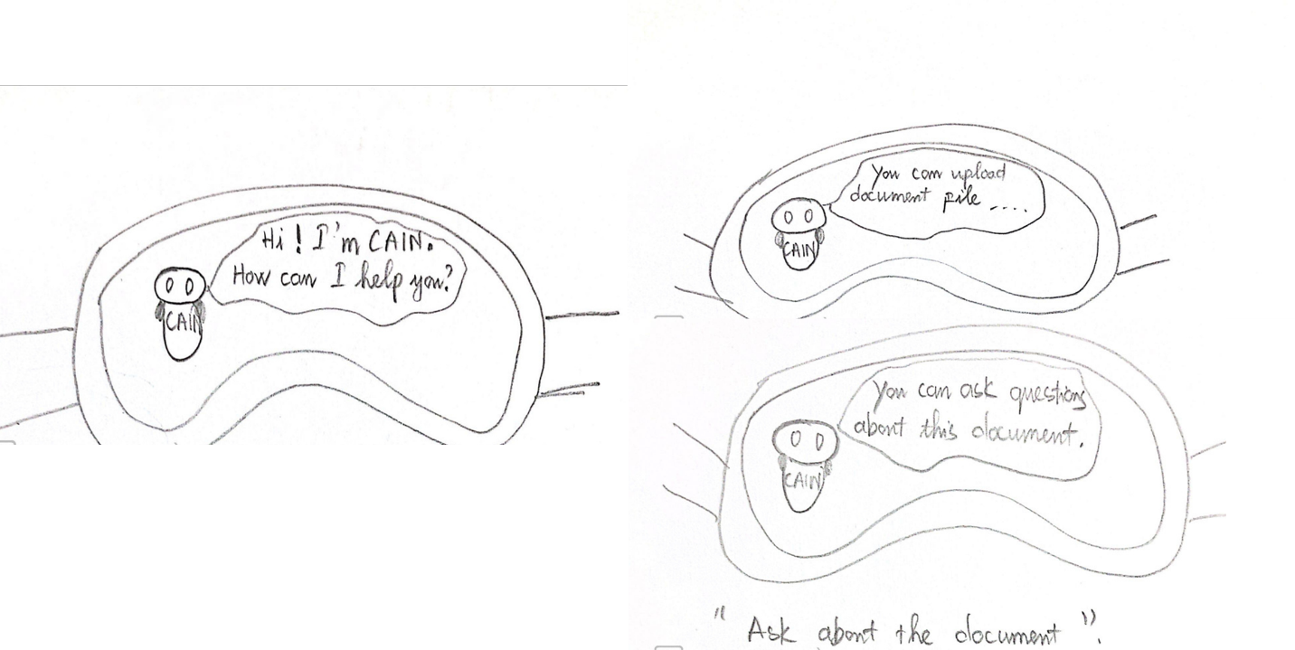Figure 1. This is a VR app realization with lifelike visuals.

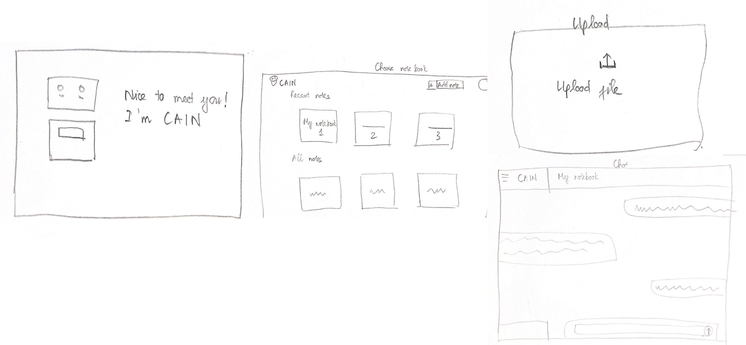Figure 2. This is a website.

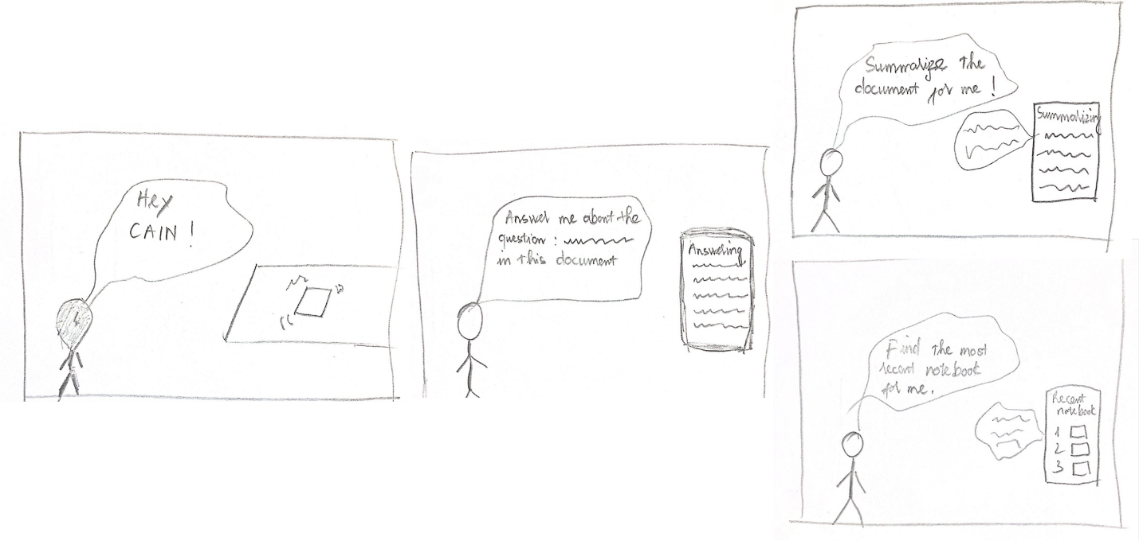Figure 3. This is Voice-Activated CAIN.

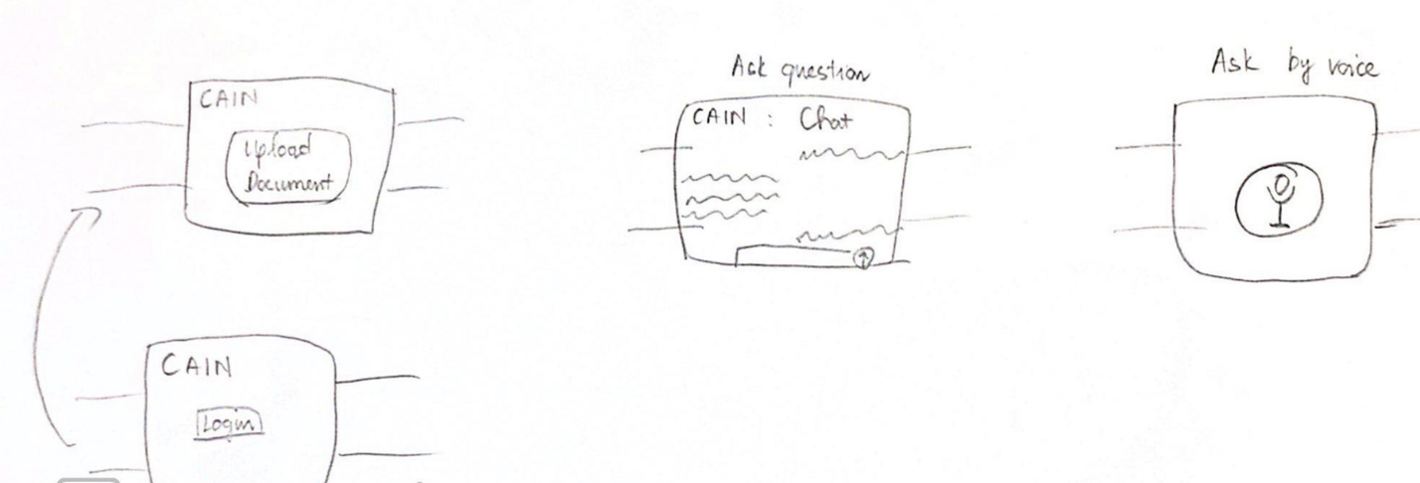Figure 4. This is CAIN as Wearable.

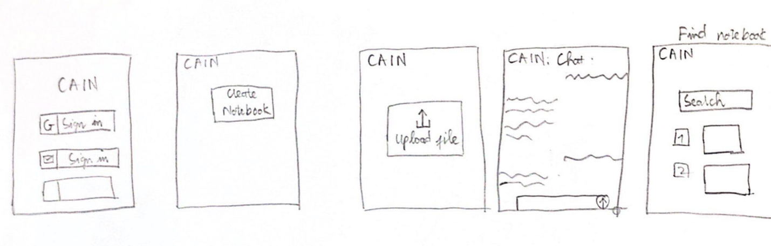Figure 5. This is Mobile app.

## SELECTED STORYBOARDS

Figure 6.Mobile app

Figure 7. Website

## FINAL INTERFACE

After exploring initial designs, we focused on a primary interface options: an interactive webstie.

**Website app**

|  |  |
| --- | --- |
| **Pros** | **Cons** |
| ● Easy document upload: Users can easily upload documents through a browser, without the need for extra steps or installations. This makes it accessible to a wider audience and is convenient for casual users.  ● Cross-platform compatibility: Websites work on any device with a browser, making them accessible to users on desktop, tablet, or mobile without restrictions.  ● Lower entry barrier: Users don’t need to install anything, which makes it easier for them to start using the service immediately. | ● Requires internet access: Users need a stable internet connection to access the website and upload documents.  ● Mobile optimization issues: Websites may not be as optimized for mobile devices, leading to potential performance issues or a suboptimal experience on small screens.  ● Potential slow performance: Depending on the complexity of the site and user’s internet connection, there may be delays when uploading large documents. |

A website is the ideal choice because it offers easy accessibility—users only need a browser, with no installation required, making it perfect for both new and occasional users. The document upload process is straightforward and works seamlessly across all devices. Additionally, developing and maintaining a website is more cost-effective compared to an app. With its broad compatibility and ability to reach a wide audience, a website ensures an efficient, user-friendly experience.

## 

## LOW-FIDELITY PROTOTYPE

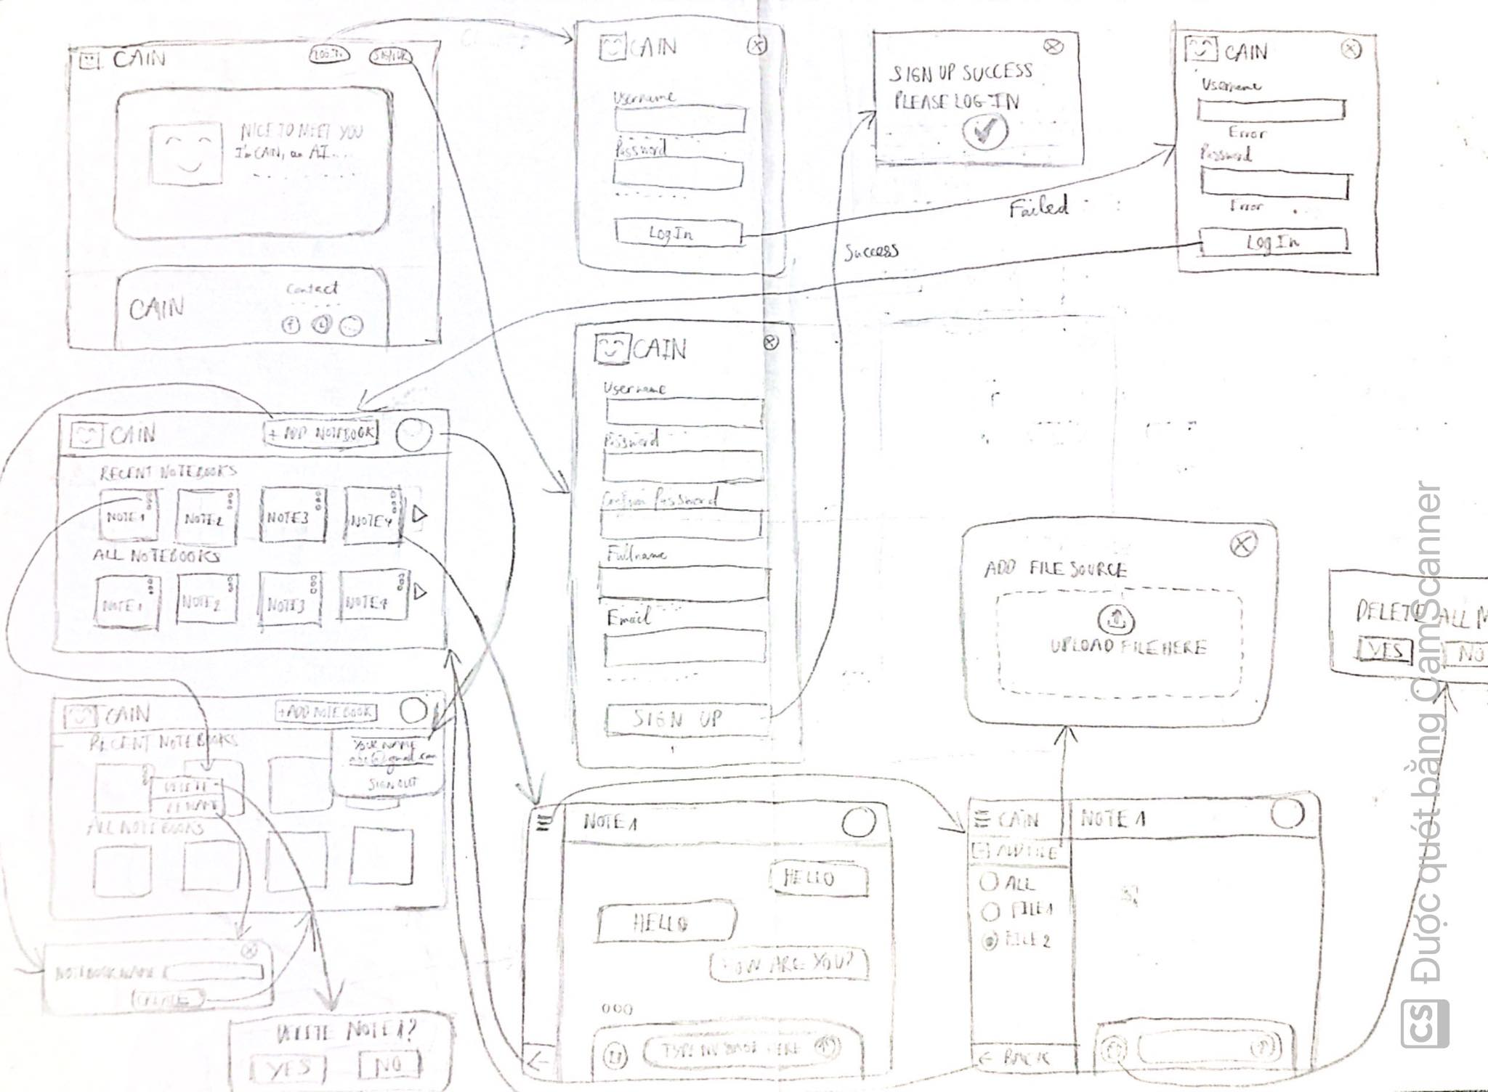

Figure 8. Low-fi prototype

## TESTING METHODOLOGY

**PARTICIPANTS**

We interviewed:

* Nguyen Huu Phong, 21, student at HUST (first language: Vietnamese)
* Dinh Cao Sang, 21, student at HUCE (first language: Vietnamese)
* Nguyen Anh Van, 21, student at DAV (first language: Vietnamese)

These participants were selected for their common cultural and linguistic background, offering valuable perspectives on the challenges Vietnamese speakers face when learning English. All participants were second-degree connections. Although no direct compensation was offered due to remote participation, we made sure to express our gratitude.

**ENVIRONMENT**

We organize direct testing at building C7-826 HUST and on HUST campus. This enabled us to track their progress with the prototype, as well as any verbal responses and facial expressions.

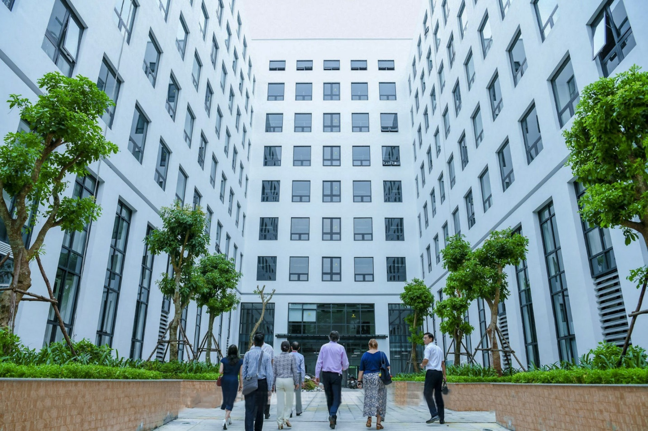

Figure 9. D8 Building

**TASKS**

1. Simple:

● Search notebook by name

2. Moderate

● Chat to ask about chosen file

3. Complex

● Upload File to Notebook

**PROCEDURE**

1. **Introduce ourselves and the project.**  
   Briefly explain the purpose of the session and what the chatbot is designed to do.
2. **Ask for consent to participate.**  
   Confirm the participant’s willingness to proceed and assure them there are no right or wrong answers.
3. **Explain the experiment.**  
   Outline the tasks they’ll perform using the paper prototype. Emphasize that the focus is on the design, not their performance.
4. **Guide the participant through the tasks.**  
   Present the paper prototype and have them perform the three main tasks: searching notebooks, asking questions about documents, and uploading files.
5. **Collect feedback.**  
   After completing the tasks, ask what they liked, disliked, and if they have any additional suggestions.
6. **Thank the participant.**  
   Show appreciation for their time and input, and let them know how valuable their feedback is for improving the design.

**TEST MEASURES**

Successes:

● Tasks completed with ease

● Signs of understanding and pleasure

Errors:

● Signs of confusion and uncertainty

● Incorrect or unexpected actions

**TEAM MEMBER ROLES**

● Greeter: Nguyen Danh Huy

● Facilitator: Phung Minh Chien

● Note: Ma Khoa Hoc

## RESULTS

We asked our participants to interact with the prototype while thinking aloud, giving us insight into what aspects were effective and where improvements were needed. Below is a summary of their feedback:

**All participants :**

* Found the chatbot easy to use
* Thought it would be better to use a different shaped button (not a circle) to select files to chat with.
* Confused between Searching notebook icon and notebook naming

**2 participants :**

* Found the chatbot easy to interact with and appreciated its user-friendly interface.
* Suggested adding a progress bar to track task completion, making the experience more transparent.

**One participants:**

* Recommended including a feature to preview selected files before confirming the choice.

## APPENDIX

**CRITICAL INCIDENT LOG**

1 User progressed without hesitation

2 User hesitated or otherwise had to think about the next step

3 User had an issue progressing to the next step

4 User had to ask for help to progress

5 User could not progress

**Participant One:Phong**

**Participant Two:Sang**

**Participant Three**

**BLANK CONSENT FORM**

This student team is interviewing and observing as part of the coursework for Human-Machine Interaction. Participants provide data that is used to understand the possible opportunities of the design. Data may be collected by interview, observation, and questionnaire.

Participation in this experiment is voluntary. Participants may withdraw themselves and their data at any time without fear of consequences. Concerns about the experiment may be discussed with the researchers Mã Khoa Học, Phùng Minh Chiến, and Nguyễn Danh Huy, or with the instructor of the course.

**Instructor Contact:**  
Nguyen Viet Tung  
Human-Machine Interaction Department  
HaNoi University of Science and Technology  
Email Address: tung.nguyenviet@hust.edu.vn

Participant anonymity will be maintained by the separate storage of names from data. Data will only be identified by participant number. No identifying information about the participants will be available to anyone except the student researchers and their supervisors/teaching staff.

I hereby acknowledge that I have been given an opportunity to ask questions about the nature of the research and my participation in it. I give my consent to have data collected on my behavior and opinions in relation to the team’s research. I also give permission for images or audio/video recordings of me being interviewed to be used in presentations or publications, as long as I am not personally identifiable in the images/video. I understand that I may withdraw my permission at any time.

Name: ___________________________________________  
Participant Number: _____________________________  
Date: ____________________________________________  
Signature: ______________________________________

Witness Name: ___________________________________  
Witness Signature: ____________________________