|  |  |  |  |  |  |  |  |  |  |  |  |
| --- | --- | --- | --- | --- | --- | --- | --- | --- | --- | --- | --- |
|  |  |  |  | Proportion reproductive costs (%) | | | | |  | Proportion success costs (%) | |
|  |  |  |  | Discarded | | Success | | |  |  |  |
| species | Seed size (mg) | Seedset | Reproductive costs  (mg) | Pollen attraction | Packaging and dispersal | Pollen attraction | Packaging and dispersal | Seed | Success costs (mg) | Pollen attraction | Provisioning |
| *Epacris microphylla* | 0.014 | 0.317 | 0.525 | 54.6 | 12.3 | 27.0 | 1.9 | 4.2 | 0.112 | 81.6 | 18.4 |
| *Pimelea linifolia* | 0.183 | 0.274 | 10.463 | 64.0 | 2.1 | 23.7 | 8.1 | 2.0 | 3.05 | 70.0 | 30.0 |
| *Hemigenia purpurea* | 0.222 | 0.312 | 7.054 | 45.5 | 21.8 | 21.7 | 6.9 | 4.1 | 1.841 | 65.5 | 34.5 |
| *Leucopogon esquamatus* | 0.405 | 0.312 | 24.695 | 29.4 | 25.6 | 13.1 | 28.4 | 3.5 | 5.164 | 28.8 | 71.2 |
| *Conospermum ericifolium* | 0.589 | 0.177 | 24.020 | 43.0 | 34.5 | 11.1 | 8.7 | 2.7 | 5.078 | 52.4 | 47.6 |
| *Pultenaea tuberculata* | 0.867 | 0.067 | 121.561 | 85.1 | 5.5 | 5.9 | 2.4 | 1.2 | 6.951 | 62.8 | 37.2 |
| *Phyllota phylicoides* | 1.394 | 0.047 | 302.609 | 87.1 | 4.4 | 4.0 | 2.9 | 1.6 | 7.449 | 48.0 | 52.0 |
| *Boronia ledifolia* | 2.158 | 0.036 | 151.481 | 68.8 | 11.9 | 4.2 | 12.3 | 2.8 | 14.802 | 21.8 | 78.2 |
| *Petrophile pulchella* | 2.531 | 0.341 | 180.254 | 18.2 | 10.5 | 8.5 | 60.5 | 2.2 | 119.907 | 11.3 | 88.7 |
| *Persoonia lanceolata* | 3.368 | 0.062 | 1140.445 | 50.6 | 12.2 | 2.3 | 34.4 | 0.4 | 283.475 | 6.4 | 93.6 |
| *Hakea teretifolia* | 7.559 | 0.004 | 4348.682 | 80.0 | 14.0 | 0.3 | 5.5 | 0.2 | 205.875 | 5.6 | 94.4 |
| *Grevillea speciosa* | 7.728 | 0.014 | 587.822 | 59.4 | 19.5 | 1.6 | 17.4 | 2.0 | 83.208 | 8.0 | 92.0 |
| *Banksia ericifolia* | 18.511 | 0.032 | 3385.342 | 16.8 | 10.4 | 0.7 | 71.0 | 1.1 | 2218.899 | 0.8 | 99.2 |
| *Grevillea buxifolia* | 22.408 | 0.015 | 844.298 | 68.7 | 9.5 | 1.4 | 17.1 | 3.3 | 149.768 | 6.2 | 93.8 |

**Tables**



**Table 1.** Reproductive investment data for each species. Seed size indicates the mass of the embryo and endosperm only (mg). Seedset is mature seeds per ovule initiated. Reproductive costs are the total reproductive investment per seed matured. The proportion of reproductive costs allocated to discarded tissues formed for pollen-attraction versus packaging and dispersal, successful pollen-attraction tissues, successful packaging and dispersal tissues and the seed itself are shown. Success costs are the components of total reproductive costs required for the formation of a successful seed, and are divided into two components, pollen attraction costs and provisioning costs. Note that for seed costs, the weight of the seed itself is considered part of provisioning costs. Colored dots indicate plotting colors used for each species in Figure 3.

|  |  |  |
| --- | --- | --- |
| Reproductive cost component | r2 | Slope  *(confidence interval)* |
| Total reproductive costs | 0.91 | 1.27 (1.05 - 1.54) |
| Total accessory costs | 0.90 | 1.27 (1.05 - 1.54) |
| Success costs | 0.88 | 1.28 (1.02 - 1.59) |
| Pollen-attraction costs | 0.82 | 0.67 (0.52 - 0.87) |
| Provisioning costs | 0.89 | 1.51 (1.23 - 1.85) |
| Discarded tissue costs | 0.87 | 1.26 (1.01 - 1.57) |
| Discarded pollen-attraction costs | 0.85 | 1.28 (1.01 - 1.63) |
| Discarded provisioning costs | 0.87 | 1.30 (1.03 - 1.63) |

**Table 2.** Scaling of reproductive tissue costs with seed size. All variables were showed a strong correlation with seed size (p < 0.0001). Tables show properties of SMA line fits, between different variables and seed size.

|  |  |  |  |  |  |
| --- | --- | --- | --- | --- | --- |
| Estimate of reproductive investment | | n | | r2 | |
| Total plant weight (mg) | | 357 | | 0.620 | |
| Embryo and endosperm investment (mg) | | 223 | | 0.660 | |
| Propagule investment (mg) | | 223 | | 0.525 | |
| Fruit investment (mg) | | 223 | | 0.675 | |
| Flower investment (mg)  (flower weight * bud count) | | 223 | | 0.922 | |
| Successful investment (mg)  (success costs * seed count) | | 223 | | 0.728 | |
| Successful pollen-attraction investment (mg) | | 223 | | 0.380 | |
| Successful provisioning investment (mg) | | 223 | | 0.736 | |
| Discarded tissues (mg) | | 357 | | 0.968 | |

**Table 3. Correlation of different estimates of reproductive investment (and total plant weight) against total reproductive investment (mg).** Regressions are done across all individuals of all 14 study species for which both reproductive investment and the *estimate* variable are greater than zero. The total cost of failed tissues or simply the energy expenditure into flowers provides the best approximation of total reproductive investment. All fits were highly significant with p < 0.0001.

# Figures

1. **Investment categories**

Pollen-attraction costs

Provisioning costs

Success costs

Discarded tissue costs

Reproductive costs

Packaging and dispersal costs

Seed size

Discarded pollen-attraction costs

Discarded provisioning costs

1. **Trade-offs**

Trade-off 1. Trade-off 2. Trade-off 3.

Seed count vs. Ovule count vs. Choosiness vs.

reproductive costs pollen-attraction costs pollen-attraction costs

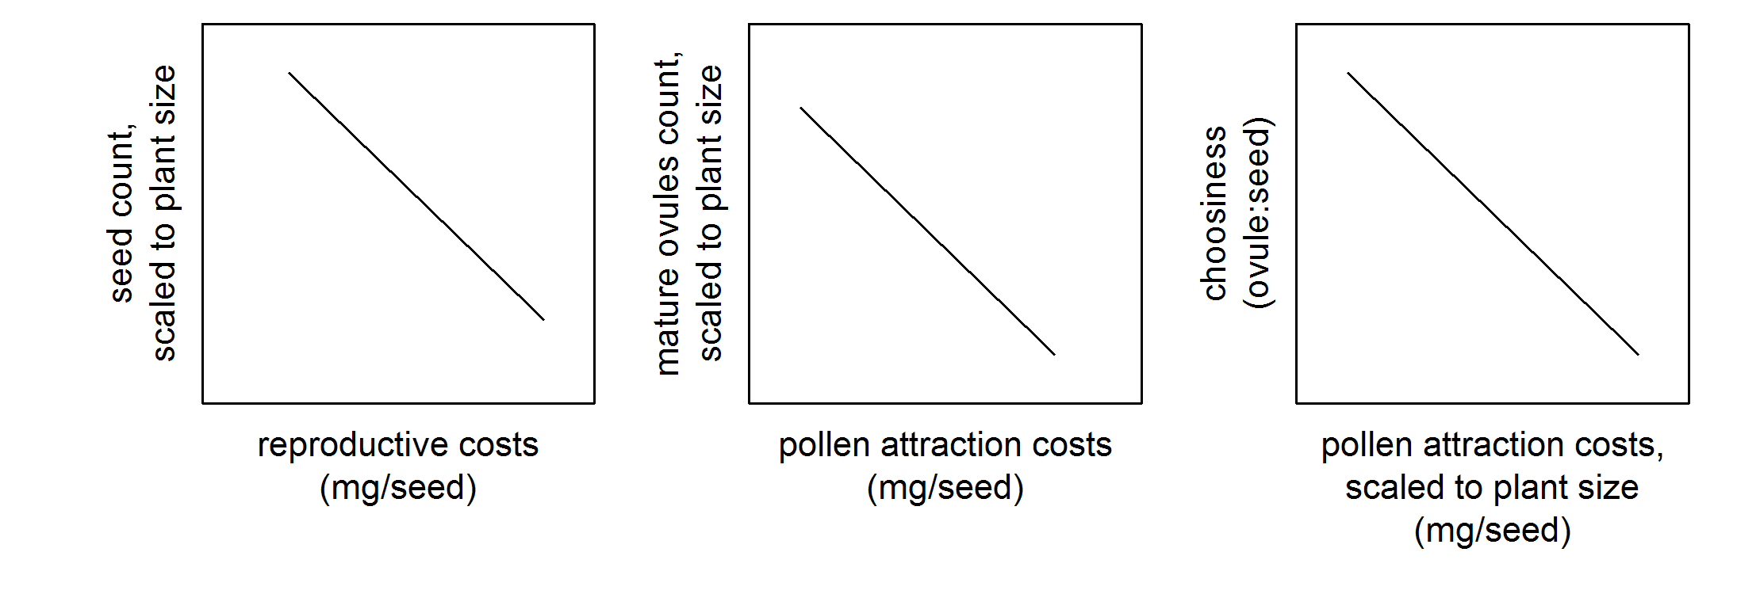

1. **Links between trade-offs**

Lower pollen attraction costs

Lower seed count

CONNECTION 1

CONNECTION 2

Higher reproductive costs

Higher ovule count

Low pollen attraction costs

relative to plant size

Trade-off 2:

Trade-off 1:

Trade-off 3:

High choosiness

(Low seedset)

+

+

+

**Large-seeded syndrome**

**Figure 1**. a) Categories of reproductive investment, expressed as “costs”, defined as investment divided by count of seeds matured. Categories in red are components of total accessory costs. b) Three trade-offs are predicted: Trade-off 1. For a given energy pool to be invested in total reproduction, there is a trade-off between total reproductive investment per seed produced and number of seeds produced; Trade-off 2. For a given energy pool to be invested to the point of pollination, there is a trade-off between pollen-attraction costs and the number of mature ovules produced; and Trade-off 3: A trade-off between “choosiness”, the ratio of mature ovules to mature seeds, and pollen-attraction costs, scaled to plant size, is also predicted, for a plant with more costly pollen-attraction tissues will be able to produce fewer excess ovules. c) Together, these trade-offs predict a syndrome of reproductive traits for large versus small-seeded species, for the three trade-offs are linked by natural selection and logic. Connection 1 indicates that species with high reproductive costs will also be highly selective about which ovules to mature. Connection 2 shows that a species on the low seed-count end of trade-off 1 and the high choosiness end of trade-off 3 will, by definition, have a relatively high ovule count. The figure depicts the end of each trade-off predicted for a large-seeded species. A small-seeded species is predicted to have cost and count values at the opposite end of each trade-off.

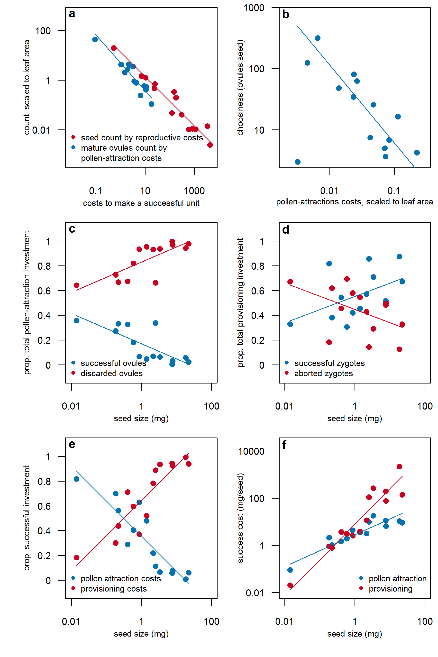

**Figure 2.** Species shift energy allocation patterns with seed size, reflecting different tissue construction costs and counts of ovules and seed produced. Each point shows average values for indivduals of a species. a) The hypothesized trade-offs between pollen-attraction costs and ovule count (r2=0.88) and between total success costs and seed count (r2=0.93) both exist. b) There also exists a trade-off between pollen-attraction costs (scaled to total leaf area) and choosiness (the ratio of mature ovules to mature seeds) (r2=0.76). As a result of these trade-offs, the proportion of energy invested in discarded versus successful tissues and into pollen-attraction costs versus provosioning costs shifts with seed size: c) larger seeded species invest a greater proportion of their success costs into provisioning tissues; d) larger seed species invest a greater proportion of pollen-attraction investment into discarded tissues versus successful tissues; e) there is a weak trend toward larger seeded species investing a greater proportion of their provisioning investment into successful tissues versus discarded tissues. Together, these allocation differences mean that the slope of the successful pollen-attraction costs-seed size regression is significantly lower than the slope of the successful provosioning costs-seed size regression.

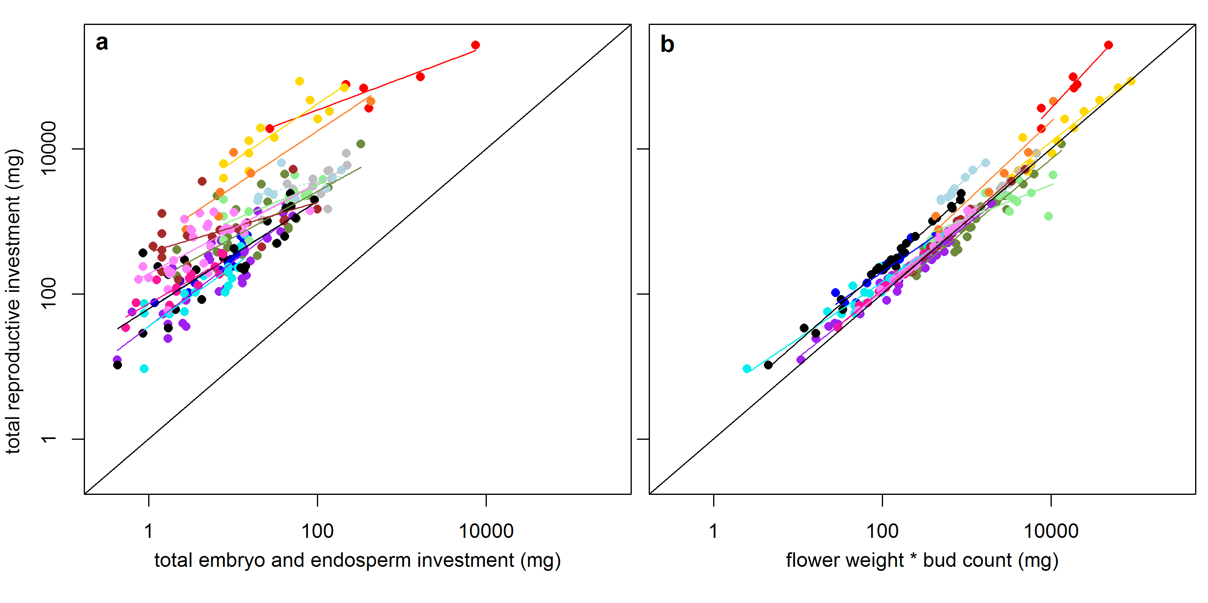

**Figure 3.** Embryo and endosperm investment is much more poorly correlated with total reproductive investment, than is a composite variable, the product of a count of the buds initiated multiplied by average flower weight. In each plot, different colored points represent the 14 study species; see Table 1 for the key. The colored lines are best fit lines through each species’ points. There are more points in panel b, as some individuals produce buds, but no seeds. In plot b, some individual’s flower weight * bud count is higher than their total reproductive investment due to a large proportion of buds aborting prior to reaching their mature flower weight. In this plot, propagule weight, the weight of the dispersed unit, not embryo and endosperm weight are used, as the purpose is to plot the commonly used currency.