David Fan

dmf98

EECS 325

Project 2 Writeup

**Websites Tested:**

* google.com
* facebook.com
* youtube.com
* github.com
* gismeteo.ru
* case.edu
* repubblica.it
* evernote.com
* voyeurhit.com
* yahoo.com
* gome.com.cn
* mlh.io
* oracle.com

From the original 10 websites assigned to me, I had to replace several to obtain enough data points for a meaningful scatter plot. 2 websites that timed out were kept to test my recovery method and for illustrative purposes.

**RTT VS HOP COUNT**

**Measurement Results:**

|  |  |  |  |
| --- | --- | --- | --- |
| Site | RTT(ms) | Hop Count | Original Bytes Received |
| google.com | 1.148462 | 13 | 28 |
| facebook.com | 1.136780 | 13 | 548 |
| Youtube.com | 1.154423 | 13 | 28 |
| github.com | 1.966476 | 15 | 548 |
| gismeteo.ru | 134.066105 | 17 | 548 |
| case.edu | 1.094580 | 0 | 548 |
| repubblica.it | Timed out | Timed out | Timed out |
| evernote.com | 1.452923 | 13 | 28 |
| voyeurhit.com | 1.270533 | 11 | 548 |
| yahoo.com | 17.809153 | 17 | 28 |
| gome.com.cn | Timed out | Timed out | Timed out |
| mlh.io | 1.265287 | 11 | 548 |
| oracle.com | 77.985764 | 20 | 28 |

**Graph:**

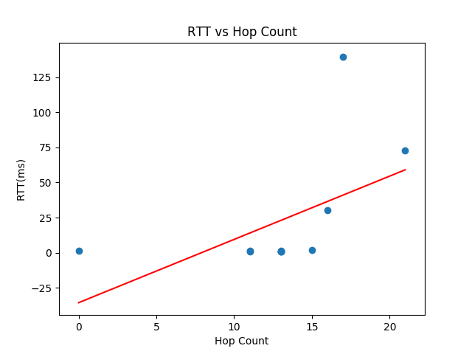

We can see from our line of best fit that there seems to exist some positive correlation between hop count and RTT. However, this is probably skewed up by a single outlier. One of the sites probed is hosted in Russia which resulted in a significantly higher RTT. Also, the line having a negative intercept clearly makes no sense as RTT can’t be negative.

**How you will match ICMP responses with the probes you are sending out?**

To match ICMP responses with the probes I sent out, I’m going to check if various fields in the headers align with what we expected. It’s not a perfect method that will catch everything, but if every field is correct, there’s a high probability that it’s the correct ICMP response. The fields I will check for are:

* ICMP type which should be 3
* ICMP code which should also be 3
* Source IP address from the IP header which should (usually) equal the IP we sent the datagram to
* Destination IP address from the IP header which should be the IP of our machine
* Source IP address from the UDP header which should be the IP of our machine
* Destination IP address from the UDP header which should be the IP we sent the datagram to
* Destination Port from the UDP header which should be the unused port that we sent the datagram to

**Some reasons why we might not get the possible answer when probing:**

* Dropped packet at some hop
* Timeouts
* Firewall specifications at some hop or the destination

**GEO DISTANCE**

**Measurement Results:**

|  |  |  |
| --- | --- | --- |
| Site | Direct distance (km) | Indirect distance (km) |
| google.com | 10717.545857 | 16699.398009 |
| facebook.com | 2843.627157 | 25688.466814 |
| Youtube.com | 10717.545857 | 16699.398009 |
| github.com | 8716.124299 | 18119.663250 |
| gismeteo.ru | 15725.726212 | 23969.709133 |
| case.edu | 13412.122731 | 13412.122731 |
| repubblica.it | 15460.353623 | 23397.317481 |
| evernote.com | 10717.545857 | 16699.398009 |
| voyeurhit.com | 9400.167428 | 18883.501176 |
| yahoo.com | 10659.046850 | 16918.241218 |
| gome.com.cn | 5115.730643 | 31832.082396 |
| mlh.io | 9400.167428 | 18883.501176 |
| oracle.com | 10103.481533 | 16799.247796 |

**Graphs:**

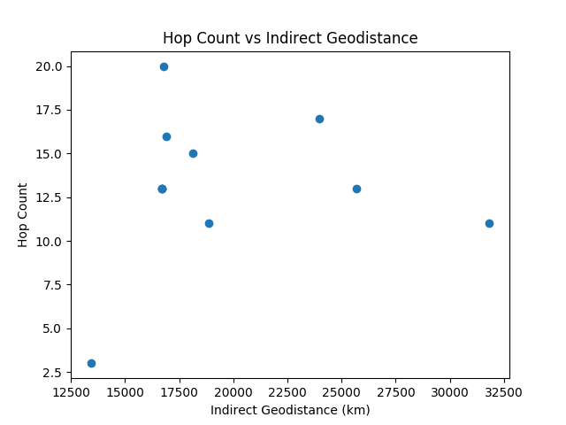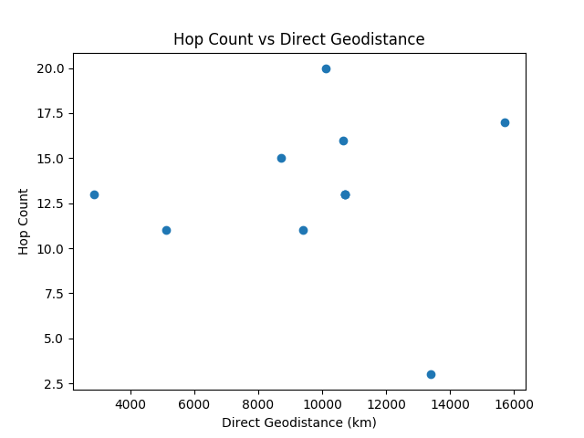

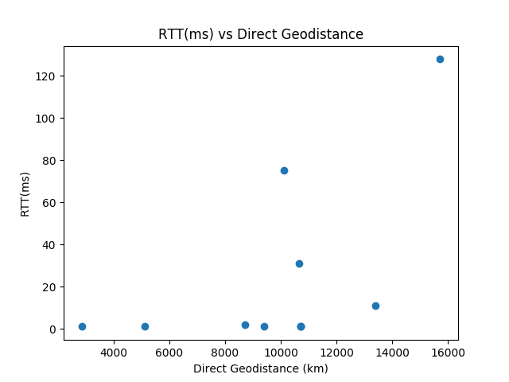

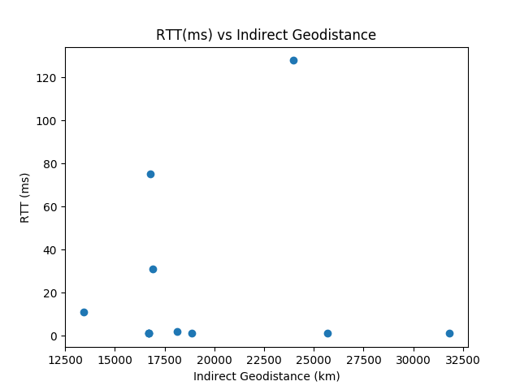

**Correlation Coefficients:**

r(direct_dist, hops): 0.001481

r(indirect_dist, hops): 0.111302

r(direct_dist, RTT): 0.567149

r(indirect_dist, RTT): 0.090948

r(hops, RTT): 0.544819

From these correlation coefficients we can clearly see that there does not exist any strong correlation between the direct distance measure and the hop measure, the indirect distance measure and the hop count measure, and the indirect distance measure and the RTT measure. Direct distance and RTT and hop count and RTT seem to have some correlation, but it also does not seem strong (~ >= .75). From this I conclude that it is difficult to use different metrics to predict others.