Evidence my weights ordered derivative is correct:

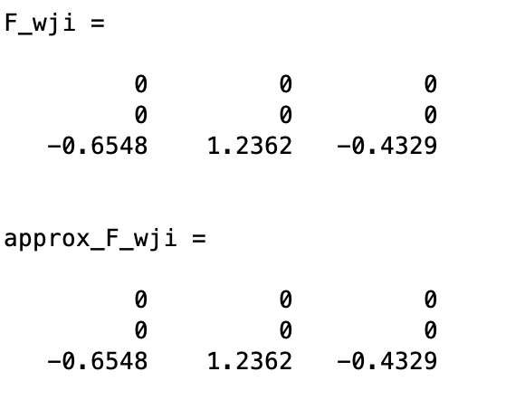

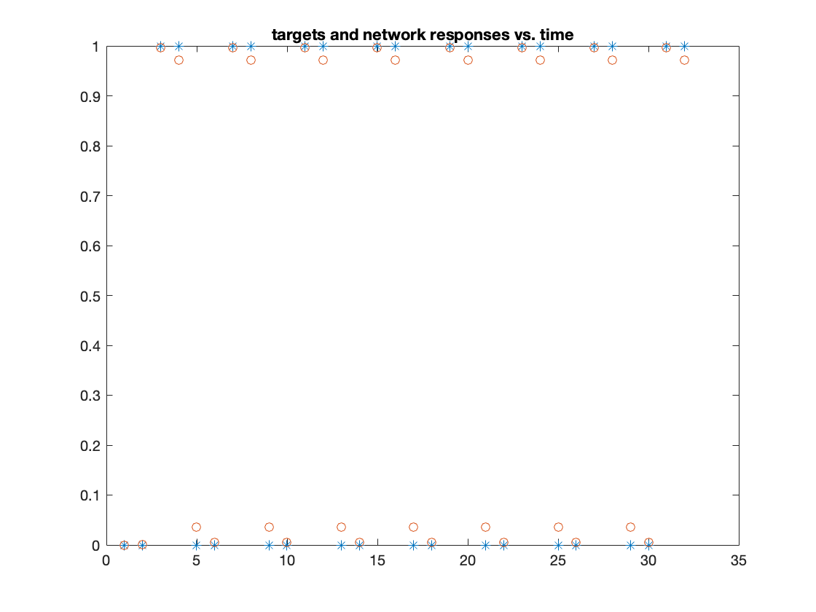Training Beats.dat with 1 hidden neuron after 18000 iterations:

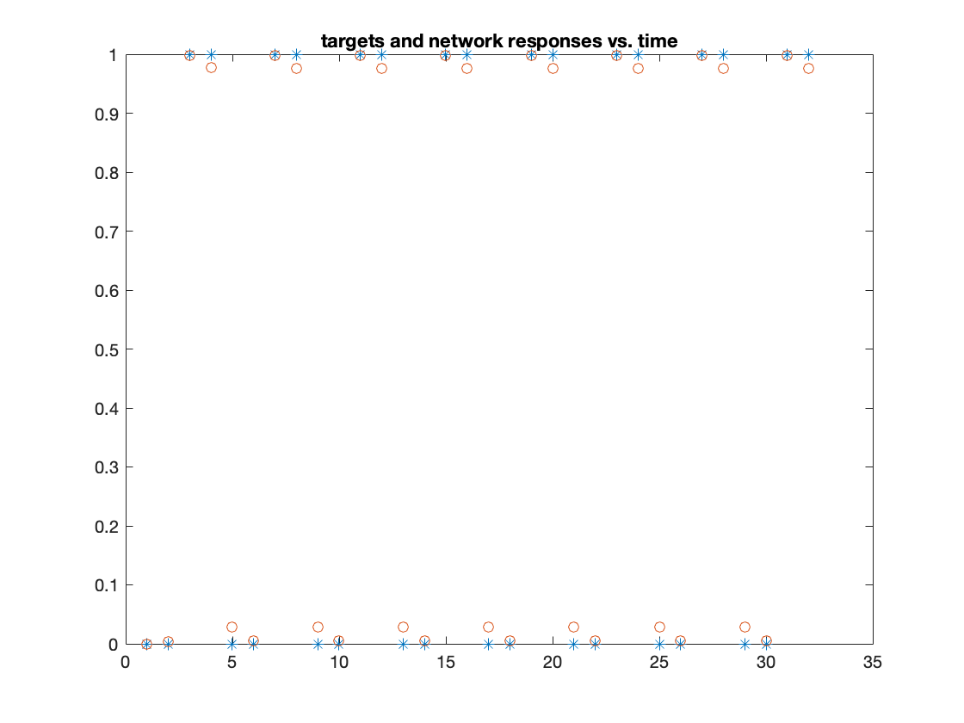Changing ETA and ETA_SIG to 0.05 in 5000 iters:

Changing ETA and ETA_SIG to 0.1 in 2500 iters:

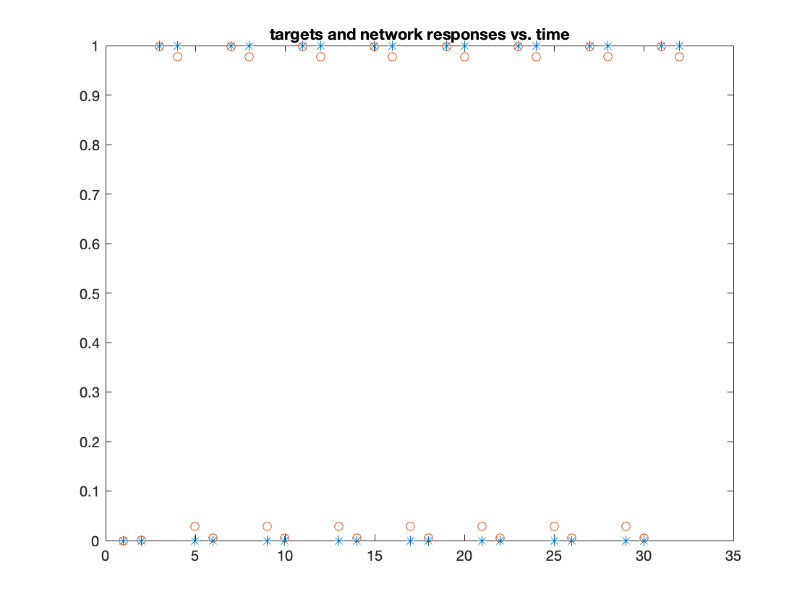

Changing ETA and ETA_SIG to 0.15 in 1000 iters:

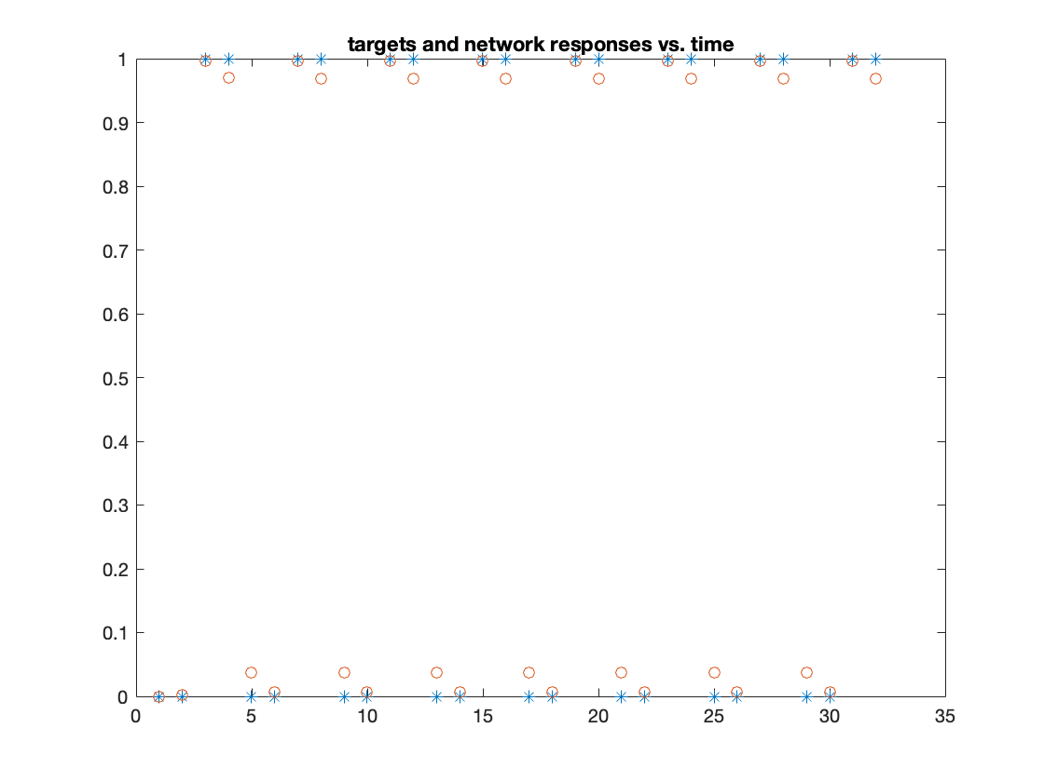

Changing ETA and ETA_SIG to 0.2 in 1000 iters:

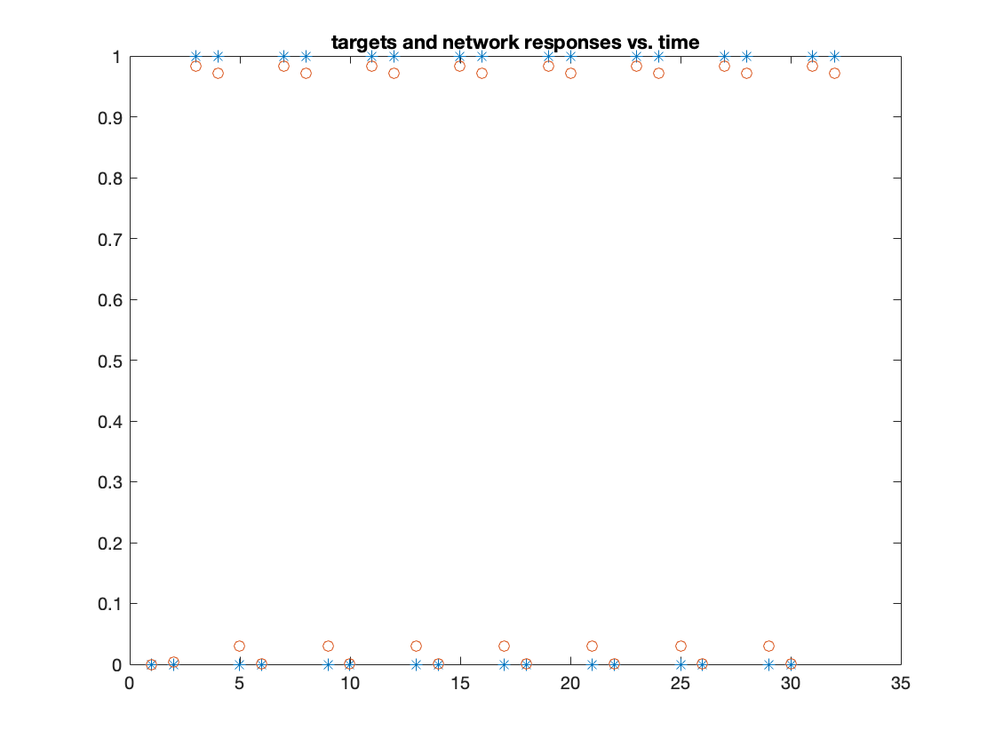

Here we see a decay in accuracy so it would seem that 0.15 is a close value to optimal for ETA and ETA_SIG for beats.dat.

**BEATS2.dat**

|  |  |
| --- | --- |
| Eta, eta_sig = 0.05  NNeurons = 5  Iterations = 50000 |  |
| Eta, eta_sig = 0.05  NNeurons = 6  Iterations = 50000 |  |
| Eta, eta_sig = 0.05  NNeurons = 7  Iterations = 25000 |  |
| Eta, eta_sig = 0.05  NNeurons = 6  Iterations = 25000 |  |
| Eta, eta_sig = 0.1  NNeurons = 6  Iterations = 5000 |  |
| Eta, eta_sig = 0.15  NNeurons = 6  Iterations = 5000 |  |
| Eta, eta_sig = 0.20  NNeurons = 6  Iterations = 5000 |  |

6 NNeurons seems to be needed to reach convergence in any reasonable time.

Between .15 and .2 seems to be an adequate learning parameter.