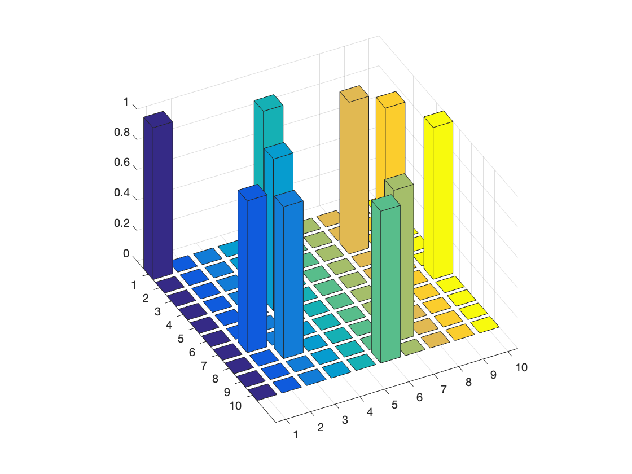 Result with default params after 400 iterations. Integral-error feedback enabled.

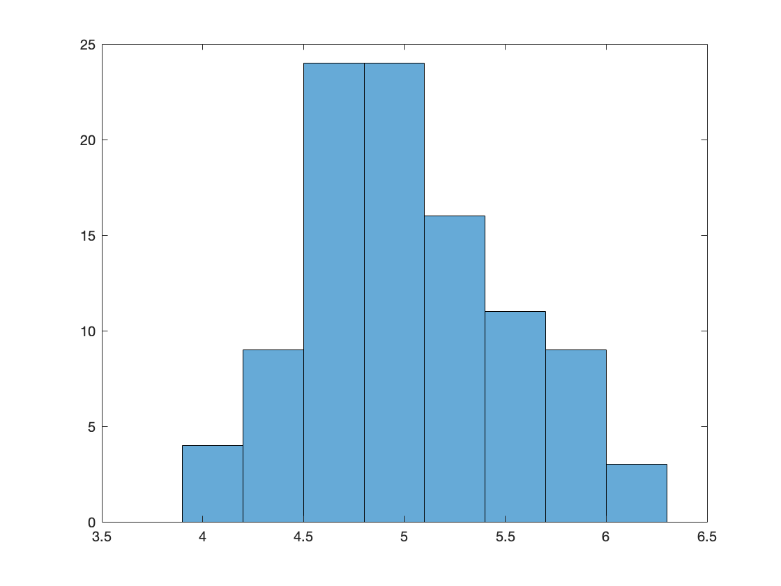 Histogram of generating 100 solutions with default params. Each solution run for 2000 iterations. Integral-error feedback enabled for each.

Statistics:

minimum_ =3.9229

maximum_ = 6.5362

mean_ = 5.0578

median_ = 4.9763

std_ = 0.5546

Compared to the exhaustive search statistics:

mean(all_solutions) = 6.1484

std(all_solutions) = 0.6230

min(all_solutions) = 3.7309

max(all_solutions) = 8.0657

The generated solutions would likely approach the exhaustive search statistics as more solutions are generated.

**Trying different params**

I first test the influence of having A > B and then B > A to see if prioritizing penalties for same city different day or different city same day has any effect.

|  |  |
| --- | --- |
| 100 solutions  A=750.0;  B=500.0;  C=200.0;  D=1000.0; | Stats:  minimum_ = -5.5742  maximum_ = 6.8470  mean_ = 5.1421  median_ = 5.3022  std_ = 1.2446  Seems that one solution wasn’t valid resulting in a negative distance |
| 100 solutions  A=500.0;  B=750.0;  C=200.0;  D=1000.0; | Stats:  minimum_ = 4.0893  maximum_ = 6.4746  mean_ = 5.0392  median_ = 4.9446  std_ = 0.4881  Seems to be less spread out than the default params and the exhaustive search. |
| 100 solutions  A=500.0;  B=500.0;  C=500.0;  D=1000.0;  Increasing global inhibition to 500 | Stats:  minimum_ = -1.3416  maximum_ = -1.3416  mean_ = -1.3416  median_ = -1.3416  std_ = 2.6780e-15  Clearly everything broke here… |
| 100 solutions  A=500.0;  B=500.0;  C=200.0;  D=500.0;  Dropping the data term to 500 | Stats:  minimum_ = 3.9229  maximum_ = 6.8141  mean_ = 5.3267  median_ = 5.3944  std_ = 0.5722  Quite close to the default params. |