HALS impulse response validation

1 Validation approach
This report checks how accurately HALS preserves the timing, magnitude and phase of an impulse response (IR). First, we establish what Stage 1 preprocessing changes. We then use the real tweeter to check reconstruction and export against Stage 1. Finally, we use a synthetic source to isolate what happens when an accurate complex response is converted into an IR.
Headline results: from 200 Hz–20 kHz, the synthetic Stage 5 IR export differs from the windowed original by no more than 0.066 dB and 0.59°. For the measured tweeter, the final IR differs from Stage 1 by no more than 0.79 dB and 5.34° from 300 Hz–20 kHz.
The IR peak stays at the same sample in both datasets. These tests check responses at measured microphone positions, not accuracy at previously unmeasured positions.

2 Stage 1 preprocessing
Before judging the reconstruction, we need to understand what Stage 1 changes. It applies frequency-dependent windowing and complex smoothing. A shorter window retains less of the captured sound and noise, changing the spectrum. Complex smoothing averages the complex response, so components with differing phase can partly cancel. These comparisons involve Stage 1 only, not the model or export.
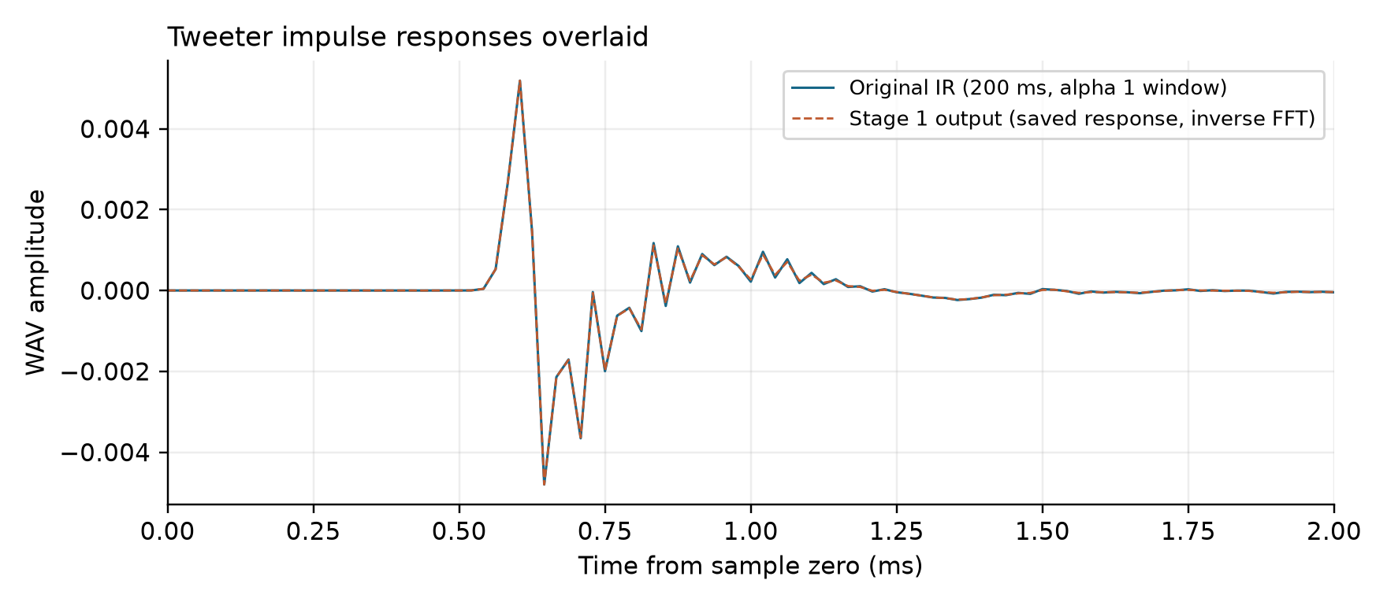
Figure 1. Original and Stage 1 processed impulse responses overlaid. Both peak at the same sample.
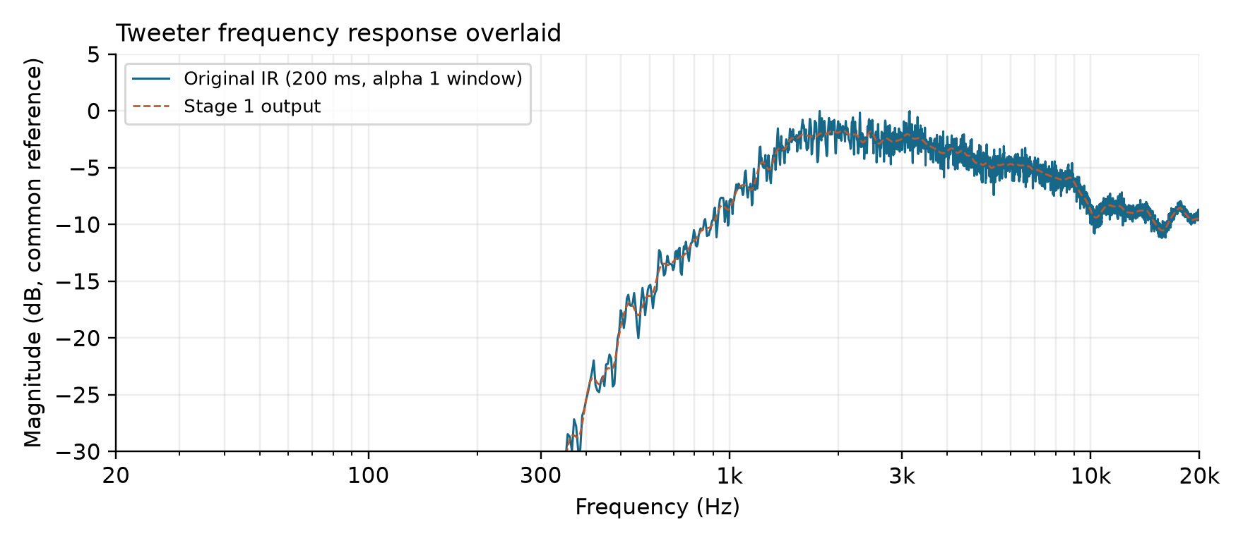
Figure 2. Original and Stage 1 frequency responses overlaid, showing the effect of smoothing.
Smoothing is a significant reason that Stage 1 output is the natural reference for comparison with later processing stages.
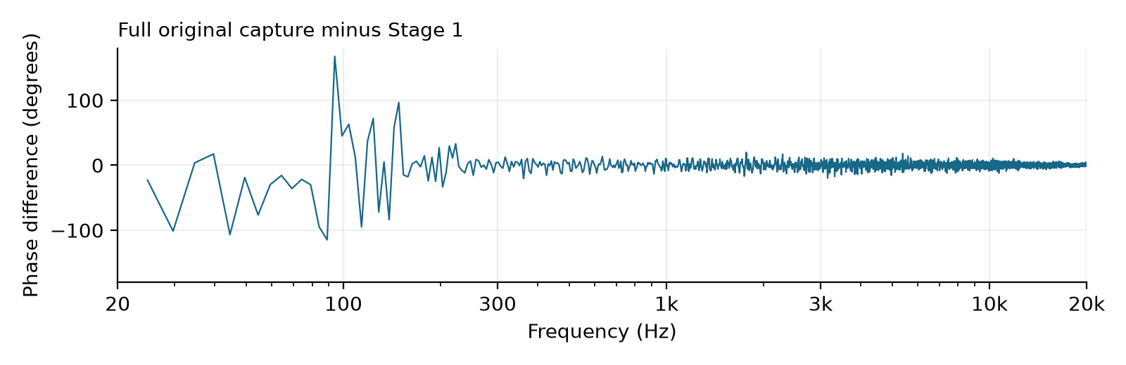
Figure 3. Full original tweeter capture minus Stage 1. This includes the deliberate change from the 1.5 s capture to Stage 1’s shorter windows.
The phase difference plot shows the Stage 1 phase subtracted from the original phase, so that only the difference remains. It can be seen that the largest phase changes occur in the low frequency range below 300 Hz. The original IR is however 1.5 s in length, while the Stage 1 result is windowed to a maximum of 200 ms, which can directly affect the low frequency range. For a closer comparison, we apply a single fixed 200 ms, alpha 1 window to the original IR, then compare it with the same Stage 1 output.
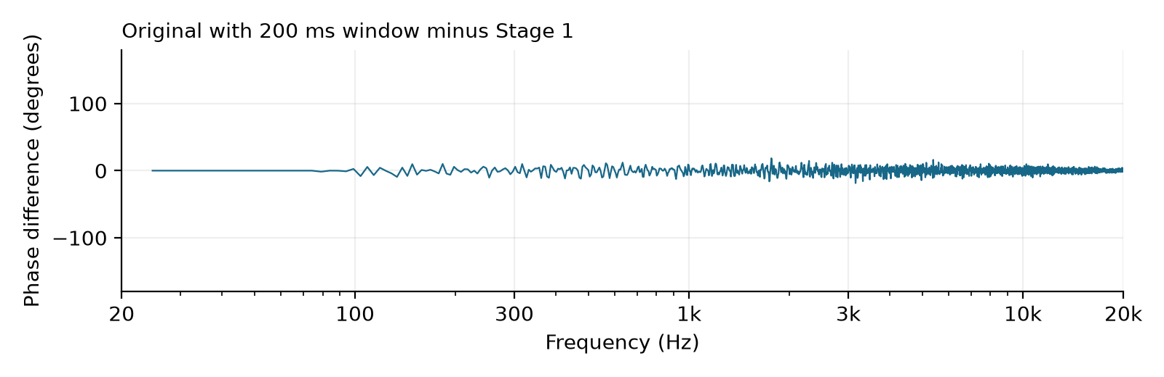
Figure 4. Original tweeter IR with a fixed 200 ms, alpha 1 window minus Stage 1. No holographic reconstruction or Stage 5 export is involved.
Most of the low-frequency phase difference now disappears. Much of the apparent mismatch therefore comes from comparing different time windows; the smaller remaining differences reflect Stage 1’s frequency-dependent processing and smoothing. From here onward, Stage 1 is the reference for the model because it is the smoothed and time-windowed measurement the model was built from.

3 Real tweeter reconstruction and export
With Stage 1 established as our reference, we can now check how closely the exported holographic model response follows the processed tweeter measurement. This comparison includes model construction, reconstruction and IR generation. The reference and final export both peak at sample 29, or 0.60417 ms at 48 kHz. 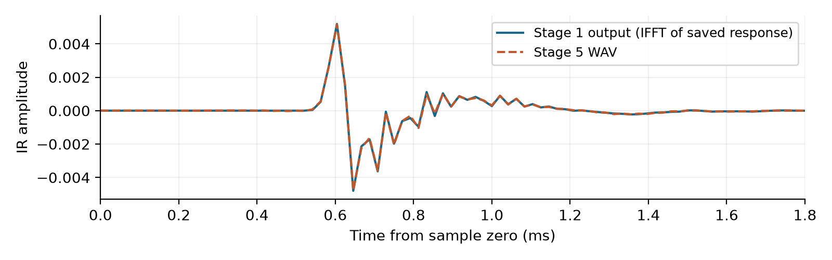
Figure 5. Stage 1 reference and the Stage 5 IR export overlaid. Both retain the same sample-zero time origin and peak at sample 29.
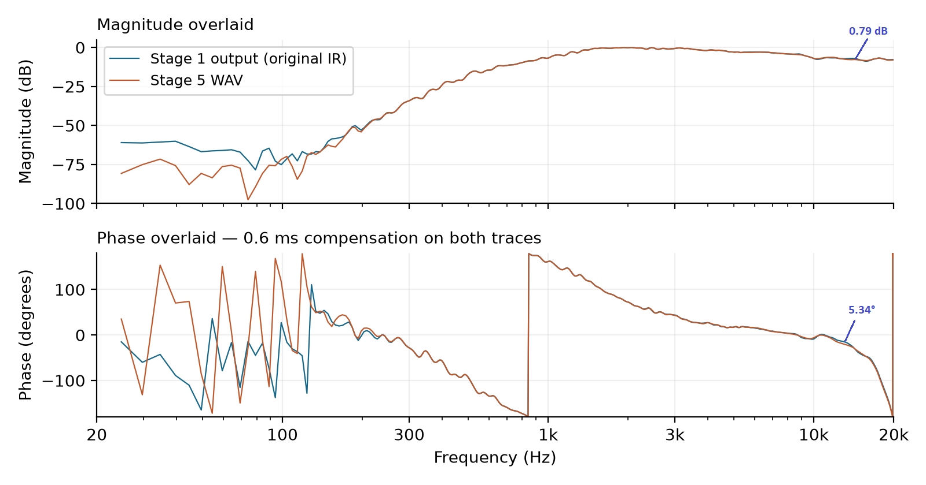
Figure 6. Stage 1 and the Stage 5 IR export overlaid. Both phase traces receive the same 0.6 ms delay compensation.
From 300 Hz–20 kHz, the final IR differs from the reference by no more than 0.79 dB and 5.34°.

Tweeter differences magnified
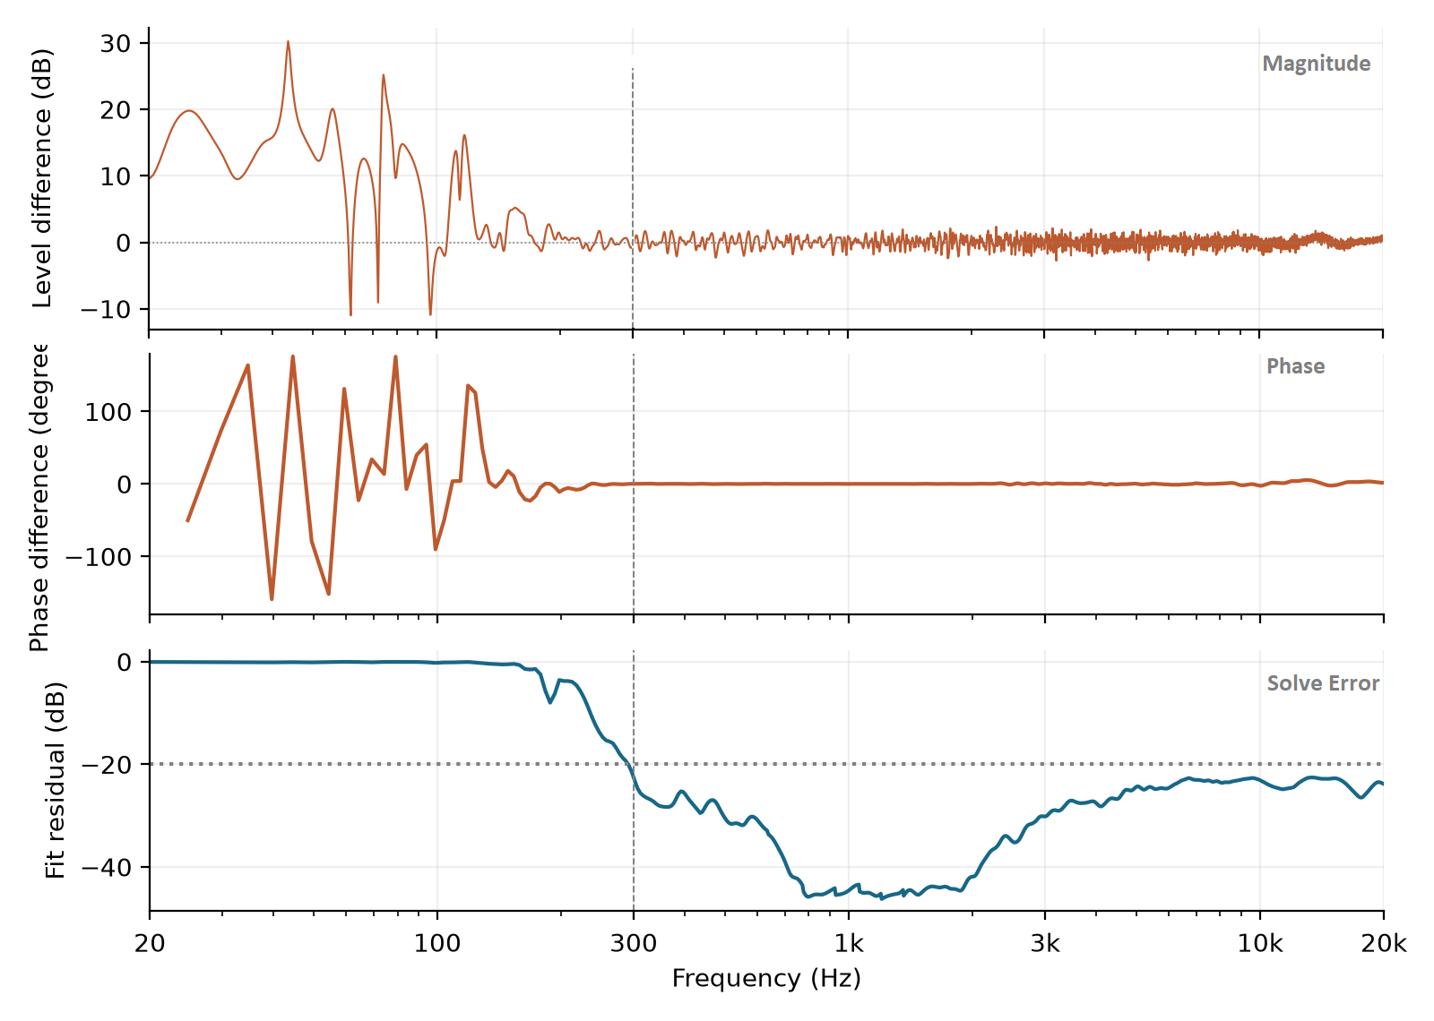
Figure 7. Stage 1 minus the Stage 5 IR export. Top - Magnitude, Middle -Phase, Bottom - Solve Fit Error. Dashed lines mark 300 Hz, the lower limit for the quoted results. Zero means agreement.
Below about 300 Hz, it can be seen that the tweeter SPL output becomes very weak and the model fit worsens sharply. The fit residual is about −23.2 dB at 300 Hz, −3.6 dB at 200 Hz and −0.24 dB at 100 Hz. More negative values mean a better fit; −20 dB means the residual norm is 10% of the input norm.
This makes clear why the <300 Hz range for the tweeter reconstruction shows significant deviation from the reference - the source SPL in this range is too close to the environment noise floor and the holographic model can not fit essentially random noise. At the same time, this range is of little practical interest, so a sensible lower limit for the quoted results from the tweeter reconstruction is >300 Hz.

4 IR generation with the synthetic source
The tweeter test checks holographic model and IR export together. To isolate IR generation, we now use a synthetic point source with strong output at all frequencies and a small solve residual. If its complex reconstruction is already accurate, does turning it into an IR change anything? We compare its complex, FRD and IR exports with the original, using the same fixed 200 ms, alpha 1 reference window.
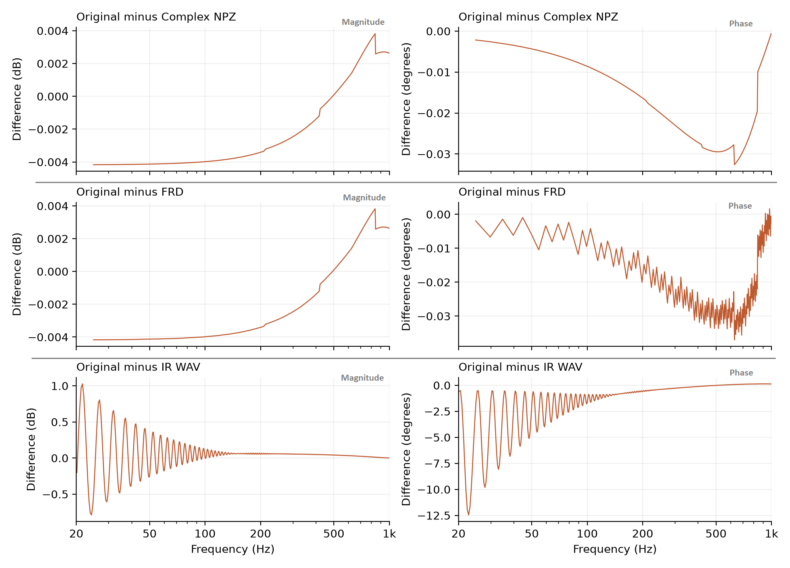
Figure 8. Original minus complex, FRD and IR exports, from top to bottom. Magnitude is on the left and phase on the right. Different vertical scales make each difference visible; the table gives maximum differences over 20–200 Hz.
Maximum difference  20–200 Hz | Magnitude | Phase
Complex export | 0.0042 dB | 0.0162°
FRD | 0.0042 dB | 0.0201°
IR export | 1.027 dB | 12.456°

The complex and FRD exports are very close to the original; the larger ripple appears in the IR export. To check the cause, we passed the Stage 1 reference directly through the IR generator without the holographic modelling process. Almost the same ripple appeared: 1.029 dB and 12.452°. This identifies IR generation as the main source of the synthetic low-frequency discrepancy.

Testing the 15 Hz low frequency taper
The IR generator maps the complex response onto the frequency grid needed for an inverse FFT. It applies a cosine taper from DC to 15 Hz and another at the top of the band, performs the inverse FFT, then fades the last 5% of the IR. To see how much the low-frequency taper contributes, we disable only that taper. Every other step stays unchanged.
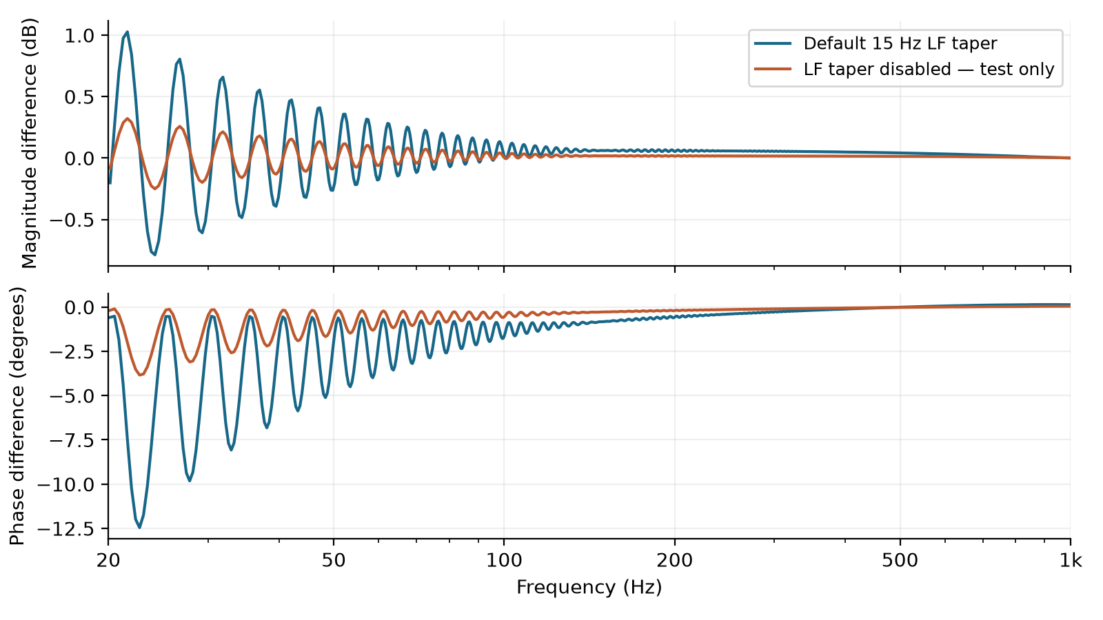
Figure 9. Synthetic reference minus the normal Stage 5 IR export and a test export with only the 15 Hz low-frequency taper disabled. Both use exactly the same reconstructed complex response.
Removing the taper reduces the maximum 20–200 Hz difference from 1.027 dB and 12.456° to 0.322 dB and 3.842°. The taper accounts for a large part of the ripple, but not all of it. The supplied reconstruction still has no DC bin, so disabling the taper cannot restore that missing information.
The taper deliberately suppresses DC and very-low-frequency content; it is not required by the inverse FFT. This experiment does not change the normal 15 Hz setting. If preserving the low-frequency complex response is the priority, the FRD or full complex export avoids these additional IR-conversion steps.

Synthetic timing and final frequency response
Having isolated the conversion effects, we can look at the synthetic source’s final exported IR.
The synthetic source is a single omnidirectional point at the origin. Both the original and exported IR peak at sample 25, or 0.52083 ms at 48 kHz. Neither waveform has been shifted to make the peaks line up.
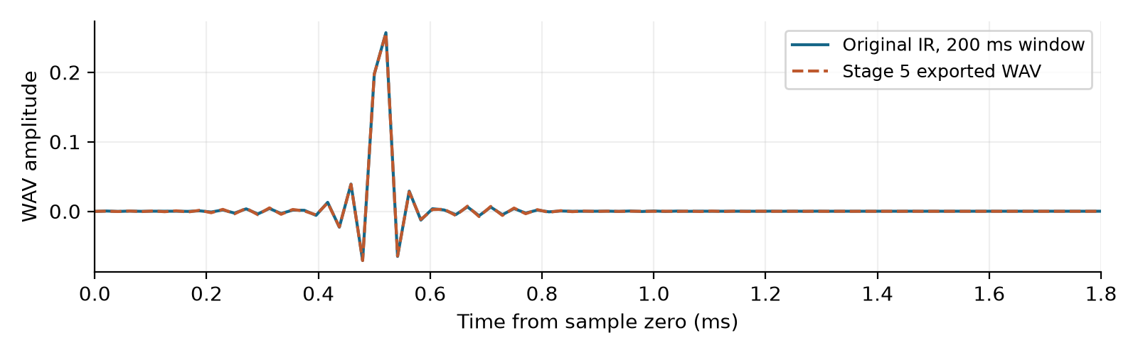
Figure 10. Synthetic original and Stage 5 IR export. Both share sample zero and peak at sample 25, without shifting either waveform.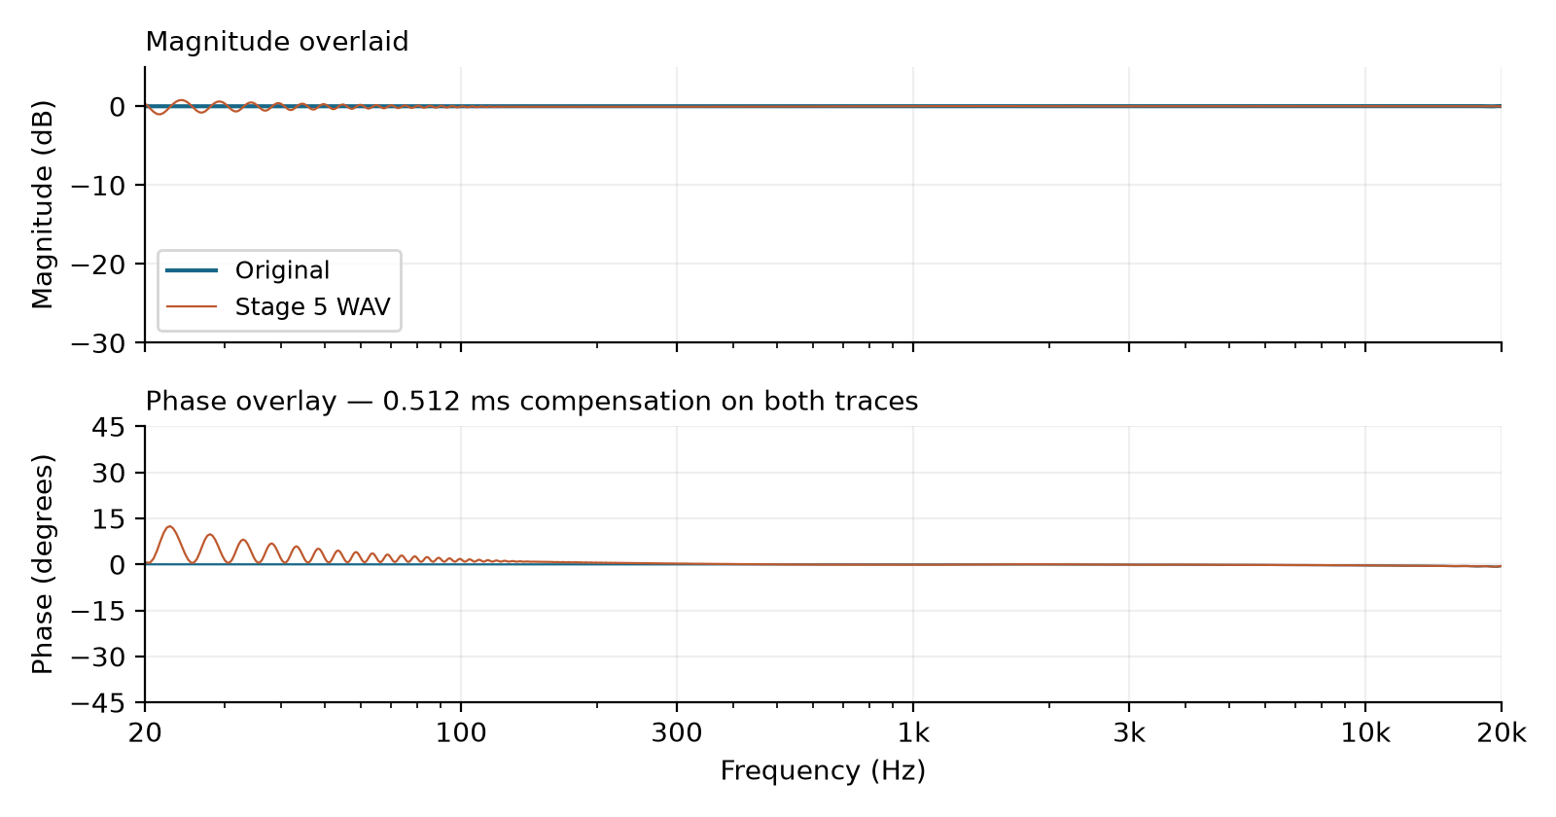
Figure 11. Synthetic magnitude and phase overlaid. The same 0.512 ms display delay compensation is applied to both phase traces.
From 200 Hz–20 kHz, the maximum differences are just 0.066 dB and 0.59°.

5 Conclusions
Stage 1 preprocessing: most of the apparent low-frequency phase mismatch disappears when the original tweeter IR is given a comparable time window. Stage 1 is therefore the appropriate reference for examining what the later model and export steps change.
Real tweeter reconstruction and export: the final IR preserves the peak sample and follows Stage 1 to within 0.79 dB and 5.34° from 300 Hz–20 kHz. Below about 300 Hz, the weak tweeter output and worsening fit limit what this dataset can tell us about reconstruction accuracy. These results include IR generation; they are not a model-only comparison.
Synthetic IR generation: the complex and FRD exports remain much closer to the original at low frequencies than the IR export. Bypassing the solve reproduces almost the same ripple, and disabling the 15 Hz taper substantially reduces it, identifying conversion as the main source of this difference. The final IR preserves the peak sample and is within 0.066 dB and 0.59° of the windowed original from 200 Hz–20 kHz.

Appendix A Test setup and coordinates
Cylindrical R is horizontal distance from the global Z axis, Phi is azimuth around that axis, and Z is height. Stage 5 spherical radius is distance from the global origin; Theta is measured down from +Z, and Phi is the same azimuth. The manual coordinate list uses absolute positions.
Convert using radius = √(R² + Z²) and Theta = atan2(R, Z). Convert radius from millimetres to metres for the coordinate list. Negative azimuths can be written by adding 360°.
Position | Original cylindrical coordinates | Stage 5 manual coordinates
Synthetic | R 143 mm  Phi −173.7°  Z −102 mm | Theta 125.50°  Phi 186.30°  Radius 0.17565 m
Tweeter | R 219.999 mm  Phi 3.10°  Z 246 mm | Theta 41.81°  Phi 3.10°  Radius 0.33002 m

The tweeter source position is approximately (62, 0, 234) mm. It is not subtracted from these global microphone coordinates. The rounded manual coordinates above are those used for the existing exports.
Setting | Synthetic | Real tweeter
Speed of sound | 343 m/s | 347 m/s in saved solve
Stage 1 FDW reference time | 5 ms | 8 ms
Stage 1 smoothing | Enabled, Auto | Enabled, Auto
Stage 4 order | N8 maximum | Saved solve uses N2–N11; current project cap N13
Optimised origins | Off | Enabled in current project
Observation mode | Internal in supplied export | Full
Capture padding subtraction | 0 samples | 0 samples
IR timing for comparison | Preserve captured delay | Preserve captured delay
Display delay compensation | 0.512 ms for both traces | 0.6 ms for both traces

Use TOF subtraction Off and leave capture padding at 0. The included export script was tested against both saved solves and recreated both supplied WAVs exactly, sample for sample. Removing five padding samples would deliberately advance the older tweeter capture by five samples. Project settings describe the current project; the reported order range comes from the saved solve.
The primary tweeter comparison uses the saved Stage 1 complex response for the original IR as its reference. The inverse FFT of that response supplies the Stage 1 IR used in the timing overlay, and its saved frequency grid is used for the magnitude and phase comparisons with Stage 5. The complete original 1.5 s capture is compared with Stage 1 separately to show the effects of Stage 1. Synthetic comparisons use the fixed 200 ms, alpha 1 window throughout. HALS retains samples before the detected peak, then applies a half-cosine decay to the window end; the synthetic capture has 199.479 ms available after its peak, so the window is capped there. No timing shift is applied.
The synthetic generator is supplied in reproduction, configured with source centre (0, 0, 0) m, piston radius 0 m, one source point, 48 kHz sampling and 0.2 s duration. The supplied synth_ir_grid.csv has 1,443 positions. Zero source radius puts the point exactly at the origin; zero Stage 5 padding is a separate timing setting.

Appendix B Reproduction procedure
The accompanying test package contains the original and exported WAV files, selected Stage 1 response, synthetic complex and FRD exports, solve-fit data, screenshots, figures and scripts. It also contains the test-only IR with the low-frequency taper disabled. The instructions below refer to that package; this Word document does not embed those data files or scripts.

Recreate the figures and report
From this IR_testing folder, with a Python environment containing NumPy, SciPy, SoundFile, Matplotlib and python-docx, run:
python analyze_edited_report.py
python revise_edited_report.py
Run these commands from IR_testing with the listed Python packages installed. The original revision script reads HALS_IR_Validation-tweaked.docx and writes HALS_IR_Validation-revised.docx; it recreates that report, not this editorial rewrite. The Stage 5 IR spectrum is evaluated on the saved Stage 1 frequency grid. Timing uses an inverse FFT of Stage 1. No fitted delay or separate gain alignment is applied; the same 0.6 ms display phase compensation is applied to both traces. Synthetic conversion diagnostics focus on 20 Hz–1 kHz.

Repeat a Stage 5 export
The LF-taper experiment is part of analyze_edited_report.py. It uses the bundled converter snapshot, changes only its LF taper operation and writes synthetic_stage5_no_lf_taper_TEST_ONLY.wav. The normal converter is checked against the existing export before the test variant is generated. The production HALS code and its 15 Hz default are unchanged.
In a HALS Python environment, supply your solved coefficient file:
python export_ir.py synthetic --coeff path/to/MySpeaker_coefficients.h5
python export_ir.py tweeter --coeff path/to/DirectivaR2-Tweeter_coefficients.h5
The export script writes to reexports, preserving the evidence WAVs in data. It uses the manual coordinates and observation modes listed above, TOF subtraction Off, capture padding 0 and microphone calibration Off. Use --repo if the folder has been moved outside the HALS repository.

Generate the synthetic measurement set
Run reproduction/synth_ir_gen_tof_test.py with reproduction/synth_ir_grid.csv beside it, then process and solve the generated IRs in HALS. Use the supplied synthetic settings, N8 maximum, 343 m/s and optimised origins Off. The generator and settings are included so this part can be independently repeated.
The complete tweeter measurement set and coefficients are not included. The supplied data reproduces the comparisons, but cannot independently reproduce that solve. These are checks at measured positions; they do not establish accuracy elsewhere or audibility of the differences.

Appendix C ARTA comparisons
These original ARTA screenshots compare the full tweeter capture with the Stage 5 export, using one-third-octave display averaging. They retain the earlier visual check and its display settings. The main quantitative tweeter comparisons instead use Stage 1 as their reference, so that preprocessing is accounted for.
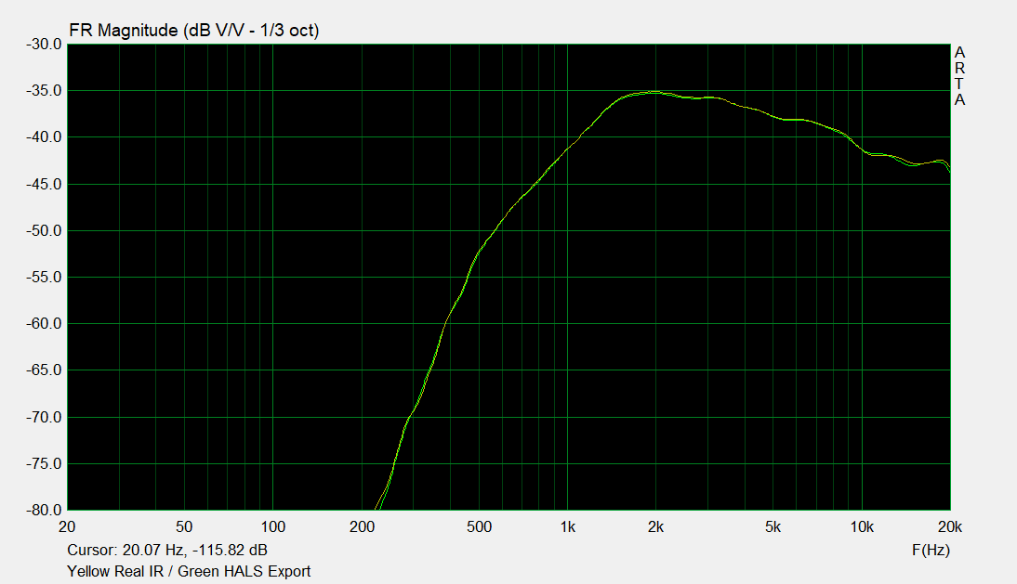
Figure 12. Original ARTA magnitude comparison.
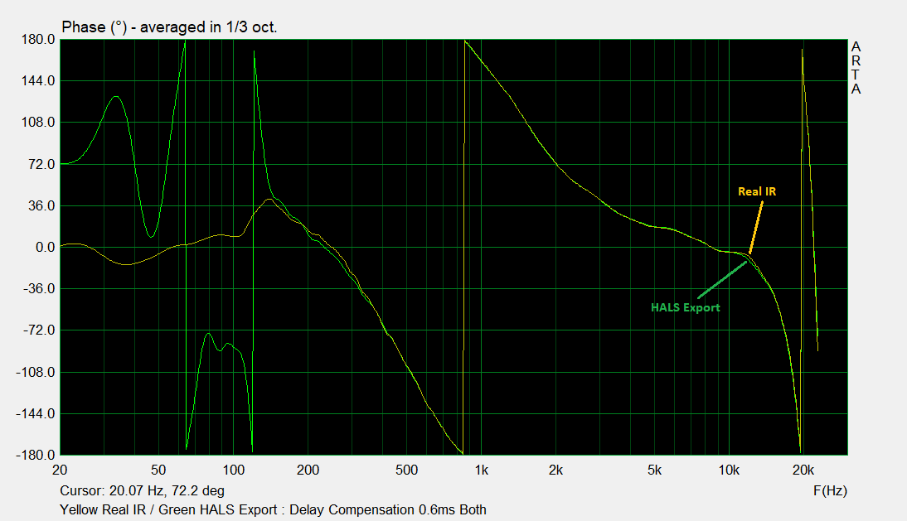
Figure 13. Original ARTA phase overlay, with 0.6 ms compensation on both traces and one-third-octave display averaging.

