**Welcome**

The Intelligent Systems Group (ISG) is a research group devoted to the research of Artificial Intelligence and its applications. ISG is composed of researchers from different departments (Computer Engineering, Computer Science and Mathematics) of the University of Alcalá, in Madrid, Spain.

The group is active in high scientific and commercial areas in: Machine Learning, Intelligent Control (Robotics), Process optimization based on Bio-inspired computing and Quantum Computing. Main applications are Pattern Behavior Recognition for people and systems, Early Detection of Users Commercial Intentions, Social Networks, Simulation Environments or Space engineer.

**Research**

*Machine Learning - David*

The SOPRENE (Maintenance detection error based on the condition of Navy ships) project aims to develop an expert system for the prediction of faults and indicators of predictive maintenance for the Spanish Navy ships. It is based on IA architectures (physical and logical) and techniques associated with soft computing. The UAH contribution to the project is the model training and the model validation of the data.

*Intelligent Control (Robotics) - Malola*

We use AI Planning & Scheduling solutions for tasks allocation in complex scenarios such as the science program of a spacecraft. We employ technologies for modelling the scenarios such as PDDL or DDL (used by ESA in various projects) for dealing with resources and temporal constraints. For implementing the solvers we use techniques such as HTN, heuristic search and, more recently, genetic algorithms.

Path planning and navigation for robotics systems, specially focused (but not limited to) surface robotics. We have developed path planning algorithms for robots with limited turning capabilities or those who have to deal with complex terrains, such as the Mars surface.

*Process optimization based on Bio-inspired computing - David*

*Quantum Computing (Fer)*

**PRODUCTS**

The **LARES** (An AI-based teleassistance system for emergency home monitoring) project is the result of three different projects funded by different public Spanish entities to contribute on the research of the elderly assistance. The projects are described next:

1.LARES: it consists of: i) a Wireless Sensor Network for receiving information of the environment and the dependent person, (ii) an AI autonomous robot able to take decisions based on the received information, and (iii) a Web-based system to provide telecare assistance and process the data.

2.Human falling detection: we have used a smart watch (composed of a triaxial accelerometer) and ML techniques to process the output data of the watch to detect the human falling.

3. Automatic detection of emergencies: based on the data collected on the home and the watch, we are able to infer person’s patterns of behaviour and trigger emergencies by using ML techniques. This project allowed to deploy LARES in two real home environments.

The **QCPVC** (Detection of manufacturing defects in PVC profiles) project provides automatic Quality Control (QC) to the production lines of PVC companies. QC remains primarily a human task in which skilled operators must analyse and discard those products with manufacturing defects. Based on the operator’s experience, we have built an artificial vision system that detects defects in the PVC profiles and learn from those decisions by using ML techniques.

**OGATE (PABLO)**

We have an open research line in assessing autonomous controllers with the objective of Verifying & Validating autonomous robots, an activity started in a PhD program funded by ESA. In this sense our objective is to create a common framework to enhance the trust in autonomous systems with a particular focus on the space exploration. This framework allows us to exhaustively test autonomous controllers in different circumstances, characterizing different behaviours while assessing the performance and identifying flaws that are hardly to observe otherwise.

Vid: https://www.youtube.com/watch?v=sqF0uFA1w_8

Vid: https://www.youtube.com/watch?v=kI0dgTOlo-Q

**MoBaR (Pablo)**

MoBaR is an autonomous controller based on modeling technologies to deploy autonomous robot applications. In order to provide fast deployments in different scenarios, MoBaR relies on mature technologies such as PDDL planners for the deliberation, a PLEXIL executive (made by NASA-AMES) for execution and monitoring and a ROS layer to control the robotic platform. The design of MoBaR allows to use it as a versatile system to test assets such as the UP2TA planner, or to easily deploy and test different solutions for the LARES autonomous robot.

Vid: https://www.youtube.com/watch?v=igpn3k_gbRA

Vid: https://www.youtube.com/watch?v=TiOf5CBca0M

Vid: https://www.youtube.com/watch?v=QEVBsY89R-U

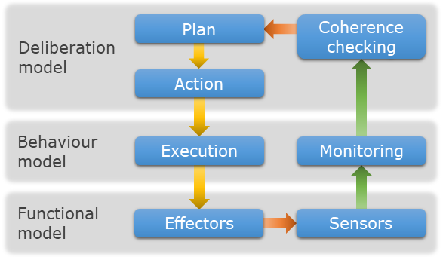

**UP2TA (Pablo)**

UP2TA is a planner that integrates our knowledge in PDDL based planning and our research in path planning for mobile robots. The UP2TA planner allows to optimize mobile robots to accomplish a set of tasks by reducing the paths length and considering best tasks sequencing. From the point of view of the user, this planner works as a standard PDDL planner, thus it is easily exploitable for its application in systems such as the MoBaR controller. Moreover, its design allows to use different path planning algorithms, from classical ones such as A* to our latest algorithm, 3Dana.

Vid: https://www.youtube.com/watch?v=iRlg25wF6jw

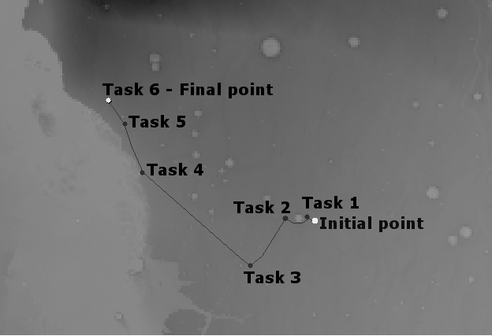

**3DANA (Pablo)**

Path planning for mobile robots is a relevant problem to optimize efficiency meanwhile reducing the risks by avoiding hazardous areas. In this direction, we have created 3Dana, a path planning algorithm that enables slope-limited paths with hazardous avoidance (using cost maps) and provides a heading change heuristic to minimize heading changes (inherited from our S-Theta* algorithm). The objective of 3Dana is to generate safer paths in uneven terrains like Mars. Also, 3Dana is integrated in the UP2TA planner.

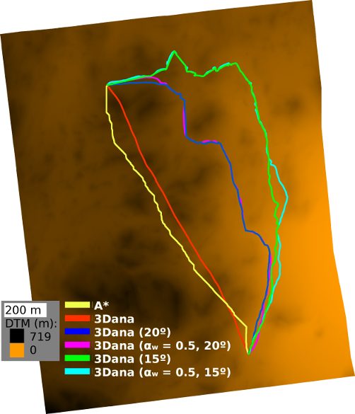

**ARIES (FER)**

We also face the robotic cooperation for future exploration missions in which we want to explore a large area of a planet by means of an autonomous rover and an aerial vehicle. Both robots have to cooperate to successfully achieve their objectives; while the rover has limited mobility but high battery capacity, the aerial vehicle can cover long distances faster, but requiring to recharge its battery through the rover. In order to support this cooperation approach, we are building a simulation environment on the Virtual Robot Experimentation Platform (V-REP).

**Quantum Tool**